Protocol Human approach test (pen level)
Saskia Kliphuis, Maëva Manet and Jary Weerheijm
Introduction:
The human approach test will be used to assess fearfulness towards humans in 10 week old ISA Brown and Dekalb White laying hens. To simulate the on-farm situation, the human approach test will be performed on pen level. The researcher will be able to assess the pullets using a scoresheet (table 1, 2 & 3a/b). Each pen will be tested for 5 minutes in which the latency to approach and the latency to touch the researcher will be noted down. After this a capturing simulation will be executed. During this simulation, the researcher will crouch down, stick out one arm towards the pullets and move this arm from left to right at a moderate tempo, without targeting any pullet, but moving indiscriminately. This would be a common occurrence commercially, and thus valuable information. The pen will be divided into 5 areas based on visual attributes in the pens (concrete edge, feeder, perch) (figure 1) which will be used to assess the pullets’ approaching distance.
Testing age: 10 weeks of age.
Materials:
- Stopwatch
- Pen
- Scoresheet (1 per pen, see second page of protocol)
- DO NOT DISTURB! sign to put on the stable door

Methods:
Prior to test:
- Make sure to silence mobile phones.
- Randomise the pen order.
- Remove jewellery.
- Make sure to wear neutral coloured (white or black) shoes.
- Place the “DO NOT DISTURB!” sign on the stable door.
- Spend 30min in the stable, walking up and down the room to habituate the pullets to human presence.
Test protocol:
- Stand at the first pen door and score the position of the pullets prior to entering at “pre” (table 1). This will serve as a baseline position.
- Upon entering the pen close the door and step back towards the pen door while facing the opposing wall.
- Start the timer. Stand still during the 5 minutes of scoring and make sure to avoid eye contact.
- Score the position of the pullets relative to the researcher (figure 1) every minute from 0 onwards, up to 5 (table 1)
- Score the latency to move towards the researcher and to touch the researchers for the first 3 pullets to do so (tables 2a/b).
- After 5 minutes, stop the stopwatch.
- Crouch down and simulate an attempt to capture a pullet (see introduction). Note down the immediate responses (table 3).
- Exit the pen and proceed to the next pen.

Scoresheet Human Approach Test Pen number: _______ Time:______

Table 1: Scoresheet human approach test. Each number correlates with the area of the pen given in figure 1. Before the pen is entered the pullets will be observed from the outside. The place of the pullets during this observation will be written down at “pre” and will serve as a baseline. The number of pullets in each area of the pen will be noted down every minute. “5 ↓” indicates pullets beneath the perch and “5 ↑” indicates pullets on top of the perch.
Time (min) | Areas in pen
 | 1 | 2 | 3 | 4 | 5 ↓ | 5 ↑ | Remarks
Pre
0
1
2
3
4
5

Table 2a: Scoresheet latency to approach the researcher (making at least one step towards the experimenter). The order of approaching pullets ought to be noted down. If possible note the tag number of the pullet under “Chick ID”. If no pullets approach during the 5 minutes of timed testing, note down 300 in latency – the maximum duration of the test, and “000” in Chick ID.
Order | Latency to approach (sec) | Chick ID | Remarks
#1
#2
#3

Table 2b: Scoresheet latency to touch the researcher (make physical contact with the researcher). The order of approaching pullets ought to be noted down. If possible note the tag number of the pullet under “Chick ID”. If no pullets approach during the 5 minutes of timed testing, note down 300 in latency – the maximum duration of the test, and “000” in Chick ID.
Order | Latency to touch (sec) | Chick ID | Remarks
#1
#2
#3

Table 3: Scoresheet capture simulation. “Made contact” refers to any other form of physical contact with the researcher; “Approached” refers to pullets making at least one step towards the experimenter; “Remained immobile” refers to pullets not making any step in any direction, but could make body or head movements; “Fled” refers to pullets making at least one step in the opposite direction of the experimenter.
Made contact | Approached | Remained immobile | Fled | Remarks
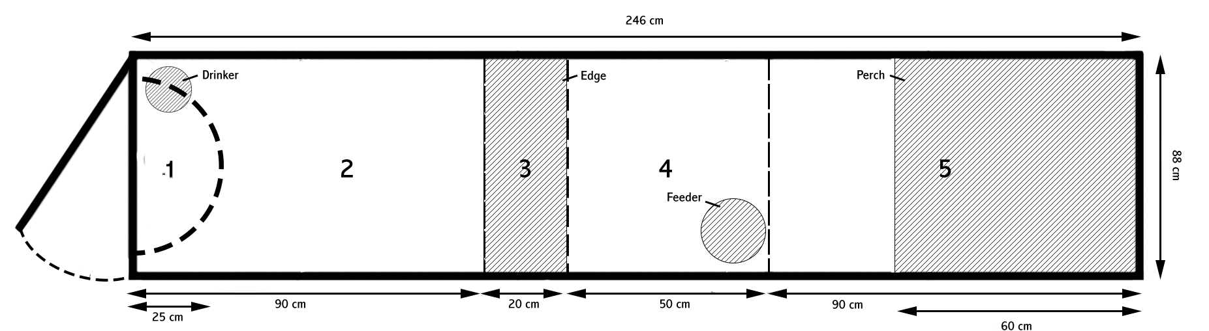
Figure 1: Zone layout in the pens. Each zone is determined by visual cues such as the concrete edge (zone 3), the feeder (zone 4) and the perch (zone 5). Zone 1, however does not depend on visual cues, but rather on distance (25 cm around the researcher). Zone 5 is divided into 2 parts (5↑ and 5↓) depending on whether the pullets are on top or below the perch, respectively.

