IJESRT
International Journal of Engineering Sciences & Research Technology
PERFORMANCE OF CO-AXIAL PROBE FED RECTANGULAR MICROSTRIP ANTENNA WITH RADOME THICKNESS AND DILECTRIC CONSTANTS
V. Saidulu*
*Department of ECE, Mahatma Gandhi Institute of Technology, Hyderabad, India

DOI: 10.5281/zenodo.829813

ABSTRACT
This paper presents the variation of some selected parameters of a co-axial probe fed rectangular microstrip antenna as a function of Radome thickness and dielectric constant. Better range of radome thickness at 2300MHz in S-Band is found to be 0.1-0.6 mm with superstrate dielectric constant of 2.2. To give a maximum VSWR of 3:1. The better range of superstrate (a) Dielectric constant is up to 5 at 0.1mm thickness. (b) Dielectric constant is up to 3 at 0.2-0.3mm thickness (c) Dielectric constant is up to 2 at 0.3-0.6mm thickness at a maximum VSWR of 3:1. Some characteristics of co-axial fed rectangular microstrip antenna as a function of dielectric constant and thickness of a radome have been evaluated using computer simulation using IE3D software from Zeland. The antenna characteristics are investigated includes frequency shift, VSWR variation, gain, beam widths in E &H- Planes respectively.

KEYWORDS: Microstrip antennas, Resonant frequency, Superstrates, VSWR, Gain, Beam width etc.

- INTRODUCTION
Microstrip antenna consists of radiating patch on the one side of the substrate having the ground plane on the other side. The major advantages are light weight, low profile, conformal, easy to fabricate. The antenna is suitable for high speed vehicles, air craft’s, space crafts and missiles because of low profile and conformal nature [2].But antenna should be with stand various environmental conditions. So Radome (super-strate) is used on a microstrip antenna as a cover to protect antenna from external environmental conditions like temperature, pressure etc. The Radome is supposed to be transparent to microwave radiation. At the operating frequency, ideally there will not be any change in antenna characteristics, but practically because of material properties there will be change in antenna characteristics [3-14]. Co-axial probe fed rectangular microstrip antenna characteristics have been investigated by computer simulation using IE3D software [1]. The variation of some selected antenna characteristics has been studied as a function of radome dielectric constant and it’s thickness. Rectangular microstrip patch antenna with dielectric cover (Radome) is shown in Fig.2.

- ANTENNA SPECIFICATION AND COMPUTER SIMULATION
The geometry of a probe fed rectangular microstrip antenna is shown in Fig 1. The antenna under investigation is a patch of width 48mm and length 41mm on a substrate of thickness1.5875mm, dielectric constant 2.33, tanδ=0.00012and feed radius of 0.65mm.The corresponding resonant frequency is 2300 MHz. The antenna fed location is (-7,0) is shown in Fig 1. The ground plane dimensions are assumed as infinite for simplicity of calculations. The patch and ground plane are perfectly conducting. Antenna geometry, material properties and boundary conditions are considered and simulated using IE3D. Initially antenna is simulated without radome.
We found that the antenna VSWR at resonant frequency is 1.089, band width is 75MHz, gain is 6.77dBi, beam width in E-Plane is 99⁰ and beam width in H-Plane is 77.5⁰ respectively. The antenna VSWR and resonant frequency, radiation parameters are found as a function of radome dielectric constant and its thickness. The variation of antenna parameters is studied for the following two cases:
- Effect of varying the thickness of superstrate from 0.1mm to 10mm at ε_{r2}=2.2
- Effect of varying ε_{r2} from 1 to 10 for different variation of thickness (d)from (0.1 to 0.8 mm)

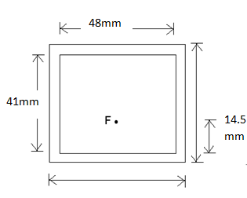
Fig1. Geometry of rectangular patch (Top view)
14.5mm
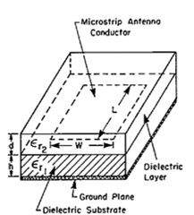
Fig2. Rectangular patch with dielectric cover (Radome)

- CAD FORMULA DESIGN FOR RESONANT FREQUENCY
CAD formula for the resonant frequency of rectangular patch antenna with dielectric cover

- Width of Antenna:
The approximate width (W) of antenna =(1)
Where: free space permeability and permittivity respectively.

- Length of Patch:
The actual Length of the patch (L) can be determined from following equation.
L=(2)

- Incremental Length of Antenna:
The extended incremental length () is due to fringing field at edge, it can be determined by following equation.
=0.412h(3)
The effective dielectric constant ( = (4)
- Resonant input resistance and Feed point selection
Radiation of patch is done from the two slots separated by length L. The total admittance at slot1 (input admittance) is obtained by transferring the admittance of slot2 from output terminals to input terminals using the admittance transformation lines. The transformed admittance of slot2 becomes
Y2=G2+jB2=G1-jB1 (5)

From above
G2 = G1
B2 = -B1

Therefore the total resonant input admittance is real and given by
Yin=Y1+Y2 = 2G1 (6)
(7)
The conductance (G1) at slots is calculated as following equation.
(8)
From the above equations the approximate equations for conductance as follows.
(9)
The input resonant input resistance (Rin) with considering the mutual conductance (G12) is modified as follows.
(10)
- Superstrate (Radome) Effects
A microstrip patch antenna may be subjected to superstrate material and the performance. In particularly, the resonant frequency is lowered, causing tuning problems and severely degrading performance, which may be serious, as the band width of these antennas is inherently low. Patch antenna with radome (cover) is shown in Fig.3.
If ε_{e} = ε_{e0} + Δε_{e}and Δε_{e}≤0.1 ε_{e0}

Fig 3 Microstrip antenna with dielectric cover

Bandwidth is 106.85, 110.24 degrees and antenna efficiency 42.77%. It is observed that there is shift in center frequency as radome thickness increases. The center frequency comes down from 2290 MHz to 2210 MHz the variation of VSWR with different radome thicknesses at 2300MHz. As radome thickness increases, VSWR increases. The variation of gain at different radome thicknesses. As radome thickness increases, the gain decreases from 6.65dBi to 1.03dBi , the beam width in E plane decreases from 99⁰ to 82⁰ and Beam width in H plane with variation of radome thickness almost constant which is around 77.5⁰respectively. The change in resonant frequency, VSWR variation, Gain variation, Beam width variation for different dielectric constant varies at various thicknesses. From these figures, we observed that for a small change in dielectric constant in therange 1-10, there is abrupt change in Resonant frequency, VSWR, Gain, and E plane Beam width. The H- plane beam width remains constant.

- RESULTS AND DISCUSSION
It is observed that there is shift in center frequency as radome thickness increases. The center frequency comes down from 2290 MHz to 2210 MHz shown in Fig 4. Fig.5 shows variation of VSWR with different radome thicknesses at 2300MHz. As radome thickness increases, VSWR increases. Fig 6 shows thevariation of gain at different radome thicknesses. As radome thickness increases, the gain decreases from 6.65dBi to 1.03dBi Fig.7 and Fig. 8 shows that beam width in E plane decreases from 99⁰ to 82⁰ and Beam width in H plane with variation of radome thickness almost constant which is around 77.5⁰ respectively. The change in resonant frequency, VSWR variation, gain variation, beam width variation for different dielectric constant vary at various thickness in shown in Fig. 4 to Fig 13 respectively. From these figures, we observed that for a small change in dielectric constant in the range 1-10, there is abrupt change in Resonant frequency, VSWR, Gain, and E plane Beam width. The H- plane beam width remains constant. We noticed that, there is abrupt change in the center frequency between 2300MHz to 2135MHz for the dielectric constant variation from Fig.4.
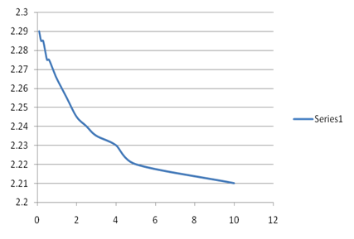
Resonant Frequency
(GHz)
Thickness (mm), d

Fig 4: Variation of resonant frequency with different radome thickness
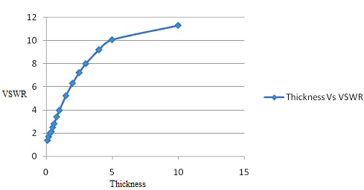
Fig5.Variation of VSWR with different radome thicknesses
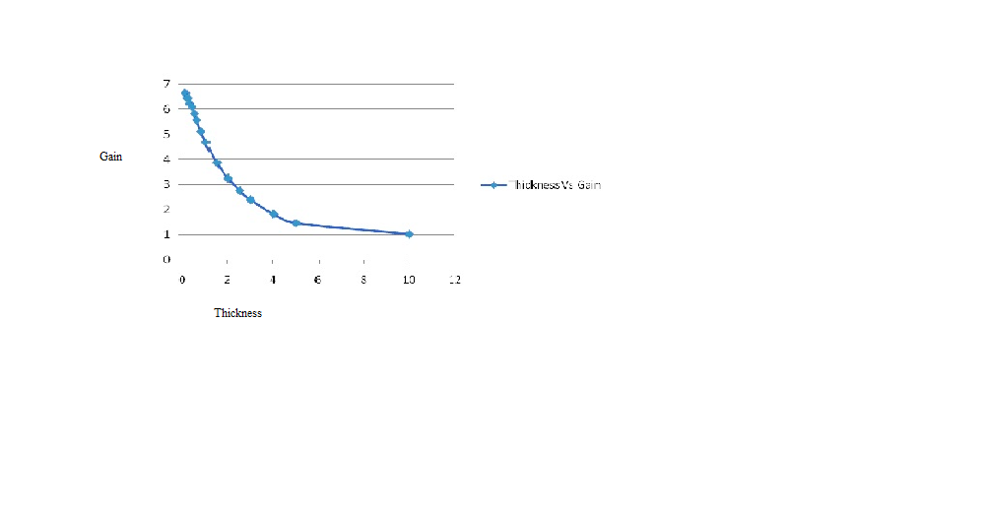
Fig.6Variation of gain at different radome thicknesses.
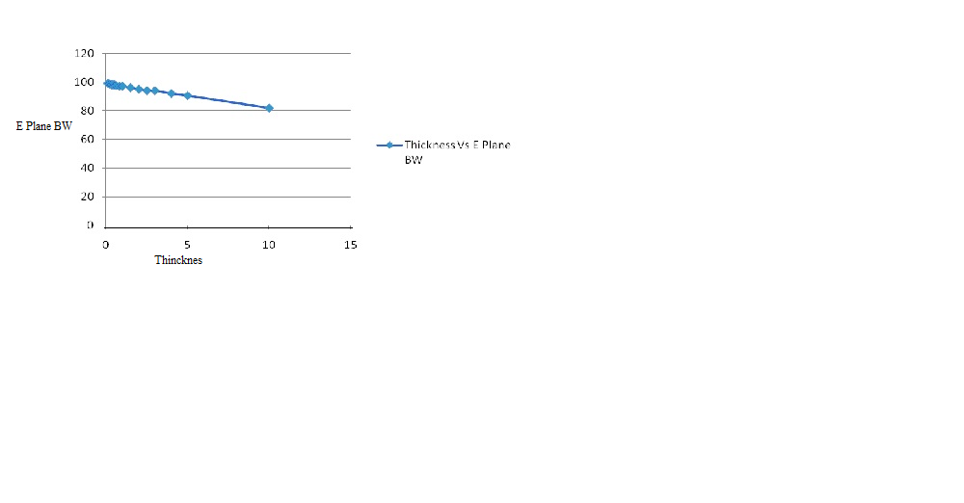
Fig. 7 Variation of E-Plane beamwidth at different radomethickness
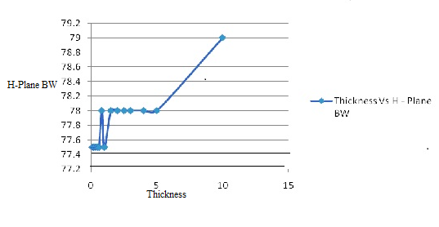
Fig.8Variation of H-Plane beamwidth at different radome thickness
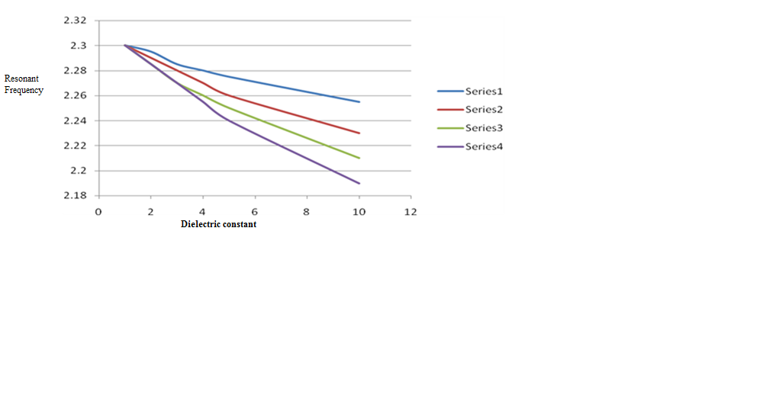
Fig.9(a) Variation of dielectric constant and resonant frequency at different radome thicknesses 0.1-0.4mm
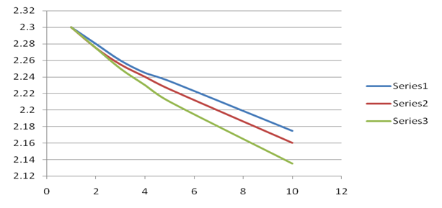Dielectric constant ,ε_{r2}
Resonant Frequency
(GHz)

Fig. 9(b) Variation of dielectric constant and resonant frequency at different radome thickness 0.5, 0.6, 0.8mm

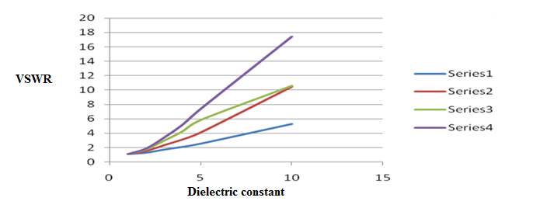
Fig. 10(a)Variation of dielectric constant and VSWR at radome thickness at 0.1-0.4mm
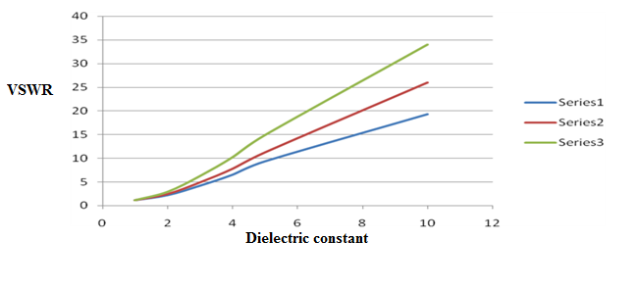
Fig.10(b)Variation of dielectric constant and VSWR at radome thickness at 0.5, 0.6, 0.8mm
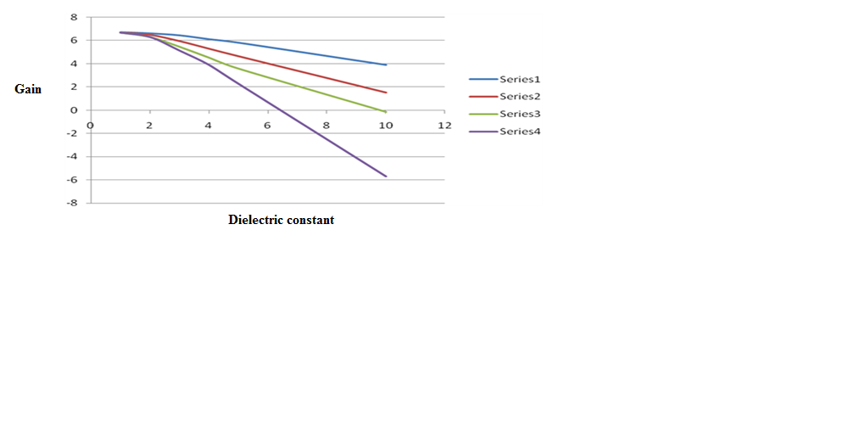
Fig.11(a)Variation of dielectric constant and gain at radome thickness 0.1-0.4mm
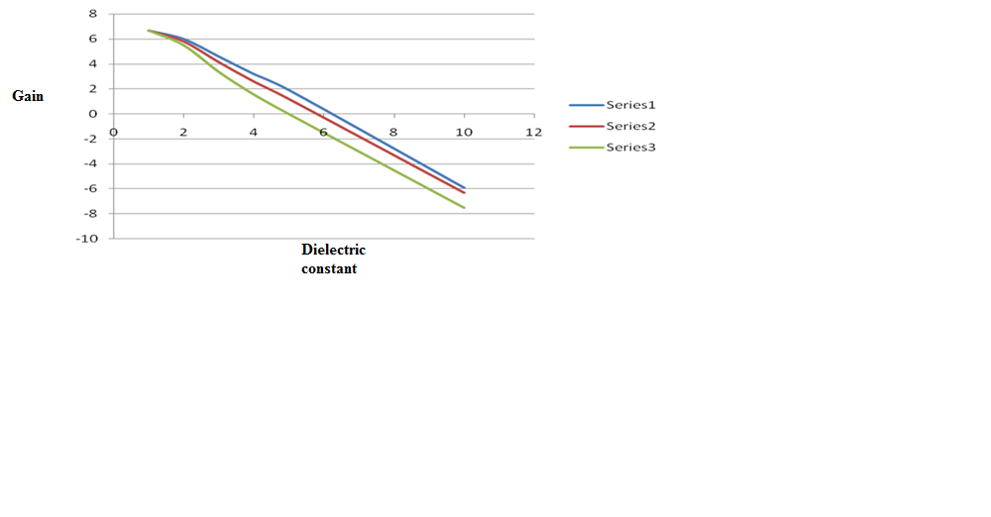
Fig.11(b)Variation of dielectric constant and gain at radome thickness 0.5, 0.6, 0.8mm

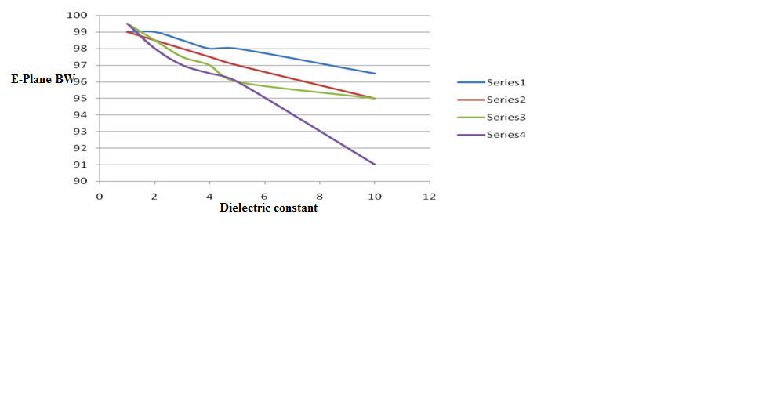

Fig.12(a) Variation of dielectric constant and E-Plane beamwidth at radome thickness 0.1- 0.4mm
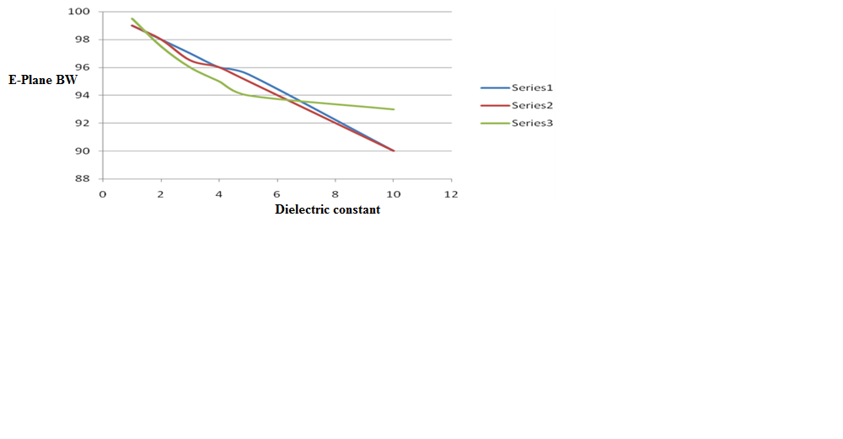
Fig.12(b) Variation of dielectric constant and E-Plane beamwidth at radome thickness 0.5, 0.6, 0.8mm

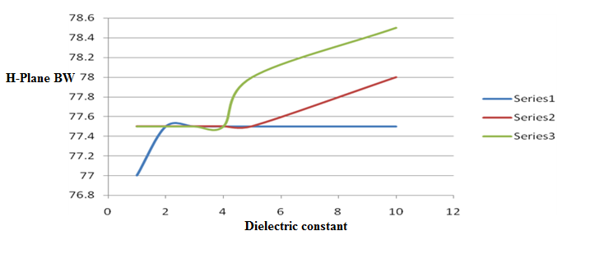
Fig.13(a)Variation of dielectric constant and H-Plane beamwidth at radome thickness 0.1- 0.4mm

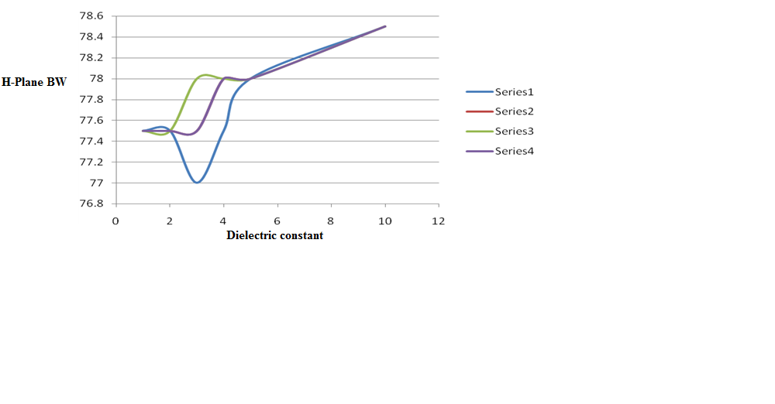
Fig.13(b)Variation of dielectric constant and H-Plane beam-width at radome thickness 0.5, 0.6, 0.8mm
- CONCLUSION
Simulation results shows that, when radome thickness increases there will be decrease in beam width and gain. The center frequency shifts in the lower side as radome thickness increases. Experiments are being planned to verify the results predicted by computer simulation. From the above discussions we conclude that the better dielectric combination of superstrate thickness is 0.1-0.6mm for εr2 of 2.2 and better range of superstrate dielectric constant is up to 5 at 0.1mm, dielectric constant is up to 3 at 0.2mm to 0.3mm thickness and up to 2 at 0.3 to 0.6mm thickness.

- ACKNOWLEDGEMENTS
The authors would like to thank toV SrinivasaRao, Scientist, RCI for the discussions they had from time to time.

REFERENCES
- IE3D Manual, Zeland software Inc.,Fremount, USA, 1999
- I J Bhal and P Bhartia, “Microstrip antennas”, Artech house, 1980.
- R.Shavit,”Dielectric cover effect on Rectangular Microstrip Antennas array”. IEEE Trans. Antennas propagat.,Vol 40,. PP.992-995,Avg.1992.
- Inder ,Prakash and Stuchly, “Design of Microstrip Antennas covered with a Dielectric Layer. IEEE Trans. Antennas Propagate. Vol.AP-30.No.2,Mar 1992.
- O.M.Ramahi and Y.T.LO, ”Superstrate effect on the Resonant frequency of Microstrip Antennas”, Microwave Opt.Technol. Lett. Vol.5, PP.254-257,June 1992.
- A.Bhattacharyya and T. Tralman, “Effects of Dielectric Superstrate on patch Antennas”, Electron Lett., Vol.24,PP.356-358, Mar 1998.
- R.Afzalzadeh and R.N.Karekar, ”Characteristics of a Rectangular Microstrip patch Antenna with protecting spaced Dielectric Superstrate”, Microwave Opt. Technol. Lett., Vol.7, PP.62-66, Feb 1994.
- A.K.Vermal, A.Bhujpal, .Rostamy andG.P.Srivastav. “Analysis of Rectangular Patch Antenna with dielectric cover”.IEICE Trans.No. E 74,PP.1270-1276,May 1991.
- I J Bahl P. Bhartia, S.Stuchly“ Design of microstrip antennas covered with a dielectric layer. IEEE Trans. Antennas Propogat. No. 30, PP. 314-318, Mar 1982
- Jennifer T Bernhard and Carolyn J. Tousignant “Resonant frequencies of Rectangular microstrip antenna with flush and spaced dielectric superstrates” IEEE transactions on antennas and propogation, Vol 47.
- F. Bouttout, F.Benabdelaziz, T. Fortaki, and D. Khedrouche, “Resonant frequency and band with of a superstrate-loaded rectangular patch on a unixale anisotropic substrate”. Commm. Ngmer. Meth. Engng; Vol. 16 no.7, pp.459-473, July 2000
- V.A. Dmitrier, J.C.W.A. Costa, “Theoritical investigation of compact microstripe resonators with stubs for patch antennas”. IEEE trans. Microwave theory Tech; 50, PP.27-29,
- R.E. Collin , Antennas radial wave propagation. Newyork, McGraw-Hill 1985
- V.Saidulu and K. SrinivasaRao, “ Analogy of Microstrip Patch Antenna with Superstrate:” published paper in the proceeding of International on Innovations and advancement in Computing (ICIAC-2016), GITAM University, Hyderabad, pp. 207-213, March, 2016.
- V. Saidulu, “Design and Analysis of Microstrip Patch Antenna with Superstrate for Wireless Application” published in the proceeding of National Conference on Advanced Signal Processing, Embedded & Communication Systems (ASPECS-2016) jointly organized by Department of Electronics and Communication Engineering and Research Centre Imarat, DRDO, Hyderabad, during 11th-12th, August, 2016..

CITE AN ARTICLE
It will get done by IJESRT Team

