Elite Landsat land surface temperature/ emissivity dataset User Manual（V1.0）

Author: Jie Cheng, Shengyue Dong
Institute of Remote Sensing Science and Engineering, Faculty of Geographical Science, Beijing Normal University
目 录
1. Dataset descriptions 1
2. Algorithm description 1
3. Data source 2
4. Dataset details 2
Reference 4

Dataset descriptions
Land surface temperature (LST) is one of the key parameters in land–surface physical processes on regional and global scales and has been widely applied to hydrology, meteorology, and the surface energy balance. Remote sensing is a unique way of obtaining the LST at regional and global scales. In order to obtain high spatial resolution LST products with high accuracy, Landsat thermal infrared data was used as the main data source to overcome the existing problems in LST retrieval.
Firstly, a new scheme for estimating Landsat 5/7/8 land surface emissivity (LSE) was proposed. Then, the MERRA2 reanalysis products were used for thermal infrared data atmospheric corrections. Finally, LST product with high spatial resolution based on Landsat 5/7/8 data were generated by the radiative transfer equation method.

Algorithm description
The flowchart is shown in Figure 1.
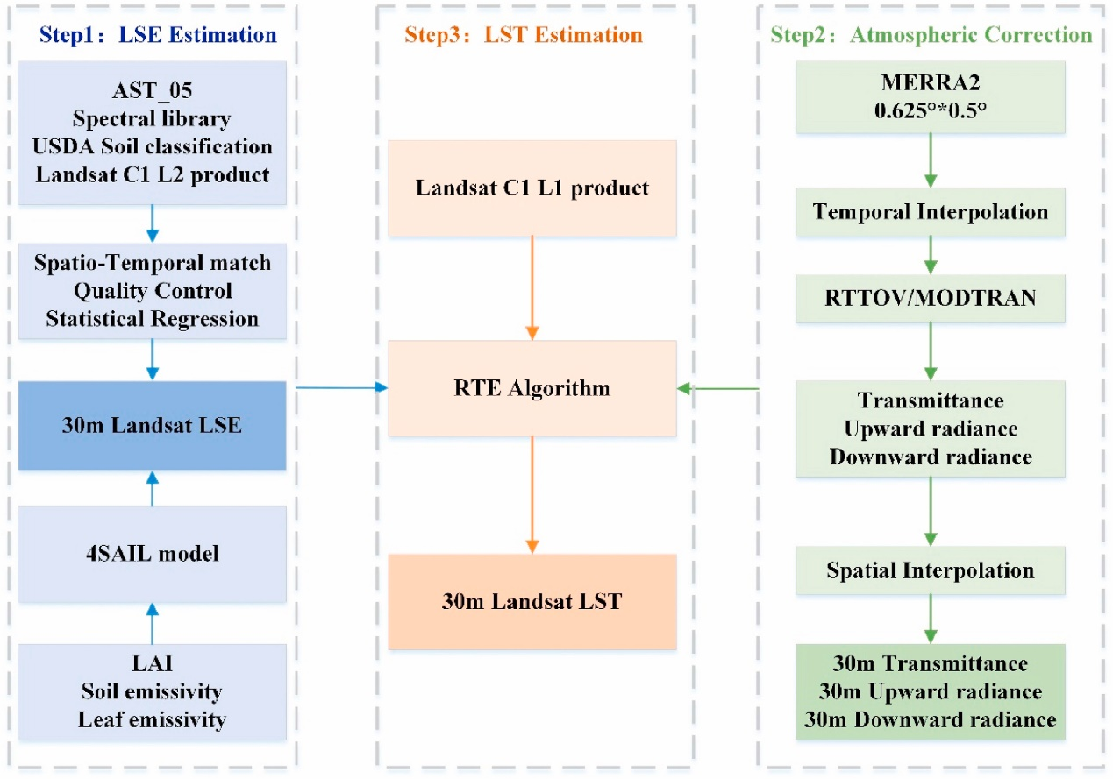
Fig. 1 Overall flow chart for generating 30 m land surface temperature from the observations of Landsat 5/7/8.
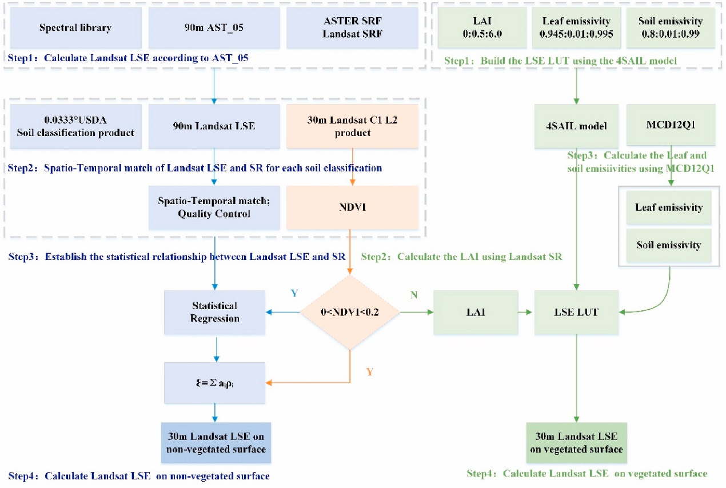
Fig. 2 Flow chart for generating Landsat land surface emissivity, excluding ice/snow and water.
Three steps are included:
- LSE estimation using the new scheme.
- atmospheric correction based on MERRA2 reanalysis data(Meng and Cheng 2018).
- LST estimation based on the RTE algorithm(Cheng et al. 2021).

Data source
Basic information about the used datasets is reported in Table 1.
Table 1. Basic information about the data used in this study.
Name | Introduction | Resolution | Usage
Landsat 5/7/8 L1 | Landsat 5/7/8 TOA Radiance | 30m | LST retrieval
Landsat 5/7/8 L2 | Landsat 5/7/8 BOA Reflection | 30m | LSE estimation
MERRA2 | Atmospheric profiles | 0.625°× 0.5° | atmospheric correction
ASTER | LSE product | 90 m | LSE estimation
Soil taxonomy data | Soil taxonomy data | 0.0333° | LSE estimation
MCD12Q1 | MODIS LUCC | 500 m | LSE estimation

Dataset details
Filename：ELITE.LST.Landsatx.PathRow.YYYYDOY.V1.0.tif/
ELITE.EMIS.Landsatx.PathRow.YYYYDOY.V1.0.tif/
ELITE.QC.Landsatx.135032.2005002.V1.0.tif
- Landsatx: Landsat5/7/8；
- LST: LST product; EMIS: LST product for Landsat5 band6/ Landsat7 band6/ Landsat8 band10; QC:the corresponding quality control band
- YYYY: Year；
- DOY: Day of year
- Vn: Version number
Table2 QC bit index
Index | Bytes | Value | Meaning
0 | 1 | 0（0）  1（1） | LST retrieval failed  LST retrieval successful
1 | 1 | 0（0）  1（1） | From Landsat5/7/8  Fill value
2 | 1 | 0（0）  1（1） | LST estimation based on the RTE algorithm  LST estimation based on the SW algorithm
3 | 1 | 0（0）  1（1） | Clear-sky pixel  Cloudy pixel
4 | 1 | 0（0）  1（1） | Clear-sky pixel  Probably Clear-sky pixel
5 | 1 | 0（0）  1（1） | Not water pixel  water pixel
6 | 1 | 0（0）  1（1） | Not snow pixel  snow pixel

Reference
Cheng, J., Meng, X., Dong, S., & Liang, S. (2021). Generating the 30-m land surface temperature product over continental China and USA from landsat 5/7/8 data. Science of Remote Sensing, 4, 100032
Meng, X., & Cheng, J. (2018). Evaluating Eight Global Reanalysis Products for Atmospheric Correction of Thermal Infrared Sensor—Application to Landsat 8 TIRS10 Data. Remote Sensing, 10, 474

