1 Landslides triggering
In the original version of CAESAR-Lisflood (CL) (1.9 b), the threshold angle of the landslide triggering can be only input as a single global value. This means that the threshold angle within the entire basin is the same, which is not capable to meet the need to investigate the spatial variance of hillslope process or corresponding scenarios. Hence, here we have modified CL model by adding a spatially variable slope failure threshold (Figure 1) that is defined by an input file containing the spatial extents of different failure angles threshold. By setting the failure angle at specific locations we could therefore trigger landslides where required.

Set up in CL.
The user should input a slope failure index file ending with “.txt” at the “Slope Process” module (Figure 1). The input file containing the spatial extents of different failure angles, has the same format as the DEM (arcgis ascii file) that contains an integer number that corresponds to different zones of failure threshold angle.
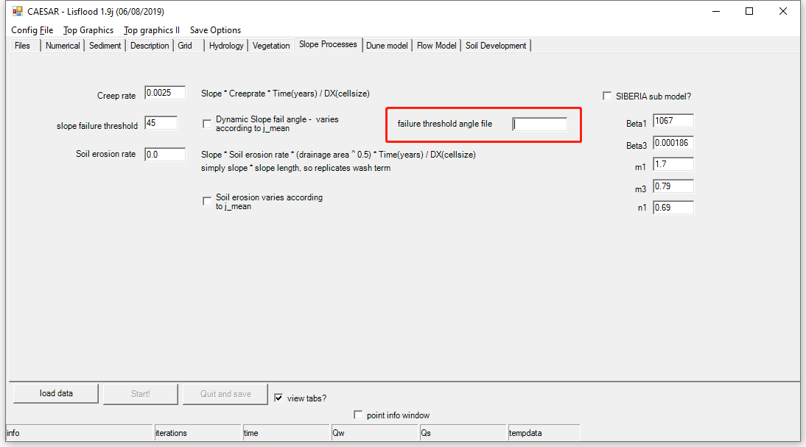
Figure 1 failure angle threshold file input

2. Landslides grain size input
In the revised CL, a spatial index file of grain size distribution (GSD) in the basin is established (Figure 2), and each index corresponds to a specific particle size distribution input to CL model. This GSD index file is used to establish a spatial link between other dataset used in the CL model and the sediment GSD via spatial index described above.
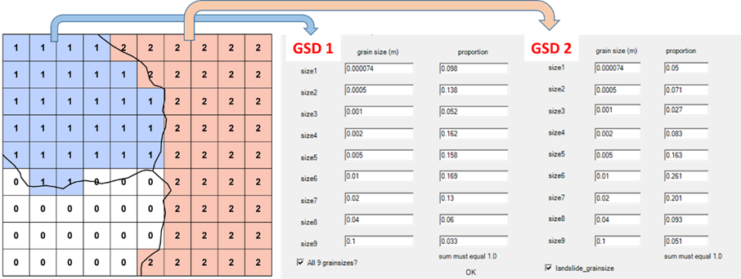
Figure 2. Schematic diagram of GSD index matrix

Set up in CL.
First, if you would like to input the landslide grain size distribution to differentiate from background sediment grain composition, you need tick the checkbox “landslide_grainsize” in “Sediment” module (Figure 3). The grain size and proportion tabs will then appear for landslide grain size input.
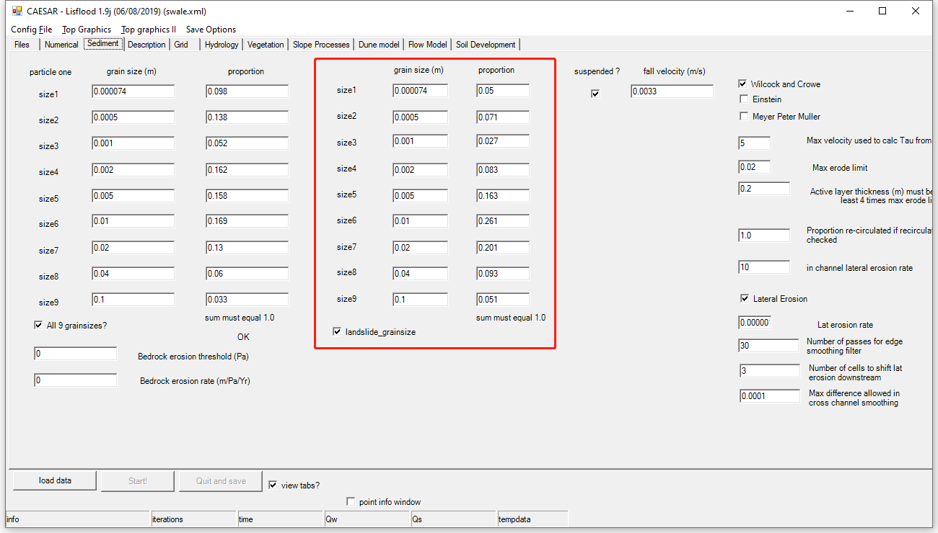
Figure 3. Landslide grain size distribution input

You need also input a grain index file to indicate the spatial domain of corresponding grain size set input. Grain index is a file in the same format as the DEM (arcgis ascii file) that contains an integer number that corresponds to different zones of grain size distribution input. For example, in the case with landslide GSD input, the study catchment has two types of grain size input then you can have 1 for area without landslide impact and 2 for landslide affected area (figure 2).
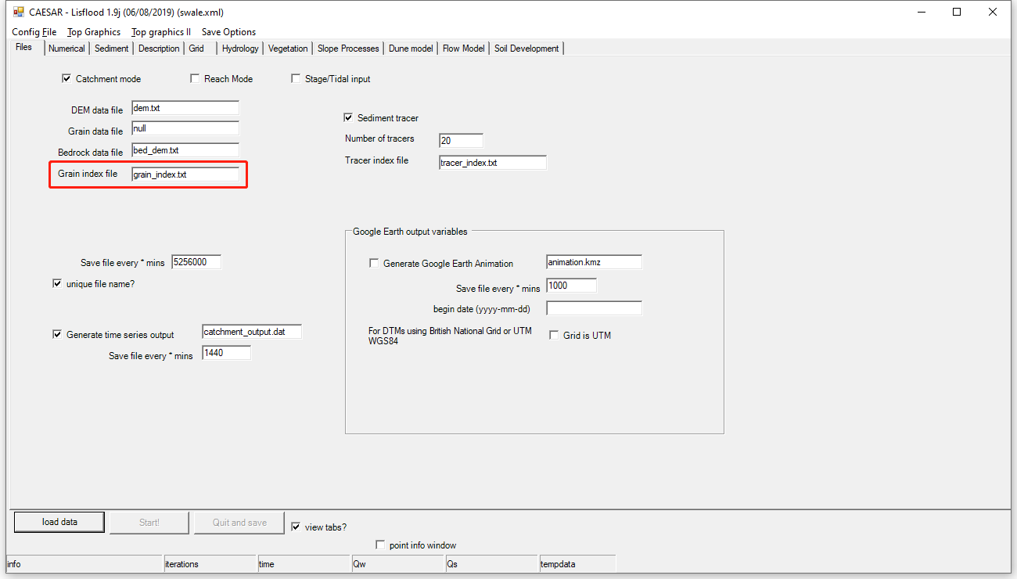
Figure 4. Grain index file input

3. Sediment tracing
The tracing function in CL is developed by adding another tracer index array to the model, so that the grainsize information of every grid cell is marked with different index to represent different source areas (Figure 5).
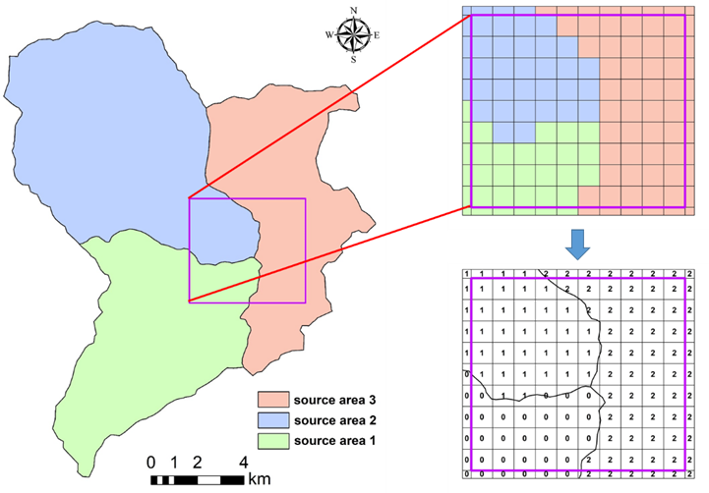
Figure 5. Delineation of source area and tracer index

Set up in CL.
If you would like to use tracing function in CL, you need tick the checkbox “sediment tracer” in “File” input module (figure 6). Then, you need input the number of tracers and tracer index file accordingly. The tracer index is a file in the same format as the DEM (arcgis ascii file) that contains an integer number (tracer number) that corresponds to different zones of source area (figure 5). For example, if your catchment has 2 tracer index (1 and 2) in addition to the background area (0), then you should input “Number of tracers” in “Sediment tracer” module as 2, and the tracer index in tracer index file should be 0, 1 and 2.

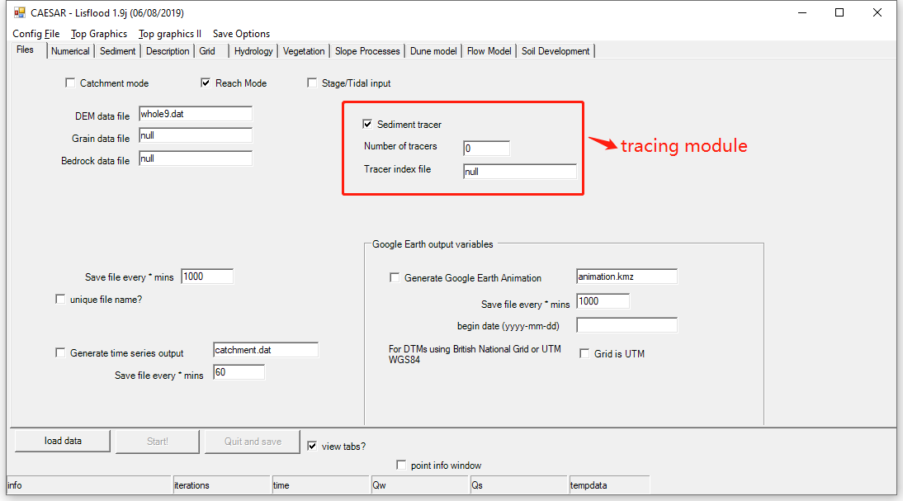
Figure 6. Tracing module input

4. Model output
The modified CL model can output a series of simulation results, which includes the daily sediment yield at the basin outlet from each source area with up to nine grain size fraction (total or separate) and the spatial distribution of sediment transport of each sediment source as well as the elevation change for the whole basin or local landform change at user-defined time interval.
If you need output the spatial distribution of sediment transport from different source areas, then you need tick the tracer file checkbox in the drop-down menu of save options (Figure 7). Same as elev, water depth etc.. If checked, CL will save (at the time interval specified in the box) files (as checked on the main menu) data with a unique file name. E.g 0tracer1.txt, 0tracer2.txt etc.. where the number at the end of the filename is the days elapsed (Figure 8), the number at the start of the filename is the tracer index from sourced area.
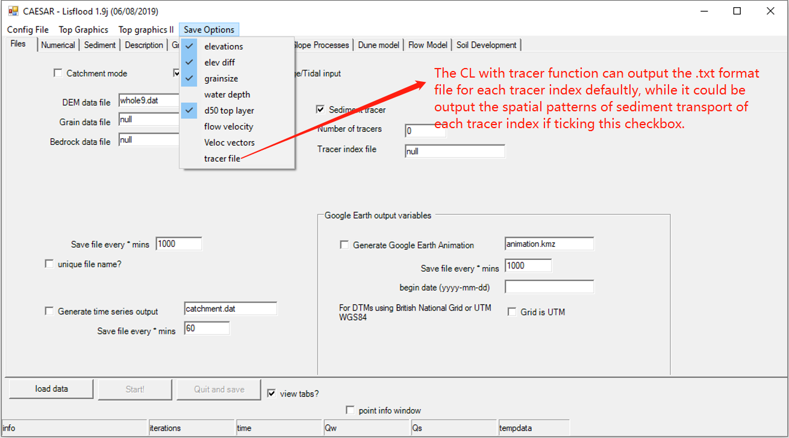
Figure 7. Selection of tracer file output

The output of CL can defaultly generate output files for different tracing source areas corresponding to difference tracer index. The tracer index will added to the starting of the output file name.
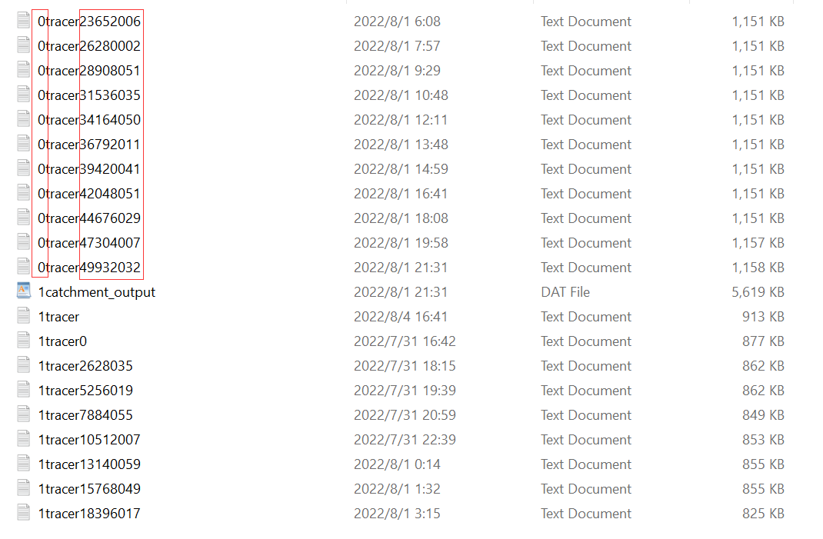
Figure 8. Output file list
The water and sediment discharge record at the basin outlet can be recorded. This (figure 9) can be output through this file (often referred to as the catchment.dat file). The file will (at the time step specified) save a 14 columns of data as a new row on this file, with (in order from l to r) Time, Qw (actual), Qw (expected), Blank, Total sediment output in time step (m³), and the following nine columns have the volumes in m³of sediment for each of the nine separate grain size fractions.
Note: The catchment.dat output file of the modified CL version can generate the sediment yield of 9 grain sizes (column 6-14) for different sourced areas, while the fifth column of catchment.dat file for all source areas are all the same representing the total basin sediment yield. So if you want get the total sediment yield from each sourced area, you need to manually sum up the sediment yield of 9 grain sizes (column 6-14) of each catchment.dat file.
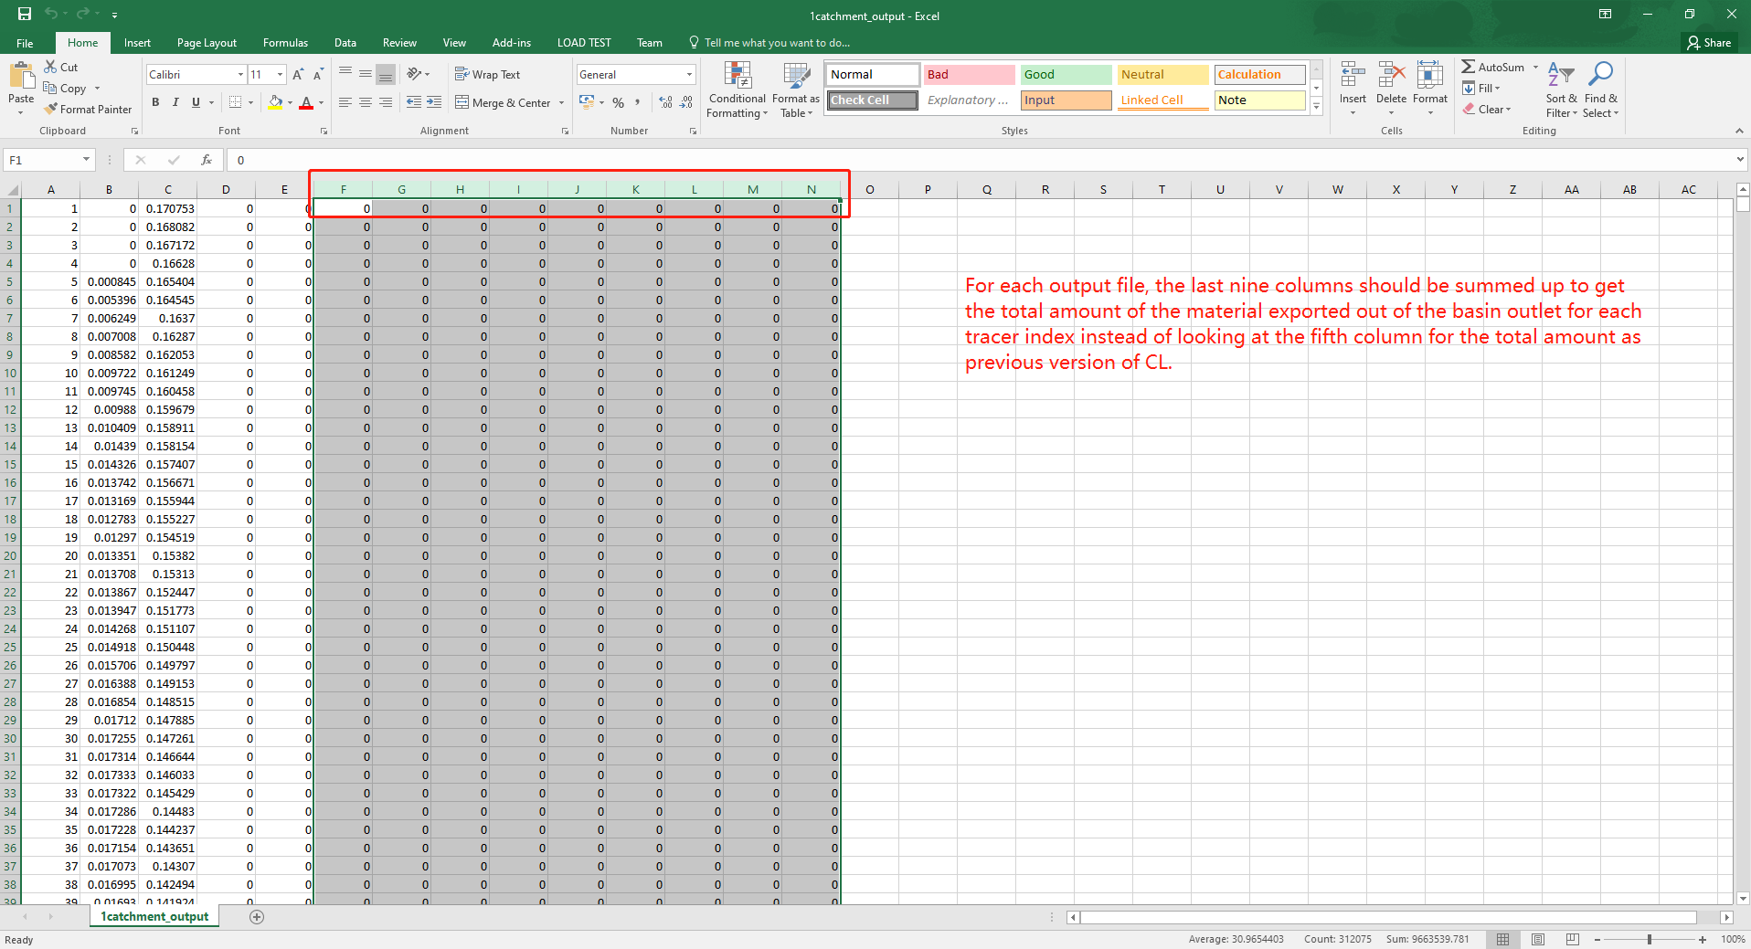
Figure 9. Illustration of catchment.dat output file

