Supplementary Material
Table S1. Excess adult mortality (with MR-BRT and GEMM risk models) attributable to PM2.5 and anthropogenic carbonaceous aerosols (CA) long term exposure in each country assuming equal (1) and differential toxicity (2). The two last columns in each group indicate the relative contribution of CA (in percentages) to total excess mortality (from PM2.5).
MR-BRT |  |  |  |  |  | GEMM
Country | PM25 | CA |  | % Contribution of CA |  | PM2.5 | CA |  | % Contribution of CA
 |  | 1 | 2 | 1 | 2 |  | 1 | 2 | 1 | 2
Albania | 1200 (800-1500) | 154(100-200) | 307(199-399) | 12 | 25 | 2300 (1600-3100) | 300 (200-400) | 600 (400-800) | 13 | 26
Andorra | 5(4-3) | 0 | 1 | - | - | 25 (19-32) | 2 (2-3) | 5 (4-6) | 9 | 19
Austria | 3200 (2300-3700) | 534(386-623) | 1068(772-1245) | 16 | 32 | 8400 (6900-9900) | 1300 (1100-1600) | 2700 (2200-3100) | 16 | 32
Armenia | 900(700-900) | 140(109-140) | 280(217-281) | 16 | 32 | 2300 (1900-2700) | 300 (300-400) | 700 (500-800) | 14 | 29
Belgium | 4400(3100-5200) | 700(752-540) | 1505(1079-1791) | 15 | 31 | 11600 (9500-13700) | 2000 (1600-2300) | 3900 (3200-4600) | 17 | 34
Bosnia & Herzegovina | 2900(2000-3500) | 553(376-666) | 1106(751-1333) | 18 | 36 | 4700 (3900-5500) | 900 (700-1000) | 1800 (1400-2100) | 19 | 37
Bulgaria | 6100(4500-6900) | 988(727-1130) | 1977(1454-2259) | 16 | 32 | 11700 (9600-13800) | 1800 (1500-2200) | 3700 (3000-4300) | 16 | 32
Belarus | 4600(3600-4800) | 730(559-754) | 1461(1118-1509) | 16 | 31 | 10300 (8500-12200) | 1600 (1300-1900) | 3100 (2600-3700) | 15 | 30
Croatia | 3200(2300-3700) | 652(478-766) | 1304(955-1532) | 20 | 39 | 6400 (5200-7500) | 1300 (1100-1500) | 2600 (2100-3000) | 20 | 40
Cyprus | 400(300-500) | 40(26-47) | 80(52-95) | 9 | 18 | 700 (600-900) | 100 (100-100) | 100 (100-200) | 10 | 19
Czech Republic | 7500(5400-8800) | 1665(1207-1956) | 3330(2414-3911) | 21 | 42 | 14200 (11600-16600) | 3100 (2500-3600) | 6100 (5100-7200) | 22 | 43
Denmark | 1400(1100-1500) | 202(153-215) | 403(306-430) | 13 | 26 | 4400 (3600-5300) | 600 (500-700) | 1200 (1000-1500) | 14 | 28
Estonia | 300(200-400) | 51(38-63) | 103(75-126) | 16 | 31 | 1100 (900-1400) | 200 (100-200) | 400 (300-400) | 16 | 32
Finland | 800(700-800) | 140(115-139) | 281(230-277) | 15 | 30 | 3600 (2900-4200) | 600 (500-700) | 1100 (900-1300) | 16 | 32
France | 14500(10500-16100) | 2447(1772) | 4894(3544-5507) | 15 | 30 | 49400 (40600-) | 8100 (6700-9500) | 16200 (13300-19100) | 16 | 33
Germany | 37600(27300-43400) | 5936(4298) | 11871(8596-13716) | 15 | 30 | 99900 (82500-117200) | 15300 (12700-18000) | 30700 (25300-36000) | 15 | 31
Greece | 5000(3700-5800) | 680(497-788) | 1361(995-1575) | 13 | 26 | 12100 (9900-14300) | 1600 (1300-1900) | 3200 (2600-3800) | 13 | 26
Hungary | 7800(5700-9200) | 1712(1252-2014) | 3425(2503-4027) | 21 | 42 | 16200 (13300-18900) | 3500 (2900-4100) | 7000 (5700-8100) | 22 | 43
Iceland | 0 | 0 | 0 | 0 | 0 | 35 (28-43) | 1 (1-2) | 3 (2-3) | 4 | 8
Ireland | 400(400-300) | 46(33-40) | 91(65-80) | 9 | 18 | 1900 (1500-2200) | 200 (200-200) | 400 (300-500) | 11 | 21
Italy | 29300(21100-34100) | 5161(3725-6033) | 10323(7449-12065) | 16 | 33 | 71800 (59400-84100) | 12300 (10100-14400) | 24500 (20300-28700) | 17 | 34
Latvia | 1000(800-1100) | 183(137-203) | 366(273-405) | 17 | 34 | 2500 (2000-3000) | 400 (300-500) | 800 (700-1000) | 17 | 34
Liechtenstein | 16(11-19) | 3(2-4) | 7(5-8) | 19 | 44 | 30 (25-36) | 6 (5-7) | 13 (11015) | 21 | 42
Lithuania | 1700(500-1900) | 306(228-340) | 612-456-680) | 17 | 35 | 3900 (3200-4600) | 700 (600-800) | 1300 (1100-1600) | 17 | 35
Luxembourg | 200(100-200) | 26(18-32) | 52(36-64) | 11 | 23 | 400 (300-500) | 100 (100-100) | 100 (100-200) | 17 | 33
Malta | 100(0-100) | 11(8-13) | 23(16-26) | 11 | 21 | 300 (200-300) | 27 (22-33) | 54 (44-100) | 10 | 21
Moldova | 1700(500-1900) | 333(252-365) | 665(503-730) | 19 | 39 | 3900 (3200-4600) | 700 (600-900) | 1400 (1200-1700) | 19 | 37
Montenegro | 300(200-400) | 44(31-52) | 87(61-104) | 14 | 29 | 600 (500-800) | 100 (100-100) | 200 (100-200) | 13 | 25
Netherlands | 4800(2600-5400) | 697(512-789) | 1394(1023-1579) | 13 | 26 | 14000 (11500-16500) | 2000 (1600-2400) | 4000 (3300-4700) | 14 | 28
Norway | 400(300-200) | 41(27-41) | 82(53-81) | 7 | 15 | 2100 (1700-2500) | 210 (172-247) | 400 (300-500) | 10 | 20
Poland | 23300(9100-27300) | 5306(3853-6223) | 10611(7706-12445) | 21 | 43 | 49500 (40800-58000) | 10953 (9038-12842) | 21900(18000-25700) | 22 | 44
Portugal | 2900(1700-2900) | 395(301-398) | 791(603-795) | 11 | 21 | 8300 (6800-9800) | 1107 (904-1314) | 2215(1808-2628) | 13 | 27
Romania | 13700(5700-15800) | 2663(1972-3077) | 5326(3945-6154) | 19 | 38 | 29000 (23900-43000) | 5484 (4522-6436) | 11000(900-12900) | 19 | 38
Russia | 39800(16500-35400) | 7440(6288-7049) | 14880(12576-14098) | 17 | 35 | 104300 (86200-121900 | 17549 (14527-20508) | 35100(29100-4100) | 17 | 34
Serbia | 8200(3800-8700) | 1524(1116-1791) | 3047(2232-3581) | 18 | 36 | 13900 (11500-16300) | 2520 (2079-2954) | 5000(4200-5900) | 18 | 36
Slovakia | 2900(900-3500) | 486(342-593) | 971(683-1186) | 17 | 33 | 6200 (5100-7300) | 1000 (800-1200) | 2000(1700-2400) | 16 | 33
Slovenia | 800(400-1000) | 153(108-191) | 307(216-383) | 18 | 36 | 2200 (1800-2700) | 400 (300-500) | 800(600-900) | 18 | 36
Spain | 9400(5300-9200) | 1508(1163-1505) | 3015(2326-3011) | 12 | 25 | 32100 (26400-37800) | 4900 (4100-5800) | 9900(8100-11600) | 15 | 31
Sweden | 1600(800-1400) | 210(172-195) | 420(345-389) | 10 | 21 | 6200 (5100-7400) | 800 (600-900) | 1500(1300-1800) | 12 | 25
Switzerland | 2100(900-2500) | 335(240-399) | 670(480-798) | 15 | 30 | 6100 (5000-7200) | 900 (800-1100) | 1900(1500-2200) | 15 | 31
Ukraine | 30700(7400-31600) | 4950(3813-5096) | 9900(7625-10193) | 16 | 32 | 65900 (54300-77400) | 10400 (8500-12200) | 20700(17100-24300) | 16 | 31
North Macedonia | 1300(600-1500) | 194(138-229) | 389(276-459) | 14 | 29 | 2000 (1700-2400) | 300 (200-400) | 600(500-700) | 15 | 30
United Kingdom | 15200(8200-15300) | 2369(1890-2425) | 4738-3780-4850) | 13 | 26 | 52000 (43100-60900) | 7800 (6500-9200) | 15700(13000-18400) | 15 | 30

Table S2: Annual adult excess mortality (with MR-BRT) per country and disease normalized to the population. The highest mortality per disease and country is highlighted with bold.

Country | IHD | Stroke | COPD | LRI | LC | T2D
Albania | 31 | 26 | 3 | 1 | 5 | 2
Andorra | 4 | 2 | 1 | 1 | 1 | 1
Austria | 24 | 7 | 4 | 1 | 5 | 11
Armenia | 26 | 8 | 3 | 1 | 3 | 7
Belgium | 19 | 11 | 8 | 5 | 8 | 7
Bosnia & Herzegovina | 44 | 36 | 6 | 1 | 10 | 24
Bulgaria | 55 | 37 | 5 | 2 | 6 | 8
Belarus | 47 | 15 | 1 | 1 | 3 | 1
Croatia | 49 | 28 | 7 | 2 | 10 | 12
Cyprus | 16 | 6 | 4 | 1 | 4 | 22
Czechia | 49 | 17 | 6 | 4 | 8 | 15
Denmark | 10 | 7 | 6 | 3 | 5 | 7
Estonia | 23 | 6 | 1 | 1 | 3 | 2
Finland | 11 | 4 | 1 | 0 | 2 | 1
France | 11 | 6 | 3 | 2 | 5 | 7
Germany | 26 | 9 | 6 | 3 | 6 | 11
Greece | 27 | 17 | 6 | 4 | 7 | 4
Hungary | 57 | 21 | 9 | 1 | 14 | 9
Iceland | 0 | 0 | 0 | 0 | 0 | 0
Ireland | 5 | 2 | 2 | 1 | 2 | 2
Italy | 21 | 14 | 6 | 2 | 6 | 17
Latvia | 41 | 22 | 2 | 1 | 4 | 4
Liechtenstein | 28 | 20 | 4 | 1 | 6 | 5
Lithuania | 53 | 19 | 3 | 2 | 5 | 2
Luxembourg | 16 | 9 | 5 | 3 | 6 | 5
Malta | 22 | 8 | 3 | 3 | 4 | 8
Moldova | 43 | 18 | 2 | 2 | 3 | 1
Montenegro | 31 | 38 | 2 | 1 | 8 | 7
Netherlands | 12 | 7 | 6 | 3 | 7 | 7
Norway | 4 | 2 | 1 | 1 | 1 | 1
Poland | 40 | 17 | 5 | 4 | 10 | 8
Portugal | 8 | 10 | 4 | 3 | 2 | 10
Romania | 44 | 35 | 4 | 3 | 7 | 3
Russia | 26 | 15 | 1 | 1 | 2 | 2
Serbia | 66 | 61 | 9 | 3 | 14 | 19
Slovakia | 44 | 15 | 3 | 3 | 6 | 4
Slovenia | 23 | 14 | 4 | 3 | 8 | 6
Spain | 8 | 5 | 4 | 1 | 3 | 6
Sweden | 10 | 4 | 2 | 1 | 2 | 4
Switzerland | 15 | 6 | 4 | 2 | 4 | 7
Ukraine | 65 | 20 | 2 | 1 | 3 | 1
North Macedonia | 28 | 34 | 3 | 1 | 6 | 17
United Kingdom | 12 | 6 | 5 | 4 | 4 | 3

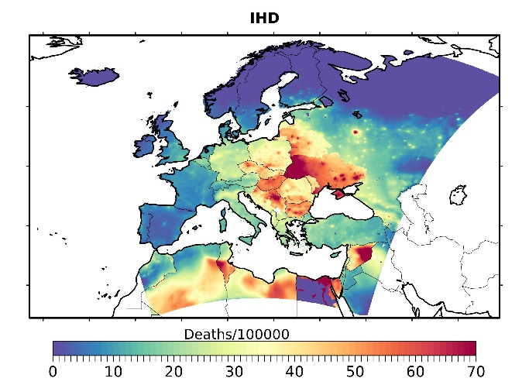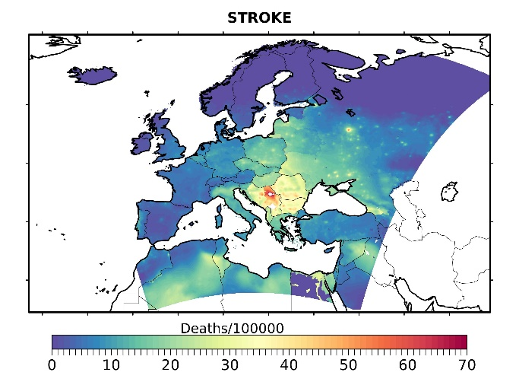
(a) | (b)

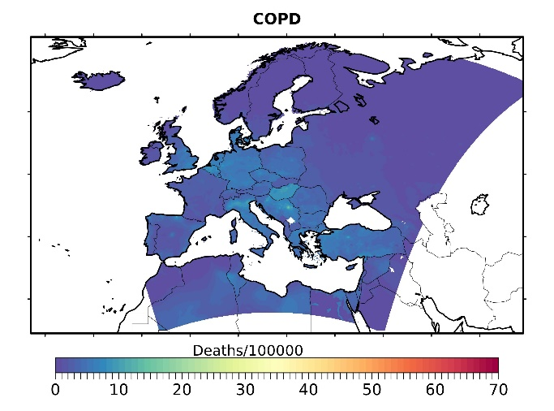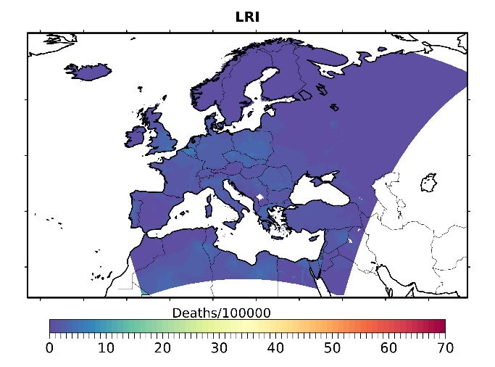
(c) | (d)

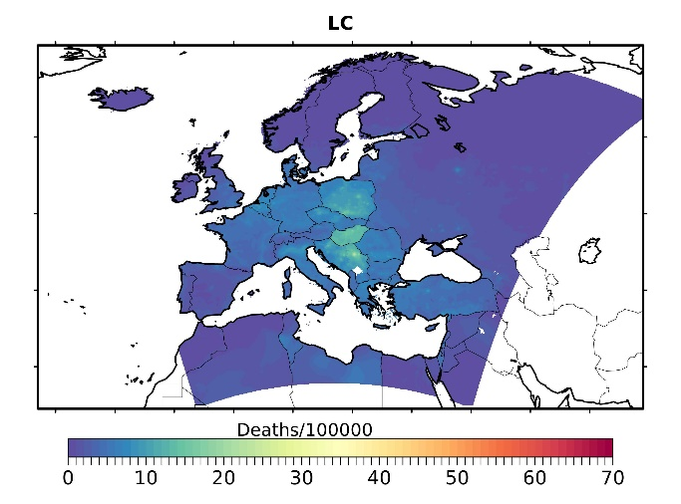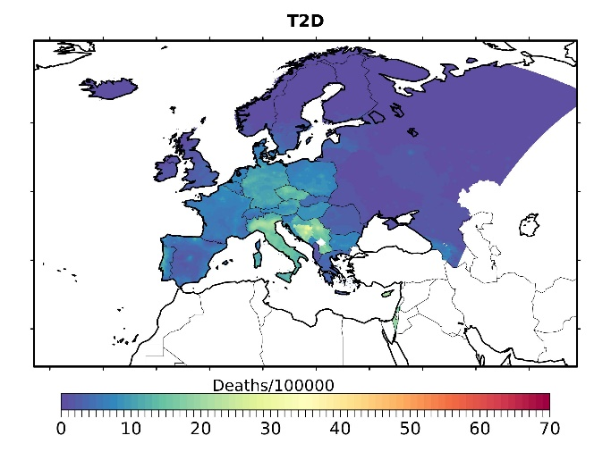
(e) | (f)
Figure S1: Excess mortality due to PM2.5 exposure (with MR-BRT)) normalized to the population in each grid box for each cause of death. (a): Ischemic Heart Disease – IHD, (b): Stroke, (c): Chronic Obstructive Pulmonary Disease – COPD, (d): Lower Respiratory Infections – LRI, (e): Lung Cancer – LC, (f): Type II Diabetes – T2D).

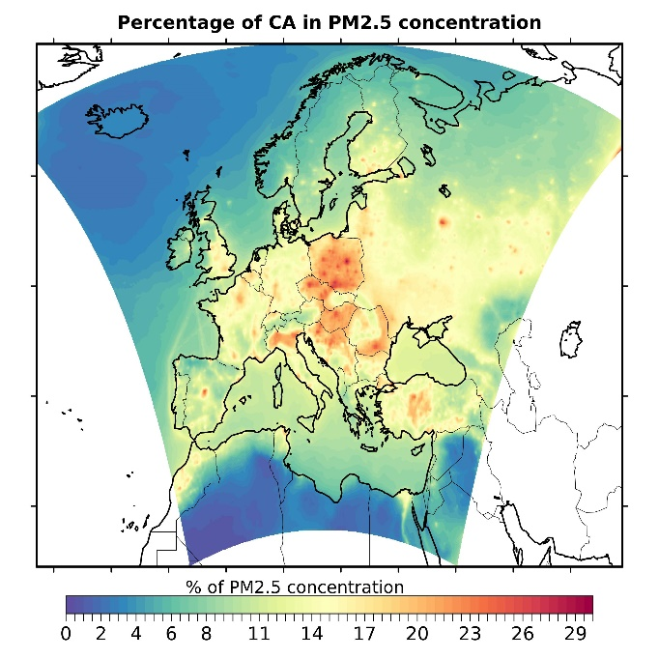
Figure S2. The relative contribution of anthropogenic carbonaceous aerosols to total PM2.5 mass concentration.

