


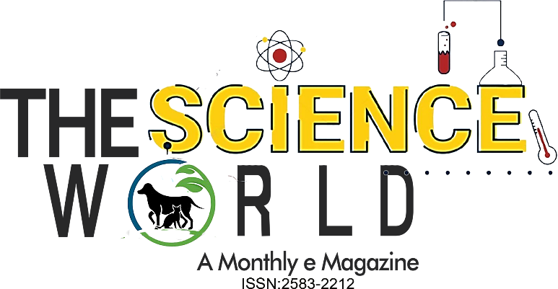
.

June, 2023; 3(06), 1212-1215
Popular Article
Strategies For Reducing Age at First Calving in Dairy Animals

Man Singh, Amandeep*, D. S. Bidhan, Vishal Sharma, Sandeep, D. C. Yadav, Narender Singh and Ashish

Department of Livestock Production Management, Lala Lajpat Rai University of Veterinary and Animal Sciences, Hisar (Haryana)-125004

Introduction
Raising heifers is one of the most expensive components of the dairy farm operations as they are future of dairy farm. They are produced to replace the older and uneconomical females of the farm through culling. When genetic trends are positive, such replacements help harvest the benefits of genetic gain. Heifer production is most expensive part of the dairy farm operation as it requires more inputs for a longer period of time with no visible returns than any other farm operation. The major issue is the lower growth rate of calves during early months of their age and just after weaning which is either due to underfeeding or imbalanced feeding which results in higher age at puberty and thus higher age at first calving in heifers. Genetics also play its role as well. Age at puberty and calving is related with weight.

