Women's emotional and mental wellbeing after hysterectomy: A Comprehensive Review

Soumendra Darbar,◊, Sangita Agarwal^{2,Ω} and Srimoyee Saha^{3,¥}

¹Research and Development Division, Dey’s Medical Stores (Mfg.) Ltd., 62, Bondel Road, Kolkata-700019, West Bengal, India.
²Department of Applied Science, RCC Institute of Information Technology, Canal South Road, Beliaghata, Kolkata700015, India.
³Faculty of Science, Jadavpur University, 188, Raja S C Mallick Road, Kolkata-700032, West Bengal, India.

To cite this article:
Soumendra Darbar, Sangita Agarwal and Srimoyee Saha. “Women's emotional and mental wellbeing after hysterectomy: A Comprehensive Review”, Parana Journal of Science and Education. v.9, n.4, 2023, pp. 1-8.

Received: May 19, 2023; Accepted: June 15, 2023; Published: June 17, 2023.

Abstract
Hysterectomy is typically performed to treat cancer, pelvic inflammatory disease, and uterine fibroids. Depending on which part of the reproductive system is removed along with the uterus, the procedure may be radical, complete, or partial. Laparoscopic and vaginal hysterectomy has less risk than abdominal hysterectomy, which is more dangerous. After a hysterectomy, women no longer have monthly periods and are unable to become pregnant. Surgical menopause is the outcome of the ovaries and uterus being removed together. Depending on the procedure and the patient's health, recovery can take anywhere from 4 to 8 weeks. Normal hormonal levels are significantly disturbed after surgery, which causes several difficulties in women. It raises the possibility of long-term mental health problems, particularly depression and anxiety. Following a hysterectomy, hormone replacement therapy (HRT) may help to restore hormonal balance and lessen side effects. One should not panic after a hysterectomy; instead, should follow the doctor's instructions, also taking care of oneself and continuing with the daily routine will help in recovering faster.

Keywords: Hysterectomy, Female hormone, Emotion; Depression, Hormone Replacement Therapy, Menopause.

1. Introduction
The word hysterectomy is derived from two words “”hystero” meaning uterus and “ectomy” meaning removal [1]. Hysterectomy is indicated in many gynaecological problems by the medical practitioners and it is common non-pregnancy related major surgery in women of reproductive age [2, 3]. The surgical procedure can either be total or subtotal and depends on the way it is performed such as vaginal, abdominal, laparoscopic or laparoscopic assisted vaginal hysterectomy.
Hysterectomy is a type of surgery in which a woman's uterus (or womb) is removed, sometimes along with the ovaries, cervix, Fallopian tubes, or other structures. It is the second most common surgery among women in the United States [4]. It may be recommended as a treatment for uterine fibroids, endometriosis, and certain gynaecological cancers, among other concerns. Although medical science has made significant advances but still the removal of uterus surgically is the only option in many cases of benign and most cases of neoplastic gynaecological conditions [5]. The risk of mortality and morbidity associated with this surgical procedure has reduced because of advanced techniques in comparison to earlier times, but the effect of hysterectomy on social, personal and economic fronts still require intervention and strategic initiatives.
Hysterectomies may be common, but surprisingly research shows nearly all of them are elective [6]. Furthermore, about 90 percent of hysterectomies aren't necessary: The conditions they're meant to treat can be effectively dealt with in other ways that usually are less risky and that preserve the uterus. For example, a 2017 study found that a minimally-invasive procedure for treating uterine fibroids called uterine fibroid embolization is vastly underused [7].
The surgical or medical approach in hysterectomy is influenced by multiple factors such as education, race, age, geographic location, insurance coverage and marital status.
As per the statistics available, almost 26.2% women have undergone hysterectomy is US followed by 22.2% in Ireland, 22% in Australia, 8.8% in Taiwan and 7.5% in Singapore [8].

Uterus is an important organ of the reproductive system in women and it has a strong association with sexuality and femininity [9]. Hysterectomy not only effects physical health of women but also drains them emotionally and mentally [10-12]. Patients suffer bouts of depression, stress and anxiety [13] along with urinary incontinence and sexual dysfunction [14].

2. Hysterectomy
The surgical removal of the uterus in all or part is known as a hysterectomy. The removal of the cervix, ovaries, Fallopian tubes, and other nearby structures can also fall under this category. Women who have uncomfortable periods, uterine fibroids, endometriosis, or cervical or ovarian cancer frequently undergo this surgery. Through the vagina or the abdomen, the procedure can be carried out [15].
2.1 Types of hysterectomy
There are various hysterectomies, including:

- Total hysterectomy: removal of the uterus, cervix, and ovaries, but preservation of the fallopian tubes.
- Hysterectomy with salpingo-oophorectomy: A hysterectomy with salpingo-oophorectomy involves removing your fallopian tubes [16], cervix, ovaries, and uterus.
- Sub-total hysterectomy: this procedure just removes the uterus, leaving the ovaries, fallopian tubes, and cervix intact.

2.2 Common Reasons for a Hysterectomy
2.2.1 Fibroids in the womb
Non-cancerous growths in the uterine wall are known as uterine fibroids. Other pelvic organs may come under pressure from the fibroid tumors as they enlarge significantly. In some situations, women with uterine fibroids may feel significant pelvic pain or extensive bleeding.
2.2.2 Cancer of the womb
In some cases of gynaecological cancer or precancerous, a hysterectomy may be the best line of action. This comprises cancers of the uterine lining, ovarian, cervical, and genital systems. Radiation and chemotherapy are additional therapies for these disorders [17], and your doctor will decide which is best for you based on how far along the disease is.

Figure 1: Types of Hysterectomy.
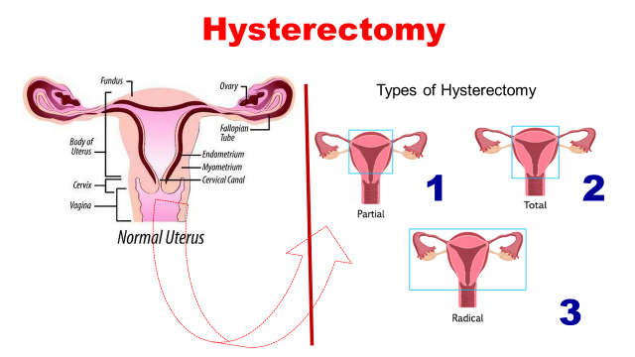
Source: Mayo Foundation for Medical Education and Research (MFMER). (2023). Abdominal hysterectomy. https://www.mayoclinic.org/tests-procedures/abdominal-hysterectomy/about/pac-20384559

2.2.3 Disturbed Bleeding
It may be harmful if you have heavy or protracted bleeding brought on by an infection, cancer, hormonal imbalance, or fibroids. A hysterectomy may be recommended if other forms of treatment are unsuccessful.
2.2.4 Uterine Prolapse
The term "uterine prolapse" refers to a condition when the uterus falls into the vagina. In addition to being a concern for obese women and postmenopausal women, prolapse is frequently observed in women who have given birth several times [18]. In addition to pelvic pressure or pain, the illness can cause urinary and gastrointestinal problems.
2.2.5 Adenomyosis
Similar to endometriosis, adenomyosis is a disorder in which the uterine lining grows in places where it shouldn't. Contrary to endometriosis, the tissue grows inside the uterine walls, where it has no business being, which can lead to bleeding and pain [19].
2.2.6 Endometriosis
Endometriosis is a disorder where the uterine lining tissue spreads to other parts of the body, including the pelvic cavity, the ovaries, fallopian tubes, and the exterior of the uterus.
2.2.7 Severe Pelvic Inflammatory Disease (PID)
A bacterial infection in the pelvic cavity known as pelvic inflammatory disease (PID) can result in excruciating pelvic discomfort [20]. Antibiotics can be used to treat PID if it is identified early.
2.2.8 Endometrial Hyperplasia
Endometrial hyperplasia is the medical term for excessive uterine lining thickness. It can occur when hormone levels are fluctuating, such as during perimenopause, and is frequently brought on by the prolonged presence of oestrogen without progesterone.

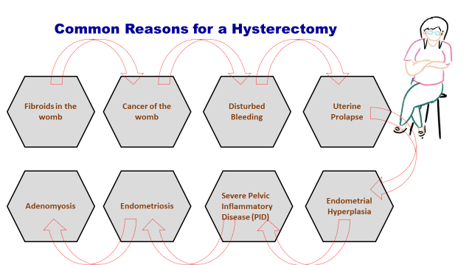
Figure 2: Reasons for conduct Hysterectomy

Source: Angie L. Goeser, Matthew J. Hasiak, Jared L. Hochstettler. (2023). An Overview of Hysterectomy. US Pharm. 2008; 33(9):HS-5-HS-10. URL: https://www.uspharmacist.com/article/an-overview-of-hysterectomy

2.3 Ways to perform a hysterectomy
A hysterectomy can be carried out in a variety of methods [21], including:
- Laparoscopic – Laparoscopic surgery uses a laparoscope, a tube containing a camera, to perform keyhole surgery through small abdominal incisions.
- Vaginal – The procedure is carried out via your vagina.
- Abdominal – With a cut made in your lower abdomen.
2.4 Risks and Side Effects of Hysterectomy
The majority of the time, hysterectomy is a safe treatment with high success rates. However, the surgery could have the following risks [22, 23] and adverse effects:
- Early menopause if the ovaries are removed, with symptoms like hot flashes, mood swings, or sleeplessness;
- Prolonged bleeding and the requirement for blood transfusions;
- The possibility of harming nearby organs such the bladder, intestines, ureters, blood arteries, and nerves;
- Lung or leg blood clots;
- Pain;
- Scar tissue formation;
- Hernia;
- Bad reactions to anesthesia;
- Infection;
- Damage abdominal organ.

Figure 3: Some common complication observed after hysterectomy
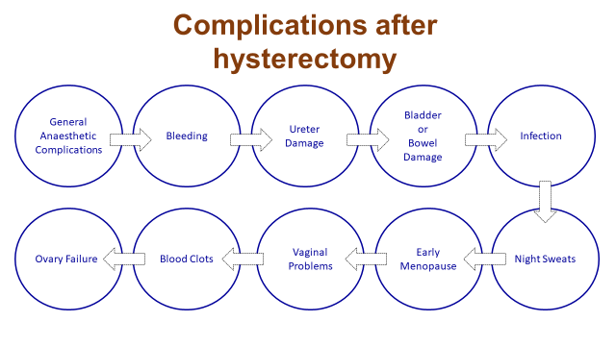
Source: Kumar, G. S., & Lekkala, S. (2016). Complications after a total laparoscopic hysterectomy: a study in tertiary care unit in Telangana, India -. International Surgery Journal, 3, 1141-1145. URL: https://www.semanticscholar.org/paper/Complications-after-a-total-laparoscopic-a-study-in-Kumar-Lekkala/2b427e345e874659424df6e24e837cbfcc93b629

2.5 Emotional Adjustments Following a Hysterectomy
A hysterectomy has both physical and emotional side effects. Not every woman anticipates how emotionally taxing having a hysterectomy may be. Recognizing the probable emotional impacts will nevertheless prepare the body to handle the shifts in thoughts and emotions throughout this transformative time. In general, a hysterectomy won't result in emotional issues for people who are generally psychologically well, although this is not to suggest that all women will experience emotional pain as a result of one.
There are a number of reasons why women becoming more emotional:

2.6 No more childbearing
After a hysterectomy, women can no longer can bear children, which is a great loss. All young women who go through this procedure feel the loss of early end to fertility irrespective of whether they have a family or not. Those women who did not want children also felt sad and lost if the option was taken away from them. In order to boost one’s sense of femininity some changes are essential after hysterectomy. The loss of femininity and low self-esteem is very much distressing than the changes in physical body felt after hysterectomy.

2.6 Menopause and hormonal changes

The hormone oestrogen is not produced when ovaries are removed or when menopause occurs. Many women become irritable, experience mood swings, lack of sleep, have weeping outbursts and are melancholy after abrupt changes. After hysterectomy, if ovaries are not removed then also the oestrogen levels decline gradually.

2.7 Pre-existing emotional distress

Women who have experienced anxiety, depression, or other psychological challenges become more emotional after hysterectomy. Many women who are experiencing mid-life crisis due to employment and family issues are prone to emotional insecurity and hence after hysterectomy the stress is escalated especially if hysterectomy results in surgical menopause.

2.8 Lack of control

If hysterectomy is only option left that instance women feel frustrated and powerless. The powerless feeling brings low self-esteem in women and which is very devastating, they feel like they have to follow instructions and have no control over their life.

Figure 4: post emotional changes after hysterectomy

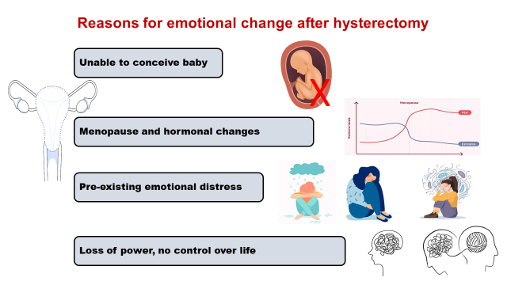
Source: The Hysterectomy Centre. (2023). Emotional Changes After A Hysterectomy. The Shalbourne Suite. The Brunel Treatment Centre. The Great Western Hospital. Marlborough Road, Swindon, Wilts, SN3 6BB. URL: https://www.hysterectomycentre.com/what-we-do/post-operative-advice/emotional/

2.9 Woman’s reproductive health after the operation
Menstrual bleeding is permanently stopped by all hysterectomies. The production of reproductive hormones and hormonal menstrual cycles without periods will nonetheless continue in those who have not had their ovaries removed.
A person who has undergone a hysterectomy and had both ovaries removed will experience surgically induced menopause [24-26]. They won't have periods or menstrual cycles caused by hormones. Then, some medical professionals could advise hormone therapy to help prevent osteoporosis and/or other menopause side effects [27].
Due to the fact that the uterus is the only organ in the body where fertilised eggs can develop, those who have had a hysterectomy are no longer able to carry a baby. Though an ectopic pregnancy (when a fertilised egg starts to develop in the fallopian tube or another section of the reproductive tract) may theoretically occur in a person with ovaries, the likelihood of this is essentially negligible [28].

2.10 Hormonal Changes
It would seem logical that since you kept your ovaries, they are still producing all the hormones you require and you shouldn't experience the consequences of menopause when your uterus is removed alone. However, because the uterus and the ovaries have a common blood supply, removing the uterus compromises the blood supply to your ovaries, which increases the risk of ovarian malfunction or atrophy and lower levels of oestrogen, progesterone, and testosterone.
Table 1: Some Common menopause symptoms
Sl. No. | Menopausal Symptoms
1. | Hot Flashes
2. | Night Sweats
3. | Weight Gain
4. | Depression
5. | Anxiety
6. | Vaginal Dryness
7. | Low Libido
8. | Insomnia
9. | Brain Fog
10. | Mood Swings
11. | Fatigue
12. | Migraines
13. | Frequent Urination
14. | Urinary Incontinence
Source: [Authors].

Women are frequently not informed that even if their ovaries are not removed, they may still experience blood supply loss and experience diminishing hormone levels. You will experience menopause symptoms as soon as your ovaries and uterus are removed. In either case, the sharp decline in oestrogen, testosterone, and progesterone levels can leave women feeling dreadfully uncomfortable and frequently out of their element. You may get depressed, anxious, and moody as a result.

3. Nutritional Supplements
A well-balanced diet post-hysterectomy, containing protein, fruits, and vegetables, was advised by medical professionals and nutritionists to aid in the healing process. To maintain your body fully hydrated, you need 8–10 glasses of fluids each day, primarily water [29–31]. If a patient has a heart condition, they should discuss their food and fluid intake with their primary care physician. Magnesium and calcium supplements, as well as multivitamins, are crucial for both early and late hysterectomy patients. Consume low-fat foods after surgery, such as yoghurt, toast, broiled chicken, and plain rice [32]. Avoid constipation and straining if someone's bowel motions are irregular shortly after surgery. After surgery, your surgeon may occasionally advise taking probiotics since they can lessen the risk of infection, reduce post-operative sepsis, speed up wound healing, increase immunity, and occasionally even help prevent episodes of diarrhoea brought on by antibiotics [33, 34].
Table 2: Naturopathic Solutions for Support after Hysterectomy
Sl. No. | Food constituents
1. | Zinc
2. | Calcium
3. | Vitamin A
4. | B-complex vitamins
5. | Vitamin C
6. | Vitamin D
7. | Vitamin E
8. | Vitamin K
Source: [Authors].

4. Summary and conclusion
The uterus (the womb) is surgically removed during a hysterectomy. A woman who has had a hysterectomy is no longer able to become pregnant and will no longer have monthly cycles. Following a hysterectomy, it is typical for women to feel pain, bleeding, vaginal discharge, and constipation. This procedure created a hormonal imbalance and nearly stopped the generation of oestrogen. Women can cause irritation, mood changes, weeping fits, melancholy, and insomnia. Exercise on a regular basis and hormone replacement therapy might assist.

Acknowledgments
The authors acknowledge all the faculties, scholars and staff of Faculty Council of Science, Jadavpur University and Dey’s Medical Stores (Mfg.) Ltd. for their enormous effort and support to sum-up this report for the benefit of mankind during this pandemic situation. We sincerely thank Elsevier for allowing the open access publication of this article without fees.

Conflict of interest
The authors have no conflict of interest to declare.

References
[1] Leppert P. C., Legro R. S., Kjerulff K. H. Hysterectomy and loss of fertility: implications for women's mental health. Journal of Psychosomatic research. 2007 Sep 1; 63 (3):269-74.
[2] Carlson K. J. Outcomes of hysterectomy. Clinical obstetrics and gynecology. 1997 Dec 1; 40 (4):939-46.
[3] Khastgir G, Studd J. W., Catalan J. The psychological outcome of hysterectomy. Gynecological endocrinology. 2000 Jan 1; 14 (2):132-41.
[4] Ryan M. M, Dennerstein L, Pepperell R. Psychological aspects of hysterectomy: a prospective study. The British Journal of Psychiatry. 1989 Apr; 154 (4):516-22.
[5] Wang X. Q., Lambert C. E., Lambert V. A. Anxiety, depression and coping strategies in post‐hysterectomy Chinese women prior to discharge. International Nursing Review. 2007 Sep; 54(3):271-9.
[6] Stewart E. A., Shuster L. T., Rocca W. A. Reassessing hysterectomy. Minn Med. 2012; 95(3):36-9. URL: https://www.ncbi.nlm.nih.gov/pmc/articles/PMC3804006/
[7] Narayanan, S., Gonzalez, A., Echenique, A, et.al. Nationwide analysis of hospital characteristics, demographics, and cost of uterine fibroid embolization. JVIR. Feb 2017. Vol 28, Issue 2, Supp, p S48. URL: https://doi.org/10.1016/j.jvir.2016.12.700
[8] Desai S., Campbell O. M., Sinha T., Mahal A., Cousens S. Incidence and determinants of hysterectomy in a low-income setting in Gujarat, India. Health Policy Plan. 2017; 32(1):68–78.
[9] Marván M. L., Quiros V, López-Vázquez E., Ehrenzweig Y. Mexican beliefs and attitudes toward hysterectomy and gender-role ideology in marriage. Health Care Women Int. 2012; 33(6):511–524.
[10] Keskin G, Gumus A. B. Turkish hysterectomy and mastectomy patients-depression, body image, sexual problems and spouse relationships. Asian Pac J Cancer Prev. 2011; 12(2):425–432
[11] Alshawish E, Qadous S, Yamani M. A. Experience of Palestinian women after hysterectomy using a descriptive phenomenological study. The Open Nursing Journal. 2020 Jun 1; 14(1).
[12] Schmidt A., Sehnem G. D., Cardoso L. S., Quadros J. S., Ribeiro A. C., Neves E. T. Sexuality experiences of hysterectomized women. Escola Anna Nery. 2019 Jul 29; 23.
[13] Raza N., Waqas A., Jamal M. Post-operative anxiety, depression and psychiatric support in patients undergoing hysterectomy: a cross sectional survey. J Pak Med Assoc. 2015; 65(4):443–445.
[14] Gloria A., Bachmann G. Hysterectomy: a critical review. J Reprod Med. 1990; 35(9):839–862.
[15] Clayton R. D. Hysterectomy. Best practice & research Clinical obstetrics & gynaecology. 2006 Feb 1; 20(1):73-87.
[16] Campbell ES, Xiao H, Smith MK. Types of hysterectomy. Comparison of characteristics, hospital costs, utilization and outcomes. The Journal of reproductive medicine. 2003 Dec 1; 48(12): 943-9.
[17] Broder MS, Kanouse DE, Mittman BS, Bernstein SJ. The appropriateness of recommendations for hysterectomy. Obstetrics & Gynecology. 2000 Feb 1; 95(2):199-205.
[18] Yucel O, Ozdemir I, Yucel N, Somunkiran A. Emergency peripartum hysterectomy: a 9-year review. Archives of gynecology and obstetrics. 2006 May; 274:84-7.
[19] Zekam N, Oyelese Y, Goodwin K, Colin C, Sinai I, Queenan JT. Total versus subtotal hysterectomy: a survey of gynecologists. Obstetrics & Gynecology. 2003 Aug 1; 102(2):301-5.
[20] Hakkarainen J, Nevala A, Tomás E, Nieminen K, Malila N, Pitkäniemi J, Auranen A. Decreasing trend and changing indications of hysterectomy in Finland. Acta obstetricia et gynecologica scandinavica. 2021 Sep; 100(9):1722-9.
[21] Oetker-Black SL, Jones S, Estok P, Ryan M, Gale N, Parker C. Preoperative teaching and hysterectomy outcomes. Aorn Journal. 2003 Jun 1; 77(6):1215-31.
[22] Clarke-Pearson DL, Geller EJ. Complications of hysterectomy. Obstetrics & Gynecology. 2013 Mar 1; 121(3):654-73.
[23] Stewart EA, Shuster LT, Rocca WA. Reassessing hysterectomy. Minnesota medicine. 2012 Mar; 95(3):36.
[24] American College of Obstetricians and Gynecologists. FAQ008: Hysterectomy. 2018 Oct. Retrieved from https://www.acog.org/Patients/FAQs/Hysterectomy
[25] National Health Service. Hysterectomy. 2016 Mar 22. Accessed August 2018 from https://www.nhs.uk/conditions/hysterectomy/
[26] Hembree WC, Cohen-Kettenis PT, Gooren L, Hannema SE, Meyer WJ, Murad MH, Rosenthal SM, Safer JD, Tangpricha V, T'Sjoen GG. Endocrine treatment of gender-dysphoric/gender-incongruent persons: An endocrine society clinical practice guideline. Endocr Pract. 2017 Dec; 23(12):1437. doi: 10.4158/1934-2403-23.12.1437.
[27] Machado LS. Emergency peripartum hysterectomy: Incidence, indications, risk factors and outcome. North American Journal of Medical Sciences. 2011 Aug; 3(8):358.
[28] Fylstra DL. Ectopic pregnancy after hysterectomy: a review and insight into etiology and prevention. Fertility and Sterility. 2010 Jul 1; 94(2):431-5.
[29] Agarwal S, Saha S, Deb T, Darbar S. Immunity augmenting food supplements for susceptible individuals in combating pandemic COVID-19. Parana Journal of Science and Education. 2020; 6(4):79-88.
[30] Darbar S, Saha S, Agarwal S. Immunomodulatory role of vitamin C, D and E to fight against COVID-19 infection through boosting immunity: A Review‖. Parana Journal of Science and Education. 2021; 7(1):10-8.
[31] Agarwal S, Darbar S, Saha S, Deb T. Prevention is always better than Cure: Immunity Boosting to Fight Infections. Open Journal of Medical Sciences. 2021 Aug 15; 1(1):28-42.
[32] Darbar S, Agarwal S, Saha S. Effective food habits to improve immunity against Covid-19. Journal of Basic Pharmacology and Toxicology. 2021 May 1; 5(1):1-6.
[33] Agarwal S, Darbar S, Saha S, Deb T. The role of immunity in the physical and mental well-being of women in India during Covid-19 pandemic. Parana Journal of Science and Education. 2020; 6(7):1-8.
[34] Darbar S, Saha S. Immune boosting role of vitamins in prevention of COVID-19 infection. Journal of Basic Pharmacology and Toxicology. 2020 Dec 13; 4(2):1-5.

◊Email: dr.soumendradarbar@deysmedical.com (Corresponding Author) ^{Ω}Email: mailsangvee@gmail.com ¥Email: srimoyee10@yahoo.co.in
Source: https://www.verywellhealth.com/in-depth-overview-of-hysterectomy-surgery-3157277

