Supplementary Figures 1: Random Forest from mice brains of different groups identified 15 different lipid features and ranked by the mean decrease in classification accuracy.
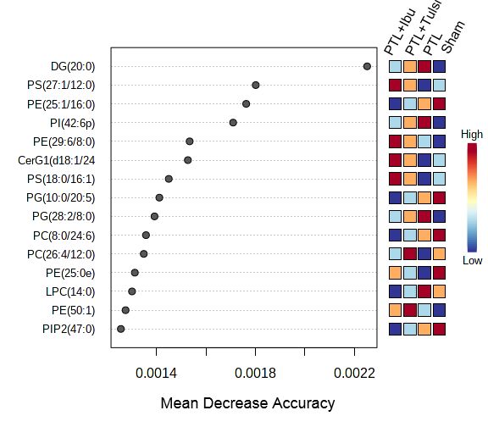

Supplementary Figures 2: The volcano map showed the differential lipids expression level in the mice brain of sham vs PTL groups (log2 FC= 1.5 and p-value <0.05 considered significant). Upregulated lipids are shown by red colour dots while downregulated lipids are shown by blue coloured dots.
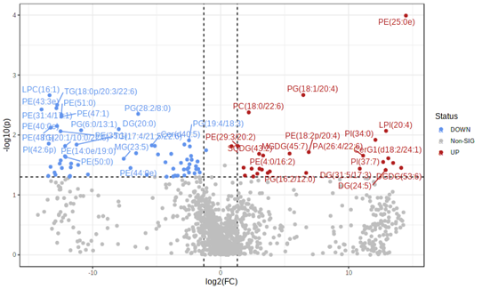
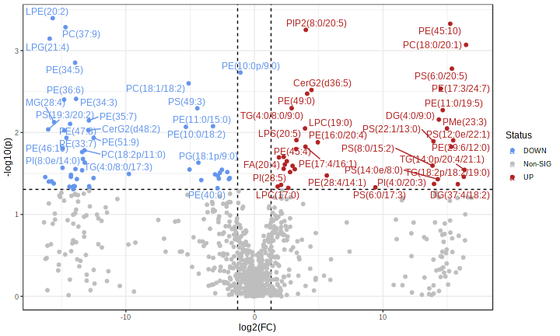

Supplementary Figures 3: (A) Partial Least Squares - Discriminant Analysis (PLS-DA) plot of lipid species in mice brain of sham vs PTL groups revealing the component variance 19.2% and 17.8%. (B) VIP score of lipid species in PLS-DA in the mice brain of sham vs PTL groups. The coloured boxes on the right side represent the relative concentration of the corresponding lipid species. Red color indicates high and blue color indicates low.
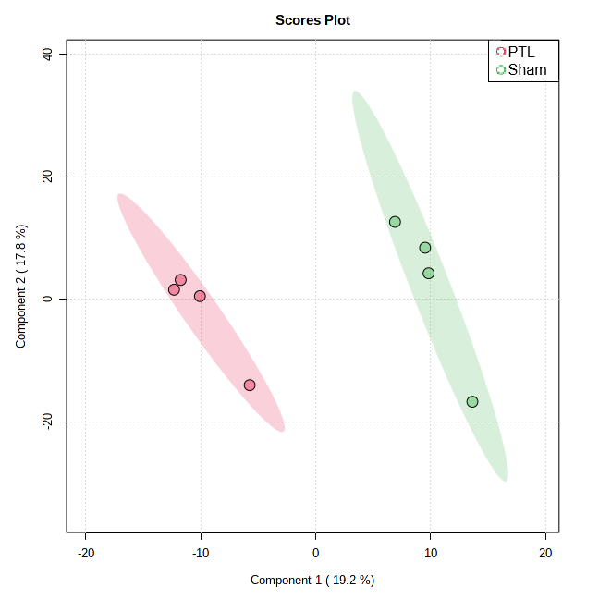
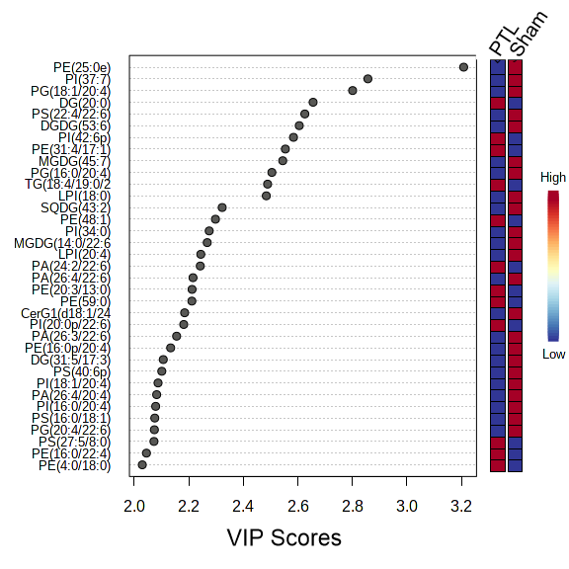

Supplementary Figures 4: (A) Heatmap of the expression of identified differential lipids in the mice brain between sham vs PTL groups. The coloured boxes on the right side represent the relative concentration of the corresponding lipid species. Red color indicates high and green color indicates low. (B) Random Forest from mice brains of sham vs PTL groups identified 15 different lipid features and ranked by the mean decrease in classification accuracy.
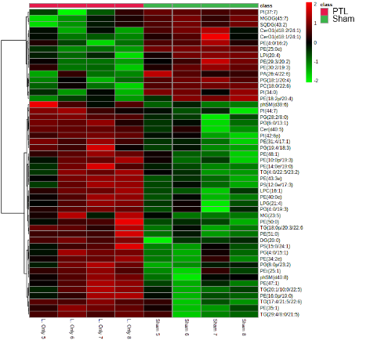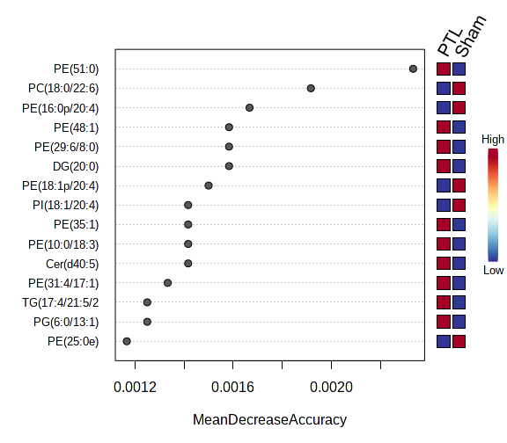

Supplementary Figures 5: The volcano map showed the differential lipids expression level in the mice brain of PTL vs PTL plus Tulsi groups (log2 FC= 1.5 and p-value <0.05 considered significant). Upregulated lipids are shown by red colour dots while downregulated lipids are shown by blue coloured dots.
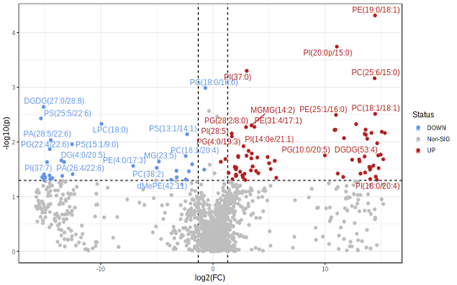

Supplementary Figures 6: (A) Partial Least Squares - Discriminant Analysis (PLS-DA) plot of lipid species in mice brain of PTL vs PTL plus Tulsi groups revealing the component variance 36.1% and 14.3%. (B) VIP score of lipid species in PLS-DA in the mice brain of PTL vs PTL plus Tulsi groups. The coloured boxes on the right side represent the relative concentration of the corresponding lipid species. Red color indicates high and blue color indicates low.
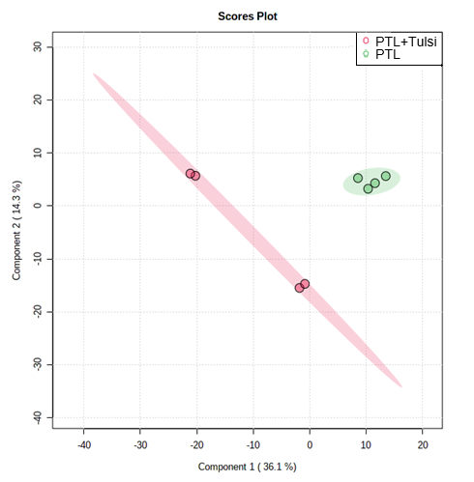
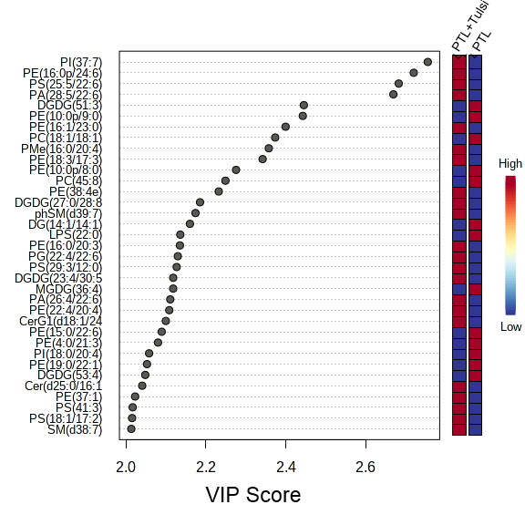

Supplementary Figures 7: (A) Heatmap of the expression of identified differential lipids in the mice brain between PTL vs PTL plus Tulsi groups. The coloured boxes on the right side represent the relative concentration of the corresponding lipid species. Red color indicates high and green color indicates low. (B) Random Forest from mice brains of PTL vs PTL plus Tulsi groups identified 15 different lipid features and ranked by the mean decrease in classification accuracy.
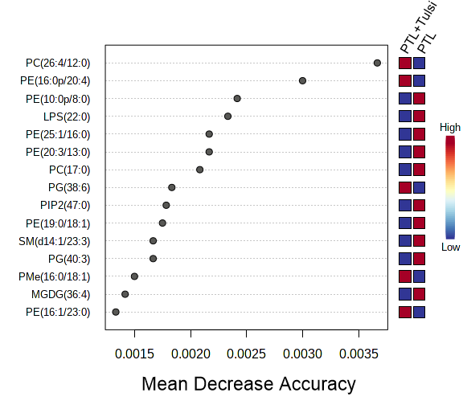
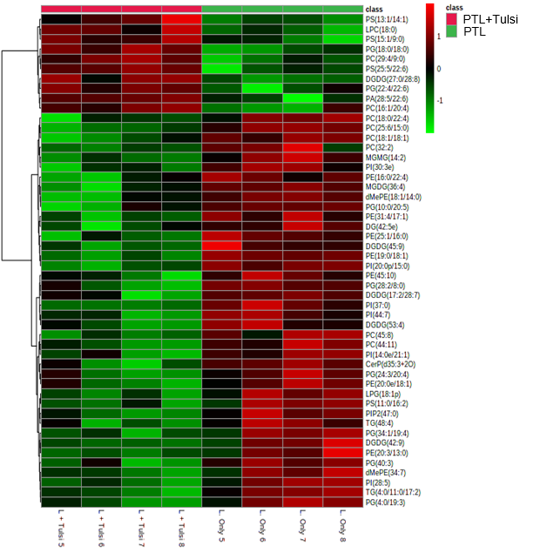

Supplementary Figures 8: The volcano map showed the differential lipids expression level in the mice brain of PTL vs PTL plus Ibu groups (log2 FC= 1.5 and p-value <0.05 considered significant). Upregulated lipids are shown by red colour dots while downregulated lipids are shown by blue coloured dots.
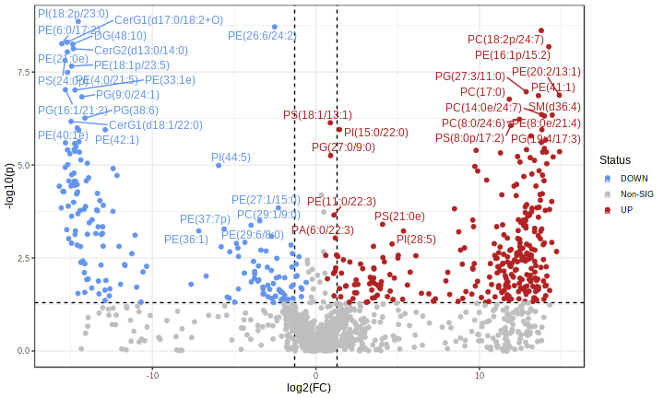

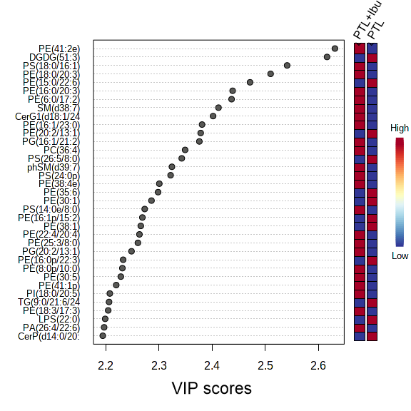
Supplementary Figures 9: (A) Partial Least Squares - Discriminant Analysis (PLS-DA) plot of lipid species in mice brain of PTL vs PTL plus Ibu groups revealing the component variance 47.1% and 12.5%. (B) VIP score of lipid species in PLS-DA in the mice brain of PTL vs PTL plus Ibu groups. The coloured boxes on the right side represent the relative concentration of the corresponding lipid species. Red color indicates high and blue color indicates low.
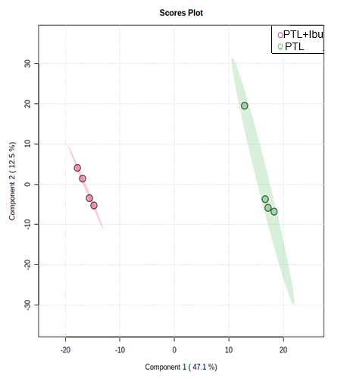
Brain

Supplementary Figures 10: (A) Heatmap of the expression of identified differential lipids in the mice brain between PTL vs PTL plus Ibu groups. The coloured boxes on the right side represent the relative concentration of the corresponding lipid species. Red color indicates high and green color indicates low. (B) Random Forest from mice brains of PTL vs PTL plus Ibu groups identified 15 different lipid features and ranked by the mean decrease in classification accuracy.
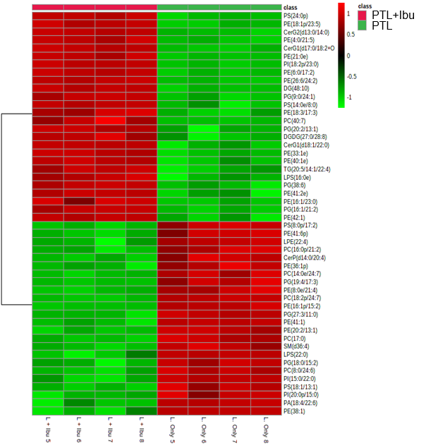
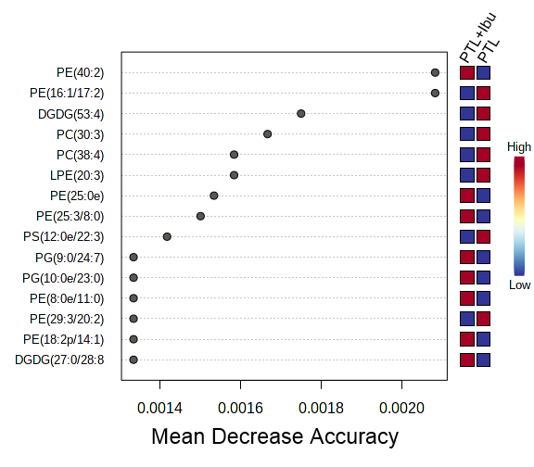

Supplementary Figures 11: The volcano map showed the differential lipids expression level in the mice plasma of sham vs PTL groups (log2 FC= 1.5 and p-value <0.05 considered significant). Upregulated lipids are shown by red colour dots while downregulated lipids are shown by blue coloured dots.

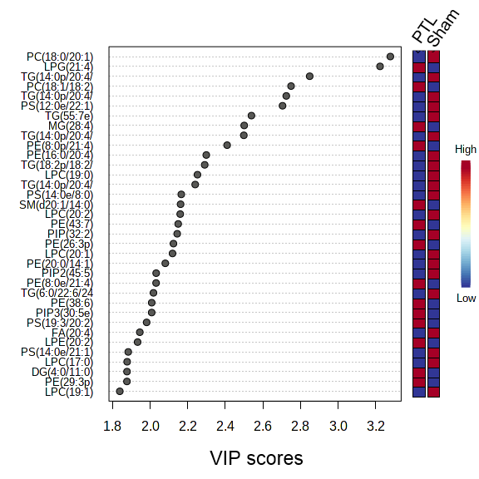
Supplementary Figures 12: (A) Partial Least Squares - Discriminant Analysis (PLS-DA) plot of lipid species in mice plasma of sham vs PTL groups revealing the component variance 20.8% and 18%. (B) VIP score of lipid species in PLS-DA in the mice plasma of sham vs PTL groups. The coloured boxes on the right side represent the relative concentration of the corresponding lipid species. Red color indicates high and blue color indicates low.
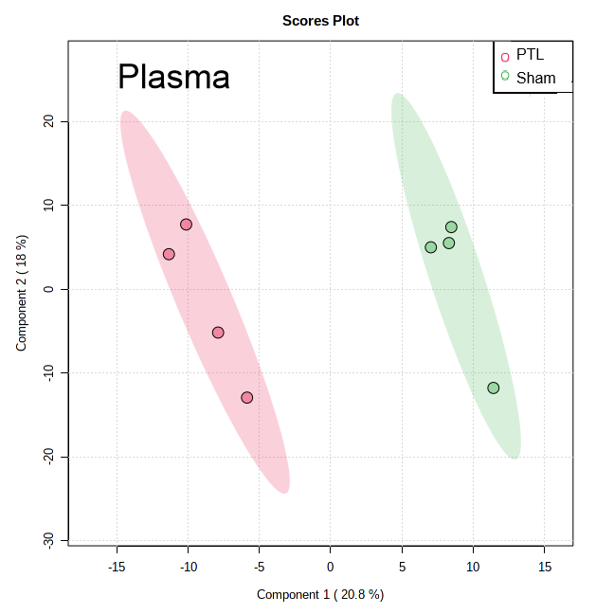

Supplementary Figures 13: (A) Heatmap of the expression of identified differential lipids in the mice plasma between sham vs PTL groups. The coloured boxes on the right side represent the relative concentration of the corresponding lipid species. Red color indicates high and green color indicates low. (B) Random Forest from mice plasma of sham vs PTL groups identified 15 different lipid features and ranked by the mean decrease in classification accuracy.
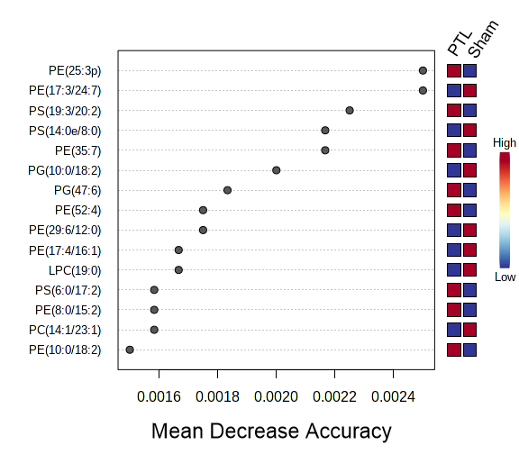
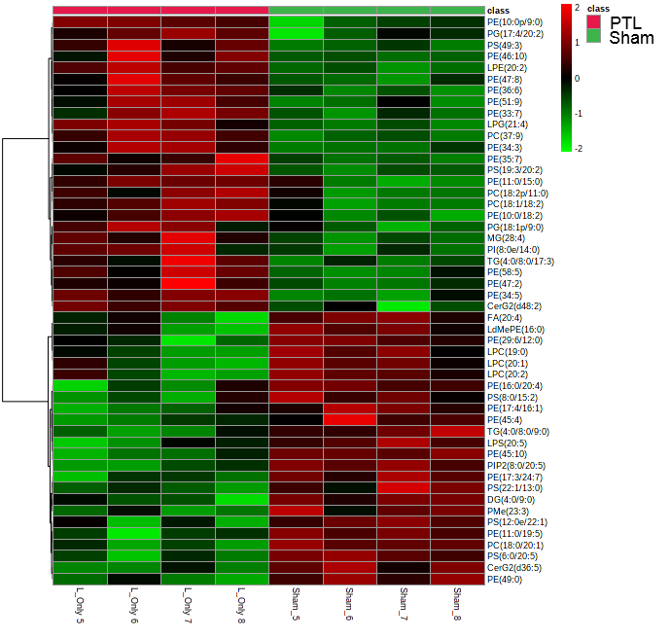

Supplementary Figures 14: The volcano map showed the differential lipids expression level in the mice plasma of PTL vs PTL plus Tulsi groups (log2 FC= 1.5 and p-value <0.05 considered significant). Upregulated lipids are shown by red colour dots while downregulated lipids are shown by blue coloured dots.
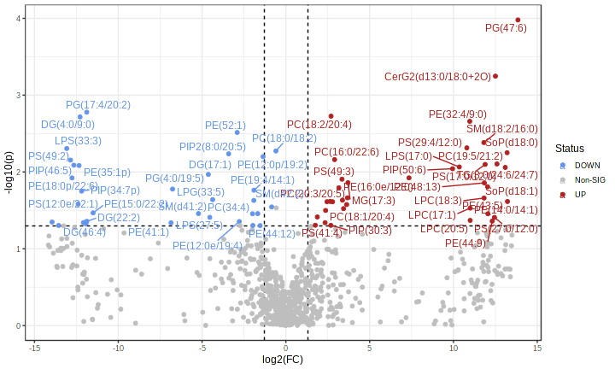

Supplementary Figures 15: (A) Partial Least Squares - Discriminant Analysis (PLS-DA) plot of lipid species in mice plasma of PTL vs PTL plus Tulsi groups revealing the component variance 27.4% and 18.5%. (B) VIP score of lipid species in PLS-DA in the mice plasma of PTL vs PTL plus Tulsi groups. The coloured boxes on the right side represent the relative concentration of the corresponding lipid species. Red color indicates high and blue color indicates low.
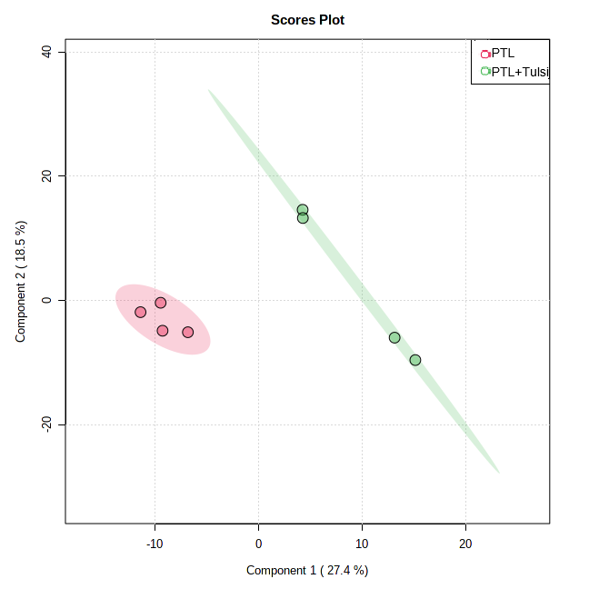
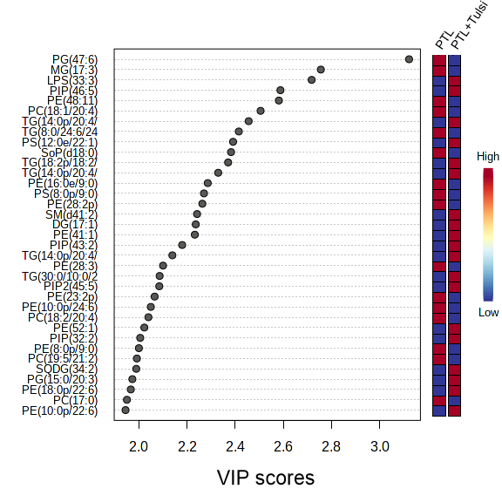
Plasma

Supplementary Figures 16: (A) Heatmap of the expression of identified differential lipids in the mice plasma between PTL vs PTL plus Tulsi groups. The coloured boxes on the right side represent the relative concentration of the corresponding lipid species. Red color indicates high and green color indicates low. (B) Random Forest from mice plasma of PTL vs PTL plus Tulsi groups identified 15 different lipid features and ranked by the mean decrease in classification accuracy.
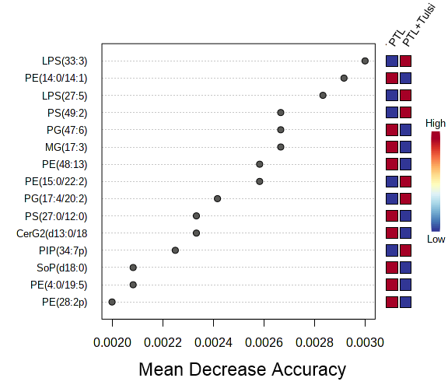
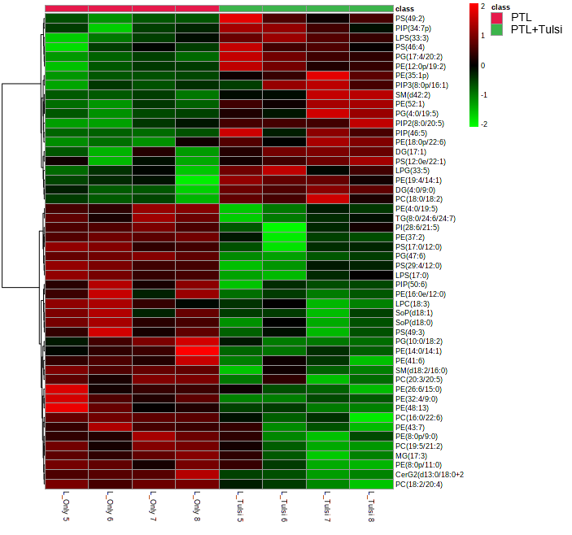

Supplementary Figures 17: The volcano map showed the differential lipids expression level in the mice plasma of PTL vs PTL plus Ibu groups (log2 FC= 1.5 and p-value <0.05 considered significant). Upregulated lipids are shown by red colour dots while downregulated lipids are shown by blue coloured dots.
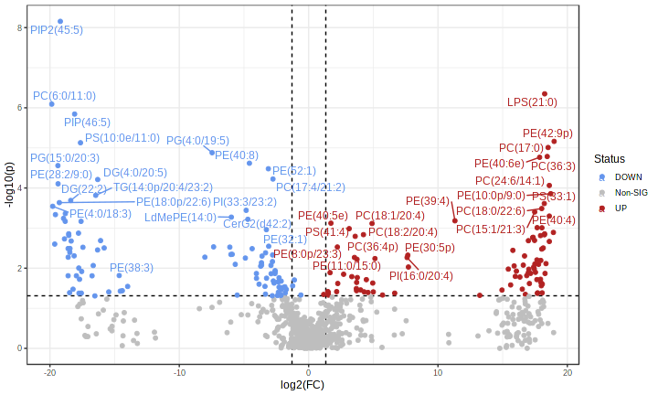

Supplementary Figures 18: (A) Partial Least Squares - Discriminant Analysis (PLS-DA) plot of lipid species in mice plasma of PTL vs PTL plus Ibu groups revealing the component variance 34.7% and 17.7%. (B) VIP score of lipid species in PLS-DA in the mice plasma of PTL vs PTL plus Ibu groups. The coloured boxes on the right side represent the relative concentration of the corresponding lipid species. Red color indicates high and blue color indicates low.
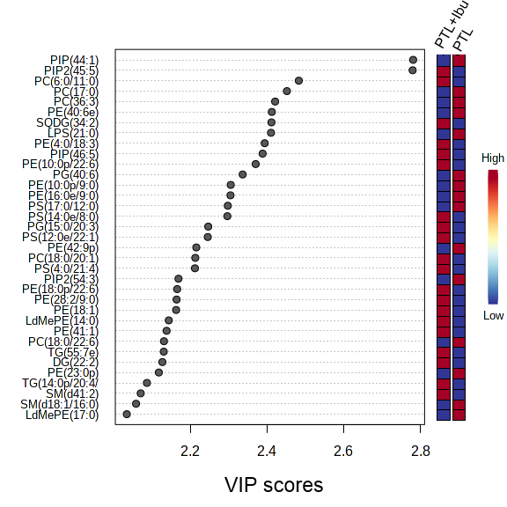
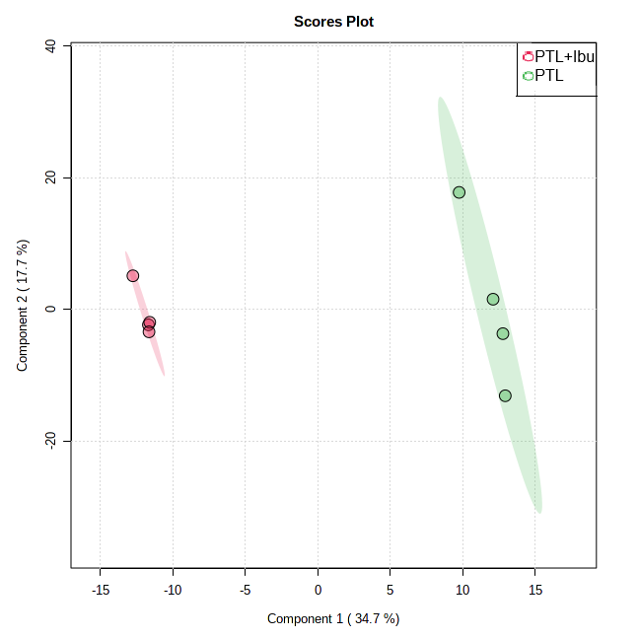
Plasma

Supplementary Figures 19: (A) Heatmap of the expression of identified differential lipids in the mice plasma between PTL vs PTL plus Ibu groups. The coloured boxes on the right side represent the relative concentration of the corresponding lipid species. Red color indicates high and green color indicates low. (B) Random Forest from mice plasma of PTL vs PTL plus Ibu groups identified 15 different lipid features and ranked by the mean decrease in classification accuracy.
