WGU
Course D212 Performance Assessment

COURSE D212: Data Mining II

Instructor: Dr. Kesselly Kamara

Fady "Fady" Missiha
Student ID: 001254668
MSDA (September 1, 2019)
Mentor: Lea Yoakem
Mobile: +1 774 301 9601 Eastern Time (GMT-4)
Email: fmissih@wgu.edu

Part I: Research Question

  - Can we use the Market Basket Analysis model to identify the key associations of customer purchases?
  - This study aims to prepare data and use the Market Basket Analysis model to analyze customers' purchases and identify the key associations, providing recommendations.

Part II: Method Justification

  - The Market Basket Analysis is a modeling technique used by retailers to increase sales by better understanding customer purchasing patterns.
The Market Basket Analysis analyzes the data set such as purchase transactions history to reveal product groupings and products likely to be purchased together.(TechTarget 2021)
In Market Basket Analysis, association rules are used to predict the likelihood of products being purchased together. Associations rules count the frequency of items that occur together, finding association that occurs far more often than expected.(TechTarget 2021)

  - Transaction in the Dataset like list of purchase items in one transaction as follows:
    - Apple Lightning to Digital AV Adapter
    - TP-Link AC1750 Smart WiFi Router
    - Apple Pencil
  - Assumption:
The underlying assumption in Market Basket Analysis is that joint occurrence of two or more products in most baskets implies that these products are complements in the purchase. Therefore, the purchase of one goes lead to the purchase of others; in this study.
(WordPress 2021)
Part III: Data Preparation

- The Code and The cleaned copy are attached files.
  - Code Snapshots:
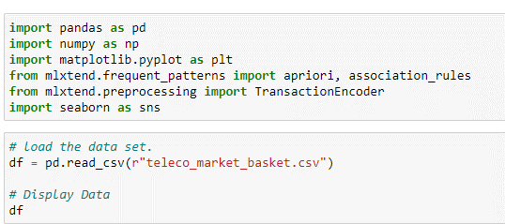
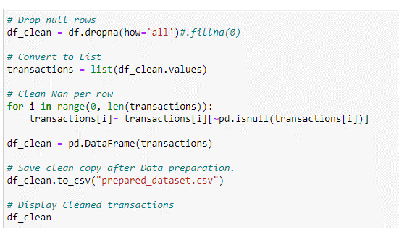
  - Code Execution:

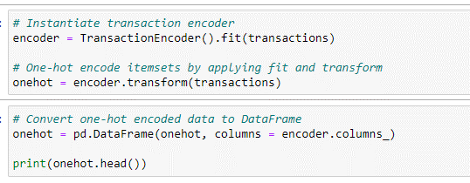
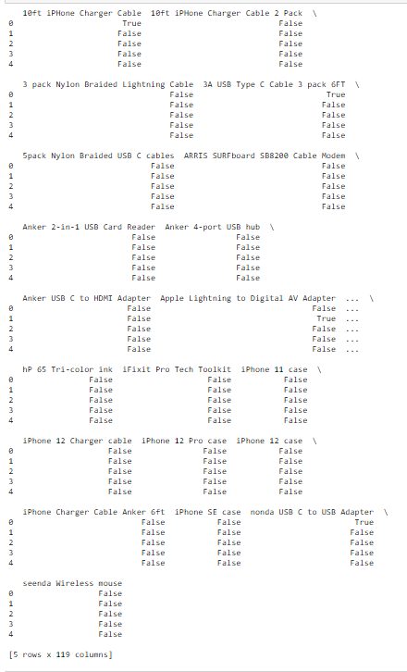
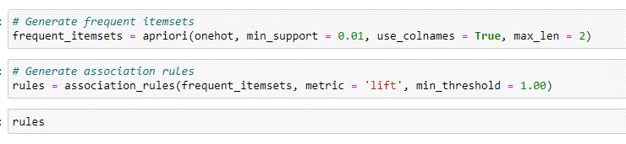
    - The explanation for the parameters of the Apriori algorithm:
      - Oneshot is the list of lists. Encoded data is used to extract rules.
      - Min_support is used to select the items with support values greater than the parameter value.
      - Use_columes is used to display the names of the columns.
      - Max_len is used to limit the length of the itemsets generated.
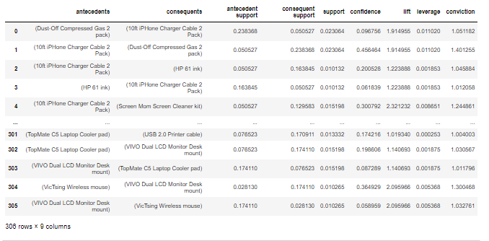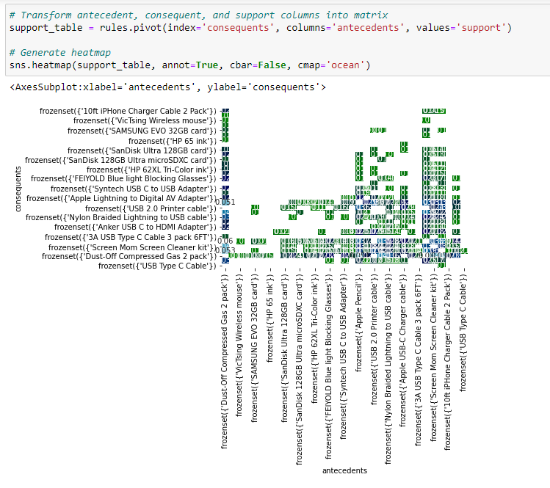
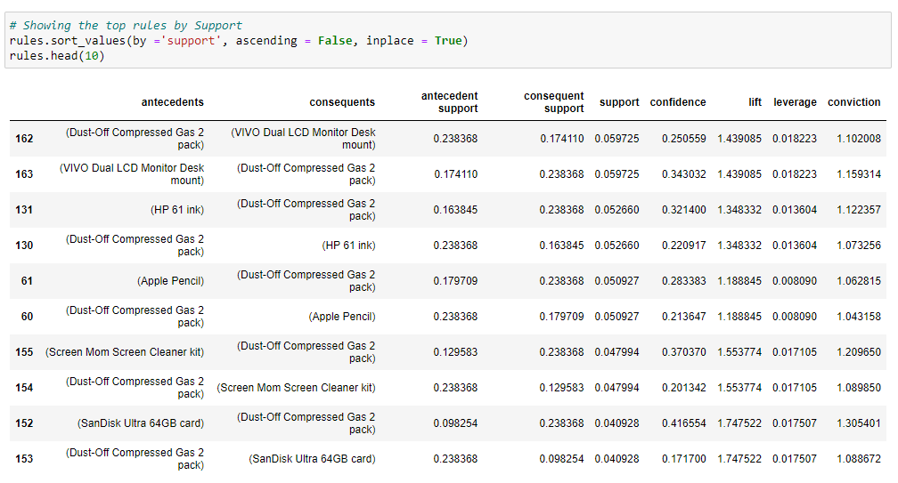
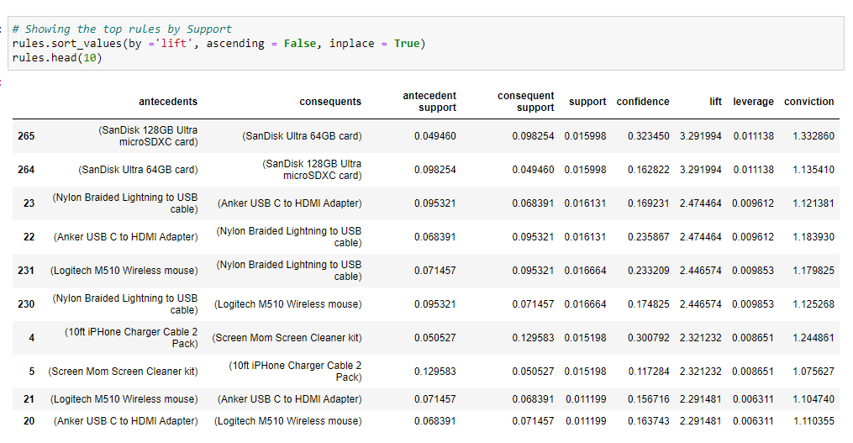
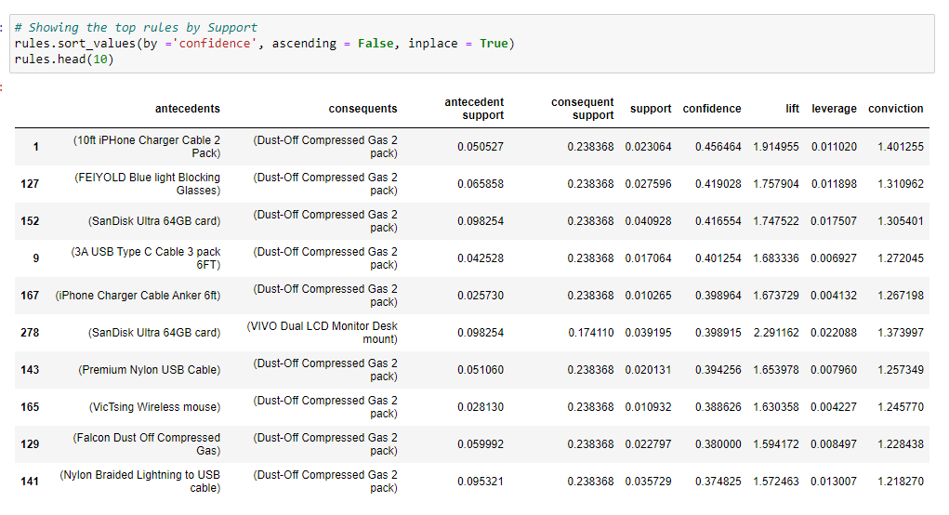

The Top 3 rules:

Support:
Lift:
Confidence:

Part V: Data Summary and Implications

- The Summary:
  - Summarize the significance.
    - Support: indicate the item popularity in the transactions and measure the percentage appearing in the transactions. For example, the top support item in the study is 0.059 mean significance appearing in about 6% of all the transactions.
    - Lift: indicate how likely the consequent item appears in the purchase transaction if the antecedent item is included in the same purchase transaction. For example, the top Lift item in the study is 3.29, which is greater than one, meaning significance there is a very likely purchase of the consequent item if the antecedent item is purchased.
    - Confidence: indicate how likely the consequent item appears in the purchase transaction if the antecedent item is included in the same purchase transaction and measured in percentage. For example, the top Confidence item in the study is 0.45, meaning significance in about 45 % percent that the consequent item will be purchased if the antecedent item is purchased.

  - The study found that the Market Basket Analysis is a perfect practical significance tool to analyze the purchase history and define the associations between the purchased items, improving the business decision and increasing sales.
For example, the results show (Dust-Off Compressed Gas 2 pack) and (VIVO Dual LCD Monitor Desk mount) items together appear in 6% in the purchase transactions and the significant relation between (SanDisk 128GB Ultra microSDXC card) and (SanDisk Ultra 64GB card) items in the purchase history. About 45 % percent that the (Dust-Off Compressed Gas 2 pack) item will appear in the transaction if the customer purchase (10ft iPhone Charger Cable 2 Pack) item, the Market team could use the top items for support, lift. Confidence items list analyzes and defines customer behavior and characteristics and improves marketing plans and offers, which support increased sales.

  - Actionable recommendations:
The telecommunications providers could use the algorithm to define the associations between the purchased items and define the customer characteristics, targeting the marketing proposals like offering the associated items together based on the algorithm results. Moreover, the algorithm could improve business decisions and increase sales.
The Market team could use the top items for support, lift, and Confidence lists as reports as valuable information and recommendation to improve marketing plans and offers, which support increased sales.
For example, the market team could use the top list of confidence and lift to create offers for the items together in one offer and use the top of the support list to increase the number of items available in the store. Both recommendations will improve the sales.

- Acknowledge Sources:

Towards Data Science. (2021, November 17) Market Basket Analysis. [Web Site]. Retrieved from
https://towardsdatascience.com/market-basket-analysis-on-online-retail-data-24ee7214a762

TechTarget. (2021, November 17) Market Basket Analysis. [Web Site]. Retrieved from
https://searchcustomerexperience.techtarget.com/definition/market-basket-analysis

WordPress. (2021, November 17) Market Basket Analysis. [Web Site]. Retrieved from
https://sarahtianhua.wordpress.com/portfolio/market-basket-analysis/

