SUPPORTING INFORMATION

Discussion
The results based on the trees from Nyakatura and Bininda-Emonds (2012) and Perri et al. (2021), showed very distinct dispersal patterns to the ones observed using our tree, failing to indicate both the location where the clades of wolves and foxes had their center of diversification and association between increases in diversification and colonization of new areas. These contrasting results can be explained by the nature of both trees, and the different number of lineages within the clades of canids on those phylogenies compared to ours. Other available phylogenies for canids were not taken into account due to some limitations that we thought would be a problem for the ideas proposed by our study. For example, the tree from Tedford et al. (2009), although robust, provides the evolutionary relationships only for canid species (extinct and extant) from North America, and it was built solely with osteological data without any molecular markers. ‬‬‬‬‬‬‬‬‬‬‬‬‬‬‬‬‬‬‬‬‬‬‬‬‬‬‬‬‬‬‬‬‬‬‬‬‬‬‬‬‬‬‬‬‬‬‬‬‬‬‬‬‬‬‬‬‬‬‬‬‬‬‬‬‬‬‬‬‬‬‬‬‬‬‬‬‬‬‬‬‬‬‬‬‬‬‬‬‬‬‬‬‬‬‬‬‬‬‬‬‬‬‬‬‬‬‬‬‬‬‬‬‬‬‬‬‬‬‬‬‬‬‬‬‬‬‬‬‬‬‬‬‬‬‬‬‬‬‬‬‬‬‬‬‬‬‬‬‬‬‬‬‬‬‬‬‬‬‬‬‬‬‬‬‬‬‬‬‬‬‬‬‬‬‬‬‬‬‬‬‬‬‬‬‬‬‬‬‬‬‬‬‬‬‬‬‬‬
The study from ‬‬‬‬‬‬‬‬‬‬‬‬‬‬‬‬‬‬‬‬‬‬‬‬‬‬‬‬‬‬‬‬‬‬‬‬‬‬‬‬‬‬‬‬Chavez et al. (2022) showed diversification events of South American canids into S. America. Their results are very similar to the ones presented here. First, their best-fitting biogeographical model was DIVALIKE, as we did. Secondly, even though we did not specify distinct states related to the Andes, we can still compare the nature of both results. ‬‬‬‬‬‬‬‬‬‬‬‬‬‬‬‬‬‬‬‬‬‬‬‬‬‬‬‬‬‬‬‬‬‬‬‬‬‬‬‬‬‬‬‬Chavez et al. (2022) found that diversification of Lycalopex genus is related to the west of the Andes, while other S. American canids and the first lineages that arrived in S. America had their diversification related to the east of the Andes. These results are very similar to those found here. In Figure 3A, we showed that the diversification of the Lycalopex genus took place in our state C, the southwestern part of the continent which is the west of the Andes (on the left side of the Andean mountains) in ‬‬‬‬‬‬‬‬‬‬‬‬‬‬‬‬‬‬‬‬‬‬‬‬‬‬‬‬‬‬‬‬‬‬‬‬‬‬‬‬‬‬‬‬Chavez et al. (2022) paper, while the other S. American canids as well as the first lineages of the group that arrived on the continent had their diversification associated with our state B (Figure 1), which can be interpreted as the east of the Andes (on the right side of the Andean mountains) in their study. The study from ‬‬‬‬‬‬‬‬‬‬‬‬‬‬‬‬‬‬‬‬‬‬‬‬‬‬‬‬‬‬‬‬‬‬‬‬‬‬‬‬‬‬‬‬Chavez et al. (2022) gives strong support to the results found here for the whole Canidae family, as not only similar geographical patterns of diversification in S. America were found, but the choice for the biogeographical model was identical. However, as we have more species (including extinct ones) in our phylogeny compared to ‬‬‬‬‬‬‬‬‬‬‬‬‬‬‬‬‬‬‬‬‬‬‬‬‬‬‬‬‬‬‬‬‬‬‬‬‬‬‬‬‬‬‬‬Chavez et al. (2022), we present a more complete scenario. For example, our ancestral range estimation (Figure 3A) suggests when, and in which lineages, area expansions from S. America to N. America took place in the South American clade.

SUPPLEMENTARY TEXT: FIGURES

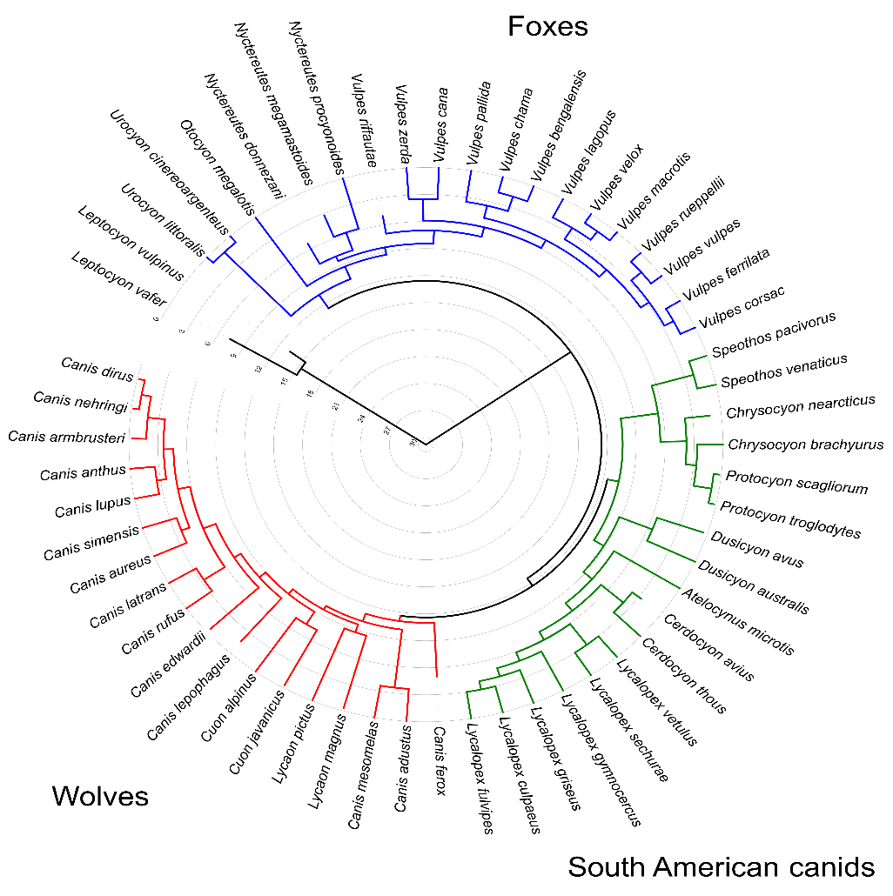
Figure S1 Phylogenetic tree with 56 species of canids used during our analyses. This tree was constructed by adding 19 extinct species to the phylogeny of extant canids of Porto et al. (2019). The three major clades of Caninae are identified by the colors red (Wolves), blue (Foxes), and green (South American canids).

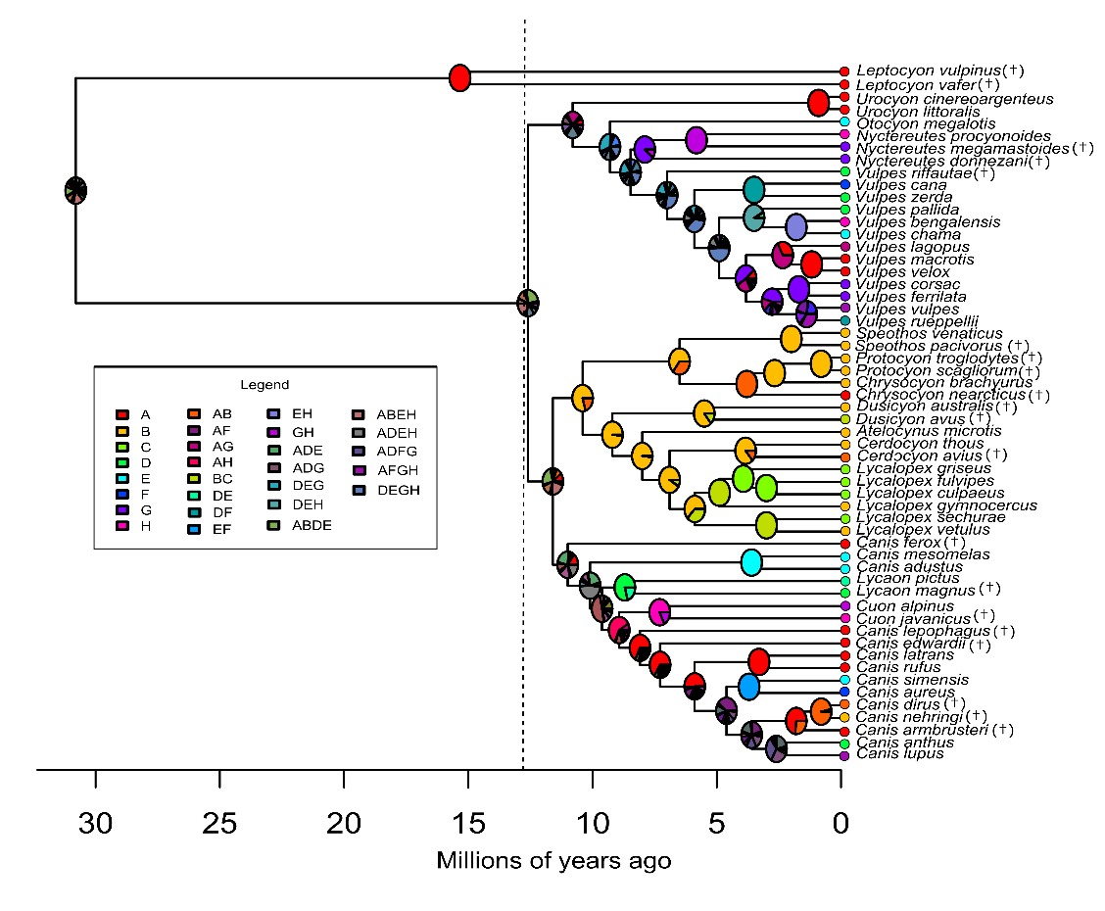

Figure S2 Phylogenetic tree and ancestral range reconstruction for the whole tree under DEC. The ancestral areas of the lineages are indicated at the nodes of the tree and the color-coded circles at the tips represent the current areas occupied by each lineage. The colors represent the different biogeographic regions as indicated in the legend.

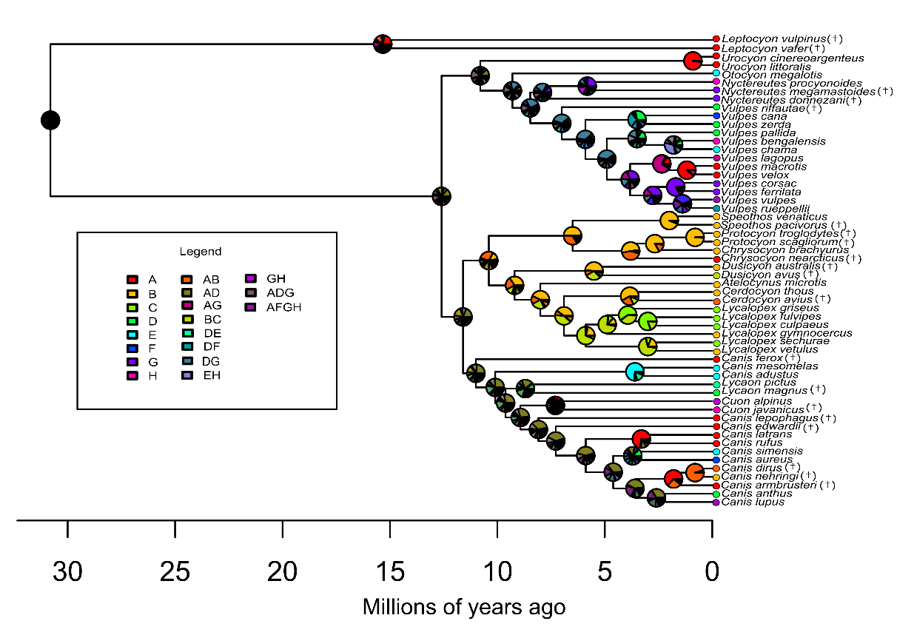
Figure S3 Phylogenetic tree and ancestral range reconstruction for the whole tree under BAYAREALIKE. The ancestral areas of the lineages are indicated at the nodes of the tree and the color-coded circles at the tips represent the current areas occupied by each lineage. The colors represent the different biogeographic regions as indicated in the legend.

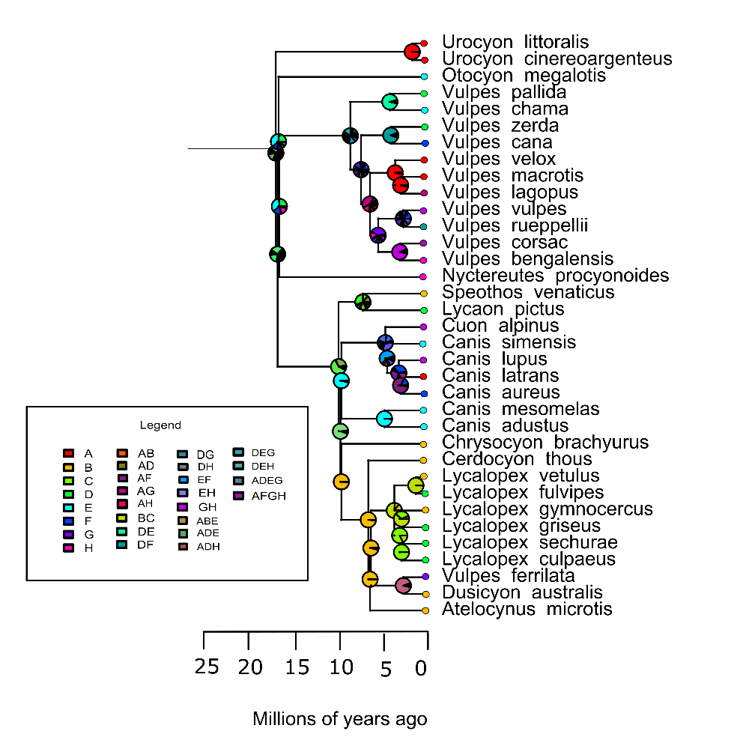
Figure S4 Ancestral range reconstruction on the phylogeny from Nyakatura & Bininda-Emonds (2012) under the DIVALIKE model. The ancestral areas of the lineages are indicated at the nodes of the tree and the color-coded circles at the tips represent the current areas occupied by each lineage. The colors represent the different biogeographic regions as indicated in the legend.

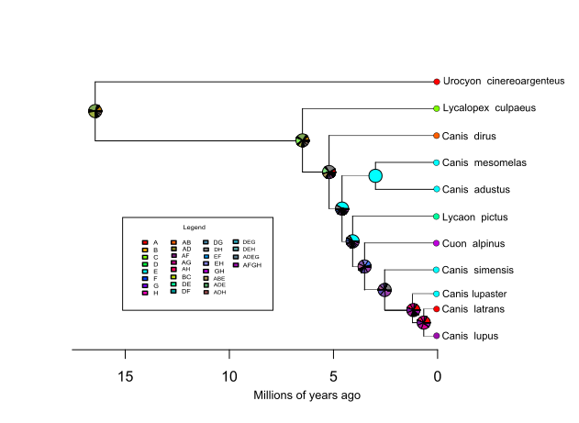
Figure S5 Ancestral range reconstruction on the phylogeny from Perri et al. (2021) under the DIVALIKE model. The ancestral areas of the lineages are indicated at the nodes of the tree and the color-coded circles at the tips represent the current areas occupied by each lineage. The colors represent the different biogeographic regions as indicated in the legend.

Figure S6 Extinction rates for the whole tree (A) and for the three major clades of Caninae: wolves (B), foxes (C), and South American canids (D).

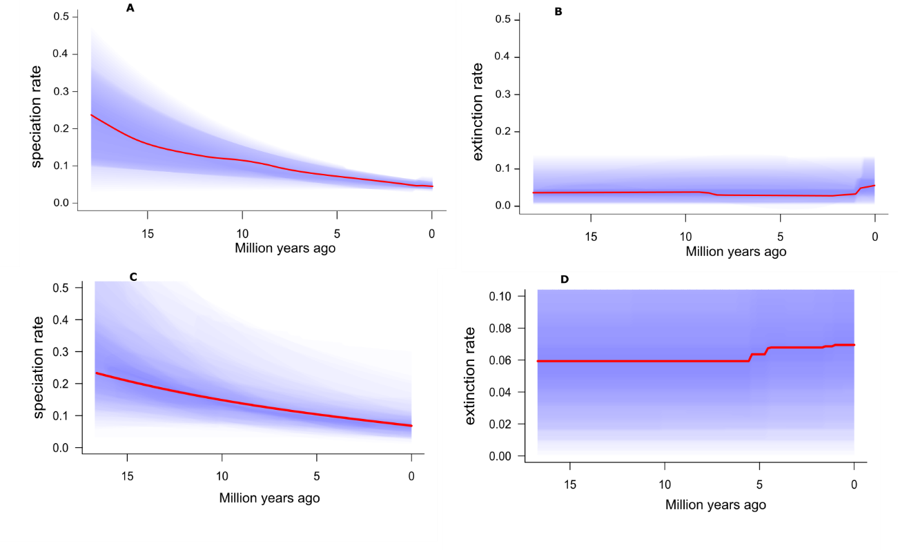
Figure S7 Rates through time estimated form the two phylogenies used for phylogenetic uncertainty. (A and B) Speciation and extinction rates from Nyakatura & Bininda-Emonds (2012) tree, respectively. (C and D) Speciation and extinction rates from Perri et al. (2021) tree, respectively.

SUPPLEMENTARY TEXT: TABLE LIST

Table S1. List of the 56 species of Canidae included in our study with the distribution areas that they belong based on our eight biogeographical regions (Fig. 1 in the main text). The original descriptor is also specified. Species marked with (*) are the 19 extinct canids include in the tree of Porto et al. (2019).
Species | Biogeographic area | Descriptor
Canis lupus | AFGH | Linnaeus, 1758
Canis anthus | D | Cuvier, 1820
Canis aureus | F | Linnaeus, 1758
Canis simensis | E | Rüppell, 1840
Canis rufus | A | Audubon and Bachman, 1851
Canis latrans | A | Say, 1823
Cuon alpinus | GH | Pallas, 1811
Lycaon pictus | DE | Temminck, 1820
Canis adustus | E | Sundevall, 1847
Canis mesomelas | E | Schreber, 1775
Lycalopex vetulus | B | Lund, 1842
Lycalopex sechurae | C | Thomas, 1900
Lycalopex gymnocercus | B | Fischer, 1814
Lycalopex culpaeus | C | Molina, 1782
Lycalopex fulvipes | C | Martin, 1837
Lycalopex griseus | C | Gray, 1837
Cerdocyon thous | B | Linnaeus, 1766
Atelocynus microtis | B | Sclater, 1883
Dusicyon australis † | B | Kerr, 1792
Chrysocyon brachyurus | B | Illiger, 1815
Speothos venaticus | B | Lund, 1842
Vulpes rueppellii | DF | Schinz, 1825
Vulpes vulpes | AFGH | Linnaeus, 1758
Vulpes ferrilata | G | Hodgson, 1842
Vulpes corsac | G | Linnaeus, 1768
Vulpes velox | A | Say, 1823
Vulpes macrotis | A | Merriam, 1888
Vulpes lagopus | AG | Linnaeus, 1758
Vulpes chama | E | Smith, 1833
Vulpes bengalensis | H | Shaw, 1800
Vulpes pallida | D | Cretzschmar, 1826
Vulpes zerda | D | Zimmermann, 1780
Vulpes cana | F | Blanford, 1877
Nyctereutes procyonoides | H | Gray, 1834
Otocyon megalotis | E | Desmarest, 1822
Urocyon littoralis | A | Baird, 1857
Urocyon cinereoargenteus | A | Schreber, 1775
*Canis dirus † | AB | Leidy, 1858
*Canis armbrusteri † | A | Gidley, 1913
*Leptocyon vafer † | A | Leidy, 1858
*Leptocyon vulpinus † | A | Matthew, 1907
*Cuon javanicus † | H | Desmarest, 1820
*Canis ferox † | A | Miller and Carranza-Castaneda, 1998
*Canis edwardii † | A | Gazin, 1942
*Lycaon magnus † | D | Ewer and Singer, 1956
*Canis lepophagus † | A | Johnston, 1938
*Vulpes riffautae † | D | de Bonis et al., 2007
*Cerdocyon avius † | AB | Torres and Ferrusquia, 1981
*Chrysocyon nearcticus † | A | Tedford et al., 2009
*Dusicyon avus † | BC | Burmeister, 1866
*Canis nehringi † | B | Ameghino, 1902
*Protocyon troglodytes † | B | Lund, 1838
*Protocyon scagliorum † | B | Giebel, 1855
*Nyctereutes donnezani † | G | Depéret, 1890
*Nyctereutes megamastoides † | G | Pomel, 1842
*Speothos pacivorus † | B | Lund, 1839

REFERENCES
Chavez, D.E., Gronau, I., Hains, T., Dikow, R.B., Frandsen, P.B., Figueiró, H. V., et al. 2022. Comparative genomics uncovers the evolutionary history, demography, and molecular adaptations of South American canids. Proc. Natl. Acad. Sci. 119.
Nyakatura, K. & Bininda-Emonds, O.R. 2012. Updating the evolutionary history of Carnivora (Mammalia): a new species-level supertree complete with divergence time estimates. BMC Biol. 10: 12. BioMed Central Ltd.
Perri, A.R., Mitchell, K.J., Mouton, A., Álvarez-Carretero, S., Hulme-Beaman, A., Haile, J., et al. 2021. Dire wolves were the last of an ancient New World canid lineage. Nature 591: 87–91.
Porto, L.M.V., Maestri, R. & Duarte, L.D.S. 2019. Evolutionary relationships among life-history traits in Caninae (Mammalia: Carnivora). Biol. J. Linn. Soc. 128: 311–322.
Tedford, R.H., Wang, X. & Taylor, B.E. 2009. Phylogenetic Systematics of the North American Fossil Caninae (Carnivora: Canidae). Bull. Am. Museum Nat. Hist. 325: 1–218.

