Annex 1. Instrument
Interview Guide



For women, over 18 years of age, victims of domestic violence residing in the region of Apurímac.

Title:

VIOLENCE AGAINST WOMEN ANALYZED UNDER THE THOUGHT OF EDMUND HUSSERL IN THE CONTEXT OF THE SOCIETY OF APURIMAC
Interviewee: 1 Province:
Interview
The instrument aims to generate an interpretative analysis from the phenomenological perspective of violence against women in the department of Apurímac.

Details | Answers | Notes
VIOLENCE AGAINST WOMEN
Have you been a victim of gender-based violence and what was the situation you experienced?
Explain the social role that men play in Apurímac society?
What is the social role of women in Apurímac society?
What legal and institutional support does the Apurímac region provide to women who have been victims of gender-based violence?
What are the most common situations of violence against
women in the Apurímac region?
Do you consider that the instruments for the protection and eradication of violence against women are effective in the
Apurímac region? Explain your answer.
Do you consider that the Law for the Protection of Violence against Women is effective in protecting women and eradicating gender- based violence? Please explain why?
Do you consider that there is impunity for cases of domestic violence in the Apurímac region? Explain why?
Do you consider that theprotection measures provided to victims are enforced in a timely manner? Please explain why?
PHENOMENOLOGICAL APPROACH
What are the situations that in your view are considered acts of violence against women?
What is your conception of the role that women should have in the family?

Explain, what is your conception of the role that women should have in the socio- cultural plan?
What is the socio- economic situation in the Apurímac region? Do you think that the socio-economic situation can lead to situations of violence against women in the Apurímac region?
Does the lack of policies at the regional level cause difficulties in combating violence against women in the Apurímac region? Explain why?
Do you consider that the complaints processed in the Apurímac region have contributed to reducing situations of violence against
women in the Apurímac region? Explain why?
Thank you very much for your cooperation

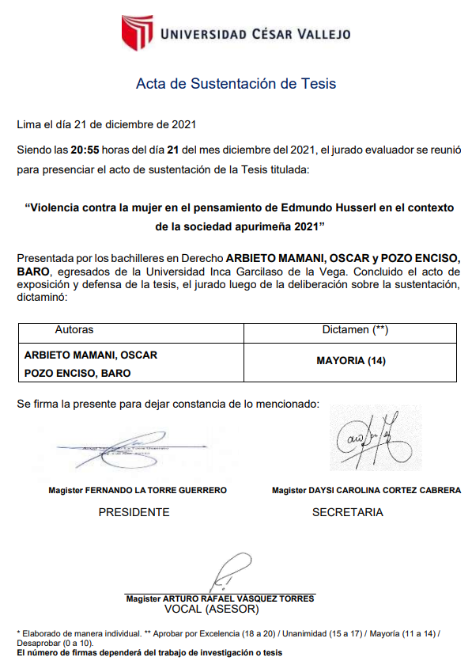
Anexx 2: Thesis Approval

