Supplemental Information
HIV-Tat Exacerbates the actions of Atazanavir, Efavirenz and Ritonavir on cardiac ryanodine receptor (RyR2)

Fadhel A. Alomar^{1*}, Chengju Tian^{2*}, Sean R. Bidasee², Zachary Venn², Evan Schroder², Nicholas Polermo³, Mohammad Alshabeeb⁴, Benson J. Edagwa², Jason Payne⁵, and Keshore R. Bidasee^{2,6,7}

¹Department of Pharmacology and Toxicology, College of Clinical Pharmacy, Imam Abdulrahman Bin Faisal University, Dammam 31441, Saudi Arabia, ²Departments of Pharmacology and Experimental Neuroscience, University of Nebraska Medical Center, Omaha, NE 68198, ³Department of Pharmaceutical Sciences, University of Nebraska Medical Center, Omaha NE, ⁴Population Health Research Section, King Abdullah International Medical Research Center, King Saudi bin Abdulaziz University for Health Sciences, Riyadh, Saudi Arabia, ⁵Department of Internal Medicine, University of Nebraska Medical Center, Omaha, NE 68198, and ⁶Department of Environment and Occupational Health, University of Nebraska Medical Center, Omaha, NE 68198, and ⁷Nebraska Redox Biology Center, Lincoln NE.

Corresponding Author:
Keshore R. Bidasee, Ph.D.,
Department of Pharmacology and Experimental Neuroscience, 985800 Nebraska Medical Center, Durham Research Center, DRC 3047, Omaha, NE, USA. Tel: (402) 559-9018; Fax: (402) 559-7495, E-mail: kbidasee@unmc.edu.

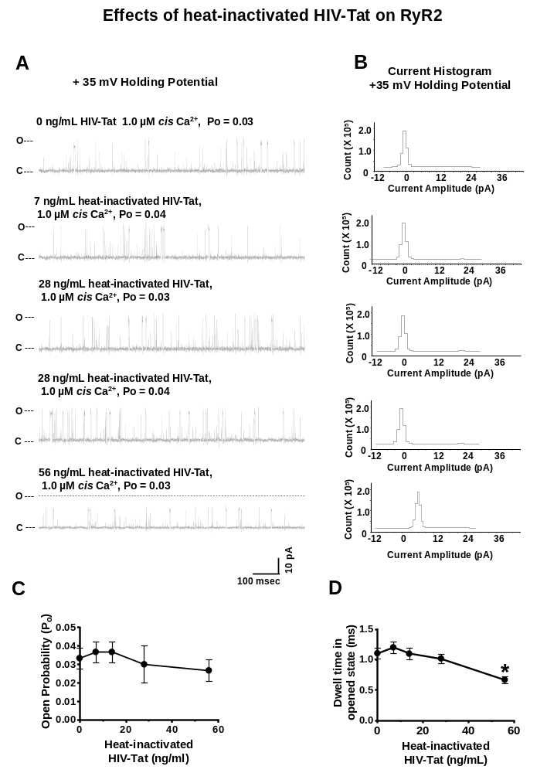
Supplemental Figure 1: Effects of heat-inactivated HIV-Tat on the open probability of RyR2. Panel A shows representative 1.0 sec recordings of a RyR2 channel with 1.0 µM cis Ca²⁺ and cumulative amounts of cis heat-inactivated HIV-Tat. Panel B shows current histograms for that channel with cumulative amounts of cis heat-inactivated HIV-Tat. Panels C and D are graphs of the mean open probability and dwell times of RyR2 as a function of cis concentrations of HIV-Tat channels for n = 8 channels. Recordings shown are at +35 mV (upward deflections) in symmetric KCl buffer solution (0.25 mM KCl, 20 mM K/HEPES, pH 7.4). O, open; C, closed.

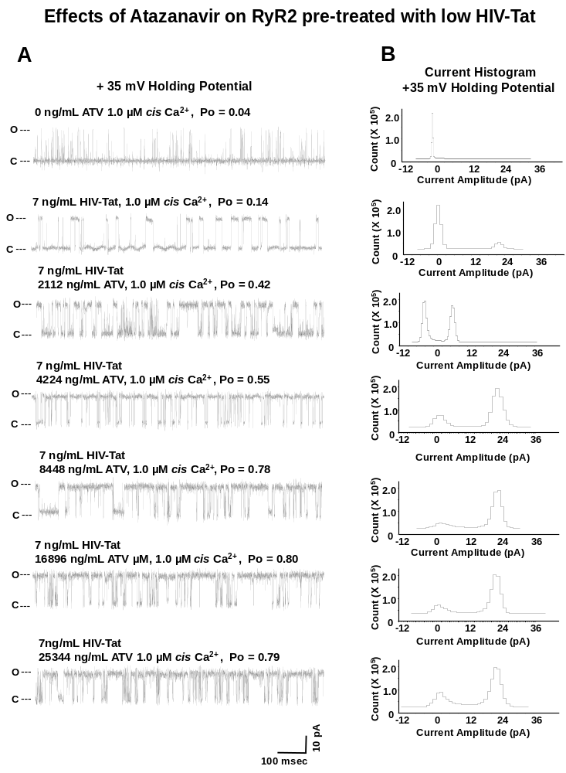
Supplemental Figure 2: Effects of ATV on the open probability of RyR2 that had been pretreated with 7 ng/mL HIV-Tat. Panel A show representative 1.0 sec recordings of a RyR2 channel with 1.0 µM cis Ca²⁺ and before and after pre-treated with 7 ng/mL HIV-tat and varying amount of ATV (representative of n = 10 channels). Single-channel currents were recorded at +35 mV (upward deflections) in symmetric KCl buffer solution (0.25 mM KCl, 20 mM K/HEPES, pH 7.4). O, open; C, closed.

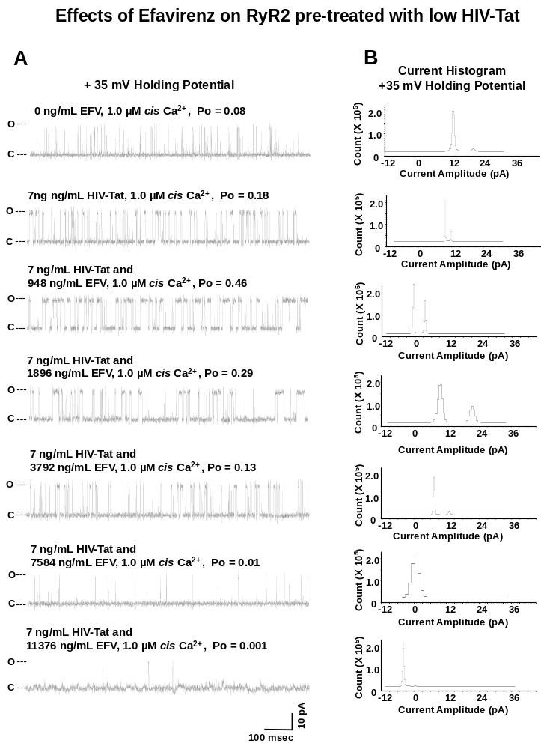
Supplemental Figure 3: Effects of EFV on the open probability of RyR2 that had been pretreated with 7 ng/mL HIV-Tat. Panel A show representative 1.0 sec recordings of a RyR2 channel with 1.0 µM cis Ca²⁺ and before and after pre-treated with 7 ng/mL HIV-tat and varying amount of EFV (representative of n = 10 channels). Single-channel currents were recorded at +35 mV (upward deflections) in symmetric KCl buffer solution (0.25 mM KCl, 20 mM K/HEPES, pH 7.4). O, open; C, closed.

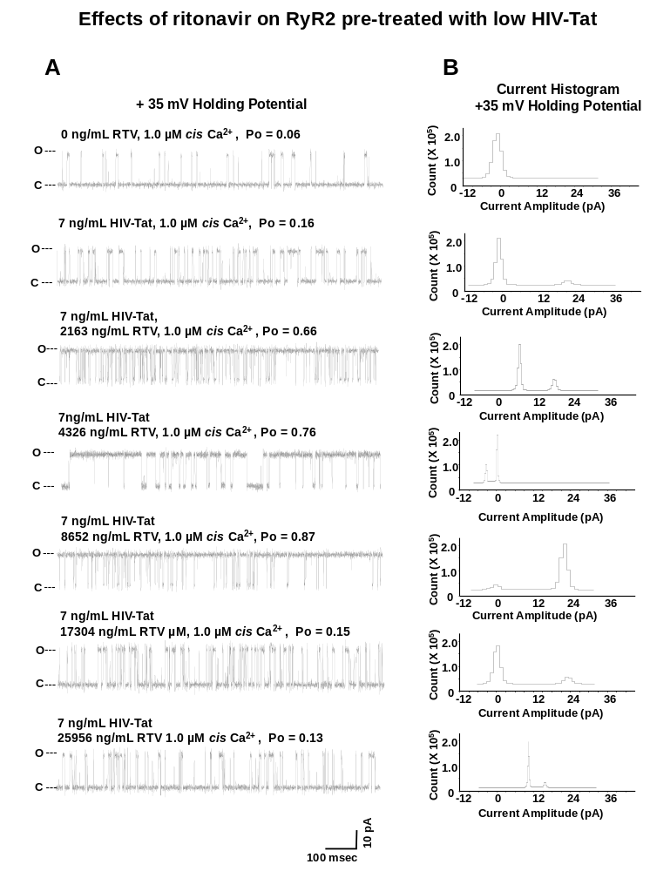
Supplemental Figure 4: Effects of RTV on the open probability of RyR2 that had been pretreated with 7 ng/mL HIV-Tat. Panel A show representative 1.0 sec recordings of a RyR2 channel with 1.0 µM cis Ca²⁺ and before and after pre-treated with 7 ng/mL HIV-tat and varying amount of RTV (representative of n = 10 channels). Single-channel currents were recorded at +35 mV (upward deflections) in symmetric KCl buffer solution (0.25 mM KCl, 20 mM K/HEPES, pH 7.4). O, open; C, closed.

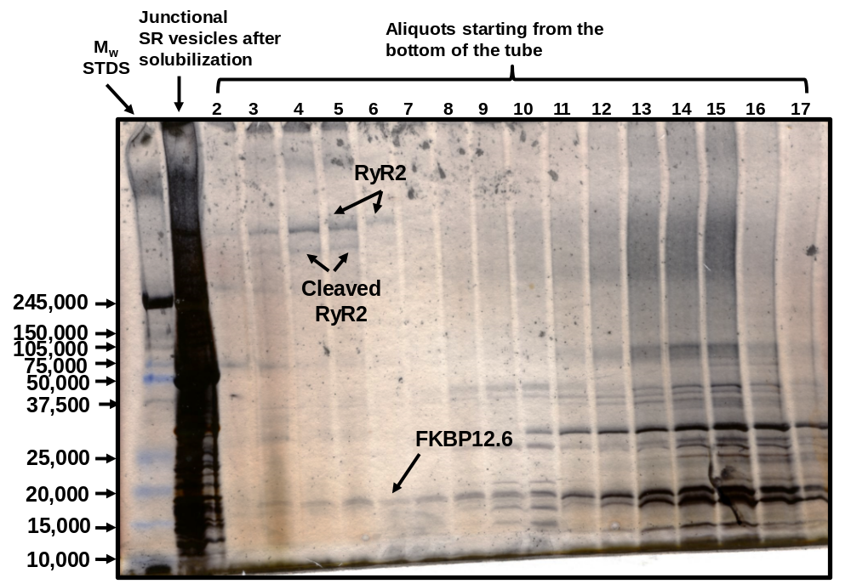

Supplemental Figure 5: Silver stain SDS-PAGE Gel (5-15% linear gradient) showing the protein content of proteoliposomes fractions. Panel A shows representative silver-stained profiles of solubilized junctional SR vesicles (left) and proteoliposome aliquots after linear sucrose gradient centrifugation, collected from the bottom upwards. Aliquots were mixed with gel dissociation medium and electrophorese on 4-15% linear gradient Tris-glycine polyacrylamide gel for 180 min. Arrows indicate bands corresponding to RyR2, cleaved RyR2 and FKBP12.6. Aliquot #6 was used for all single channel recordings.

