SUPPLEMENTARY INFORMATION

Hourly marginal electricity mixes and their relevance for assessing the environmental performance of installations with variable load or power

Jens F. Peters^{1,2}, Diego Iribarren², Pedro Juez Martel³, Mercedes Burguillo¹

¹ University of Alcalá (UAH), Department of Economics, Alcalá de Henares, Madrid, Spain
² Systems Analysis Unit, IMDEA Energy, Móstoles, Spain
³ Department of Applied Economics, Universidad Nacional de Educación a Distancia, Madrid, Spain

This Supplementary Information contains additional graphs and figures, the tabulated hourly impact factors of the average and marginal electricity mix, details about the time series decomposition and the complete inventory data tables for the electricity mix as implemented in openLCA / ecoinvent 3.7.1.
All underlying datafiles, calculations and inventory data for import into LCA software can be accessed and downloaded under https://doi.org/ 10.5281/zenodo.6652128

Index
S.1. Marginal generation by source (2021) 2
S.2. Annual marginal generation mix 6
S.3. Hourly average generation by month 7
S.4. Annual average generation by year 8
S.5. Hourly impact / emission factors of electricity generation 9
S.6. Time series decomposition 21
S.7. Inventory tables for annual average and marginal electricity mix 26
S.8. Results when calculated with LCA software 28
S.9. Generation mix of imported electricity 29
Bibliography 30

Marginal generation by source (2021)
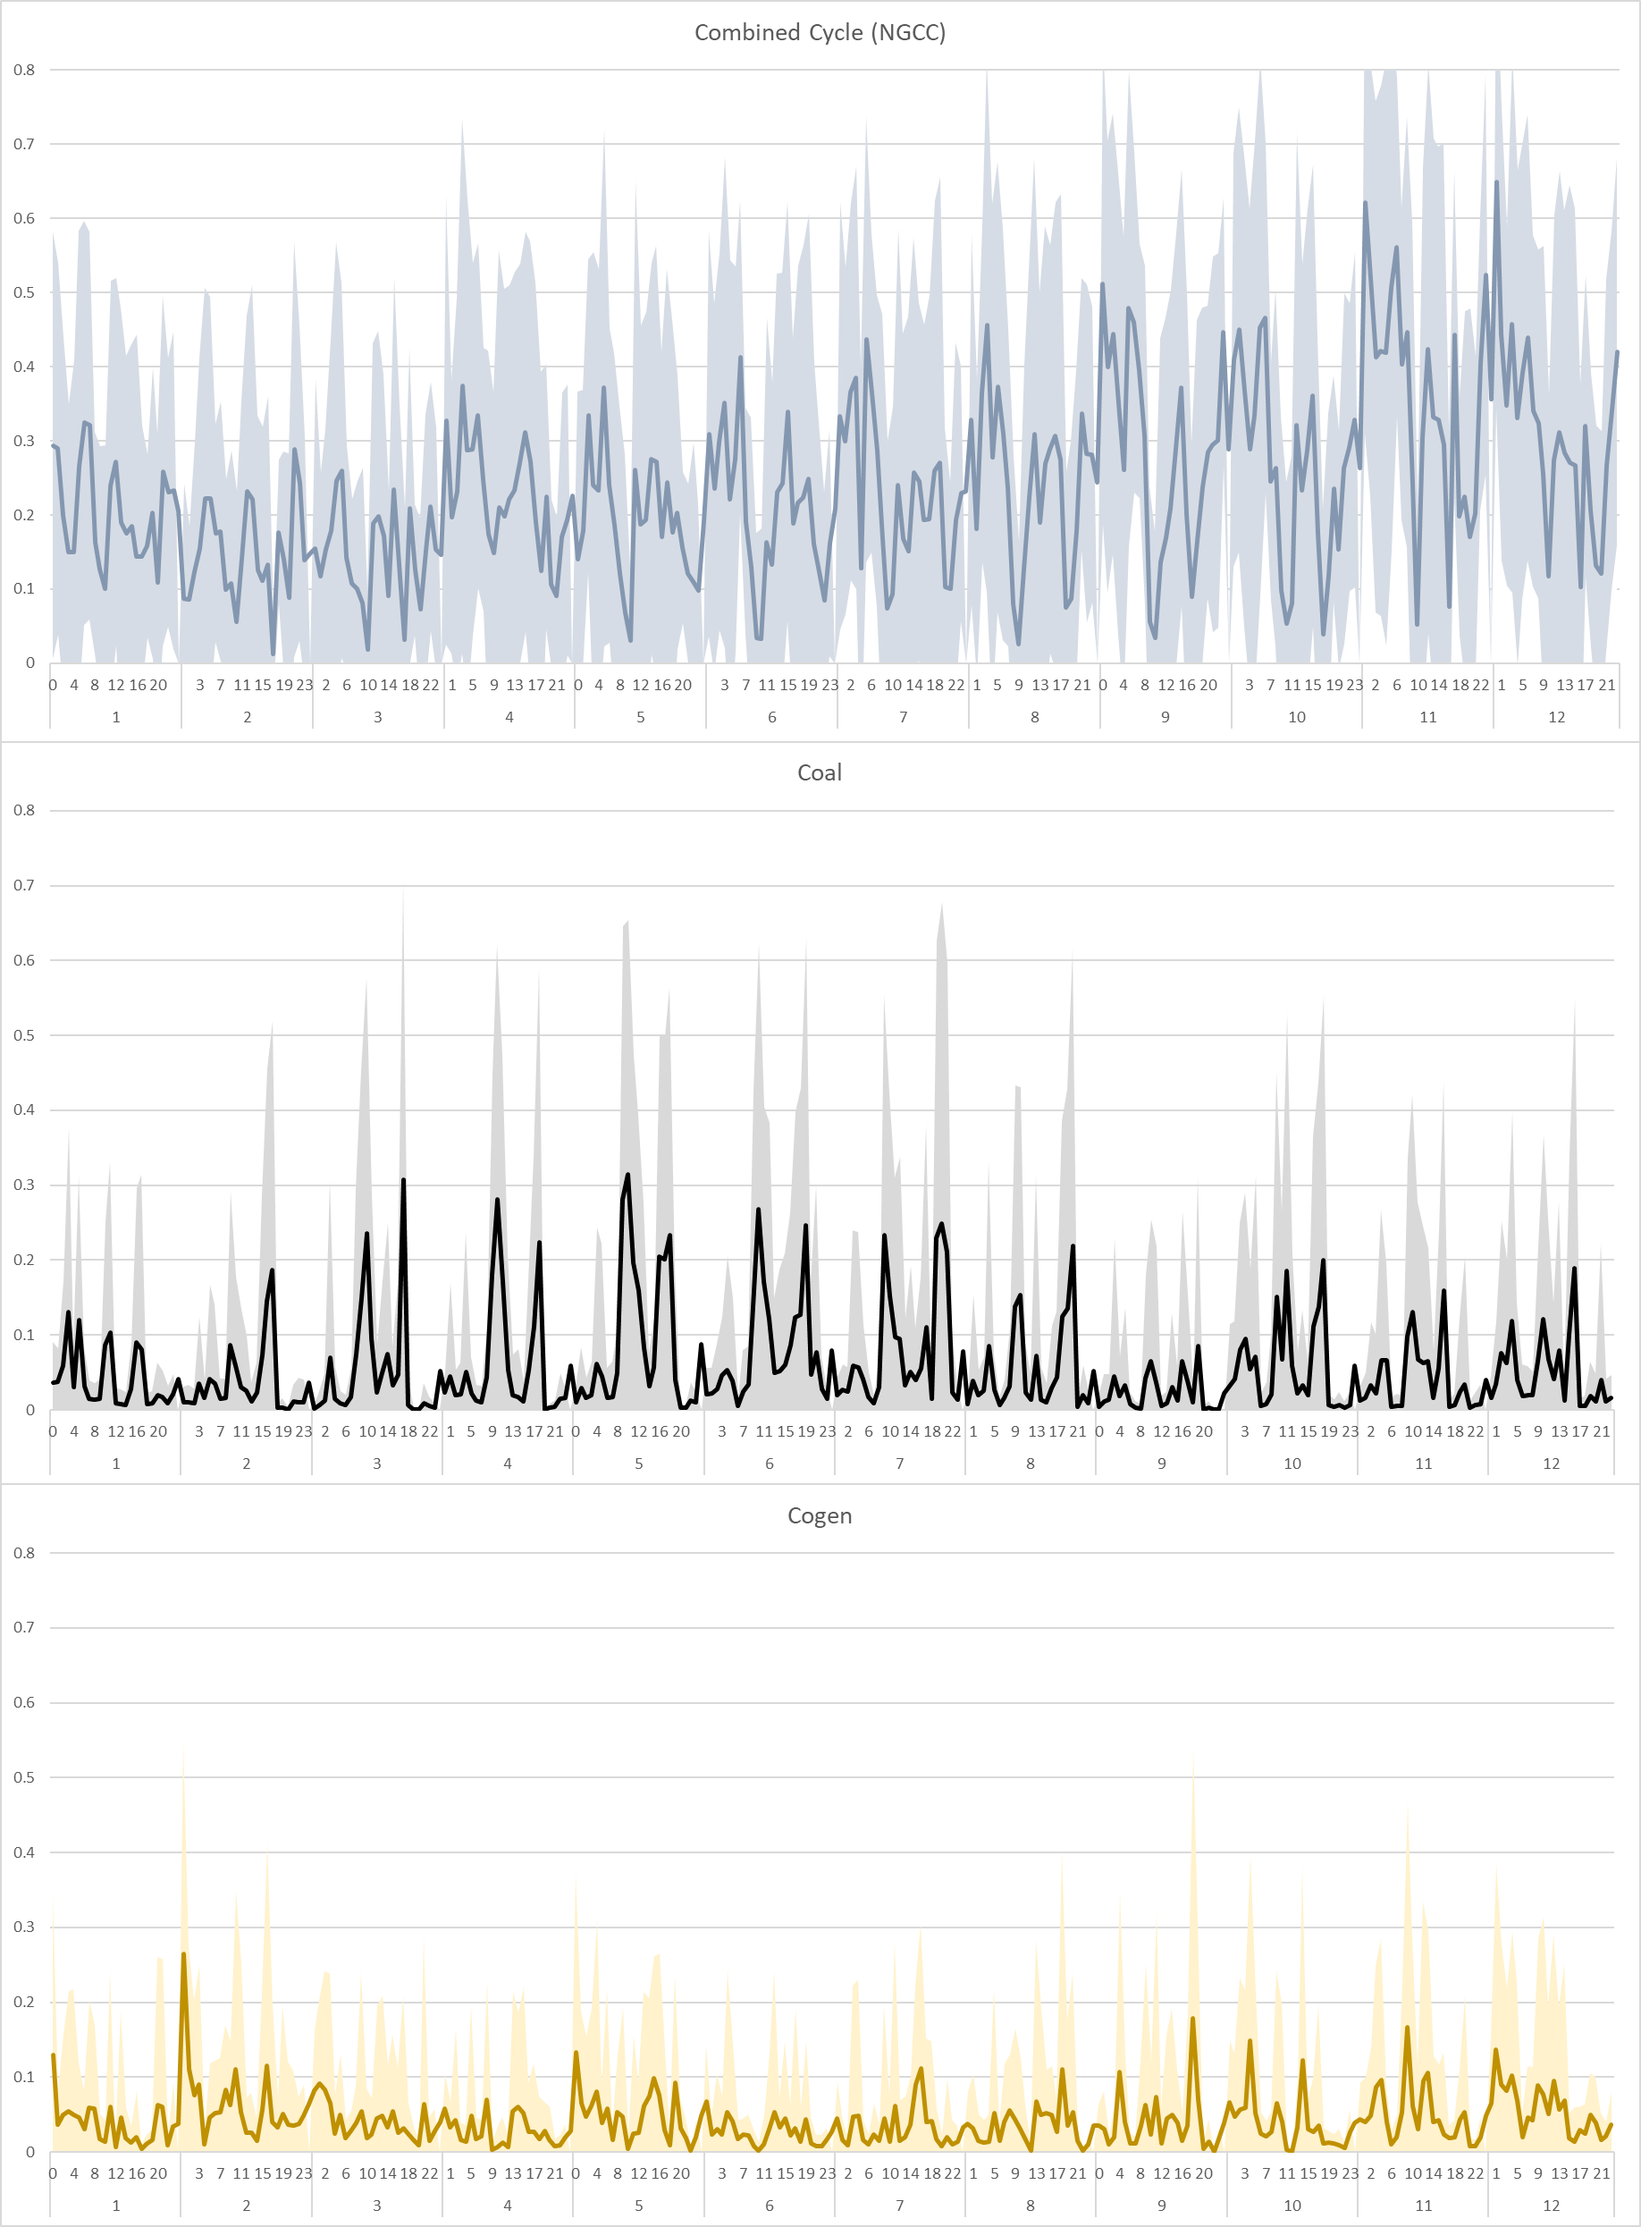
Figure S2. Hourly marginal generation share and standard deviation of Natural Gas Combined Cycle (NGCC), Coal and Cogeneration by month (2021)

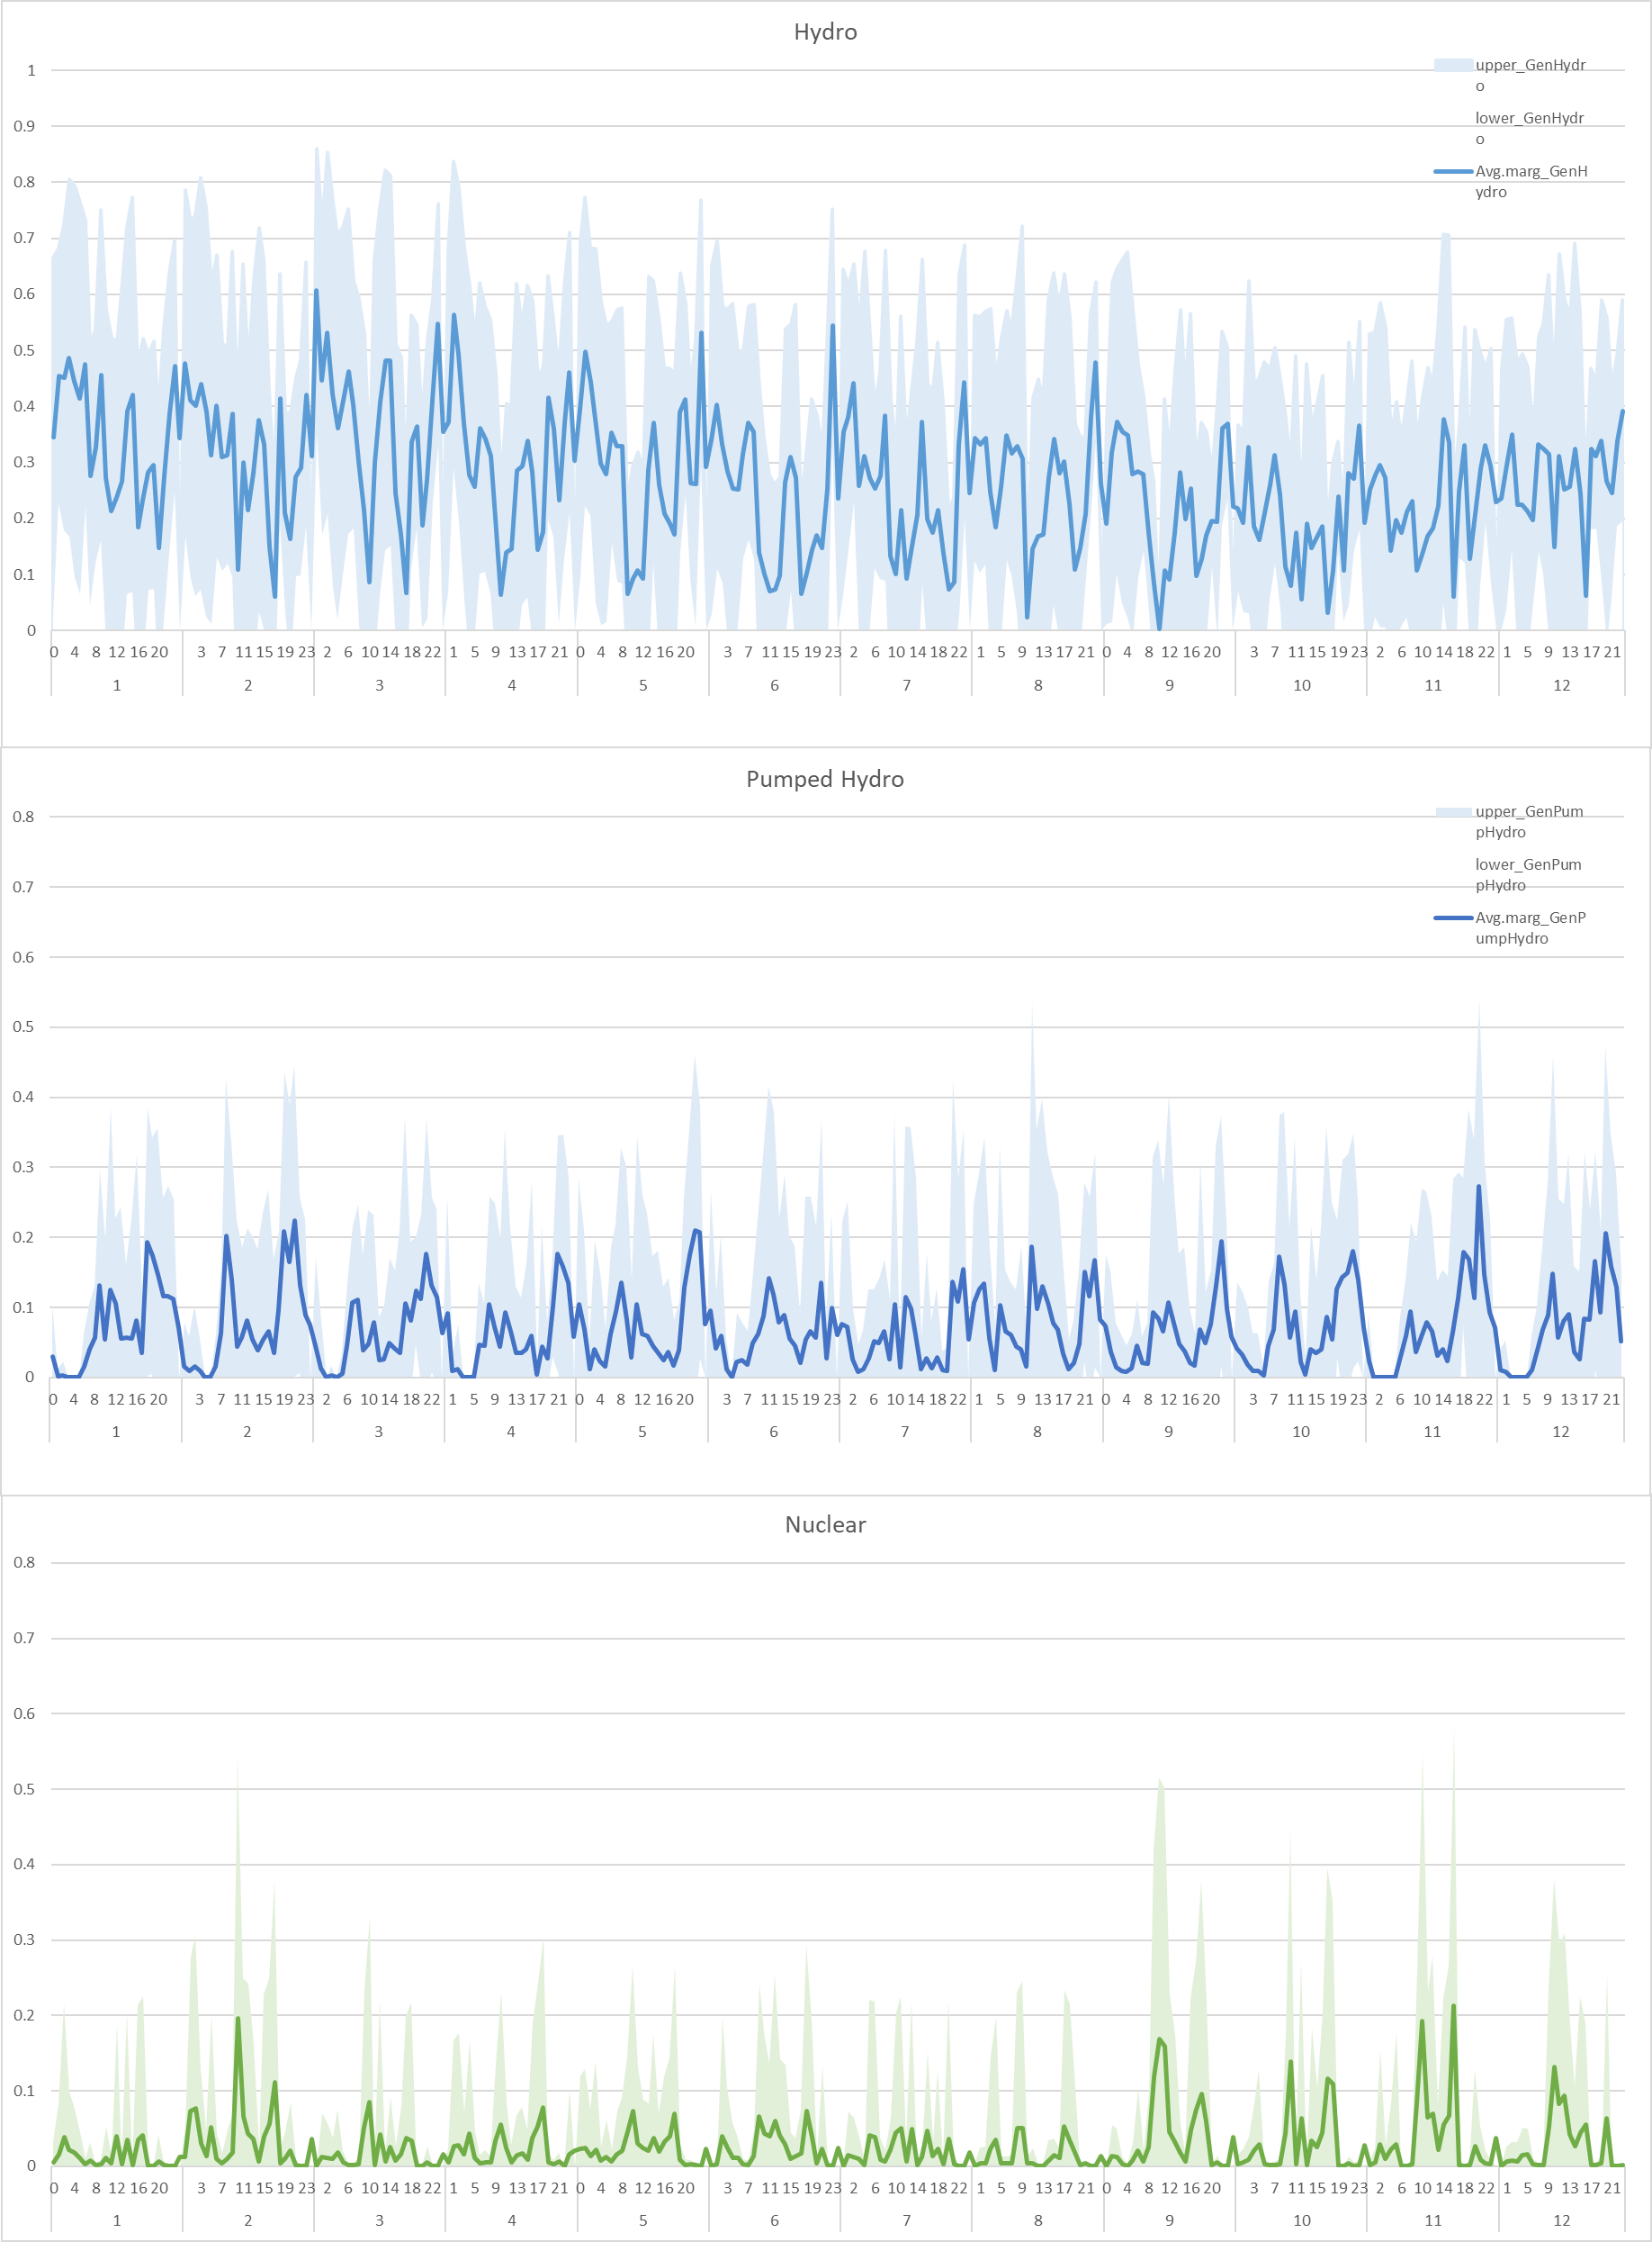
Figure S3. Hourly marginal generation share and standard deviation Hydropower, Pumped Hydro and Nuclear by month (2021)

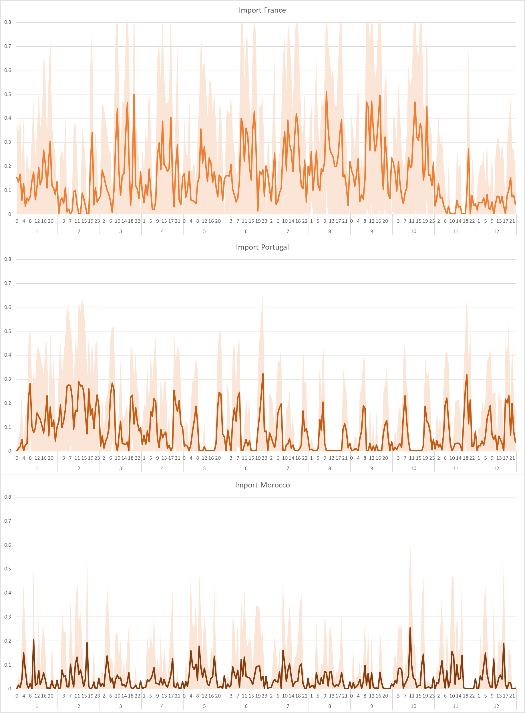
Figure S4. Hourly marginal generation share and standard deviation of imported electricity (France, Portugal and Morocco) by month (2021)

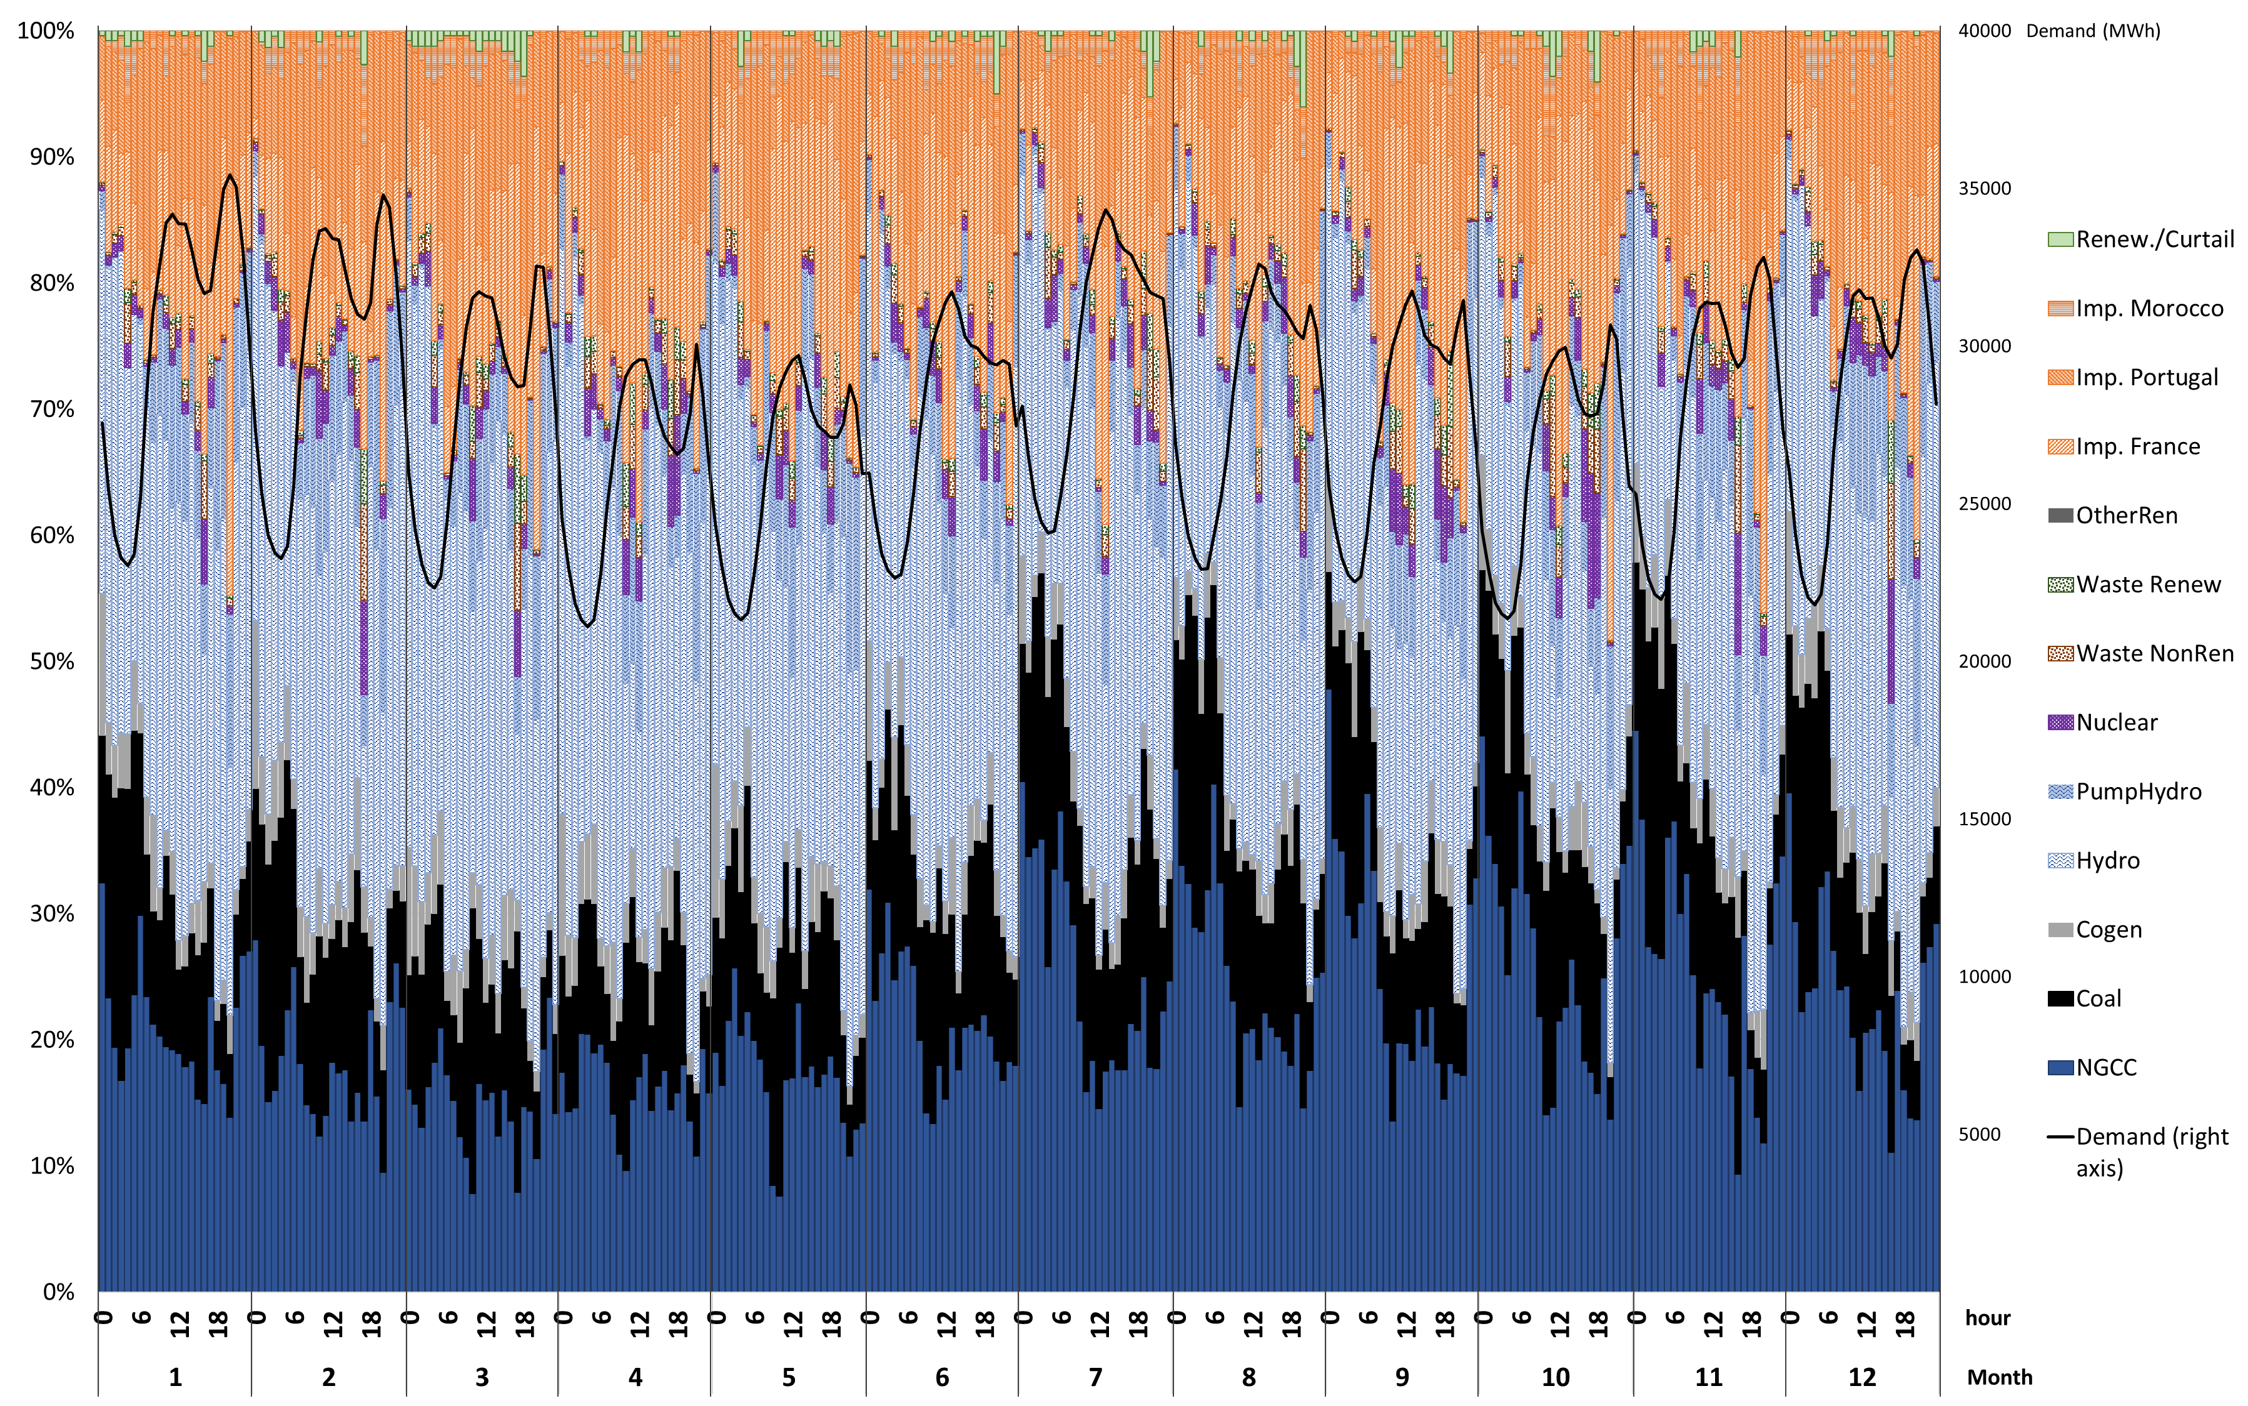
Figure S5. Hourly marginal generation mix (average 2015-2021)

Annual marginal generation mix
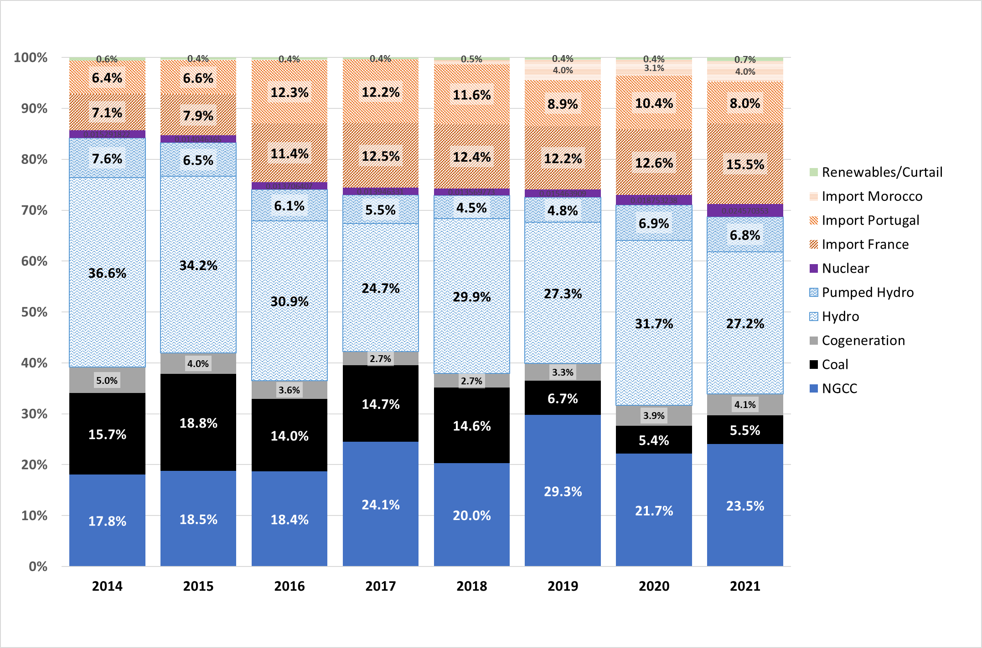
Figure S6. Annual marginal generation mix 2014-2021
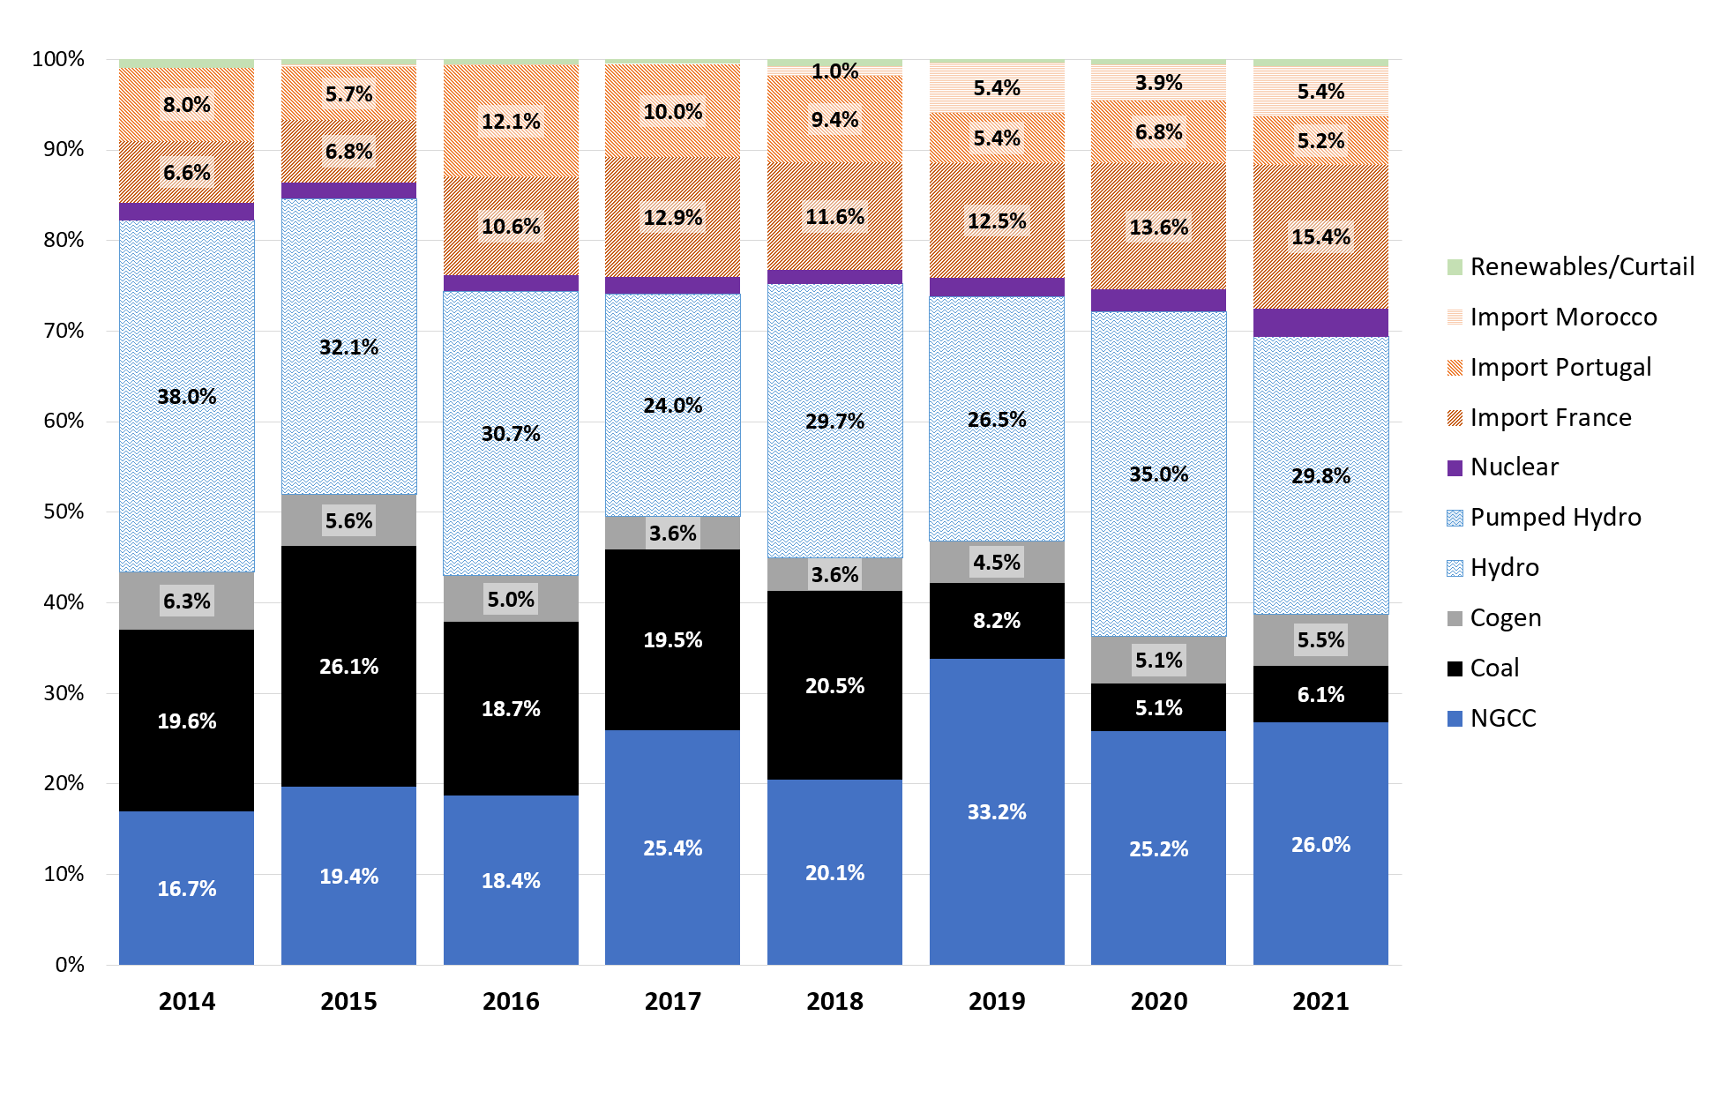
Figure S7. Annual marginal generation mix for pumped hydro charge 2014-2021

Hourly average generation by month
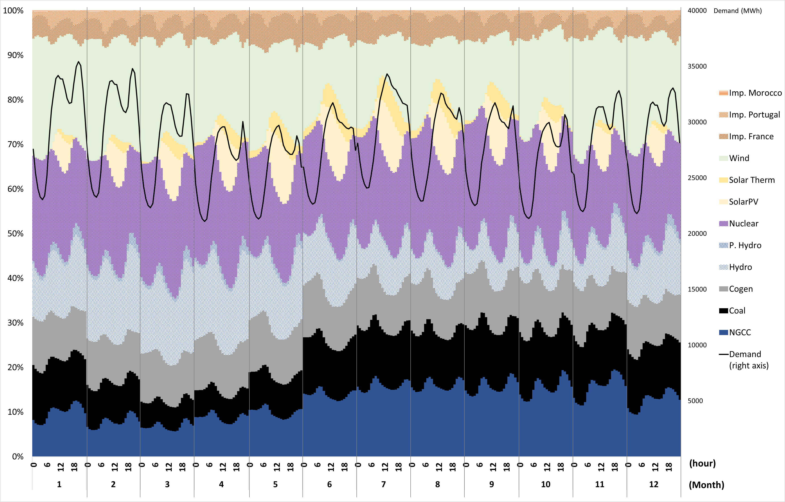
Figure S8. Hourly average generation mix by month for the years 2014-2021

Annual average generation by year
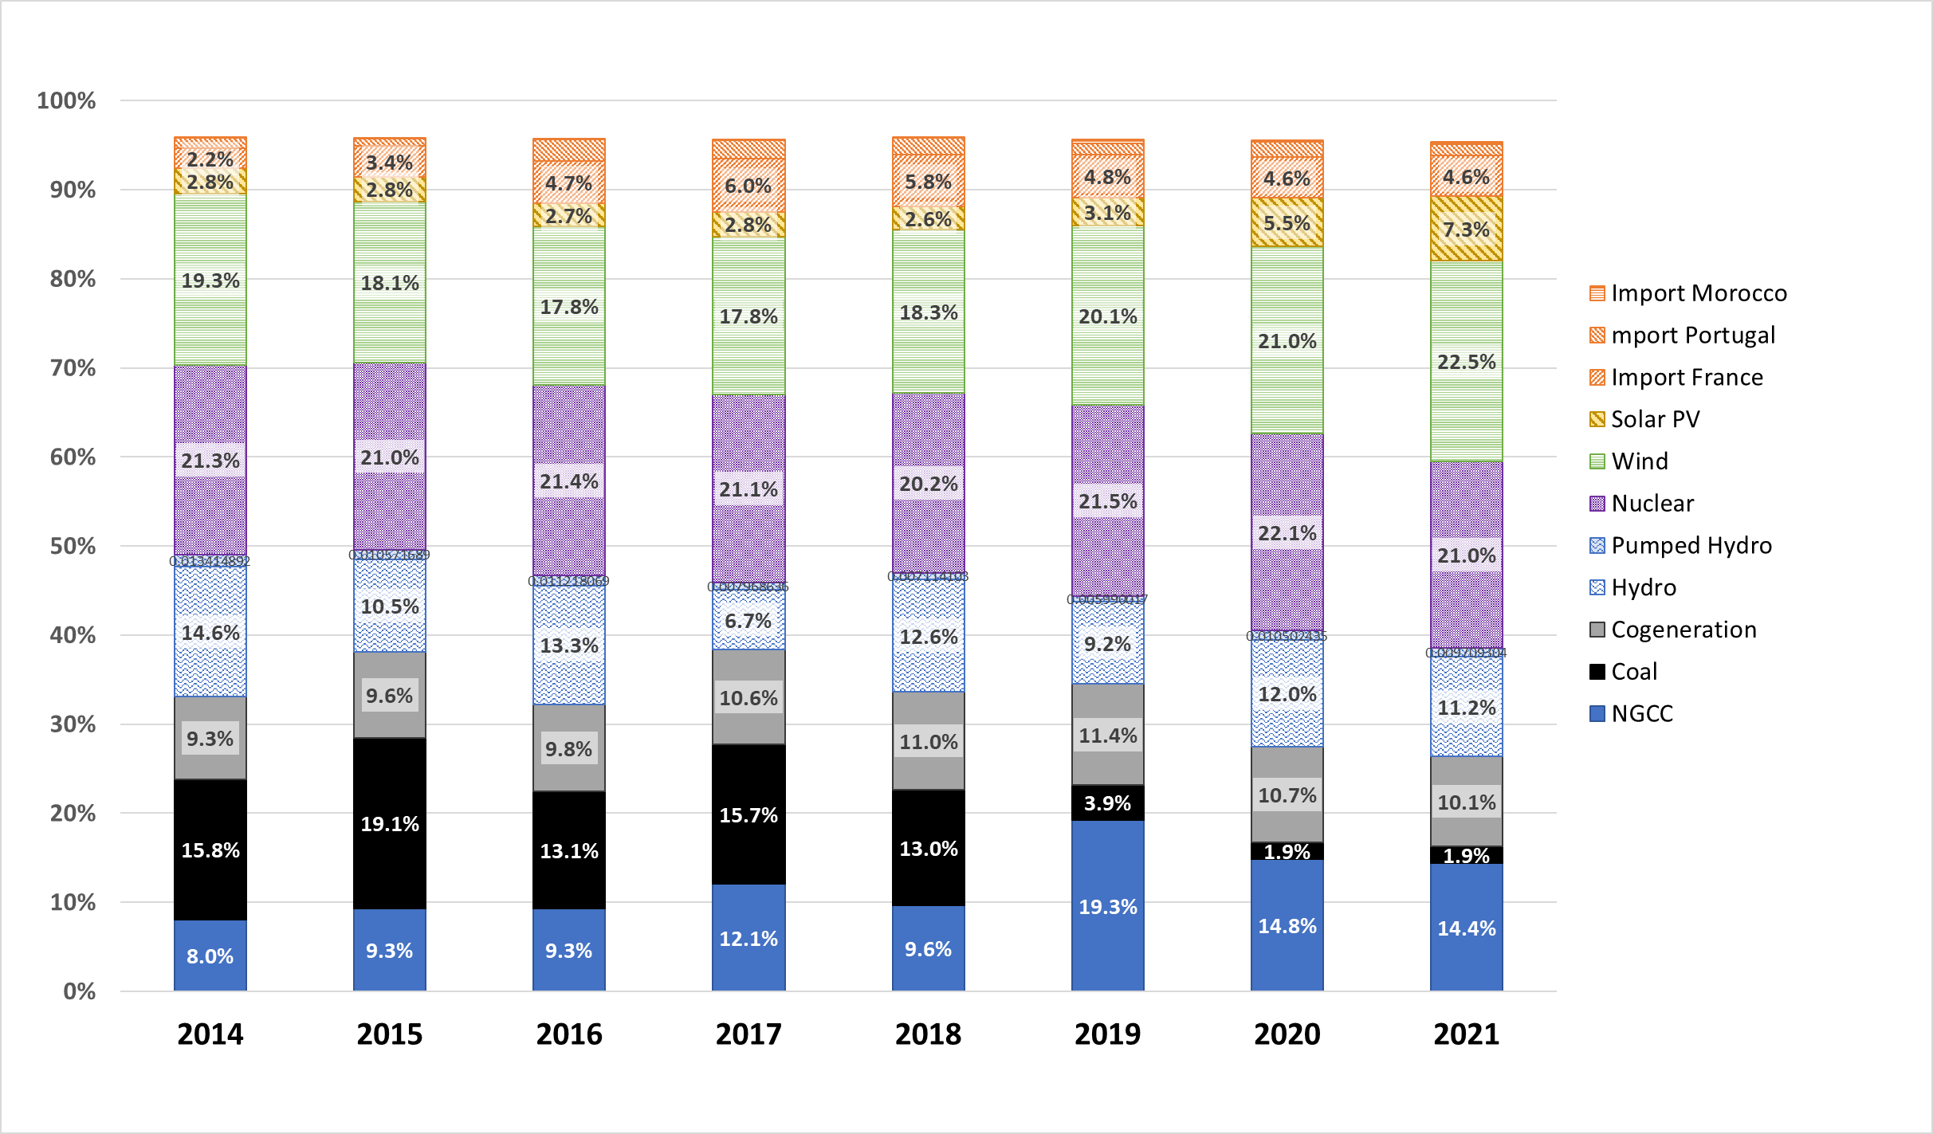

Figure S9. Annual average generation mix 2014-2021

Hourly impact / emission factors of electricity generation
Table S1. Hourly average greenhouse gas (GHG) emissions of the grid electricity for the year 2021. Colour coding (heat map) for each month individually (red = above the average of the given month; green = below the given month’s average)
TIER 1 | Hourly emissions [gCO₂eq/kWh] - average mix
hour | Jan | Feb | Mar | Apr | May | Jun | Jul | Aug | Sep | Oct | Nov | Dec
00:00 | 134.4 | 95.7 | 120.0 | 152.9 | 151.4 | 177.0 | 154.1 | 164.6 | 201.5 | 202.9 | 213.8 | 192.8
01:00 | 132.9 | 96.5 | 123.2 | 153.2 | 151.9 | 179.6 | 153.8 | 167.3 | 200.9 | 200.9 | 212.7 | 191.2
02:00 | 132.8 | 97.4 | 124.5 | 155.1 | 151.7 | 183.6 | 153.6 | 167.2 | 200.7 | 199.1 | 213.5 | 191.3
03:00 | 132.2 | 98.8 | 125.6 | 155.9 | 152.0 | 184.0 | 154.6 | 167.3 | 201.8 | 202.9 | 212.0 | 191.1
04:00 | 132.9 | 99.7 | 126.2 | 156.8 | 154.0 | 186.2 | 157.9 | 170.0 | 204.1 | 204.2 | 212.8 | 191.0
05:00 | 133.9 | 99.3 | 128.7 | 158.6 | 156.0 | 188.2 | 161.8 | 172.9 | 206.9 | 206.6 | 217.0 | 193.0
06:00 | 136.0 | 99.4 | 131.0 | 167.3 | 161.6 | 194.1 | 169.1 | 175.0 | 212.1 | 211.9 | 223.1 | 194.6
07:00 | 140.2 | 101.4 | 129.2 | 169.7 | 161.1 | 193.1 | 173.3 | 177.6 | 215.6 | 208.1 | 223.9 | 194.9
08:00 | 138.5 | 101.8 | 125.6 | 166.6 | 154.4 | 185.6 | 166.5 | 171.1 | 215.8 | 207.2 | 222.6 | 194.6
09:00 | 135.7 | 99.9 | 122.4 | 161.7 | 146.9 | 178.0 | 158.5 | 160.8 | 204.8 | 199.5 | 215.4 | 190.0
10:00 | 132.9 | 96.7 | 117.9 | 158.4 | 138.1 | 170.6 | 150.7 | 151.2 | 188.4 | 187.1 | 206.8 | 185.7
11:00 | 131.7 | 93.8 | 116.0 | 155.0 | 134.8 | 167.2 | 146.3 | 146.5 | 180.3 | 177.6 | 201.4 | 183.0
12:00 | 130.0 | 91.8 | 114.7 | 152.4 | 132.1 | 163.6 | 142.5 | 144.3 | 175.4 | 173.5 | 200.9 | 181.6
13:00 | 129.6 | 91.9 | 112.5 | 149.7 | 130.0 | 161.1 | 139.0 | 142.3 | 172.9 | 168.4 | 200.7 | 181.8
14:00 | 130.2 | 92.0 | 112.4 | 149.5 | 127.4 | 158.5 | 137.2 | 141.2 | 172.5 | 167.5 | 201.1 | 184.1
15:00 | 132.3 | 93.9 | 112.9 | 149.1 | 126.4 | 156.1 | 135.3 | 139.9 | 171.5 | 167.3 | 204.8 | 186.7
16:00 | 135.6 | 95.9 | 115.5 | 149.5 | 126.7 | 156.5 | 134.4 | 138.3 | 173.7 | 171.3 | 215.2 | 195.5
17:00 | 141.6 | 101.1 | 121.3 | 152.7 | 126.7 | 160.1 | 137.2 | 139.2 | 180.1 | 180.1 | 232.0 | 205.9
18:00 | 143.3 | 106.1 | 126.3 | 158.1 | 128.9 | 165.0 | 141.4 | 143.6 | 189.2 | 198.3 | 231.8 | 204.2
19:00 | 143.2 | 107.2 | 127.5 | 160.0 | 135.8 | 166.9 | 146.0 | 153.9 | 203.4 | 206.1 | 230.5 | 202.0
20:00 | 140.2 | 105.2 | 122.9 | 158.9 | 142.1 | 171.5 | 151.4 | 163.7 | 209.1 | 200.1 | 228.3 | 199.7
21:00 | 138.5 | 101.6 | 121.2 | 156.8 | 142.9 | 172.5 | 156.1 | 168.5 | 209.3 | 199.0 | 231.3 | 199.7
22:00 | 138.1 | 99.8 | 121.0 | 158.7 | 146.8 | 175.4 | 156.6 | 168.4 | 211.5 | 200.5 | 233.0 | 201.4
23:00 | 136.3 | 97.8 | 121.4 | 159.7 | 149.5 | 179.1 | 156.7 | 167.5 | 209.4 | 200.4 | 229.2 | 199.2
Avg | 135.6 | 98.4 | 121.3 | 156.8 | 141.6 | 172.6 | 150.3 | 157.1 | 194.9 | 192.1 | 217.0 | 193.0

Table S2. Hourly average greenhouse gas (GHG) emissions of the grid electricity for the year 2021. Colour coding (heat map) for the whole year (red = above the average of the whole year; green = below the annual average)
TIER 1 | Hourly emissions [gCO₂eq/kWh] - average mix
hour | Jan | Feb | Mar | Apr | May | Jun | Jul | Aug | Sep | Oct | Nov | Dec
00:00 | 134.4 | 95.7 | 120.0 | 152.9 | 151.4 | 177.0 | 154.1 | 164.6 | 201.5 | 202.9 | 213.8 | 192.8
01:00 | 132.9 | 96.5 | 123.2 | 153.2 | 151.9 | 179.6 | 153.8 | 167.3 | 200.9 | 200.9 | 212.7 | 191.2
02:00 | 132.8 | 97.4 | 124.5 | 155.1 | 151.7 | 183.6 | 153.6 | 167.2 | 200.7 | 199.1 | 213.5 | 191.3
03:00 | 132.2 | 98.8 | 125.6 | 155.9 | 152.0 | 184.0 | 154.6 | 167.3 | 201.8 | 202.9 | 212.0 | 191.1
04:00 | 132.9 | 99.7 | 126.2 | 156.8 | 154.0 | 186.2 | 157.9 | 170.0 | 204.1 | 204.2 | 212.8 | 191.0
05:00 | 133.9 | 99.3 | 128.7 | 158.6 | 156.0 | 188.2 | 161.8 | 172.9 | 206.9 | 206.6 | 217.0 | 193.0
06:00 | 136.0 | 99.4 | 131.0 | 167.3 | 161.6 | 194.1 | 169.1 | 175.0 | 212.1 | 211.9 | 223.1 | 194.6
07:00 | 140.2 | 101.4 | 129.2 | 169.7 | 161.1 | 193.1 | 173.3 | 177.6 | 215.6 | 208.1 | 223.9 | 194.9
08:00 | 138.5 | 101.8 | 125.6 | 166.6 | 154.4 | 185.6 | 166.5 | 171.1 | 215.8 | 207.2 | 222.6 | 194.6
09:00 | 135.7 | 99.9 | 122.4 | 161.7 | 146.9 | 178.0 | 158.5 | 160.8 | 204.8 | 199.5 | 215.4 | 190.0
10:00 | 132.9 | 96.7 | 117.9 | 158.4 | 138.1 | 170.6 | 150.7 | 151.2 | 188.4 | 187.1 | 206.8 | 185.7
11:00 | 131.7 | 93.8 | 116.0 | 155.0 | 134.8 | 167.2 | 146.3 | 146.5 | 180.3 | 177.6 | 201.4 | 183.0
12:00 | 130.0 | 91.8 | 114.7 | 152.4 | 132.1 | 163.6 | 142.5 | 144.3 | 175.4 | 173.5 | 200.9 | 181.6
13:00 | 129.6 | 91.9 | 112.5 | 149.7 | 130.0 | 161.1 | 139.0 | 142.3 | 172.9 | 168.4 | 200.7 | 181.8
14:00 | 130.2 | 92.0 | 112.4 | 149.5 | 127.4 | 158.5 | 137.2 | 141.2 | 172.5 | 167.5 | 201.1 | 184.1
15:00 | 132.3 | 93.9 | 112.9 | 149.1 | 126.4 | 156.1 | 135.3 | 139.9 | 171.5 | 167.3 | 204.8 | 186.7
16:00 | 135.6 | 95.9 | 115.5 | 149.5 | 126.7 | 156.5 | 134.4 | 138.3 | 173.7 | 171.3 | 215.2 | 195.5
17:00 | 141.6 | 101.1 | 121.3 | 152.7 | 126.7 | 160.1 | 137.2 | 139.2 | 180.1 | 180.1 | 232.0 | 205.9
18:00 | 143.3 | 106.1 | 126.3 | 158.1 | 128.9 | 165.0 | 141.4 | 143.6 | 189.2 | 198.3 | 231.8 | 204.2
19:00 | 143.2 | 107.2 | 127.5 | 160.0 | 135.8 | 166.9 | 146.0 | 153.9 | 203.4 | 206.1 | 230.5 | 202.0
20:00 | 140.2 | 105.2 | 122.9 | 158.9 | 142.1 | 171.5 | 151.4 | 163.7 | 209.1 | 200.1 | 228.3 | 199.7
21:00 | 138.5 | 101.6 | 121.2 | 156.8 | 142.9 | 172.5 | 156.1 | 168.5 | 209.3 | 199.0 | 231.3 | 199.7
22:00 | 138.1 | 99.8 | 121.0 | 158.7 | 146.8 | 175.4 | 156.6 | 168.4 | 211.5 | 200.5 | 233.0 | 201.4
23:00 | 136.3 | 97.8 | 121.4 | 159.7 | 149.5 | 179.1 | 156.7 | 167.5 | 209.4 | 200.4 | 229.2 | 199.2
Avg | 135.6 | 98.4 | 121.3 | 156.8 | 141.6 | 172.6 | 150.3 | 157.1 | 194.9 | 192.1 | 217.0 | 193.0

Table S3. Hourly marginal greenhouse gas (GHG) emissions of the grid electricity for the year 2021. Colour coding (heat map) for each month individually (red = above the average of the given month; green = below the given month’s average)
TIER 2 | Hourly marginal emissions [gCO₂eq/kWh]
hour | Jan | Feb | Mar | Apr | May | Jun | Jul | Aug | Sep | Oct | Nov | Dec
00:00 | 291.2 | 247.3 | 171.3 | 259.1 | 221.3 | 267.2 | 238.0 | 239.3 | 324.8 | 326.7 | 325.1 | 351.3
01:00 | 245.2 | 189.8 | 195.7 | 193.5 | 224.6 | 240.2 | 246.5 | 249.2 | 294.0 | 380.6 | 325.6 | 341.5
02:00 | 226.4 | 237.7 | 166.1 | 210.4 | 230.1 | 259.2 | 237.7 | 262.4 | 260.4 | 339.0 | 295.4 | 333.0
03:00 | 297.3 | 251.7 | 254.4 | 250.0 | 240.6 | 265.0 | 324.0 | 273.5 | 231.9 | 364.1 | 335.0 | 377.7
04:00 | 285.8 | 197.3 | 265.1 | 256.9 | 361.7 | 282.3 | 233.7 | 247.0 | 249.9 | 397.4 | 422.6 | 422.5
05:00 | 331.2 | 248.9 | 257.9 | 300.8 | 324.1 | 306.6 | 292.4 | 270.6 | 333.8 | 409.8 | 384.2 | 418.3
06:00 | 247.4 | 230.1 | 173.7 | 308.0 | 294.3 | 286.4 | 277.2 | 243.8 | 263.5 | 310.4 | 336.0 | 352.2
07:00 | 278.3 | 293.9 | 212.4 | 278.9 | 281.0 | 264.3 | 292.1 | 242.6 | 297.9 | 268.9 | 353.1 | 297.3
08:00 | 245.9 | 259.5 | 258.9 | 272.8 | 258.8 | 184.5 | 202.7 | 215.4 | 314.3 | 282.3 | 300.1 | 264.0
09:00 | 181.6 | 257.6 | 295.2 | 319.7 | 535.3 | 379.7 | 493.6 | 277.1 | 230.5 | 347.3 | 332.3 | 280.5
10:00 | 389.3 | 295.2 | 409.8 | 479.7 | 515.1 | 464.6 | 379.4 | 400.6 | 286.4 | 391.7 | 367.7 | 397.7
11:00 | 362.0 | 318.3 | 303.6 | 434.2 | 425.0 | 513.5 | 332.1 | 308.9 | 277.8 | 430.9 | 375.9 | 252.0
12:00 | 234.7 | 272.5 | 230.1 | 321.7 | 465.6 | 402.3 | 356.2 | 277.4 | 292.8 | 386.6 | 345.8 | 274.4
13:00 | 273.8 | 280.1 | 215.1 | 242.9 | 302.6 | 311.2 | 312.7 | 338.5 | 273.2 | 350.0 | 361.9 | 323.0
14:00 | 180.6 | 199.0 | 201.3 | 268.8 | 254.4 | 282.4 | 304.5 | 242.2 | 266.2 | 317.8 | 249.9 | 236.7
15:00 | 213.7 | 222.9 | 255.0 | 233.3 | 280.5 | 305.7 | 249.2 | 236.4 | 264.9 | 299.1 | 267.0 | 305.4
16:00 | 326.1 | 375.8 | 263.0 | 290.7 | 416.2 | 263.0 | 276.8 | 269.5 | 240.5 | 388.1 | 337.2 | 485.3
17:00 | 258.7 | 389.3 | 508.6 | 391.5 | 400.3 | 391.7 | 309.0 | 220.5 | 219.2 | 390.0 | 288.0 | 258.6
18:00 | 221.0 | 200.8 | 206.6 | 487.6 | 472.6 | 376.5 | 271.8 | 319.7 | 277.9 | 405.5 | 237.1 | 220.1
19:00 | 244.4 | 231.4 | 185.9 | 208.2 | 270.1 | 467.9 | 385.0 | 326.0 | 289.2 | 242.2 | 278.3 | 206.0
20:00 | 234.3 | 208.6 | 180.0 | 185.8 | 199.7 | 358.1 | 432.9 | 558.4 | 212.0 | 232.1 | 270.3 | 218.5
21:00 | 263.8 | 274.5 | 244.4 | 249.8 | 187.6 | 318.9 | 448.3 | 261.0 | 249.8 | 242.0 | 236.8 | 275.5
22:00 | 210.8 | 255.3 | 193.5 | 206.3 | 216.4 | 244.1 | 231.0 | 224.5 | 225.9 | 243.4 | 256.0 | 247.5
23:00 | 230.9 | 210.3 | 160.7 | 196.4 | 162.0 | 163.3 | 200.9 | 208.0 | 252.1 | 233.9 | 298.1 | 267.0
Avg | 261.4 | 256.2 | 242.0 | 285.3 | 314.2 | 316.6 | 305.3 | 279.7 | 267.9 | 332.5 | 315.8 | 308.6

Table S4. Hourly marginal greenhouse gas (GHG) emissions of the grid electricity for the year 2021. Colour coding (heat map) for the whole year (red = above the average of the whole year; green = below the annual average)
TIER 2 | Hourly marginal emissions [gCO₂eq/kWh]
hour | Jan | Feb | Mar | Apr | May | Jun | Jul | Aug | Sep | Oct | Nov | Dec
00:00 | 291.2 | 247.3 | 171.3 | 259.1 | 221.3 | 267.2 | 238.0 | 239.3 | 324.8 | 326.7 | 325.1 | 351.3
01:00 | 245.2 | 189.8 | 195.7 | 193.5 | 224.6 | 240.2 | 246.5 | 249.2 | 294.0 | 380.6 | 325.6 | 341.5
02:00 | 226.4 | 237.7 | 166.1 | 210.4 | 230.1 | 259.2 | 237.7 | 262.4 | 260.4 | 339.0 | 295.4 | 333.0
03:00 | 297.3 | 251.7 | 254.4 | 250.0 | 240.6 | 265.0 | 324.0 | 273.5 | 231.9 | 364.1 | 335.0 | 377.7
04:00 | 285.8 | 197.3 | 265.1 | 256.9 | 361.7 | 282.3 | 233.7 | 247.0 | 249.9 | 397.4 | 422.6 | 422.5
05:00 | 331.2 | 248.9 | 257.9 | 300.8 | 324.1 | 306.6 | 292.4 | 270.6 | 333.8 | 409.8 | 384.2 | 418.3
06:00 | 247.4 | 230.1 | 173.7 | 308.0 | 294.3 | 286.4 | 277.2 | 243.8 | 263.5 | 310.4 | 336.0 | 352.2
07:00 | 278.3 | 293.9 | 212.4 | 278.9 | 281.0 | 264.3 | 292.1 | 242.6 | 297.9 | 268.9 | 353.1 | 297.3
08:00 | 245.9 | 259.5 | 258.9 | 272.8 | 258.8 | 184.5 | 202.7 | 215.4 | 314.3 | 282.3 | 300.1 | 264.0
09:00 | 181.6 | 257.6 | 295.2 | 319.7 | 535.3 | 379.7 | 493.6 | 277.1 | 230.5 | 347.3 | 332.3 | 280.5
10:00 | 389.3 | 295.2 | 409.8 | 479.7 | 515.1 | 464.6 | 379.4 | 400.6 | 286.4 | 391.7 | 367.7 | 397.7
11:00 | 362.0 | 318.3 | 303.6 | 434.2 | 425.0 | 513.5 | 332.1 | 308.9 | 277.8 | 430.9 | 375.9 | 252.0
12:00 | 234.7 | 272.5 | 230.1 | 321.7 | 465.6 | 402.3 | 356.2 | 277.4 | 292.8 | 386.6 | 345.8 | 274.4
13:00 | 273.8 | 280.1 | 215.1 | 242.9 | 302.6 | 311.2 | 312.7 | 338.5 | 273.2 | 350.0 | 361.9 | 323.0
14:00 | 180.6 | 199.0 | 201.3 | 268.8 | 254.4 | 282.4 | 304.5 | 242.2 | 266.2 | 317.8 | 249.9 | 236.7
15:00 | 213.7 | 222.9 | 255.0 | 233.3 | 280.5 | 305.7 | 249.2 | 236.4 | 264.9 | 299.1 | 267.0 | 305.4
16:00 | 326.1 | 375.8 | 263.0 | 290.7 | 416.2 | 263.0 | 276.8 | 269.5 | 240.5 | 388.1 | 337.2 | 485.3
17:00 | 258.7 | 389.3 | 508.6 | 391.5 | 400.3 | 391.7 | 309.0 | 220.5 | 219.2 | 390.0 | 288.0 | 258.6
18:00 | 221.0 | 200.8 | 206.6 | 487.6 | 472.6 | 376.5 | 271.8 | 319.7 | 277.9 | 405.5 | 237.1 | 220.1
19:00 | 244.4 | 231.4 | 185.9 | 208.2 | 270.1 | 467.9 | 385.0 | 326.0 | 289.2 | 242.2 | 278.3 | 206.0
20:00 | 234.3 | 208.6 | 180.0 | 185.8 | 199.7 | 358.1 | 432.9 | 558.4 | 212.0 | 232.1 | 270.3 | 218.5
21:00 | 263.8 | 274.5 | 244.4 | 249.8 | 187.6 | 318.9 | 448.3 | 261.0 | 249.8 | 242.0 | 236.8 | 275.5
22:00 | 210.8 | 255.3 | 193.5 | 206.3 | 216.4 | 244.1 | 231.0 | 224.5 | 225.9 | 243.4 | 256.0 | 247.5
23:00 | 230.9 | 210.3 | 160.7 | 196.4 | 162.0 | 163.3 | 200.9 | 208.0 | 252.1 | 233.9 | 298.1 | 267.0
Avg | 261.4 | 256.2 | 242.0 | 285.3 | 314.2 | 316.6 | 305.3 | 279.7 | 267.9 | 332.5 | 315.8 | 308.6

Table S5. Hourly greenhouse gas (GHG) emissions of the grid electricity for the year 2021 according to REE, the Spanish grid operator [1]. Colour coding (heat map) for each month individually (red = above the average of the given month; green = below the given month’s average)
TIER 1 | Hourly emissions [kgCO2/kWh] - average values from 2021 - using REE CO₂ intensity acc. To REE data
hour | Jan | Feb | Mrz | Apr | Mai | Jun | Jul | Aug | Sep | Okt | Nov | Dec
00:00 | 91.6 | 62.9 | 76.9 | 106.4 | 100.5 | 123.4 | 105.0 | 115.8 | 143.3 | 144.2 | 157.5 | 141.9
01:00 | 92.2 | 65.6 | 80.3 | 108.1 | 103.5 | 126.4 | 105.6 | 119.9 | 144.1 | 142.9 | 158.4 | 141.5
02:00 | 93.8 | 67.7 | 82.0 | 110.6 | 104.3 | 129.1 | 105.8 | 121.4 | 145.0 | 142.5 | 161.2 | 143.9
03:00 | 94.4 | 69.1 | 83.9 | 110.7 | 105.1 | 129.0 | 106.4 | 121.9 | 146.2 | 145.7 | 162.1 | 144.2
04:00 | 95.8 | 70.0 | 84.0 | 111.2 | 106.9 | 130.2 | 108.6 | 123.5 | 147.9 | 146.2 | 162.5 | 144.4
05:00 | 95.7 | 69.0 | 84.8 | 113.0 | 107.9 | 131.6 | 111.2 | 124.7 | 148.8 | 148.0 | 164.2 | 145.9
06:00 | 94.8 | 66.8 | 84.8 | 117.0 | 108.3 | 133.5 | 114.6 | 124.0 | 149.9 | 148.3 | 168.3 | 146.0
07:00 | 96.2 | 65.7 | 82.8 | 117.9 | 106.6 | 132.0 | 116.2 | 123.6 | 151.4 | 143.9 | 167.2 | 144.8
08:00 | 94.5 | 63.7 | 78.9 | 114.0 | 100.0 | 125.7 | 112.1 | 117.5 | 151.0 | 141.8 | 165.6 | 143.5
09:00 | 90.7 | 59.8 | 73.7 | 107.9 | 91.6 | 117.5 | 103.5 | 107.0 | 141.9 | 135.7 | 157.9 | 138.6
10:00 | 85.6 | 55.8 | 68.7 | 103.5 | 83.8 | 110.7 | 95.9 | 98.1 | 127.7 | 125.1 | 149.4 | 132.5
11:00 | 84.5 | 53.0 | 66.9 | 99.8 | 81.7 | 107.5 | 92.4 | 94.3 | 121.0 | 118.2 | 145.0 | 130.8
12:00 | 83.8 | 51.6 | 66.0 | 97.0 | 80.1 | 104.7 | 88.9 | 91.9 | 116.6 | 116.0 | 145.2 | 130.6
13:00 | 83.1 | 51.5 | 65.1 | 94.9 | 79.2 | 102.7 | 86.0 | 89.6 | 114.7 | 113.0 | 145.0 | 130.7
14:00 | 84.1 | 52.0 | 65.8 | 95.4 | 78.3 | 101.5 | 84.8 | 88.8 | 115.1 | 113.2 | 146.1 | 133.4
15:00 | 86.4 | 53.8 | 67.2 | 96.8 | 79.3 | 101.3 | 84.8 | 89.3 | 115.2 | 114.8 | 150.3 | 136.5
16:00 | 89.3 | 56.5 | 69.2 | 98.0 | 80.7 | 101.8 | 84.9 | 88.8 | 116.8 | 117.4 | 159.0 | 143.4
17:00 | 94.1 | 60.9 | 74.4 | 100.6 | 81.0 | 103.6 | 86.7 | 89.8 | 121.8 | 123.0 | 172.5 | 150.9
18:00 | 94.5 | 65.9 | 79.9 | 104.8 | 82.9 | 107.1 | 90.4 | 94.0 | 128.6 | 135.6 | 171.0 | 148.9
19:00 | 93.8 | 64.7 | 80.3 | 109.0 | 86.3 | 109.7 | 94.1 | 102.4 | 139.9 | 140.7 | 168.5 | 146.7
20:00 | 91.3 | 62.3 | 75.7 | 108.0 | 89.7 | 114.2 | 99.4 | 111.4 | 144.2 | 135.9 | 165.4 | 144.4
21:00 | 90.1 | 60.5 | 74.1 | 104.6 | 89.1 | 117.3 | 105.2 | 115.7 | 145.3 | 135.9 | 167.3 | 144.3
22:00 | 90.8 | 59.7 | 74.7 | 107.1 | 92.5 | 119.5 | 105.7 | 116.6 | 149.7 | 140.4 | 172.1 | 148.1
23:00 | 92.3 | 60.9 | 76.6 | 109.6 | 97.3 | 124.6 | 107.3 | 118.4 | 151.1 | 144.2 | 173.2 | 151.3
Avg | 91.0 | 61.2 | 75.7 | 106.1 | 92.4 | 116.9 | 99.8 | 107.8 | 136.5 | 133.9 | 160.6 | 142.0

Table S6. Hourly average acidification impacts of the grid electricity for the year 2021. Colour coding (heat map) for each month individually (red = above the average of the given month; green = below the given month’s average)
TIER 1 | Hourly acidification impacts [molH⁺eq/kWh] - average mix
hour | Jan | Feb | Mar | Apr | May | Jun | Jul | Aug | Sep | Oct | Nov | Dec
00:00 | 0.529 | 0.267 | 0.333 | 0.369 | 0.443 | 0.509 | 0.391 | 0.416 | 0.575 | 0.658 | 0.652 | 0.724
01:00 | 0.532 | 0.272 | 0.358 | 0.366 | 0.444 | 0.519 | 0.390 | 0.419 | 0.584 | 0.672 | 0.668 | 0.750
02:00 | 0.536 | 0.275 | 0.370 | 0.374 | 0.453 | 0.544 | 0.394 | 0.421 | 0.592 | 0.675 | 0.679 | 0.765
03:00 | 0.525 | 0.281 | 0.372 | 0.385 | 0.457 | 0.551 | 0.400 | 0.425 | 0.599 | 0.685 | 0.677 | 0.775
04:00 | 0.526 | 0.285 | 0.375 | 0.390 | 0.456 | 0.558 | 0.405 | 0.438 | 0.604 | 0.699 | 0.687 | 0.781
05:00 | 0.535 | 0.285 | 0.376 | 0.381 | 0.453 | 0.553 | 0.409 | 0.444 | 0.610 | 0.694 | 0.689 | 0.775
06:00 | 0.525 | 0.280 | 0.362 | 0.398 | 0.465 | 0.555 | 0.417 | 0.439 | 0.599 | 0.667 | 0.653 | 0.735
07:00 | 0.502 | 0.278 | 0.350 | 0.404 | 0.466 | 0.552 | 0.436 | 0.452 | 0.580 | 0.628 | 0.620 | 0.685
08:00 | 0.480 | 0.281 | 0.342 | 0.410 | 0.466 | 0.541 | 0.425 | 0.449 | 0.580 | 0.613 | 0.602 | 0.665
09:00 | 0.470 | 0.289 | 0.353 | 0.421 | 0.476 | 0.546 | 0.437 | 0.450 | 0.569 | 0.601 | 0.597 | 0.645
10:00 | 0.482 | 0.298 | 0.366 | 0.438 | 0.485 | 0.549 | 0.441 | 0.451 | 0.563 | 0.601 | 0.596 | 0.645
11:00 | 0.482 | 0.302 | 0.379 | 0.449 | 0.490 | 0.555 | 0.433 | 0.449 | 0.551 | 0.596 | 0.596 | 0.644
12:00 | 0.485 | 0.304 | 0.389 | 0.453 | 0.490 | 0.552 | 0.431 | 0.446 | 0.547 | 0.592 | 0.594 | 0.640
13:00 | 0.486 | 0.304 | 0.382 | 0.451 | 0.490 | 0.549 | 0.427 | 0.444 | 0.541 | 0.582 | 0.594 | 0.643
14:00 | 0.491 | 0.301 | 0.376 | 0.462 | 0.483 | 0.539 | 0.426 | 0.441 | 0.542 | 0.581 | 0.596 | 0.652
15:00 | 0.497 | 0.305 | 0.374 | 0.468 | 0.475 | 0.535 | 0.420 | 0.439 | 0.544 | 0.589 | 0.602 | 0.660
16:00 | 0.501 | 0.301 | 0.376 | 0.467 | 0.465 | 0.532 | 0.416 | 0.436 | 0.551 | 0.603 | 0.605 | 0.668
17:00 | 0.499 | 0.295 | 0.366 | 0.460 | 0.455 | 0.539 | 0.419 | 0.432 | 0.553 | 0.606 | 0.606 | 0.665
18:00 | 0.485 | 0.286 | 0.346 | 0.447 | 0.444 | 0.539 | 0.419 | 0.425 | 0.558 | 0.614 | 0.586 | 0.635
19:00 | 0.475 | 0.277 | 0.319 | 0.409 | 0.443 | 0.529 | 0.416 | 0.424 | 0.552 | 0.598 | 0.580 | 0.626
20:00 | 0.471 | 0.271 | 0.302 | 0.379 | 0.430 | 0.511 | 0.402 | 0.411 | 0.533 | 0.570 | 0.576 | 0.622
21:00 | 0.474 | 0.266 | 0.297 | 0.370 | 0.417 | 0.491 | 0.386 | 0.400 | 0.529 | 0.578 | 0.586 | 0.629
22:00 | 0.489 | 0.271 | 0.305 | 0.377 | 0.421 | 0.491 | 0.387 | 0.405 | 0.550 | 0.599 | 0.609 | 0.654
23:00 | 0.499 | 0.268 | 0.316 | 0.378 | 0.429 | 0.504 | 0.390 | 0.412 | 0.570 | 0.623 | 0.634 | 0.672
Avg | 0.497 | 0.286 | 0.354 | 0.416 | 0.459 | 0.535 | 0.414 | 0.432 | 0.563 | 0.618 | 0.616 | 0.677

Table S7. Hourly marginal acidification impacts of the grid electricity for the year 2021. Colour coding (heat map) for each month individually (red = above the average of the given month; green = below the given month’s average)
TIER 2 | Hourly acidification impacts [molH⁺eq/kWh] - marginal mix
hour | Jan | Feb | Mar | Apr | May | Jun | Jul | Aug | Sep | Oct | Nov | Dec
00:00 | 0.529 | 0.267 | 0.333 | 0.369 | 0.443 | 0.509 | 0.391 | 0.416 | 0.575 | 0.658 | 0.652 | 0.724
01:00 | 0.532 | 0.272 | 0.358 | 0.366 | 0.444 | 0.519 | 0.390 | 0.419 | 0.584 | 0.672 | 0.668 | 0.750
02:00 | 0.536 | 0.275 | 0.370 | 0.374 | 0.453 | 0.544 | 0.394 | 0.421 | 0.592 | 0.675 | 0.679 | 0.765
03:00 | 0.525 | 0.281 | 0.372 | 0.385 | 0.457 | 0.551 | 0.400 | 0.425 | 0.599 | 0.685 | 0.677 | 0.775
04:00 | 0.526 | 0.285 | 0.375 | 0.390 | 0.456 | 0.558 | 0.405 | 0.438 | 0.604 | 0.699 | 0.687 | 0.781
05:00 | 0.535 | 0.285 | 0.376 | 0.381 | 0.453 | 0.553 | 0.409 | 0.444 | 0.610 | 0.694 | 0.689 | 0.775
06:00 | 0.525 | 0.280 | 0.362 | 0.398 | 0.465 | 0.555 | 0.417 | 0.439 | 0.599 | 0.667 | 0.653 | 0.735
07:00 | 0.502 | 0.278 | 0.350 | 0.404 | 0.466 | 0.552 | 0.436 | 0.452 | 0.580 | 0.628 | 0.620 | 0.685
08:00 | 0.480 | 0.281 | 0.342 | 0.410 | 0.466 | 0.541 | 0.425 | 0.449 | 0.580 | 0.613 | 0.602 | 0.665
09:00 | 0.470 | 0.289 | 0.353 | 0.421 | 0.476 | 0.546 | 0.437 | 0.450 | 0.569 | 0.601 | 0.597 | 0.645
10:00 | 0.482 | 0.298 | 0.366 | 0.438 | 0.485 | 0.549 | 0.441 | 0.451 | 0.563 | 0.601 | 0.596 | 0.645
11:00 | 0.482 | 0.302 | 0.379 | 0.449 | 0.490 | 0.555 | 0.433 | 0.449 | 0.551 | 0.596 | 0.596 | 0.644
12:00 | 0.485 | 0.304 | 0.389 | 0.453 | 0.490 | 0.552 | 0.431 | 0.446 | 0.547 | 0.592 | 0.594 | 0.640
13:00 | 0.486 | 0.304 | 0.382 | 0.451 | 0.490 | 0.549 | 0.427 | 0.444 | 0.541 | 0.582 | 0.594 | 0.643
14:00 | 0.491 | 0.301 | 0.376 | 0.462 | 0.483 | 0.539 | 0.426 | 0.441 | 0.542 | 0.581 | 0.596 | 0.652
15:00 | 0.497 | 0.305 | 0.374 | 0.468 | 0.475 | 0.535 | 0.420 | 0.439 | 0.544 | 0.589 | 0.602 | 0.660
16:00 | 0.501 | 0.301 | 0.376 | 0.467 | 0.465 | 0.532 | 0.416 | 0.436 | 0.551 | 0.603 | 0.605 | 0.668
17:00 | 0.499 | 0.295 | 0.366 | 0.460 | 0.455 | 0.539 | 0.419 | 0.432 | 0.553 | 0.606 | 0.606 | 0.665
18:00 | 0.485 | 0.286 | 0.346 | 0.447 | 0.444 | 0.539 | 0.419 | 0.425 | 0.558 | 0.614 | 0.586 | 0.635
19:00 | 0.475 | 0.277 | 0.319 | 0.409 | 0.443 | 0.529 | 0.416 | 0.424 | 0.552 | 0.598 | 0.580 | 0.626
20:00 | 0.471 | 0.271 | 0.302 | 0.379 | 0.430 | 0.511 | 0.402 | 0.411 | 0.533 | 0.570 | 0.576 | 0.622
21:00 | 0.474 | 0.266 | 0.297 | 0.370 | 0.417 | 0.491 | 0.386 | 0.400 | 0.529 | 0.578 | 0.586 | 0.629
22:00 | 0.489 | 0.271 | 0.305 | 0.377 | 0.421 | 0.491 | 0.387 | 0.405 | 0.550 | 0.599 | 0.609 | 0.654
23:00 | 0.499 | 0.268 | 0.316 | 0.378 | 0.429 | 0.504 | 0.390 | 0.412 | 0.570 | 0.623 | 0.634 | 0.672
Avg | 0.497 | 0.286 | 0.354 | 0.416 | 0.459 | 0.535 | 0.414 | 0.432 | 0.563 | 0.618 | 0.616 | 0.677

Table S8. Hourly average resource use (fossil) of the grid electricity for the year 2021. Colour coding (heat map) for each month individually (red = above the average of the given month; green = below the given month’s average)
TIER 1 | FR - Hourly fossil resource use [MJprim/kWh] - average mix
hour | Jan | Feb | Mar | Apr | May | Jun | Jul | Aug | Sep | Oct | Nov | Dec
00:00 | 5.111 | 4.429 | 5.106 | 5.476 | 5.472 | 5.403 | 5.682 | 5.964 | 6.645 | 6.591 | 5.806 | 5.401
01:00 | 5.210 | 4.526 | 5.261 | 5.593 | 5.573 | 5.546 | 5.809 | 6.125 | 6.741 | 6.639 | 5.857 | 5.439
02:00 | 5.274 | 4.593 | 5.353 | 5.709 | 5.642 | 5.682 | 5.943 | 6.245 | 6.834 | 6.688 | 5.926 | 5.491
03:00 | 5.303 | 4.662 | 5.401 | 5.764 | 5.681 | 5.734 | 6.044 | 6.314 | 6.911 | 6.796 | 5.926 | 5.536
04:00 | 5.314 | 4.688 | 5.433 | 5.793 | 5.734 | 5.795 | 6.148 | 6.417 | 6.986 | 6.822 | 5.945 | 5.551
05:00 | 5.313 | 4.657 | 5.451 | 5.810 | 5.766 | 5.827 | 6.219 | 6.486 | 7.026 | 6.847 | 5.995 | 5.561
06:00 | 5.260 | 4.543 | 5.336 | 5.776 | 5.761 | 5.829 | 6.239 | 6.434 | 6.986 | 6.844 | 5.974 | 5.516
07:00 | 5.152 | 4.395 | 5.073 | 5.612 | 5.581 | 5.648 | 6.166 | 6.382 | 6.819 | 6.580 | 5.829 | 5.415
08:00 | 4.993 | 4.326 | 4.841 | 5.425 | 5.267 | 5.349 | 5.845 | 6.147 | 6.704 | 6.489 | 5.724 | 5.339
09:00 | 4.808 | 4.166 | 4.637 | 5.184 | 4.951 | 5.080 | 5.493 | 5.737 | 6.342 | 6.244 | 5.485 | 5.175
10:00 | 4.630 | 4.027 | 4.446 | 5.023 | 4.647 | 4.859 | 5.168 | 5.353 | 5.892 | 5.856 | 5.251 | 5.013
11:00 | 4.539 | 3.937 | 4.366 | 4.914 | 4.511 | 4.740 | 4.996 | 5.136 | 5.641 | 5.579 | 5.111 | 4.924
12:00 | 4.485 | 3.880 | 4.329 | 4.830 | 4.409 | 4.634 | 4.863 | 5.015 | 5.489 | 5.426 | 5.085 | 4.875
13:00 | 4.448 | 3.861 | 4.276 | 4.764 | 4.349 | 4.568 | 4.759 | 4.932 | 5.414 | 5.300 | 5.070 | 4.863
14:00 | 4.482 | 3.906 | 4.308 | 4.776 | 4.326 | 4.520 | 4.703 | 4.897 | 5.417 | 5.294 | 5.087 | 4.917
15:00 | 4.580 | 3.994 | 4.373 | 4.818 | 4.352 | 4.510 | 4.690 | 4.891 | 5.449 | 5.337 | 5.181 | 5.001
16:00 | 4.714 | 4.085 | 4.484 | 4.875 | 4.408 | 4.547 | 4.704 | 4.887 | 5.522 | 5.470 | 5.427 | 5.226
17:00 | 4.883 | 4.258 | 4.653 | 4.999 | 4.457 | 4.651 | 4.807 | 4.950 | 5.684 | 5.706 | 5.811 | 5.472
18:00 | 4.892 | 4.379 | 4.803 | 5.152 | 4.547 | 4.799 | 4.955 | 5.111 | 5.949 | 6.175 | 5.802 | 5.414
19:00 | 4.840 | 4.342 | 4.799 | 5.215 | 4.761 | 4.871 | 5.114 | 5.394 | 6.308 | 6.377 | 5.742 | 5.342
20:00 | 4.758 | 4.277 | 4.635 | 5.188 | 4.966 | 5.040 | 5.323 | 5.661 | 6.384 | 6.147 | 5.690 | 5.290
21:00 | 4.759 | 4.235 | 4.631 | 5.101 | 4.998 | 5.104 | 5.469 | 5.727 | 6.360 | 6.143 | 5.767 | 5.315
22:00 | 4.845 | 4.330 | 4.770 | 5.268 | 5.146 | 5.199 | 5.506 | 5.785 | 6.530 | 6.283 | 5.879 | 5.432
23:00 | 4.978 | 4.451 | 4.979 | 5.448 | 5.327 | 5.385 | 5.641 | 5.883 | 6.657 | 6.411 | 5.920 | 5.490
Avg | 4.872 | 4.267 | 4.781 | 5.236 | 4.962 | 5.080 | 5.360 | 5.598 | 6.213 | 6.114 | 5.607 | 5.274

Table S9. Hourly marginal resource use (fossil) of the grid electricity for the year 2021. Colour coding (heat map) for each month individually (red = above the average of the given month; green = below the given month’s average)
TIER 2 | FR - Hourly fossil resource use [MJprim/kWh] - marginal mix
hour | Jan | Feb | Mar | Apr | May | Jun | Jul | Aug | Sep | Oct | Nov | Dec
00:00 | 4.822 | 3.588 | 2.632 | 3.842 | 3.964 | 4.360 | 4.372 | 3.933 | 5.533 | 6.337 | 5.604 | 5.962
01:00 | 3.965 | 2.918 | 3.181 | 2.966 | 3.375 | 3.979 | 3.653 | 4.113 | 5.046 | 6.420 | 5.624 | 5.457
02:00 | 3.706 | 3.113 | 3.182 | 3.465 | 3.953 | 4.178 | 3.807 | 3.897 | 4.387 | 5.395 | 5.307 | 5.069
03:00 | 3.825 | 3.684 | 3.640 | 4.457 | 4.487 | 5.114 | 5.636 | 5.001 | 4.570 | 6.634 | 5.545 | 5.829
04:00 | 4.178 | 3.331 | 4.436 | 4.985 | 5.587 | 4.367 | 4.856 | 5.650 | 5.355 | 6.395 | 6.696 | 6.375
05:00 | 4.536 | 3.500 | 4.348 | 4.716 | 5.188 | 4.818 | 4.681 | 5.061 | 5.196 | 6.482 | 5.856 | 6.272
06:00 | 3.706 | 2.764 | 2.556 | 4.501 | 4.651 | 4.556 | 4.314 | 4.191 | 4.910 | 5.051 | 5.510 | 5.671
07:00 | 4.096 | 3.328 | 2.160 | 3.829 | 3.549 | 3.851 | 4.811 | 4.315 | 4.907 | 4.362 | 5.051 | 4.631
08:00 | 3.161 | 2.529 | 3.101 | 3.616 | 3.427 | 3.169 | 2.991 | 3.461 | 5.019 | 3.777 | 4.424 | 3.803
09:00 | 2.162 | 3.604 | 5.208 | 4.801 | 6.353 | 6.083 | 7.141 | 4.318 | 4.392 | 4.858 | 4.744 | 4.246
10:00 | 5.001 | 3.436 | 5.910 | 7.696 | 7.478 | 7.679 | 6.030 | 8.597 | 5.686 | 5.530 | 4.269 | 4.473
11:00 | 4.494 | 3.722 | 4.036 | 5.717 | 5.787 | 6.918 | 5.158 | 5.298 | 4.348 | 5.889 | 4.817 | 3.449
12:00 | 3.007 | 2.996 | 3.165 | 4.808 | 6.817 | 7.092 | 4.739 | 5.079 | 4.880 | 6.688 | 5.057 | 4.183
13:00 | 4.135 | 3.324 | 3.657 | 4.452 | 4.802 | 5.558 | 4.744 | 4.867 | 4.784 | 5.993 | 5.165 | 4.149
14:00 | 2.640 | 2.565 | 2.972 | 5.112 | 4.351 | 4.835 | 5.586 | 4.164 | 4.754 | 5.724 | 3.712 | 3.644
15:00 | 3.059 | 2.759 | 5.689 | 4.382 | 5.751 | 4.765 | 4.313 | 4.308 | 5.386 | 5.342 | 3.779 | 4.196
16:00 | 4.548 | 4.677 | 4.503 | 5.265 | 6.590 | 4.892 | 5.876 | 5.373 | 4.995 | 6.589 | 3.679 | 5.809
17:00 | 3.419 | 4.005 | 6.035 | 6.955 | 6.497 | 7.729 | 7.224 | 4.453 | 5.453 | 6.954 | 3.920 | 3.500
18:00 | 2.273 | 2.010 | 2.649 | 6.265 | 6.856 | 6.789 | 6.337 | 6.217 | 5.149 | 4.961 | 2.238 | 2.567
19:00 | 3.830 | 2.940 | 2.024 | 2.992 | 4.302 | 5.880 | 5.667 | 5.982 | 4.143 | 3.753 | 2.981 | 2.643
20:00 | 3.120 | 2.881 | 3.746 | 2.583 | 2.679 | 5.329 | 5.844 | 7.359 | 3.661 | 4.255 | 4.212 | 3.259
21:00 | 3.553 | 3.139 | 2.846 | 2.996 | 2.366 | 3.798 | 4.701 | 4.311 | 3.568 | 3.285 | 2.196 | 3.384
22:00 | 2.646 | 3.301 | 2.660 | 2.119 | 2.267 | 3.322 | 3.176 | 3.310 | 2.800 | 3.324 | 3.686 | 3.583
23:00 | 3.017 | 2.547 | 2.079 | 2.361 | 1.322 | 2.204 | 2.558 | 2.631 | 4.147 | 3.887 | 4.574 | 4.155
Avg | 3.621 | 3.194 | 3.601 | 4.370 | 4.683 | 5.053 | 4.926 | 4.829 | 4.711 | 5.328 | 4.527 | 4.430

Table S10. Hourly average resource use (metals and minerals) of the grid electricity for the year 2021. Colour coding (heat map) for each month individually (red = above the average of the given month; green = below the given month’s average)
TIER 1 | FR - Hourly metal and mineral resource use [gSbeq/kWh] - average mix
hour | Jan | Feb | Mar | Apr | May | Jun | Jul | Aug | Sep | Oct | Nov | Dec
00:00 | 0.352 | 0.345 | 0.342 | 0.310 | 0.343 | 0.307 | 0.310 | 0.307 | 0.287 | 0.338 | 0.379 | 0.387
01:00 | 0.366 | 0.342 | 0.353 | 0.314 | 0.340 | 0.304 | 0.310 | 0.301 | 0.289 | 0.348 | 0.388 | 0.401
02:00 | 0.377 | 0.339 | 0.361 | 0.318 | 0.345 | 0.307 | 0.312 | 0.297 | 0.291 | 0.357 | 0.393 | 0.411
03:00 | 0.382 | 0.337 | 0.356 | 0.322 | 0.342 | 0.307 | 0.308 | 0.294 | 0.291 | 0.355 | 0.391 | 0.416
04:00 | 0.385 | 0.334 | 0.356 | 0.321 | 0.339 | 0.304 | 0.304 | 0.292 | 0.290 | 0.360 | 0.391 | 0.417
05:00 | 0.386 | 0.334 | 0.351 | 0.312 | 0.334 | 0.294 | 0.297 | 0.286 | 0.287 | 0.354 | 0.389 | 0.414
06:00 | 0.375 | 0.331 | 0.338 | 0.311 | 0.334 | 0.294 | 0.293 | 0.277 | 0.280 | 0.345 | 0.373 | 0.393
07:00 | 0.356 | 0.329 | 0.351 | 0.313 | 0.408 | 0.398 | 0.369 | 0.295 | 0.270 | 0.331 | 0.361 | 0.371
08:00 | 0.351 | 0.385 | 0.578 | 0.452 | 0.770 | 0.759 | 0.722 | 0.554 | 0.384 | 0.365 | 0.484 | 0.377
09:00 | 0.503 | 0.624 | 0.928 | 0.764 | 1.188 | 1.125 | 1.146 | 1.041 | 0.837 | 0.739 | 0.920 | 0.608
10:00 | 0.743 | 0.859 | 1.160 | 1.032 | 1.439 | 1.347 | 1.389 | 1.354 | 1.220 | 1.231 | 1.217 | 0.930
11:00 | 0.867 | 0.995 | 1.294 | 1.230 | 1.574 | 1.491 | 1.522 | 1.508 | 1.403 | 1.464 | 1.316 | 1.084
12:00 | 0.923 | 1.066 | 1.367 | 1.355 | 1.629 | 1.562 | 1.590 | 1.589 | 1.494 | 1.545 | 1.327 | 1.140
13:00 | 0.937 | 1.079 | 1.380 | 1.398 | 1.647 | 1.597 | 1.619 | 1.620 | 1.523 | 1.563 | 1.311 | 1.142
14:00 | 0.930 | 1.068 | 1.373 | 1.416 | 1.658 | 1.599 | 1.619 | 1.619 | 1.519 | 1.560 | 1.279 | 1.112
15:00 | 0.874 | 1.029 | 1.334 | 1.400 | 1.635 | 1.589 | 1.607 | 1.597 | 1.496 | 1.537 | 1.185 | 1.028
16:00 | 0.720 | 0.900 | 1.230 | 1.331 | 1.561 | 1.537 | 1.553 | 1.532 | 1.429 | 1.457 | 0.911 | 0.762
17:00 | 0.460 | 0.645 | 0.991 | 1.188 | 1.441 | 1.432 | 1.462 | 1.410 | 1.280 | 1.235 | 0.490 | 0.423
18:00 | 0.336 | 0.387 | 0.601 | 0.970 | 1.244 | 1.273 | 1.302 | 1.198 | 0.995 | 0.769 | 0.351 | 0.335
19:00 | 0.330 | 0.336 | 0.356 | 0.622 | 0.920 | 0.990 | 1.016 | 0.829 | 0.530 | 0.372 | 0.349 | 0.334
20:00 | 0.327 | 0.337 | 0.319 | 0.337 | 0.518 | 0.592 | 0.594 | 0.420 | 0.285 | 0.319 | 0.346 | 0.333
21:00 | 0.329 | 0.335 | 0.316 | 0.290 | 0.342 | 0.325 | 0.329 | 0.294 | 0.267 | 0.322 | 0.344 | 0.336
22:00 | 0.337 | 0.343 | 0.326 | 0.299 | 0.340 | 0.304 | 0.308 | 0.297 | 0.269 | 0.328 | 0.350 | 0.349
23:00 | 0.342 | 0.347 | 0.336 | 0.305 | 0.340 | 0.309 | 0.313 | 0.303 | 0.276 | 0.334 | 0.359 | 0.360
Avg | 0.526 | 0.580 | 0.731 | 0.741 | 0.938 | 0.910 | 0.924 | 0.868 | 0.784 | 0.794 | 0.681 | 0.596
Table S11. Hourly marginal resource use (metals and minerals) of the grid electricity for the year 2021. Colour coding (heat map) for each month individually (red = above the average of the given month; green = below the given month’s average)
TIER 2 | FR - Hourly metal and mineral resource use [gSbeq/kWh] - marginal mix
hour | Jan | Feb | Mar | Apr | May | Jun | Jul | Aug | Sep | Oct | Nov | Dec
00:00 | 0.147 | 0.193 | 0.126 | 0.105 | 0.136 | 0.120 | 0.101 | 0.106 | 0.112 | 0.178 | 0.121 | 0.135
01:00 | 0.148 | 0.128 | 0.185 | 0.099 | 0.204 | 0.157 | 0.102 | 0.134 | 0.200 | 0.258 | 0.201 | 0.163
02:00 | 0.125 | 0.381 | 0.142 | 0.119 | 0.129 | 0.123 | 0.100 | 0.126 | 0.098 | 0.211 | 0.193 | 0.320
03:00 | 0.242 | 0.301 | 0.246 | 0.219 | 0.246 | 0.165 | 0.220 | 0.093 | 0.128 | 0.421 | 0.388 | 0.278
04:00 | 0.611 | 0.240 | 0.466 | 0.227 | 0.595 | 0.353 | 0.267 | 0.167 | 0.206 | 0.463 | 0.562 | 0.393
05:00 | 0.335 | 0.135 | 0.369 | 0.269 | 0.446 | 0.333 | 0.191 | 0.194 | 0.231 | 0.422 | 0.289 | 0.703
06:00 | 0.157 | 0.115 | 0.158 | 0.302 | 0.373 | 0.241 | 0.186 | 0.149 | 0.095 | 0.115 | 0.114 | 0.338
07:00 | 0.116 | 0.463 | 0.212 | 0.384 | 0.436 | 0.350 | 0.347 | 0.251 | 0.199 | 0.163 | 0.356 | 0.203
08:00 | 0.163 | 0.220 | 0.104 | 0.185 | 0.173 | 0.090 | 0.075 | 0.173 | 0.438 | 0.204 | 0.123 | 0.119
09:00 | 0.063 | 0.133 | 0.174 | 0.183 | 0.749 | 0.555 | 0.728 | 0.374 | 0.167 | 0.254 | 0.286 | 0.136
10:00 | 0.784 | 0.461 | 0.356 | 0.219 | 0.464 | 0.338 | 0.429 | 0.433 | 0.343 | 0.910 | 0.733 | 0.566
11:00 | 0.177 | 0.549 | 0.236 | 0.304 | 0.273 | 0.645 | 0.220 | 0.150 | 0.130 | 0.518 | 0.575 | 0.101
12:00 | 0.137 | 0.275 | 0.250 | 0.172 | 0.477 | 0.351 | 0.373 | 0.345 | 0.356 | 0.309 | 0.200 | 0.179
13:00 | 0.347 | 0.344 | 0.140 | 0.251 | 0.294 | 0.298 | 0.483 | 0.380 | 0.144 | 0.198 | 0.477 | 0.266
14:00 | 0.127 | 0.178 | 0.148 | 0.178 | 0.184 | 0.260 | 0.298 | 0.159 | 0.124 | 0.178 | 0.228 | 0.274
15:00 | 0.203 | 0.126 | 0.159 | 0.130 | 0.192 | 0.228 | 0.163 | 0.127 | 0.123 | 0.162 | 0.252 | 0.248
16:00 | 0.346 | 0.261 | 0.180 | 0.217 | 0.311 | 0.168 | 0.245 | 0.171 | 0.115 | 0.210 | 0.576 | 0.786
17:00 | 0.197 | 0.703 | 0.391 | 0.368 | 0.281 | 0.375 | 0.256 | 0.141 | 0.250 | 0.531 | 0.099 | 0.147
18:00 | 0.064 | 0.093 | 0.097 | 0.616 | 0.543 | 0.457 | 0.263 | 0.291 | 0.283 | 0.554 | 0.057 | 0.061
19:00 | 0.092 | 0.078 | 0.054 | 0.104 | 0.322 | 0.407 | 0.406 | 0.306 | 0.155 | 0.075 | 0.079 | 0.169
20:00 | 0.088 | 0.088 | 0.092 | 0.083 | 0.084 | 0.533 | 0.602 | 0.312 | 0.077 | 0.099 | 0.106 | 0.164
21:00 | 0.203 | 0.154 | 0.132 | 0.158 | 0.079 | 0.205 | 0.229 | 0.088 | 0.076 | 0.096 | 0.050 | 0.075
22:00 | 0.078 | 0.079 | 0.062 | 0.054 | 0.084 | 0.246 | 0.083 | 0.065 | 0.057 | 0.080 | 0.071 | 0.079
23:00 | 0.087 | 0.087 | 0.066 | 0.066 | 0.049 | 0.070 | 0.059 | 0.062 | 0.081 | 0.099 | 0.094 | 0.104
Avg | 0.210 | 0.241 | 0.189 | 0.209 | 0.297 | 0.295 | 0.268 | 0.200 | 0.174 | 0.279 | 0.260 | 0.250

Time series decomposition

For obtaining a preliminary estimation of the possible daily and seasonal variability in future (with increasing renewable generation capacity), we apply a simple time series decomposition in combination with a long-term annual forecast from existing publications relying on an energy model with yearly time resolution [2–4]. This model provides the generation shares of all major generation technologies until the year 2050 (Table S14). However, due to its annual time resolution, it does not consider seasonal fluctuations (and the corresponding need for storage), which is why we combine these annual forecasts with the cyclic behaviour derived from the time series.

All generation share time series are decomposed into two cyclical components (hourly and monthly), plus the long-term trend. Multiplying the obtained seasonal and daily fluctuation with the long-term forecast (trend) taken from the energy model with yearly time resolution provides a simple outlook on the possible daily and seasonal variability of the generation and corresponding problems.
With the Seasonal Decomposition procedure we removed periodic fluctuations from time series, such as annual or seasonal highs or lows. We used it primarily as a preliminary tool to analyze trend in the series.
To make seasonal decomposition there are two different modeling approaches; multiplicative or additive.
- Multiplicative. The seasonal component is a factor by which the seasonally adjusted series is multiplied to yield the original series. In effect, seasonal components that are proportional to the overall level of the series. Observations without seasonal variation have a seasonal component of 1.
- Additive. The seasonal adjustments are added to the seasonally adjusted series to obtain the observed values. This adjustment attempts to remove the seasonal effect from a series in order to look at other characteristics of interest that may be "masked" by the seasonal component. In effect, seasonal components that do not depend on the overall level of the series. Observations without seasonal variation have a seasonal component of 0.
We used a multiplicative model where the number 1 represents an average consumption of the energy source.
All generation share time series are decomposed into two cyclical components (hourly and monthly), plus the long-term trend. Multiplying the obtained seasonal and daily fluctuation with the long-term forecast (trend) taken from the energy model with yearly time resolution provides a simple outlook on the possible daily and seasonal variability of the generation and corresponding problems.

For each year n, the centralization parameter Cn corresponds to the date on which the first-order time moment with respect to the chosen origin (by symmetry, August 1), of the energy source recorded during year n,

Cn = Σ (xi pi) /Pn ; Σ (pi) = Pn (i = 1, 2, ... .12); (1)

Where pi represents the percentage that this source of energy supposed, i and xi is the order of the day or the hour, estimated by interpolation in the respective month, from the selected annual origin, and Pn the total annual generation. Therefore, the intra-annual dispersion parameter is defined as:
Dn = [Σ (di 2 pi) / Σ (pi)] 1/2 ; di = │xi - Cn│ (2)
The results of the decomposition are provided in Tables S12 and S13.

Table S12. Seasonal factors (hourly) as obtained from the time series decomposition
Hour | NGCC | Coal | Cogen | Hydro | Waste NoRen | Waste Ren | Import FR | Import PT | Import MA | Nuclear | Pump Hydro | Solar PV | Solar Therm | Wind
1 | 92.8 | 102.0 | 110.8 | 81.0 | 114.7 | 115.0 | 98.0 | 24.7 | 116.8 | 114.5 | 59.8 | 3.0 | 26.3 | 114.5
2 | 95.8 | 104.2 | 109.7 | 83.7 | 113.4 | 113.6 | 120.2 | 112.2 | 111.3 | 113.3 | 79.3 | 8.5 | 23.4 | 110.3
3 | 99.3 | 103.0 | 107.6 | 87.9 | 110.8 | 111.1 | 87.0 | 119.2 | 101.7 | 110.8 | 94.6 | 24.4 | 20.6 | 104.5
4 | 102.7 | 102.7 | 104.7 | 93.0 | 107.3 | 107.5 | 54.8 | 42.9 | 96.7 | 107.4 | 102.9 | 51.3 | 17.7 | 98.2
5 | 104.7 | 102.3 | 101.5 | 98.8 | 103.5 | 103.6 | 101.5 | 155.5 | 94.6 | 103.6 | 105.4 | 86.7 | 13.8 | 92.1
6 | 105.6 | 101.8 | 98.5 | 104.3 | 99.3 | 99.3 | 90.8 | 134.0 | 86.8 | 99.6 | 105.6 | 127.9 | 9.7 | 86.6
7 | 104.6 | 100.7 | 95.9 | 107.6 | 95.6 | 95.3 | 91.5 | 121.5 | 77.5 | 96.0 | 107.5 | 170.8 | 7.7 | 82.3
8 | 102.5 | 99.2 | 94.0 | 107.5 | 92.7 | 92.2 | 142.1 | 143.3 | 78.0 | 93.1 | 105.5 | 213.2 | 21.5 | 79.6
9 | 98.7 | 97.8 | 92.6 | 105.3 | 90.7 | 90.3 | 124.6 | 82.9 | 87.1 | 91.2 | 99.0 | 249.3 | 66.4 | 79.2
10 | 95.7 | 96.6 | 91.7 | 102.0 | 89.8 | 89.5 | 56.6 | 111.7 | 93.2 | 90.4 | 90.6 | 269.2 | 129.6 | 80.9
11 | 94.0 | 95.8 | 91.6 | 99.1 | 89.8 | 89.6 | 88.7 | 105.9 | 96.8 | 90.3 | 87.0 | 267.3 | 188.8 | 84.3
12 | 94.0 | 95.2 | 92.0 | 97.9 | 90.2 | 90.2 | 64.4 | 107.6 | 97.7 | 90.7 | 88.0 | 246.3 | 222.0 | 88.6
13 | 95.5 | 95.4 | 92.8 | 99.0 | 91.0 | 91.0 | 26.0 | 106.7 | 99.2 | 91.4 | 92.9 | 211.0 | 234.6 | 93.0
14 | 98.3 | 96.0 | 93.5 | 103.1 | 91.7 | 91.8 | 73.3 | 111.2 | 97.4 | 92.0 | 107.8 | 167.7 | 252.8 | 97.0
15 | 102.2 | 96.9 | 94.2 | 108.9 | 92.3 | 92.4 | 103.0 | 45.2 | 101.5 | 92.5 | 126.4 | 123.6 | 266.6 | 100.2
16 | 106.0 | 95.5 | 95.0 | 114.2 | 93.1 | 93.0 | 79.2 | 81.4 | 102.4 | 93.0 | 139.5 | 82.6 | 255.7 | 103.0
17 | 109.4 | 98.6 | 96.3 | 116.0 | 94.4 | 94.2 | 124.5 | 35.9 | 102.2 | 94.1 | 133.3 | 48.9 | 203.1 | 105.8
18 | 109.9 | 100.3 | 98.2 | 115.2 | 96.5 | 96.3 | 121.2 | 126.4 | 103.4 | 96.1 | 130.7 | 25.1 | 144.7 | 108.8
19 | 107.6 | 101.6 | 100.6 | 112.3 | 99.3 | 99.0 | 184.2 | 5.4 | 103.8 | 98.8 | 125.4 | 10.4 | 96.6 | 111.4
20 | 104.0 | 102.5 | 103.0 | 106.7 | 102.2 | 102.2 | 109.0 | 95.9 | 105.3 | 101.6 | 114.9 | 4.0 | 60.6 | 113.4
21 | 99.7 | 103.0 | 105.6 | 99.4 | 105.5 | 105.7 | 134.6 | 56.5 | 106.0 | 104.9 | 103.7 | 2.4 | 42.3 | 115.2
22 | 94.4 | 103.4 | 108.5 | 91.0 | 109.3 | 109.6 | 83.1 | 142.2 | 109.8 | 108.7 | 84.3 | 2.2 | 35.4 | 117.0
23 | 91.2 | 103.1 | 110.6 | 84.6 | 112.6 | 112.9 | 100.8 | 82.3 | 113.7 | 112.1 | 63.5 | 2.3 | 31.6 | 117.6
24 | 91.3 | 102.4 | 111.2 | 81.4 | 114.4 | 114.7 | 141.2 | 249.4 | 117.2 | 114.1 | 52.4 | 2.3 | 28.6 | 116.8

Table S13. Seasonal factors (monthly) as obtained from the time series decomposition
Month | NGCC | Coal | Cogen | Hydro | Waste NoRen | Waste Ren | Import FR | Import PT | Import MA | Nuclear | Pump Hydro | Solar PV | Solar Therm | Wind
1 | 91.9 | 110.7 | 95.4 | 97.9 | 94.3 | 98.4 | 77.9 | 66.9 | -73.4 | 101.6 | 127.4 | 60.3 | 27.5 | 118.3
2 | 72.1 | 98.5 | 95.9 | 126.8 | 98.2 | 98.8 | 88.6 | 111.8 | 99.4 | 103.1 | 134.9 | 77.2 | 48.0 | 123.7
3 | 58.4 | 53.0 | 97.7 | 145.6 | 102.1 | 103.6 | 78.3 | 102.0 | 167.2 | 110.5 | 143.3 | 101.0 | 82.9 | 124.8
4 | 64.1 | 59.7 | 103.8 | 142.2 | 93.8 | 84.4 | 113.7 | 111.4 | 162.8 | 108.2 | 144.1 | 113.4 | 95.4 | 110.8
5 | 85.1 | 66.0 | 106.4 | 135.4 | 90.9 | 60.5 | 150.4 | 86.3 | 136.3 | 86.9 | 111.4 | 136.1 | 158.3 | 105.4
6 | 111.5 | 94.8 | 103.5 | 104.5 | 99.2 | 103.3 | 136.8 | 142.1 | 108.7 | 91.0 | 54.7 | 135.7 | 183.4 | 79.7
7 | 126.9 | 111.7 | 95.9 | 75.1 | 96.3 | 104.4 | 117.1 | 171.1 | 120.5 | 96.8 | 40.8 | 126.9 | 184.0 | 77.5
8 | 119.1 | 112.2 | 95.9 | 70.3 | 107.2 | 105.8 | 131.3 | 193.7 | 114.7 | 108.1 | 53.2 | 125.4 | 171.8 | 78.6
9 | 114.5 | 128.2 | 103.0 | 67.6 | 110.9 | 111.0 | 126.3 | 148.2 | 102.6 | 110.3 | 61.0 | 111.9 | 123.4 | 73.5
10 | 127.2 | 122.8 | 105.9 | 57.7 | 110.2 | 108.3 | 76.6 | 180.3 | 95.6 | 103.7 | 86.6 | 91.3 | 70.1 | 89.0
11 | 121.3 | 127.5 | 99.4 | 82.3 | 100.3 | 107.0 | 40.5 | -60.6 | 91.0 | 83.0 | 111.4 | 62.5 | 29.6 | 111.7
12 | 108.0 | 115.0 | 97.2 | 94.8 | 96.8 | 114.5 | 62.6 | -53.2 | 74.6 | 96.7 | 131.2 | 58.4 | 25.5 | 107.0

As observed in Figures S10-S13, the rapidly increasing share of renewables in the electricity mix causes a much higher variability in the generation. Already in 2030 the foreseen high share of solar in combination with its pronounced seasonal and daily variability creates substantial challenges for the electricity grid. In fact, it is hardly imaginable that the future grid will be able to deal with these fluctuations without a massive deployment of storage capacity. While the present approach is very simple and not suitable for providing a meaningful forecast, it still allows to point out drawbacks of existing models with yearly time resolution and the need for considering intra-annual (seasonal and daily) fluctuations.

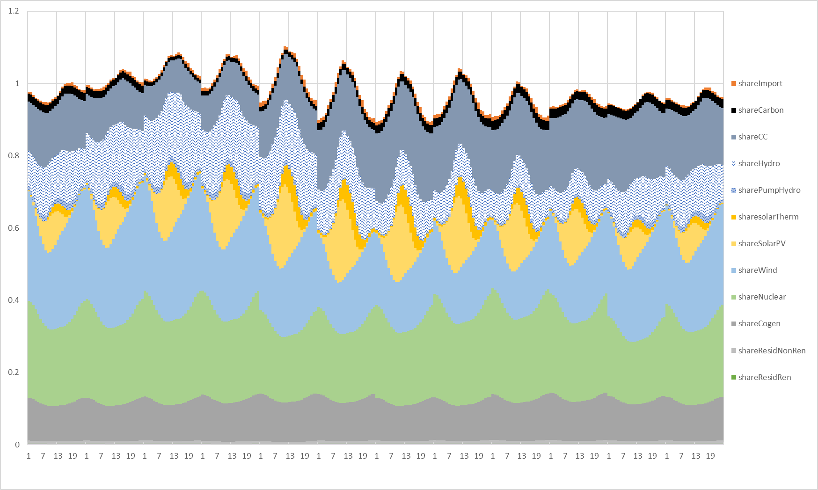
Figure S10. Average generation mix in 2020

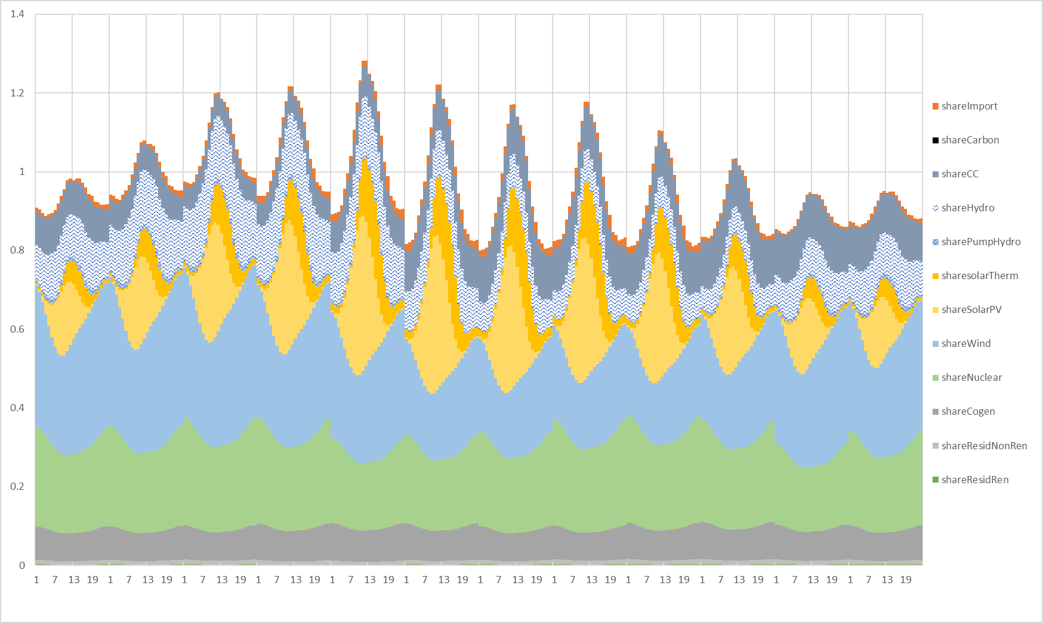
Figure S11. Average generation mix in 2025

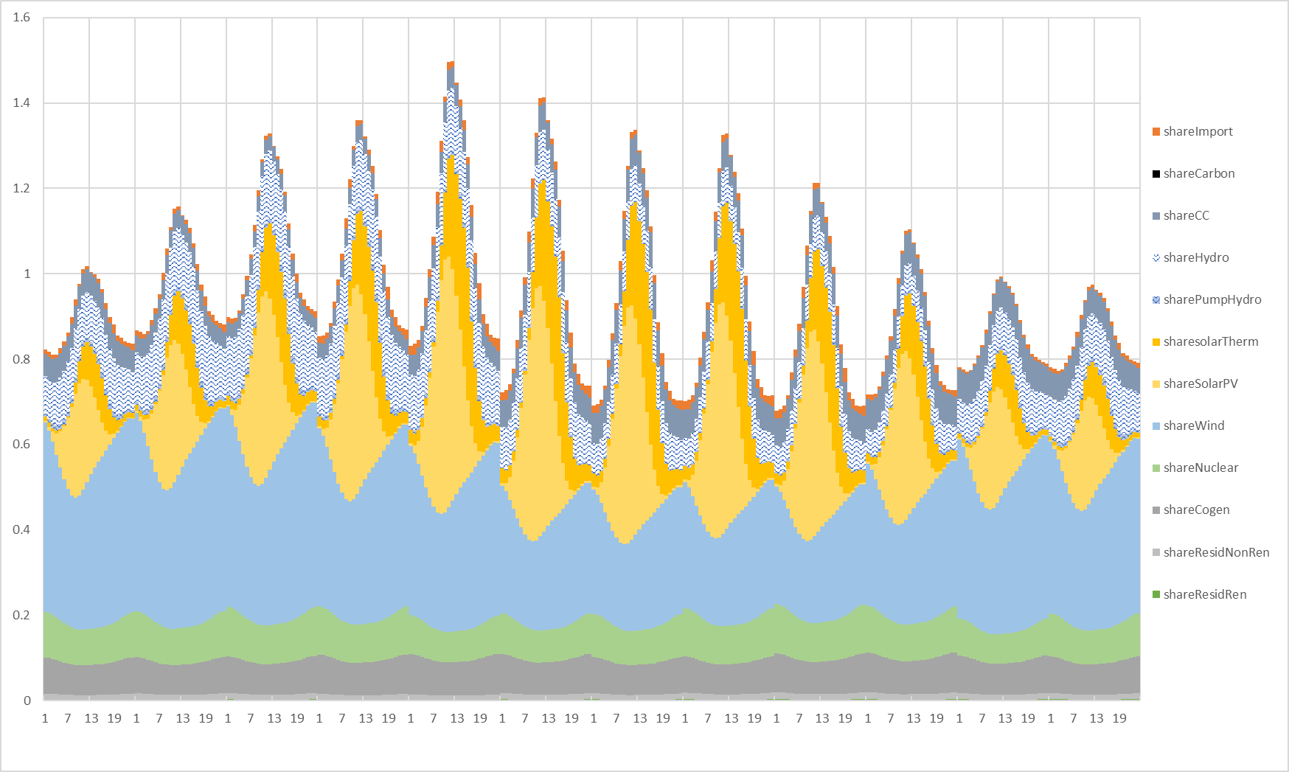
Figure S12. Average generation mix in 2030

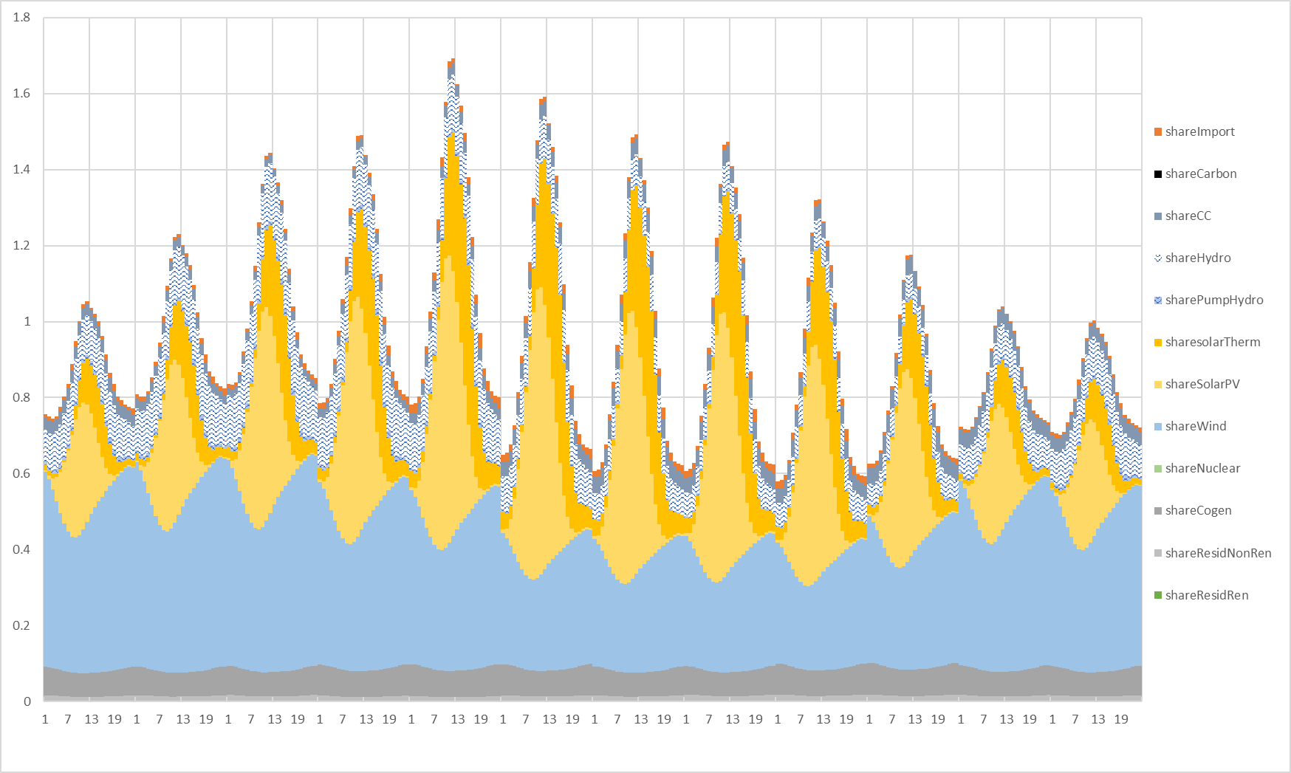
Figure S13. Average generation mix in 2035

Table S14. Long-term forecast of the generation shares for main generation technologies
year | shareCoal | shareCC | shareCogen | shareHydro | sharePumpHydro | shareNuclear | shareSolarPV | sharesolarTherm | shareWind | shareResidRen | shareResidNonRen | shareother Ren | shareImport
2014 | 0.1638 | 0.0842 | 0.0964 | 0.1554 | 0.0145 | 0.2185 | 0.0311 | 0.0198 | 0.2020 | 0.0020 | 0.0071 | 0.0153 | -0.010
2015 | 0.2005 | 0.0989 | 0.0994 | 0.1121 | 0.0114 | 0.2159 | 0.0310 | 0.0201 | 0.1885 | 0.0026 | 0.0092 | 0.0135 | -0.003
2016 | 0.1390 | 0.1011 | 0.1028 | 0.1434 | 0.0124 | 0.2225 | 0.0301 | 0.0201 | 0.1878 | 0.0026 | 0.0098 | 0.0136 | 0.0147
2017 | 0.1676 | 0.1329 | 0.1113 | 0.0729 | 0.0089 | 0.2194 | 0.0316 | 0.0211 | 0.1876 | 0.0029 | 0.0097 | 0.0142 | 0.0199
2018 | 0.1378 | 0.1043 | 0.1145 | 0.1348 | 0.0079 | 0.2102 | 0.0292 | 0.0175 | 0.1934 | 0.0029 | 0.0091 | 0.0140 | 0.0244
2019 | 0.0426 | 0.2041 | 0.1181 | 0.0987 | 0.0066 | 0.2228 | 0.0353 | 0.0206 | 0.2120 | 0.0029 | 0.0083 | 0.0144 | 0.0136
2020 | 0.0199 | 0.1591 | 0.1117 | 0.1267 | 0.0114 | 0.2313 | 0.0617 | 0.0188 | 0.2231 | 0.0025 | 0.0079 | 0.0185 | 0.0074
2021 | 0.0085 | 0.1509 | 0.0992 | 0.1209 | 0.0105 | 0.2309 | 0.0708 | 0.0252 | 0.2287 | 0.0026 | 0.0082 | 0.0274 | 0.0161
2022 | 0.0046 | 0.1453 | 0.0939 | 0.1140 | 0.0097 | 0.2264 | 0.0804 | 0.0316 | 0.2373 | 0.0027 | 0.0087 | 0.0294 | 0.0160
2023 | 0.0008 | 0.1387 | 0.0881 | 0.1149 | 0.0092 | 0.2203 | 0.0890 | 0.0374 | 0.2437 | 0.0026 | 0.0091 | 0.0306 | 0.0156
2024 | 0.0000 | 0.1330 | 0.0829 | 0.1112 | 0.0086 | 0.2152 | 0.0974 | 0.0431 | 0.2505 | 0.0026 | 0.0095 | 0.0331 | 0.0130
2025 | 0.0000 | 0.0977 | 0.0804 | 0.1122 | 0.0087 | 0.2171 | 0.1088 | 0.0501 | 0.2652 | 0.0026 | 0.0102 | 0.0339 | 0.0131
2026 | 0.0000 | 0.0873 | 0.0799 | 0.1074 | 0.0087 | 0.2122 | 0.1166 | 0.0554 | 0.2714 | 0.0025 | 0.0106 | 0.0340 | 0.0141
2027 | 0.0000 | 0.0770 | 0.0790 | 0.1069 | 0.0088 | 0.2068 | 0.1236 | 0.0603 | 0.2764 | 0.0024 | 0.0109 | 0.0343 | 0.0136
2028 | 0.0000 | 0.0679 | 0.0774 | 0.1042 | 0.0085 | 0.2023 | 0.1308 | 0.0651 | 0.2821 | 0.0024 | 0.0112 | 0.0351 | 0.0131
2029 | 0.0000 | 0.0343 | 0.0803 | 0.1047 | 0.0084 | 0.2037 | 0.1416 | 0.0718 | 0.2958 | 0.0024 | 0.0119 | 0.0322 | 0.0129
2030 | 0.0000 | 0.0606 | 0.0797 | 0.1120 | 0.0090 | 0.0915 | 0.1616 | 0.0832 | 0.3282 | 0.0026 | 0.0127 | 0.0451 | 0.0139
2031 | 0.0000 | 0.0585 | 0.0791 | 0.1089 | 0.0087 | 0.0891 | 0.1677 | 0.0874 | 0.3318 | 0.0025 | 0.0123 | 0.0404 | 0.0137
2032 | 0.0000 | 0.0561 | 0.0772 | 0.1060 | 0.0085 | 0.0868 | 0.1733 | 0.0914 | 0.3351 | 0.0024 | 0.0120 | 0.0377 | 0.0133
2033 | 0.0000 | 0.0423 | 0.0734 | 0.1042 | 0.0084 | 0.0854 | 0.1805 | 0.0962 | 0.3415 | 0.0024 | 0.0118 | 0.0409 | 0.0131
2034 | 0.0000 | 0.0348 | 0.0695 | 0.1025 | 0.0083 | 0.0838 | 0.1867 | 0.1004 | 0.3465 | 0.0023 | 0.0116 | 0.0408 | 0.0128
2035 | 0.0000 | 0.0363 | 0.0710 | 0.1085 | 0.0088 | 0.0000 | 0.2081 | 0.1128 | 0.3793 | 0.0025 | 0.0123 | 0.0470 | 0.0136
2036 | 0.0000 | 0.0331 | 0.0669 | 0.1061 | 0.0085 | 0.0000 | 0.2136 | 0.1166 | 0.3830 | 0.0024 | 0.0120 | 0.0445 | 0.0133
2037 | 0.0000 | 0.0312 | 0.0628 | 0.1038 | 0.0084 | 0.0000 | 0.2187 | 0.1202 | 0.3861 | 0.0024 | 0.0118 | 0.0417 | 0.0130
2038 | 0.0000 | 0.0324 | 0.0574 | 0.1015 | 0.0082 | 0.0000 | 0.2235 | 0.1236 | 0.3892 | 0.0023 | 0.0115 | 0.0377 | 0.0127
2039 | 0.0000 | 0.0261 | 0.0516 | 0.0998 | 0.0081 | 0.0000 | 0.2292 | 0.1274 | 0.3939 | 0.0023 | 0.0113 | 0.0378 | 0.0125
2040 | 0.0000 | 0.0201 | 0.0460 | 0.0982 | 0.0079 | 0.0000 | 0.2346 | 0.1311 | 0.3982 | 0.0023 | 0.0111 | 0.0382 | 0.0123
2041 | 0.0000 | 0.0192 | 0.0448 | 0.0956 | 0.0077 | 0.0000 | 0.2375 | 0.1333 | 0.3985 | 0.0022 | 0.0108 | 0.0384 | 0.0120
2042 | 0.0000 | 0.0187 | 0.0436 | 0.0931 | 0.0075 | 0.0000 | 0.2400 | 0.1353 | 0.3985 | 0.0021 | 0.0106 | 0.0390 | 0.0117
2043 | 0.0000 | 0.0182 | 0.0426 | 0.0908 | 0.0073 | 0.0000 | 0.2426 | 0.1373 | 0.3987 | 0.0021 | 0.0103 | 0.0388 | 0.0114
2044 | 0.0000 | 0.0189 | 0.0417 | 0.0889 | 0.0072 | 0.0000 | 0.2461 | 0.1398 | 0.4007 | 0.0020 | 0.0101 | 0.0334 | 0.0111
2045 | 0.0000 | 0.0184 | 0.0408 | 0.0870 | 0.0070 | 0.0000 | 0.2491 | 0.1419 | 0.4019 | 0.0020 | 0.0099 | 0.0309 | 0.0109
2046 | 0.0000 | 0.0184 | 0.0399 | 0.0851 | 0.0069 | 0.0000 | 0.2517 | 0.1438 | 0.4027 | 0.0020 | 0.0096 | 0.0292 | 0.0107
2047 | 0.0000 | 0.0185 | 0.0395 | 0.0842 | 0.0068 | 0.0000 | 0.2502 | 0.1506 | 0.3999 | 0.0019 | 0.0095 | 0.0282 | 0.0106
2048 | 0.0000 | 0.0181 | 0.0390 | 0.0831 | 0.0067 | 0.0000 | 0.2482 | 0.1606 | 0.3954 | 0.0019 | 0.0094 | 0.0271 | 0.0104
2049 | 0.0000 | 0.0192 | 0.0371 | 0.0818 | 0.0066 | 0.0000 | 0.2454 | 0.1704 | 0.3916 | 0.0019 | 0.0093 | 0.0266 | 0.0103
2050 | 0.0000 | 0.0213 | 0.0363 | 0.0801 | 0.0065 | 0.0000 | 0.2417 | 0.1792 | 0.3874 | 0.0018 | 0.0091 | 0.0266 | 0.0100

Inventory tables for annual average and marginal electricity mix

Table S15. Inventory dataset for electricity, high voltage, annual average mix, 2021 (ES)
Flow / Provider | Amount | Unit
electricity prod., high voltage, hard coal - ES | 1.9427E-02 | kWh
electricity prod., high voltage, hydro, pumped storage - ES | 1.0562E-02 | kWh
electricity prod., high voltage, hydro, reservoir, non-alpine region - ES | 4.1296E-02 | kWh
electricity prod., high voltage, hydro, run-of-river - ES | 8.0165E-02 | kWh
electricity prod., high voltage, lignite - ES | 1.1394E-03 | kWh
electricity prod., high voltage, nat. gas, combined cycle power plant - ES | 1.5662E-01 | kWh
electricity prod., high voltage, natural gas, conventional power plant - ES | 0.0000E+00 | kWh
electricity prod., high voltage, nuclear, boiling water reactor - ES | 4.5571E-02 | kWh
electricity prod., nuclear, pressure water reactor - ES | 1.8280E-01 | kWh
electricity prod., high voltage, oil - ES | 0.0000E+00 | kWh
electricity prod., high voltage, solar thermal parabolic trough, 50 MW - ES | 1.8288E-02 | kWh
electricity prod., high voltage, solar tower power plant, 20 MW - ES | 4.1213E-04 | kWh
electricity prod., high voltage, wind, 1-3MW turbine, offshore - ES | 4.7536E-05 | kWh
electricity prod., high voltage, wind, 1-3MW turbine, onshore - ES | 1.5754E-01 | kWh
electricity prod., high voltage, wind, <1MW turbine, onshore - ES | 8.6716E-02 | kWh
electricity prod., high voltage, wind, >3MW turbine, onshore - ES | 4.1832E-04 | kWh
electricity, high voltage, import from FR - ES | 5.0167E-02 | kWh
electricity, high voltage, import from MA - ES | 2.6167E-03 | kWh
electricity, high voltage, import from PT - ES | 1.3216E-02 | kWh
heat and power co-generation, high voltage, biogas, gas engine - ES | 3.1787E-03 | kWh
heat and power co-generation, high voltage, natural gas, 100MW electrical | 1.0551E-01 | kWh
heat and power co-generation, high voltage, wood chips, 6667 kW - ES | 1.9933E-02 | kWh
market for electricity, high voltage - ES | 3.9995E-02 | kWh
market for transmission network, electricity, high voltage - GLO | 6.5821E-09 | km
transmission network construction, long-distance - UCTE | 3.1700E-10 | km
treatment of blast furnace gas, in power plant - ES | 4.3364E-03 | kWh
treatment of coal gas, in power plant - ES | 4.7105E-05 | kWh

Table S16. Inventory dataset for electricity, medium voltage, annual average mix, 2021 (ES)
Flow / Provider | Amount | Unit
market for electricity, medium voltage - ES | 5.4071E-03 | kWh
electricity, from municipal waste incineration, medium voltage - ES | 8.8281E-03 | kWh
electricity voltage transformation from high to medium voltage - ES | 9.9117E-01 | kWh
market for sulfur hexafluoride, liquid - RER | 1.1300E-07 | kg
market for transmission network, electricity, medium voltage - GLO | 1.8628E-08 | km

Table S17. Inventory dataset for electricity, low voltage, annual average mix, 2021 (ES)
Flow / Provider | Amount | Unit
market for distribution network, electricity, low voltage - GLO | 8.7405E-08 | km
electricity voltage transformation from medium to low voltage - ES | 9.2748E-01 | kWh
electricity production, low voltage, photovoltaic, 3kWp slanted-roof installation, single-Si, panel, mounted - ES | 1.9299E-02 | kWh
market for electricity, low voltage - ES | 3.9464E-02 | kWh
electricity production, low voltage, photovoltaic, 570kWp open ground installation, multi-Si - ES | 2.9177E-02 | kWh
electricity production, low voltage, photovoltaic, 3kWp slanted-roof installation, multi-Si, panel, mounted - ES | 2.4043E-02 | kWh
market for sulfur hexafluoride, liquid - RER | 6.2700E-09 | kg

Table S18. Inventory dataset for electricity, high voltage, annual marginal mix, 2021 (ES)
Flow / Provider | Amount | Unit
electricity prod., high voltage, hard coal - ES | 4.8876E-02 | kWh
electricity prod., high voltage, hydro, pumped storage - ES | 6.7681E-02 | kWh
electricity prod., high voltage, hydro, reservoir, non-alpine region - ES | 9.3057E-02 | kWh
electricity prod., high voltage, hydro, run-of-river - ES | 1.8064E-01 | kWh
electricity prod., high voltage, lignite - ES | 2.8665E-03 | kWh
electricity prod., high voltage, natural gas, combined cycle power plant - ES | 2.3711E-01 | kWh
electricity prod., high voltage, nat. gas, conventional power plant - ES | 0.0000E+00 | kWh
electricity prod., high voltage, nuclear, boiling water reactor - ES | 4.4887E-03 | kWh
electricity prod., nuclear, pressure water reactor - ES | 1.8006E-02 | kWh
electricity prod., high voltage, oil - ES | 0.0000E+00 | kWh
electricity prod., high voltage, solar thermal parabolic trough, 50 MW - ES | 3.5650E-04 | kWh
electricity prod., high voltage, solar tower power plant, 20 MW - ES | 8.0339E-06 | kWh
electricity prod., high voltage, wind, 1-3MW turbine, offshore - ES | 9.2665E-07 | kWh
electricity prod., high voltage, wind, 1-3MW turbine, onshore - ES | 3.0709E-03 | kWh
electricity prod., high voltage, wind, <1MW turbine, onshore - ES | 1.6904E-03 | kWh
electricity prod., high voltage, wind, >3MW turbine, onshore - ES | 8.1545E-06 | kWh
electricity, high voltage, import from FR - ES | 1.5578E-01 | kWh
electricity, high voltage, import from MA - ES | 3.9242E-02 | kWh
electricity, high voltage, import from PT - ES | 8.0881E-02 | kWh
heat and power co-generation, high voltage, biogas, gas engine - ES | 6.2448E-03 | kWh
heat and power co-generation, high voltage, natural gas, 100MW electrical | 3.5612E-02 | kWh
heat and power co-generation, high voltage, wood chips, 6667 kW - ES | 2.0112E-02 | kWh
market for electricity, high voltage - ES | 3.9995E-02 | kWh
market for transmission network, electricity, high voltage - GLO | 6.5821E-09 | km
transmission network construction, long-distance - UCTE | 3.1700E-10 | km
treatment of blast furnace gas, in power plant - ES | 4.1484E-03 | kWh
treatment of coal gas, in power plant - ES | 1.1851E-04 | kWh

Table S19. Inventory dataset for electricity, medium voltage, annual marginal mix, 2021 (ES)
Flow / Provider | Amount | Unit
market for electricity, medium voltage - ES | 5.4071E-03 | kWh
electricity, from municipal waste incineration, medium voltage - ES | 1.2554E-02 | kWh
electricity voltage transformation from high to medium voltage - ES | 9.8745E-01 | kWh
market for sulfur hexafluoride, liquid - RER | 1.1300E-07 | kg
market for transmission network, electricity, medium voltage - GLO | 1.8628E-08 | km

Table S20. Inventory dataset for electricity, low voltage, annual marginal mix, 2021 (ES)
Flow / Provider | Amount | Unit
market for distribution network, electricity, low voltage - GLO | 8.7405E-08 | km
electricity voltage transformation from medium to low voltage - ES | 9.9848E-01 | kWh
electricity production, low voltage, photovoltaic, 3kWp slanted-roof installation, single-Si, panel, mounted - ES | 4.0349E-04 | kWh
market for electricity, low voltage - ES | 3.9464E-02 | kWh
electricity production, low voltage, photovoltaic, 570kWp open ground installation, multi-Si - ES | 6.1000E-04 | kWh
electricity production, low voltage, photovoltaic, 3kWp slanted-roof installation, multi-Si, panel, mounted - ES | 5.0266E-04 | kWh
market for sulfur hexafluoride, liquid - RER | 6.2700E-09 | kg

Table S21. Inventory dataset for electricity, high voltage voltage, consumed by pumped hydro, annual marginal mix, 2021 (ES)
Flow / Provider | Amount | Unit
electricity prod., high voltage, hard coal - ES | 5.5615E-02 | kWh
electricity prod., high voltage, hydro, pumped storage - ES | 0.0000E+00 | kWh
electricity prod., high voltage, hydro, reservoir, non-alpine region - ES | 1.0201E-01 | kWh
electricity prod., high voltage, hydro, run-of-river - ES | 1.9802E-01 | kWh
electricity prod., high voltage, lignite - ES | 3.2618E-03 | kWh
electricity prod., high voltage, natural gas, combined cycle power plant - ES | 2.6259E-01 | kWh
electricity prod., high voltage, nat. gas, conventional power plant - ES | 0.0000E+00 | kWh
electricity prod., high voltage, nuclear, boiling water reactor - ES | 5.5117E-03 | kWh
electricity prod., nuclear, pressure water reactor - ES | 2.2109E-02 | kWh
electricity prod., high voltage, oil - ES | 0.0000E+00 | kWh
electricity prod., high voltage, solar thermal parabolic trough, 50 MW - ES | 3.7051E-04 | kWh
electricity prod., high voltage, solar tower power plant, 20 MW - ES | 8.3496E-06 | kWh
electricity prod., high voltage, wind, 1-3MW turbine, offshore - ES | 9.6307E-07 | kWh
electricity prod., high voltage, wind, 1-3MW turbine, onshore - ES | 3.1916E-03 | kWh
electricity prod., high voltage, wind, <1MW turbine, onshore - ES | 1.7568E-03 | kWh
electricity prod., high voltage, wind, >3MW turbine, onshore - ES | 8.4750E-06 | kWh
electricity, high voltage, import from FR - ES | 1.5530E-01 | kWh
electricity, high voltage, import from MA - ES | 5.3713E-02 | kWh
electricity, high voltage, import from PT - ES | 5.2879E-02 | kWh
heat and power co-generation, high voltage, biogas, gas engine - ES | 6.3717E-03 | kWh
heat and power co-generation, high voltage, natural gas, 100MW electrical | 4.9497E-02 | kWh
heat and power co-generation, high voltage, wood chips, 6667 kW - ES | 2.3490E-02 | kWh
market for electricity, high voltage - ES | 3.9995E-02 | kWh
market for transmission network, electricity, high voltage - GLO | 6.5821E-09 | km
transmission network construction, long-distance - UCTE | 3.1700E-10 | km
treatment of blast furnace gas, in power plant - ES | 4.1608E-03 | kWh
treatment of coal gas, in power plant - ES | 1.3485E-04 | kWh

Results when calculated with LCA software

Table S19 provides the LCA results calculated per kWh of electricity (low voltage, at consumer) using the annual average and marginal mix (2020) implemented in ecoinvent according to the previous section. The obtained GWP is 4% higher than that estimated based on the generation shares directly for the average electricity mix, and 14% higher for the marginal. This can be explained by the fact that ecoinvent uses three voltage levels and accounts for conversion losses, which can be up to 10% from one voltage level to the other. PV electricity, injected into the low voltage grid therefore avoids these losses until the low-voltage end consumer level, and the average mix with a higher share of PV shows correspondingly lower losses. These conversion losses are not accounted for in the generation-oriented approach in the article. On high voltage level, the discrepancies are below 5%, attributable mainly to the more detailed modelling in ecoinvent considering more generation technologies.

Table S19. Characterisation results per 1 kWh of electricity, low voltage
Impact category | average mix | marginal mix | Unit
Acidification | 0.00067 | 0.00177 | mol H⁺ eq
Climate change | 0.21065 | 0.37901 | kg CO₂ eq
Climate change - Biogenic | 0.0009 | 0.00337 | kg CO₂ eq
Climate change - Fossil | 0.2075 | 0.36544 | kg CO₂ eq
Climate change - Land use and LU change | 0.00224 | 1.02E-02 | kg CO₂ eq
Ecotoxicity, freshwater | 3.2117 | 4.27184 | CTUe
Ecotoxicity, freshwater - inorganics | 0.13431 | 1.57E-01 | CTUe
Ecotoxicity, freshwater - metals | 3.075 | 4.10754 | CTUe
Ecotoxicity, freshwater - organics | 0.01341 | 0.01818 | CTUe
Eutrophication, freshwater | 3.78E-05 | 8.20E-05 | kg P eq
Eutrophication, marine | 0.00015 | 3.00E-04 | kg N eq
Eutrophication, terrestrial | 0.00159 | 3.35E-03 | mol N eq
Human toxicity, cancer | 1.23E-10 | 1.30E-10 | CTUh
Human toxicity, cancer - inorganics | 0 | 0.00E+00 | CTUh
Human toxicity, cancer - metals | 9.46E-11 | 9.37E-11 | CTUh
Human toxicity, cancer - organics | 2.83E-11 | 3.62E-11 | CTUh
Human toxicity, non-cancer | 2.00E-09 | 2.93E-09 | CTUh
Human toxicity, non-cancer - inorganics | 2.27E-10 | 3.28E-10 | CTUh
Human toxicity, non-cancer - metals | 1.63E-09 | 2.42E-09 | CTUh
Human toxicity, non-cancer - organics | 1.16E-10 | 1.24E-10 | CTUh
Ionising radiation | 0.2277 | 8.54E-02 | kBq U-235 eq
Land use | 1.41435 | 1.53E+00 | Pt
Ozone depletion | 2.37E-08 | 3.58E-08 | kg CFC11 eq
Particulate matter | 3.64E-09 | 5.51E-09 | disease inc.
Photochemical ozone formation | 0.00042 | 8.90E-04 | kg NMVOC eq
Resource use, fossils | 6.80584 | 6.57786 | MJ
Resource use, minerals and metals | 3.82E-06 | 3.29E-06 | kg Sb eq
Water use | 0.09745 | 1.53E-01 | m³ depriv.

Bibliography
[1] REE, ‘Generación | Red Eléctrica de España’, 2020. https://www.ree.es/es/datos/generacion (accessed Apr. 27, 2020).
[2] D. Iribarren, M. Martín-Gamboa, Z. Navas-Anguita, D. García-Gusano, and J. Dufour, ‘Influence of climate change externalities on the sustainability-oriented prioritisation of prospective energy scenarios’, Energy, vol. 196, Art. no. 117179, 2020, doi: 10.1016/j.energy.2020.117179.
[3] Z. Navas-Anguita, D. García-Gusano, and D. Iribarren, ‘Prospective Life Cycle Assessment of the Increased Electricity Demand Associated with the Penetration of Electric Vehicles in Spain’, Energies, vol. 11, no. 5, Art. no. 5, May 2018, doi: 10.3390/en11051185.
[4] D. García-Gusano, D. Iribarren, and J. Dufour, ‘Is coal extension a sensible option for energy planning? A combined energy systems modelling and life cycle assessment approach’, Energy Policy, vol. 114, pp. 413–421, Mar. 2018, doi: 10.1016/j.enpol.2017.12.038.
[5] REN, ‘Eletricidade - Balanço Mensal’, Ren Website Root, 2021. https://datahub.ren.pt/pt/eletricidade/balanco-mensal/?date=2020-12-31 (accessed Feb. 04, 2022).
[6] H. Ritchie and M. Roser, ‘Energy Country Profiles’, Our World in Data, Nov. 2020. Accessed: Feb. 04, 2022. [Online]. Available: https://ourworldindata.org/energy/country/morocco
[7] ‘Estimating the marginal carbon intensity of electricity with machine learning - Tomorrow Blog’. https://www.tmrow.com/blog/marginal-carbon-intensity-of-electricity-with-machine-learning/ (accessed Jun. 21, 2021).

