Supplementary Information 2 – GHPI and LHPI Figures per Habitat

Title: Habitat Protection Indexes - new monitoring measures for the conservation of threatened marine habitats

Corresponding Author: Joy A. Kumagai (joy.kumagai@senckenberg.de)

Authors: Joy A. Kumagai & Fabio Favoretto, Sara Pruckner, Alex D. Rogers, Lauren V. Weatherdon, Octavio Aburto-Oropeza, Aidin Niamir

Global Habitat Protection Index (GHPI) and Local Habitat Protection Index (LHPI) per Habitat

In this supplementary material, we present the Global Habitat Protection Index (GHPI) and Local Habitat Protection Index (LHPI) for each habitat considered in the analysis.

For quick reference the GHPI indicates the amount of habitat within PAs divided by the total global area of the same habitat and the LHPI indicates the amount of habitat within PAs divided by the area of the habitat within each jurisdiction.

Overview:
  - Supplementary Figure 1: GHPI and LHPI for cold corals
  - Supplementary Figure 2: GHPI and LHPI for warm water corals
  - Supplementary Figure 3: GHPI and LHPI for knolls and seamounts
  - Supplementary Figure 4: GHPI and LHPI for mangroves
  - Supplementary Figure 5: GHPI and LHPI for saltmarshes
  - Supplementary Figure 6: GHPI and LHPI for seagrasses

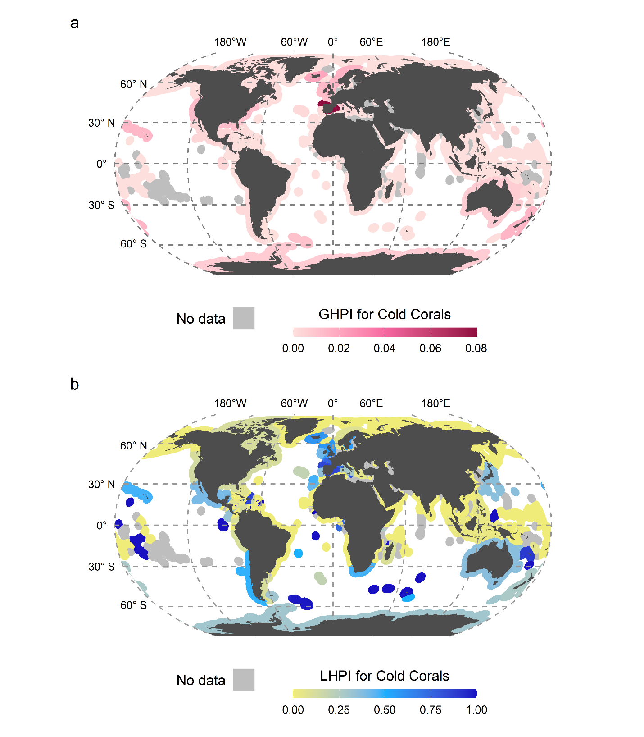
  - Supplementary Figure 1: Global habitat protection index and local habitat protection index for cold corals. a) GHPI illustrates the contribution of jurisdictions to the global protection of cold corals, ranging from light pink (low contribution) to burgundy (high contribution). The index ranges from 0 to 1, but only 0 to ~0.08 is depicted here due to no jurisdictions scoring higher than ~0.08. b) LHPI illustrates how much a jurisdiction is covering their cold corals with PAs compared to the maximum habitat extent, ranging from yellow (low contribution) to dark blue (high) contribution.
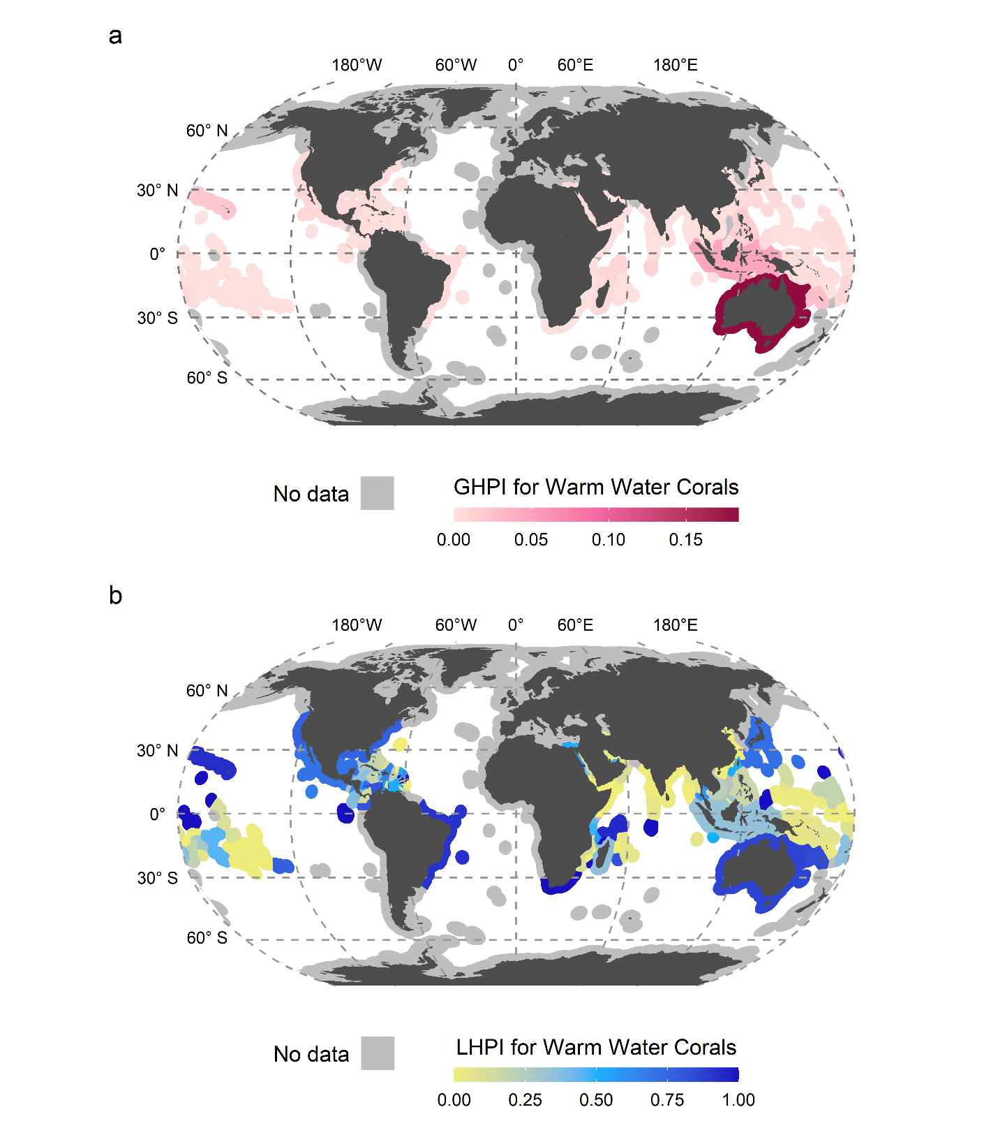
- Supplementary Figure 2: Global habitat protection index and local habitat protection index for warm water corals. a) GHPI illustrates the contribution of jurisdictions to the global protection of warm water corals, ranging from light pink (low contribution) to burgundy (high contribution). The index ranges from 0 to 1, but only 0 to ~0.18 is depicted here due to no jurisdictions scoring higher than ~0.18. b) LHPI illustrates how much a jurisdiction is covering their warm water corals with PAs compared to the maximum habitat extent, ranging from yellow (low contribution) to dark blue (high) contribution.

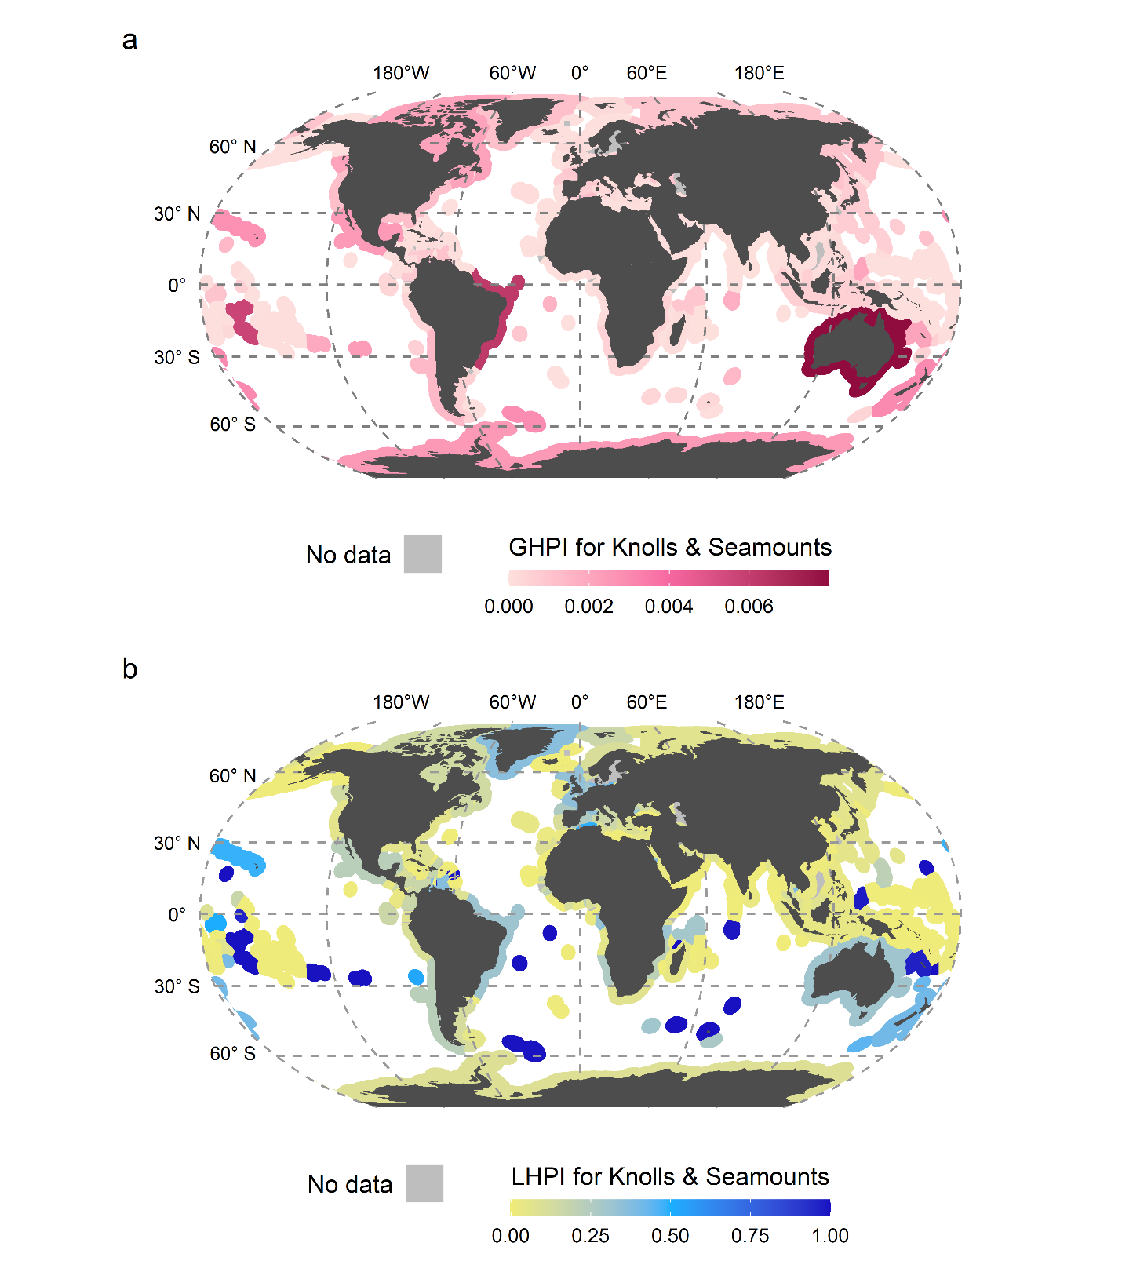
- Supplementary Figure 3: Global habitat protection index and local habitat protection index for knolls and seamounts. a) GHPI illustrates the contribution of jurisdictions to the global protection of knolls and seamounts, ranging from light pink (low contribution) to burgundy (high contribution). The index ranges from 0 to 1, but only 0 to ~0.008 is depicted here due to no jurisdictions scoring higher than ~0.008. b) LHPI illustrates how much a jurisdiction is covering their knolls and seamounts with PAs compared to the maximum habitat extent, ranging from yellow (low contribution) to dark blue (high) contribution.

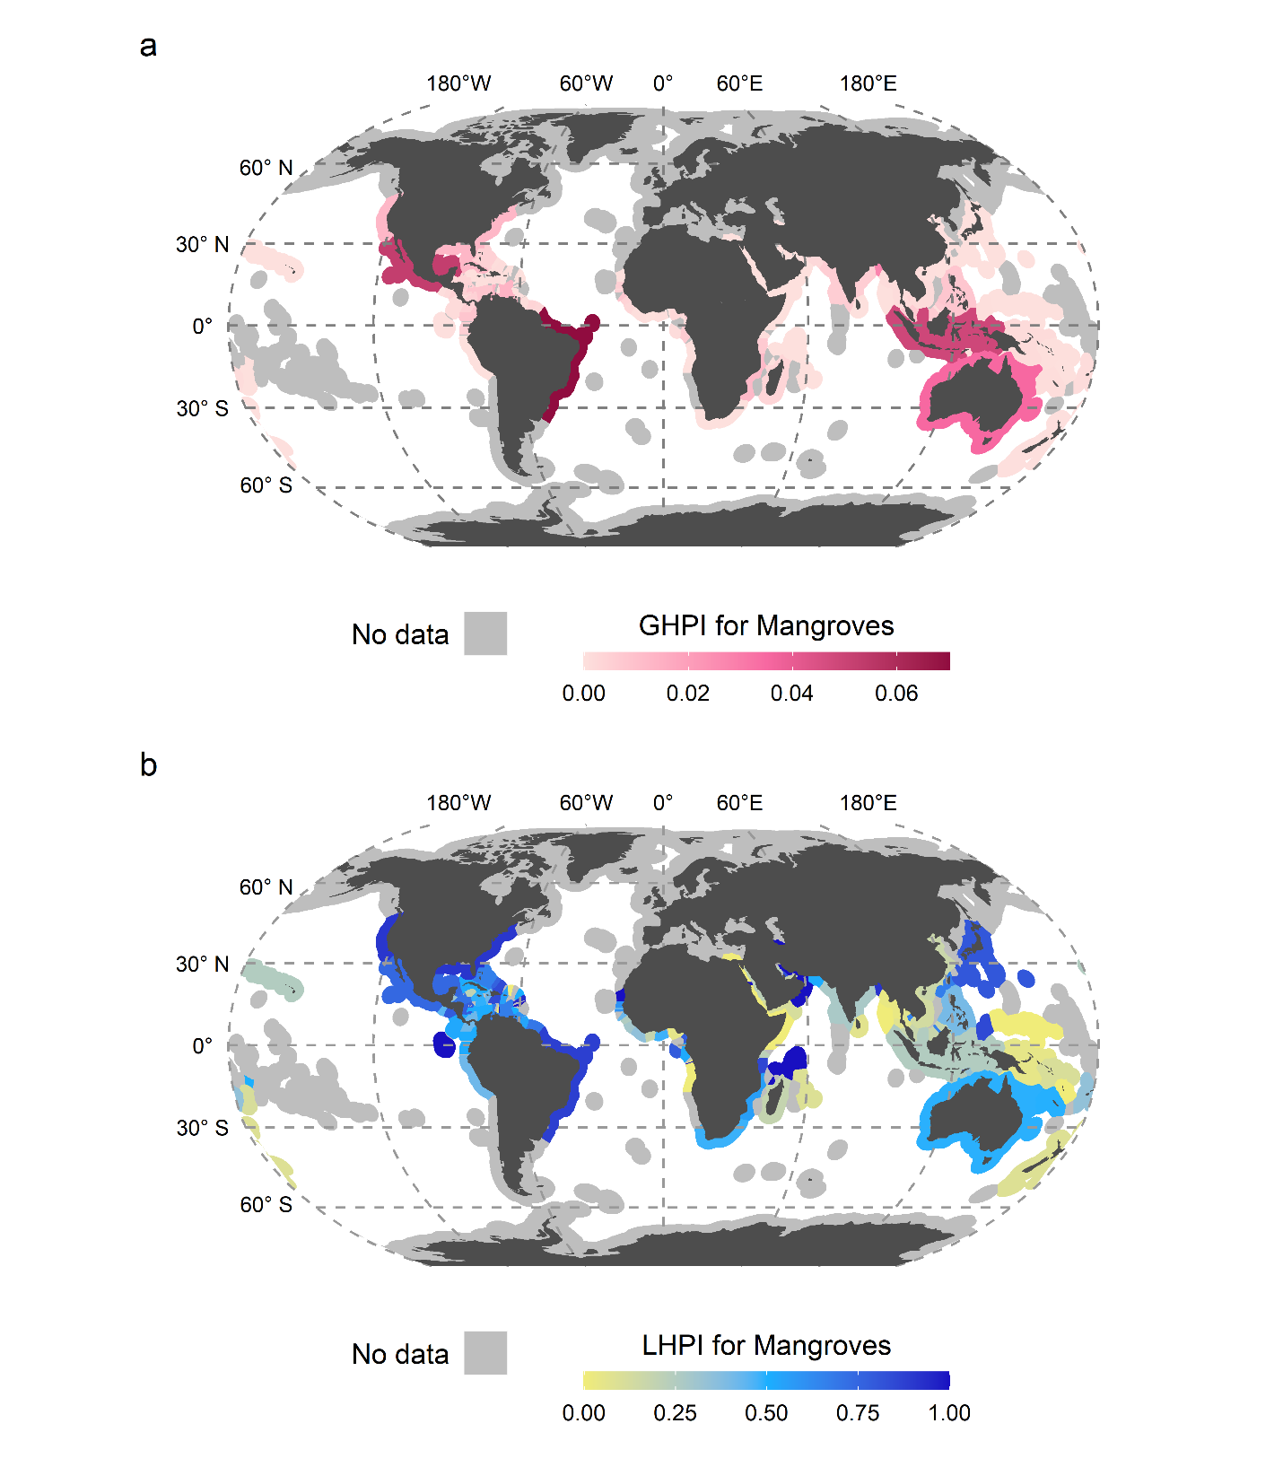
- Supplementary Figure 4: Global habitat protection index and local habitat protection index for mangroves. a) GHPI illustrates the contribution of jurisdictions to the global protection of mangroves, ranging from light pink (low contribution) to burgundy (high contribution). The index ranges from 0 to 1, but only 0 to ~0.07 is depicted here due to no jurisdictions scoring higher than ~0.07. b) LHPI illustrates how much a jurisdiction is covering their mangroves with PAs compared to the maximum habitat extent, ranging from yellow (low contribution) to dark blue (high) contribution.

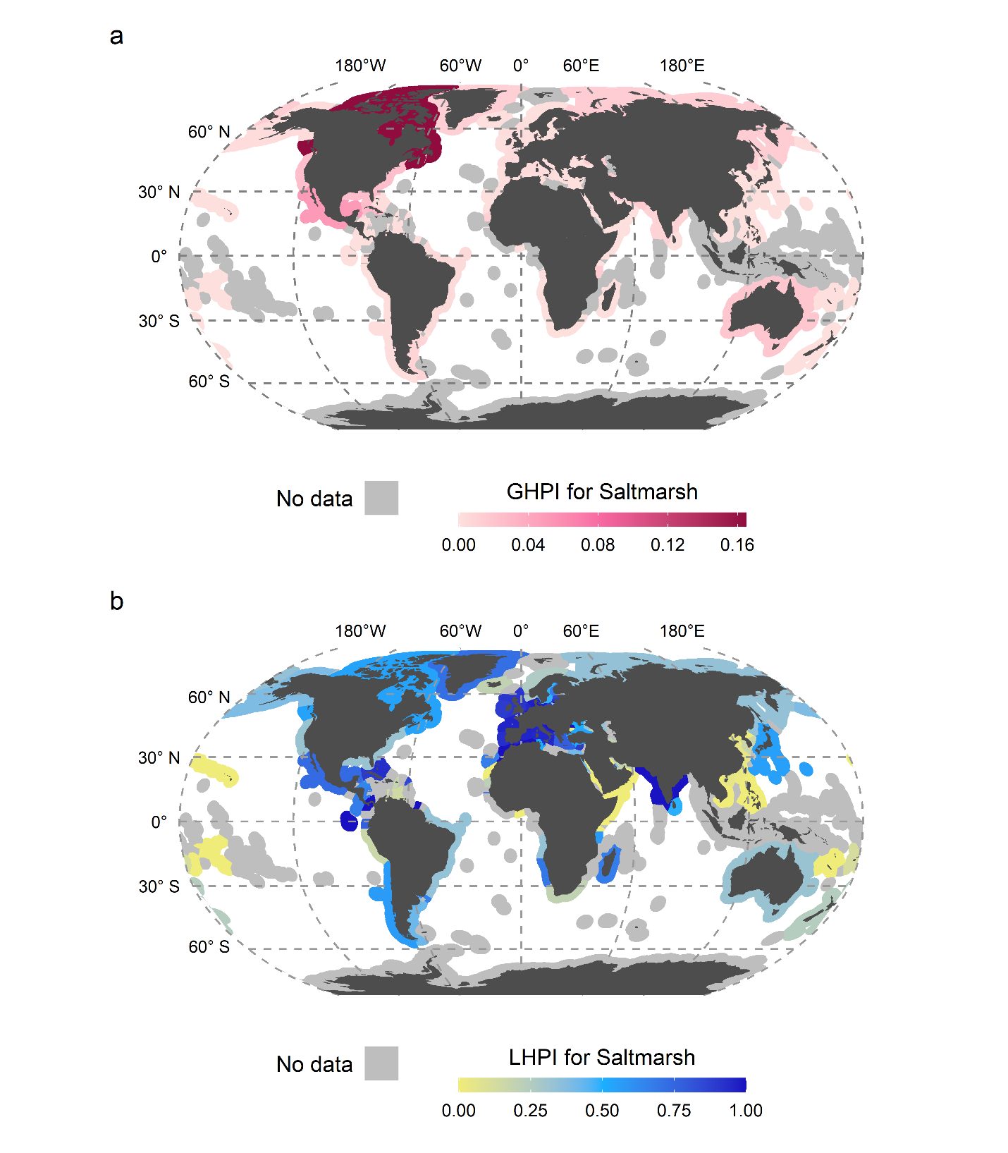
- Supplementary Figure 5: Global habitat protection index and local habitat protection index for saltmarshes. a) GHPI illustrates the contribution of jurisdictions to the global protection of saltmarshes, ranging from light pink (low contribution) to burgundy (high contribution). The index ranges from 0 to 1, but only 0 to ~0.16 is depicted here due to no jurisdictions scoring higher than ~0.16. b) LHPI illustrates how much a jurisdiction is covering their saltmarshes with PAs compared to the maximum habitat extent, ranging from yellow (low contribution) to dark blue (high) contribution.

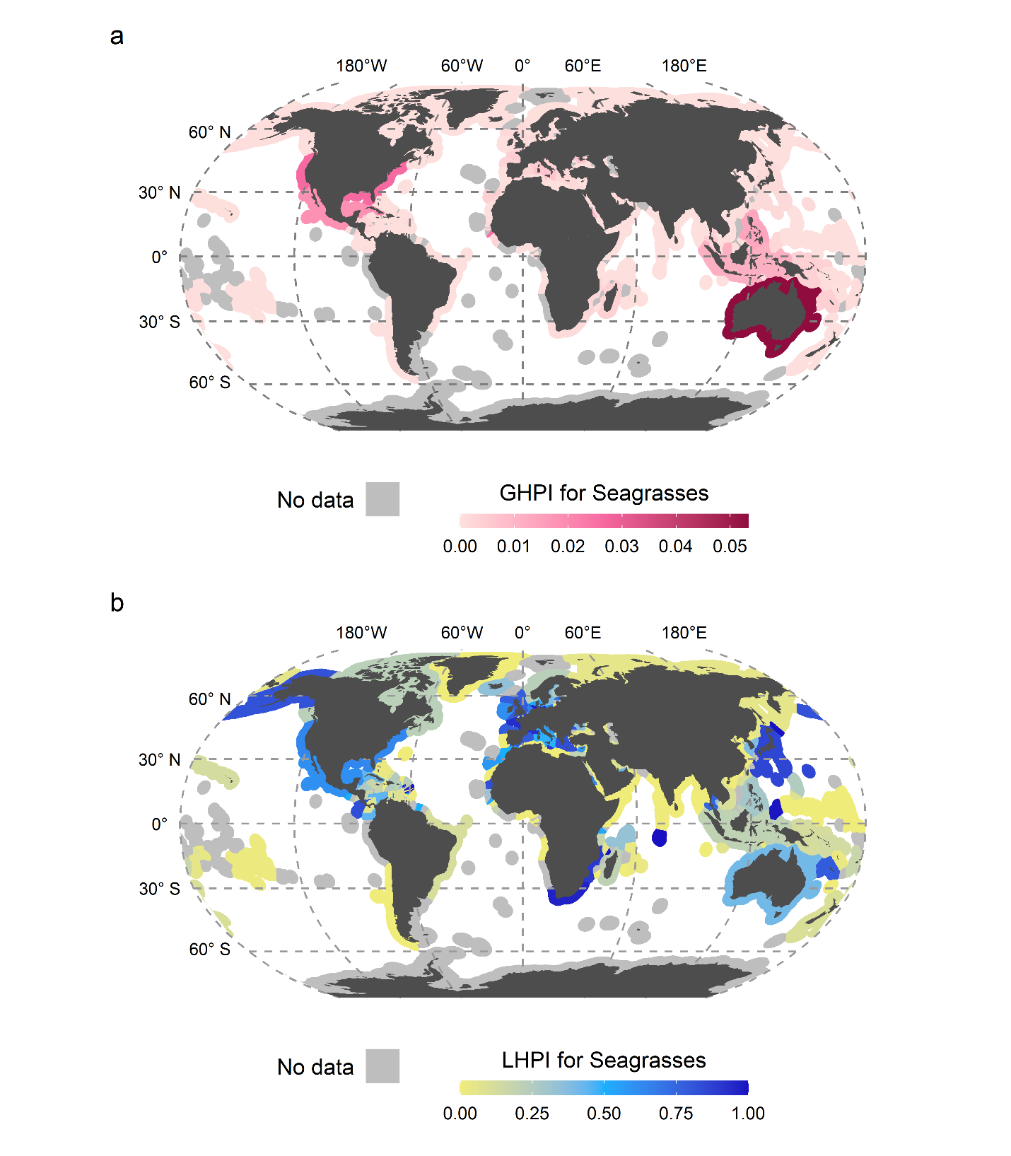
- Supplementary Figure 6: Global habitat protection index and local habitat protection index for seagrasses. a) GHPI illustrates the contribution of jurisdictions to the global protection of seagrasses, ranging from light pink (low contribution) to burgundy (high contribution). The index ranges from 0 to 1, but only 0 to ~ 0.05 is depicted here due to no jurisdictions scoring higher than ~0.05. b) LHPI illustrates how much a jurisdiction is covering their seagrasses with PAs compared to the maximum habitat extent, ranging from yellow (low contribution) to dark blue (high) contribution.

