Experiment Design for Data Science
Exercise 2: Reproduce experimental results: On Heavy-user Bias in A/B Testing - Group 23

Fisnik Berisha
TU Wien
Vienna, Austria
e12124486@ student.tuwien.ac.at
Rina Kastrati
TU Wien
Vienna, Austria
e12129481@student.tuwien.ac.at
Ylli Parduzi
TU Wien
Vienna, Austria
e12014533@student.tuwien.ac.at

ABSTRACT
The publication includes references to the code that was used to replicate the experiment. These references in many cases may or may not be included in different papers, depending on where you obtain it. Despite the fact that code is available, reproducing the results appears to be challenging. This is because the code is inadequately documented. In addition, the seed was not specified, hence the results were different each time the code was executed. We tried to re-run the experiment using different seeds and analyze the results. Also, used a dataset that was used for A/B Testing, and compared the results with the actual ones from the paper. All of these results will be further explained in addition.
KEYWORDS
A/B Testing, jackknife, bootstrap, reproducibility
1 INTRODUCTION
Many software and technology businesses use A/B testing or online controlled trials to evaluate modifications to software applications. Users are randomly allocated to the treatment group, the ones who are exposed to the new feature, or the control group who are not exposed to the new feature, while they are using the product or service in a typical online controlled experiment that is testing this new feature. In the original paper it is discussed about a phenomenon called heavy user bias, which explains users that are more likely to be included in the experiment than infrequent users, causing the estimated average treatment effect biased. The idea behind this paper is to help improve community understanding about this under looked issue. Throughout the trial, the assignment remains consistent, and statistics on user behavior are gathered. After the experiment, both groups' metrics are computed, and statistical tests are run to see whether there are any differences between them. The question is whether the external validity: being, if the results of the sample can be applied to the full population - is valid. External validity is influenced by factors such as the novelty effect and the weekday/weekend effect. Another major element is heavy-user bias, which is investigated in this study. Consider the following scenario: A software has 200 users, with 100 of them visiting it every day considered as heavy users and the others using it with a chance of 0.5 per day. Considering that the website runs an experiment for one day, 150 users will participate, with two-thirds of them being heavy users. The authors of the research show that the heavy-user bias is inversely related to the length of the experiment under some reasonable assumptions and suggest a re-sampling estimator for bias correction.

Table 1 Notations
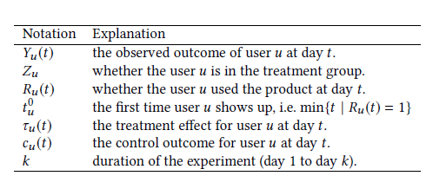

1st Assumption – The assumption of stable unit treatment states that each user’s result is unaffected by the treatment of other users.

2nd Assumption – The behavior of each user is an i.i.d. sample by a super population.

3rd Assumption – Incremental experiment assumption: The group assignments have no effect on the number of user visits, hence the frequency of user visits remains the same. This is quite a reasonable assumption, considering most tests have no effect on the frequency of the users visits.

Considering these three assumptions and Notations table above, the observed outcomes of user u on day t is defined as:

Yu (t ) = Ru (t ){Zuτu (t ) + cu (t )}

Simulated examples

The bias adjusted estimator was tested by simulating two models. The studies were simulated to last 14 days for both models, with a maximum of 1000 users in each group, where some users may not use the product during the experiment, which was taken into consideration. The ground truth Δscaled was set to be 1/3. The data generation method was repeated 100 times for each model. The bias adjusted estimator, the naive difference in means estimator, and a block bootstrap estimator were all computed each time. The bias adjusted estimator provided the least bias in the experiment on average.

2 REPRODUCIBILITY
The code was available by the authors and accessible as a Jupyter Notebook and it can be downloaded from Github. The seed was not specified in the code, so Jupyter Notebook results varied from the actual results that the paper contained, however they were still within reason. Although the experiment stages are detailed in the study, it is not stated which set-up was used, such as the operating system or Python version. The code and paper provide all of the parameters required for their study, however some appear to be chosen arbitrarily, such as the number of days and, in particular, the parameter for the ground truth Δscaled, which will be examined in the following section. The authors ran the data generation procedure 100 times, estimated the bias for each of the three estimations, and published the mean bias, but they did not perform a significance test.

As mentioned in the introduction part, we used a dataset to reproduce the experiment and compared the results. The dataset that we used contained several fields like: User ID, timestamp, group (treatment/control) and other fields that were not used and therefore dropped. Initially the dataset had approximately 300k records and did not have any missing data. This dataset contained information regarding a website, where each user had an specific ID number. In addition the timestamp field contains the dates when a user used the software, where it was noticed that the testing was between 2nd to 24th of January 2017. So, that means that the duration of the experiment (k-value) was 23 days. The group field randomly separated the users in Treatment or Control, which means that 50% were included in the Treatment group, and the other 50% was in Control group. Another field that the dataset contained was the landing page, which had only two unique values. These two values were named: new_page and old_page. The new_page represented the users that used the updated version of the website and the old_page represented the users that used the old version.
In the preprocessing steps, we converted the timestamp column from datetime to int as we removed the month and year and left only the days of the month, where the 2nd of January would be the first day of the experiment and 24th would be the last day (day 23).

Despite the dataset that we used to reproduce the experiment, we also tried to repeat the simulation by building a parameter grid with different values of seeds, number of repeated simulations, number of users and the duration of the experiment.
This leads to the next component, which is the implementation, that has been scrutinized. As a result, we turned the provided simulation code into a function to make experimenting with various parameters and parameter grids. However, the algorithm's essential implementation was not altered. The experiments were simulated 100 times each in the original study, and the bias of the three separate estimations were calculated each time. The code featured box plots, where the mean values and standard errors were reported.

3 RESULTS
We made 81 simulations, using different parameters for each data model. The values used:

- Seed (10, 100, 300)
- Number of repeated simulation (20, 70, 300)
- Number of users (200, 800, 2000)
- Duration of the experiment (5, 10, 50)

Simulation 1
In this simulation we used values:
Seed: 10
Number of repeated simulation: 20
Number of users: 200
Duration of the experiment: 5

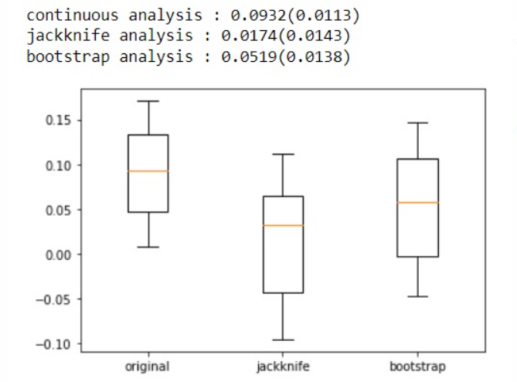

Simulation 2
In the second simulation we used values:
Seed: 100
Number of repeated simulation: 70
Number of users: 800
Duration of the experiment: 10

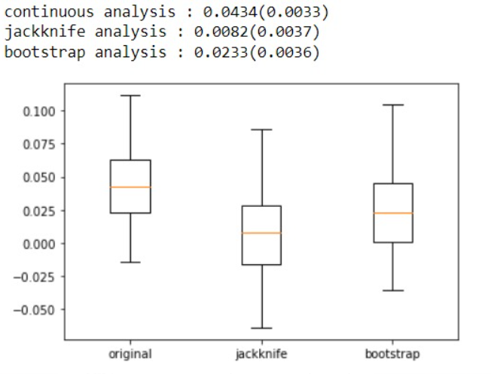

Simulation 3
In this simulation we used values:
Seed: 300
Number of repeated simulation: 300
Number of users: 2000
Duration of the experiment: 50

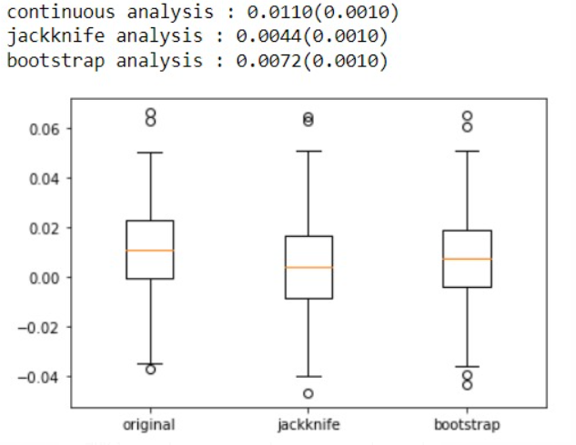

The simulations above were made by the first model, were we can see that each simulation has different values regarding the continuous analysis, jackknife and bootstrap analysis. It is quite noticeable that the results tend to be more significant when the duration of the experiment is shorter, as was mentioned by the author in the original paper. The difference between means in these simulations tends to be high while the p-value tends to be low. The inverse can be seen in simulations when the duration of the experiment is longer.

The ground truth Δscaled is set to 1/3 in the original experiment. The estimators are produced for each data generation process, as well as the bias, which is the difference between the estimator and the true value. However, because the true value has no impact on the data generation process, a different ground truth has no impact on the assessment of the true value. Furthermore, because the bias is not measured as the absolute value of the difference, it can be negative. As a result, a shift in the ground truth merely results in a shift in the bias. When the ground truth is set to a greater value, such as 1/2, the bias mean values fall below 0.
The jackknife estimator is no longer the best estimator with the smallest bias because its values are the smallest. However, we are unable to answer the question of whether the bias should be expressed as an absolute value. As a result, we didn't incorporate the ground truth in our reproduction's parameter grid.

4 CONCLUSIONS
Regarding our findings from this reproducibility, there are several things worth mentioning. In terms of the ground truth, the value picked appears to be arbitrary. It has no effect on the ranking of the estimators because it is not included in the data generation process, so it may be ignored for the significance test of difference between the means.
However, it appears that excluding the ground truth from the data production process is questionable.
However, the process of reproducing the experiment was doable including changing different parameters. The proposed bias adjusted estimator outperformed the competition in all relevant circumstances, as evidenced by statistical tests. Further research into the integration of ground truth in the data generation process and its impact on the results would be interesting.
Regarding the dataset that was used to reproduce the experiment, the results were quite similar, however we believe that there are other datasets that would give better results according to the code that was available.

5 REFERENCES
[1] Yu Wang, Somit Gupta, Jiannan Lu, Ali Mahmoudzadeh and Sophia Liu. 2019. On Heavy-User Bias in A/B Testing. In Proceedings of the 28th ACM International Conference on Information and Knowledge Management (Beijing, China) (CIKM ’19).
[2] The Jackknife and the Bootstrap for General Stationary Observations, https://projecteuclid.org/journals/annals-of-statistics/volume-17/issue-3/The-Jackknife-and-the-Bootstrap-for-General-Stationary-Observations/10.1214/aos/1176347265.full
[3] https://www.kaggle.com/zhangluyuan/ab-testing?select=ab_data.csv

