Supplementary Tables
Table S1. Summary of p values obtained with Turkey’s multiple comparison test of CXCL1 levels detected in the sera from wild-type, Gata1^{low}, Psel^{null} and Gata1^{low}Psel^{null} mice (all in the CD1 background) presented in Figure S3C. Gender (M, males; F, females) and age (adult and old) were analyzed as independent variables. The number of mice analyzed in each experimental group is indicated by n. (see Figure 1C for further details). Values statistical significant are in red fonts.
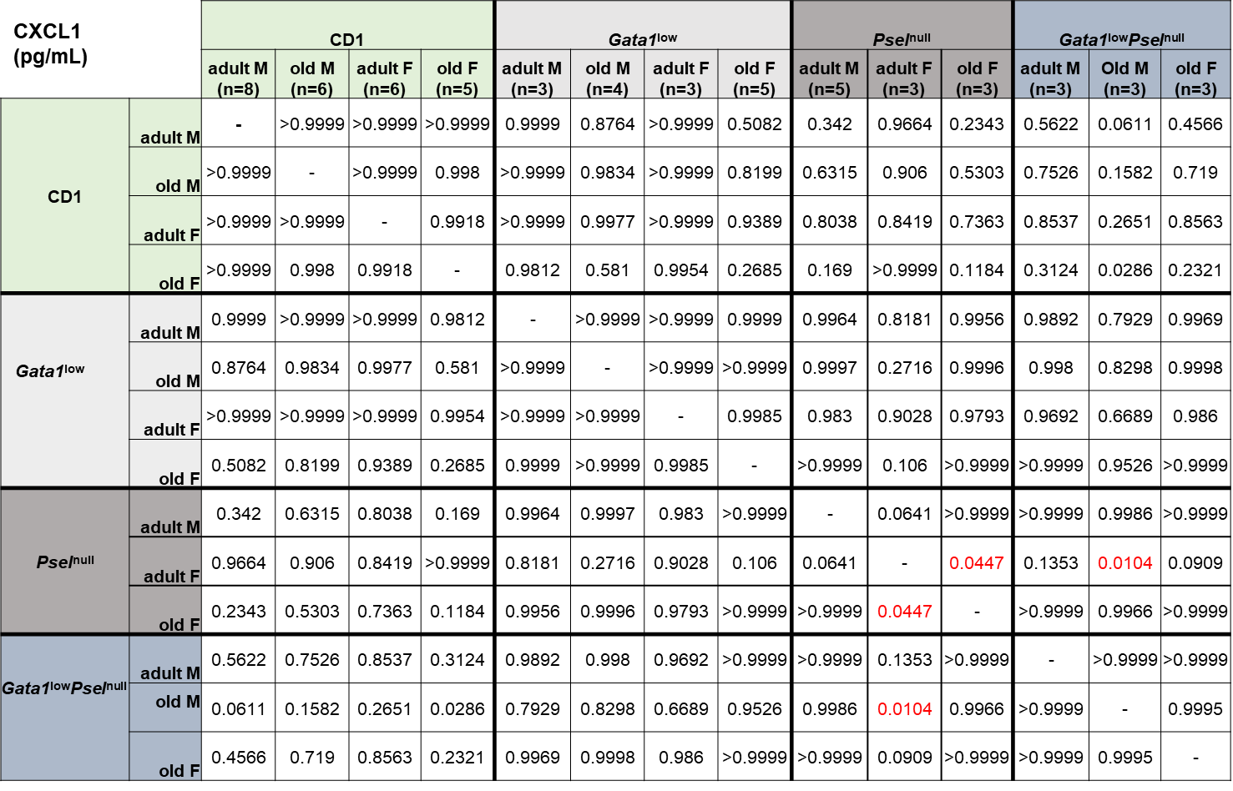
Table S2. Summary of p values obtained with Turkey’s multiple comparison test of TGF-β1 levels detected in the sera from CD1, C57BL/6 and DBA/2 mice presented in Figure S4. Gender (M, males; F, females) and age (adult and old) were analyzed as independent variables. The number of mice analyzed in each experimental group is indicated by n. (see Figure 2 for further details). Values statistical significant are in red fonts.

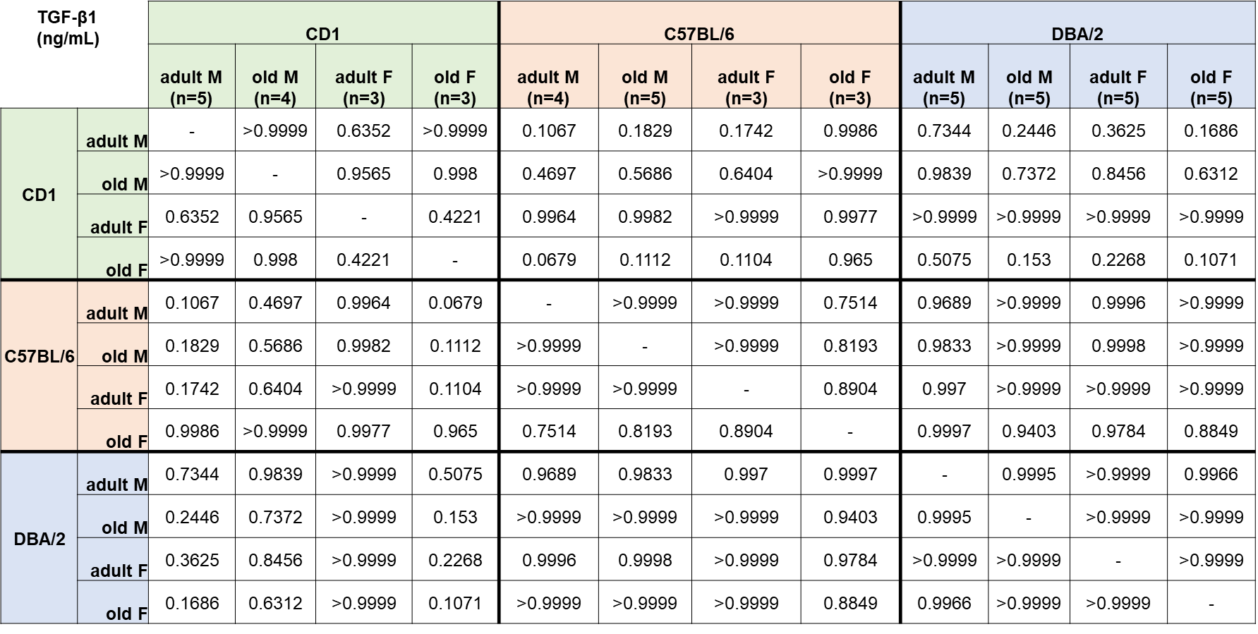

Table S3. Summary of p values obtained with Turkey’s multiple comparison test of LCN2 levels detected in the sera from CD1, C57BL/6 and DBA/2 mice presented in Figure S4. Gender (M, males; F, females) and age (adult and old) were analyzed as independent variables. The number of mice analyzed in each experimental group is indicated by n. (see Figure 2 for further details). Values statistical significant are in red fonts.
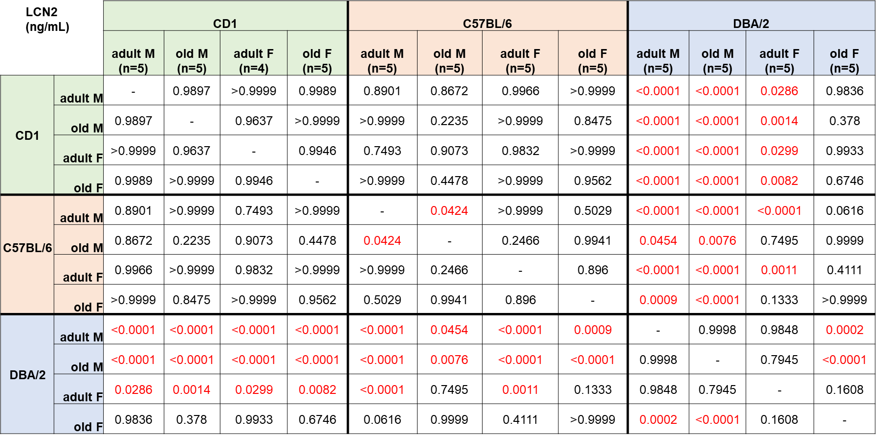

Table S4. Summary of p values obtained with Turkey’s multiple comparison test of CXCL1 levels detected in the sera from CD1, C57BL/6 and DBA/2 mice presented in Figure S4. Gender (M, males; F, females) and age (adult and old) were analyzed as independent variables. The number of mice analyzed in each experimental group is indicated by n. (see Figure 2 for further details). Values statistical significant are in red fonts.
