Rutting and Fatigue Analysis of Flexible Pavement using KENPAVE and IITPAVE: A Review

Kiran S.^{1*}, Kavitha Madhu²
¹Post Graduate Student, ²Associate Professor
Department of Civil Engineering, TKM College of Engineering, Kollam,
Kerala, India.
*Corresponding Author
E-Mail Id: kiranmyd97@gmail.com

ABSTRACT
Pavements are the vital part of any highway system. Due to harsh climatic conditions and premature distresses, pavements are falling apart in initial years of construction, even though they are designed for 15-20 years. Furthermore, pavements frequently fail prematurely due to poor quality control during construction, high axle loads, extreme weather conditions, and insufficient maintenance funding. Understanding the deterioration pattern of the flexible pavement is necessary to take the decision for strengthening the pavement. Premature failures like rutting and fatigue in flexible pavement causes severe distresses in the pavement. The designers adopt the new Mechanistic-Empirical (M-E) pavement design procedure rather than the old empirical design approach for designing pavement structures effectively and efficiently. KENPAVE and IITPAVE software give the pavement responses in terms of stresses and strains and have significant influence on performance prediction which is based on the M-E design approach. This paper reviews the existing literatures on the response analysis of flexible pavement using KENPAVE and IITPAVE. The selection of materials for the pavement and the performance of pavement can be evaluated more accurately with KENPAVE and IITPAVE.

Keywords:- KENPAVE, IITPAVE, Flexible Pavement, Rutting, Fatigue

INTRODUCTION

The highways are intended to provide a public route for people and vehicles while maintaining an acceptable level of comfort. The design of a flexible pavement is determined by the environmental conditions at each location. Mechanistic empirical method is one of the flexible pavement design based on theory of mechanics.

This method is a combination of mechanistic and empirical approaches for analysing pavement stress, strain, and deflection values. The critical pavement responses, such as stresses and strains, are determined using multilayer elastic theory and then correlated with pavement field performance using empirical models. During the design process, these mechanistic parameters are limited to an acceptable level. Year after year, road infrastructure experiences an increase in loading from both traffic volume and vehicle axle load. Tyre pressure has a significant impact on stresses and strains in upper parts of pavement structures, as well as pavement fatigue and rutting.

As a result, the road must be capable of carrying the vehicular capacity and have adequate subgrade bearing strength. Road infrastructure that cannot withstand the burden of traffic passing through it is subjected to premature failures like fatigue and rutting in the pavement layers. Hence for a pavement design it is important to minimize such premature failures. Road infrastructure that is unable to withstand the traffic load passing through it suffers from premature failures such as fatigue and rutting in the pavement layers. Hence, it is critical for pavement design to minimise such premature failures.

Software in Flexible Pavement Design
The design of the flexible pavement needs to make different experimental tests and calculations which might occur a lot of errors during the design phase and results in road failures. Therefore, the use of flexible pavement software can ensure effective design by minimizing the chances of distresses in the road design.

IITPAVE Software
IITPAVE Software is a mechanistic- empirical software used for the design, analysis of the flexible pavement. The input data used in this program to obtain stresses and strains at different layers are the elastic modulus, poisson’s ratio, the thickness of different layers, wheel load and tyre pressure of a vehicle. The result of strains obtained from IITPAVE software (as shown in Figure 1) will be compared with the allowable strains and if the strains obtained are less than the allowable standard strains then the pavement thickness is called satisfied.


Fig.1:- Main screen of IITPAVE

KENLAYER Software
The software called KENPAVE for pavement analysis was developed by Yang at the University of Kentucky (screenshot shown in Figure 2). The software comprises of the data input interface LAYERINP and graphic program LGRAPH together with KENLAYER and KENSLABS used for the analysis of flexible and rigid pavements respectively. It can be used to analyse the layered pavement in various wheel configurations such as dual-tandem, dual-tridem, single, and dual wheel with linear elastic, nonlinear, and visco-elastic layer behaviour taken into account.

The software generates stresses, strains, and deflections at ten distinct radial coordinates or 19 different vertical coordinates, and analyse pavements with up to 19 layers. The superposition and x and y coordinate system of referencing are considered for tandem and tridem wheel configuration. The solution of stresses, strains, and deflections in the KENLAYER program is based on a fourth order differential equation (Omer and Eghan [8]).


Fig.2:- Main screen of KENPAVE

EFFECT OF REINFORCEMENT AND MODIFIERS ON THE PAVEMENT PERFORMANCE
In this section the effect of reinforcement and material properties of different layers of pavement using software like KENPAVE and IITPAVE are discussed.

Visvanathan et al. [19] conducted a study on coir reinforced low volume road subjected to static loading. Various field tests were used to determine the improved elastic modulus values, with the Plate Load test results being used for analysis. The KENPAVE software was used for damage analysis. When coir geotextiles were used as reinforcements, the aggregate layer thickness decreased significantly when compared to unreinforced sections. Geotextiles with higher mass per unit area, higher tensile strength, and smaller aperture size have been shown to improve the performance of reinforced sections.

Reddy et al. [12] designed a Low-Volume Road (LVR) with Recycled Concrete Aggregate (RCA) bases treated with Bitumen-Emulsion. The KENPAVE software was used for obtaining the stress and strain to optimize the thickness of each layer. The maximum vertical compressive strains are observed at the centre of dual wheel system. Researchers found that cement treated mixes with 75% RCA and 100% RCA can be used for the base/sub-base layer materials especially for Low Volume Roads (LVRs) and the use of cement-treated bases/subbases with RCA can produce a reduction in thickness.

Hafez et al. [4] investigates the influence of using recycled plastic Polyethylene Terephthalate (PET) as a soil reinforcement material on the Resilient modulus (M_{R}) of a clayey soil which is an ordinary soil in the delta region in Egypt. A typical flexible pavement section with 10.16 cm (4 in.) asphalt layer atop 25.4 cm (10 in.) granular base layer resting on a subgrade layer was designed and the damage analysis was performed using KENLAYER software. For improving the performance of the pavement structure, recycled plastic bottles was used for reinforcing the subgrade as an alternative method. The plastic waste reinforced subgrade increases its resilient modulus (M_{R}) until a certain content of PET then the M_{R} lowers when the PET content increases. The universal model can predict the M_{R} values of subgrade. Reinforcing subgrade layer with 0.6% PET enhances the fatigue and rutting life of pavement. Figure 3 shows the comparison of the horizontal tensile strain at bottom of bituminous layer of the original and reinforced sections whereas Figure 4 represents the comparison of vertical strain at top of subgrade layer of the original and reinforced sections. The horizontal tensile strain at the bottom of bituminous layer was decreased by 3.25% in reinforced subgrade with 0.6% plastic content compared to the original section under the centre line of wheel load. Similarly, a reduction in the vertical compressive strain was observed in the reinforced subgrade by 12.7% under the centreline of wheel load. This study proves that reinforced subgrade can also be modelled on KENPAVE software.

Chandak et al. [2] focused to discover the optimum content of using the identified wastes like crumb rubber, plastic, e-waste to replace bitumen and aggregates of rural roads. A few laboratory tests on modified mixtures were conducted in order to understand the feasibility and optimal content of wastes in the construction of village roads. The California Bearing Ratio (CBR) test was used to estimate the subgrade strength in the research area. IITPAVE software was used to analyse the performance of rural roads of the study area based on the suitability of identified wastes in bituminous layer. The design charts were created based on utilizing the wastes for rural roads in Karad, District – Satara, India using the IITPAVE software.

Gonwala et al. [3] used industrial waste such as Electric Arc Furnaces (EAF) slag Ground Granulated Blast Furnace Slag (GGBFS) in base or subbase layer and studied its effect. Different trail mixes of EAF slag + Cement and EAF slag + GGBFS were tested to find an optimum mix by varying the composition. The IITPAVE Software was used to obtain the pavement thickness with the optimum mix as well as to validate the critical strains are within the allowable limit. The use of industrial waste in Indian rural roads gives a remedy for the waste management in the sustainable viewpoint.

Reddy and Ramu [13] focused on the preparation of high modulus bituminous mixes using hard grade bitumen with Polyphosphoric Acid (PPA) as modifier. Researchers found that the high-grade bitumen resist more towards high temperature, plastic deformation, and its resilient modulus is twice that of virgin bitumen. Marshall stability and Indirect tensile strength of hard grade bituminous mix was higher than the conventional mix. A pavement section was designed for 300 msa by using IITPAVE as per IRC: 37-2018 guidelines. The reduction of 40 mm was observed in the pavement section with high grade bituminous mix compared to the conventional mix.

Harish [5] designed the flexible pavement by incorporating alternate materials like cementitious and reclaimed asphalt materials and analysed the critical responses using the software IITPAVE. For that a road stretch around Bangalore is selected and subgrade properties soil was studied. The different pavement composition materials like cementitious Base and cementitious Sub-base of aggregate interlayer for crack relief, cementitious base, and sub-base with Stress Absorbing Membrane Interlayer (SAMI) at the interface of base and the bituminous layer, Foamed bitumen/bitumen emulsion treated Recycled Asphalt Pavement (RAP) or fresh aggregates, and cementitious sub-base were used. Then the section was designed, analysed, and compared with the conventional granular base and granular subbase. In compared to standard granular base and granular sub-base, the study reveals that using different composition materials in pavement structure enhances serviceability. Cemented base and subbase with SAMI, a significant reduction in stresses, thickness, and cost was noticed and also enhanced serviceability when compared to alternative designs among all the compositions.

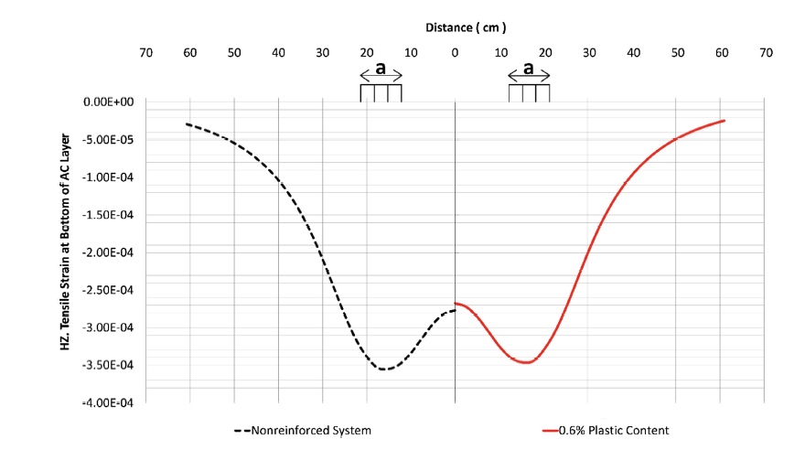
Fig.3:- Comparison of the horizontal tensile strain at bottom of AC layer of the
original and reinforced sections
(Source: [4])
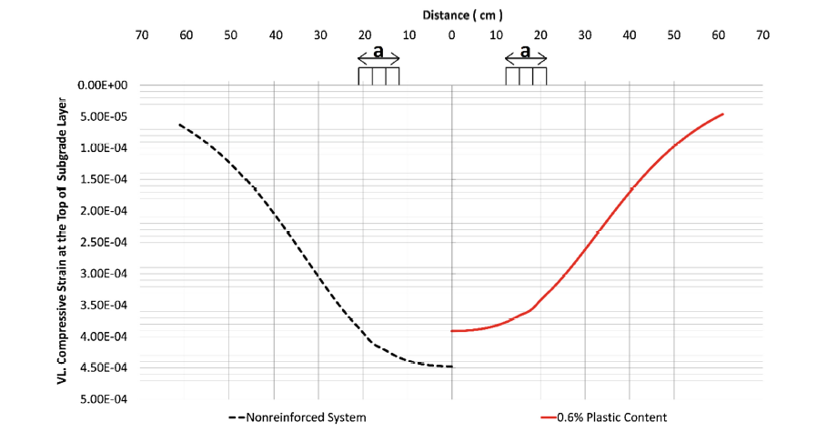
Fig.4:- Comparison of vertical strain at top of subgrade layer of the original
and reinforced sections
(Source: [4])

EFFECT OF VARIATION OF THICKNESS OF PAVEMENT LAYERS AND RESILIENT MODULUS ON PAVEMENT RESPONSE
Sahis et al. [15] observed that granular layer thickness is more responsive to pavement performance in terms of rutting and cracking than bituminous layer thickness. The thickness of the granular layer required against rutting and fatigue decreases with the increase in bituminous layer thickness and vice versa. Researchers found that the optimum thickness of the pavement section will be the coordinates of the intersection point of the curves in terms of the bituminous and granular layer as shown in Figure 5. The deflection of the pavement section determined using Odemark's-Boussinesq's approach were compared with results obtained for similar sections using KENPAVE and IITPAVE software have been found good in agreement.

Rind et al. [14] analysed a flexible pavement using KENLAYER software with respect to rutting and fatigue distresses. Researchers used the NHA (N-55) stretch of road in Sehwan, Pakistan, as the reference pavement and examined it by changing the bituminous course thicknesses by 25%. Rutting and Fatigue early failures were investigated using the KENLAYER software on 20 cross-sections. As the thickness of asphaltic wearing course and asphaltic base course were increasing, the micro strains were decreasing and allowance for number of loading repetition was increased and vice versa.

Using the software KENPAVE, Srikanth [17] examined the effect of surface layer thickness and modulus of elasticity on pavement performance. Using modulus of elasticity (E) and thickness (h) as main parameters, researcher investigated the effects of vertical compressive stress as well as horizontal tensile strain on pavement performance. The results showed that as the surface thickness increases, the compressive and tensile micro stress reduces. Changes in surface thickness can help to alleviate pavement distress and cutting costs.

Priyanka et al. [11] used KENPAVE software tool for the analysis of low volume road. The resilient modulus of subgrade and granular layers were determined based on the equation provided in IRC: 37-2012. Tensile and compressive strains, Fatigue and Rutting lives and damage ratio were obtained from the KENPAVE software by conducting damage analysis. From the analysis it is seen that in extreme conditions of full or partial submergence of pavements in heavy rainfall conditions the resilient modulus (M_{R}) will be reduced. On simulating the reduction in M_{R} value, vertical displacement increased about 1.3-4 times, fatigue life and rutting life reduced by 58-98% and 72-100% respectively from the conventional values.

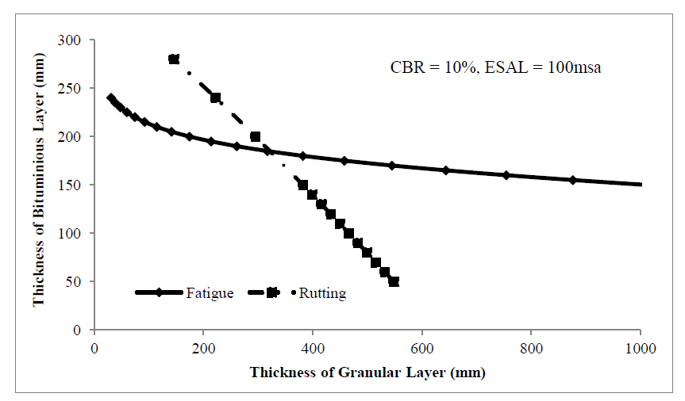
Fig.5:- Variation of bituminous and granular layer thickness under fatigue and rutting
(Source: [15])

EFFECT OF AXLE LOAD ON PAVEMENT PERFORMANCE
The effect of axle load and its configuration on the response is reviewed in this section.

Sahis et al. [15] studied the effect of axle load with layer thickness. The rate of increase in bituminous layer thickness was found to be less with the changes in axle load repetitions beyond 50 msa. However, the variation of granular layer thickness with axle load repetitions was found reasonably higher for lower subgrade CBR than the subgrade with higher CBR. But the variation of bituminous layer thickness was found to increase significantly with increase in axle load repetitions for subgrade with lower to higher CBR.

Tajudin and Priyatna [18] analysed the flexible pavement mechanistic response to axle configurations and tyre variations with the help of KENPAVE program based on field survey conducted in Cipularang Highway Km. 97. The axle load divided by the number of tyres gives each tyre load. Vertical compressive strain at the top of the subgrade was used to analyse rutting damage while horizontal tensile strain at the bottom of the bituminous layer was used to analyse fatigue damage.

The data input needed were elastic modulus, poisson’s ratio, thickness of pavement layers, and load condition. The responses at various points along the transverse direction were compared to determine the critical response caused by axle and tyre configuration. The number of allowable repetitions (N_{R}) and (N_{f}) is inversely proportional to the horizontal strain value, meaning that the greater the horizontal strain value, the number of vehicle repetitions will be smaller while crossing the road without causing rutting fatigue. It can also be seen that the pavement used will not experience groove damage because the actual repetition value is below the N_{R} and N_{f}. On single axle single tyre, the biggest strain value is at the center of the tyre. Single axle dual tyres experience the highest strain at the tyre radius. Tandem and tridem axle dual tyres have the greatest strain values at centre point in between tyres. The critical mechanistic parameters are influenced by both axle configuration and vehicle loading.

Pandey et al. [9] evaluated the effect on the service life of bituminous pavement in rutting and fatigue damage of bituminous pavement with that of higher axle load. ANSYS Mechanical APDL finite element software was used to develop the three-dimensional Finite Element Model (FEM) of bituminous pavement. The surface deflection produced via KENPAVE was validated by comparing it to the FEM model. The validated model was tested to dynamic loading conditions in order to acquire the pavement reaction at varying axle loads under real-time truck loading. The critical strains causing fatigue and rutting damage in pavement were calculated using the most damaging vehicle speed.

The critical strains measured were incorporated into the Rutting and Fatigue models generated by the Asphalt Institute to estimate the service life of bituminous pavement. FEM was used to examine the impact of vehicle speed on crucial mechanistic parameters. The impact of higher axle load on pavement service life is assessed in order to develop a policy to penalise heavy vehicles based on the extent of damage caused by them on the pavement. From Figure 6 and 7, higher axle load condition and slow-moving traffic conditions were observed to cause severe distress on the pavement.

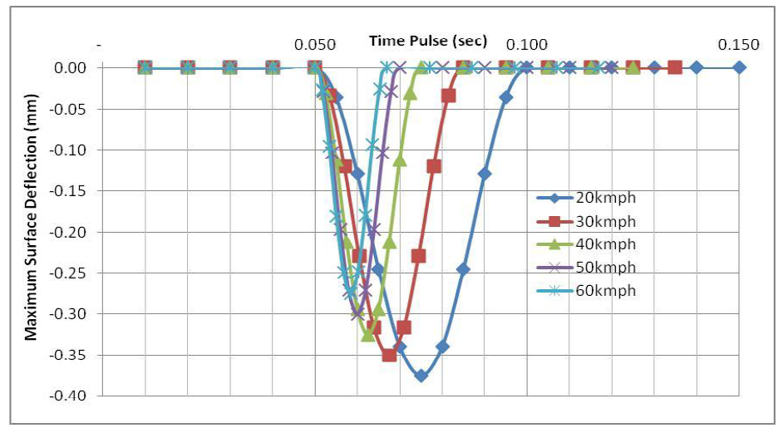
Fig.6:- Maximum surface deflection at different vehicles
(Source: [9])

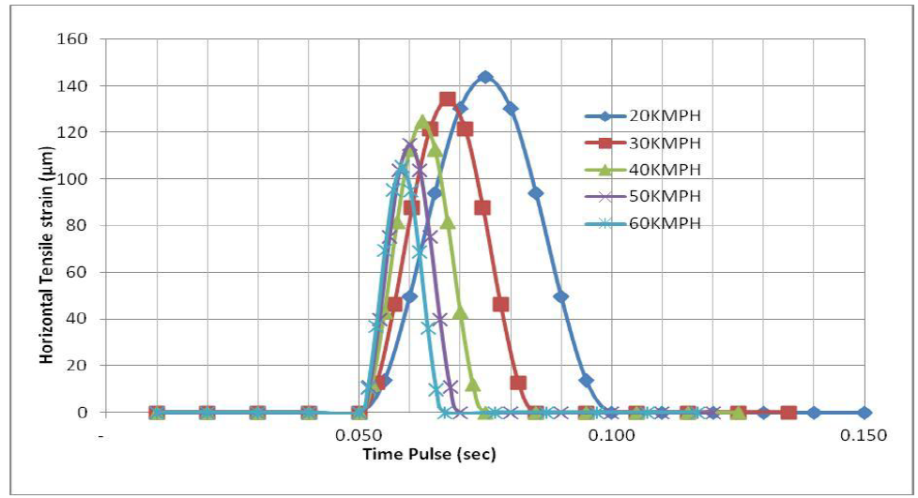
Fig.7:- Maximum horizontal critical strain at different vehicles speed
(Source: [9])

VALIDATION OF PAVEMENT RESPONSE
This section deals with the review of literatures which validate the pavement response from other software. The comparison of real response with the response from IITPAVE and KENPAVE is discussed in some papers as well as its accountability is verified with economic software.

Singh et al. [16] deals with the prediction, comparison, and analysis of the overlay to be provided over the existing pavement of the National highway in the state of Haryana, India using the salient features of KGPBACK, IITPAVE and HDM-4. Researchers used the existing Falling Weight Deflectometer (FWD) technique to measure the deflection of the pavement on three selected portions that were classed as H-1, H-2, and H-3 based on the pavement condition. The elastic moduli of each layer were calculated through KGPBACK software by using the deflection data from FWD. The elastic moduli of the H-3 were detected to be best whereas for section H-1, it was found out to be the lowest which tells the effect of the pavement condition on the elastic modulus. The overlay thickness was found to vary based on the elastic modulus of the existing pavement. IITPAVE software was used to predict it. The HDM-4 software validated the provided overlay thickness, a significant reduction in ravelling, rutting, cracking, and also roughness distress values were observed. The modelling of bituminous overlay maintenance improved the conditions of all pavement sections, and the lifetime of the Indian Highway Roads can be increased.

Mohan and Kumar [7] dealt with the analysis of flexible pavement using IITPAVE Software and Economic Analysis of the Project using HDM-4 Software. In this study researchers aimed at collection of data related to traffic studies and subgrade soil CBR values from the field and designing the flexible pavement as per the guidelines of IRC: 37-2012. Then IITPAVE software was used for validation. The road selected for the study was Madhugiri-Chikkabbalapur section of NH-234. The best engineering and economic alternatives for the road sections are found out using IITPAVE and HDM-4 software. The actual horizontal tensile strains and vertical compressive strains are within the allowable limit at both the locations. Thus, the assumed pavement thickness is correct, and the pavement designed is safe. The Economic evaluation of project road using HDM-4 software gives results of economic indicators like Economic Internal Rate of Return (EIRR) and Economic Net Present Value (ENPV).

Patil et al. [10] discusses importance of KGP Back software and it is used for revising the thickness of pavements. Researchers selected NH-218 (Bijapur to Hubballi) for the study. FWD test was conducted at the selected locations and the test results were analysed using KGPBACK software as per IRC: 115-2014 and the design was verified by IITPAVE software. Equation for fatigue and rutting given in IRC: 37-2012 were used to calculate the allowable strains which later compared with the calculated strains from IITPAVE. A new thickness was proposed for the pavement based on the KGPBACK and IITPAVE results.

Armilli et al. [1] studied on the mechanical behaviour of materials to evaluate the distress parameters of flexible pavements. The pavement designing tool ANSYS was primarily used to analyse and compare the mechanical behaviour of a standard pavement with hot bituminous surfacing, foamed base pavements as well as cold recycled emulsified with fresh overlay. KENPAVE and IITPAVE were used to verify the results obtained from this ANSYS. A slight lesser tensile strain and vertical displacement values were observed in ANSYS, but the linear elastic analysis in both KENPAVE and IITPAVE match well. The study was extended towards the comparative cost benefit analysis of both recycled and conventional mixes.

Pandey et al. [9] studied the effect of higher axle load on the rutting and fatigue life of the flexible pavement. Researchers used ANSYS for developing the 3D model and the obtained response was validated with KENPAVE. Figure 8 shows the surface deflection at various distances obtained through KENPAVE and ANSYS match well.

Khan et al. [6] used KENLAYER and General Analysis of Multi-layered Elastic Systems (GAMES) for the analysis and design of asphalt highway pavement and compared their results. The programmes are equivalent for analysing any flexible pavement; the KENLAYER software is used to determine the pavement's responses, while the GAMES software is used to model asphalt pavement with multiple layers and loads with layer interface slip and have more accuracy. GAMES computer program model provides 68% vertical deflection results more than that the value of KENLAYER program Pavement deflection data analysis in this project shows that the modulus values have been decreased, which indicates the decrease in the capacity and capability of the pavement. Both the software in fact have viability for the analysis and design of an asphalt pavement. The design traffic load application also elaborated its accumulative applicable application for the design of traffic load, using some theoretical analysis. The KENLAYER software idealises a more realistic approach to determining and generating distinct outputs for Layered elastic analysis for three-layered elastic pavements.

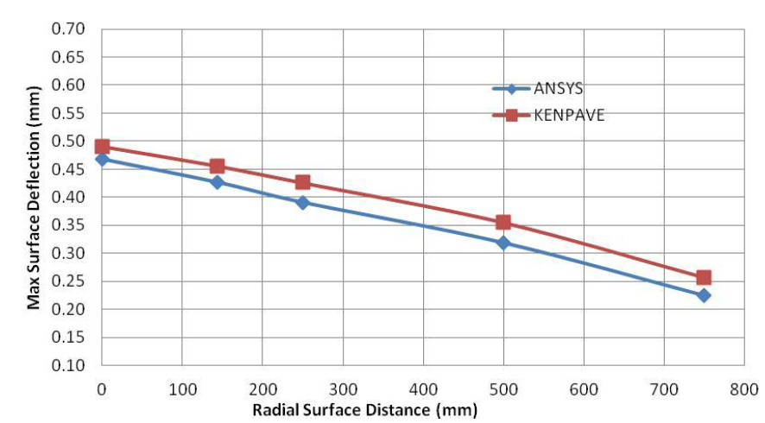
Fig.8:- Surface deflection at various radial distances
(Source: [9])

CONCLUSION
This review examines how the mechanistic approach response can be used to assess the performance of a pavement. Based on the pavement studies examined in this paper, it is possible to conclude that under both static and dynamic wheel loads, layered elastic analysis is a good approximation of actual pavement responses. The layered elastic method is appropriate for predicting pavement responses under various environmental and loading conditions. As evidenced by various research studies, direct measurement of pavement responses has limitations. Due to the limitations of both theoretical modelling and direct measurement, the exact pavement response cannot be represented. Nevertheless, the software KENPAVE and IITPAVE can be used for response analysis of flexible pavement. The following are some specific conclusions based on the analysis of the KENPAVE and IITPAVE software.
- Reduction in the critical mechanistic parameters like horizontal tensile strain and vertical compressive strain can be achieved by increasing the thickness of pavement layer, thereby increasing the rutting and fatigue life of the pavement.
- During heavy rainfall, the resilient modulus values of the pavement decrease, reducing rutting and fatigue life of the pavement.
- The analysis shows severe distresses at high axle loading and slow-moving traffic conditions.
- The reinforced and unreinforced sections can be reliably modelled and compared using software such as KENPAVE and IITPAVE.
- Reinforced sections can extend the life of the pavement and reduce material consumption.
- The KENPAVE and IITPAVE can be used to validate other software.

REFERENCES
- Arimilli, S., Nagabhushana, M. N., and Jain, P. K. (2018). Comparative mechanistic-empirical analysis for design of alternative cold recycled asphalt technologies with conventional pavement. Road Materials and Pavement Design, 19(7), 1595-1616.
- Chandak, P. G., Tapase, A. B., Patil, R. P., Sayyed, S. S., and Attar, A. C. (2019) Utilizing different wastes in rural roads of Karad, District–Satara, India., International Journal of Innovative Technology and Exploring Engineering (IJITEE) ISSN: 2278-3075, 8(11),3464-3469.
- Gonawala, R. J., Khapre, S., Kumar, R., and Chauhan, K. A. (2019). Suitability of EAF slag and GGBFS mix as cementitious base/subbase layer for low volume road construction. International Journal of Geotechnical Engineering, 15(2), 252-258.
- Hafez, M., Mousa, R., Awed, A., and El-Badawy, S. (2018). “Soil reinforcement using recycled plastic waste for sustainable pavements.” International Congress and Exhibition Sustainable Civil Infrastructures: Innovative Infrastructure Geotechnology, (pp. 7-20). Springer, Cham.
- Harish, G. R. (2017). Analysis of Flexible Pavements Design Using IIT PAVE. Imperial Journal of Interdisciplinary Research (IJIR), 3(6), 815-818.
- Khan, J. S., Ali, T. H., Memon, A. A., Khoso, S., Keerio, M. A., and Sohu, S. (2017). Modelling Analysis of GAMES and KENLAYER for Highway Pavement and Management. Engineering Science and Technology International Research Journal, 1(3), 28-32.
- Mohan, A. N. and Kumar, P. (2020). Analysis of Flexible Pavement using IITPAVE Software and Economic Analysis of the Project using HDM-4 Software. International Journal for Research in Applied Science and Engineering Technology, 8(5), 2651-2657.
- Omer, J. R., and Eghan, B. A. (2018). “Numerical analysis of road pavement response”. Advancements in Civil Engineering and Technology, 2(2), 1-9.
- Pandey, S., Chowdary, T. H., and Rokade, S. (2019). “Effect of higher axle loads on service life of bituminous pavement”. In Pavement and Asset Management (pp. 557-565). CRC Press.
- Patil, C. C., Shivananda, P., and Vinod, B. R. (2018). Flexible Pavement Evaluation by Falling Weight Deflectometer Test Using IITPAVE And KGPBACK Software. International Journal of Applied Engineering Research, 13(7), 180-183.
- Priyanka, B. A., Lekha, B. M., Goutham, S., and Ravi Shankar, A. U. (2015). “Kenpave analysis for low volume road with reduced resilient modulus values”. 2nd Conference on Transportation Systems Engineering and Management, NIT Tiruchirappalli, India.
- Reddy, B. S., Reddy, G. S., and Sashidhar, C. (2020). “Pavement Design of Cement Treated Recycled Concrete Aggregate Bases for Low Volume Roads”. Journal of Critical Reviews, 7(18), 1105-1112.
- Reddy, G. S., and Ramu, P. (2019). Design of Bituminous Mixes for Heavily Trafficked Roads–A Boon to Indian Roads. Int. J. Tech. Res. Sci., 6(4), 34-38.
- Rind, T. A., Memon, N. A., and Qureshi, A. S. (2019) “Analysis and Design of Flexible Pavement Using Empirical-Mechanistic Based Software (KENPAVE)”. International Conference on sustainable development in civil engineering, Muet, Pakistan.
- Sahis, M. K., and Biswas, P. P. (2021). Optimization of Bituminous Pavement Thickness using Mechanistic-Empirical Strain-Based Design Approach. Civil Engineering Journal, 7(5), 804-815.
- Singh, A., Sharma, A., and Chopra, T. (2020). Analysis of the flexible pavement using falling weight deflectometer for Indian National Highway Road network. Transportation Research Procedia, 48, 3969-3979.
- Srikanth, M. R. (2015). “Study on Effect of Surface Course Thickness and Modulus of Elasticity on Performance of Flexible Pavement using a Software Tool”. International Journal of Engineering Research and Technology, 4(08), 771 –774.
- Tajudin, A. N. and Priyatna, R. (2019). “Effect of Axle and Tire Configurations on Flexible Pavement Response”. In IOP Conference Series: Materials Science and Engineering (Vol. 508, No. 1, p. 012004). IOP Publishing.
- Visvanathan. A., Velayudhan, S., and Mathew, S., (2020). “Field evaluation of coir geotextile reinforced subgrade for low volume pavements”. Journal of natural fibers.doi:10.1080/15440478.2020.1758279.

Cite this article as: [To be assigned]

