Supporting Information

Title
Variable vulnerability to climate change in New Zealand lizards

Authors
Scott Jarvie^{1,2,3,4,5}, Travis Ingram², David G. Chapple⁶, Rodney A. Hitchmough⁷, Stuart V. Nielsen⁸,
Joanne M. Monks^{1,2}

Affiliations
¹Te Papa Atawhai | Department of Conservation, Biodiversity Group, PO Box 5244, Dunedin, 9058, Aotearoa New Zealand
²Te Tari Mātai Kararehe | Department of Zoology, University of Otago, 340 Great King Street, PO Box 56 9054, Dunedin, Aotearoa New Zealand
³Section for Ecoinformatics and Biodiversity, Department of Biology, Aarhus University, Aarhus C 8000, Denmark
⁴Center for Biodiversity Dynamics in a Changing World (BIOCHANGE), Aarhus University, Aarhus C 8000, Denmark
⁵Otago Regional Council, Science Team, 70 Stafford Street, Dunedin, 9010, Aotearoa New Zealand
⁶School of Biological Sciences, Monash University, Wellington Road, Clayton, VIC 3800, Australia
⁷Te Papa Atawhai | Department of Conservation, Wellington, 6143, Aotearoa New Zealand
⁸Division of Herpetology, Florida Museum of Natural History, Gainesville, FL, United States of America

Correspondence
Scott Jarvie
E-mail: sjarvie@gmail.com

Phylogeny Reconstruction
Phylogenetic trees have been constructed for Aotearoa New Zealand (hereafter NZ) geckos by (Nielsen et al., 2011) and for NZ skinks by (Chapple et al., 2009). For geckos we used a subset of the sequences used by Nielsen et al. (2011) for four genes, two nuclear (RAG 1, PDC) and two mitochondrial (16S, ND2 along with flanking tRNA sequences). For skinks, we used sequences from Chapple et al. (2009) for one nuclear (RAG 1) and five mitochondrial (ND2, ND4, Cyt b, 12S and 16S) genes, and additional ND2 sequences for taxa not included in the original phylogeny (Chapple et al., 2011, p. 201). In total we used sequences for all recognised extant taxa (Hitchmough et al., 2016) as at 2019 except for three species of skink (O. aff. inconspicuum “Okuru”, O. robinsoni, and O. aff. inconspicuum “North Otago”) and two species of gecko (M. “Cupola” and W. “Kaikouras”) for which genetic data were not available. The taxonomic names listed below, however, reflect current updated names for all taxa (Hitchmough et al., 2016, 2020, 2021; Melzer et al., 2017, 2019, Whitaker et al., 2018). We also included in the gecko alignment four New Caledonian diplodactylids, four Australian diplodactylids, and as outgroup taxa five non-diplodactylid geckos. In the skink alignment, we included O. lichengerum from Lord Howe Island, three New Caledonian species and three Australian outgroup species.

Sequences were aligned using the web interface of the multiple sequence alignment algorithm MUSCLE (Edgar, 2004) with default settings, then alignments were checked by eye. We partitioned the data by gene, with a separate partition for the combined tRNA sequences in the gecko alignment. We used PartitionFinder (Lanfear et al., 2012) to assess support for partitioning each of the protein coding genes into codons 1+2 and codon 3 and to identify the best substitution model for each partition using the Bayesian Information Criterion (BIC). The preferred scheme used third codon partitions for PDC (for geckos) and for all four protein coding genes (for skinks), with substitution models varying among partitions (Table S1).

We inferred time-calibrated phylogenetic trees of geckos and skinks using Markov chain Monte Carlo (MCMC) analysis with the program BEAST (Drummond et al., 2012). We used the uncorrelated lognormal relaxed clock model, with the partitions and substitution models as selected by PartitionFinder. For geckos, we constrained the diplodactylids, the NZ species, and the New Caledonian species to be monophyletic as has been well-supported in past analyses. We calibrated the gecko tree using a uniform prior with an upper bound of 37 Ma for the stem New Caledonian lineage, and exponential prior with a mean of 17 Ma and an offset of 16 Ma for the stem NZ lineage, and a normal prior with a mean of 71.1 and a standard deviation of 9.0 for the split between diplodactylids and the outgroup taxa (Nielsen et al., 2011). For skinks we constrained the NZ species to be sister to the Lord Howe O. lichengerum, and the NZ + Lord Howe clade to be sister to the New Caledonian species. We calibrated the skink tree using an exponential prior with a mean of 21 Ma and an offset of 16 Ma for the split between the NZ and Lord Howe Island species, and a uniform prior with upper and lower bounds of 37 Ma and 16 Ma for the split between the outgroup taxa and the clade including the NZ, Lord Howe Island and New Caledonian species (Chapple et al., 2009). For each substitution rate parameter, we used an exponential prior with a mean of 0.1 for geckos and skinks. We used a Yule tree prior with a flat prior on birth rate. We input as starting trees the maximum likelihood trees obtained using the PhyML algorithm in the PartitionFinder analysis, with branching times manually adjusted to ensure all constraints were satisfied.

For both the gecko and skink analyses, we carried out four MCMC analyses of 15 million generations each, sampling every 2500 generations, using BEAST v1.7.5 (for geckos) and v1.10.4 (for skinks). We used the program Tracer to assess convergence and to confirm that sampling was well mixed (effective sample sizes > 200 for likelihoods and all evolutionary parameters of interest). We discarded the first one-sixth of each run as burn-in, leaving 5000 samples per run. We thinned the tree sample by a factor of 20 and combined trees from the four runs to produce a sample of 1000 trees from the posterior distribution for geckos and for skinks. We used the TreeAnnotator utility to identify the maximum clade credibility tree from each posterior distribution, and computed branch lengths from the median node heights across sampled trees. For all subsequent analyses, we pruned the non-NZ species from the maximum clade credibility (MCC) tree and each tree in the posterior distribution, leaving 41 gecko and 59 skink species.

Table S1. Substitution models for New Zealand Diplodactylidae geckos and for New Zealand Scincidae skinks based on PartitionFinder (Lanfear et al., 2012). The best substitution model was identified using the Bayesian Information Criterion (BIC) for the partitioning of the three protein coding genes into codons 1+2 and codon 3, partition
Partition names | Number of sites | Best model
Geckos
Rag1_pos1, Rag1_pos2, Rag1Pos3 | 1051 | GTR+G+X
PDC_pos1, PDC_pos2 | 263 | K80+G
PDC_pos3 | 132 | K80+G
tRNAs1, tRNAs2 | 452 | GTR+I+G+X
ND2_pos1, ND2_pos2, ND2_pos3 | 1044 | GTR+I+G+X
R16S | 609 | GTR+I+G+X
Skinks
ND2_pos3 | 185 | HKY+G+X
ND2_pos1, ND2_po2 | 368 | TRN+I+G+X
Cytb_pos1, Cytb_pos2 | 464 | HKY+I+G+X
Cytb_pos2 | 232 | TRN+I+G+X
ND4_pos3 | 224 | TRN+G+X
ND4_pos1, ND4_pos2 | 447 | HKY+I+G+X
R16S | 469 | GTR+I+G+X
R12S | 819 | GTR+I+G+X
Rag1_pos3 | 284 | K80+G
Rag1_pos1, Rag1_pos2, | 570 | HKY+G+X

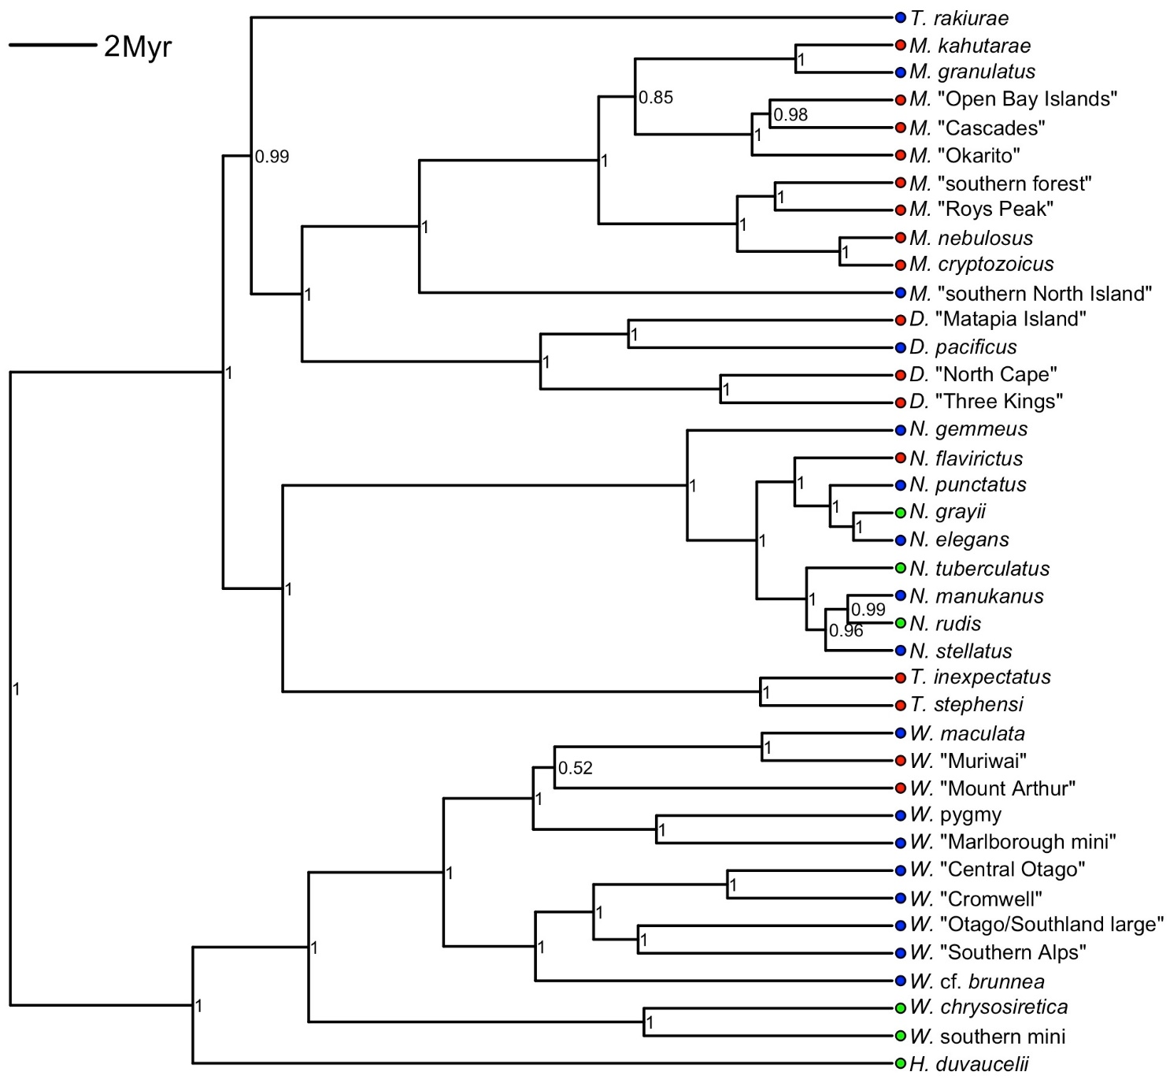
Figure S1. Maximum clade credibility (MCC) phylogeny of New Zealand Diplodactylidae, based on four genes: two nuclear (Rag-1 and PDC) and two mitochondrial (ND2 and 16S). Circles beside species name indicate the range of spatially thinned occurrence records for each species (red = ≤ 15 records; green = > 15, but ≤ 29 records; blue = ≥ 30 records).

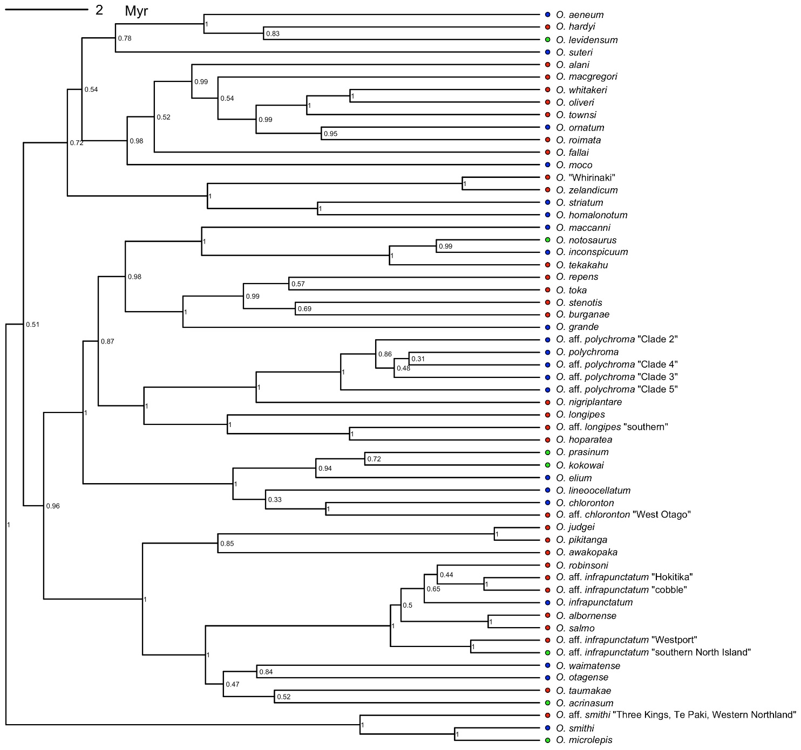
Figure S2. Maximum clade credibility (MCC) phylogeny of New Zealand Scincidae, based on five genes: one nuclear (Rag-1) and five mitochondrial (ND2, ND4, Cytochorme b, 12SrRNA, 16SrRNA). Circles beside species name indicate the range of spatially thinned occurrence records for each species (red = ≤ 15 records; green = > 15 but ≤ 29 records; blue = ≥ 30 records).
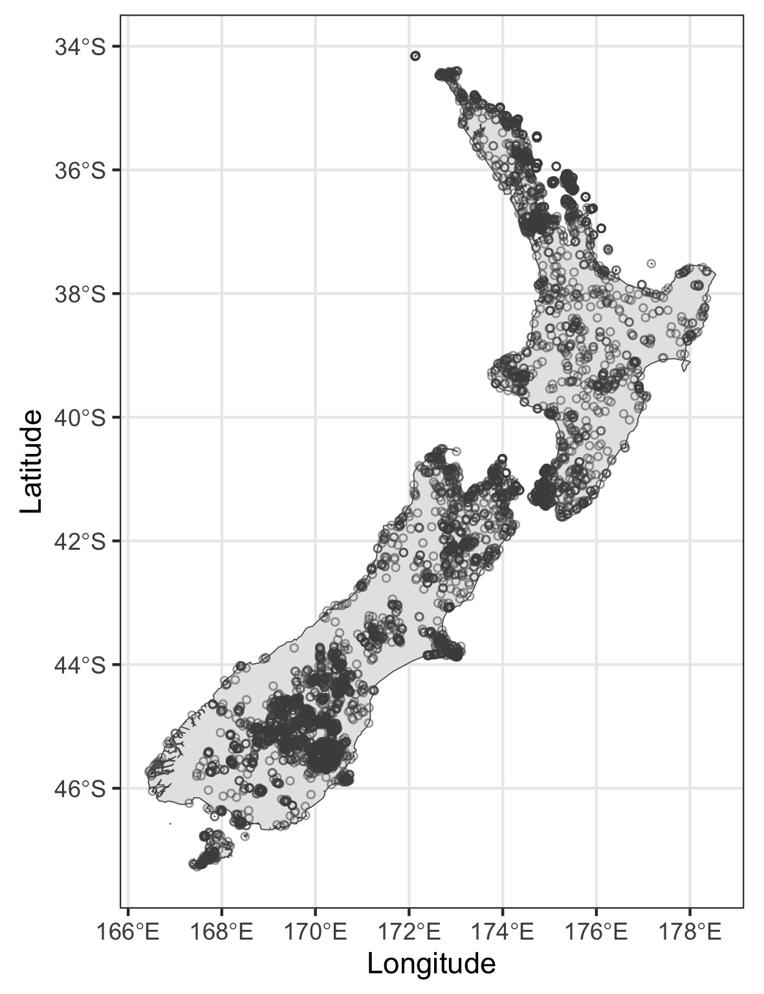
Fig S3. Presence records of New Zealand lizards used as background localities in the maximum entropy (Maxent) algorithm (Phillips et al., 2017) used to predict climatic suitability under current and future climate scenarios.
Table S2. Summary statistics and results from correlative species distribution models (SDMs) for New Zealand lizards from maximum entropy (Maxent) models (Phillips et al., 2017) using taxon-specific parameter tuning in the R package ENMeval (Muscarella et al., 2014; R Core Team, 2020); inds, number of occurrence records for each species; n, the number of occurrence records used for modelling after thinning at 1 km resolution; FC, selected feature class for variable transformation; RM, regularisation multiplier; CBI, continuous Boyce index; OR_{MTP}, omission rate based on the minimum training presence threshold. Life-history and ecological traits for body size, activity phase and habitat use were compiled from the Landcare Research New Zealand Lizards Database (Bell 2010). Within each family (Diplodactylidae and Scincidae), genera or clades are ordered alphabetically, with the species within ordered north to south according to the mean latitude of the distributional area from the SDMs under present climate scenarios. Mean elevation was estimated from the occurrence record using the Shuttle Radar Topography Mission Digital Elevation Model (Robinson et al., 2014). See (Chapple, 2016) for detailed descriptions and maps showing the biogeography of New Zealand lizards. Note that the sum of inds and n do not equal the total occurrence records and the total spatially thinned occurrence records, respectively, as these numbers included taxa we did not run SDMs for.

Species | inds | n | FC | RM | CBI | OR_{MTP} | activity phase | body size (SVL, mm) | OR₁₀ latitude | elevation (m)
Diplodactylidae
Dactylocnemis
D. pacificus | 267 | 221 | LQ | 1.5 | 0.983 | 0.036 | nocturnal | 80 | -38.517 | 124.5
Hoplodactylus
H. duvaucelii | 159 | 26 | L | 0.5 | 0.916 | 0.125 | nocturnal | 161 | -37.365 | 65.6
Mokopirirakau
M. granulatus | 290 | 200 | LQ | 1 | 0.884 | 0.04 | nocturnal | 95 | -39.902 | 219.0
M. “southern North Island” | 109 | 93 | LQP | 0.5 | 0.96 | 0.054 | nocturnal | 90 | -40.068 | 318.0
Naultinus
N. grayii | 24 | 19 | L | 2 | 0.454 | 0.112 | diurnal | 95 | -36.760 | 56.5
N. elegans | 177 | 112 | LQ | 0.5 | 0.619 | 0.111 | diurnal | 70 | -39.224 | 122.6
N. manukanus | 47 | 35 | LQ | 0.5 | 0.956 | 0.056 | diurnal | 81 | -40.416 | 180.5
N. punctatus | 207 | 71 | LQP | 4 | 0.523 | 0.087 | diurnal | 95 | -40.639 | 295.7
N. tuberculatus | 23 | 19 | LQ | 0.5 | 0.179 | 0.25 | diurnal | 85 | -40.786 | 560
N. stellatus | 85 | 65 | LQP | 0.5 | 0.433 | 0.062 | diurnal | 80 | -40.832 | 480.4
N. rudis | 23 | 17 | LQP | 0.5 | 0.765 | 0.062 | diurnal | 72 | -41.872 | 478.5
N. gemmeus | 169 | 112 | LQ | 0.5 | 0.918 | 0.054 | diurnal | 80 | -44.191 | 301.1
Tukutuku
T. rakiurae | 85 | 31 | LQ | 0.5 | 0.685 | 0 | nocturnal | 71 | -47.030 | 250.4
Woodworthia
W. chrysosirectica | 41 | 27 | LQ | 0.5 | 0.113 | 0.036 | nocturnal | 80 | -39.307 | 146.3
W. maculata | 725 | 317 | LQ | 0.5 | 0.797 | 0 | nocturnal | 82 | -40.231 | 187.6
W. “Marlborough mini” | 84 | 54 | LQ | 1 | 0.722 | 0.125 | nocturnal | 65 | -41.213 | 295.5
W. cf. brunnea | 104 | 50 | LQ | 0.5 | 0.857 | 0.019 | nocturnal | 80 | -41.766 | 279.5
W. “pygmy” | 44 | 38 | LQ | 0.5 | 0.936 | 0.194 | nocturnal | 50 | -42.062 | 1089.3
W. “Southern Alps” | 468 | 312 | LQ | 0.5 | 0.907 | 0.022 | nocturnal | 73 | -43.026 | 771.4
W. “Cromwell” | 88 | 60 | LQ | 0.5 | 0.798 | 0.083 | nocturnal | 78 | -44.536 | 698.6
W. “Central Otago” | 88 | 62 | L | 0.5 | 0.946 | 0.017 | nocturnal | 71 | -44.947 | 471
W. “southern mini” | 21 | 18 | LQP | 4 | 0.174 | 0 | nocturnal | 60 | -45.123 | 726.6
W. “Otago/Southland large” | 455 | 302 | LQP | 1 | 0.969 | 0.016 | nocturnal | 85 | -45.256 | 537.6
Scincidae
Clade 1
O. lineoocellatum | 162 | 60 | LQ | 0.5 | 0.778 | 0.2 | diurnal | 111 | -39.699 | 135.4
O. aff. polychroma Clade 2 | 65 | 41 | L | 0.5 | 0.955 | 0.045 | diurnal | 77 | -41.066 | 554
O. elium | 38 | 31 | LQ | 0.5 | 0.828 | 0.237 | diurnal | 95 | -42.530 | 750.9
O. polychroma | 624 | 281 | LQP | 0.5 | 0.747 | 0.093 | diurnal | 77 | -40.122 | 1091.7
O. aff. polychroma Clade 3 | 108 | 42 | L | 0.5 | 0.945 | 0.05 | diurnal | 77 | -41.997 | 554
O. aff. polychroma Clade 4 | 109 | 76 | LQ | 0.5 | 0.775 | 0.079 | diurnal | 77 | -41.861 | 235.6
O. kokowai | 46 | 27 | LQ | 0.5 | 0.712 | 0.179 | diurnal | 103 | -42.431 | 219
O. maccanni | 1410 | 953 | LQ | 0.5 | 0.987 | 0.009 | diurnal | 73 | -43.974 | 694.4
O. inconspicuum | 77 | 52 | LQP | 2 | 0.862 | 0.019 | diurnal | 75 | -44.377 | 487.3
O. aff. polychroma Clade 5 | 422 | 297 | L | 0.5 | 0.733 | 0.107 | diurnal | 77 | -44.807 | 283.1
O. grande | 109 | 55 | LQ | 0.5 | 0.923 | 0.143 | diurnal | 115 | -44.916 | 532.2
O. chloronoton | 91 | 70 | LQ | 2 | 0.911 | 0.059 | diurnal | 125 | -45.452 | 297.7
O. notosaurus | 45 | 29 | L | 0.5 | 0.993 | 0.143 | diurnal | 76 | -46.978 | 159.3
Clade 2
O. robinsoni | 28 | 17 | L | 0.5 | 0.964 | 0.125 | diurnal | 115 | -39.635 | 6
O. infrapunctatum | 82 | 36 | LQP | 4 | 0.887 | 0 | diurnal | 115 | -43.679 | 286.7
O. waimatense | 82 | 43 | LQ | 1 | 0.806 | 0.118 | diurnal | 110 | -43.679 | 1038.3
O. otagense | 162 | 78 | LQ | 0.5 | 0.873 | 0.188 | diurnal | 133 | -44.869 | 489.2
O. acrinasum | 52 | 19 | LQP | 1 | 0.998 | 0 | diurnal | 88 | -45.018 | 45
Clade 3
O. aeneum | 594 | 298 | L | 4 | 0.812 | 0.03 | diurnal | 62 | -38.849 | 95.9
Clade 4
O. ornatum | 338 | 165 | LQ | 0.5 | 0.785 | 0.012 | nocturnal | 80 | -38.773 | 114.2
Clade 5
O. homalonotum | 155 | 48 | LQ | 0.5 | 0.977 | 0.083 | diurnal | 143 | -37.349 | 108.1
O. striatum | 52 | 38 | LQ | 1 | 0.925 | 0.025 | diurnal | 76 | -39.265 | 291.9
O. zelandicum | 218 | 86 | LQ | 0.5 | 0.838 | 0.19 | diurnal | 73 | -40.154 | 144.5
Clade 6
O. suteri | 168 | 52 | L | 0.5 | 0.934 | 0.129 | nocturnal | 108 | -36.654 | 48.7
Clade 7
O. moco | 194 | 75 | LQ | 0.5 | 0.926 | 0.042 | diurnal | 73 | -36.737 | 73.6
Clade 8
O. smithi | 485 | 191 | LQ | 0.5 | 0.932 | 0.011 | diurnal | 80 | -36.721 | 40
O. aff. smithi "Three Kings, Te Paki, Western Northland" | 59 | 34 | LQ | 0.5 | 0.957 | 0.062 | diurnal | 80 | -37.092 | 30.6
O. microlepis | 31 | 17 | LQ | 0.5 | 0.871 | 0.062 | diurnal | 70 | -40.810 | 739.5

Table S3. Estimates of climatically suitable area under current and future climates from correlative species distribution models (SDMs) for New Zealand lizards from maximum entropy (Maxent) models (Phillips et al., 2017). The SDMs were for current (1979–2013) and future climate scenarios (2070, average 2061–2080) for Representative Concentration Pathways (RCPs) 4.5 and 8.5. We also estimate climatically suitable area for a no-dispersal scenario under RCP4.5 and RCP8.5.

Species | Climatic suitability (km²) |  |  | No-dispersal (km²)
 | Current | RCP4.5 | RCP8.5 | RCP4.5 | RCP8.5
Diplodactylidae
Dactylocnemis
D. pacificus | 45644 | 56862 | 84000 | 44874 | 44935
Hoplodactylus
H. duvaucelii | 5636 | 9851 | 37910 | 5636 | 5636
Mokopirirakau
M. granulatus | 130831 | 144156 | 126654 | 118938 | 97512
M. “southern North Island” | 94749 | 23403 | 15825 | 23390 | 15752
M. “Cascades” | 14094 | 11243 | 10324 | 11225 | 10226
Naultinus
N. grayii | 122917 | 99957 | 73374 | 99881 | 73353
N. elegans | 70492 | 95180 | 62451 | 61349 | 42839
N. manukanus | 31412 | 18310 | 15040 | 18310 | 14821
N. punctatus | 154543 | 155445 | 142469 | 151772 | 137164
N. tuberculatus | 69788 | 60536 | 67800 | 57751 | 54658
N. stellatus | 133900 | 107739 | 83637 | 107739 | 83637
N. rudis | 150719 | 146774 | 126920 | 137841 | 114833
N. gemmeus | 102162 | 95297 | 74732 | 64613 | 42586
Tukutuku
T. rakiurae | 863 | 25 | 0 | 4 | 0
Woodworthia
W. chrysosirectica | 46621 | 31398 | 23770 | 30773 | 14183
W. maculata | 92852 | 15905 | 30340 | 15902 | 15192
W. “Marlborough mini” | 74288 | 43687 | 29510 | 43687 | 29510
W. cf. brunnea | 97704 | 66097 | 73201 | 57731 | 45539
W. “pygmy” | 22698 | 9087 | 4171 | 9081 | 3968
W. “Southern Alps” | 74912 | 81081 | 62451 | 68722 | 56973
W. “Cromwell” | 18737 | 12979 | 6184 | 11707 | 6167
W. “Central Otago” | 19067 | 6415 | 1971 | 5997 | 1915
W. “southern mini” | 68031 | 53935 | 42253 | 53935 | 42253
W. “Otago/Southland large” | 23527 | 390 | 0 | 210 | 0
Scincidae
Oligosoma
Clade 1
O. lineoocellatum | 49055 | 36630 | 22445 | 34707 | 16046
O. aff. polychroma Clade 2 | 56337 | 31686 | 21371 | 31686 | 21371
O. elium | 94706 | 76851 | 65313 | 76847 | 65313
O. longipes | 39533 | 32656 | 24293 | 32595 | 24136
O. polychroma | 39081 | 25095 | 49120 | 18211 | 27733
O. aff. polychroma Clade 3 | 65642 | 54005 | 43103 | 54005 | 43103
O. aff. polychroma Clade 4 | 146815 | 140293 | 161446 | 132685 | 135967
O. prasinum | 49055 | 36630 | 22445 | 34707 | 16046
O. aff. longipes "southern" | 28914 | 19752 | 17679 | 19480 | 16431
O. maccanni | 29037 | 20737 | 15551 | 20737 | 15546
O. inconspicuum | 127748 | 100886 | 112870 | 100886 | 103708
O. aff. chloronoton "West Otago" | 18455 | 11535 | 5233 | 11535 | 5233
O. aff. polychroma Clade 5 | 73472 | 52104 | 27349 | 52100 | 27070
O. grande | 18040 | 5794 | 411 | 5781 | 377
O. chloronoton | 129089 | 112511 | 111630 | 107807 | 97729
O. stenotis | 8520 | 3194 | 810 | 3194 | 810
O. notosaurus | 2225 | 1660 | 951 | 1660 | 951
Clade 2
O. robinsoni | 12456 | 17096 | 12623 | 11113 | 9370
O. infrapunctatum | 42175 | 32666 | 42351 | 32659 | 34555
O. waimatense | 37099 | 27510 | 20254 | 27510 | 20254
O. otagense | 30277 | 19101 | 10600 | 18626 | 8444
O. acrinasum | 568 | 223 | 339 | 223 | 274
Clade 3
O. aeneum | 78993 | 98163 | 126409 | 78993 | 78993
Clade 4
O. ornatum | 11959 | 8897 | 2086 | 8773 | 1605
Clade 5
O. homalonotum | 2599 | 159 | 0 | 123 | 0
O. striatum | 77898 | 47851 | 37918 | 47247 | 32334
O. zelandicum | 97237 | 91049 | 109624 | 90742 | 97229
Clade 6
O. suteri | 2530 | 2733 | 2225 | 1925 | 53
Clade 7
O. moco | 8151 | 6129 | 4500 | 5080 | 2306
Clade 8
O. smithi | 11389 | 26336 | 50243 | 11389 | 11389
O. aff. smithi "Three Kings, Te Paki, Western Northland" | 9422 | 4708 | 3178 | 3445 | 1269
O. microlepis | 77877 | 60799 | 48717 | 60798 | 48716

Statistical analysis
For all the Bayesian phylogenetic mixed models (BPMMs), we ran each analysis for 2,000,000 MCMC iterations, with a burn-in period of 200,000 iterations, and a thinning interval of 1,000 to achieve an effective sample size >1,000 for estimated model coefficients in the R package MCMCglmm (Hadfield, 2010). We used the MCMCglmm default prior for the fixed effects, the inverse-gamma prior for the residuals (with variance, V = 1 and belief parameter, nu = 0.002) and a parameter expanded prior for the random factor to improve mixing and decrease autocorrelation among iterations (described by the parameters V = 1, nu = 0.2, and the prior mean alpha.mu = 1000) (Hadfield, 2010). To determine whether our conclusions held when we excluded species with fewer than 30 spatially thinned occurrence records (below which performance of SDMs can be reduced f0r model projections; (Wisz et al., 2008)), we repeated BPMMs with the reduced dataset. Results for these BPMMs were qualitatively similar (see Supplemental Tables S2a- d cf. S4a–d) and are not discussed further. We also assessed whether there was a taxonomic bias in which species we could generate SDMs for (i.e., species having > 10 spatially thinned occurrence records) using BPMMs with a binomial error structure and a probit link. We ran these BPMMs with the same number of MCMC iterations, a burn-in period and thinning interval. They were fitted as a ‘null’ mixed model (intercept-only) along with species-specific intercepts (i.e. the random factor, for the phylogenetic tree), using an inverse-gamma prior for the residuals (with variance, V = 1 and belief parameter, nu = 0.002) and a parameter expanded prior for the random factor (V = 1, nu = 1, alpha.mu = 1,000, and the prior covariance matrix alpha.V = 1000). To assess the convergence of BPMMs, we visually checked trace plots of MCMC chains. We also carried out Gelman-Rubin diagnostic tests based on four independent runs in the R package coda (Plummer Martyn et al., 2006), and confirmed that all models had converged by having a potential scale reduction factor < 1.1 (Gelman & Rubin, 1992).
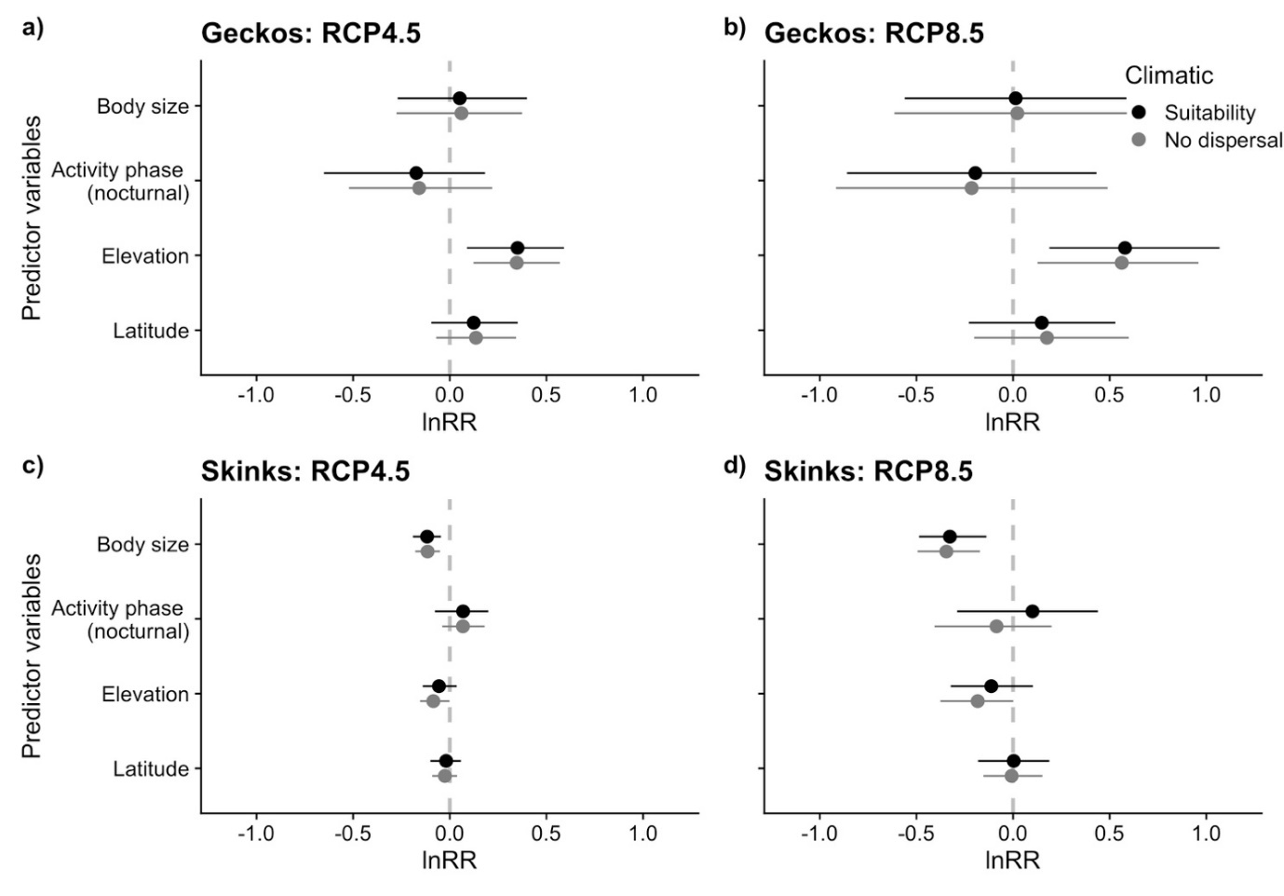
Fig S4. Regression coefficients from Bayesian phylogenetic mixed models (BPMMs) for New Zealand diplodactylid geckos and eugongyline skinks, showing both the relative change and the overlap in climatically suitability habitat for current (representative of 1979–2013) and two future climate scenarios (2070, average 2061–2080) via the consensus of four general circulation models and the Representative Concentration Pathways, RCP4.5 and RCP8.5. As the response variable in the BPMMs, we used log-transformed ratio of the projected range area relative to the current range area (hereafter lnRR for log range ratio) from species distribution models (SDMs) trained with ≥ spatially thinned occurrence records, while the predictors variables were body size, activity phase (diurnal or nocturnal), elevation and latitude. Mean estimates for regression coefficients are shown by circles for relative change in climatic suitability (black) and a ‘no-dispersal’ scenario for climatic suitability (grey) with their 95% credible intervals shown by lines. See Figure Fig 3 for regression coefficients from BPMMs where estimates of climatically suitable area are from SDMs for New Zealand lizards trained with > 15 spatially thinned occurrence records.
References

Bell, T. (2010) New Zealand Lizards Database. http://nzlizards.landcareresearch.co.nz
Chapple, D. G. (Ed.). (2016). New Zealand Lizards. Springer International Publishing.
Chapple, D. G., Ritchie, P. A., & Daugherty, C. H. (2009). Origin, diversification, and systematics of the New Zealand skink fauna (Reptilia: Scincidae). Molecular Phylogenetics and Evolution, 52, 470–487.
Drummond, A. J., Suchard, M. A., Xie, D., & Rambaut, A. (2012). Bayesian phylogenetics with BEAUti and the BEAST 1.7. Molecular Biology and Evolution, 29, 1969–1973.
Edgar, R. C. (2004). MUSCLE: a multiple sequence alignment method with reduced time and space complexity. BMC Bioinformatics, 5, 113.
Elith, J., H. Graham, C., P. Anderson, R., Dudík, M., Ferrier, S., Guisan, A., J. Hijmans, R., Huettmann, F., R. Leathwick, J., Lehmann, A., Li, J., G. Lohmann, L., A. Loiselle, B., Manion, G., Moritz, C., Nakamura, M., Nakazawa, Y., McC. M. Overton, J., Townsend Peterson, A., … E. Zimmermann, N. (2006). Novel methods improve prediction of species’ distributions from occurrence data. Ecography, 29, 129–151.
Elith, J., Phillips, S. J., Hastie, T., Dudík, M., Chee, Y. E., & Yates, C. J. (2011). A statistical explanation of MaxEnt for ecologists. Diversity and Distributions, 17, 43–57.
Gelman, A. (2008). Scaling regression inputs by dividing by two standard deviations. Statistics in Medicine, 27, 2865–2873.
Hadfield, J. D. (2010). MCMC methods for multi-response generalized linear mixed models: the MCMCglmm R package. Journal of Statistical Software, 33.
Hitchmough, R., Barr, B., Lettink, M., Monks, J., Reardon, J., Tocher, M., van Winkel, D., & Rolfe, J. (2016). Conservation status of New Zealand reptiles, 2015. New Zealand Threat Classicification Series 17. Department of Conservation, pp. 1–14.
Hitchmough, R., Nielsen, S. V., & Bauer, A. M. (2020). Earning your stripes: a second species of striped gecko in the New Zealand gecko genus Toropuku (gekkota: Diplodactylidae). Zootaxa, 4890, 578–588.
Hitchmough, R., Nielsen, S. V., Lysaght, J. A., & Bauer, A. M. (2021). A new species of Naultinus from Te Paki area, northern New Zealand. Zootaxa, 4915, 389–400.
Lanfear, R., Calcott, B., Ho, S. Y. W., & Guindon, S. (2012). PartitionFinder: Combined selection of partitioning schemes and substitution models for phylogenetic analyses. Molecular Biology and Evolution, 29, 1695–1701.
Melzer, S., Bell, S., Patterson. (2017). Hidden conservation vulnerability within a cryptic species complex: taxonomic revision of the spotted skink (Oligosoma lineoocellatum; Reptilia: Scincidae) from New Zealand. Zootaxa, 4300, 355–379.
Melzer, S., Hitchmough, R. A., Bell, T., Chapple, D. G., & Patterson, G. B. (2019). Lost and Found: Taxonomic revision of the speckled skink (Oligosoma infrapunctatum; Reptilia; Scincidae) species complex from New Zealand reveals a potential cryptic extinction, resurrection of two species, and description of three new species. Zootaxa, 4623, 441–484.
Muscarella, R., Galante, P. J., Soley-Guardia, M., Boria, R. A., Kass, J. M., Uriarte, M., & Anderson, R. P. (2014). ENMeval: An R package for conducting spatially independent evaluations and estimating optimal model complexity for Maxent ecological niche models. Methods in Ecology and Evolution, 5, 1198–1205.
Nielsen, S. V., Bauer, A. M., Jackman, T. R., Hitchmough, R. A., & Daugherty, C. H. (2011). New Zealand geckos (Diplodactylidae): Cryptic diversity in a post-Gondwanan lineage with trans-Tasman affinities. Molecular Phylogenetics and Evolution, 59, 1–22.
Pearson, R. G., Raxworthy, C. J., Nakamura, M., & Townsend Peterson, A. (2006). Predicting species distributions from small numbers of occurrence records: A test case using cryptic geckos in Madagascar. Journal of Biogeography, 34, 102–117.
Phillips, S. J., Anderson, R. P., Dudík, M., Schapire, R. E., & Blair, M. E. (2017). Opening the black box: An open-source release of Maxent. Ecography, 40, 887–893.
Phillips, S. J., Dudík, M., Elith, J., Graham, C. H., Lehmann, A., Leathwick, J., & Ferrier, S. (2009). Sample selection bias and presence-only distribution models: Implications for background and pseudo-absence data. Ecological Applications, 19, 181–197.
Plummer Martyn, Best Nicky, Cowles Kate, & Vines Karen. (2006). CODA: convergence diagnosis and output analysis for MCMC. R News, 6, 7–11.
R Core Team. (2020). R: A language and environment for statistical computing. R Foundation for Statistical Computing, Vienna, Austria.
Robinson, N., Regetz, J., & Guralnick, R. P. (2014). EarthEnv-DEM90: A nearly-global, void-free, multi-scale smoothed, 90m digital elevation model from fused ASTER and SRTM data. ISPRS Journal of Photogrammetry and Remote Sensing, 87, 57–67.
Wisz, M. S., Hijmans, R. J., Li, J., Peterson, A. T., Graham, C. H., Guisan, A., & NCEAS Predicting Species Distributions Working Group. (2008). Effects of sample size on the performance of species distribution models. Diversity and Distributions, 14, 763–773.

