Supplementary Information for

Pandemics are catalysts of scientific novelty: Evidence from COVID-19

Supplementary Note 1: Existing approaches of measuring scientific novelty

Scientific novelty, which is also known as newness, originality or atypicality (Uzzi, Mukherjee, Stringer et al., 2013), is generally conceptualized as the degree to which scientific discovery provides subsequent studies with new findings, theories, methods or data (Guetzkow, Lamont, & Mallard, 2004; Shibayama & Wang, 2020). Scientific novelty is closely related to two important concepts, creativity and innovation. Novelty and usefulness are described as core components of creativity, which suggests that novelty constitutes an essential part of creativity (Amabile, 1983; Lee, Walsh, & Wang, 2015). Innovation is the successful implementation of creative ideas. Therefore, scientific novelty is widely considered as the basic building block of innovation (Gilmartin, 1999). Conventionality, or commonness, is the opposite side of novelty, indicating the degree to which knowledge commonly appears in the knowledge pool (Uzzi et al., 2013). Additionally, it is essential to differentiate novelty from other relevant performance indicators, such as citations and “hit paper” status. Citations are used to measure the degree to which a paper or patent is used by subsequent work so that the number of citations is used as a proxy for usefulness, one important feature of creativity, but it is independent of novelty (Fleming, 2001; Lee et al., 2015; Wang, 2016). “Hit papers” indicate highly cited papers. For example, Uzzi et al. (2013) defined “hit papers” as those in the upper 5th percentile of citations received across the whole dataset that covers 17.9 million papers. The authors further found that the generation of hit papers is mainly based on a conventional combination of prior work and an intrusion of novel combination.
A reliable measure of scientific novelty is essential for the assessment of scientific output and decision-making in the scientific community (Merton, 1973; Partha & David, 1994; Stephan, 1996). In early work, novelty was often evaluated through peer reviews or surveys (Chubin, Hackett, & Hackett, 1990; Dirk, 1999; Guetzkow et al., 2004), which is practical only on a small scale. Applying bibliometric methods, researchers developed different kinds of measurements of scientific novelty that can be categorized based on their conceptualization and operationalization.
The first group (group 1) of measures focus on the introduction of a new concept or object. Researchers suggest that it can be inferred that a research paper or patent delivers new knowledge if it includes a certain word that is new to the universe of published research. Drawing on Medical Subject Headings (MeSH), Azoulay et al. (2011) used the average age of keywords to measure the scientific novelty of a research paper in life science, which quantifies the extent to which a research paper is novel relative to the world’s knowledge frontier. In the field of biochemistry, novelty is measured based on new chemical entities introduced in research (Foster, Rzhetsky, & Evans, 2015). This idea has also been applied to measure the novelty of patents (Arts, Hou, & Gomez, 2021; Balsmeier, Assaf, Chesebro et al., 2018).
Building on the perspective of recombinant novelty, the second group (group 2) of approaches conceptualized scientific novelty as the degree to which a scientific document includes new or rare combinations of pre-existing knowledge components that are operationalized in different forms. This group of methods has been widely applied in innovation studies. In this category, researchers used text information or citation information to operationalize knowledge components, such as patent classes (Fleming, 2001), keywords (Boudreau, Guinan, Lakhani, et al., 2016; Chai & Menon, 2019), referenced articles (Dahlin & Behrens, 2005; Trapido, 2015), referenced journals (Uzzi et al., 2013; Wang et al., 2017) and chemical entities (Foster et al., 2015). For example, Fleming (2001) suggested that patents that combine technology subclasses that have not been combined previously can be considered creative combinations. The author and colleagues further measured the generative creativity of inventors by investigating the occurrence of new combinations of patents’ technology subclasses (Fleming, Mingo, & Chen, 2007). Boudreau et al. (2016) proposed a novelty measure of a research grant proposal on the basis of a new combination of MeSH keywords. Similarly, Verhoeven et al. (2016) defined novelty based on whether the patent contained at least one pair of international patent classification (IPC) groups that had not previously co-occurred. Recently, a patent’s novelty was quantified on the basis of a new combination of two words that appeared in the patent (Arts et al., 2021).
In addition to text information, the second group of approaches draws on citation information to measure novelty. This strategy views cited documents, such as cited references (Dahlin et al., 2005; Trapido, 2015) and cited journals (Uzzi et al., 2013; Wang et al., 2017), as knowledge elements. The key idea is that a document citing a set of documents that have rarely been cited together before can be considered novel. For example, researchers measured the novelty of a patent or a research paper based on a usual combination of cited references (Dahlin et al., 2005; Matsumoto, Shibayama, Kang, et al., 2020; Trapido, 2015). This approach further consolidated knowledge components at the journal level by using cited journals as bodies of knowledge components. For example, Uzzi et al. (2013) proposed a way to capture the combinatorial process of research papers by calculating the relative commonness of journal pairs referenced by a paper. The lowest 10th percentile commonness scores of a paper’s series of commonness scores are used to measure the paper’s novelty, and the median commonness score is applied to measure its conventionality. This strategy has been applied and adapted in a series of subsequent work (Lee et al., 2015; Wagner et al., 2019; Wang et al., 2017).
The recent advancement of machine-learning algorithms generated the third group (group 3) of approaches that are used to measure the uniqueness of a scientific document based on semantic information. For instance, applying the word2vec approach, Hain et al. (2020) measured a patent’s novelty by generating a word embedding that quantifies a semantic relationship between pairs of words, computing technology similarities and calculating the distance between every pair of patents. The key idea of this method is that a patent is considered novel if it is distant from any other patent. Recently, a study measured the recombinant novelty of research articles by using the word2vec approach and considering cited documents as units of knowledge elements (Shibayama, Yin, & Matsumoto, 2021).
In short, the necessity and innovativeness of this method are three-fold. First, our approach takes into account the semantic relationship of knowledge components, which is more accurate than those that only draws on text information superficially (group 1), such as methods based on the first occurrence of a word that appears in a document (Arts, Hou, & Gomez, 2021; Azoulay, Graff Zivin, & Manso, 2011). Our methods have two major advantages over the existing methods (group 2) that used information from cited documents. Methods of group 2 indirectly measure the unit of knowledge based on cited references (Dahlin & Behrens, 2005; Trapido, 2015) or cited journals (Uzzi et al., 2013; Wang, Veugelers, & Stephan, 2017) but do not dig deeper into the content of the cited document. However, this method directly measures biomedical knowledge using bio-entities that appear in research papers. In addition, methods of group 2 quantify scientific novelty based on pure co-occurrence frequency of cited documents without considering contextual information. Our method addresses this problem by applying BioBert models to generate embeddings and measure the contextual and semantical dissimilarity between bio-entities, which has higher accuracy than group 2 methods. Last but not least, this method can be applied to measure scientific novelty when citation data is not available, which cannot be achieved by the methods of group 2. Compared to methods that draw on word2vec that is trained and evaluated with general-domain texts (group 3), this approach is advantageous for the application of BioBERT that takes into account domain-specific contexts and is well applied to address biomedical text mining tasks (B. Chiu & Baker, 2020; Lee et al., 2020). Additionally, this method draws on limited text information (i.e., titles and abstracts) and a publicly shared library for word embeddings (i.e., BioBERT v5), which minimizes data requirement, saves computational cost and maximizes the utility of the measure.

Supplementary Note 2: Bio-entities extraction

Entities extracted from CORD-19 papers’ titles and abstracts are the basic elements used for calculating novelty scores of entity combinations in each CORD-19 paper. We extract bio-entities from titles and abstracts of CORD-19 papers from January 1951 to December 2020 using PubTator Central (PTC), a web-based application that automatically tags the input text with standardized biological entities (Wei, Allot, Leaman et al., 2019). As PTC has annotated entities for all the papers indexed by PubMed, for those CORD-19 papers that have PubMed IDs, we programmatically retrieve their annotations by submitting PubMed IDs, in batches of 100 to PTC. For those not having a PubMed ID, we first submit the request with their abstracts and titles, for which entities will be annotated by the PTC server, then retrieved the annotated files by submitting the session ID returned by the previously submitted request. 133,590 unique bio-entities from 164,100 CORD-19 papers, which account for 99.7% of all the CORD-19 papers in which authors’ country information is captured, were identified by PTC and were automatically categorized into four types: species, disease, gene and chemical. The distribution of entities extracted from CORD-19 papers by type is illustrated in Supplementary Fig.S4.

Supplementary Note 3: Introduction to BioBERT models

BioBERT is a language model pre-trained on PubMed articles and designed for biomedical text mining tasks, such as biomedical named entity recognition and relation extraction (J. Lee et al., 2020). BioBERT generates a contextual representation for biomedical corpora, allowing different embeddings for the same word in different contexts, instead of producing context-independent word embeddings like word2vec (Mikolov, Chen, Corrado, & Dean, 2013) or GloVe (Pennington, Socher, & Manning, 2014) does. BioBERT models significantly outperform the current state-of-the-art word embedding techniques, with higher accuracy in various biomedical text mining tasks (Alsentzer et al., 2019; Ji, Wei, & Xu, 2020; Lee et al., 2020). Most existing word-embedding techniques, such as word2vec and BERT, are trained and evaluated on general domain corpus, such as Wikipedia, which is not well applied to addressing biomedical text-mining tasks due to the linguistic difference between general English and biomedical literature (Chiu & Baker, 2020). As a medical version of the BERT language model for the biomedical text, BioBERT successfully addresses this challenge and has been widely used to generate domain-specific results. BioBERT has five versions (Lee et al., 2020), from which we use the version BioBERT-Base v1.1 that is pre-trained on 29 million PubMed articles with titles and pre-trained for one million steps based on BERT-base-Cased with the same vocabulary.

Supplementary Note 4: Investigation of the dynamic effect of COVID-19 on scientific novelty and two collaboration patterns

To further investigate the dynamic effect of the outbreak of COVID-19 in the country on countries’ novelty, we introduce a set of dummy variables that reflect the timing of the occurrence of the first cases. If the outbreak of COVID-19 in month t truly impacts countries’ novelty, we expect to find the effect coming solely after the first cases are confirmed with similar patterns of change for the treatment and control groups before the first cases are detected. Following the strategy proposed in one study (Agrawal, 2013), we test this by replacing COVID19 in Equation 4 in the manuscript by a set of dummy variables that relate countries’ novelty score to the outbreak of COVID-19 in the prior, current and succeeding years:

${Novelty score}_{i,t}=α+\sum_{n=1}{(T-n)}+{T0}_{i}+\sum_{n=1}{(T+n)}+γ{control}_{i,t}+δ_{t}+θ_{i}+ε$ (1)

Where T0 refers to the month when the first case is confirmed: T-n indicates whether the observation occurs n month(s) before the month of the first case; and T+n represents whether the observation occurs n month(s) after the month of the first case. The outbreak of COVID-19 that causes an effect in a given month can be effective in T0 or later years, but it cannot have an impact before the month of the outbreak. Controls include variables that might be related to scientific novelty: countries’ monthly average first-time collaboration ratio, the fraction of internationally collaborative papers by the country in the month, the average team sizes of papers by the country in the month; $δ_{t}$ and $θ_{i}$ indicate fixed effects regarding month and country, respectively; ε indicates the error term.

Supplementary Note 5: Robustness check

To ensure the robustness of the results, we use an existing strategy to measure scientific novelty of papers and perform the major regression analyses again. We use an existing method that was proposed to quantify papers’ scientific novelty in life science. In a study of the incentives and creativity of academic life scientists, the average age of MeSH keywords, i.e., the number of years since its first appearance, for a research article is used to capture the extent to which a paper is novel relative to the research frontier of the global scientific corpus (Azoulay et al., 2011). A keyword is considered to be born the first year it appears in any publication indexed by PubMed. The idea that the recency or vintage of knowledge units of a paper or patent is used to measure scientific novelty can be found in a series of research (Arts, Hou, & Gomez, 2021; Balsmeier, Assaf, Chesebro et al., 2018; Fleming, 2001). We calculate the average age of MeSH keywords of a coronavirus-related paper to measure the degree to which this paper is novel as compared to the world’s research frontier. The older the average age of a paper’s MeSH keywords, the less novel the paper is. Column 1 of Table S7 shows that a paper’s scientific novelty score based on BioBERT is significantly negatively related to (coefficient: -0.004, p<0.01), the average age of its MeSH keywords.
We use the method proposed by Azoulay (2011) to measure papers’ scientific novelty for robustness check for several reasons. The method used in this paper to measure scientific novelty is constructed based on the recombinant novelty concept. Although many researchers have operationalized the combinatorial novelty measure, the reliability and validity of this idea are under dispute because they have not yet been confirmed based on ground-truth data. Therefore, we prefer to use a strategy that does not apply the perspective of recombinant novelty as we did in this paper for robustness check. Second, the coronavirus-related papers examined in this study are indexed by PubMed and should belong to life sciences or biomedical research. A research topic that is considered novel in one discipline is not necessarily viewed as novel in other disciplines, which suggests that scientific novelty might be a discipline-specific concept. In this sense, it might be more appropriate to use a method that measures scientific novelty in the discipline that is close to the disciplines coronavirus-related papers belong to for robustness check. Additionally, the approaches that use citation information to measure novelty are popular in previous studies (Lee et al., 2015; Trapido, 2015; Uzzi et al., 2013; Wagner et al., 2019; Wang et al., 2017). These approaches consolidate the unit of knowledge at the level of references or journals, while the validity of viewing a document or a journal as a unit of knowledge without scrutinizing its content is debatable (Bornmann, Tekles, Zhang et al., 2019; Fontana et al., 2020). The use of MeSH keywords that are more granular than references and journals allows us to capture units of knowledge in coronavirus-related papers more precisely.
The results of the robustness check are shown in Tables S7 to S9. Generally, most of these results are consistent with those based on scientific novelty scores calculated using BioBERT models.

Supplementary Figures
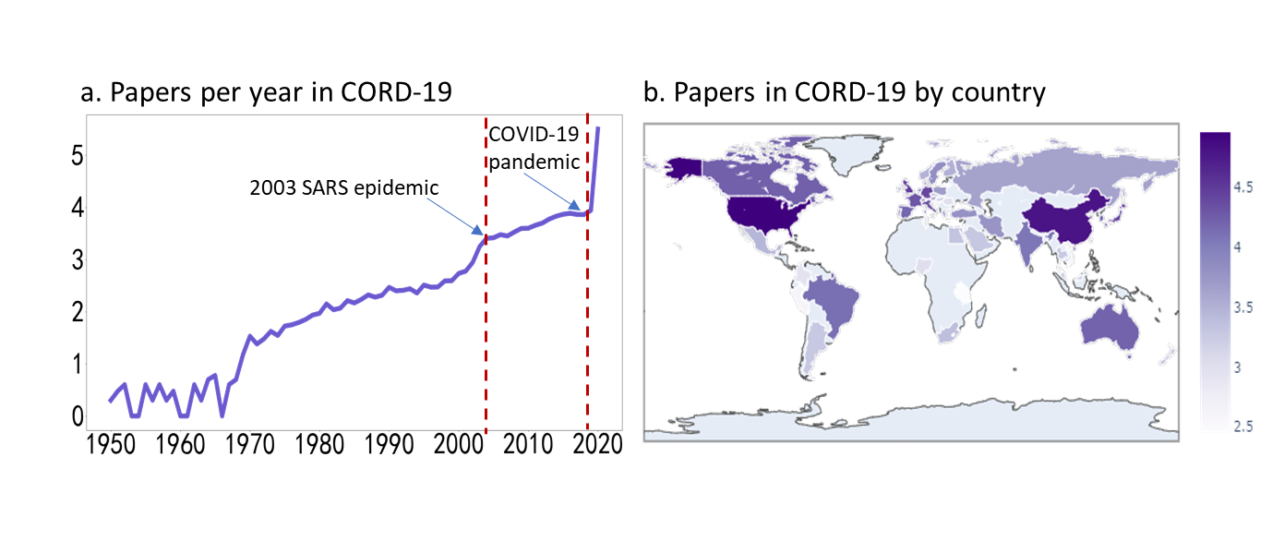
Fig. S1. The distribution of papers per year and by country in the CORD-19 dataset from January 1951 to April 2020.

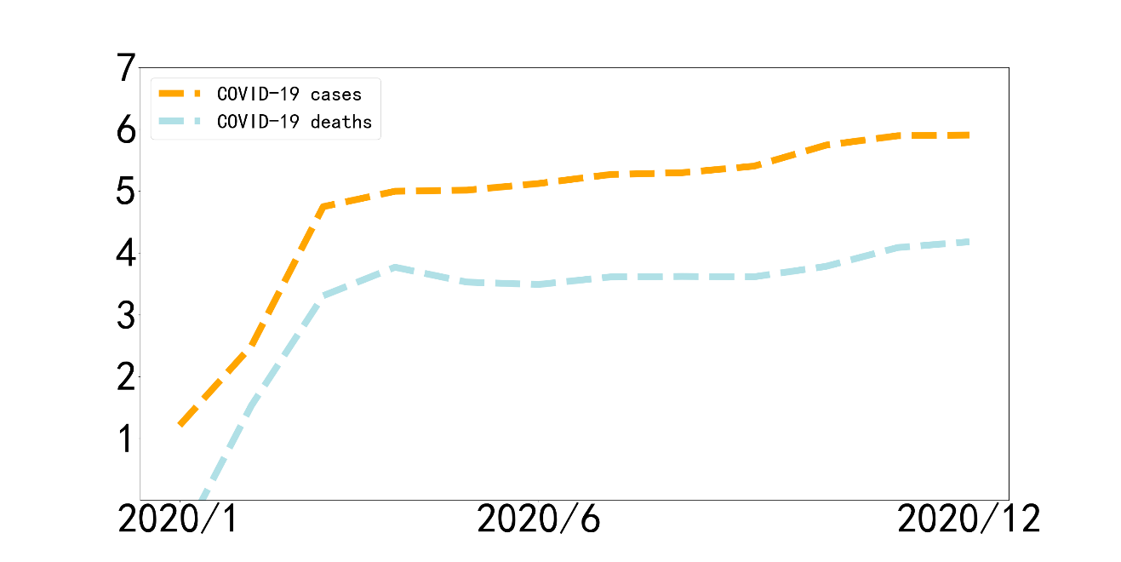
Fig. S2. The global distribution of COVID-19 cases and deaths by month. Y-axis indicates the logged-transferred number (log 10) of COVID-19 new cases and deaths in each month. Data source: https://ourworldindata.org/covid-cases. This dataset was downloaded on August 9th, 2021.

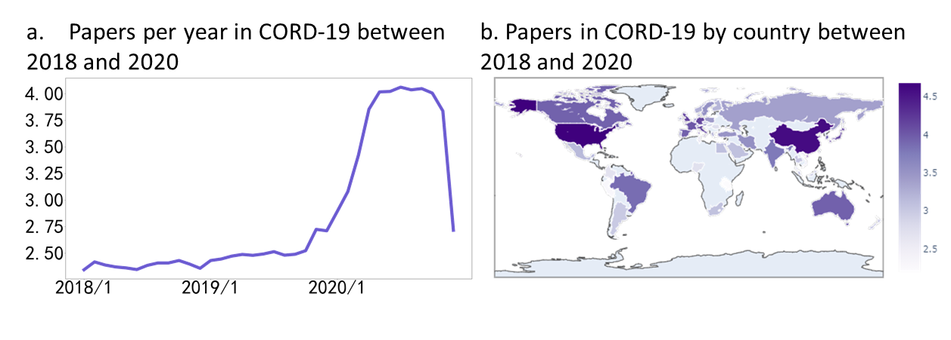
Fig. S3. The distribution of papers per month and by country in the CORD-19 dataset from January 2018 to December 2020. Y-axis in subfigure a indicates the logged-transferred number (log 10) of COVID-19 new cases and deaths in each month.

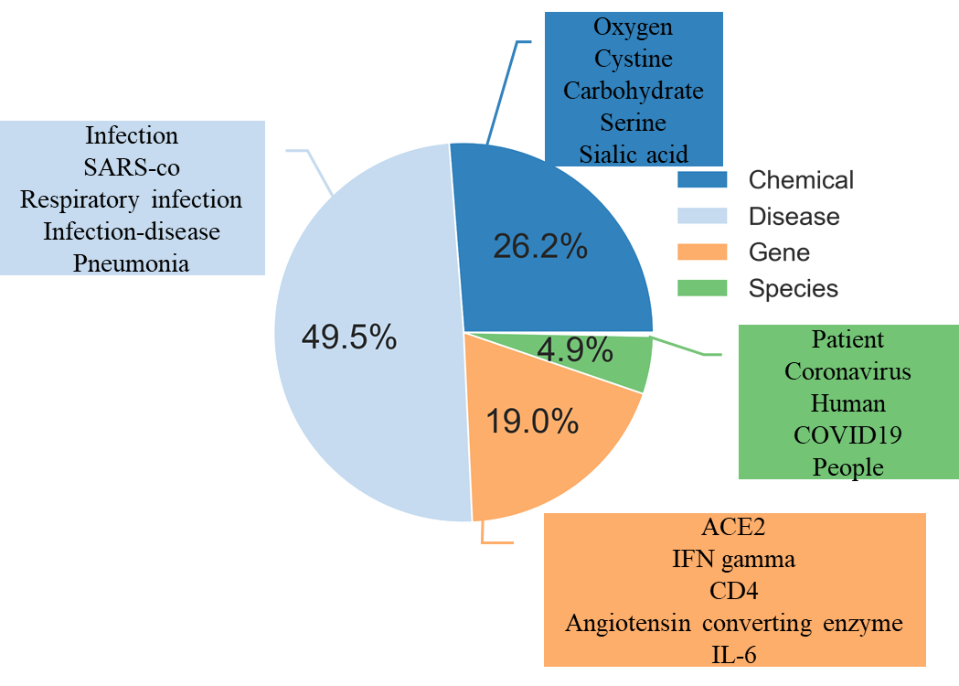
Fig. S4. The distribution of entities extracted from CORD-19 papers’ titles and abstracts from January 1951 to December 2020 by type and the top five entities in each type.

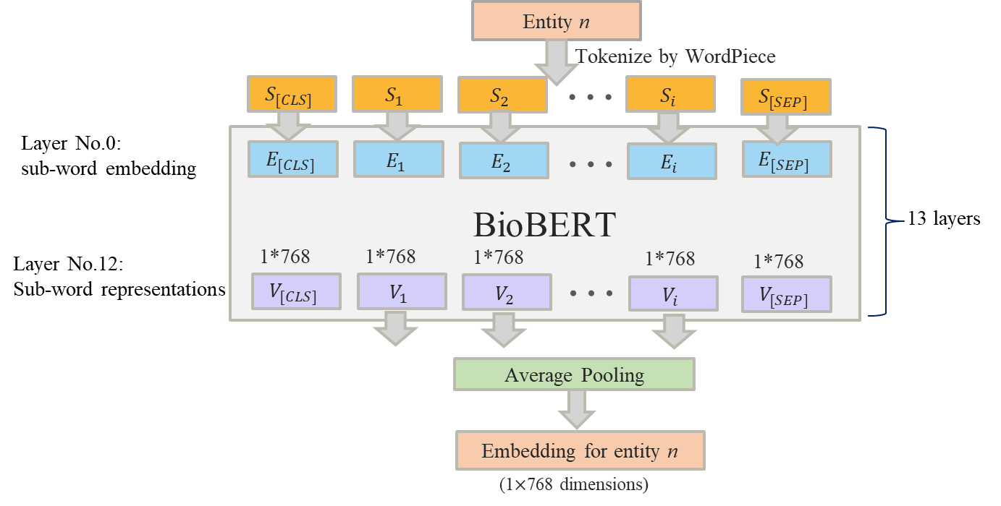
Fig. S5. The pipeline of generating sub-word representation for each bio-entity extracted from CORD-19 papers using BioBERT. Entity n is segmented by the WordPiece tokenizer (Y. Wu et al., 2016) into a sequence of sub-words to mitigate the out-of-vocabulary (OOV) problem. (CLS) is added at the beginning and (SEP) is added at the end of, and get sub-words S=${\{S}_{CLS}$, $S_{1}$, $S_{2}$, ..., $S_{i}$, $S_{SEP}\}$. For example, Entity “coronaviruses” is transformed into “(CLS) Co##rona##virus##es (SEP)”. The segmented entity, S, is then fed into the BioBERT. We use the last layer of BioBERT as the contextual representation, which generates a sequence of sub-word representations, V, in $R^{d ×(i+2) }$ where d denotes the 768 dimensions of a hidden layer in BioBERT and i indicates the number of tokens except CLS and SEP for entity n. For instance, for the entity of “coronaviruses”, the model generates a vector, with $6×768$ dimensions. The sub-word representations of CLS and SEP are ignored and the rest of the sequence of sub-word representations, V, are fed into average pooling that is used to calculate the average for each patch of the feature map with the kernel size of (number of tokens, 1) to get the final vector V in $R^{d }$.

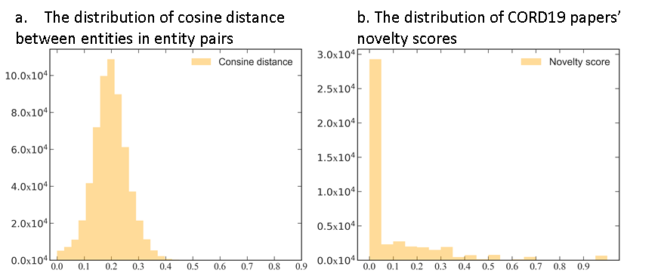

Fig. S6. The distribution of the distance between two entities in entity pairs in CORD-19 papers and that of CORD-19 papers’ novelty scores. The Y-axis indicates the frequency.

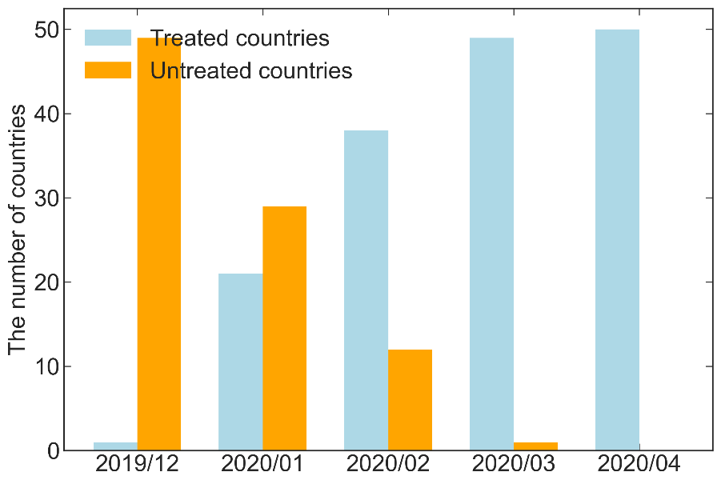
Fig. S7. The distribution of treated countries and untreated countries by month.

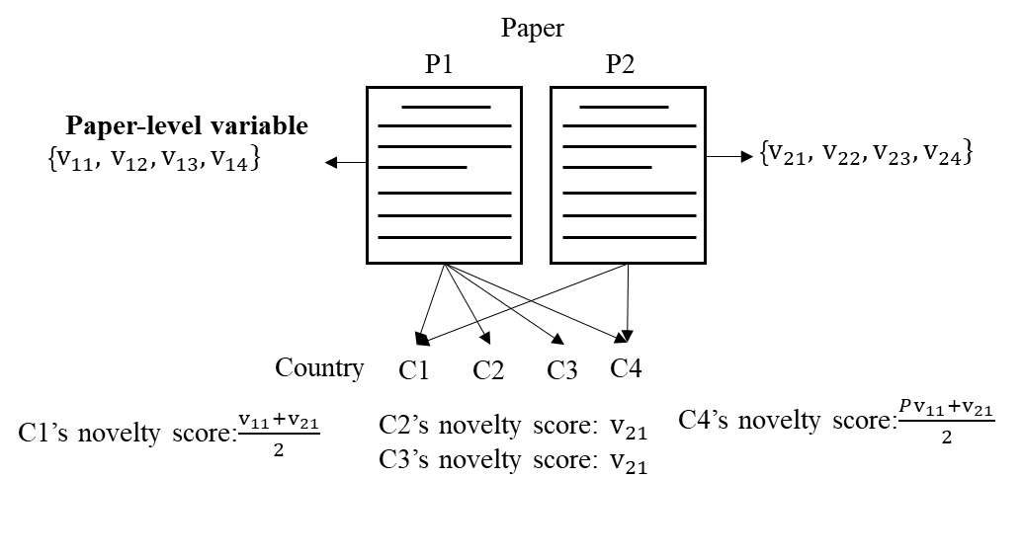

Fig. S8. An example demonstrating the procedure to aggregate four paper-level variables to the country level. The element in the vector represents a variable for paper $i$, such as paper’s novelty score ($v_{i1}$), parachuting collaboration ratio ($v_{i2}$), whether or not the paper is internationally collaborative ($v_{i3}$) and team size ($v_{i4}$). There are two papers, P1 by authors from four countries (i.e., C1, C2, C3 and C4), and P2 by authors from two countries (C1 and C4), respectively. We do not consider the number of authors from a country in a paper. C1’s novelty score is the average novelty score of P1 and P2, ($v_{11}+v_{21})/2$. It is the same for C4. The novelty score of C2 and that of C3 is P2’s novelty score, i.e., $v_{21}$. In this way, other paper-level variables, such as international collaboration ratio, international collaboration, team size, are aggregated to the country-level.

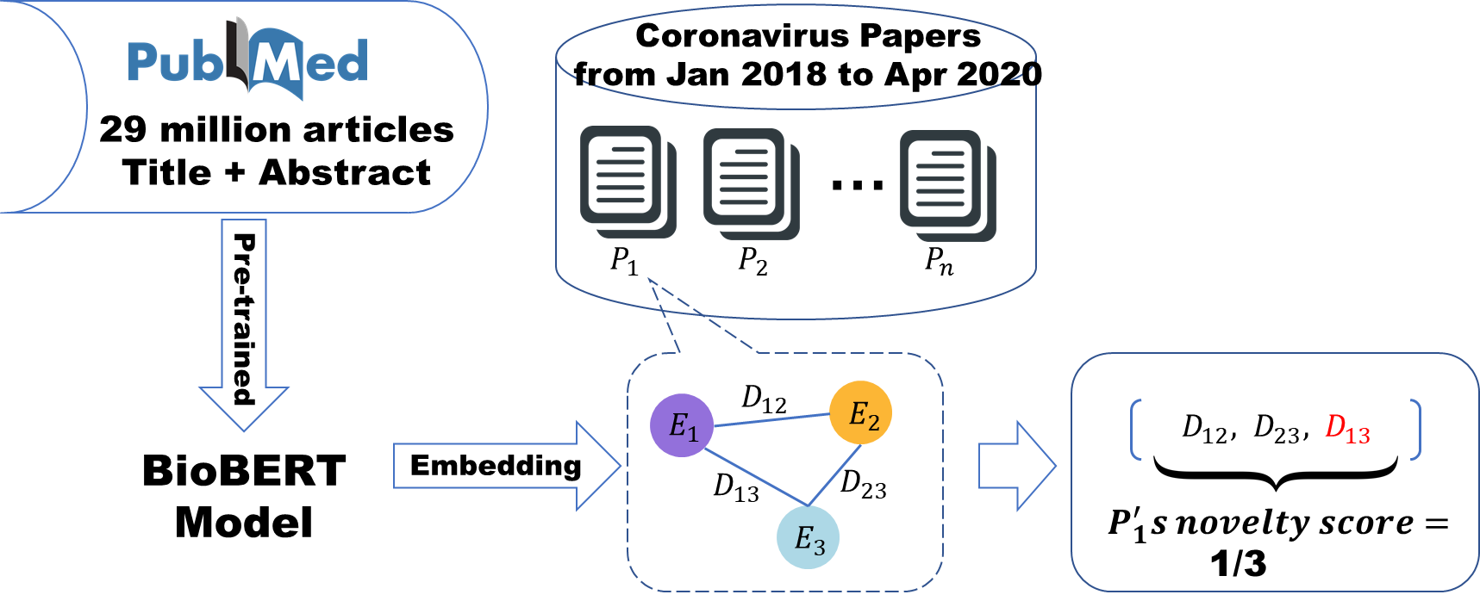

Fig. S9. An example of calculating a paper’s novelty score. $P$ and $E$ indicate papers and entities respectively. The formula used to calculate the novelty score for a paper is shown in the following equation.
$$Novelty score_{i}=\frac{m}{C_{n}^{2}}$$
where $i$ denotes paper $i$; $n$ indicates the number of bio-entities extracted from paper $i$; $C_{n}^{2}$ refers to the number of combinations of two that can be drawn from the set of n bio-entities extracted from paper $i$, i.e., the number of entity pairs generated by n bio-entities; $m$ denotes the number of entity pairs in which two entities’ distance is in the upper 10th percentile of the distribution of the distance of two entities in all entity pairs generated from CORD-19 papers. For example, for paper $P_{i}$ that contains three bio-entities (i.e., $E_{1}$, $E_{2}$ and $E_{3}$), the number of entity pairs for this paper is three. If the distance between $E_{1}$ and $E_{3}$ is in the upper 10th percentile of the distribution of the distance of two entities in all entity pairs generated from 133,590 coronavirus-related research articles, the combination of $E_{1}$ and $E_{3}$ is considered novel and thus the novelty score for this paper is 1/3.

Supplementary Tables

Table S1. The productivity of the 50 sampled countries/regions and the timing when the first COVID-19 case is confirmed in the country.

December 2019 |  | January 2020 |  | February 2020 |  | March 2020
China | 38855 | US | 47900 | Spain | 8651 | Turkey | 3115
 |  | UK | 14372 | Brazil | 7275 | Poland | 2677
 |  | Japan | 13637 | Netherlands | 6256 | Portugal | 2158
 |  | Italy | 13331 | Switzerland | 3547 | Saudi Arabia | 1217
 |  | Germany | 13122 | Iran | 3520 | South Africa | 1197
 |  | France | 10124 | Sweden | 3384 | Czech Republic | 1151
 |  | Australia | 8784 | Denmark | 2723 | Argentina | 983
 |  | Canada | 8736 | Belgium | 2707 | Hungary | 754
 |  | South Korea | 7675 | Israel | 2008 | Colombia | 491
 |  | India | 5859 | Austria | 1991 | Tunisia | 401
 |  | Taiwan | 3641 | Greece | 1714 | Peru | 196
 |  | Russia | 2425 | Norway | 1706 | Tanzania | 158
 |  | Finland | 1551 | Mexico | 1439
 |  | Thailand | 1071 | Egypt | 1252
 |  | Malaysia | 928 | Ireland | 1182
 |  | Hong Kong | 445 | New Zealand | 921
 |  | Vietnam | 407 | Croatia | 711
 |  |  |  | Romania | 552
 |  |  |  | Nigeria | 514
 |  |  |  | Lithuania | 158

Notes: the first row indicates the first month when the first COVID-19 case was officially confirmed in the countries listed below; the numbers in the table indicate the total number of papers by countries/regions during the January 2018-December 2020 period. The number of papers is calculated using a full counting method at the country level.

Table S2. Statistical summary of variables

Variable | Observation | Mean | Std. Dev. | Min | Max
Novelty score | 1,569 | 0.086 | 0.09 | 0 | 1
COVID-19 | 1,725 | 0.322 | 0.467 | 0 | 1
COVID-19 new cases (log 10) | 1,725 | 1.72 | 2.988 | 0 | 10.308
COVID-19 new deaths (log 10) | 1,725 | 0.747 | 1.537 | 0 | 6.386
International collaboration ratio | 1,725 | 0.925 | 0.102 | 0 | 1
First-time collaboration ratio | 1,722 | 0.978 | 0.037 | 0.595 | 1
Team size (log 10) | 1,725 | 2.018 | 0.33 | 0.693 | 4.635

Notes: COVID-19 case, COVID-19 death and team size are logged transformed (log 10).

Table S3. Correlation matrix of variables

 |  | (1) | (2) | (3) | (4) | (5) | (6)
(1) | Novelty score | 1
(2) | COVID-19 | 0.260*** | 1
(3) | COVID-19 new cases (log 10) | 0.232*** | 0.836*** | 1
(4) | COVID-19 new deaths (log 10) | 0.197*** | 0.706*** | 0.932*** | 1
(5) | International collaboration ratio | -0.101*** | -0.304*** | -0.268*** | -0.234*** | 1
(6) | First-time collaboration ratio | 0.064** | 0.089*** | 0.117*** | 0.100*** | -0.075*** | 1
(7) | Team size (log 10) | 0.005 | -0.058** | -0.037 | -0.034 | 0.349*** | -0.007

Notes: COVID19 case, COVID19 death and team size are logged transformed (log 10).

Table S4. The DID estimates of the relationship between the occurrence of the first COVID-19 case in a country and countries’ novelty scores and two collaboration variables in the month.

 | (1) | (2) | (3) | (4) | (5) | (6)
 | Novelty score |  | International  collaboration ratio |  | First-time collaboration  ratio
COVID-19 | 0.048*** |  | -0.063*** |  | 0.007***
 | (0.005) |  | (0.005) |  | (0.002)
Two months before the first case(t_2) |  | -0.021 |  | -0.012 |  | 0.001
 |  | (0.015) |  | (0.014) |  | (0.005)
One month before the first case(t_1) |  | 0.021 |  | 0.004 |  | 0.005
 |  | (0.014) |  | (0.014) |  | (0.005)
The month of the first case(t0) |  | 0.051*** |  | -0.044*** |  | 0.013***
 |  | (0.014) |  | (0.014) |  | (0.005)
One month after the first case(t+1) |  | 0.027* |  | -0.060*** |  | 0.011**
 |  | (0.014) |  | (0.014) |  | (0.005)
Two months after the first case(t+2) |  | 0.048*** |  | -0.075*** |  | 0.010**
 |  | (0.014) |  | (0.014) |  | (0.005)
Three months after the first case(t+3) |  | 0.026* |  | -0.078*** |  | 0.007
 |  | (0.014) |  | (0.014) |  | (0.005)
Four months after the first case(t+4) |  | 0.027** |  | -0.062*** |  | 0.002
 |  | (0.014) |  | (0.014) |  | (0.005)
Team size (log 10) | 0.009 | 0.012 | 0.103*** | 0.105*** | -0.0004 | 0.003
 | (0.008) | (0.009) | (0.007) | (0.007) | (0.004) | (0.003)
First-time collaboration ratio | 0.003 | -0.005
 | (0.068) | (0.070)
International collaboration ratio | 0.004 | -0.079**
 | (0.032) | (0.031)
Month fixed effects | Y | Y |  | Y | Y | Y
Country fixed effects | Y | Y |  | Y | Y | Y
Constant | 0.044 | 0.133* | 0.737*** | 0.722*** | 0.971*** | 0.971***
 | (0.073) | (0.074) | (0.014) | (0.015) | (0.005) | (0.005)
Observations | 1,569 | 1,569 | 1,725 | 1,725 | 1,722 | 1,722
R-squared | 0.126 | 0.096 | 0.240 | 0.202 | 0.197 | 0.202

Notes: The independent variable is whether the first COVID-19 case in the country has been confirmed by the month; fixed effects regarding month and country are included; robust standard errors clustered by countries are in parentheses; ***, ** and * represent significance at the 1%, 5% and 10% levels.

Table S5. The OLS estimates of the relationship between the logged number of new COVID-19 cases and deaths in the country and countries’ novelty scores in a month.

 | (1) | (2) | (3) | (4) | (5) | (6)
 | Scientific novelty |  | International  collaboration ratio |  | First-time collaboration  ratio
COVID-19 new cases (log 10) | 0.006*** |  | -0.009*** |  | 0.000
 | (0.001) |  | (0.001) |  | (0.000)
COVID-19 new deaths (log 10) |  | 0.010*** |  | -0.016*** |  | 0.001
 |  | (0.002) |  | (0.002) |  | (0.001)
First-time collaboration ratio | 0.019 | 0.023
 | (0.069) | (0.069)
International collaboration ratio | -0.027 | -0.054*
 | (0.031) | (0.031)
Team size (log 10) | 0.009 | 0.009 | 0.106*** | 0.107*** | 0.003 | 0.003
 | (0.008) | (0.009) | (0.007) | (0.007) | (0.003) | (0.003)
Month fixed effects | Y | Y | Y | Y | Y | Y
Country fixed effects | Y | Y | Y | Y | Y | Y
Constant | 0.063 | 0.086 | 0.727*** | 0.722*** | 0.972*** | 0.972***
 | (0.074) | (0.074) | (0.014) | (0.014) | (0.005) | (0.005)
Observations | 1,569 | 1,569 | 1,725 | 1,725 | 1,722 | 1,722
R-squared | 0.111 | 0.099 | 0.226 | 0.211 | 0.196 | 0.196

Notes: The independent variables in columns 1, 3 and 5 are the monthly logged transformed number of new COVID-19 cases per million, and that in columns 2, 4 and 6 are the monthly logged transformed number of new COVID-19 deaths per million, respectively; fixed effects of country and month are included; robust standard errors clustered by countries are in parentheses; ***, ** and * represent significance at the 1%, 5% and 10% levels.

Table S6. The estimated relationship between papers’ novel scores and the two collaboration patterns.

 | (1) | (2) | (3) | (4)
 | All papers | All papers | Papers published  before COVID-19 | Papers published  during COVID-19
First-time collaboration ratio | -0.012* | -0.006 | -0.013* | 0.035**
 | (0.007) | (0.006) | (0.007) | (0.016)
International collaboration | -0.004 | -0.009* | -0.009* | 0.002
 | (0.003) | (0.005) | (0.005) | (0.004)
COVID-19 | -0.045** | -0.015
 | (0.022) | (0.017)
COVID-19 × First_C | 0.043**
 | (0.018)
COVID-19 × International_C |  | 0.008
 |  | (0.006)
Team size (log 10) | 0.004* | 0.004 | 0.005 | 0.001
 | (0.002) | (0.002) | (0.003) | (0.004)
Year fixed effect | Y | Y | Y | N
Constant | -0.002 | -0.003 | -0.003 | 0.080***
 | (0.004) | (0.004) | (0.005) | (0.017)
Observations | 31,773 | 31,773 | 16,421 | 15,352
R-squared | 0.009 | 0.009 | 0.004 | 0.000

Notes: Fixed effects regarding publication year of papers are included; robust standard errors are in parentheses; ***, ** and * represent significance at the 1%, 5% and 10% levels. In column 3, the coefficients on international collaboration and first-time collaboration ratio for papers that are published before COVID-19 are both significantly negative at the significance level of 0.1; however, the coefficients on these two variables become positive for papers that are published during COVID-19, though the coefficient on international collaboration is not significant.

Table S7. The DID estimates of the relationship between the occurrence of the first COVID-19 case in a country and countries’ average age of MeSH terms in the month.

 | (1) | (2) | (2)
 | Age of MeSH terms
Novelty score | -0.004***
 | (0.001)
COVID-19 |  | -6.270***
 |  | (0.210)
Two months before the first case(t_2) |  |  | 1.739
 |  |  | (1.545)
One month before the first case(t_1) |  |  | 0.450
 |  |  | (1.133)
The month of the first case(t0) |  |  | -2.286
 |  |  | (2.017)
One month after the first case(t+1) |  |  | -4.585***
 |  |  | (1.266)
Two months after the first case(t+2) |  |  | -6.318***
 |  |  | (0.433)
Three months after the first case(t+3) |  |  | -6.290***
 |  |  | (0.286)
Four months after the first case(t+4) |  |  | -5.882***
 |  |  | (0.612)
First-time collaboration ratio |  | 2.917 | 1.498
 |  | (2.690) | (5.044)
International collaboration ratio |  | 1.952* | 8.728***
 |  | (1.138) | (2.339)
Team size (log 10) |  | -0.259 | -0.304
 |  | (0.318) | (0.618)
Month fixed effects | N | Y | Y
Country fixed effects | N | Y | Y
Year fixed effects | Y | N | N
Constant | 0.339*** | 62.753*** | 56.721***
 | (0.067) | (2.850) | (5.388)
Observations | 1,515 | 1,635 | 1,635
R-squared | 0.087 | 0.450 | 0.269

Notes: The dependent variable in this table is the average age of papers’ MeSH terms that is used to proxy scientific novelty. The smaller the average age of MeSH terms of a paper, the more novel this paper is; in column 1, year fixed effects are included to control for time-variant effects on papers’ average age of MeSH terms; in columns 2 and 3, fixed effects regarding month and country are incorporated; robust standard errors clustered by countries are in parentheses; ***, ** and * represent significance at the 1%, 5% and 10% levels.

Table S8. The OLS estimates of the relationship between the logged number of new COVID-19 cases and deaths per million in the country and countries’ average age of MeSH terms in a month.

 | (1) | (2)
Variables | Age of MeSH terms
COVID-19 new cases (log 10) | -0.978***
 | (0.036)
COVID-19 new deaths (log 10) |  | -1.666***
 |  | (0.075)
First-time collaboration ratio | 1.748 | 0.819
 | (2.777) | (2.939)
International collaboration ratio | 3.991*** | 6.600***
 | (1.160) | (1.211)
Team size (log 10) | -0.256 | -0.265
 | (0.328) | (0.347)
Month fixed effects | Y | Y
Country fixed effects | Y | Y
Constant | 61.616*** | 59.695***
 | (2.941) | (3.110)
Observations | 1,635 | 1,635
R-squared | 0.413 | 0.342

Notes: The dependent variable in this table is the average age of papers’ MeSH terms that is used to proxy scientific novelty. The smaller the average age of MeSH terms of a paper, the more novel this paper is; fixed effects regarding month and country are incorporated; robust standard errors clustered by countries are in parentheses; ***, ** and * represent significance at the 1%, 5% and 10% levels.

Table S9. The estimated relationship between papers’ average age of MeSH terms and the two collaboration patterns.

 | (1) | (2) | (3) | (4)
 | All papers | All papers | Papers published  before COVID-19 | Papers published  during COVID-19
First-time collaboration ratio | 1.937*** | 6.231*** | 1.847*** | 9.288***
 | (0.323) | (0.234) | (0.321) | (0.324)
International collaboration | 0.487*** | 0.974*** | 0.194** | -2.447***
 | (0.082) | (0.092) | (0.098) | (0.202)
COVID-19 | -7.392*** | 1.072***
 | (0.507) | (0.306)
COVID-19 × First_C | 6.526***
 | (0.439)
COVID-19 × International_C |  | -2.133***
 |  | (0.169)
Team size (log 10) | 0.471*** | 0.472*** | 1.167*** | -0.377***
 | (0.031) | (0.032) | (0.043) | (0.058)
Year fixed effect | Y | Y | Y | Y
Constant | 18.040*** | 13.451*** | 55.983*** | 54.283***
 | (0.423) | (0.363) | (0.329) | (0.370)
Observations | 204,171 | 204,171 | 102,800 | 101,371
R-squared | 0.252 | 0.252 | 0.010 | 0.018

Notes: Fixed effects regarding publication year of papers are included; robust standard errors are in parentheses; ***, ** and * represent significance at the 1%, 5% and 10% levels; the dependent variable is the average age of papers’ MeSH terms that is used to proxy papers’ scientific novelty; the smaller the average age of a paper’s MeSH terms, the more novel the paper is.

References

Agrawal, A. K. (2013). The impact of investor protection law on corporate policy and performance: Evidence from the blue sky laws. Journal of Financial Economics, 107(2), 417-435.
Alsentzer, E., Murphy, J. R., Boag, W., et al. (2019). Publicly available clinical BERT embeddings. arXiv preprint arXiv:1904.03323.
Amabile, T. M. (1983). The social psychology of creativity: A componential conceptualization. Journal of personality and social psychology, 45(2), 357.
Arts, S., Hou, J., & Gomez, J. C. (2021). Natural language processing to identify the creation and impact of new technologies in patent text: Code, data, and new measures. Research policy, 50(2), 104144.
Balsmeier, B., Assaf, M., Chesebro, T., et al. (2018). Machine learning and natural language processing on the patent corpus: Data, tools, and new measures. Journal of Economics & Management Strategy, 27(3), 535-553.
Boudreau, K. J., Guinan, E. C., Lakhani, K. R., et al. (2016). Looking across and looking beyond the knowledge frontier: Intellectual distance, novelty, and resource allocation in science. Management science, 62(10), 2765-2783.
Chai, S., & Menon, A. (2019). Breakthrough recognition: Bias against novelty and competition for attention. Research policy, 48(3), 733-747.
Chiu, B., & Baker, S. (2020). Word embeddings for biomedical natural language processing: A survey. Language and Linguistics Compass, 14(12), e12402.
Chubin, D. E., Hackett, E. J., & Hackett, E. J. (1990). Peerless science: Peer review and US science policy: Suny Press.
Dahlin, K. B., & Behrens, D. M. (2005). When is an invention really radical?: Defining and measuring technological radicalness. Research policy, 34(5), 717-737.
Dirk, L. (1999). A measure of originality: The elements of science. Social studies of science, 29(5), 765-776.
Fleming, L. (2001). Recombinant uncertainty in technological search. Management science, 47(1), 117-132.
Fleming, L., Mingo, S., & Chen, D. (2007). Collaborative brokerage, generative creativity, and creative success. Administrative science quarterly, 52(3), 443-475.
Foster, J. G., Rzhetsky, A., & Evans, J. A. (2015). Tradition and innovation in scientists’ research strategies. American Sociological Review, 80(5), 875-908.
Gilmartin, M. J. (1999). Creativity: The fuel of innovation. Nursing Administration Quarterly, 23(2), 1-8.
Guetzkow, J., Lamont, M., & Mallard, G. (2004). What is Originality in the Humanities and the Social Sciences? American Sociological Review, 69(2), 190-212.
Hain, D., Jurowetzki, R., Buchmann, T., et al. (2020). Text-based technological signatures and similarities: how to create them and what to do with them. arXiv preprint arXiv:2003.12303.
Ji, Z., Wei, Q., & Xu, H. (2020). BERT-based Ranking for Biomedical Entity Normalization. AMIA Joint Summits on Translational Science proceedings. AMIA Joint Summits on Translational Science, 2020, 269-277. Retrieved from https://pubmed.ncbi.nlm.nih.gov/32477646
https://www.ncbi.nlm.nih.gov/pmc/articles/PMC7233044/
Lee, J., Yoon, W., Kim, S., et al. (2020). BioBERT: a pre-trained biomedical language representation model for biomedical text mining. Bioinformatics, 36(4), 1234-1240.
Lee, Y.-N., Walsh, J. P., & Wang, J. (2015). Creativity in scientific teams: Unpacking novelty and impact. Research policy, 44(3), 684-697.
Merton, R. K. (1973). The sociology of science: Theoretical and empirical investigations: University of Chicago press.
Mikolov, T., Chen, K., Corrado, G., et al. (2013). Efficient estimation of word representations in vector space. arXiv preprint arXiv:1301.3781.
Partha, D., & David, P. A. (1994). Toward a new economics of science. Research policy, 23(5), 487-521.
Pennington, J., Socher, R., & Manning, C. D. (2014). Glove: Global vectors for word representation. Paper presented at the Proceedings of the 2014 conference on empirical methods in natural language processing (EMNLP).
Shibayama, S., Yin, D., & Matsumoto, K. (2021). Measuring novelty in science with word embedding. PLoS One, 16(7), e0254034.
Stephan, P. E. (1996). The economics of science. Journal of Economic literature, 34(3), 1199-1235.
Trapido, D. (2015). How novelty in knowledge earns recognition: The role of consistent identities. Research policy, 44(8), 1488-1500.
Uzzi, B., Mukherjee, S., Stringer, M., et al. (2013). Atypical combinations and scientific impact. Science, 342(6157), 468-472.
Verhoeven, D., Bakker, J., & Veugelers, R. (2016). Measuring technological novelty with patent-based indicators. Research policy, 45(3), 707-723.
Wagner, C. S., Whetsell, T. A., & Mukherjee, S. (2019). International research collaboration: Novelty, conventionality, and atypicality in knowledge recombination. Research policy, 48(5), 1260-1270.
Wang, J. (2016). Knowledge creation in collaboration networks: Effects of tie configuration. Research policy, 45(1), 68-80.
Wang, J., Veugelers, R., & Stephan, P. (2017). Bias against novelty in science: A cautionary tale for users of bibliometric indicators. Research policy, 46(8), 1416-1436.
Wei, C.-H., Allot, A., Leaman, R., et al. (2019). PubTator central: automated concept annotation for biomedical full text articles. Nucleic acids research, 47(W1), W587-W593.

Accessible at https://www.ncbi.nlm.nih.gov/research/pubtator.
Accessible at https://github.com/dmis-lab/biobert

