HYGROTHERMAL properties of historic bricks from various sites of latvia

Introduction
There are available hygrothermal simulation tools that allow to model possible scenarios for optimisation of thermal transmittance of historic wall, creating complex insulation systems. The accuracy of the results depends on the conformity of the input data to the specific design of existing wall. The properties of materials selected in the simulation tool should reflect as close as possible the properties of the wall under investigation.
For theses tools to be widely applicable the material library has to include various materials from various regions, thus allowing architects, planners, real estate developers and homeowners of Latvia to use the simulation tool with greater reliance on the accuracy of the simulation results.
In order to obtain a result in mathematical modelling programmes simulating the humidity transfer processes, which would reflect the situation as close to the real conditions as possible, the database built into the modelling programme should be supplemented with materials specific to the Latvian construction periods and obtained in different locations. Samples from different regions of Latvia were collected during brick collection (see Fig. ‎1 tab. 1).

Material Samples

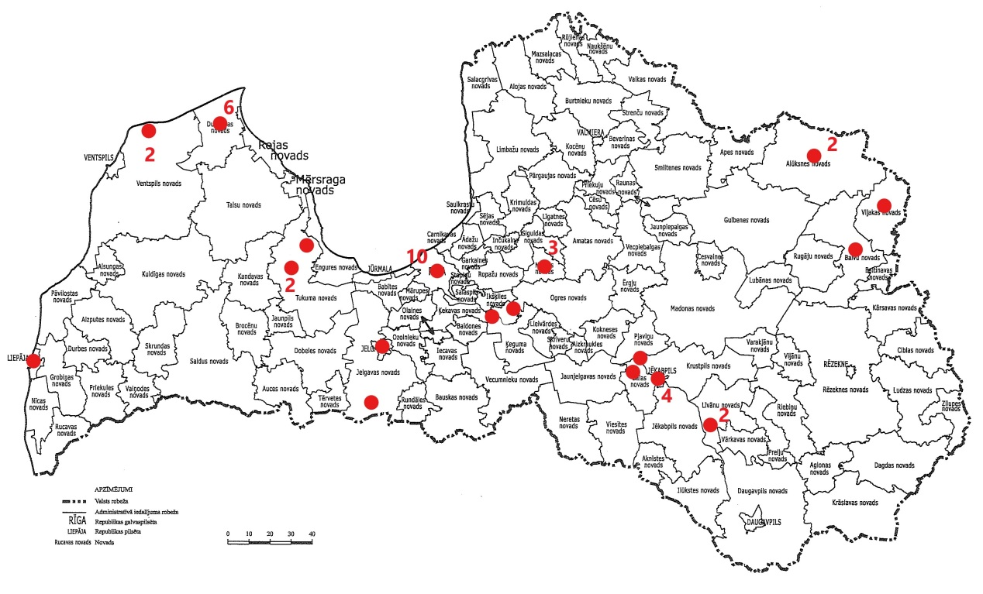
Figure 1. Sites of the collection of brick samples in Latvia

Table. 1. List of brick samples
Material No. | Year of construction | Address
18_4 | 1910- 1915 | A. Briāna, Rīga
18_5 | before 1960 | Pulka iela 8, Rīga
18_6 | 19th century | Brīvības iela 78a, Rīga
18_7 | 18th century | Jēkaba iela 24, Rīga
18_15 | 1920 - 1930 | Lāčplēša iela 1, Alūksne
18_16 | 19th century | T- Breikša iela 41, Liepāja
19_1 | before 1903 | Kuģu iela, Rīga
19_2 | before 1903 | Kuģu iela, Rīga
19_4 | 19th century | Irlavas pagasts, Tukuma rajons
19_5 | 20th century | O. Vācieša 6. Rīga
19_6 | 20th century | Irlavas pagasts, Tukuma rajons
19_7 | 18th century | Mālpils
19_8 | 18th century | Mālpils
19_9 | 19th century | Mālpils
19_10 | 1920 - 1930 | Lāčplēša iela 1, Alūksne
19_11 | 20th century | O. Vācieša 6, Rīga
19_12 | 20th century | Pulka iela 8, Rīga
19_13 | 1930 | Raudas pag., Tukuma rajons
19_14 | 1830 | Dundaga
19_15 | 1960 | Irbene
19_16 | 1960 | Irbene
19_17 | 1960 | Dundaga
19_18 | 1902 - 1903 | Ogresgals
20_1 | 1985 | Dundaga
20_2 | 19th century | Rožupes pagasts, Līvānu novads
20_3 | 1960 | Upenieki
20_4 | 17th century | Rīgas iela 216b, Jēkabpils
20_5 | 1932 | Cukurfabrikas iela 2, Jēkabpils
20_6 | 1850 | Sēlpils
20_7 | 1940 | Jēkabpils
20_8 | 1910 | Jelgava
20_9 | 20th century | Kr. Valdemāra iela, Rīga
20_10 | 19th century | Eleja
20_11 | 1922 | Dundaga
20_12 | 19th century | Talsu iela 2, Dundaga
20_13 | 17th century | Pils iela 14, Dundaga
20_14 | - | Berkava
20_15 | 1900 | Brīvības 120, Jēkabpils
20_16 | - | Žīguri
20_18 | - | Balvi

Methodology
Standard measurement methods with some adjustments were used (see table 2. and 3.).
Table 2. Standard measurement methods for material properties tests of historic bricks
Density | EN 772-13:2000. Methods of test for masonry units. Determination of net and gross dry density of masonry units (except for natural stone)
Porosity | EN 772-3:1998. Methods of test for masonry units. Determination of net volume and percentage of voids of clay masonry units by hygrostatic weighing
Vapor permeability | CUP-Tests (μ values). EN ISO 12572:2001 – Hygrothermal performance of building materials and products – Determination of water vapour transmission properties
Free water uptake | ISO 15148:2002, 2002: Hygrothermal performance of building materials and products – Determination of water absorption coefficient by partial immersion
The material properties were determined for a specific reason, to be used as a input data for creation of hygrothermal simulation tool material file, in this case DELPHIN simulation tool. Therefore, some deviations from the testing standards were implemented. These deviation were developed by Dresden University of Technology (also the developers of DELPHIN simulation tool) and will be described further on. Measurement methods for material properties test developed by Dresden University of Technology are compiled in Table ‎3.
Table 3. Measurement methods for material properties tests approved and developed by Dresden University of Technology
Moisture storage | Hygroscopic sorption and water retention properties are tested following the method developed in Dresden University of Technology based on DS/EN ISO 12571:2013 Hygrothermal performance of building materials and products – Determination of hygroscopic sorption properties and (DS/EN ISO 11274 Soil quality - Determination of the water-retention characteristic – Laboratory methods  [38], [39]
Drying Curve | Non-isothermal combined vapour and liquid transfer testing method developed in Dresden University of Technology
Heat capacity and thermal conductivity | heat pulse technology by means of ISOMET equipment
Only general explanation of tests and included deviations are described, as the detailed description of all tests perfomed can be found in the corresponding standarts.

Density and porosity
Density is determined according to the standard EN 772-13:2000. Methods of test for masonry units. Determination of net and gross dry density of masonry units (except for natural stone). Porosity is determined according to the standard EN 722-3:1998. Methods of test for masonry units. Determination of net volume and percentage of voids of clay masonry units by hydrostatic weighing.
To determine bulk density, the bulk volume and the dry mass must be determined. For the determination of the dry mass, samples were oven dried in the 105 °C, until the constant mass of the samples is reached. Mass was assumed to be constant, when it doesn’t change more than 0,2 % over the 24 h period. For the determination of the volume three methods were used. First method was hygrostatic weighing, second method was measurements of sample dimensions using a caliper and the third was immersion method. Hygrostatic weighing was used on the full-size bricks, and was done in three steps:
- Brick was saturated with water;
  - This is done, to avoid water uptake by the brick during weighing;
- Weight of the saturated brick was determined (in the air);
- Weight of the brick was determined (immersed under the water);
  - Brick in hanged under the scale, and the determined weight is lower due to buoyance.
To determine the bulk volume of the samples, equation (1) was used:
$V_{s}=\frac{(m_{s}-m_{sw})}{ρ_{w}}$ (1)
where
V_{s} – bulk volume of sample, cm³
m_{s} - weight of the saturated sample, g
m_{sw} - weight of the saturated sample, when weighted under the water, g
ρ_{w} - density of the water, g/cm³.
Immersion method was used for the cut-out samples of the brick and was performed in three steps:
- Filling the container with water, up to the rim;
- Immersion of the water saturated sample into the water filled container, while the overflowing water is collected, in another container;
- The overflowing water volume equals the volume of the sample;
- Weighing of the collected overflowing water;
- Calculating of the overflowing water volume, (assuming that 1 g of water equals 1cm³ of water, the mass of water in grams equals the volumes of sample in cm³).
Prior to determination of the sample volume by immersion method, the samples had to be conditioned by saturation with water. After the samples were saturated, for determination of the volume two different size cups were used. Smaller cup was filled with the water, up to the rim and put into the larger cup, after that the brick sample was immersed into the smaller cup, with the help of an adhesive tape. The overflowing water from the smaller cup was collected into the larger cup, and the mass of overflown water was determined.
To calculate the bulk density equation (2) was used:
$ρ_{s}=\frac{m_{d}}{V_{s}}$ (2)
where
m_{d} - Dry mass of the sample [g];
V_{s} – Bulk volume of sample [cm³];
ρ_{s} - Bulk density of the sample [g/cm³].
The average value of the bulk density was used for further calculations.

To determine open porosity, samples were saturated with water under the vacuum. Vacuum saturation was used to determine maximum saturation of the samples. For the vacuum saturation a desiccator filled with water and vacuum pump CVC 3000 vacuubrand was used (fig. 2.). The samples were kept under approximately 3 mBar pressure until the constant mass was reached. To determine open porosity, the equation (3) was used:
$P_{o}=\left(\frac{m_{v}{-m}_{d}}{ρ_{w}·V_{s}}\right)x100\%$ (3)
where
P_{o} – open porosity of the sample, %
m_{v}- mass of vacuum saturated sample, g
ρ_{w} - density of the water, g/cm³
m_{d} - dry mass of the sample, g.
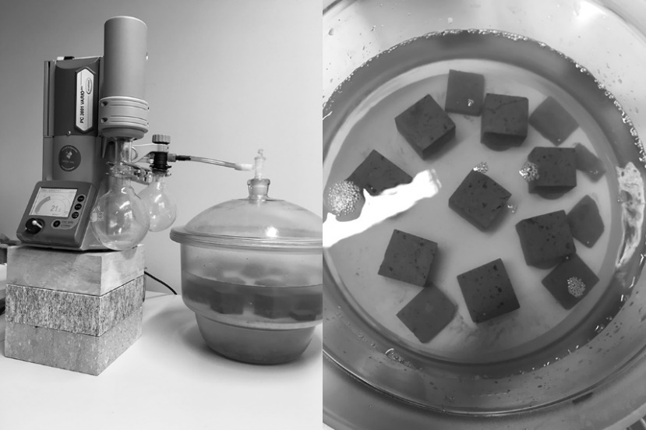
Figure 2. Vacuum saturation of brick samples
Prior to determination of the sample maximum (vacuum ) saturation, the effective saturation of the material were determined by submerging the samples under the water (fig. 3.).
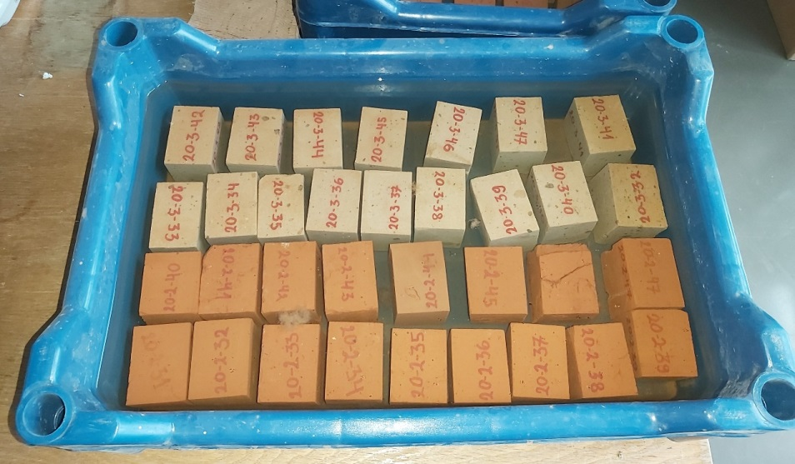
Figure 3. Effective saturation test

Vapor permeability
Vapor permeability test (cup test method) are performed according to the standard EN ISO 12572 Hydrothermal performance of building materials and products – Determination of water vapour transmission properties.
For the cup test method 3 samples of the brick are used in the cut sizes of 7 x 7 x 1 cm. Samples are installed in the lids of the cups, with the help of a wax (fig. 4.). Test is repeated two times, first time in low humidity conditions (Dry-cup test) and the second time in high humidity conditions (Wet-cup test).
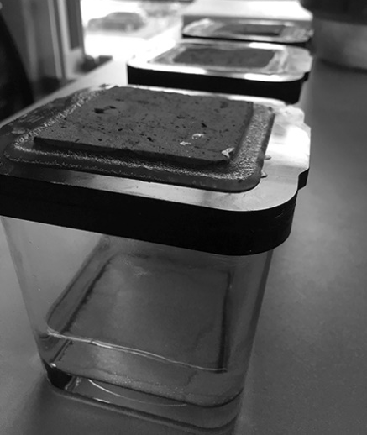 | 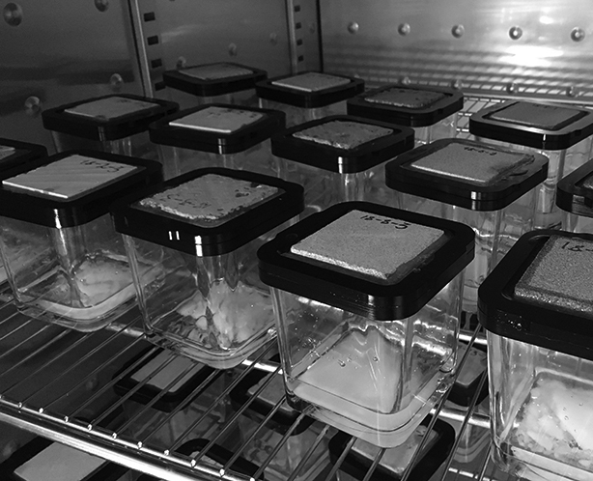
a) | b)
Figure 4. Cup tests a) sample installed in the lid of a cup b) cups inserted in the controlled environment
For the Dry-cup test silica gel desiccant is used, to keep low (5 %) relative humidity inside the cup. The desiccant is poured in the bottom of the cups and the cups are inserted in the climatic chamber TH-G-1000 with the constant temperature of 23 C° and relative humidity 35 %. For the Wet-cup test saturated salt solution of KH2PO4 is used, to keep high (96 %) relative humidity inside the cups and the cups are inserted in climatic chamber with constant temperature 23 C° and relative humidity 65 %. To calculate water vapour resistance factor, increasing mass of the cups in the case of Dry-cup test, or decreasing mass of the cups in the case of Wet-cup test, are determined, by the weighing of the cups over the period of time. Mass increase/decrease of the cup indicates how much water vapour is passed through the samples, due to the difference in the water vapour pressure in climatic chamber and cups caused by the difference in relative humidity inside the cups and in the climatic chamber. Several equations are used to calculate water vapour resistance factor. The main equations are showed below:
Density of water vapour flow:
$g=\frac{G}{A}$ (4)
where
g – density of water vapour flow, kg/(m²·s)
A – surface area of the sample (exposed to vapour transfer), m²
G – slope of the mass plotted as a function of time (cup mass increase/decrease), kg/s.
Water vapour pressure:
$p_{v}=φ·610.5·e^{\frac{17.269 -ϴ}{237.3+ϴ}}$ (5)
where
p_{v} – water vapour pressure, Pa
φ – relative humidity, [-]
e – base of natural logarithm (2.718…), [-]
ϴ - temperature, °C.
Water vapour permeance:
$W=\frac{g}{Δp}$ (6)
where
W – water vapour permeance, kg/ (m²·s·Pa
g – density of water vapour flow, kg/(m²·s)
Δp – pressure difference (cup, chamber), Pa.
Water vapour permeability of still air:
$δ_{a}=\frac{2.306·{10}^{-5}·P_{0}}{R_{v}·θ·P_{a}}·{\left(\frac{θ}{273.15}\right)}^{1.81}$ (7)
where
δ_{a} – water vapour permeability of still air, kg/ (m·s·Pa
R_{v} – gas constant of water vapour (461.5), N·m/(kg·K)
ϴ - temperature, °C
P₀ – standard barometric pressure (101325), Pa
P_{a} – pressure in climatic chamber, Pa.
Water vapour permeability:
$δ=W·d$ (8)
where
δ – water vapor permeability of a sample, kg/(m·s·Pa)
W – water vapor permeance, kg/(m²·s·Pa)
d – height (thickness) of a sample, m.
Water vapour resistance factor:
$µ=\frac{δ_{a}}{δ}$ (9)
where
µ - water vapour resistance factor, [-]
δ - water vapour permeability of still air, kg/(m·s·Pa)
δ – water vapour permeability of a sample, kg/(m·s·Pa).

Free water uptake
Free water uptake tests are performed according to the standard ISO 15148:2002, 2002: Hydrothermal performance of building materials and products – Determination of water absorption coefficient by partial immersion.
Free water uptake test are performed, to determine capillary moisture content and capillary absorption coefficient of the brick. After preparing the bricks samples for the test and pre-conditioning, side edges of the samples are sealed with the aluminium tape, to protect samples from drying out sideways. The top and bottom part of the sample is left uncovered. The prepared samples were put into water, and only up to 5 mm of the bottom part is immersed. The sample itself is put on the pins, so that bottom plane is opened to water contact (fig. 5.).
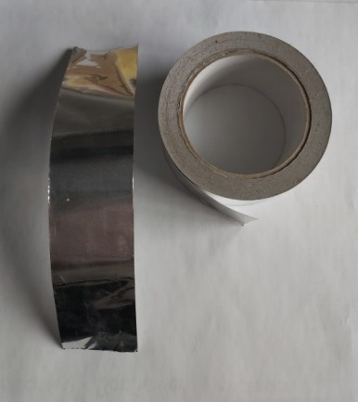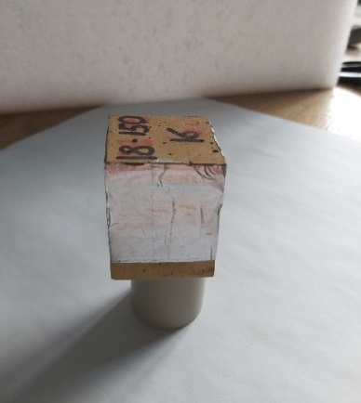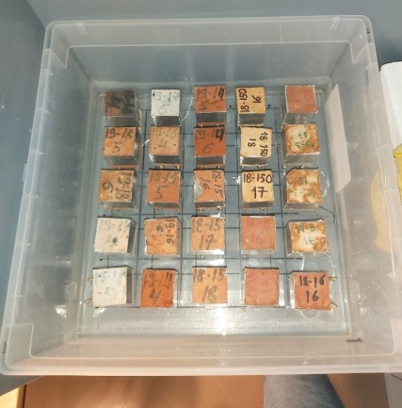
Figure 5.. From left. Tape, sample prepared, partial immersion
During the free water uptake test mass of the samples is determined periodically with decreasing frequency of period. In the beginning of the test, when the free water uptake happens faster, the mass is determined with a higher frequency (from 5 min. interval to 1 h interval), when test progresses, the weighing interval can be as long as 24 h. Test frequency and duration of the test varies for different bricks due to different material properties.
The main results of the free water uptake test is a water uptake coefficient, capillary saturation level and suction curve, with corresponding boundary conditions.

Moisture storage
Two methods are used to determine water storage properties. In hygroscopic range a desiccator method is used to determine sorption curves, and in over-hygroscopic range, the pressure plate method is used to determine water retention curve.
Desiccator method are performed according to the standard EN ISO 12571:2013. Hydrothermal performance of building materials and products - Determination of hygroscopic sorption properties. In this test series of decreasing/increasing equilibrium relative humidity at a given temperature are established. Five different equilibrium relative humidity are established in this test. To achieve different relative humidity, individual desiccators for each relative humidity are filled with saturated salt solution and are kept at the constant temperature (23 °C), to maintain specifi relative humidity above saturated salt solution (see table 4.).
Table 4. Relative humidity above saturated salt solution at 23 °C [73]
Salt solution | Relative humidity
Potassium hydroxide (KOH) | 7.38 %
Magnesium chloride (MgCl2) | 32.9 %
Magnesium nitrate (MgNO3) | 53 %
Potassium chloride (KCl) | 84.7 %
Mono potassium phosphate (KH2PO4) | 96 %
In total 10 samples with cut out size of 4 x 4 x 1 cm are used for each brick to determine sorption curves with desiccator method. Before the test samples are conditioned, by oven drying until the constant mass is reached, indicating that the samples are dry. Then the samples are divided in two groups with 5 samples in each group. One group of the samples is inserted in the desiccator with highest relative humidity (96 %) and the other group is inserted in the desiccator with the lowest relative humidity (7.38 %) (fig. 6). When the equilibrium is reached, the samples are weighed and moved to the next desiccator with lower or higher relative humidity, respectively, from 7.38 % to 32.9 %, and from 96 % to 84.7 %. The moving of the samples is continued until both groups of the samples have reached the equilibrium state in each of 5 relative humidity environments. Weighing results of the sample group moving from lowest relative humidity to higher relative humidity are used to obtain adsorption curve and the weighing results of the sample group moving from the highest relative humidity to the lower relative humidity are used to obtain desorption curve.
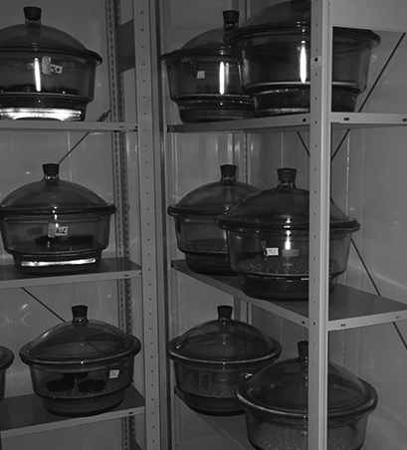 | 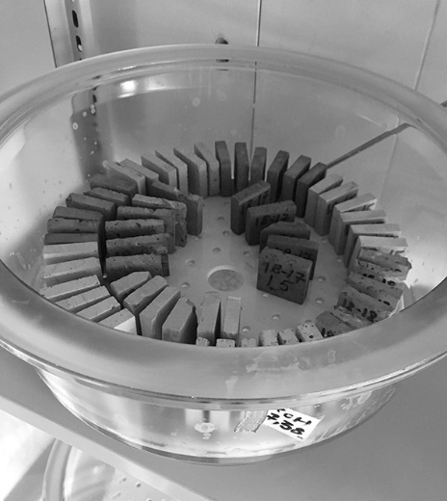
a) | b)
Figure 6 Setup of desiccator method a) chamber with a constant temperature of 23 °C b) desiccator filled with samples
To calculate the moisture content (MC) [g/g] of the sample, equation (10) is used:
$MC=\frac{m-m_{d}}{m_{d}}$ (10)
Where
MC –moisture content, g/g
m – mass of the weighted sample, g
m_{d} – dry mass of the sample, g.
Pressure plate tests are performed according to the standard DIN EN ISO 11274 Soil quality - Determination of the water-retention characteristic - Laboratory methods.
Pressure plate method is similar to desiccator method, but instead of the different relative humidity, a different pressure levels are applied to the test samples. Equilibrium of the samples is achieved when there is no water flow from the pressure chamber outlet. With the desiccator method moisture storage are expressed as the dependence of the relative humidity, but with the pressure plate method as the dependence of the capillary pressure. Both of parameters can be expressed as the other with the Kelvin equation (Eq. (11)). The same formula is used to calculate MC after the equilibrium of the samples is reached at each pressure. Two pressure plate chambers are used in this test. To increase testing procedure, both pressure chambers are used in parallel with four different samples in each chamber. In total 8 samples with cut out size of 4 x 4 x 1 cm are used in pressure plate method. Before the test samples are saturated for 1 month by partially immersing them in the water. Saturated samples are placed on the ceramic plates; and the kaolin clay and the filter paper are used to provide better contact between samples and the plates. Ceramic plates together with samples are inserted into a pressure chamber and the pressure is applied (fig. 7.). When the pressure is applied to the chamber, the samples are drained until the equilibrium is reached. When the equilibrium is reached, the samples are weight and the applied pressure increased to the next step. In total 5 different pressures are applied: 0.1 bar, 0.3 bar, 4 bar, 8 bar and 15 bar.

Kelvin equation:
$P_{c}\left(φ\right)=ρ_{l}∙R_{v}∙T∙lnφ$ (11)
where
P_{c} – Capillary pressure, Pa
ρ_{l} - Density of the liquid water, kg/m³
R_{v} – Gas constant of water vapour, J/kg·K
T – Absolute (Kelvin) temperature, deg
φ – Relative humidity, [-].
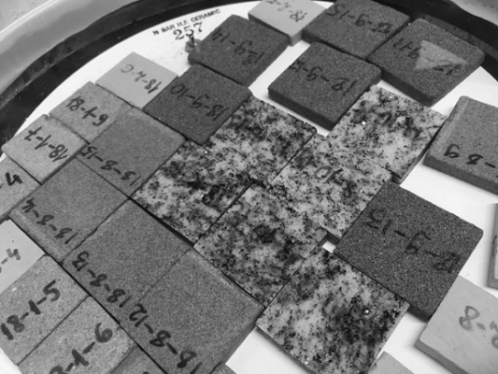 | 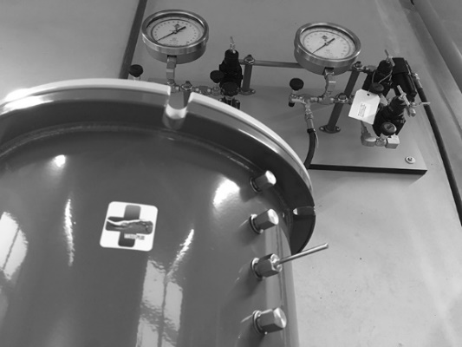
a) | b)
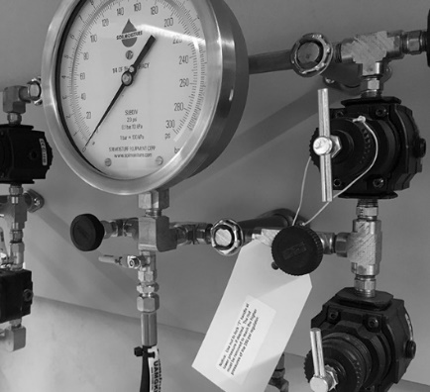 | 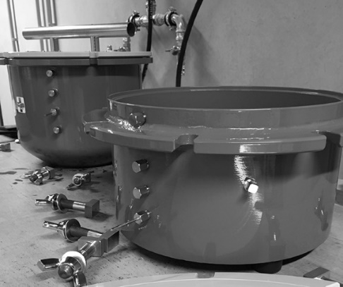
c) | d)
Figure 7. Pressure plate method a) saturation process of the samples b) water outlet of the pressure chamber c) pressure regulation system d) left: pressure chamber up to the 5 bar, right: pressure chamber up to the 15 bar

Drying curve
To determine a drying curve a non-isothermal combined vapour and liquid transfer testing method, developed in Dresden University of Technology, is used. In this method samples are conditioned by submerging in the water, until the effective saturation is reached. After conditioning, the brick samples are placed in the drying cabinet and measurements are made periodically to record changes in the weight and surface temperature of the samples. In the drying the cabinet flowing air above the samples is maintained, temperature and relative humidity is monitored. The placement of the samples inside the cabinet are managed in the manner, so that only the top surface of these samples are exposed to the moving air above these samples (fig. 8.).
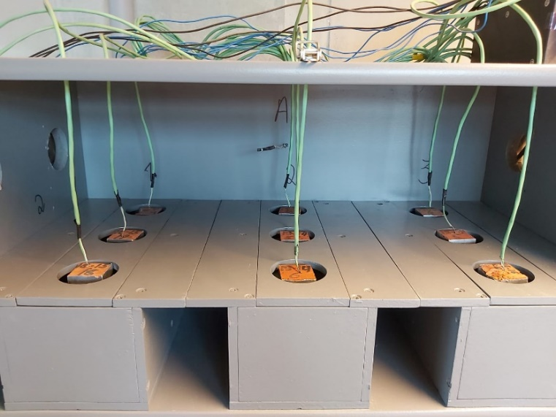
Figure 8. Samples in drying cabinet
Results of the drying test is a drying curve and corresponding boundary conditions, that are mainly used to calibrate the relevant Delphin material file (see chapter 3.).

Specific heat capacity and heat conductivity
Thermal conductivity and specific heat capacity are determined with the ISOMET 2114 from Applied precision. Surface probe IPS 1105 with the measurement range from 0.3 to 3 W/(m·K) is used. Precision of the measurements are 3 % of reading + 0.001 W/(m·K) for thermal conductivity and 3 % of reading + 1.10³ J/(m³·K) for the volume heat capacity. Prior to the test the brick samples are oven dried in 105 C°. After preparing the bricks samples for the test, the brick samples are placed in desiccator, and measurements are performed with ISOMET 2114.
Rsults are included in separate excel file, with all the single value results in sheet1 and individual sheet for each curve.

