Energy and Flexibility Modelling
Hands-on exercise 11: Installing FlexTool
Pease use the following citation for this exercise:
Pooya Hoseinpoori, Alex Kell, & Adam Hawkes. (2021, March). Hands-on 11: Energy and Flexibility Modelling (Version 1.4) https://doi.org/10.5281/zenodo.4618320

Please download the IRENA FlexTool Package from this link

Learning outcomes
By the end of this exercise you will be able to:
1) Install and use FlexTool on your computer
2) Diagnose possible installation errors
3) Become familiar with the tool interface and different files
4) Run a model on your computer and get the result file

About FlexTool
IRENA FlexTool is a software package developed by IRENA and VTT Technical Research Centre of Finland published under GNU Lesser General Public License. Users are free to modify and redistribute the software under LGPL. New versions will be published on irena.org. The main aim of the tool is to make a quick but yet thorough assessment of potential flexibility gaps and identify the cost-effective mix of options to fill such gaps.
Note: To be able to use FlexTool, users must have Excel on their machines.

Installing FlexTool
There are a few easy steps for Installing FlexTool :

Downloading FlexTool and extracting to disk
- Download FlexTool from the following link to IRENA’s website https://www.irena.org/energytransition/Energy-System-Models-and-Data/IRENA-FlexTool
- FlexTool can be run from anywhere on the computer. Therefore you can save the file in any place on your computer. Here we install FlexTool on “c:\FlexTool”. Create a folder named “FlexTool” in your C drive and extract the downloaded zip file to it. We will call this the “root folder”.

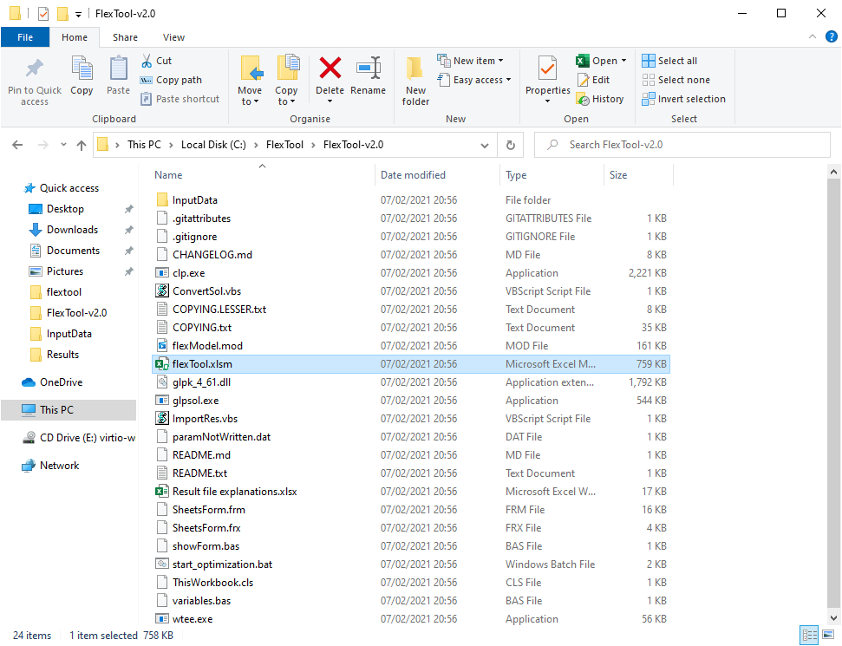

Figure 1: FlexTool root folder. The main interface file flexTool.xlsm is highlighted. The input file can be found in the InputData folder

- The extracted folder contains an InputData folder where you can find input excel workbooks, the executables files and the main interface of the tool, which is an excel file named flexTool.xlsm (highlighted in Figure 1).

Enabling macros in the main worksheet
- From the root folder, open “flextTool.xlsm” excel file.
- You may be asked if you trust the document. Click “yes”

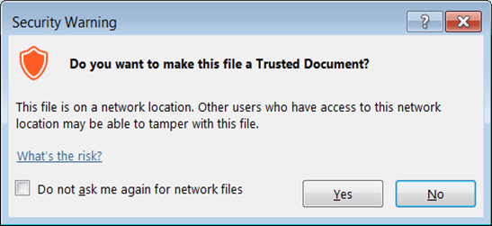

- After opening the file you should enable content of the workbook
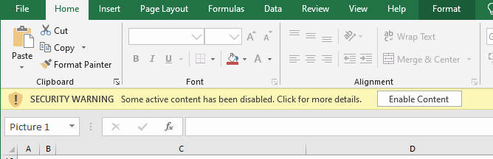

- Enable macros:
- From the excel menu go to “File” -> “Options”.
- Then from the left pane select “Trust Center”
- Click on “Trust Center Settings”
- A new window will open. From the left pane select “Macro Settings”
- Enable “Trust access to the VBA project object model”
- Click “OK” to save settings and close.
Note: These steps are needed only for the first time you run the tool.
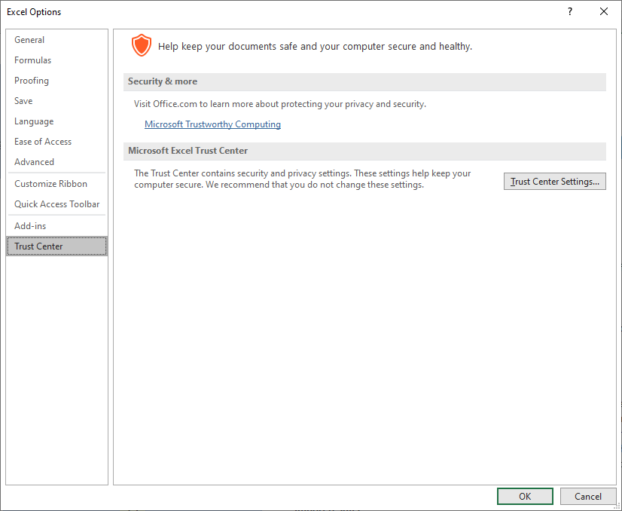

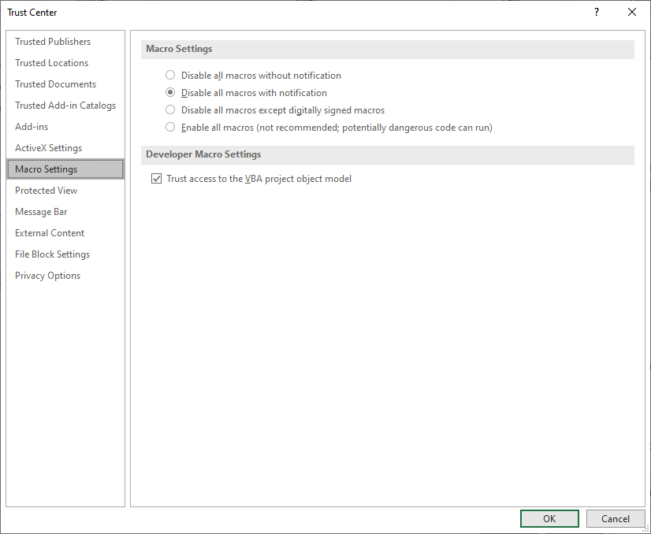

Troubleshooting:
If optimization fails check errors from Results/Input data file name/Scenario name/output_[D/I]_y.txt.
(x = scenario number, y = phase number in optimisation, D/I = dispatch or investment mode)
The table above summarizes the possible errors you may encounter in the installation process and possible causes and solutions.

Error: | Cause/Possible solution
Result file created but empty | Solver memory issue, CLP can handle larger models than GLPSOL
Programmatic access to visual basic project is not trusted | Check macro settings. "Trust access to the VBA project object model" have to be selected
flexmodel.mod:240: ts_inflow[NODE,0] out of domain (or similar) | You may have wrong time series, try to update the time series
Anti-virus program blocks some of the used executables: clp.exe, glpsol.exe, wtee.exe | Make an exception in the anti-virus program for the executable
The main files
The tool includes three main MS Excel files:
- The main flexTool.xlsm file
- Input data files
- Result files

- The flexTool.xlsm file acts as the interface to the tool. It is used to select the model and scenario used in the simulation, start running the model and define the sensitivity cases in “Sensitivity definitions” sheet.

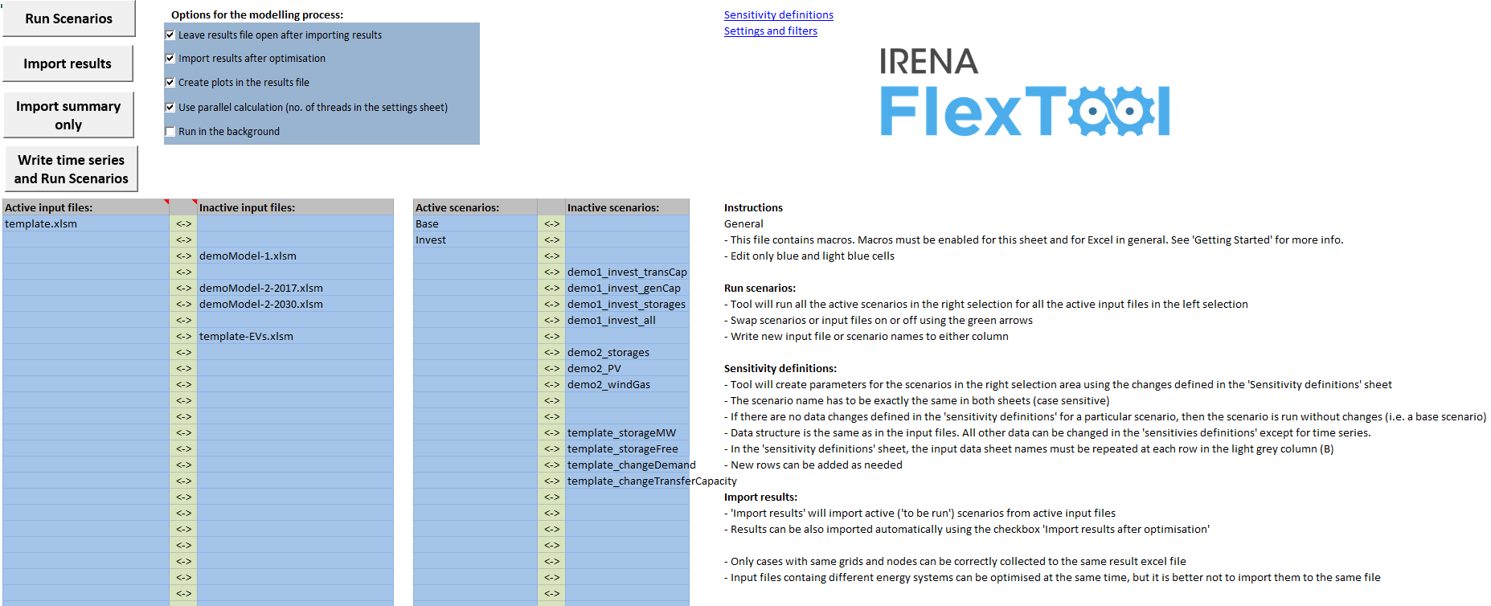

- Input file: In FlexTool the Input data file define the model version. The flexTool.xlsm file is the same for all countries or regions, but input data is unique and case-specific. Therefore every case, region or model year needs its own input data file (e.g., Thailand 2019, Thailand 2030).

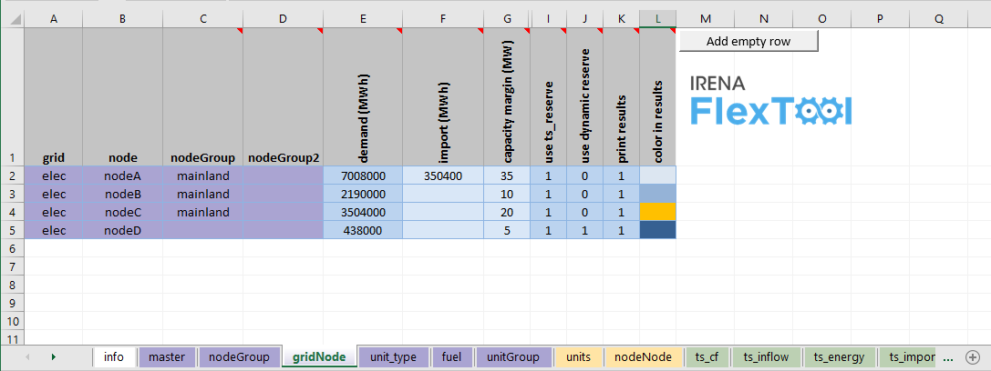

- Result output files: The results file includes a diverse range of results for all the scenarios. The user can show only one scenario or to compare results from multiple scenarios.
Once you run the model, a result folder is generated in the root folder which contains the result output excel files.

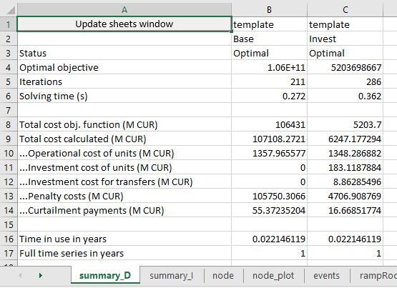

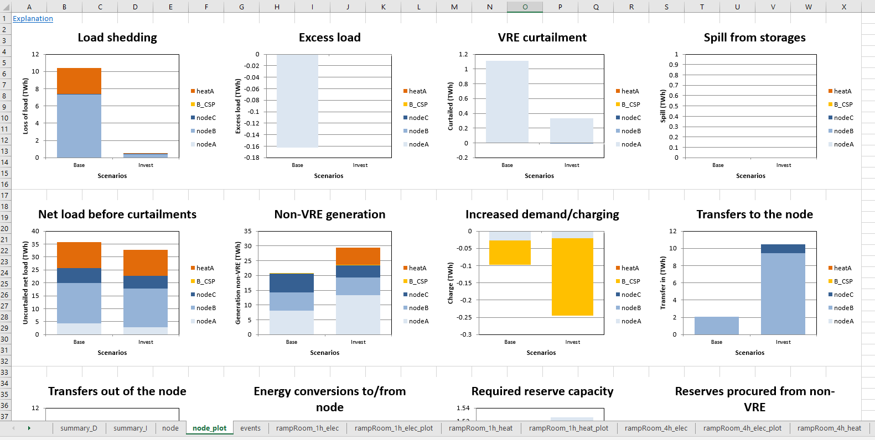

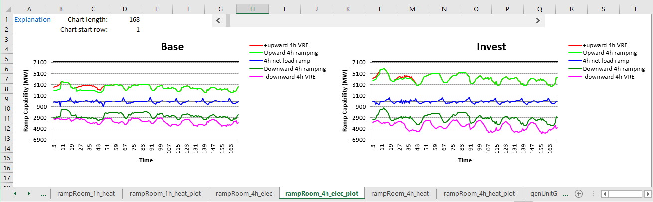

Running a model
As we said in FlexTool, the input data file will define the model version. A few models and templates are included in the package and you can read them from “InputData” folder in the root folder.
- “template.xlsm” is the template to create new models
- “template-XX.xlsm” are additional example templates with specific technologies
- Other input data files such as country-specific or versions for different years demo models.
To run a model:
- Open the interface worksheet (“flexTool.xlsm”). Make sure macros are enabled, as explained above.
- Navigate to “Sensitivity scenarios” sheet.
- Click on the first cell in “Active input files” column.
- A file picker opens. Select “template.xlsm” from InputData folder and click “Open”.
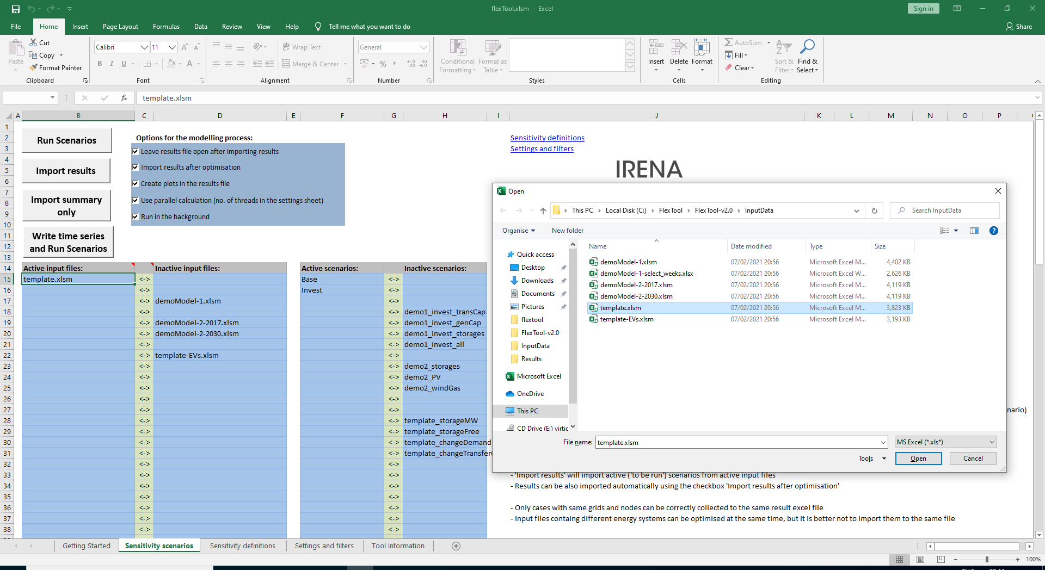

- In “Active Scenarios” column, activate the “Base” scenario.
- You can toggle scenarios active or inactive by clicking on the green arrow (“<->”).
- Only scenarios in the “Active Scenarios” column will be run by the model.
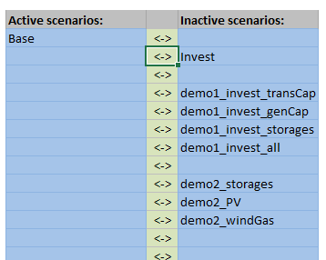

- Click on “‘Write time series and Run Scenarios” to start running the model.
Note: Input file must be closed before running the model. If the input file is still open FlexTool will warn you to close the file.
- A prompt window will open while the model is running to display the status of the execution.
- In “Options for the modelling process” you can set various processing options.

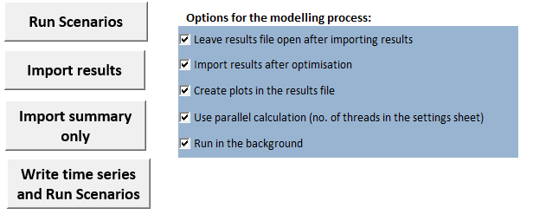

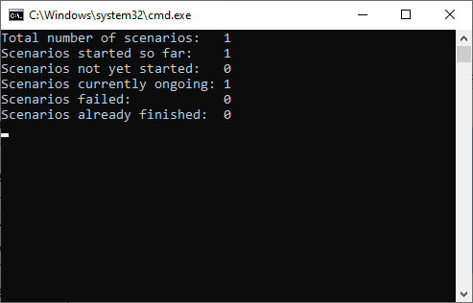

If the option is enabled, after successful execution of the model results file is automatically opened. In any case, results are automatically saved in the “Results” folder in the root directory.

In the results file go to the “summary_D” sheet which contains the most important results. You can use the quick selection window to find “summary_D” sheet to explore the results. The attributed input data files and scenarios are shown on the top two rows.

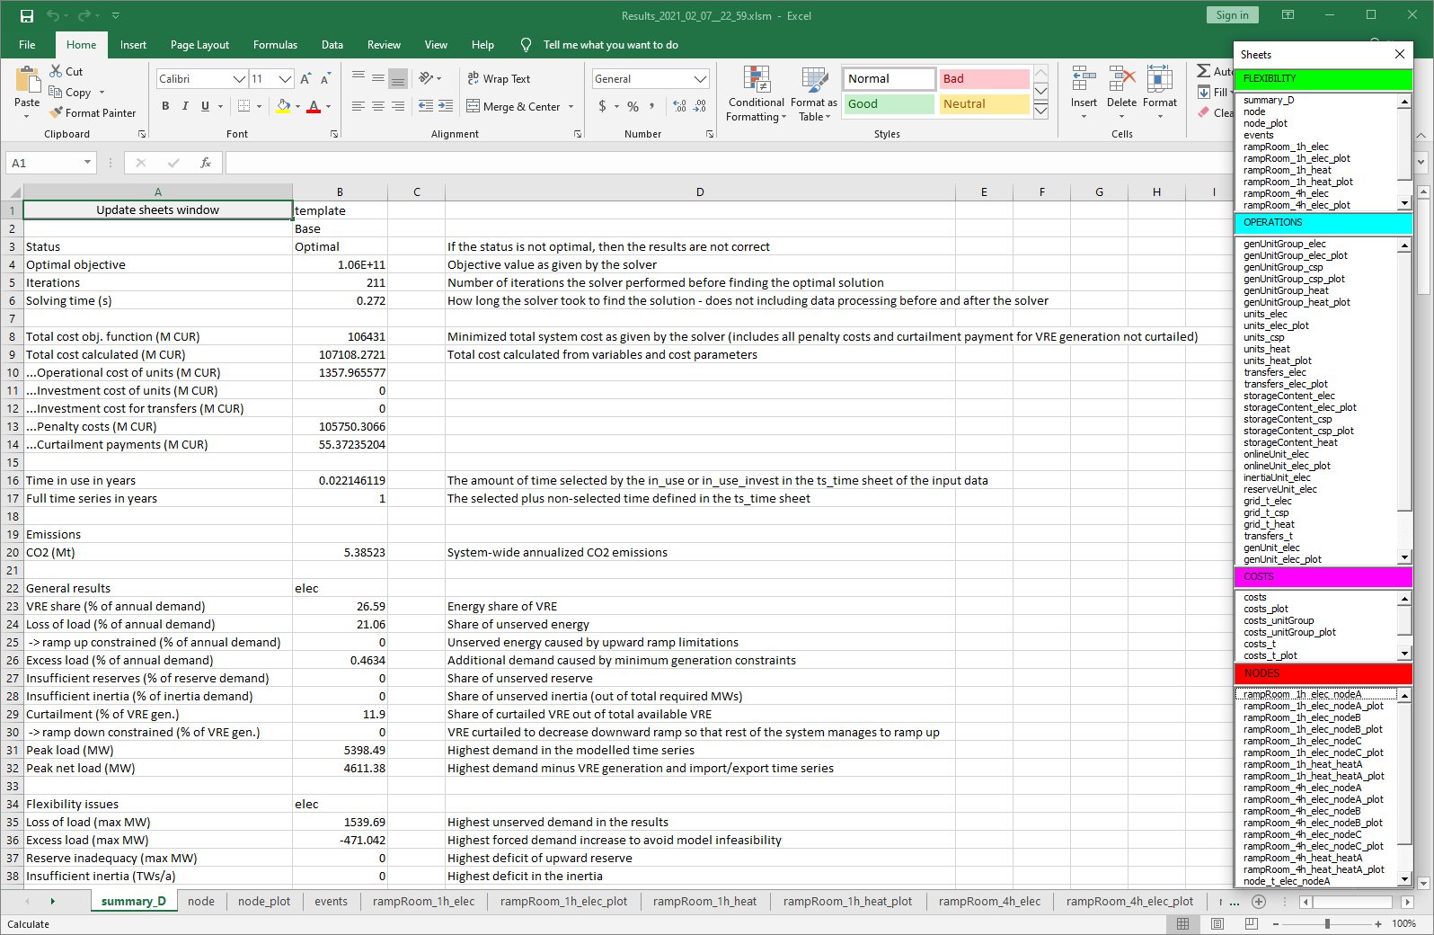

Activity: Try to run different combination of input files and scenarios that are included in the package and go through input files and results files to familiarize yourself with the Tool and content of each file.
In the following sessions you will learn to make your own input files and scenarios.

