Supplemental Methods

Whole genome sequencing
The mutational status was determined for FLT3-ITD, NPM1 and 7 splicing factors (SF1, SF3A1, SF3B1, SRSF2, U2AF1, U2AF2 and ZRSR2). Whole genome sequencing (WGS) libraries were generated from 1µg of DNA extracted from bone marrow or peripheral blood samples using the TruSeq PCR free library prep kit, following the manufacturer’s recommendations (Illumina, San Diego, CA, USA) and sequenced on a NovaSeq6000 or HiSeqX Illumina instruments following a 2x150bp paired-end reads standard protocol at a mean depth of coverage of >100x. Bioinformatic analysis of WGS data was performed using Illumina’s BaseSpace Sequence Hub and in-house pipelines. Reads were aligned against human genome build GRCh37/hg19 with the tool Isaac3.¹ Variant calling was performed using Strelka2² and additional variant annotation was performed using Ensembl VEP.³ Only exonic (non-synonymous single nucleotide variants (SNVs) and small insertions/deletions (indels)) and variants at splicing acceptor/donor sites were considered in this study. Because matched normal samples were not available, tumor-unmatched normal variant calling was performed using a pool gender-matched DNA (Promega, Madison, WI, USA). In order to remove germline and benign variants as well as technical artifacts from the dataset a strict filtering strategy was applied as described below.

Variant calling from RNA sequencing data
Variant calling was performed using Isaac 2.3.1¹ and additional variant annotation was performed using Ensembl VEP.³ Only non-synonymous SNVs and indels were considered in this study.

Filtering whole genome sequencing data
Upon variant calling from WGS and RNA sequencing data the following in-house filtering strategy⁴ was applied to remove sequencing artifacts as well as germline and likely benign variants, resulting in a dataset consisting of reliable and likely somatic, pathogenic variants.

Sequencing artifacts
Repetitive regions and regions potentially troublesome for variant calling were annotated based on Ensembl repeat database and the Global Alliance for Genomics and Health (GA4GH) database. Firstly, variants located in regions of established low confidence variant calling (as specified in Genome in a Bottle Consortium using sample NA12878/HG001, https://github.com/genome-in-a-bottle). Subsequently, we discarded variants with low frequency (VAF < 15%) located in low complexity regions (homopolymers), tandem repeats (i.e. microsatellites), segmental duplications or repetitive regions interspersed throughout the genome (i.e. transposable elements). Finally, variants supported by ≤ 3 reads for the alternative allele as well as with the total depth of coverage ≤ 5 were removed from downstream analysis.

Germline variants
First, variants with the global population frequency ≥ 0.001 (based on the genome aggregation database; gnomAD) were discarded. Next, variants labelled as germline in ClinVar or COSMIC databases were filtered out. Finally, variants not well annotated in hematological malignancies with a VAF between 40-60% or > 90% in all samples were eliminated. This strategy was applied in order to remove as many of the germline variants as possible although it should be noted that due to the lack of matched germline control some residual germline variants are likely to be retained in our dataset. However, since this study focuses on genes recurrently mutated in AML these residual germline variants are not expected to affect the analysis.

Likely benign variants
First, variants listed as benign/likely benign in ClinVar database were removed. Subsequently, we used an in-house developed tool HePPy (Hematological Predictor of Pathogenicity)⁵ to remove missense variants with HePPy score < 0.75 (indicating low pathogenicity).

References
1. Raczy C.et al: Isaac: Ultra-fast whole-genome secondary analysis on Illumina sequencing platforms. Bioinformatics 29:2041–2043, 2013
2. Kim S. et al: Strelka2: fast and accurate calling of germline and somatic variants. Nature Methods 15:591–594, 2018
3. McLaren, W. et al. The Ensembl Variant Effect Predictor. Genome Biology 6: 122, 2016
4. Palomo L. et al. Molecular landscape and clonal architecture of adult myelodysplastic/myeloproliferative neoplasms. Blood Jun 23:blood.2019004229, 2020
5. Hutter S. et al: A Novel Machine Learning Based in silico Pathogenicity Predictor for Missense Variants in a Hematological Setting. Blood 134:2090–2090, 2019

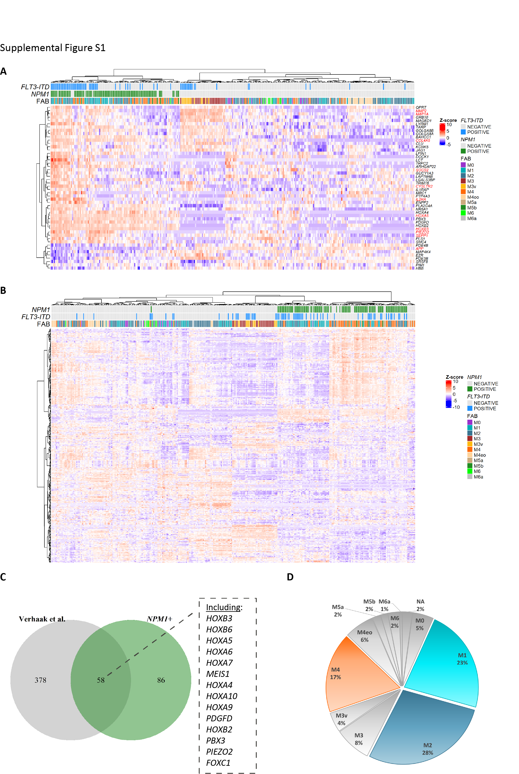

Supplemental Figure S1. FLT3-ITD and mutated NPM1-associated gene expression signatures in the total sample set and FAB type distribution of samples. A – Hierarchical clustering of genes previously reported (Valk et al., NEJM 2004) to be differentially expressed in association to FLT3-ITD plotted for AML samples in the total sample cohort in the current study. Genes significantly differentially expressed in the current study are highlighted in red. B – Hierarchical clustering of genes previously reported (Verhaak et al., Blood 2005) to be differentially expressed in association to NPM1 plotted for AML samples in the total sample cohort in the current study. C – Overlap between genes included in the NPM1-associated gene expression signature from Verhaak et al. Blood 2005 and significantly differentially expressed genes in relation to mutated NPM1 in the total cohort of the current study. D – FAB type composition of the total cohort with the most represented FAB types (M1, M2 and M4) highlighted.

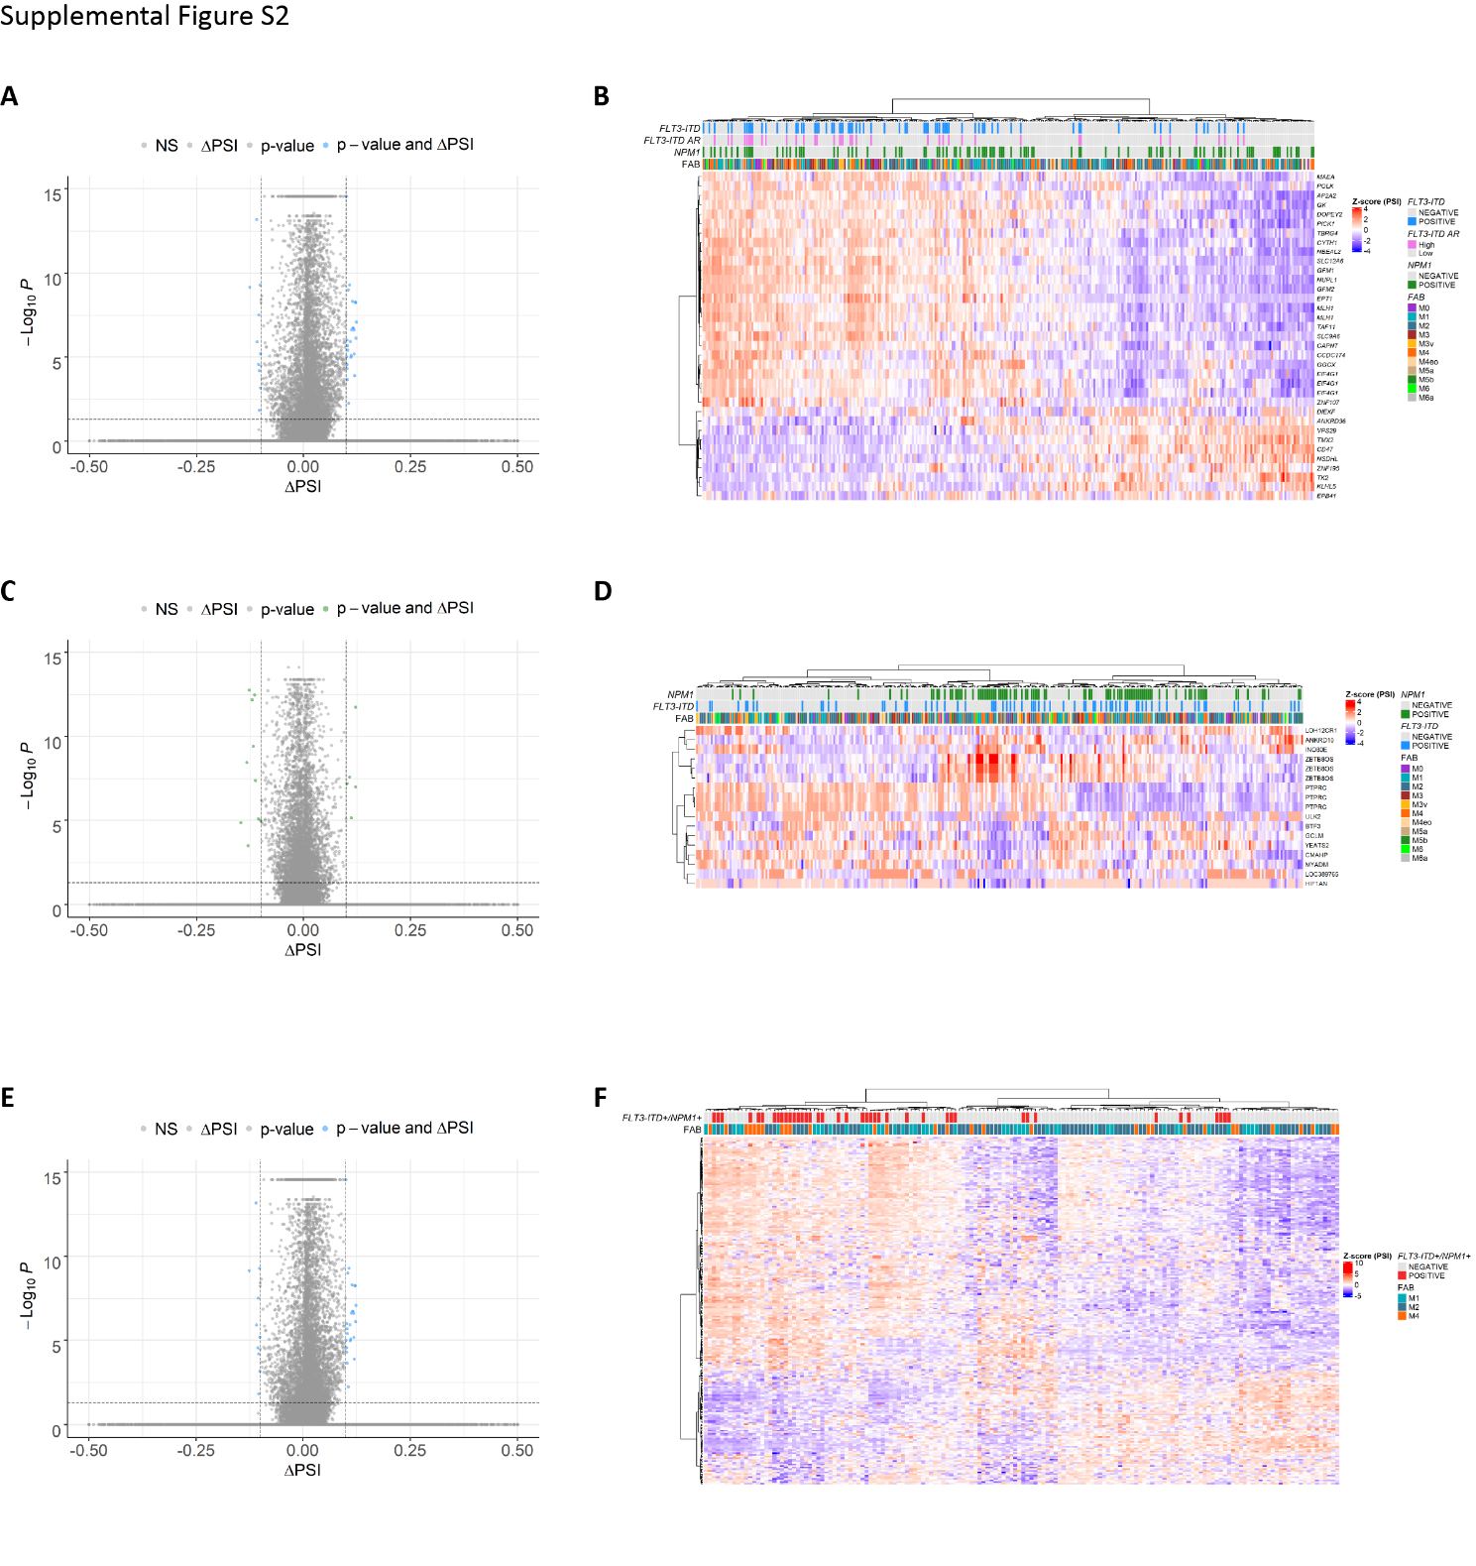

Supplemental Figure S2. FLT3-ITD and mutated NPM1-associated splicing patterns in the total sample set. A, B – An overview of the differential splicing analysis in relation to FLT3-ITD performed with rMATS in the total cohort of AML patients. A – Volcano plot of PSI (proportion spliced-in). B – Hierarchical clustering of significant differential splicing events (FDR < 0.05) with a minimal splicing difference between the two groups of 0.1 (|ΔPSI| > 0.1). C, D – An overview of the differential splicing analysis in relation to NPM1 mutations performed with rMATS in the total cohort of AML patients (combined M1, M2 and M4 FAB types). C – Volcano plot of PSI (proportion spliced-in) values. D - Hierarchical clustering of significant differential splicing events (FDR < 0.05) with a minimal splicing difference between the two groups of 0.1 (|ΔPSI| > 0.1). E, F – An overview of the differential splicing analysis in relation to FLT3-ITD with a concomitant NPM1 mutation performed with rMATS in the total cohort of AML patients (combined M1, M2 and M4 FAB types). E – Volcano plot of PSI (proportion spliced-in) values. F - Hierarchical clustering of significant differential splicing events (FDR < 0.05) with a minimal splicing difference between the two groups of 0.1 (|ΔPSI| > 0.1).

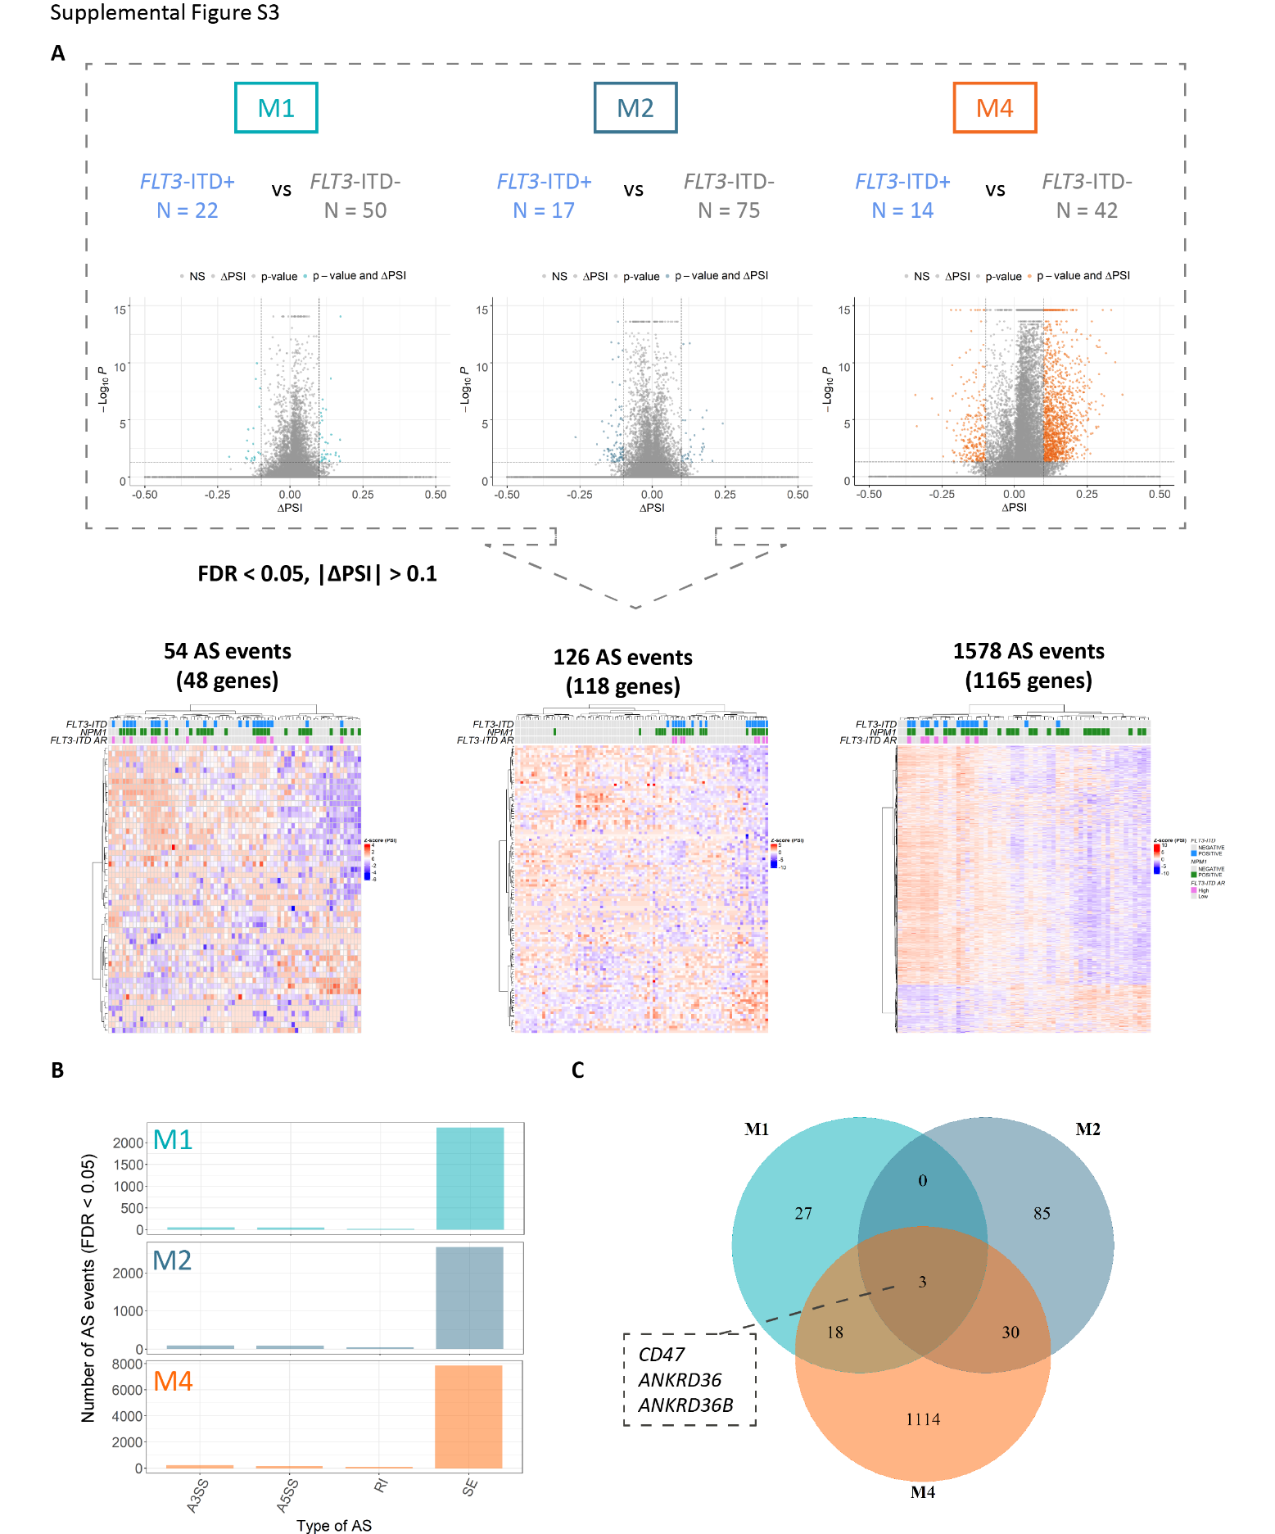
Supplemental Figure S3. FLT3-ITD-associated splicing patterns differ per FAB type. A – An overview of the differential splicing analysis performed with rMATS in three major FAB subtypes of AML (M1, M2 and M4) including volcano plots of PSI (proportion spliced-in) values and hierarchical clustering of significant differential splicing events (FDR < 0.05) with a minimal splicing difference between the two groups of 0.1 (|ΔPSI| > 0.1). The numbers of FLT3-ITD+ and FLT3-ITD- patients as well as the number of significant differential splicing (AS) events in each analysis are indicated. B – The distribution of significant AS events in M1, M2 and M4 FAB types between the four main AS categories – skipped exons (SE), alternative 3’ splice site selection (A3SS), alternative 5’ splice site selection (A5SS) and retained introns (RI). C – Overlap between significantly differentially spliced genes (FDR < 0.05, |ΔPSI| > 0.1) in relation to FLT3-ITD in M1, M2 and M4 FAB subtypes. The three events overlapping between all three FAB subtypes are indicated.

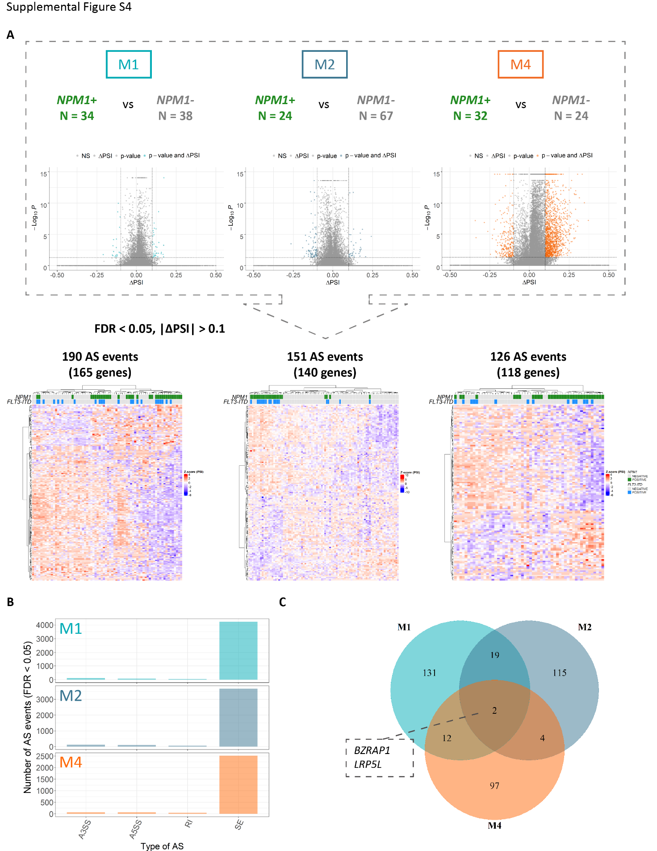
Supplemental Figure S4. NPM1-associated splicing patterns differ per FAB type. A – An overview of the differential splicing analysis performed with rMATS in three major FAB subtypes of AML (M1, M2 and M4) including volcano plots of PSI (proportion spliced-in) values and hierarchical clustering of significant differential splicing events (FDR < 0.05) with a minimal splicing difference between the two groups of 0.1 (|ΔPSI| > 0.1). The numbers of NPM1+ and NPM1- patients as well as the number of significant differential splicing (AS) events in each analysis are indicated. B – The distribution of significant AS events in M1, M2 and M4 FAB types between the four main AS categories – skipped exons (SE), alternative 3’ splice site selection (A3SS), alternative 5’ splice site selection (A5SS) and retained introns (RI). C – Overlap between significantly differentially spliced genes (FDR < 0.05, |ΔPSI| > 0.1) in relation to NPM1 in M1, M2 and M4 FAB subtypes. The two events overlapping between all three FAB subtypes are indicated.

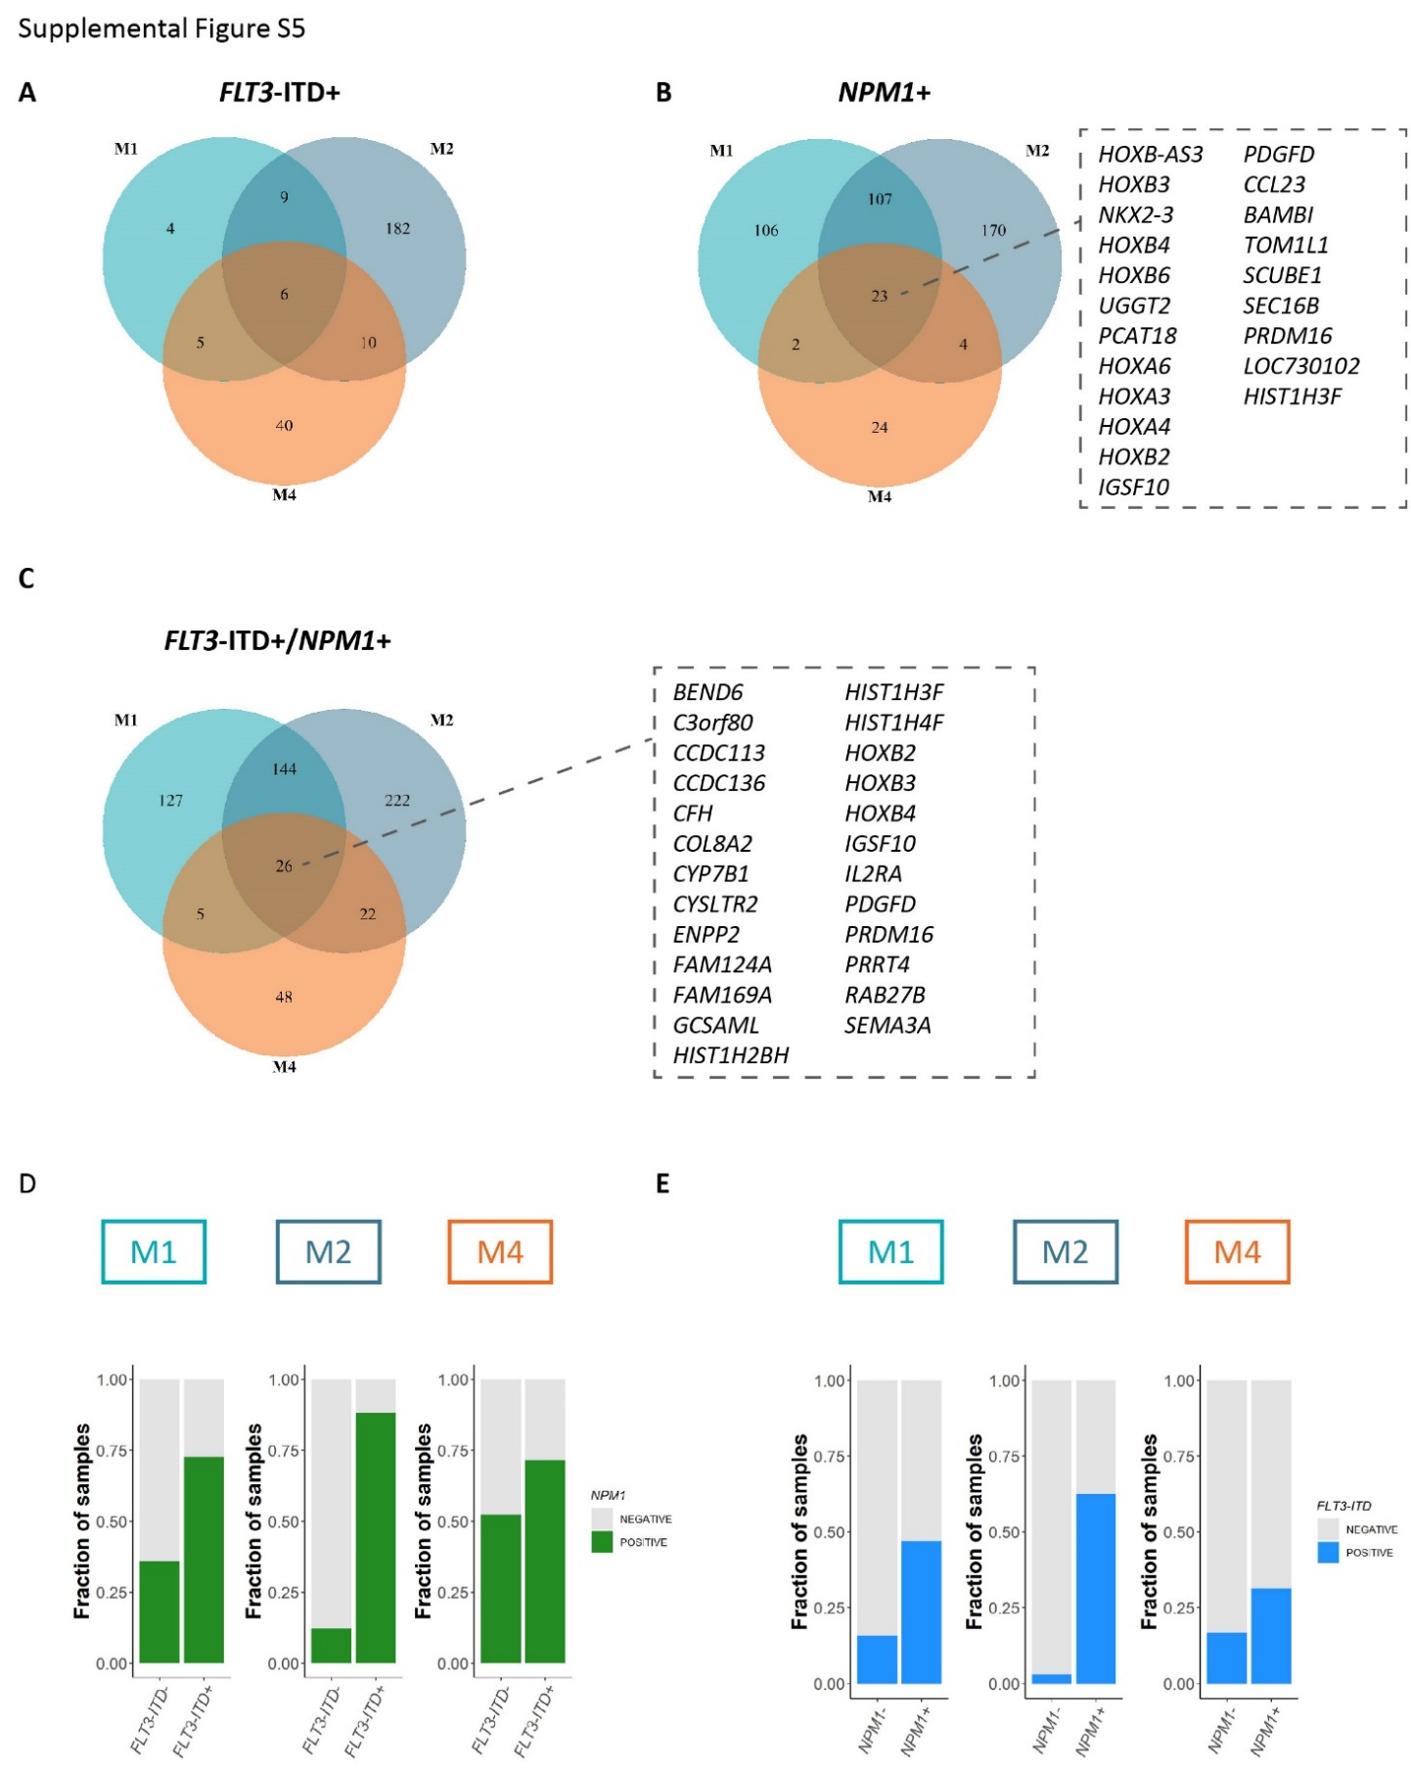
Supplemental Figure S5. FLT3-ITD and NPM1-associated gene expression in M1, M2 and M4 FAB subtypes. A, B, C – Overlap between significantly differentially expressed genes (FDR < 0.05, |log2Fc| > 1.5) in relation to the presence of FLT3-ITD (A), NPM1 mutations (B) and the concomitant presence of FLT3-ITD and NPM1 mutations (C) in M1, M2 and M4 FAB types. D – The proportion of NPM1 mutated cases among FLT3-ITD+ and FLT3-ITD- samples in the three analysed FAB types. E – The proportion of FLT3-ITD+ cases among NPM1+ and NPM1- samples in the three analysed FAB types. Fc – fold-change.

Supplemental Figure S5. FLT3-ITD and NPM1-associated gene expression in M1, M2 and M4 FAB subtypes. A, B, C – Overlap between significantly differentially expressed genes (FDR < 0.05, |log2Fc| > 1.5) in relation to the presence of FLT3-ITD (A), NPM1 mutations (B) and the concomitant presence of FLT3-ITD and NPM1 mutations (C) in M1, M2 and M4 FAB types. D – The proportion of NPM1 mutated cases among FLT3-ITD+ and FLT3-ITD- samples in the three analysed FAB types. E – The proportion of FLT3-ITD+ cases among NPM1+ and NPM1- samples in the three analysed FAB types. Fc – fold-change.

Supplemental Figure S5. FLT3-ITD and NPM1-associated gene expression in M1, M2 and M4 FAB subtypes. A, B, C – Overlap between significantly differentially expressed genes (FDR < 0.05, |log2Fc| > 1.5) in relation to the presence of FLT3-ITD (A), NPM1 mutations (B) and the concomitant presence of FLT3-ITD and NPM1 mutations (C) in M1, M2 and M4 FAB types. D – The proportion of NPM1 mutated cases among FLT3-ITD+ and FLT3-ITD- samples in the three analysed FAB types. E – The proportion of FLT3-ITD+ cases among NPM1+ and NPM1- samples in the three analysed FAB types. Fc – fold-change.
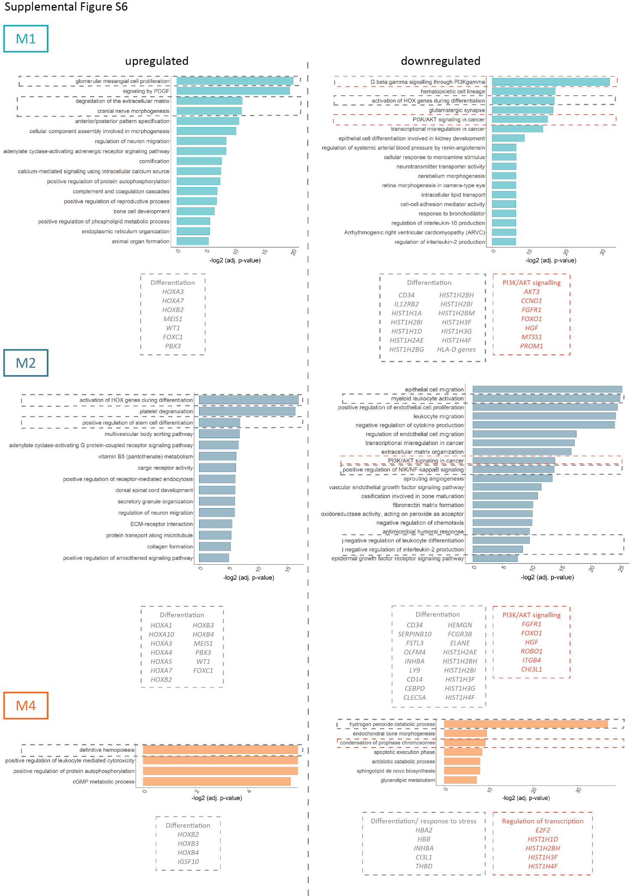

Supplemental Figure S6. Functional analysis of differentially expressed genes in relation to concomitant FLT3-ITD and NPM1 mutations. The figure depicts functional enrichment among significantly upregulated and downregulated genes (FDR < 0.05, |log2Fc| > 1.5) in relation to concomitant FLT3-ITD and NPM1 mutations in M1, M2 and M4 FAB subtypes. For each FAB subtype processes and respective genes involved in regulation of differentiation and signalling are highlighted.
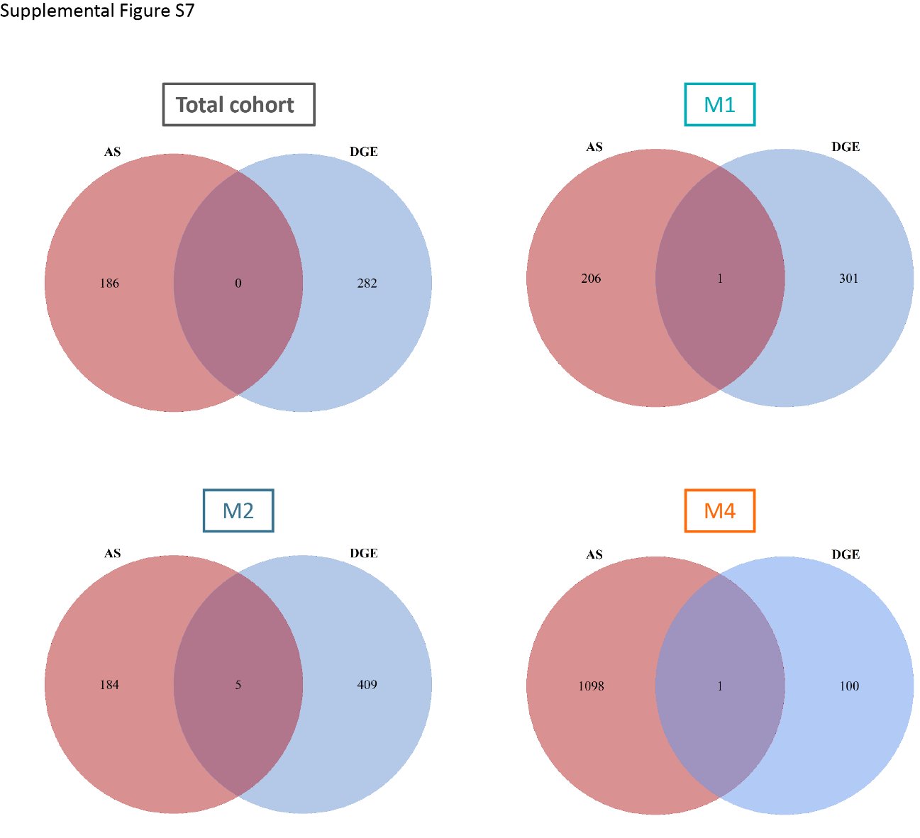

Supplemental Figure S7. Overlap between differential gene expression (DGE) and differential splicing (AS) in relation to concomitant FLT3-ITD and NPM1 mutations. The figure illustrates the overlap between significantly differentially spliced (AS, FDR < 0.05, |ΔPSI| > 0.1) and significantly differentially expressed (DGE, FDR < 0.05, |log2Fc| > 0.1) genes in the total cohort as well as in M1, M2 and M4 FAB types separately.

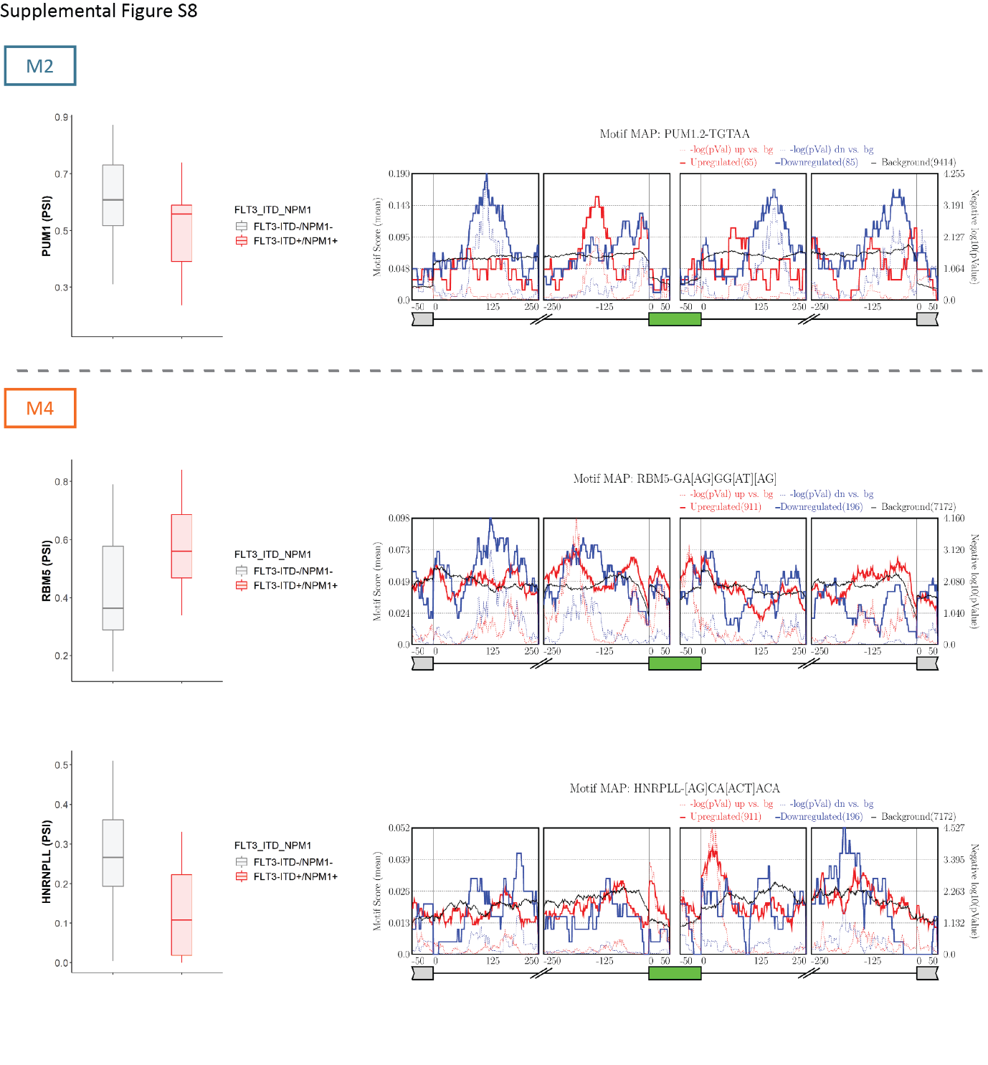

Supplemental Figure S8. Differential splicing of splicing factors and motif enrichment analysis in relation to FLT3-ITD and NPM1 mutations. The figure depicts PSI values for selected differentially spliced splicing regulators (FDR < 0.05 and |ΔPSI| > 0.1) in M1, M2 and M4 FAB types as well as motif enrichment analysis for these splicing regulators performed by rMAPS2. This tools evaluates enrichment of motifs recognized by specific splicing factors in significantly differentially spliced events as compared to the background events (all splicing events detected by rMATS, including non-differential events). The motif enrichment is assessed in the differentially spliced exons as well as immediate upstream and downstream sequences. The motif enrichment score (the left y axis) is depicted by the solid blue (for events with ΔPSI < 0) and solid red (for events with ΔPSI > 0) lines. The solid black line indicates motif score for the background events. The negative logarithm of the p-value (right y axis) is depicted by the broken blue (for events with ΔPSI < 0) and red (for events with ΔPSI > 0) lines.
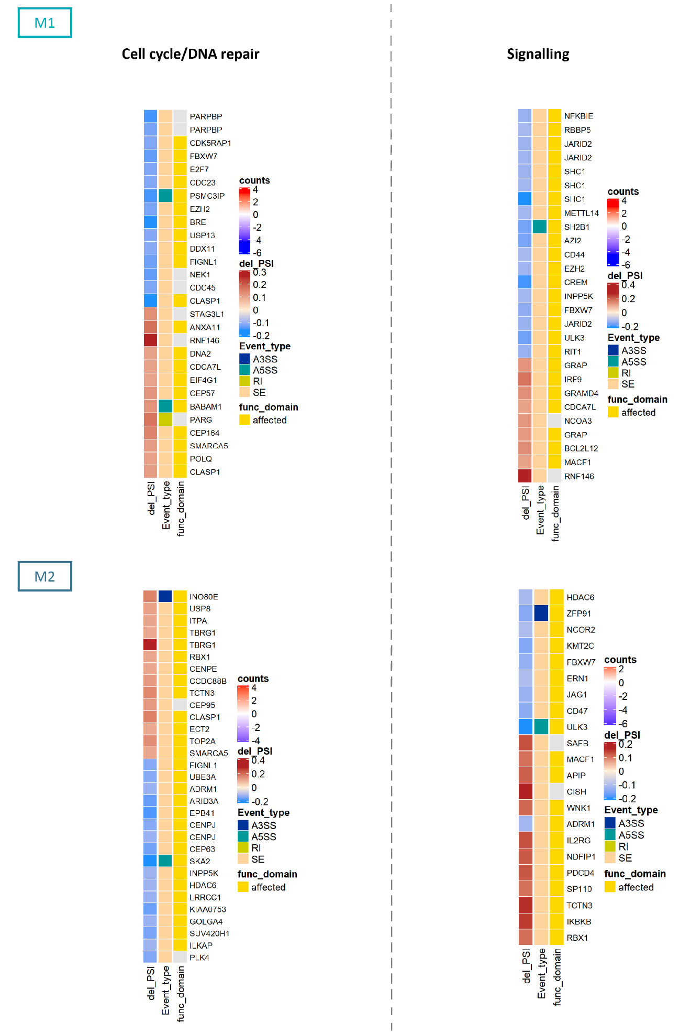

Supplemental Figure S9. Analysis of functional domains affected by splicing alterations in relation to FLT3-ITD and NPM1 mutations in M1 and M2 samples. Maser package was used to determine whether specific splicing alterations directly affect functional domains in proteins corresponding to the differentially spliced genes. Only significantly differentially spliced events (FDR < 0.05, |ΔPSI| > 0.1) affecting genes involved in regulation of cell cycle/DNA repair and signalling were evaluated. The panels indicate which differential splicing events affect functional domains as well as the ΔPSI values and event type.
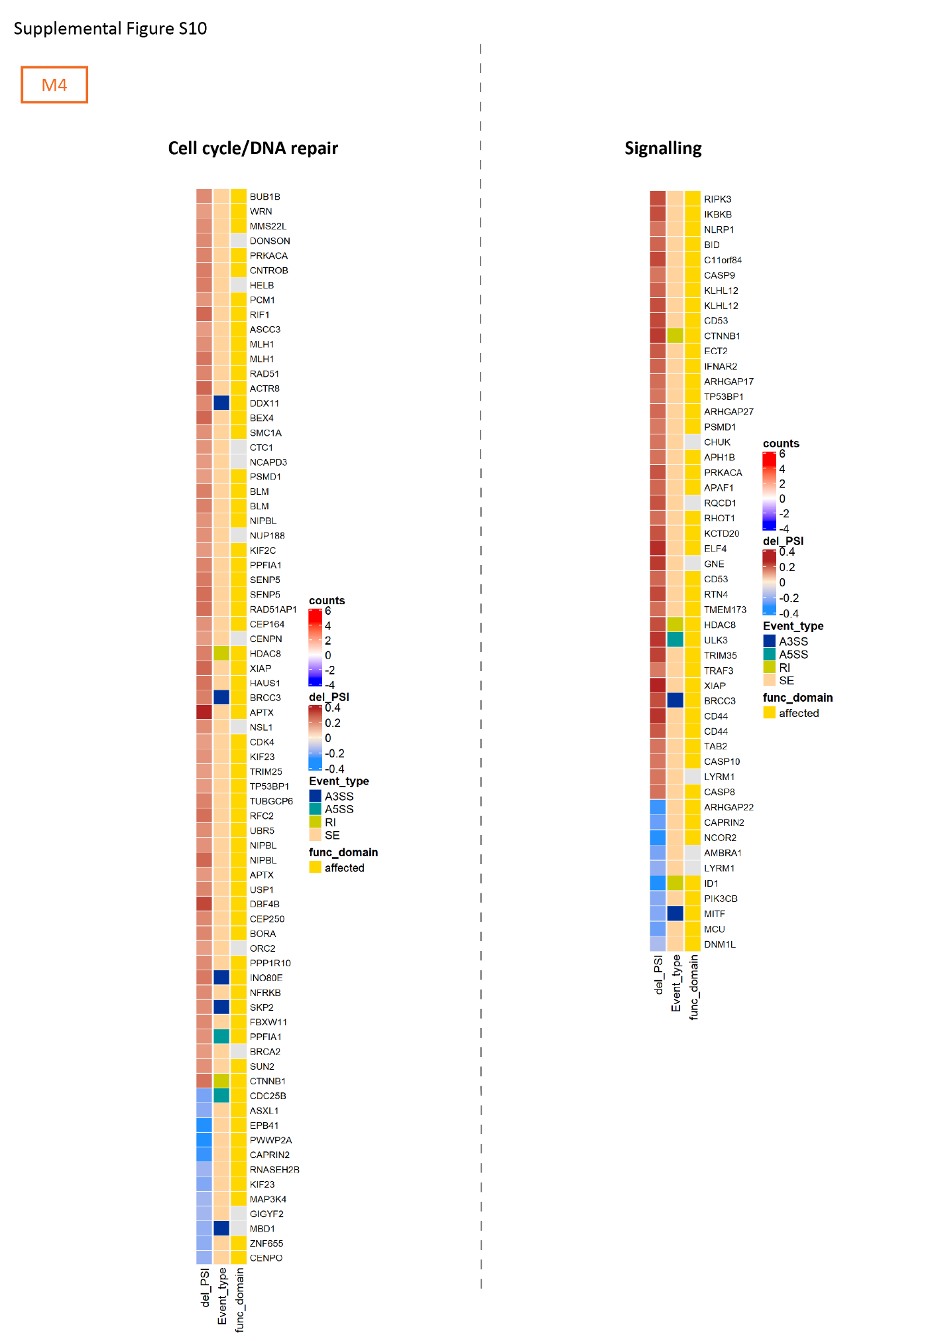

Supplemental Figure S10. Analysis of functional domains affected by splicing alterations in relation to FLT3-ITD and NPM1 mutations in M4 samples. Maser package was used to determine whether specific splicing alterations directly affect functional domains in proteins corresponding to the differentially spliced genes. Only significantly differentially spliced events (FDR < 0.05, |ΔPSI| > 0.1) affecting genes involved in regulation of cell cycle/DNA repair and signalling were evaluated. The panels indicate which differential splicing events affect functional domains as well as the ΔPSI values and event type.
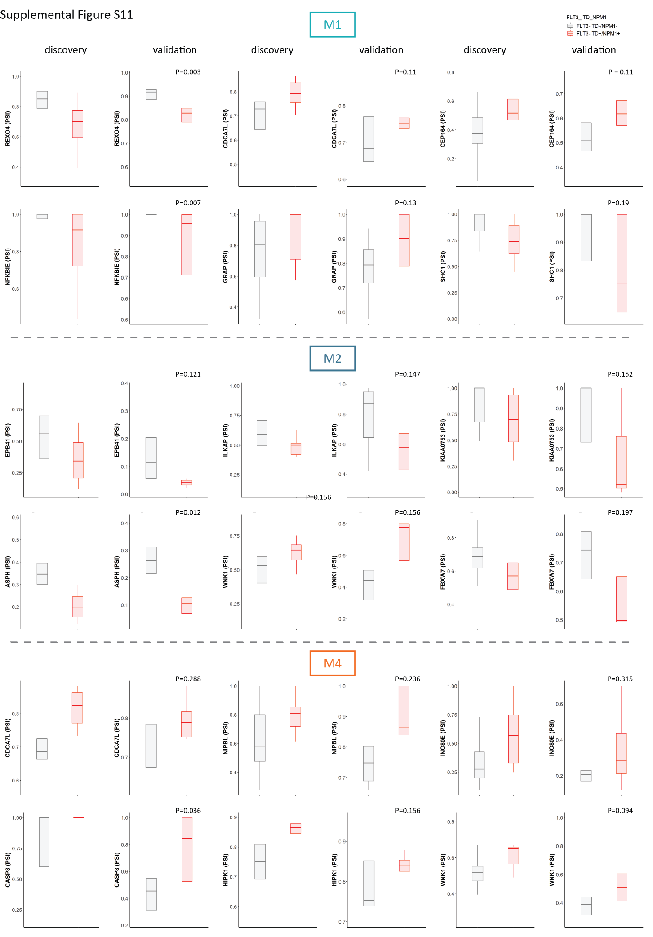

Supplemental Figure S11. Validation of selected differential splicing events in an independent sample set. The figure depicts PSI values for selected differential splicing events in our initial discovery cohort (all events with FDR < 0.05 and |ΔPSI| > 0.1) and an independent validation cohort in M1, M2 and M4 FAB types. A, C, E – Selected splicing events affecting genes involved in cell cycle regulation and DNA damage response in M1, M2 and M4 FAB types respectively. B, D, F – Selected splicing events affecting genes involved in signalling pathways in M1, M2 and M4 FAB types respectively.

