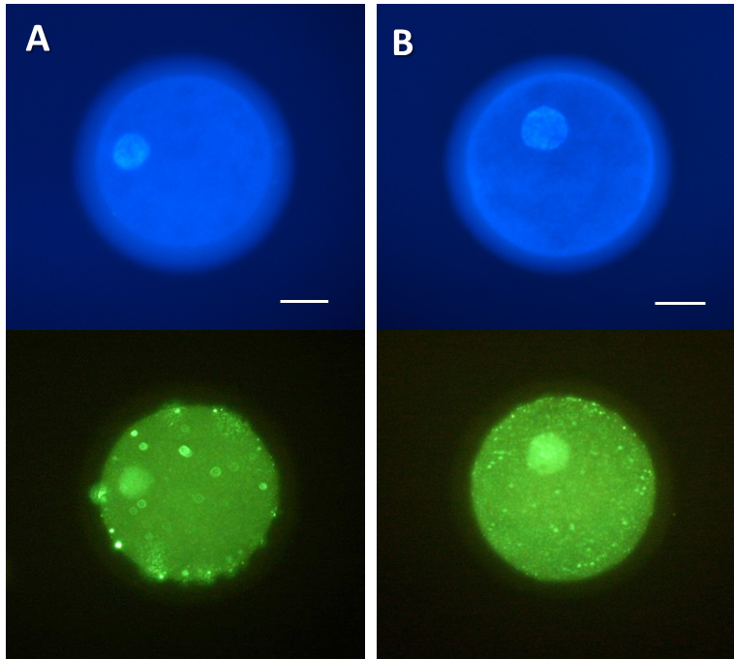
Supplementary Figure 1. BrdU incorporation by canine cloned embryos following oocyte activation. (A) DAPI staining (upper panel) and BrdU incorporation (lower panel) of embryos at 2 hpa in the DMAP-2h group. (B) DAPI staining (upper panel) and BrdU incorporation (lower panel) of embryos at 4 hpa in the DMAP-4h group. (scale bar = 40 mm).

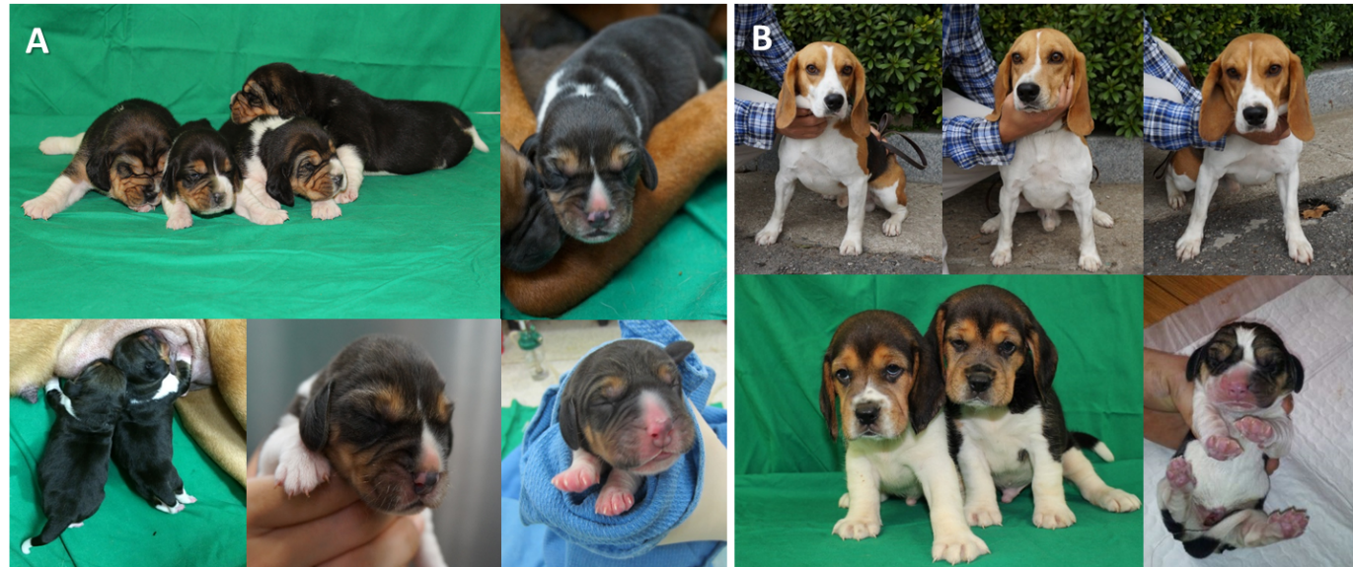
Fig. 1. Cloned puppies produced by SCNT using donor cells derived from elite quarantine sniffing dogs. (A) Nine cloned puppies derived from the DMAP-2h group. (B) Six cloned puppies derived from the DMAP-4h group.

