Article
Strategy for Managing Industrial Anaerobic Sludge through the Heterotrophic Cultivation of Chlorella sorokiniana: Effect of Iron Addition on Biomass and Lipid Production
Esteban Charria-Girón ¹, Vanessa Amazo ¹, Daniela De Angulo ¹, Eliana Hidalgo ¹, María Francisca Villegas-Torres ^{2, 3}, Frank Baganz ⁴, Nelson. H Caicedo ^{1, 3,*}.
Citation: Lastname, F.; Lastname, F.; Lastname, F. Title. Bioengineering 2021, 8, x. https://doi.org/10.3390/xxxxx
Academic Editor: Firstname Lastname
Received: date
Accepted: date
Published: date
Publisher’s Note: MDPI stays neutral with regard to jurisdictional claims in published maps and institutional affiliations.

Copyright: © 2021 by the authors. Submitted for possible open access publication under the terms and conditions of the Creative Commons Attribution (CC BY) license (https://creativecommons.org/licenses/by/4.0/).
¹ Universidad Icesi, Facultad de Ingeniería, Departamento de Ingeniería Bioquímica, Calle 18 No. 122 - 135, Cali, Colombia
² Universidad Icesi, Facultad de Ciencias Naturales, Departamento de Ciencias Químicas, Calle 18 No. 122 - 135, Cali, Colombia
³ Universidad Icesi, Centro BioInc, Calle 18 No. 122 - 135, Cali, Colombia
⁴ Department of Biochemical Engineering, University College London, Gordon Street, London, WC1H 0AH, UK
* Correspondence: e-mail@e-mail.com; Tel.: (optional; include country code; if there are multiple corresponding authors, add author initials)
Abstract: Herein, the heterotrophic cultivation of Chlorella sorokiniana was systematically studied, allowing us to detect a nutritional deficiency other than the carbon source through assessing the oxygen transfer rate on glucose or acetate fermentations. In consequence, a mathematical model of iron co-limiting effect on heterotrophic microalgae growth was developed by exploring its ability to regulate the specific growth rate and yield. For instance, higher values of specific growth rate (0.17 h⁻¹) than those reported for the heterotrophic culture of Chlorella species were obtained due to iron supplementation. On the other hand, anaerobic sludge from the wastewater treatment plant of a baker's yeast company was pretreated to obtain an extract as a media supplement for C. sorokiniana. According to the proposed model, the sludge extract allowed us to supplement iron values close to growth activation concentration (K_{Fe} ~12 mg L⁻¹). Therefore, a fed-batch strategy was evaluated on nitrogen-deprived cultures supplemented with the sludge extract to promote biomass formation and fatty acid synthesis. Our findings reveal that nitrogen and iron in sludge extract can supplement heterotrophic cultures of Chlorella and provide an alternative for the valorization of industrial anaerobic sludge.
Keywords: Anaerobic Sludge 1, Chlorella sorokiniana 2, Heterotrophic cultivation 3, Iron 4, Modeling 5.

$\frac{dX}{dt}= \frac{μ_{max} S}{Ks+S}X$ $\frac{dS}{dt}=-\frac{μ X}{Y_{X/{S }}}$
$$μ_{max}=\frac{μ_{Fe} Fe }{(K_{Fe}+Fe+\frac{{Fe}^{2}}{{Ki}_{Fe}})}$$
Figure S1. Flowchart on the computational methodology for adequate use of iron co-limitation model.

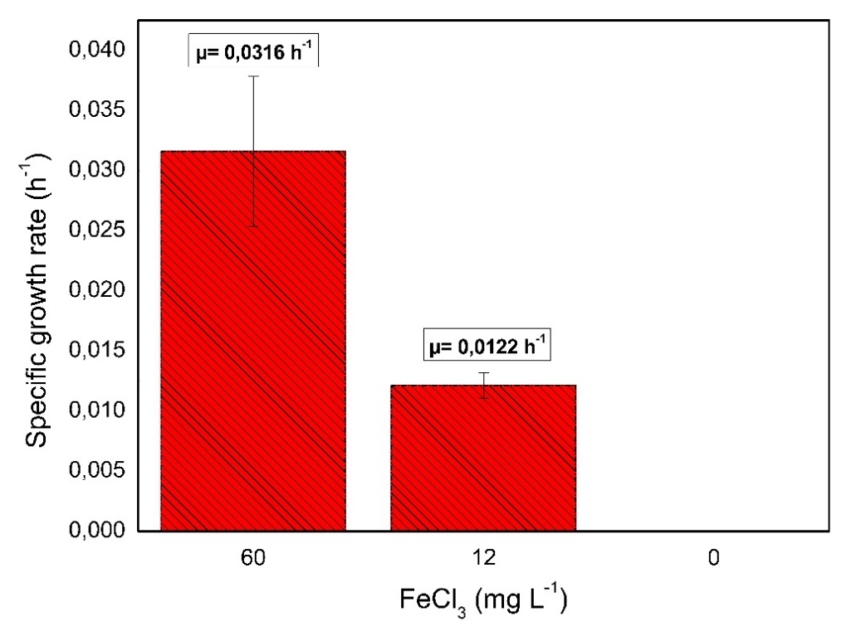
Figure S2. Specific growth rate increment calculated after iron addition (18-25 h) on the late exponential phase of the heterotrophic culture of C.sorokiniana.
Biomass growth mass balance | $$\frac{dX}{dt}=\left(μ-\frac{Fin}{V}\right)X$$
Substrate consumption mass balance | $$\frac{dS}{dt}=\frac{-1}{Yxs}μX+\left(Sfeed*Fin-S\right)\frac{Fin}{V}$$
Volume balance | $$\frac{dV}{dt}=Fin=Fo e^{μ_{*}t}$$
Initial flow rate | $Fo=\frac{\frac{μ_{*}}{Yxs}}{\left(Sfeed-S\right)}$ $\left\{\begin{aligned}6h \\ 0h\end{aligned}\right. ; μ=0.13 h^{-1}$
Table S1: Mass balance equations for fed-batch bioaugmentation process; it is noting that substrate consumption for maintenance was assumed to be cero.
Where X is the concentration of biomass (g L⁻¹); µ* is the specific growth rate (h⁻¹) fixed during the fed-batch; Fin is the feeding rate (h⁻¹), for fed-batch cultivation; Fo is the initial feeding rate for exponential feeding profile (L min⁻¹);V is the volume of the medium (L); Y_{XS} is the substrate yield coefficient (g g⁻¹); S is the glucose concentration (g L⁻¹) and Sin is the glucose concentration in the feed (g L⁻¹).

