Metadata of the published tiles

The published 9 tiles are from the dataset of airborne laser scanning of the city of Vienna, in which 4 tiles are used for training and 5 tiles are used for evaluation in the paper “A Comparison of Deep Learning Methods for Airborne Lidar Point Clouds Classification”. Their locations are presented in blue and red, respectively, in Fig. 1. Tab.1 provides the WGS84/GRS80 latitude and longitude coordinates of the extent corners of each tile (EPSG: 31256). This can be used to access images of the tiles from Google Maps or other public map service.
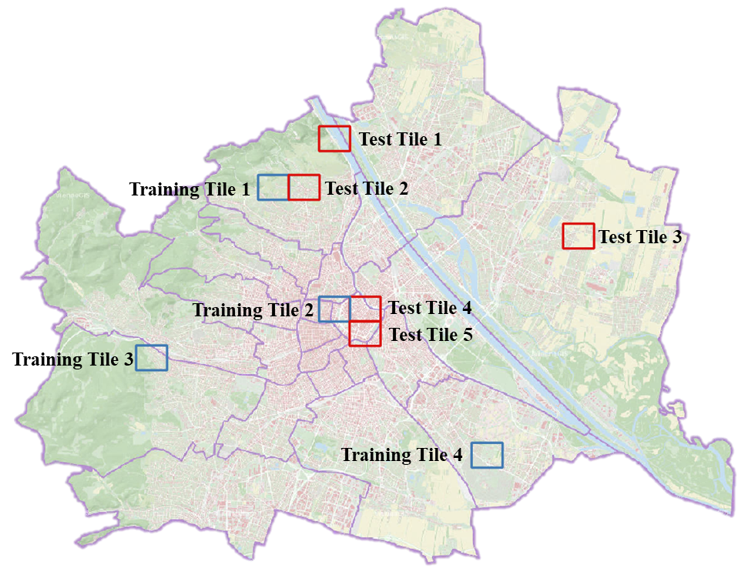
Fig. 1: Locations of the published tiles in Vienna.

Tab. 2: Corner coordinates of the extent of each published tile in lat/long
Tile | Start latitude | Start longitude | End latitude | End longitude
Training tile 1 | 48. 252276 | 16. 315164 | 48. 261451 | 16. 332265
Training tile 2 | 48. 207312 | 16. 348818 | 48. 216482 | 16. 365910
Training tile 3 | 48. 189292 | 16. 247942 | 48. 198477 | 16. 265010
Training tile 4 | 48. 153312 | 16. 432805 | 48. 162470 | 16. 449894
Test tile 1 | 48. 270264 | 16. 348833 | 48. 279434 | 16. 365946
Test tile 2 | 48. 252278 | 16. 331996 | 48. 261451 | 16. 349100
Test tile 3 | 48. 234198 | 16. 483437 | 48. 243348 | 16. 500562
Test tile 4 | 48. 207309 | 16. 365635 | 48. 217294 | 16. 382731
Test tile 5 | 48. 198315 | 16. 365630 | 48. 207483 | 16. 382722

The coordinates of points are given in MGI/Austria GK East (EPSG 31256), with units of meter.
In spite of 3D coordinates, the following attributes are contained in each “las” file: Point Source ID, Scan Angle Rank, Number of Returns, Return Number, GPS Time, Intensity and Classification.

