Online Supplementary Information

Providing a common base for life cycle assessments of Li-Ion batteries
Jens F. Peters ¹, Marcel Weil^{1, 2}
¹ Helmholtz Institute Ulm (HIU), Helmholtzstr. 11, 89081 Ulm (Germany)³
² ITAS, Institute for Technology Assessment and Systems Analysis, Karlsruhe (Germany)³
³ Karlsruhe Institute for Technology (KIT), P.O.Box 3640, 76021 Karlsruhe, Germany

In this supplementary document, the complete LCA results are provided in tabulated form together with the embedded zip-File for direct import of the inventory data and their re-use in LCA software (ILCD format; exported from openLCA), together with a short manual about the import and use of the provided LCI datasets in openLCA. Additionally, the modified and parametrized LCI data are also provided in tabulated form.

Characterization results in tabulated form S 2
Detailed impacts from the electrode binder S 5
Inventory datasets S 7
LCI data in tabulated form S13
- Characterization results in tabulated form

Table S1 to S4 provide the tabulated LCIA results for all impact categories (ILCD 2011).

Table S1. Characterization results per kg of battery; original LCI

Impact category | LFP-C (M-B) | LFP-C (Zack) | LFP-LTO (Bau) | LMO-C (Not) | NCA-C (Bau) | NCM-C (Ell) | NCM-C (M-B) | Unit
Acidification | 1.39E-01 | 2.87E-01 | 1.10E-01 | 1.22E-01 | 6.81E-01 | 3.24E-01 | 3.11E-01 | Mole H+ eq.
Climate change | 2.39E+01 | 2.12E+01 | 1.80E+01 | 8.08E+00 | 1.75E+01 | 1.74E+01 | 2.38E+01 | kg CO₂ eq.
Freshwater ecotoxicity | 1.03E+02 | 1.68E+02 | 3.40E+01 | 8.61E+01 | 6.92E+01 | 7.77E+01 | 1.06E+02 | CTUe
Freshwater eutrophicat. | 3.34E-02 | 4.60E-02 | 8.83E-03 | 2.06E-02 | 1.97E-02 | 2.40E-02 | 3.24E-02 | kg P eq.
Human tox. - carcinogenics | 3.23E-06 | 6.13E-06 | 1.39E-06 | 2.05E-06 | 1.76E-06 | 2.83E-06 | 3.12E-06 | CTUh
Human tox. - non-carcinog. | 2.06E-05 | 3.13E-05 | 5.42E-06 | 1.68E-05 | 1.46E-05 | 1.51E-05 | 2.15E-05 | CTUh
Ion. radiation – ecosystems | 6.59E-06 | 8.14E-06 | 3.00E-06 | 2.30E-06 | 3.17E-06 | 1.06E-05 | 6.71E-06 | CTUe
Ion. radiaton - human health | 2.50E+00 | 3.29E+00 | 8.11E-01 | 7.26E-01 | 9.24E-01 | 4.41E+00 | 2.55E+00 | kg U235 eq.
Land use | 8.94E+00 | 8.40E+00 | 1.31E+01 | 4.17E+00 | 1.12E+01 | 6.27E+00 | 7.65E+00 | kg SOC
Marine eutrophicat. | 1.95E-02 | 2.21E-02 | 1.48E-02 | 1.32E-02 | 1.29E-01 | 2.22E-02 | 2.07E-02 | kg N eq.
Ozone depletion | 2.27E-04 | 2.07E-04 | 6.01E-05 | 6.63E-07 | 3.61E-05 | 1.48E-06 | 2.19E-04 | kg CFC-11 eq.
Particulate matter/Respir. Inorganics | 1.52E-02 | 1.61E-02 | 1.02E-02 | 1.23E-02 | 2.96E-02 | 2.31E-02 | 2.36E-02 | kg PM2.5 eq.
Photochem. Ozone form. | 5.08E-02 | 5.45E-02 | 4.41E-02 | 3.66E-02 | 3.58E-01 | 6.87E-02 | 6.55E-02 | kg C₂H₄ eq.
Depletion of abiotic res. - elements | 3.85E-03 | 5.33E-03 | 3.89E-03 | 2.75E-03 | 4.45E-03 | 6.42E-03 | 4.31E-03 | kg Sb eq.
Resource depl. - water | 7.25E-02 | 8.49E-03 | 2.86E-02 | 7.57E-03 | 3.01E-02 | 4.98E-02 | 7.18E-02 | m³
Terrestrial eutrophic. | 1.78E-01 | 7.30E-01 | 1.43E-01 | 1.20E-01 | 1.42E+00 | 2.07E-01 | 1.98E-01 | Mole N eq.

Table S2. Characterization results per kWh of storage capacity; original LCI

Impact category | LFP-C (M-B) | LFP-C (Zack) | LFP-LTO (Bau) | LMO-C (Not) | NCA-C (Bau) | NCM-C (Ell) | NCM-C (M-B) | Unit
Acidification | 1.58E+00 | 3.09E+00 | 2.11E+00 | 1.07E+00 | 5.15E+00 | 2.90E+00 | 2.95E+00 | Mole H+ eq.
Climate change | 2.71E+02 | 2.28E+02 | 3.48E+02 | 7.09E+01 | 1.32E+02 | 1.56E+02 | 2.27E+02 | kg CO₂ eq.
Freshwater ecotoxicity | 1.17E+03 | 1.81E+03 | 6.55E+02 | 7.55E+02 | 5.23E+02 | 6.94E+02 | 1.01E+03 | CTUe
Freshwater eutrophicat. | 3.80E-01 | 4.94E-01 | 1.70E-01 | 1.81E-01 | 1.49E-01 | 2.15E-01 | 3.08E-01 | kg P eq.
Human tox. - carcinogenics | 3.68E-05 | 6.59E-05 | 2.67E-05 | 1.80E-05 | 1.33E-05 | 2.52E-05 | 2.96E-05 | CTUh
Human tox. - non-carcinog. | 2.34E-04 | 3.36E-04 | 1.04E-04 | 1.48E-04 | 1.10E-04 | 1.35E-04 | 2.05E-04 | CTUh
Ion. radiation – ecosystems | 7.48E-05 | 8.75E-05 | 5.78E-05 | 2.02E-05 | 2.40E-05 | 9.46E-05 | 6.38E-05 | CTUe
Ion. radiaton - human health | 2.84E+01 | 3.54E+01 | 1.56E+01 | 6.37E+00 | 6.99E+00 | 3.94E+01 | 2.42E+01 | kg U235 eq.
Land use | 1.02E+02 | 9.03E+01 | 2.52E+02 | 3.66E+01 | 8.44E+01 | 5.59E+01 | 7.27E+01 | kg SOC
Marine eutrophicat. | 2.21E-01 | 2.38E-01 | 2.86E-01 | 1.16E-01 | 9.77E-01 | 1.98E-01 | 1.97E-01 | kg N eq.
Ozone depletion | 2.58E-03 | 2.23E-03 | 1.16E-03 | 5.82E-06 | 2.73E-04 | 1.32E-05 | 2.08E-03 | kg CFC-11 eq.
Particulate matter/Respir. Inorganics | 1.73E-01 | 1.73E-01 | 1.97E-01 | 1.08E-01 | 2.24E-01 | 2.06E-01 | 2.24E-01 | kg PM2.5 eq.
Photochem. Ozone form. | 5.77E-01 | 5.86E-01 | 8.50E-01 | 3.21E-01 | 2.71E+00 | 6.14E-01 | 6.23E-01 | kg C₂H₄ eq.
Depletion of abiotic res. - elements | 4.38E-02 | 5.73E-02 | 7.50E-02 | 2.41E-02 | 3.36E-02 | 5.73E-02 | 4.10E-02 | kg Sb eq.
Resource depl. - water | 8.24E-01 | 9.12E-02 | 5.51E-01 | 6.64E-02 | 2.28E-01 | 4.45E-01 | 6.83E-01 | m³
Terrestrial eutrophic. | 2.02E+00 | 7.85E+00 | 2.76E+00 | 1.05E+00 | 1.07E+01 | 1.85E+00 | 1.88E+00 | Mole N eq.

Table S3. Characterization results per kg of battery; unified LCI
Impact category | LFP-C (M-B) | LFP-C (Zack) | LFP-LTO (Bau) | LMO-C (Not) | NCA-C (Bau) | NCM-C (Ell) | NCM-C (M-B) | Unit
Acidification | 1.17E-01 | 1.93E-01 | 9.38E-02 | 1.44E-01 | 6.79E-01 | 3.35E-01 | 3.33E-01 | Mole H+ eq.
Climate change | 1.60E+01 | 1.40E+01 | 1.39E+01 | 1.35E+01 | 1.53E+01 | 1.44E+01 | 1.61E+01 | kg CO₂ eq.
Freshwater ecotoxicity | 5.70E+01 | 6.08E+01 | 3.22E+01 | 8.51E+01 | 6.86E+01 | 7.67E+01 | 6.12E+01 | CTUe
Freshwater eutrophicat. | 2.00E-02 | 1.20E-02 | 1.02E-02 | 2.21E-02 | 2.14E-02 | 2.34E-02 | 1.89E-02 | kg P eq.
Human tox. - carcinogenics | 1.89E-06 | 3.86E-06 | 1.53E-06 | 2.12E-06 | 1.94E-06 | 2.00E-06 | 1.75E-06 | CTUh
Human tox. - non-carcinog. | 1.16E-05 | 6.83E-06 | 4.89E-06 | 1.62E-05 | 1.42E-05 | 1.70E-05 | 1.28E-05 | CTUh
Ion. radiation – ecosystems | 6.44E-06 | 6.03E-06 | 6.43E-06 | 6.44E-06 | 6.87E-06 | 6.59E-06 | 6.62E-06 | CTUe
Ion. radiaton - human health | 2.58E+00 | 2.47E+00 | 2.60E+00 | 2.62E+00 | 2.78E+00 | 2.64E+00 | 2.65E+00 | kg U235 eq.
Land use | 8.28E+00 | 5.45E+00 | 7.43E+00 | 4.57E+00 | 6.69E+00 | 7.32E+00 | 6.79E+00 | kg SOC
Marine eutrophicat. | 1.43E-02 | 1.42E-02 | 1.32E-02 | 1.58E-02 | 1.29E-01 | 1.83E-02 | 1.59E-02 | kg N eq.
Ozone depletion | 1.17E-04 | 1.06E-04 | 3.67E-05 | 1.35E-05 | 2.23E-05 | 5.52E-05 | 1.10E-04 | kg CFC-11 eq.
Particulate matter/Respir. Inorganics | 1.04E-02 | 1.03E-02 | 9.20E-03 | 1.29E-02 | 2.94E-02 | 2.12E-02 | 2.10E-02 | kg PM2.5 eq.
Photochem. Ozone form. | 3.91E-02 | 3.16E-02 | 3.51E-02 | 4.49E-02 | 3.56E-01 | 6.21E-02 | 5.78E-02 | kg C₂H₄ eq.
Depletion of abiotic res. - elements | 6.15E-03 | 4.91E-03 | 5.87E-03 | 5.53E-03 | 6.47E-03 | 7.79E-03 | 6.75E-03 | kg Sb eq.
Resource depl. - water | 8.72E-02 | 5.45E-03 | 2.98E-02 | 8.07E-03 | 3.16E-02 | 5.72E-02 | 8.67E-02 | m³
Terrestrial eutrophic. | 1.27E-01 | 5.95E-01 | 1.15E-01 | 1.41E-01 | 1.41E+00 | 1.76E-01 | 1.53E-01 | Mole N eq.

Table S4. Characterization results per kWh of storage capacity; unified LCI
Wirkungskategorie | LFP-C (M-B) | LFP-C (Zack) | LFP-LTO (Bau) | LMO-C (Not) | NCA-C (Bau) | NCM-C (Ell) | NCM-C (M-B) | Unit
Acidification | 1.07E+00 | 2.33E+00 | 1.79E+00 | 1.24E+00 | 5.10E+00 | 2.41E+00 | 2.55E+00 | Mole H+ eq.
Climate change | 1.47E+02 | 1.69E+02 | 2.66E+02 | 1.16E+02 | 1.15E+02 | 1.04E+02 | 1.24E+02 | kg CO₂ eq.
Freshwater ecotoxicity | 5.21E+02 | 7.33E+02 | 6.15E+02 | 7.33E+02 | 5.16E+02 | 5.51E+02 | 4.69E+02 | CTUe
Freshwater eutrophicat. | 1.83E-01 | 1.45E-01 | 1.94E-01 | 1.90E-01 | 1.61E-01 | 1.68E-01 | 1.45E-01 | kg P eq.
Human tox. - carcinogenics | 1.73E-05 | 4.65E-05 | 2.92E-05 | 1.83E-05 | 1.46E-05 | 1.44E-05 | 1.35E-05 | CTUh
Human tox. - non-carcinog. | 1.06E-04 | 8.23E-05 | 9.34E-05 | 1.40E-04 | 1.07E-04 | 1.22E-04 | 9.85E-05 | CTUh
Ion. radiation – ecosystems | 5.90E-05 | 7.27E-05 | 1.23E-04 | 5.55E-05 | 5.16E-05 | 4.74E-05 | 5.08E-05 | CTUe
Ion. radiaton - human health | 2.36E+01 | 2.97E+01 | 4.97E+01 | 2.26E+01 | 2.09E+01 | 1.90E+01 | 2.03E+01 | kg U235 eq.
Land use | 7.58E+01 | 6.57E+01 | 1.42E+02 | 3.93E+01 | 5.03E+01 | 5.26E+01 | 5.21E+01 | kg SOC
Marine eutrophicat. | 1.31E-01 | 1.71E-01 | 2.51E-01 | 1.37E-01 | 9.73E-01 | 1.31E-01 | 1.22E-01 | kg N eq.
Ozone depletion | 1.07E-03 | 1.28E-03 | 7.02E-04 | 1.16E-04 | 1.68E-04 | 3.97E-04 | 8.43E-04 | kg CFC-11 eq.
Particulate matter/Respir. Inorganics | 9.55E-02 | 1.24E-01 | 1.76E-01 | 1.12E-01 | 2.21E-01 | 1.53E-01 | 1.61E-01 | kg PM2.5 eq.
Photochem. Ozone form. | 3.58E-01 | 3.81E-01 | 6.71E-01 | 3.87E-01 | 2.67E+00 | 4.46E-01 | 4.43E-01 | kg C₂H₄ eq.
Depletion of abiotic res. - elements | 5.63E-02 | 5.93E-02 | 1.12E-01 | 4.76E-02 | 4.86E-02 | 5.60E-02 | 5.18E-02 | kg Sb eq.
Resource depl. - water | 7.98E-01 | 6.58E-02 | 5.70E-01 | 6.95E-02 | 2.37E-01 | 4.11E-01 | 6.65E-01 | m³
Terrestrial eutrophic. | 1.16E+00 | 7.17E+00 | 2.20E+00 | 1.22E+00 | 1.06E+01 | 1.27E+00 | 1.18E+00 | Mole N eq.

- Detailed impacts from the electrode binder
In the main manuscript, not all types of binder that are inventoried in the background studies are compared. Table S5 shows the characterization results for the five selected impact categories for all binder types that can be found in the analyzed studies, while Figure S1 shows the relative impacts normalized to the highest scoring binder type (including solvent use).

Table S5. Characterization results per kg of electrode binder; including solvent (if considered by the study). Solv. rec. = Solvent recovery within the process (100% = solvent 100% recovered / no solvent make-up balanced, 0% = no solvent recovery, all solvent is fully evaporated to the atmosphere / flared off and has to be added continuously). Abbreviations for binder and impact categories can be found in the Abbreviations list.
Binder | TFE-PE | TFE | TFE | Latex | SBL | SAL | CMC-SBR | CMC-PAA | PVF | Unit
Solvent | NMP | org | org | Water | Water | Water | Water | org | org
Solv. rec. | 100% | n/c | 0% | -- | -- | -- | -- | 0% | 0%
source | Zack | Bauer | NTNU | Notter | Zack | Zack | Peters | Elling | Elling
GWP | 163.12 | 162.15 | 349.63 | 2.75 | 4.08 | 5.41 | 3.56 | 169.84 | 90.84 | kgCO₂ eq.
AP | 5.73E-02 | 5.35E-02 | 2.75E-01 | 1.90E-02 | 1.55E-02 | 3.10E-02 | 2.40E-02 | 1.11E+00 | 5.88E-01 | MoleH⁺eq.
HTP | 2.71E-06 | 2.68E-06 | 1.03E-05 | 5.91E-07 | 2.30E-07 | 1.95E-07 | 8.17E-07 | 3.32E-05 | 1.79E-05 | CTUh
PMF | 5.87E-03 | 5.23E-03 | 3.23E-02 | 2.30E-03 | 1.83E-03 | 2.56E-03 | 3.84E-03 | 1.44E-01 | 7.62E-02 | kgPM2.5eq.
POF | 2.31E-02 | 1.96E-02 | 1.13E-01 | 1.44E-02 | 1.12E-02 | 1.99E-02 | 1.57E-02 | 4.85E-01 | 2.48E-01 | kgC₂H₄ eq.

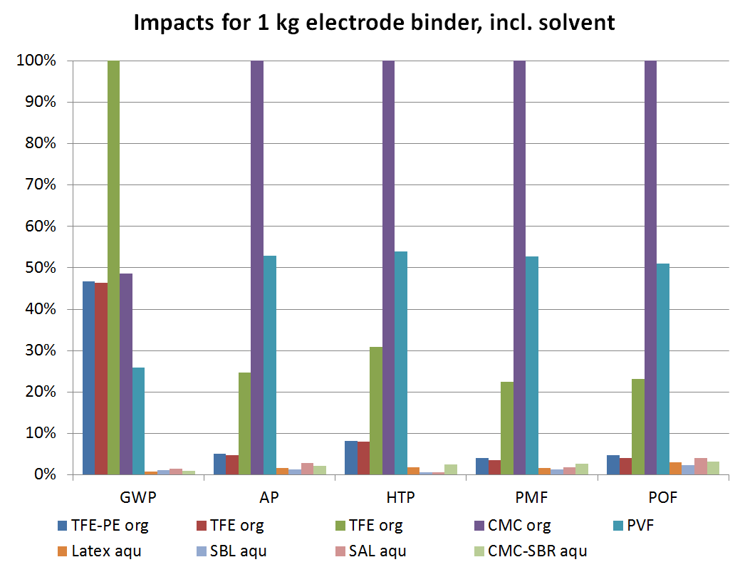
Figure S1. Relative environmental impacts of different types of binder, including solvent. Abbreviations for binder and impact categories can be found in the Abbreviations list.

- Inventory datasets for import in openLCA
  - Dataset import
The complete modularized LCI datasets (as one of the principle outcomes of this work) are exported in the ILCD format for import and immediate use in openLCA. Two import files are provided, flows and processes. Importing the flows first is recommended. The import should be done into a new database where the underlying ecoinvent datasets are already available (ecoinvent 3.2.). When importing (“Import -> File Import -> ILCD”), a folder is created named ‘Li-Ion_CommonBase’, where the LCI data can be found. The processes are structured in subfolders according the source of the original data (i.e. the corresponding publication: Bauer (Bauer, 2010), Ellingsen et al. (Ellingsen et al., 2014), Majeau-Bettez et al. (Majeau-Bettez et al., 2011), Notter et al. (Notter et al., 2010), Zackrisson et al. (Zackrisson et al., 2010) and Peters et al. (Peters et al., 2016)). The top-level processes for assessment (battery packs, but also battery cells) can be found in the sub-folder “modular” (shown graphically in Figure S2), and are listed in the following:
- Li-Ion Battery Pack production, LFP-TiO, modular (Bauer)
- Li-Ion Battery Pack production, NCA-C, modular (Bauer)
- Li-Ion battery pack production, NCM-C, modular (Ellingsen)
- Li-Ion battery pack production, LFP-C, modular, at plant (NTNU)
- Li-Ion battery pack production, NCM-C, modular, at plant (NTNU)
- Li-ion battery, LMO-C, modular | cut-off, U (Notter/ecoinvent)
- LFP-C type Li-Ion Battery, modular, at plant (Zackrisson, org.)
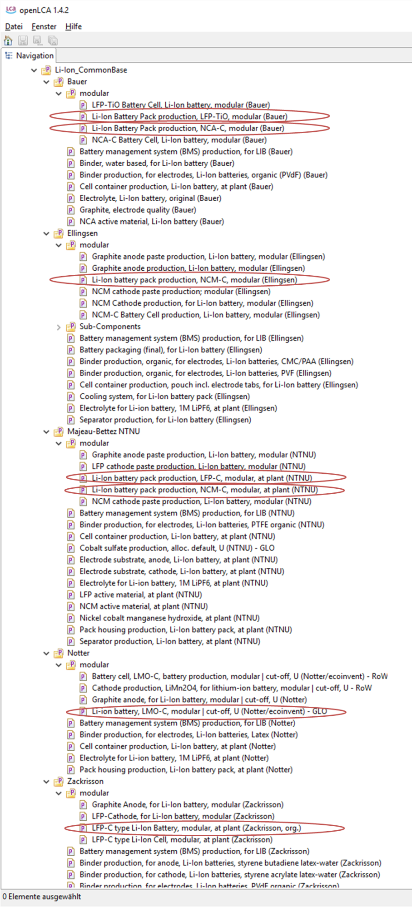
Figure S2. Top-level processes (battery packs) as basis for assessment imported in openLCA

  - Selecting default provider
Each of the battery pack production processes is modularized; the LCI source used in each dataset for the modular components is determined by setting the default provider. These are listed in Table 1, together with the dataset where the selection can be done. Since the default providers are reset during importing, they have to be checked and set again correctly before using the LCI for the first time. For reproducing the results of this work, the following default providers have to be set (see also Table S6 and Figure S3):
- BMS: Battery management system (BMS) production, for LIB, (Ellingsen)
- Pack housing: Pack housing production, Li-Ion battery pack, at plant (Zackrisson / Bauer)
- Cell package: Cell container production, pouch incl. electrode tabs, for Li-Ion battery (Ellingsen)
- Electrolyte: Electrolyte for Li­ion battery, 1M LiPF₆, at plant (Notter)
- Cathode binder: Binder production, for electrodes, Li-Ion batteries, organic (PVdF) (Bauer)
- Anode binder: Binder production, for electrodes, Li-Ion batteries, CMC-SBR / water (Peters)

Table S6. List of datasets where the default provider has to be set, together with the corresponding default provider process.
 | Inventory dataset (process) | Input flow | Default provider to be selected
Bauer | Li-Ion Battery Pack production, LFP-TiO, modular (Bauer) | BMS, for Li-Ion battery, at plant | Battery management system (BMS) production, for LIB, (Ellingsen)
 | Li-Ion Battery Pack production, NCA-C, modular (Bauer) | Li-Ion battery pack housing, at plant | Pack housing production, Li-Ion battery pack, at plant (Zackrisson / Bauer)
 | LFP-TiO Battery Cell, Li-Ion battery, modular (Bauer) | Cell container, Li-Ion battery, at plant | Cell container production, pouch incl. electrode tabs, for Li-Ion battery (Ellingsen)
 | NCA-C Battery Cell, Li-Ion battery, modular (Bauer) | Electrolyte for Li­ion battery, LiPF6, at plant | Electrolyte for Li­ion battery, 1M LiPF₆, at plant (Notter)
 |  | Binder, organic, for electrodes, Li-Ion batteries | Binder production, for electrodes, Li-Ion batteries, organic (PVdF) (Bauer)
 |  | Binder, water based, for electrodes, Li-Ion battery | Binder production, for electrodes, Li-Ion batteries, CMC-SBR / water (Peters)
Majeau-Bettez | Li-Ion battery pack production, LFP-C, modular, at plant (NTNU) | BMS, for Li-Ion battery, at plant | Battery management system (BMS) production, for LIB, (Ellingsen)
 | Li-Ion battery pack production, NCM-C, modular, at plant (NTNU) | Li-Ion battery pack housing, at plant | Pack housing production, Li-Ion battery pack, at plant (Zackrisson / Bauer)
 |  | Cell container, Li-Ion battery, at plant | Cell container production, pouch incl. electrode tabs, for Li-Ion battery (Ellingsen)
 |  | Electrolyte for Li­ion battery, LiPF6, at plant | Electrolyte for Li­ion battery, 1M LiPF₆, at plant (Notter)
 | NCM cathode paste production, Li-Ion battery, modular (NTNU) | Binder, organic, for electrodes, Li-Ion batteries | Binder production, for electrodes, Li-Ion batteries, organic (PVdF) (Bauer)
 | LFP cathode paste production, Li-Ion battery, modular (NTNU)
 | Graphite anode paste production, Li-Ion battery, modular (NTNU) | Binder, water based, for electrodes, Li-Ion battery | Binder production, for electrodes, Li-Ion batteries, CMC-SBR / water (Peters)
Ellingsen | Li-Ion battery pack production, NCM-C, modular (Ellingsen) | BMS, for Li-Ion battery, at plant | Battery management system (BMS) production, for LIB, (Ellingsen)
 |  | Li-Ion battery pack housing, at plant | Pack housing production, Li-Ion battery pack, at plant (Zackrisson / Bauer)
 | NCM-C Battery Cell production, Li-Ion battery, modular (Ellingsen) | Cell container, Li-Ion battery, at plant | Cell container production, pouch incl. electrode tabs, for Li-Ion battery (Ellingsen)
 |  | Electrolyte for Li­ion battery, LiPF6, at plant | Electrolyte for Li­ion battery, 1M LiPF₆, at plant (Notter)
 | Graphite anode paste production, Li-Ion battery, modular (Ellingsen) | Binder, water based, for electrodes, Li-Ion battery | Binder production, for electrodes, Li-Ion batteries, CMC-SBR / water (Peters)
 | NCM cathode paste production; modular (Ellingsen) | Binder, organic, for electrodes, Li-Ion batteries | Binder production, for electrodes, Li-Ion batteries, organic (PVdF) (Bauer)
Zack-risson | LFP-C type Li-Ion Battery, modular, at plant (Zackrisson, org.) | BMS, for Li-Ion battery, at plant | Battery management system (BMS) production, for LIB, (Ellingsen)
 |  | Li-Ion battery pack housing, at plant | Pack housing production, Li-Ion battery pack, at plant (Zackrisson / Bauer)
 | LFP-C type Li-Ion Cell, modular, at plant (Zackrisson) | Cell container, Li-Ion battery, at plant | Cell container production, pouch incl. electrode tabs, for Li-Ion battery (Ellingsen)
 |  | Electrolyte for Li­ion battery, LiPF6, at plant | Electrolyte for Li­ion battery, 1M LiPF₆, at plant (Notter)
 |  | Li-Ion battery pack housing, at plant | Pack housing production, Li-Ion battery pack, at plant (Zackrisson / Bauer)
 | LFP-Cathode, for Li-Ion battery, modular (Zackrisson) | Binder, organic, for electrodes, Li-Ion batteries | Binder production, for electrodes, Li-Ion batteries, organic (PVdF) (Bauer)
 | Graphite Anode, for Li-Ion battery, modular (Zackrisson) | Binder, water based, for electrodes, Li-Ion battery | Binder production, for electrodes, Li-Ion batteries, CMC-SBR / water (Peters)
Notter | Li-ion battery, LMO-C, modular | cut-off, U (Notter/ecoinvent) | BMS, for Li-Ion battery, at plant | Battery management system (BMS) production, for LIB, (Ellingsen)
 |  | Li-Ion battery pack housing, at plant | Pack housing production, Li-Ion battery pack, at plant (Zackrisson / Bauer)
 | Battery cell, LMO-C, battery production, modular | cut-off, U (Notter/ecoinvent) | Cell container, Li-Ion battery, at plant | Cell container production, pouch incl. electrode tabs, for Li-Ion battery (Ellingsen)
 |  | Electrolyte for Li­ion battery, LiPF6, at plant | Electrolyte for Li­ion battery, 1M LiPF₆, at plant (Notter)
 | Cathode production, LiMn2O4, for lithium-ion battery, modular | cut-off, U | Binder, organic, for electrodes, Li-Ion batteries | Binder production, for electrodes, Li-Ion batteries, organic (PVdF) (Bauer)
 | Graphite anode, for Li-Ion battery, modular | cut-off, U (Notter) | Binder, water based, for electrodes, Li-Ion battery | Binder production, for electrodes, Li-Ion batteries, CMC-SBR / water (Peters)

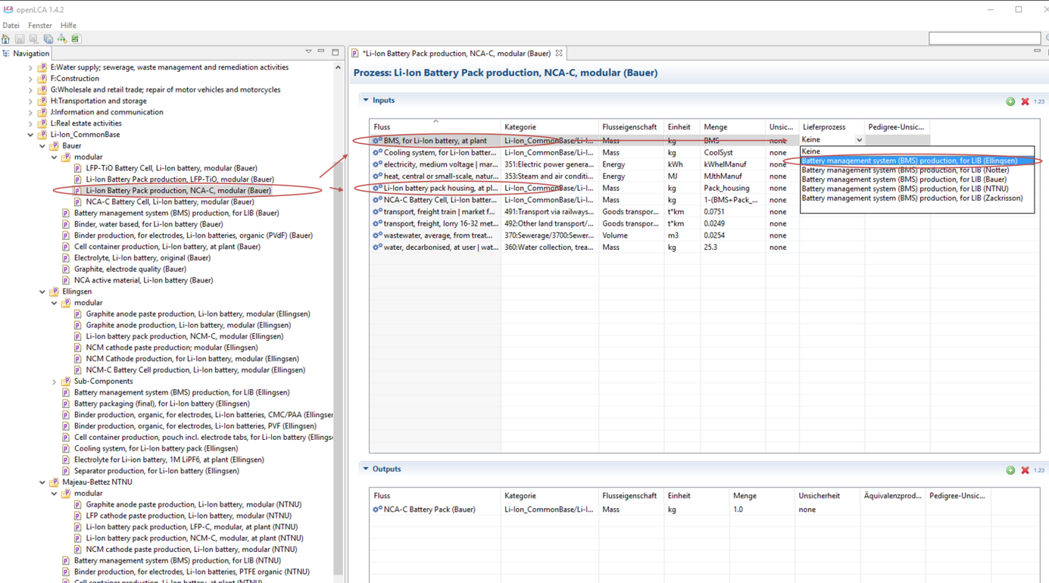
Figure S3. Selection of the default provider in openLCA

When selecting the individual default providers of the original study in each LCI instead of common ones, the original LCI can be reproduced.
  - Setting global common parameters

Global parameters are defined in order to use identical common values for the manufacturing energy demand and the mass shares of battery components like housing, BMS, cell package. The global parameters are the following (see also Figure S4):
- BMS_share: The mass of the BMS as share of the total battery pack mass (default: 0.047)
- Cell_pack_share: Mass of cell package as share of total battery cell mass (default: 0.03)
- CoolSys_share: Mass of battery cooling system as share of total battery pack (default: 0.0)
- KWhelManuf: Electricity for cell manufacturing (kWh/kg) (default: 9.0)
- MJthManuf: Thermal Energy (Natural gas; MJ/kg) for cell manufacturing (default: 20.0)
- Pack_case_share: Mass of pack housing as share of total battery pack mass (default: 0.186)

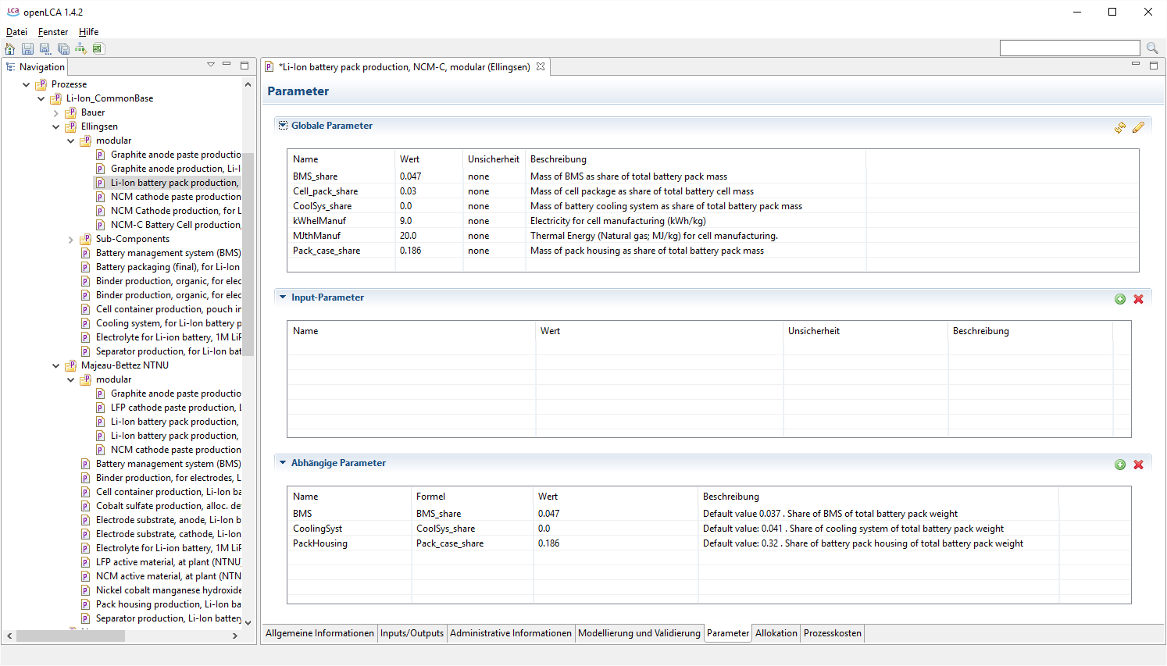
Figure S4. Global parameters as defined for the unified LCI
The default values for these global parameters are corresponding to the values given as common average values within this publication; nevertheless, local parameters are defined within each dataset that use the value provided by the global parameters. In the comment field of the local parameters (individual parameters on dataset level), the original value as provided by the source publication is indicated. If the original, non-parametrized value from the original publication wants to be used, the default value from the comment field can be introduced here manually, as indicated in Figure S5. The global values then do not affect this dataset anymore.
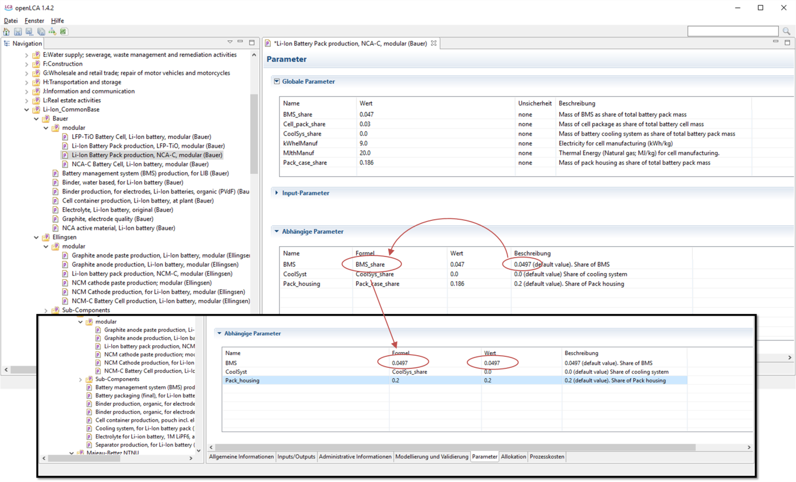
Figure S5. Use of individual, local values within the dataset

  - Import files in ILCD format
The complete inventory datasets (ILCD format) for direct import into LCA software can be downloaded free of charge from zenodo or from:
https://lci-database.hiu-batteries.de
https://lci-database.hiu-batteries.de/owncloud/index.php/f/49
The datasets were exported and tested with openLCA 1.6 and ecoinvent 3.2. and can be imported following previous instructions.
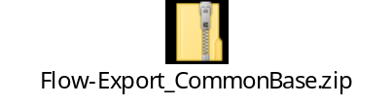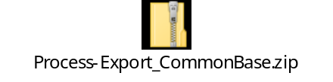
- LCI data in tabulated form
If direct import into LCA software is not practicable, the tabulated LCI can also be used. These are provided in Tables S6 – S30. The parameters used in the tables are the global common parameters as described in Section 3.3. Inventories for components that are not tabulated explicitly are not modified and can be taken directly from the original publication: (Bauer, 2010; Ellingsen et al., 2014; Majeau-Bettez et al., 2011; Notter et al., 2010; Peters et al., 2016; Zackrisson et al., 2010). These are indicated with the author’s name in the ‘Provider’ column of each table.

  - LMO battery
The inventory data for the LMO battery is based on the work by Notter et al. (Notter et al., 2010) and provided in Tables S6-S10
Table S6. LCI of LMO-C type Li-ion battery pack (Notter)
Flow | Provider | Amount | Unit
Inputs
BMS, for Li-Ion battery, at plant | Battery management system (BMS) production, for LIB (Ellingsen) | BMS | kg
Cooling system, for Li-Ion battery pack | Cooling system, for Li-Ion battery pack (Ellingsen) | CoolSyst | kg
electricity, medium voltage | market group for electricity, medium voltage | kWhelManuf | kWh
heat, central or small-scale, natural gas | market for heat, central or small-scale, natural gas | MJthManuf | MJ
Li-Ion battery pack housing, at plant | Pack housing production, Li-Ion battery pack, at plant (Zackrisson / Bauer) | Pack_housing | kg
LMO-C type Li-Ion Cell | Battery cell, LMO-C, battery production, modular (Notter) | 1-(BMS+ Pack_ housing+CoolSyst) | kg
Outputs
Li-ion battery, LMO (Notter) | Li-ion battery, LMO (Notter) | 1.00 | kg

Table S7. LCI of LMO-C type Li-Ion battery cell (Notter)
Flow | Provider | Amount | Unit
Inputs
Anode, graphite, for Li-Ion battery | Graphite anode, for Li-Ion battery (Notter) | 0.4011/(1-8.97750E-02)* (1-Cell_Pack) | kg
battery separator | market for battery separator | 0.053655/(1-8.97750E-02)* (1-Cell_Pack) | kg
Cathode, LiMn2O4, for lithium-ion battery | Cathode production, LiMn2O4, for lithium-ion battery | 0.32686/(1-8.97750E-02)* (1-Cell_Pack) | kg
Cell container, Li-Ion battery, at plant | Cell container production, pouch incl. electrode tabs, for Li-Ion battery (Ellingsen) | Cell_pack* 1.0525 | kg
chemical factory, organics | market for chemical factory, organics | 4.0E-10/(1-8.97750E-02)* (1-Cell_Pack) | p
Electrolyte for Liion battery, LiPF6, at plant | Electrolyte for Li-Ion battery, 1M LiPF6, at plant (Notter) | (0.15957+0.019037)/ (1-  8.97750E-02)* (1-Cell_Pack) | kg
nitrogen, liquid | market for nitrogen, liquid | 0.01/(1-8.97750E-02)*  (1-Cell_Pack) | kg
used Li-ion battery | market for used Li-ion battery | -0.0525/(1-0.089775)*  (1-Cell_Pack) | kg
Outputs
LMO-C type Li-Ion Cell (Notter) | LMO-C type Li-Ion Cell (Notter) | 1.00 | kg

Table S8. LCI of graphite anode for LMO-C type Li-Ion battery cell (Notter)
Flow | Provider | Amount | Unit
Inputs
binder, organic, for electrodes, Li-Ion batteries | binder production, for electrodes, Li-Ion batteries, organic (PVdF) (Bauer) | 0.000 | kg
binder, water based, for electrodes, Li-Ion battery | binder production, for electrodes, Li-Ion batteries, CMC-SBR / water (Peters) | 0.019 | kg
carbon black | market for carbon black | carbon black | 0.016 | kg
chemical factory, organics | market for chemical factory, organics | 4.00E-10 | Item(s)
copper | market for copper | 0.524 | kg
electricity, medium voltage | market group for electricity, medium voltage | 2.00E-03 | kWh
graphite, battery grade | market for graphite, battery grade | 0.494 | kg
heat, central or small-scale, other than natural gas | market for heat, central or small-scale, other than natural gas | 1.220 | MJ
sheet rolling, copper | market for sheet rolling, copper | 0.524 | kg
sulfuric acid | market for sulfuric acid | 0.081 | kg
wastewater, average | market for wastewater, average | -1.10E-04 | m3
water, deionised, from tap water, at user | market for water, deionised, from tap water, at user | 0.424 | kg
Outputs
Anode, graphite, for Li-Ion battery | Anode, graphite, for Li-Ion battery, modular (Notter) | 1.00 | kg

Table S9. LCI of LiMn₂O₄ cathode for LMO-C type Li-Ion battery cell (Notter)
Flow | Provider | Amount | Unit
Inputs
aluminium, wrought alloy | market for aluminium, wrought alloy | 0.393 | kg
binder, organic, for electrodes, Li-Ion batteries | binder production, for electrodes, Li-Ion batteries, organic (PVdF) (Bauer) | 0.010 | kg
binder, water based, for electrodes, Li-Ion battery | binder production, for electrodes, Li-Ion batteries, CMC-SBR (Peters) | 0.000 | kg
carbon black | market for carbon black | 0.026 | kg
chemical factory, organics | market for chemical factory, organics | 4.00E-10 | Item(s)
electricity, medium voltage | market group for electricity, medium voltage | 2.00E-03 | kWh
heat, district or industrial, natural gas | market group for heat, district or industrial, natural gas | 0.646 | MJ
lithium manganese oxide | market for lithium manganese oxide | 0.623 | kg
residue from shredder fraction from manual dismantling | market for residue from shredder fraction from manual dismantling | -0.053 | kg
sheet rolling, aluminium | market for sheet rolling, aluminium | 0.393 | kg
sodium hydroxide, without water, in 50% solution state | market for sodium hydroxide, without water, in 50% solution state | 0.130 | kg
wastewater, average | market for wastewater, average | -1.10E-04 | m3
water, deionised, from tap water, at user | market for water, deionised, from tap water, at user | 0.200 | kg
Outputs
Cathode, LiMn₂O₄, for lithium-ion battery | Cathode, LiMn₂O₄, for lithium-ion battery, modular (Notter) | 1.00 | kg
Water |  | 0.012 | kg
Water |  | 8.27E-05 | m3

Table S10. LCI of electrolyte production for Li-Ion battery (Notter)
Flow | Provider | Amount | Unit
Inputs
ethylene carbonate | market for ethylene carbonate | 0.894 | kg
lithium hexafluorophosphate | market for lithium hexafluorophosphate | 0.106 | kg
Outputs
Electrolyte for Li-Ion battery,  LiPF₆, at plant (Notter) | Electrolyte for Li-Ion battery,  LiPF₆, at plant (Notter) | 1.00 | kg

  - LFP battery
Two different inventory datasets are available for the LFP battery, based on the work by Majeau-Bettez et al. (Majeau-Bettez et al., 2011) and Zackrisson et al. (Zackrisson et al., 2010). The corresponding unified and parametrized inventory data are provided in Tables S11-S13 and S14-S17, respectively.
Table S11. LCI of Li-Ion battery pack, LFP-C (Majeau-Bettez)
Flow | Provider | Amount | Unit
Inputs
BMS, for Li-Ion battery, at plant | Battery management system (BMS) production, for LIB (Ellingsen) | BMS | kg
Cell container, Li-Ion battery, at plant | Cell container production, pouch incl. electrode tabs, for Li-Ion battery (Ellingsen) | Cell_pack | kg
Cooling system, for Li-Ion battery pack | Cooling system, for Li-Ion battery pack (Ellingsen) | CoolSyst | kg
electricity, medium voltage | market group for electricity, medium voltage | kWhelManuf | kWh
Electrode substrate, anode, Li-Ion battery | acc. to Majeau-Bettez et al. | 0.083/(0.6)*(1-BMS-Pack_ housing-CoolSyst-Cell_Pack) | kg
Electrode substrate, cathode, Li-Ion battery | acc. to Majeau-Bettez et al. | 0.036/(0.6)*(1-BMS-Pack_ housing-CoolSyst-Cell_Pack) | kg
Electrolyte for Liion battery, LiPF6 | Electrolyte for Li-ion battery, 1M LiPF6, at plant (Notter) | 0.12/(0.6)*(1-BMS-Pack_ housing-CoolSyst-Cell_Pack) | kg
Graphite anode paste, Li-Ion battery, at plant | Graphite anode paste production, Li-Ion battery, modular (NTNU) | 0.08/0.6*(1-BMS-Pack_ housing-CoolSyst-Cell_Pack) | kg
heat, central or small-scale, natural gas | market for heat, central or small-scale, natural gas | MJthManuf | MJ
LFP cathode paste, Li-Ion battery, at plant | LFP cathode paste production, Li-Ion battery, modular (NTNU) | 0.248/(0.6)*(1-BMS-Pack_ housing-CoolSyst-Cell_Pack) | kg
Li-Ion battery pack housing, at plant | Pack housing production, Li-Ion battery pack, at plant (Bauer) | Pack_housing | kg
precious metal refinery | market for precious metal refinery | 1.9E-8/(0.6)*(1-BMS-Pack_ housing-CoolSyst-Cell_Pack) | Item(s)
Separator, Li-Ion battery, at plant | acc. to Majeau-Bettez et al. | 0.033/(0.6)*(1-BMS-Pack_ housing-CoolSyst-Cell_Pack) | kg
transport, freight train | market for transport, freight train | 0.23 | t*km
transport, freight, lorry | transport, freight, lorry 16-32 metric ton, EURO5 | 0.051 | t*km
water, decarbonised, at user | market for water, decarbonised, at user | 380.0/(0.6)*(1-BMS-Pack_ housing-CoolSyst-Cell_Pack) | kg
Outputs
Li-Ion battery pack, LFP-C, at plant (NTNU) | Li-Ion battery pack, LFP-C, at plant, modular (NTNU) | 1 | kg

Table S12. LCI of LFP cathode paste (Majeau-Bettez)
Flow | Provider | Amount | Unit
Inputs
Binder, organic, for electrodes, Li-Ion batteries | Binder production, for electrodes, Li-Ion batteries, organic (PVdF) (Bauer) | 0.08 | kg
Binder, water based, for electrodes, Li-Ion battery | Binder production, for electrodes, Li-Ion batteries, CMC-SBR / water (Peters) | 0 | kg
carbon black | market for carbon black | carbon black | 0.05 | kg
LFP active material, at plant | acc. to Majeau-Bettez et al. | 0.87 | kg
transport, freight train | market for transport, freight train | 3.8 | t*km
transport, freight, lorry | transport, freight, lorry 16-32 metric ton, EURO5 | 0.7 | t*km
Outputs
LFP cathode paste, Li-Ion battery, at plant (NTNU) | LFP cathode paste, Li-Ion battery, at plant (NTNU) | 1.00 | kg

Table S13. LCI of graphite anode paste, for LIB (Majeau-Bettez)
Flow | Provider | Amount | Unit
Inputs
Binder, organic, for electrodes, Li-Ion batteries | Binder production, for electrodes, Li-Ion batteries, organic (PVdF) (Bauer) | 0 | kg
Binder, water based, for electrodes, Li-Ion battery | Binder production, for electrodes, Li-Ion batteries, CMC-SBR / water (Peters) | 0.05 | kg
graphite, battery grade | market for graphite, battery grade | 0.95 | kg
heat, in chemical industry | market for heat, in chemical industry | 5.00 | MJ
transport, freight train | market for transport, freight train | 0.2 | t*km
transport, freight, lorry | transport, freight, lorry 16-32 metric ton, EURO5 | 0.1 | t*km
Outputs
Graphite anode paste, Li-Ion battery, at plant (NTNU) | Graphite anode paste, Li-Ion battery, at plant (NTNU) | 1.00 | kg
Heat, waste |  | 5.00 | MJ

Table S14. LCI of Li-Ion battery pack, LFP-C (Zackrisson)
Flow | Provider | Amount | Unit
Inputs
BMS, for Li-Ion battery, at plant | Battery management system (BMS) production, for LIB (Ellingsen) | BMS | kg
Cooling system, for Li-Ion battery pack (Ellingsen) | acc. to Ellingsen | CoolSyst | kg
electricity, medium voltage | market group for electricity, medium voltage | kWhelManuf | kWh
heat, central or small-scale, natural gas | market for heat, central or small-scale, natural gas | MJthManuf | MJ
LFP-C type Li-Ion Cell, at plant (Zackrisson, org) | LFP-C type Li-Ion Cell, modular, at plant (Zackrisson) | 1-(Pack_housing+ BMS+ CoolSyst) | kg
Li-Ion battery pack housing, at plant | Pack housing production, Li-Ion battery pack, at plant (Bauer) | Pack_housing | kg
Outputs
LFP-C type Li-Ion Battery, at plant (Zackrisson, org.) | LFP-C type Li-Ion Battery, at plant, modular (Zackrisson, org.) | 1.00 | kg

Table S15. LCI of Li-Ion battery cell, LFP-C (Zackrisson)
Flow | Provider | Amount | Unit
Inputs
Cell container, Li-Ion battery, at plant | Cell container production, pouch incl. electrode tabs, for Li-Ion battery (Ellingsen) | Cell_pack | kg
Electrolyte for Liion battery, LiPF6, at plant | Electrolyte for Liion battery, 1M LiPF6, at plant (Notter) | 0.19535/ (1-0.01267) * (1-Cell_Pack) | kg
Graphite Anode, for Li-Ion battery | Graphite Anode, for Li-Ion battery, modular (Zackrisson) | 0.24921/(1-0.012671) * (1-Cell_Pack) | kg
LFP-cathode, for Li-Ion battery | LFP-Cathode, for Li-Ion battery, modular (Zackrisson) | 0.52376/(1-0.01267)* (1-Cell_Pack) | kg
Separator, for Li-ion battery | Separator production, Li-ion battery (Zackrisson) | 0.01901/(1-0.01267) * (1-Cell_Pack) | kg
Outputs
LFP-C type Li-Ion Cell, at plant | LFP-C type Li-Ion Cell, at plant, modular (Zackrisson, org) | 1.00 | kg

Table S16. LCI of LFP cathode paste (Zackrisson)
Flow | Provider | Amount | Unit
Inputs
aluminium, wrought alloy | market for aluminium, wrought alloy | 0.03831 | kg
Binder, organic, for electrodes, Li-Ion batteries | Binder production, for electrodes, Li-Ion batteries, organic (PVdF) (Bauer) | 0.05645 | kg
Binder, water based, for electrodes, Li-Ion battery | Binder production, for electrodes, Li-Ion batteries, CMC-SBR / water (Peters) | 0 | kg
carbon black | market for carbon black | carbon black | 0.05444 | kg
LFP Cathode Material, at plant | LFP Cathode Material, at plant (Zackrisson, org) | 0.85081 | kg
sheet rolling, aluminium | market for sheet rolling, aluminium | 0.03831 | kg
Outputs
LFP-cathode, for Li-Ion battery (Zackrisson) | LFP-cathode, for Li-Ion battery (Zackrisson) | 1.00 | kg

Table S17. LCI of graphite anode paste (Zackrisson)
Flow | Provider | Amount | Unit
Inputs
Binder, organic, for electrodes, Li-Ion batteries | Binder production, for electrodes, Li-Ion batteries, organic (PVdF) (Bauer) | 0 | kg
Binder, water based, for electrodes, Li-Ion battery | Binder production, for electrodes, Li-Ion batteries, CMC-SBR / water (Peters) | 0.08898 | kg
carbon black | market for carbon black | carbon black | 0 | kg
copper | market for copper | 0.19492 | kg
graphite, battery grade | market for graphite, battery grade | 0.7161 | kg
sheet rolling, copper | market for sheet rolling, copper | 0.19492 | kg
Outputs
Graphite Anode, for Li-Ion battery (Zackrisson) | Graphite Anode, for Li-Ion battery (Zackrisson) | 1.00 | kg

  - LTO battery
The parametrized inventory of the LFP-LTO battery is based on the work by Bauer (Bauer, 2010), who provides very aggregated inventory data. The corresponding LCI are given in Tables S18 and S19.
Table S18. LCI of Li-Ion battery pack, LFP-LTO (Bauer)
Flow | Provider | Amount | Unit
Inputs
BMS, for Li-Ion battery, at plant | Battery management system (BMS) production, for LIB (Ellingsen) | BMS | kg
Cooling system, for Li-Ion battery pack | Cooling system, for Li-Ion battery pack (Ellingsen) | CoolSyst | kg
electricity, medium voltage | market group for electricity, medium voltage | kWhelManuf | kWh
heat, central or small-scale, natural gas | market for heat, central or small-scale, natural gas | MJthManuf | MJ
LFP-TiO Battery Cell, Li-Ion battery | LFP-TiO Battery Cell, Li-Ion battery, modular (Bauer) | 1-(PackHousing+ BMS+CoolSyst) | kg
Li-Ion battery pack housing, at plant | Pack housing production, Li-Ion battery pack, at plant (Zackrisson / Bauer) | PackHousing | kg
transport, freight train | market for transport, freight train | 0.0751 | t*km
transport, freight, lorry | transport, freight, lorry 16-32 metric ton, EURO5 | 0.0251 | t*km
wastewater, average | market for wastewater, average | 0.0253 | m3
water, decarbonised, at user | market for water, decarbonised, at user | 25.3 | kg
Outputs
Li-Ion Battery Pack, LFP-TiO (Bauer) Li-Ion Battery Pack, LFP-TiO (Bauer) |  | 1.00 | kg

Table S19. LCI of Li-Ion battery cell, LFP-LTO (Bauer)
Flow | Provider | Amount | Unit
Inputs
aluminium, wrought alloy | market for aluminium, wrought alloy | 0.128/(1-0.0171)*(1-Cell_Pack) | kg
benzene | market for benzene | 0.0279/(1-0.0171)*(1-Cell_Pack) | kg
Binder, organic, for electrodes, Li-Ion batteries | Binder production, for electrodes, Li-Ion batteries, organic (PVdF) (Bauer) | 0.0167*0.6/(1-0.0171)*  (1-Cell_Pack) | kg
Binder, water based, for electrodes, Li-Ion battery | Binder production, for electrodes, Li-Ion batteries, CMC-SBR / water (Peters) | 0.0167*0.4/(1-0.0171)*  (1-Cell_Pack) | kg
Cell container, Li-Ion battery, at plant | Cell container production, pouch incl. electrode tabs, for Li-Ion battery (Ellingsen) | Cell_pack | kg
copper | market for copper | 0.00296/(1-0.0171)*(1-Cell_Pack) | kg
Electrolyte for Liion battery, LiPF6, at plant | Electrolyte for Liion battery, 1M LiPF6, at plant (Notter) | 0.238/(1-0.0171)*(1-Cell_Pack) | kg
extrusion, plastic film | market for extrusion, plastic film | 0.0759/(1-0.0171)*(1-Cell_Pack) | kg
iron sulfate | market for iron sulfate | 0.209/(1-0.0171)*(1-Cell_Pack) | kg
lithium carbonate | market for lithium carbonate | 0.0859/(1-0.0171)*(1-Cell_Pack) | kg
lithium hydroxide | market for lithium hydroxide | 0.0981/(1-0.0171)*(1-Cell_Pack) | kg
nickel, 99.5% | market for nickel, 99.5% | 0.00296/(1-0.0171)*(1-Cell_Pack) | kg
nitrogen, liquid | market for nitrogen, liquid | 0.0387/(1-0.0171)*(1-Cell_Pack) | kg
phosphoric acid, industrial grade, without water, in 85% solution state | market for phosphoric acid, industrial grade, without water, in 85% solution state | 0.134/(1-0.0171)*(1-Cell_Pack) | kg
polyethylene, linear low density, granulate | market for polyethylene, linear low density, granulate | 0.038/(1-0.0171)*(1-Cell_Pack) | kg
polypropylene, granulate | polypropylene production, granulate | 0.0378/(1-0.0171)*(1-Cell_Pack) | kg
sheet rolling, aluminium | market for sheet rolling, aluminium | 0.128/(1-0.0171)*(1-Cell_Pack) | kg
sheet rolling, copper | market for sheet rolling, copper | 0.00591/(1-0.0171)*(1-Cell_Pack) | kg
tap water | market for tap water | 10.8/(1-0.0171)*(1-Cell_Pack) | kg
titanium dioxide | market for titanium dioxide | 0.221/(1-0.0171)*(1-Cell_Pack) | kg
transport, freight train | market for transport, freight train | 0.635 | t*km
transport, freight, lorry | transport, freight, lorry 16-32 metric ton, EURO5 | 0.21 | t*km
wastewater, average | market for wastewater, average | 0.143/(1-0.0171)*(1-Cell_Pack) | m3
water, decarbonised, at user | market for water, decarbonised, at user | 135 | kg
whey | market for whey | 0.0196/(1-0.0171)*(1-Cell_Pack) | kg
Outputs
Carbon dioxide, fossil | to air | 0.0486 | kg
LFP-LTO Battery Cell, Li-Ion LFP-LTO Battery Cell, Li-Ion battery (Bauer) |  | 1.00 | kg

    - NCM battery
As for the LFP battery, two different inventory datasets are available for the NCM battery, based on the work by Ellingsen et al. (Ellingsen et al., 2014) and Majeau-Bettez et al. (Majeau-Bettez et al., 2011). The corresponding unified and parametrized inventory data are provided in Tables S20-S25 and S26-S27, respectively. Since the graphite anode used by Majeau-Bettez is identical for the LFP and the NCM battery, the corresponding LCI (Table S13) is also valid for the NCM battery.
Table S20. LCI of Li-Ion battery pack, NCM-C (Ellingsen)
Flow | Provider | Amount | Unit
Inputs
BMS, for Li-Ion battery, at plant | Battery management system (BMS) production, for LIB (Ellingsen) | BMS | kg
Cooling system, for Li-Ion battery pack | Cooling system, for Li-Ion battery pack (Ellingsen) | CoolingSyst | kg
electricity, medium voltage | market group for electricity, medium voltage | kWhelManuf | kWh
heat, central or small-scale, natural gas | market for heat, central or small-scale, natural gas | MJthManuf | MJ
Li-Ion battery pack housing, at plant | Pack housing production, Li-Ion battery pack, at plant (Zackrisson / Bauer) | PackHousing | kg
NCM-C Battery Cell, Li-Ion battery | NCM-C Battery Cell production, Li-Ion battery, modular (Ellingsen) | 1-(PackHousing+ BMS+CoolingSyst) | kg
precious metal refinery | market for precious metal refinery | 1.90E-08 | Item(s)
transport, freight, lorry | transport, freight, lorry 16-32 metric ton, EURO5 | 0.16 | t*km
transport, freight, sea, transoceanic ship | market for transport, freight, sea, transoceanic ship | 4.90 | t*km
Outputs
Li-Ion battery pack, NCM-C | Li-Ion battery pack, NCM-C, modular (Ellingsen) | 1.00 | kg
Heat, waste |  | 0.0014 | MJ

Table S21. LCI of Li-Ion battery cell, NCM-C (Ellingsen)
Flow | Provider | Amount | Unit
Inputs
Cell container, Li-Ion battery, at plant | Cell container, Li-Ion battery, at plant (Ellingsen) | CellPack | kg
Electrolyte for Li-ion battery, .LiPF6, at plant | Electrolyte for Liion battery, 1M LiPF6, at plant (Notter) | 0.16/(1-6.64E-03) * (1-CellPack) | kg
Graphite anode, Li-Ion battery | Graphite anode production, Li-Ion battery, modular (Ellingsen) | 0.39/(1-6.64E-03) * (1-CellPack) | kg
heat, central or small-scale, natural gas | market for heat, central or small-scale, natural gas | 0 | MJ
NCM Cathode, for Li-Ion battery | NCM Cathode production, for Li-Ion battery, modular (Ellingsen) | 0.43/(1-6.64E-03) * (1-CellPack) | kg
precious metal refinery | market for precious metal refinery | 1.90E-08 | Item(s)
Separator, PP-based, for Li-Ion battery | acc. to Ellingsen et al. | 0.022/(1-6.64E-03)* (1-CellPack) | kg
transport, freight train | market for transport, freight train | 0.26 | t*km
transport, freight, lorry | transport, freight, lorry 16-32 metric ton, EURO5 | 0.1 | t*km
water, decarbonised, at user | water production and supply, decarbonised | 380 | kg
Outputs
NCM-C Battery Cell, Li-Ion battery (Ellingsen) | NCM-C Battery Cell, Li-Ion battery, modular (Ellingsen) | 1.00 | kg
Heat, waste |  | 100 | MJ

Table S22. LCI of a graphite anode, for Li-Ion battery (Ellingsen)
Flow | Provider | Amount | Unit
Inputs
Copper current collector, Li-Ion battery | acc. to Ellingsen et al. | 0.57 | kg
Graphite anode paste, Li-Ion battery | Graphite anode paste production, Li-Ion battery, modular (Ellingsen) | 0.43 | kg
transport, freight train | market for transport, freight train | 0.37 | t*km
transport, freight, lorry | transport, freight, lorry 16-32 metric ton, EURO5 | 0.1 | t*km
Outputs
Graphite anode, Li-Ion battery (Ellingsen) |  | 1.00 | kg

Table S23. LCI of graphite anode paste, for Li-Ion battery (Ellingsen)
Flow | Provider | Amount | Unit
Inputs
Binder, organic, for electrodes, Li-Ion batteries | Binder production, organic, for electrodes, Li-Ion batteries, CMC/PAA (Ellingsen) | 0 | kg
Binder, water based, for electrodes, Li-Ion battery | Binder production, for electrodes, Li-Ion batteries, CMC-SBR / water (Peters) | 0.04 | kg
chemical factory, organics | chemical factory construction, organics | 4.00E-10 | Item(s)
graphite, battery grade | market for graphite, battery grade | 0.96 | kg
transport, freight train | market for transport, freight train | 1.2 | t*km
transport, freight, lorry | transport, freight, lorry 16-32 metric ton, EURO5 | 0.19 | t*km
Outputs
Graphite anode paste, Li-Ion battery (Ellingsen) | Graphite anode paste, Li-Ion battery (Ellingsen) | 1.00 | kg

Table S24. LCI of NCM cathode, for Li-Ion battery (Ellingsen)
Flow | Provider | Amount | Unit
Inputs
Aluminium current collector, for Li-Ion battery | acc. to Ellingsen et al. | 0.11 | kg
NCM cathode paste, for Li-Ion battery | NCM cathode paste production; modular (Ellingsen) | 0.89 | kg
transport, freight train | market for transport, freight train | 0.55 | t*km
transport, freight, lorry | transport, freight, lorry 16-32 metric ton, EURO5 | 0.1 | t*km
Outputs
NCM Cathode, for Li-Ion battery (Ellingsen) | NCM Cathode, for Li-Ion battery (Ellingsen) | 1.00 | kg

Table S25. LCI of NCM cathode paste, for Li-Ion battery (Ellingsen)
Flow | Provider | Amount | Unit
Inputs
Binder, organic, for electrodes, Li-Ion batteries | Binder production, for electrodes, Li-Ion batteries, organic (PVdF) (Bauer) | 0.04 | kg
Binder, water based, for electrodes, Li-Ion battery | Binder production, for electrodes, Li-Ion batteries, CMC-SBR / water (Peters) | 0 | kg
carbon black | market for carbon black | carbon black | 0.02 | kg
chemical factory, organics | chemical factory construction, organics | 4.00E-10 | Item(s)
NCM active material, for Li-Ion battery | NCM active material production, for cathode, Li-Ion battery (Ellingsen) | 0.94 | kg
transport, freight train | market for transport, freight train | 0.46 | t*km
transport, freight, lorry | transport, freight, lorry 16-32 metric ton, | 0.14 | t*km
Outputs
NCM cathode paste, for Li-Ion battery (Ellingsen) | NCM cathode paste, for Li-Ion battery (Ellingsen) | 1.00 | kg

Table S26. LCI of Li-Ion battery pack, NCM-C (Majeau-Bettez)
Flow | Provider | Amount | Unit
Inputs
BMS, for Li-Ion battery, at plant | Battery management system (BMS) production, for LIB (Ellingsen) | BMS | kg
Cell container, Li-Ion battery, at plant | Cell container production, pouch incl. electrode tabs, for Li-Ion battery (Ellingsen) | Cell_pack | kg
Cooling system, for Li-Ion battery pack | Cooling system, for Li-Ion battery pack (Ellingsen) | CoolSyst | kg
electricity, medium voltage | market group for electricity, medium voltage | kWhelManuf | kWh
Electrode substrate, anode, Li-Ion battery, at plant | Electrode substrate, anode, Li-Ion battery, at plant (NTNU) | 0.083/0.5980*(1-BMS-Pack_ housing- CoolSyst-Cell_Pack) | kg
Electrode substrate, cathode, Li-Ion battery, at plant | Electrode substrate, cathode, Li-Ion battery, at plant (NTNU) | 0.036/0.5980*(1-BMS-Pack_ housing-CoolSyst-Cell_Pack) | kg
Electrolyte for LiIon battery, LiPF6, at plant | Electrolyte for Li-Ion battery, 1M LiPF6, at plant (Notter) | 0.12/0.5980*(1-BMS-Pack_ housing- CoolSyst-Cell_Pack) | kg
Graphite anode paste, Li-Ion battery, at plant | Graphite anode paste production, Li-Ion battery, modular (NTNU) | 0.094/0.5980*(1-BMS-Pack_ housing-CoolSyst-Cell_Pack) | kg
heat, central or small-scale, natural gas | market for heat, central or small-scale, natural gas | MJthManuf | MJ
Li-Ion battery pack housing, at plant | Pack housing production, Li-Ion battery pack, at plant (Zackrisson / Bauer) | Pack_housing | kg
NCM cathode paste, Li-Ion battery, at plant | NCM cathode paste production, Li-Ion battery, modular (NTNU) | 0.232/0.5980*(1-BMS-Pack_ housing-CoolSyst-Cell_Pack) | kg
precious metal refinery | market for precious metal refinery | 1.90E-08 | Item(s)
Separator, Li-Ion battery, at plant | Separator production, Li-Ion battery, at plant (NTNU) | 0.033/0.5980*(1-BMS-Pack_ housing-CoolSyst-Cell_Pack) | kg
transport, freight train | market for transport, freight train | 0.23 | t*km
transport, freight, lorry | transport, freight, lorry 16-32 metric ton, EURO5 | 0.051 | t*km
water, decarbonised, at user | market for water, decarbonised, at user | 380.0/0.5980*(1-BMS-Pack_ housing-CoolSyst-Cell_Pack) | kg
Outputs
Li-Ion battery pack, NCM-C, at plant (NTNU) | Li-Ion battery pack, NCM-C, at plant (NTNU) | 1.00 | kg

Table S27. LCI of NCM cathode paste, for Li-Ion battery (Majeau-Bettez)
Flow | Provider | Amount | Unit
Inputs
Binder, organic, for electrodes, Li-Ion batteries | Binder production, for electrodes, Li-Ion batteries, organic (PVdF) (Bauer) | 0.08 | kg
Binder, water based, for electrodes, Li-Ion battery | Binder production, for electrodes, Li-Ion batteries, CMC-SBR / water (Peters) | 0 | kg
carbon black | market for carbon black | 0.05 | kg
NCM active material, at plant | acc. to Majeau-Bettez et al. | 0.87 | kg
transport, freight train | market for transport, freight train | 3.8 | t*km
transport, freight, lorry | transport, freight, lorry 16-32 metric ton, EURO5 | 0.7 | t*km
Outputs
NCM cathode paste, Li-Ion battery, at plant (NTNU) | NCM cathode paste, Li-Ion battery, at plant (NTNU) | 1.00 | kg

    - NCA battery
The LCI of the NCA battery is based on the work by Bauer (Bauer, 2010). Tables S28-S30 provide the corresponding inventory data.
Table S28. LCI of Li-Ion battery pack, NCA-C (Bauer)
Flow |  | Provider | Amount | Unit
Inputs
BMS, for Li-Ion battery, at plant |  | Battery management system (BMS) production, for LIB (Ellingsen) | BMS | kg
Cooling system, for Li-Ion battery pack |  | Cooling system, for Li-Ion battery pack (Ellingsen) | CoolSyst | kg
electricity, medium voltage |  | market group for electricity, medium voltage | kWhelManuf | kWh
heat, central or small-scale, natural gas |  | market for heat, central or small-scale, natural gas | MJthManuf | MJ
Li-Ion battery pack housing, at plant |  | Pack housing production, Li-Ion battery pack, at plant (Zackrisson / Bauer) | Pack_housing | kg
NCA-C Battery Cell, Li-Ion battery |  | NCA-C Battery Cell, Li-Ion battery, modular (Bauer) | 1-(BMS+Pack_ housing+CoolSyst) | kg
transport, freight train |  | market for transport, freight train | 0.0751 | t*km
transport, freight, lorry |  | transport, freight, lorry 16-32 metric ton, EURO5 | 0.0249 | t*km
wastewater, average |  | market for wastewater, average | 0.0254 | m3
water, decarbonised, at user |  | market for water, decarbonised, at user | 25.3 | kg
Outputs
NCA-C Battery Pack (Bauer) | NCA-C Battery Pack (Bauer) |  | 1.00 | kg

Table S29. LCI of Li-Ion battery cell, NCA-C (Bauer)
Flow | Provider | Amount | Unit
Inputs
aluminium, wrought alloy | market for aluminium, wrought alloy | 0.0708/(1-0.015)*  (1-Cell_Pack) | kg
benzene | market for benzene | 0.0118/(1-0.015)*  (1-Cell_Pack) | kg
Binder, organic, for electrodes, Li-Ion batteries | Binder production, for electrodes, Li-Ion batteries, organic (PVdF) (Bauer) | 0.0099*0.6/(1-0.0146)* (1-Cell_Pack) | kg
Binder, water based, for electrodes, Li-Ion battery | Binder production, for electrodes, Li-Ion batteries, CMC-SBR / water (Peters) | 0.0099*0.4/(1-0.0146)*(1-Cell_Pack) | kg
Cell container, Li-Ion battery, at plant | Cell container production, pouch incl. electrode tabs, for Li-Ion battery (Ellingsen) | Cell_pack | kg
copper | market for copper | 0.1486/(1-0.0146)*  (1-Cell_Pack) | kg
Electrolyte for Liion battery, LiPF6, at plant | Electrolyte for Liion battery, 1M LiPF6, at plant (Notter) | 0.18588/(1-0.0146)*  (1-Cell_Pack) | kg
extrusion, plastic film | market for extrusion, plastic film | 0.04165*2/(1-0.0146)  * (1-Cell_Pack) | kg
Graphite, electrode quality | acc. to Bauer | 0.196/(1-0.0146)*(1-Cell_Pack) | kg
NCA active material, Li-Ion battery | NCA active material, Li-Ion battery (Bauer) | 0.27765/(1-0.0146)*  (1-Cell_Pack) | kg
nickel, 99.5% | market for nickel, 99.5% | 0.0025/(1-0.0146)*  (1-Cell_Pack) | kg
polyethylene, low density, granulate | market for polyethylene, low density, granulate | 0.0416/(1-0.0146)*  (1-Cell_Pack) | kg
polypropylene, granulate | market for polypropylene, granulate | 0.0416/(1-0.0146)*  (1-Cell_Pack) | kg
sheet rolling, aluminium | market for sheet rolling, aluminium | 0.0708/(1-0.0146)*  (1-Cell_Pack) | kg
sheet rolling, copper | market for sheet rolling, copper | 0.15106/(1-0.0146)*  (1-Cell_Pack) | kg
transport, freight train | market for transport, freight train | 0.301 | t*km
transport, freight, lorry | transport, freight, lorry 16-32 metric ton, EURO5 | 0.101 | t*km
wastewater, average | market for wastewater, average | 0.141/(1-0.0146)*  (1-Cell_Pack) | m3
water, decarbonised, at user | market for water, decarbonised, at user | 135.0/(1-0.0146)*  (1-Cell_Pack) | kg
Outputs
NCA-C Battery Cell, Li-Ion battery (Bauer) | NCA-C Battery Cell, Li-Ion battery (Bauer) | 1.00 | kg

Table S30. LCI of NCA active material (Bauer)
Flow | Provider | Amount | Unit
Inputs
aluminium hydroxide | market for aluminium hydroxide | 0.04 | kg
cobalt | market for cobalt | 0.09 | kg
electricity, high voltage | market group for electricity, high voltage | 1.88 | kWh
heat, central or small-scale, natural gas | market for heat, central or small-scale, natural gas | 2.96 | MJ
hydrogen peroxide, without water, in 50% solution state | market for hydrogen peroxide, without water, in 50% solution state | 0.46 | kg
lithium hydroxide | market for lithium hydroxide | 0.27 | kg
nickel, 99.5% | market for nickel, 99.5% | 0.49 | kg
nitric acid, without water, in 50% solution state | market for nitric acid, without water, in 50% solution state | 1.97 | kg
sodium hydroxide, without water, in 50% solution state | market for sodium hydroxide, without water, in 50% solution state | 1.25 | kg
tap water | market for tap water | 55 | kg
transport, freight train | market for transport, freight train | 1.37 | t*km
transport, freight, lorry | transport, freight, lorry 16-32 metric ton, EURO5 | 0.46 | t*km
wastewater, average | market for wastewater, average | 0.05 | m3
Outputs
NCA active material, Li-Ion battery (Bauer) | NCA active material, Li-Ion battery (Bauer) | 1.00 | kg
Nitrogen dioxide |  | 1.37 | kg

Bibliography
Bauer, C., 2010. Ökobilanz von Lithium-Ionen Batterien. Paul Scherrer Institut, Labor für Energiesystem-Analysen (LEA), Villigen, Switzerland.
Ellingsen, L.A.-W., Majeau-Bettez, G., Singh, B., Srivastava, A.K., Valøen, L.O., Strømman, A.H., 2014. Life Cycle Assessment of a Lithium-Ion Battery Vehicle Pack: LCA of a Li-Ion Battery Vehicle Pack. J. Ind. Ecol. 18, 113–124. doi:10.1111/jiec.12072
Majeau-Bettez, G., Hawkins, T.R., Strømman, A.H., 2011. Life Cycle Environmental Assessment of Lithium-Ion and Nickel Metal Hydride Batteries for Plug-In Hybrid and Battery Electric Vehicles. Environ. Sci. Technol. 45, 4548–4554. doi:10.1021/es103607c
Notter, D.A., Gauch, M., Widmer, R., Wäger, P., Stamp, A., Zah, R., Althaus, H.-J., 2010. Contribution of Li-Ion Batteries to the Environmental Impact of Electric Vehicles. Environ. Sci. Technol. 44, 6550–6556. doi:10.1021/es903729a
Peters, J., Buchholz, D., Passerini, S., Weil, M., 2016. Life cycle assessment of sodium-ion batteries. Energy Env. Sci 9, 1744–1751. doi:10.1039/C6EE00640J
Zackrisson, M., Avellán, L., Orlenius, J., 2010. Life cycle assessment of lithium-ion batteries for plug-in hybrid electric vehicles – Critical issues. J. Clean. Prod. 18, 1519–1529. doi:10.1016/j.jclepro.2010.06.004

