Fire patchiness is critical for promoting in situ population recovery in a small mammal
Complete R code
Robyn Shaw
2020-11-10
Table of Contents
1 Do pale field rats have specific vegetation preferences? 3
1.1 Overview 3
1.2 Data set 4
1.3 Run global Generalised Linear Mixed Model 4
1.4 Model Selection 5
1.5 Top ranked model 6
1.5.1 Test model assumptions 6
1.5.2 Get model estimates, random effects and confidence intervals 7
1.6 Second ranked model 7
1.6.1 Test model assumptions 7
1.6.2 Get model estimates, random effects and confidence intervals 8
2 Does cover vary among different vegetation types? 9
2.1 Overview 9
2.2 Data set 9
2.3 Run Generalised Linear Mixed Model 10
2.4 Model selection 10
2.5 Test model assumptions 10
2.6 Get model estimates, random effects and confidence intervals 11
2.7 Get model predictions and plot 11
3 How is ground cover affected by fire severity and burn cover? 12
3.1 Overview 12
3.2 Data set 13
3.3 Run Generalised Linear Mixed Models 13
3.4 Model Selection 13
3.5 Test model assumptions 13
3.6 Get model estimates, random effects and confidence intervals 15
3.7 Get model predictions and plot 15
4 How does the spatial pattern of fire affect pale field rat captures? 17
4.1 Overview 17
4.2 Data set 17
4.3 Site-level analysis 17
4.3.1 Run global Generalised Linear Mixed Model 18
4.3.2 Model selection 18
4.3.3 Top ranked model 19
4.3.3.1 Test model assumptions 19
4.3.3.2 Get model estimates, random effects and confidence intervals 20
4.3.3.3 Get model predictions 20
4.4 Trap-level analysis 21
4.4.1 Run global Generalised Linear Mixed Model 21
4.4.2 Model selection 22
4.4.3 Top ranked model 22
4.4.3.1 Test model assumptions 22
4.4.3.2 Get model estimates, random effects and confidence intervals 23
4.4.3.3 Get model predictions 23
5 How does the spatial pattern of fire affect pale field rat vegetation preferences? 25
5.1 Overview 25
5.2 Data set 25
5.3 Run global Generalised Linear Mixed Model 25
5.4 Model Selection 26
5.5 Top ranked model 26
5.5.1 Test Model Assumptions 26
5.5.2 Get model estimates, random effects and confidence intervals 27
6 How does the spatial pattern of fire affect pale field rat recaptures? 27
6.1 Overview 27
6.2 Recapture data set 27
6.3 Run Generalised Linear Mixed Models 28
6.4 Model selection 29
6.5 Session 1 to Session 2 29
6.5.1 Test model assumptions 29
6.5.2 Get model estimates, random effects and confidence intervals 30
6.6 Session 1 to Session 3 30
6.6.1 Test model assumptions 30
6.6.2 Get model estimates, random effects and confidence intervals 31
6.7 Session 2 to Session 3 31
6.7.1 Test model assumptions 31
6.7.2 Get model estimates, random effects and confidence intervals 32
6.7.3 Get model predictions 32
6.8 Plot 33
7 References 35

Packages
- spdep (Bivand, Pebesma, & Gomez-Rubio, 2013)
- lme4 (Bates, Mächler, Bolker, & Walker, 2015)
- knitr (Xie, 2020)
- MuMIn (Bartoń, 2020)
- broom.mixed (Bolker & Robinson, 2020)
- car (Fox & Weisberg, 2019)
- performance (Lüdecke, Makowski, Waggoner, & Patil, 2020)
- DHARMa (Hartig, 2020)
- ggplot2 (Wickham, 2016)
- AICcmodavg (Mazerolle, 2020)
- secr (Efford, 2020)
- ggpubr (Kassambara, 2019)

Useful functions
Save functions in global environment to test for overdispersion for GLMMs and to calculate marginal and conditional R2 during model selection. The overdispersion function was found here:
GLMM FAQ, Bolker et al. (2020):
http://bbolker.github.io/mixedmodels-misc/glmmFAQ.html#testing-for-overdispersioncomputing-overdispersion-factor.
overdisp_fun <- function(model) {
rdf <- df.residual(model)
rp <- residuals(model,type="pearson")
Pearson.chisq <- sum(rp^2)
prat <- Pearson.chisq/rdf
pval <- pchisq(Pearson.chisq, df=rdf, lower.tail=FALSE)
c(chisq=Pearson.chisq,ratio=prat,rdf=rdf,p=pval)
}
The R2 function follows (Nakagawa & Schielzeth, 2013).
R2.ModSel <- function(x) {
s <- r2_nakagawa(x)
c(Conditional_R2 = s$R2_conditional, adjRsq = s$R2_marginal)
}

Do pale field rats have specific vegetation preferences?

Overview
To investigate vegetation preferences in R. tunneyi I ran a GLMM of the number of unique individuals captured at each trap (within session recaptures were not included). Group (i.e. grouped sites) was included as a random effect. Captures were included as count data (Poisson), with the number of captures at each trap within a session, offset by the number of potential capture events (total number of trap nights - non-target species - recaptures). I fitted a base model as a first step, to be used in model selection. This included the proportions all four vegetation types around each trap and the autocovariate as fixed effects (for a 20m radius around trap).

Data set
TrapDat <- read.csv("Data/Trap_Data.csv")
#The number of trials should be larger than 0. Some of the Corrected trap nights = 0 (we caught a recap/non target every night), so need to remove these entries
TrapDat <- TrapDat[!TrapDat$Corrected_Potential_Capture_Events == 0, ]
TrapDat <- droplevels(TrapDat)

Reshape dataset
To investigate pre-fire vegetation preferences, subset the data so that it only includes session 1 and calculate the spatial autocovariate.
# Subset to Session 1
TrapDat_S1 <- TrapDat[TrapDat$Session == "S1",]
TrapDat_S1 <- droplevels(TrapDat_S1)
colnames(TrapDat_S1)[c(1, 3, 38, 24:27)] <- c("Group_S1", "Trap_S1", "CorrectedTN_S1", "Trap_Rip_S1", "Trap_Tuss_S1", "Trap_AG_S1", "Trap_MG_S1")
# Define Variables
# No need to scale predictor variables, since all are bounded by 0-1 (proportions)
Group_S1 <- TrapDat_S1$Group_S1
Trap_S1 <- TrapDat_S1$Trap_S1
Rtun_Total_S1 <- TrapDat_S1$Rtun_Total
CorrectedTN_S1 <- TrapDat_S1$CorrectedTN
Trap_MG_S1 <- TrapDat_S1$Trap_MG_S1
Trap_AG_S1 <- TrapDat_S1$Trap_AG_S1
Trap_Rip_S1 <- TrapDat_S1$Trap_Rip_S1
Trap_Tuss_S1 <- TrapDat_S1$Trap_Tuss_S1
# Calculate spatial autocovariate
TrapDat_S1$Autocov_Inv_S1 <- autocov_dist(Rtun_Total_S1,
cbind(TrapDat_S1$Easting, TrapDat_S1$Northing),
nbs = 80,
longlat = NULL,
type = "inverse",
style = "B")
Autocov_Inv_S1 <- TrapDat_S1$Autocov_Inv_S1

Run global Generalised Linear Mixed Model
The idea here is to include everything, even though there will be collinearity, as the final model will not include all variables. I want to see whether there’s a positive or negative effect of different vegetation types.
# Count data, so first try Poisson:
Base.TrapVeg.S1 <- glmer(Rtun_Total_S1 ~ Trap_MG_S1 + Trap_AG_S1 + Trap_Rip_S1 + Trap_Tuss_S1 + Autocov_Inv_S1 + (1|Group_S1), offset = log(CorrectedTN_S1), data = TrapDat_S1, family = "poisson")
# Check if base model is overdispersed:
Base.TrapVeg.S1.Overdisp <- as.data.frame(overdisp_fun(Base.TrapVeg.S1))

Table 1: Overdispersion Test for session 1 global vegetation type GLMM
Statistic | Value
chisq | 1287.278
ratio | 1.234
rdf | 1043.000
p | 0.000
The Poisson model is overdispersed, use a negative binomial GLMM instead to account for overdispersion.
Base.TrapVeg.S1.nb <- glmer.nb(Rtun_Total_S1 ~ Trap_MG_S1 + Trap_AG_S1 + Trap_Rip_S1 + Trap_Tuss_S1 + Autocov_Inv_S1 + (1|Group_S1), offset = log(CorrectedTN_S1), data = TrapDat_S1)

Model Selection
Run a model selection to compare models with different combinations of fixed effects to determine which vegetation types best predict R. tunneyi captures. Rank models according to BIC.
options(na.action = "na.fail")
BIC_TrapVeg.S1.nb_Select <- dredge(Base.TrapVeg.S1.nb, fixed = "Autocov_Inv_S1", rank = "BIC", trace = 2, subset = !(`*nvar*`== 8), extra = list(R2.ModSel))
# Don't include full model in model selection - colinear
ModSel_S1_TrapVeg <- as.data.frame(round(BIC_TrapVeg.S1.nb_Select, 3))[,c(1, 5:6, 3:4, 2, 7:13)]
colnames(ModSel_S1_TrapVeg) <- c("Intercept", "Riparian", "Tussock Grasses", "Annual Grassland", "Mixed Grasses", "Spatial Autocovariate", "Cond. R2", "Mar. R2", "DF", "log(L)", "BIC", "DeltaBIC", "Weight")
Table 2: Models describing session 1 captures by proportion of each vegetation type surrounding each trap, ranked by BIC. Models with delta BIC <10 and null model are presented.
Intercept | Riparian | Tussock.Grasses | Annual.Grassland | Mixed.Grasses | Spatial.Autocovariate | Cond..R2 | Mar..R2 | DF | log.L. | BIC | DeltaBIC | Weight
-4.0 | 1.9 | 1.1 | NA | NA | 3.3 | 0.2 | 0.1 | 6 | -690.9 | 1423.4 | 0.0 | 0.5
-2.9 | NA | NA | -1.7 | -1.1 | 3.4 | 0.2 | 0.1 | 6 | -691.2 | 1424.2 | 0.8 | 0.3
-3.0 | 0.6 | NA | -1.5 | -1.0 | 3.4 | 0.2 | 0.1 | 7 | -690.0 | 1428.8 | 5.3 | 0.0
-3.8 | 1.7 | 0.9 | -0.7 | NA | 3.4 | 0.2 | 0.1 | 7 | -690.0 | 1428.8 | 5.3 | 0.0
-4.0 | 2.0 | 1.1 | NA | 0.0 | 3.3 | 0.2 | 0.1 | 7 | -690.8 | 1430.4 | 7.0 | 0.0
-2.7 | NA | -0.2 | -1.8 | -1.2 | 3.4 | 0.2 | 0.1 | 7 | -690.9 | 1430.5 | 7.0 | 0.0
-3.1 | NA | NA | -1.9 | NA | 3.8 | 0.2 | 0.1 | 5 | -697.9 | 1430.6 | 7.1 | 0.0
-3.0 | NA | NA | NA | -1.2 | 3.4 | 0.2 | 0.1 | 5 | -698.1 | 1430.9 | 7.5 | 0.0
-3.2 | 0.8 | NA | -1.7 | NA | 3.7 | 0.2 | 0.1 | 6 | -695.4 | 1432.5 | 9.1 | 0.0
-3.1 | 0.8 | NA | NA | -1.1 | 3.3 | 0.2 | 0.1 | 6 | -695.6 | 1432.9 | 9.5 | 0.0
-3.3 | NA | NA | NA | NA | 3.8 | 0.1 | 0.1 | 4 | -706.9 | 1441.5 | 18.1 | 0.0
A note about R2
The marginal R2 values for all models relating to R. tunneyi capture rate are low. This reflects the fact that we had high trapping effort and low captures. This means there are many (true) zeros in our dataset, because R. tunneyi is patchily distributed across the landscape. A particular area may have suitable habitat with no captures, simply due to low densities. However, these vegetation types are significant predictors of capture rate when R. tunneyi are present. Furthermore, we are modeling a highly variable system and there is an element of individual R. tunneyi behaviour that is impossible to model (i.e. why do animals choose to move through the specific area where a trap was placed).
In other words, our primary goal is to understand the relationships between the vegetation types (and area burnt later on) and R. tunneyi capture patterns in our model. For this objective, R2 is not particularly relevant. The regression coefficients define the relationship between each independent variable and the dependent variable. A small R2 doesn’t nullify or change the interpretation of the coefficient for an independent variable that is statistically significant.
Instead, we compare the delta BIC of the top ranked model/s to the null model (intercept and [where relevant] the spatial autocovariate only), as a more informative measure of model fit. In this case, a smaller delta BIC indicates that the model is improved by the inclusion of fixed effects despite the low R2.

Top ranked model
There are two models with delta BIC < 2. Run these models and test their validity, using the DHARMa package to test for overall goodness of fit. This package creates scaled residuals by simulating from the fitted model, then runs a KS and dispersion test to check for overall uniformity of the residuals (goodness of fit) and over/under dispersion. Also test for correlation between fixed effects with the variance inflation factor (vif). A vif of greater than 5 means that the correlation between variables is affecting the model’s ability to predict the response.
TopMod_TrapVeg.S1 <- glmer.nb(Rtun_Total_S1 ~ Trap_Rip_S1 + Trap_Tuss_S1 + Autocov_Inv_S1 + (1|Group_S1), offset = log(CorrectedTN_S1), data = TrapDat_S1)

Test model assumptions
Check goodness of fit
set.seed(123)
SimResTopMod_TrapVeg.S1 <- simulateResiduals(fittedModel = TopMod_TrapVeg.S1, n = 1000)
plotQQunif(SimResTopMod_TrapVeg.S1)
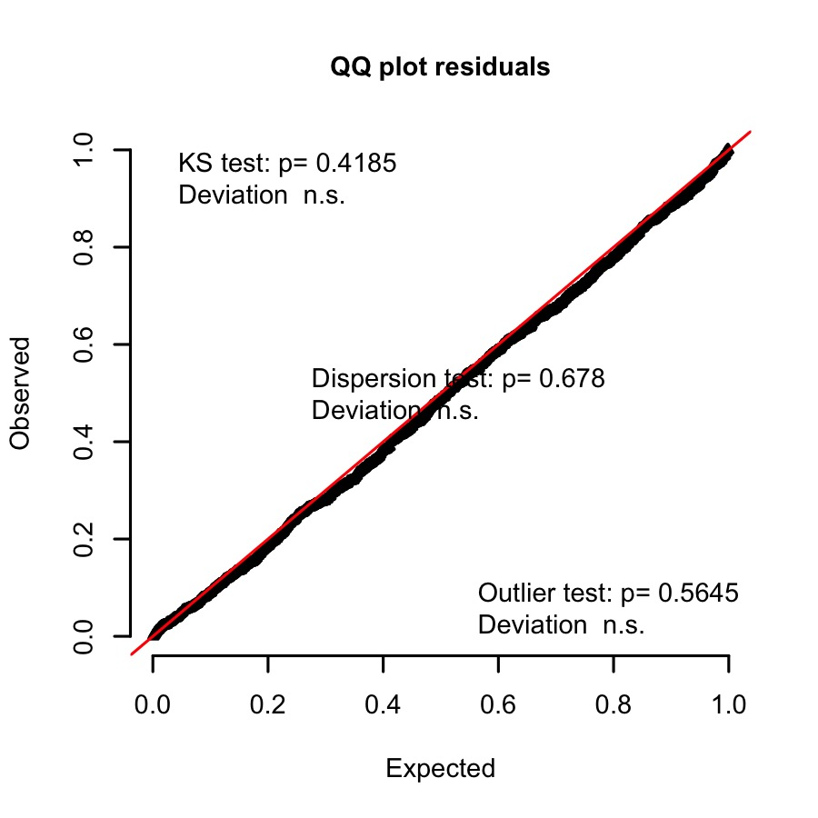
Residuals conform to assumptions
Check VIF
TopMod_TrapVeg.S1_VIF <- data.frame(Fixed = names(vif(TopMod_TrapVeg.S1)), vif = vif(TopMod_TrapVeg.S1))
Table 3: Capture rate by vegetation at trap:
variance inflation factor for top model
Fixed | vif
Trap_Rip_S1 | 1.259
Trap_Tuss_S1 | 1.261
Autocov_Inv_S1 | 1.025
VIF is less than 5 for all variables

Get model estimates, random effects and confidence intervals
# Get model summary and confidence intervals:
TopMod_TrapVeg.S1.est <- tidy(TopMod_TrapVeg.S1, conf.int = TRUE, exponentiate = FALSE, effects = "fixed")[,-1]
colnames(TopMod_TrapVeg.S1.est) <- c("Fixed terms", "Estimate", "Std. error", "z", "p", "2.5% CI", "97.5% CI")
Table 4: Capture rate by vegetation at trap: top model summary
Fixed terms | Estimate | Std. error | z | p | 2.5% CI | 97.5% CI
(Intercept) | -3.982 | 0.301 | -13.214 | 0 | -4.573 | -3.392
Trap_Rip_S1 | 1.935 | 0.405 | 4.780 | 0 | 1.142 | 2.729
Trap_Tuss_S1 | 1.128 | 0.243 | 4.645 | 0 | 0.652 | 1.603
Autocov_Inv_S1 | 3.297 | 0.515 | 6.399 | 0 | 2.288 | 4.307
# Get random effect
TopMod_TrapVeg.S1_Randeff <- as.data.frame(VarCorr(TopMod_TrapVeg.S1))[,c(1,4,5)]
colnames(TopMod_TrapVeg.S1_Randeff) <- c("Random Effect", "Variance", "Std.Dev.")
Table 5: Capture rate by vegetation at trap: top model random effects
Random.Effect | Variance | Std.Dev.
Group_S1 | 0.291 | 0.54

Second ranked model
SecondMod_TrapVeg.S1 <- glmer.nb(Rtun_Total_S1 ~ Trap_AG_S1 + Trap_MG_S1 + Autocov_Inv_S1 + (1|Group_S1), offset = log(CorrectedTN_S1), data = TrapDat_S1)

Test model assumptions
Check goodness of fit
set.seed(123)
SimResSecondMod_TrapVeg.S1 <- simulateResiduals(fittedModel = SecondMod_TrapVeg.S1, n = 1000)
plotQQunif(SimResSecondMod_TrapVeg.S1)
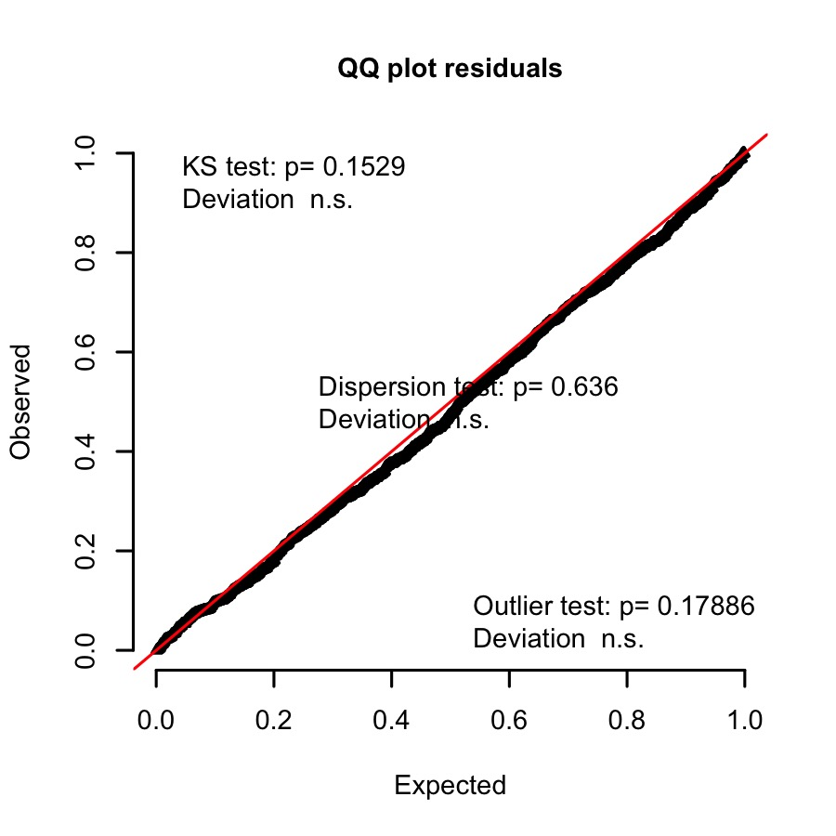
Residuals conform to assumptions
Check VIF
SecondMod_TrapVeg.S1_VIF <- data.frame(Fixed = names(vif(SecondMod_TrapVeg.S1)), vif = vif(SecondMod_TrapVeg.S1))
Table 6: Capture rate by vegetation at trap:
variance inflation factor for Second model
Fixed | vif
Trap_AG_S1 | 1.023
Trap_MG_S1 | 1.056
Autocov_Inv_S1 | 1.033
VIF is less than 5 for all variables

Get model estimates, random effects and confidence intervals
# Get model summary and confidence intervals:
SecondMod_TrapVeg.S1.est <- tidy(SecondMod_TrapVeg.S1, conf.int = TRUE, exponentiate = FALSE, effects = "fixed")[,-1]
colnames(SecondMod_TrapVeg.S1.est) <- c("Fixed terms", "Estimate", "Std. error", "z", "p", "2.5% CI", "97.5% CI")
Table 7: Capture rate by vegetation at trap: Second model summary
Fixed terms | Estimate | Std. error | z | p | 2.5% CI | 97.5% CI
(Intercept) | -2.924 | 0.278 | -10.531 | 0.000 | -3.468 | -2.380
Trap_AG_S1 | -1.673 | 0.489 | -3.422 | 0.001 | -2.631 | -0.715
Trap_MG_S1 | -1.051 | 0.302 | -3.482 | 0.000 | -1.643 | -0.460
Autocov_Inv_S1 | 3.445 | 0.517 | 6.663 | 0.000 | 2.432 | 4.459
# Get random effect
SecondMod_TrapVeg.S1_Randeff <- as.data.frame(VarCorr(SecondMod_TrapVeg.S1))[,c(1,4,5)]
colnames(SecondMod_TrapVeg.S1_Randeff) <- c("Random Effect", "Variance", "Std.Dev.")
Table 8: Capture rate by vegetation at trap: Second model random effects
Random.Effect | Variance | Std.Dev.
Group_S1 | 0.312 | 0.558

Does cover vary among different vegetation types?

Overview
I characterised the different vegetation types at each site based on the species present. I then recorded the vegetation at each trap and randomly chose two traps per unique veg type (within each site), to use as the location for the vegetation survey quadrat. The centre of the quadrat was determined by throwing a frisbee from the chosen trap. Survey quadrats were 10m x 10m. In general, each site contained 3-4 different vegetation types:
- Riparian
- Tussock Grass
- Annual Grassland
- Mixed Grasses
This data was collected by placing a pole vertically to the ground and estimating the number of grass/vegetation stems intercepting the pole at three height intervals (0 to 10 cm, 10 to 30 cm, 30 to 100 cm). The number of stem intercepts was estimated using one of the following counts: 0, 1, 3, 5, 8, 10, 15 or 20. This was repeated 50 times across the vegetation quadrat.
The model for the 0-10cm height category did not conform to assumptions. Patterns at the 10-30cm and 30-100cm intervals were consistent. Furthermore, the 30-100cm interval is likely to be the most important for providing protection from predators. For this reason, all analyses were based on the 30-100cm height interval only.

Data set
VegDat <- read.csv("Data/Veg_Point_Intercept_Data.csv")
Reshape data
To investigate the cover provided by pre-fire vegetation (vegetation density), subset the data so that it only includes session 1 and calculate the sum total vegetation intercepts (over the 50 quadrat data points) in each quadrat to get a measure of total vegetation density per quadrat.
#Sum by quadrat
VegSum <- plyr::ddply(VegDat, plyr::.(Session, Group, Site, Quadrat, Veg_type, Prop_Site_Burnt), function(x) sum(x$cm100))
colnames(VegSum)[7] <- "cm100_Sum"
#Subset to session 1 only
VegSum_S1 <- VegSum[VegSum$Session == "S1", -6]
colnames(VegSum_S1)[c(2, 5)] <- c("Group_S1", "Veg_Type_S1")
Group_S1 <- as.factor(VegSum_S1$Group_S1)
Veg_Type_S1 <- as.factor(VegSum_S1$Veg_Type_S1)
cm100_Sum_S1 <- as.numeric(VegSum_S1$cm100_Sum)

Run Generalised Linear Mixed Model
To find out how the level of cover changes across the different vegetation types, I used a GLMM. This is because we have count data and measurements within groups/quadrats are non-independent. Vegetation type is the fixed effect and quadrat nested within group are random effects.
glmm_VegType_cm100 <- glmer(cm100_Sum_S1 ~ Veg_Type_S1 -1 + (1|Group_S1), data = VegSum_S1, family= "poisson")
# Check if overdispersed:
glmm_VegType_cm100.Overdisp <- as.data.frame(overdisp_fun(glmm_VegType_cm100))
Table 9: Overdispersion Test for session 1 vegetation density by vegetation type GLMM
Statistic | Value
chisq | 1572.447
ratio | 20.421
rdf | 77.000
p | 0.000
The poisson model is overdispersed, use a negative binomial GLMM instead to account for overdispersion.
glmm_VegType_cm100.nb <- glmer.nb(cm100_Sum_S1 ~ Veg_Type_S1 -1 + (1|Group_S1), data = VegSum_S1)

Model selection
Compare to null model and check model fit (R2 and BIC).
options(na.action = "na.fail")
BIC_VegType.nb_Select <- dredge(glmm_VegType_cm100.nb, rank = "BIC", trace = 2, extra = list(R2.ModSel))
ModSel_S1_VegType <- as.data.frame(round(BIC_VegType.nb_Select[,-1], 3))
ModSel_S1_VegType <- cbind(as.data.frame(BIC_VegType.nb_Select[,1]), ModSel_S1_VegType)
colnames(ModSel_S1_VegType) <- c("Veg Type", "Cond. R2", "Mar. R2", "DF", "log(L)", "BIC", "DeltaBIC", "Weight")
Table 10: List of best models using BIC
Veg Type | Cond. R2 | Mar. R2 | DF | log(L) | BIC | DeltaBIC | Weight
+ | 0.4 | 0.4 | 6 | -431.4 | 889.2 | 0.0 | 1
NA | 0.1 | 0.0 | 3 | -462.4 | 938.0 | 48.7 | 0

Test model assumptions
Check goodness of fit
# Check goodness of fit
set.seed(123)
SimResVegType <- simulateResiduals(glmm_VegType_cm100.nb, n = 1000)
plotQQunif(SimResVegType)
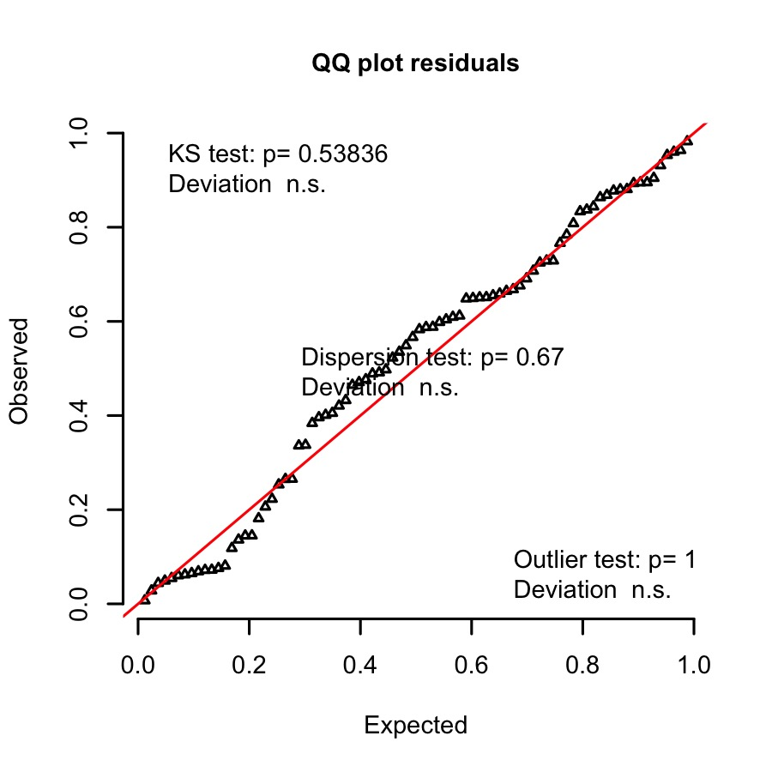
Residuals conform to assumptions

Get model estimates, random effects and confidence intervals
# Get model summary and confidence intervals:
VegType.est <- tidy(glmm_VegType_cm100.nb, conf.int = TRUE, exponentiate = FALSE, effects = "fixed")[,-1]
colnames(VegType.est) <- c("Fixed terms", "Estimate", "Std. error", "z", "p", "2.5% CI", "97.5% CI")
Table 11: Vegetation density by vegetation type: model summary
Fixed terms | Estimate | Std. error | z | p | 2.5% CI | 97.5% CI
Veg_Type_S1Annual_grassland | 4.258 | 0.116 | 36.603 | 0 | 4.030 | 4.486
Veg_Type_S1Mixed_grasses | 4.678 | 0.103 | 45.272 | 0 | 4.476 | 4.881
Veg_Type_S1Riparian | 4.430 | 0.114 | 38.789 | 0 | 4.206 | 4.654
Veg_Type_S1Tussock | 5.268 | 0.102 | 51.556 | 0 | 5.068 | 5.468
# Get random effect
VegType_Randeff <- as.data.frame(VarCorr(glmm_VegType_cm100.nb))[,c(1,4,5)]
colnames(VegType_Randeff) <- c("Random Effect", "Variance", "Std.Dev.")
Table 12: Vegetation density by vegetation type: random effects
Random.Effect | Variance | Std.Dev.
Group_S1 | 0.007 | 0.085

Get model predictions and plot
# Use table above with bootstrap CIs, can't calculate CIs using SE in models without intercept
Pred.VegType <- exp(VegType.est[, c(2, 6:7)])
Pred.VegType$Veg_Type_S1 <- c("3.AG", "4.MG", "1.Rip", "2.Tuss")
Pred.VegType$Veg_names <- c("Annual grassland", "Mixed grasses", "Riparian", "Tussock grass")
# Create location labels for plots
veg.labs <- Pred.VegType$Veg_names[order(Pred.VegType$Veg_Type_S1)]
#Order the raw veg data for plotting:
VegSum_S1.edit <- VegSum_S1
VegSum_S1.edit$Veg_Type_S1 <- as.character(VegSum_S1.edit$Veg_Type_S1)
VegSum_S1.edit$Veg_Type_S1[VegSum_S1.edit$Veg_Type_S1 == "Riparian"] <- "1.Rip"
VegSum_S1.edit$Veg_Type_S1[VegSum_S1.edit$Veg_Type_S1 == "Tussock"] <- "2.Tuss"
VegSum_S1.edit$Veg_Type_S1[VegSum_S1.edit$Veg_Type_S1 == "Annual_grassland"] <- "3.AG"
VegSum_S1.edit$Veg_Type_S1[VegSum_S1.edit$Veg_Type_S1 == "Mixed_grasses"] <- "4.MG"
colnames(VegSum_S1.edit)[6] <- "Estimate"
Veg_Intercept_Plot <- ggplot(data = Pred.VegType, aes(x = Veg_Type_S1, y = Estimate)) +
geom_point(data = VegSum_S1.edit, aes(x = Veg_Type_S1, y = Estimate), col = "lightgrey", size = 1.2, pch = 16) +
labs(x = "Vegetation type", y = "Vegetation density") +
scale_x_discrete(labels = veg.labs) +
ylim(c(-60, 420)) +
geom_hline(yintercept = 0, linetype='dashed', col = 'black', size = 0.2)+
geom_errorbar(aes(ymin = `2.5% CI`, ymax = `97.5% CI`), width = 0.09, size = 0.2) +
geom_point(colour = "black", fill = "black", size = 1.2, pch = 16) +
theme(panel.background = element_rect(fill = "white"),
panel.border = element_rect(linetype = "solid", colour = "black",
fill = "transparent", size = 0.2),
panel.grid.minor = element_blank(),
panel.grid.major = element_blank(),
axis.text = element_text(size = 5, color = "black"),
axis.title.y = element_text(size = 7, margin = margin(0,10,0,0), face ="bold"),
axis.title.x = element_text(size = 7, margin = margin(10,0,0,0), face ="bold"),
axis.ticks = element_line(size = 0.2),
legend.position = "none")
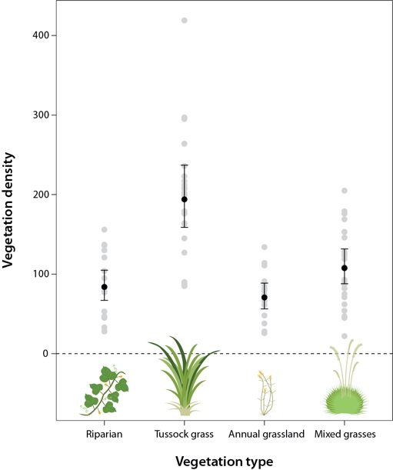

How is ground cover affected by fire severity and burn cover?

Overview
In order to determine how fire affected the vegetation, I carried out vegetation surveys before, 6 weeks after and one year after the fire. I then mapped fire scars in Qgis using aerial photographs of each site (immediately after fire). The amount of the site that was burnt was calculated as a proportion of the total area within a 50 m buffer zone of the trap lines.

Data set
# Define variables
Group <- as.factor(VegSum$Group)
Session <- as.factor(VegSum$Session)
Quadrat <- as.factor(VegSum$Quadrat)
Veg_type <- as.factor(VegSum$Veg_type)
cm100_Sum <- as.numeric(VegSum$cm100_Sum)
Prop_Site_Burnt <- as.numeric(VegSum$Prop_Site_Burnt)

Run Generalised Linear Mixed Models
glmm_vegfire_cm100 <- glmer(cm100_Sum ~ Session*Prop_Site_Burnt*Veg_type + (1|Group), data = VegSum, family= "poisson")
# Check if overdispersed:
glmm_vegfire_cm100.Overdisp <- as.data.frame(overdisp_fun(glmm_vegfire_cm100))
Table 13: Overdispersion Test for vegetation density with percentage burnt, over the three sessions
Statistic | Value
chisq | 6391.284
ratio | 29.051
rdf | 220.000
p | 0.000
The poisson model is overdispersed, use a negative binomial GLMM instead to account for overdispersion.
# Use negative binomial
glmm_vegfire_cm100.nb <- glmer.nb(cm100_Sum ~ Session*Prop_Site_Burnt*Veg_type + (1|Group), data = VegSum, control=glmerControl(optimizer = "bobyqa"))

Model Selection
Use model selection to compare to null model.
options(na.action = "na.fail")
BIC_VegFire.nb_Select <- dredge(glmm_vegfire_cm100.nb, rank = "BIC", trace = 2, subset = (`*nvar*`== 0) | (`*nvar*`== 7), extra = list(R2.ModSel))
as.data.frame(BIC_VegFire.nb_Select)
ModSel_VegFire <- cbind(as.data.frame(round(BIC_VegFire.nb_Select[,1:2], 3)), as.data.frame(BIC_VegFire.nb_Select[,3:8]), as.data.frame(round(BIC_VegFire.nb_Select[,9:15], 3)))
colnames(ModSel_VegFire) <- c("Intercept", "%Burnt", "Sess", "VegType", "%Burnt:Session", "%Burnt:VegType", "Sess:VegType", "%Burnt:Sess:VegType", "R2 Cond.", "R2 Mar.", "DF", "log(L)", "BIC", "DeltaBIC", "Weight")
Table 14: Vegetation density by vegetation type: comparison to null model
Intercept | %Burnt | Sess | VegType | %Burnt:Session | %Burnt:VegType | Sess:VegType | %Burnt:Sess:VegType | R2 Cond. | R2 Mar. | DF | log(L) | BIC | DeltaBIC | Weight
4.3 | -0.2 | + | + | + | + | + | + | 0.7 | 0.7 | 26 | -1280.6 | 2704.2 | 0.0 | 1
4.7 | NA | NA | NA | NA | NA | NA | NA | 0.1 | 0.0 | 3 | -1450.2 | 2916.9 | 212.6 | 0

Test model assumptions
Check goodness of fit
set.seed(123)
VegFireSimRes <- simulateResiduals(fittedModel = glmm_vegfire_cm100.nb, n = 1000)
plotQQunif(VegFireSimRes)
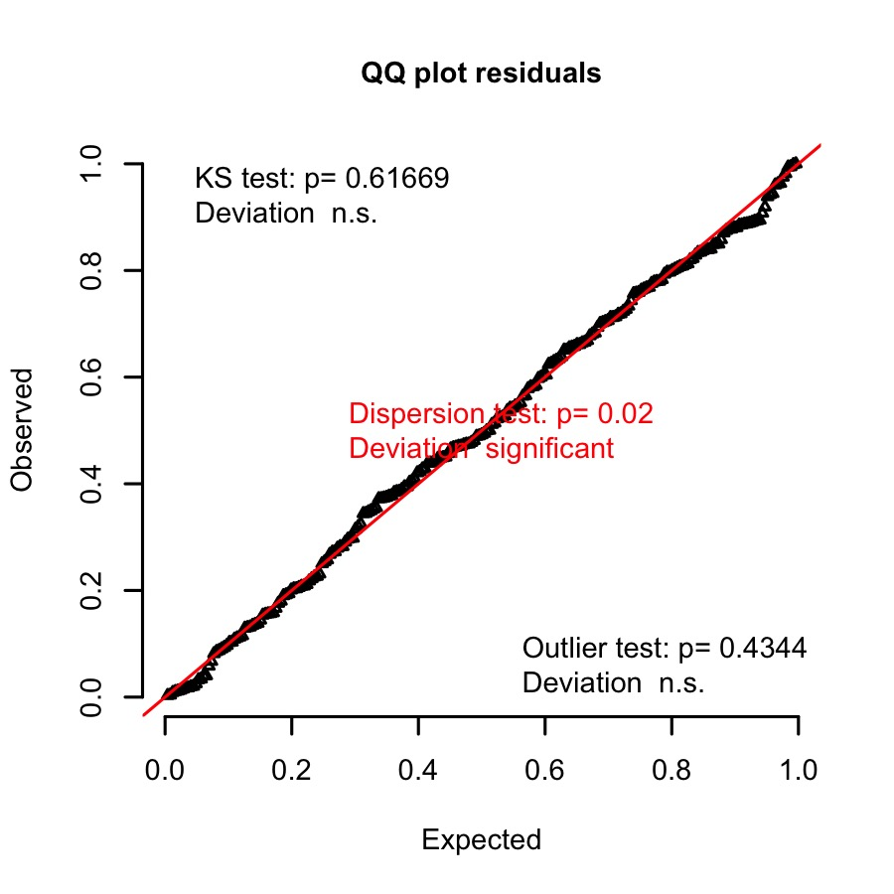
A note on significance of dispersion test from the authors of DHARMa
Significance in hypothesis tests depends on the strength of the signal and the number of data points. Hence, the p-value alone is not a good indicator of the extent to which your residuals deviate from assumptions. Specifically, if you have a lot of data points, residual diagnostics will inevitably become significant, because having a perfectly fitting model is very unlikely. That, however, doesn’t necessarily mean that you need to change your model; it is at your discretion to decide whether this deviation is worth worrying about. e.g. A significant test with a dispersion parameter of 1.01 probably reflects a large data set, while a significant test with a dispersion value of 5 is clearly a reason to move to a model that accounts for overdispersion.
In my case, the dispersion ratio is 1.16 so the significant test probably reflects the large number of data points. For interest, I also fit a model with an observation level random effect, however it was not a valid model.
Check VIF
#Calculate the variance inflation factor
Vif.glmm_vegfire_cm100.nb <- data.frame(Fixed = row.names(vif(glmm_vegfire_cm100.nb)), vif = vif(glmm_vegfire_cm100.nb))
Table 15: Vegetation density by %Burnt over three sessions: variance inflation factor
Fixed | GVIF | DF | GVIF [1/(2*df)]
Session | 63.972 | 2 | 2.828
Prop_Site_Burnt | 10.811 | 1 | 3.288
Veg_type | 106.711 | 3 | 2.178
Session:Prop_Site_Burnt | 201.322 | 2 | 3.767
Session:Veg_type | 5818.560 | 6 | 2.059
Prop_Site_Burnt:Veg_type | 277.870 | 3 | 2.555
Session:Prop_Site_Burnt:Veg_type | 12612.710 | 6 | 2.197
VIF less than 5 for all variables and interaction terms.

Get model estimates, random effects and confidence intervals
# Get model summary and confidence intervals:
VegFire.est <- tidy(glmm_vegfire_cm100.nb, conf.int = TRUE, exponentiate = FALSE, effects = "fixed")[,-1]
colnames(VegFire.est) <- c("Fixed terms", "Estimate", "Std. error", "z", "p", "2.5% CI", "97.5% CI")
Table 16: Vegetation density by %Burnt over three sessions: model summary
Fixed terms | Estimate | Std. error | z | p | 2.5% CI | 97.5% CI
(Intercept) | 4.323 | 0.185 | 23.430 | 0.000 | 3.961 | 4.685
SessionS2 | 0.265 | 0.264 | 1.003 | 0.316 | -0.253 | 0.782
SessionS3 | 0.046 | 0.250 | 0.184 | 0.854 | -0.444 | 0.535
Prop_Site_Burnt | -0.224 | 0.484 | -0.463 | 0.643 | -1.173 | 0.725
Veg_typeMixed_grasses | 0.227 | 0.235 | 0.965 | 0.335 | -0.234 | 0.688
Veg_typeRiparian | -0.067 | 0.254 | -0.265 | 0.791 | -0.565 | 0.430
Veg_typeTussock | 0.819 | 0.237 | 3.457 | 0.001 | 0.355 | 1.283
SessionS2:Prop_Site_Burnt | -3.368 | 0.827 | -4.072 | 0.000 | -4.988 | -1.747
SessionS3:Prop_Site_Burnt | -0.154 | 0.685 | -0.224 | 0.823 | -1.497 | 1.190
SessionS2:Veg_typeMixed_grasses | -0.171 | 0.338 | -0.506 | 0.613 | -0.835 | 0.492
SessionS3:Veg_typeMixed_grasses | 0.360 | 0.328 | 1.097 | 0.273 | -0.283 | 1.004
SessionS2:Veg_typeRiparian | 0.131 | 0.378 | 0.347 | 0.729 | -0.610 | 0.871
SessionS3:Veg_typeRiparian | 0.406 | 0.357 | 1.137 | 0.256 | -0.294 | 1.106
SessionS2:Veg_typeTussock | -0.471 | 0.345 | -1.365 | 0.172 | -1.148 | 0.205
SessionS3:Veg_typeTussock | -0.016 | 0.334 | -0.046 | 0.963 | -0.671 | 0.640
Prop_Site_Burnt:Veg_typeMixed_grasses | 0.652 | 0.589 | 1.108 | 0.268 | -0.501 | 1.806
Prop_Site_Burnt:Veg_typeRiparian | 0.847 | 0.624 | 1.358 | 0.175 | -0.376 | 2.069
Prop_Site_Burnt:Veg_typeTussock | 0.731 | 0.628 | 1.165 | 0.244 | -0.499 | 1.962
SessionS2:Prop_Site_Burnt:Veg_typeMixed_grasses | 0.693 | 0.967 | 0.716 | 0.474 | -1.203 | 2.588
SessionS3:Prop_Site_Burnt:Veg_typeMixed_grasses | -0.430 | 0.838 | -0.513 | 0.608 | -2.073 | 1.212
SessionS2:Prop_Site_Burnt:Veg_typeRiparian | -1.194 | 1.068 | -1.117 | 0.264 | -3.287 | 0.900
SessionS3:Prop_Site_Burnt:Veg_typeRiparian | 0.335 | 0.886 | 0.378 | 0.706 | -1.401 | 2.070
SessionS2:Prop_Site_Burnt:Veg_typeTussock | -2.292 | 1.063 | -2.157 | 0.031 | -4.375 | -0.209
SessionS3:Prop_Site_Burnt:Veg_typeTussock | -0.047 | 0.893 | -0.053 | 0.958 | -1.798 | 1.704
# Get random effect
VegFire_Randeff <- as.data.frame(VarCorr(glmm_vegfire_cm100.nb))[,c(1,4,5)]
colnames(VegFire_Randeff) <- c("Random Effect", "Variance", "Std.Dev.")
Table 17: Vegetation density by %Burnt over three sessions: random effects
Random Effect | Variance | Std.Dev.
Group | 0.015 | 0.124

Get model predictions and plot
# Make a sequence from the focal variable
VegFire.all_var <- c(Prop_Site_Burnt = list(seq(0, 1, length = 50)), lapply(model.frame(glmm_vegfire_cm100.nb)[ , c("Session", "Veg_type")], unique))
# Grab the names and unique values of the interacting variables and expand.grid on it
Pred.VegFire <- expand.grid(VegFire.all_var)
Pred.VegFire$Predictions <- predict(glmm_vegfire_cm100.nb, newdata = Pred.VegFire, re.form = NA, type = "response")
Pred.VegFire$SE <- predictSE(glmm_vegfire_cm100.nb, newdata = Pred.VegFire, re.form = NA, type = "response")$se.fit
Pred.VegFire <- within(Pred.VegFire, {
UCI <- Predictions + 1.96 * SE
LCI <- Predictions - 1.96 * SE
})
Pred.VegFire$Veg_type <- as.character(Pred.VegFire$Veg_type)
Pred.VegFire$Veg_type[Pred.VegFire$Veg_type == "Riparian"] <- "1.Rip"
Pred.VegFire$Veg_type[Pred.VegFire$Veg_type == "Tussock"] <- "2.Tuss"
Pred.VegFire$Veg_type[Pred.VegFire$Veg_type == "Annual_grassland"] <- "3.AG"
Pred.VegFire$Veg_type[Pred.VegFire$Veg_type == "Mixed_grasses"] <- "4.MG"
Pred.VegFire$Veg_names <- ifelse(Pred.VegFire$Veg_type == "1.Rip", "Riparian", ifelse(Pred.VegFire$Veg_type == "2.Tuss", "Tussock grass", ifelse(Pred.VegFire$Veg_type == "3.AG", "Annual grassland", ifelse(Pred.VegFire$Veg_type == "4.MG", "Mixed grasses", NA))))
Pred.VegFire$PercentageBurnt <- Pred.VegFire$Prop_Site_Burnt*100
# Create labels for plots
veg.labs <- unique(Pred.VegFire$Veg_names[order(Pred.VegFire$Veg_type)])
names(veg.labs) <- unique(Pred.VegFire$Veg_type)
# Edit the raw veg data for plotting:
VegSum_edit <- VegSum
VegSum_edit$Veg_type <- as.character(VegSum_edit$Veg_type)
VegSum_edit$Veg_type[VegSum_edit$Veg_type == "Riparian"] <- "1.Rip"
VegSum_edit$Veg_type[VegSum_edit$Veg_type == "Tussock"] <- "2.Tuss"
VegSum_edit$Veg_type[VegSum_edit$Veg_type == "Annual_grassland"] <- "3.AG"
VegSum_edit$Veg_type[VegSum_edit$Veg_type == "Mixed_grasses"] <- "4.MG"
VegSum_edit$PercentageBurnt <- VegSum_edit$Prop_Site_Burnt*100
colnames(VegSum_edit)[7] <- "Predictions"
VegFire_Plot <- ggplot(data = Pred.VegFire, aes(x = PercentageBurnt, y = Predictions, colour = Session)) +
geom_hline(yintercept= 0, size = 0.2, linetype = "dotted") +
geom_jitter(data = VegSum_edit, aes(x = PercentageBurnt, y = Predictions, fill = Session, shape = Session), width = 0.01, height = 0.01, size = 0.5) +
scale_shape_manual(values = c(3, 1, 2)) +
geom_ribbon(aes(ymin= LCI, ymax= UCI, linetype = NA, fill = Session), alpha = 0.2) +
geom_line(size = 0.4) +
facet_wrap(~ Veg_type, labeller = labeller(Veg_type = veg.labs)) +
scale_colour_manual(values = c("green4", "black", "grey")) +
scale_fill_manual(values = c("green4", "black", "grey")) +
labs(x = "Percentage of site burnt", y = "Vegetation density") +
theme(panel.background = element_rect(fill = "white"),
panel.border = element_rect(linetype = "solid", colour = "black",
fill = "transparent", size = 0.2),
panel.grid.minor = element_blank(),
panel.grid.major = element_blank(),
axis.text = element_text(size = 5, color = "black"),
axis.title.y = element_text(size = 6, margin = margin(0,10,0,0), face ="bold"),
axis.title.x = element_text(size = 6, margin = margin(10,0,0,0), face ="bold"),
axis.ticks = element_line(size = 0.2),
strip.background = element_rect(fill = "lightgrey", colour = "black", size = 0.2),
strip.text = element_text(size = 6, face ="bold"),
legend.title = element_text(size = 6, face ="bold"),
legend.text = element_text(size = 5, color = "black"),
legend.position = "right")
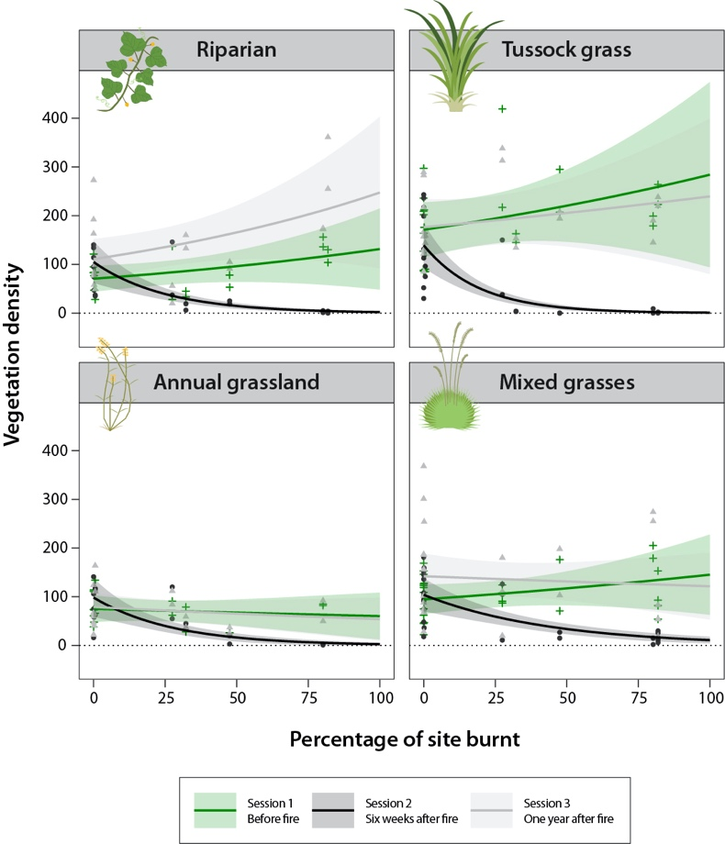

How does the spatial pattern of fire affect pale field rat captures?

Overview
I investigated how pale field rat abundance changed with fire at the site-level. To understand if fire also impacted the abundance/distribution of individuals over a local-scale, I also carried out analyses at the trap-level. I ran GLMMs of the number of unique individuals captured at each: 1) site, or 2) trap (within session recaptures were not included). I ran GLMMs using Group (i.e. grouped sites) as a random effect (as well as trap nested within group for trap-level GLMMs, due to repeated trapping). Captures were included as count data (poisson) and were offset by the number of potential capture events (total number of trap nights - non-target species - recaptures). Fixed effects included session, proportion burnt (either the total burnt at the site or the proportion burnt within a 20m radius of each trap- determined through aerial mapping of fire scars), age and sex. Trap-level GLMMs also included a spatial autocovariate to take into account the spatial non-independence of captures at traps.

Data set
TrapDat.Sex.Age <- read.csv("Data/Trap_Data_Sex_Age.csv")

Site-level analysis
Reshape data
#The number of trials should be larger than 0. Some of the Corrected trap nights = 0 (we caught a recap/non target every night), so need to remove these entries
TrapDat.S.A <- TrapDat.Sex.Age[!TrapDat.Sex.Age$Corrected_Potential_Capture_Events == 0, ]
TrapDat.S.A <- droplevels(TrapDat.S.A)
#Sum captures per site
Site_Abund <- plyr::ddply(TrapDat.S.A, plyr::.(TrapDat.S.A$Session, TrapDat.S.A$Group, TrapDat.S.A$Prop_Site_Burnt, TrapDat.S.A$Sex, TrapDat.S.A$Age), function(x) c(sum(x$Captures), sum(x$Corrected_Potential_Capture_Events)))
colnames(Site_Abund)[c(1:7)] <- c("Session_Site", "Group_Site", "PropBurnt_Site", "Sex_Site", "Age_Site", "Rtun_Total_Site", "CorrectedTN_Site")
Define variables
Group_Site <- as.factor(Site_Abund$Group_Site)
Session_Site <- as.factor(Site_Abund$Session_Site)
PropBurnt_Site <- as.numeric(Site_Abund$PropBurnt_Site)
Rtun_Total_Site <- as.integer(Site_Abund$Rtun_Total_Site)
Sex_Site <- as.factor(Site_Abund$Sex_Site)
Age_Site <- as.factor(Site_Abund$Age_Site)
CorrectedTN_Site <- as.integer(Site_Abund$CorrectedTN_Site)

Run global Generalised Linear Mixed Model
glmm_SiteCapsFire <- glmer(Rtun_Total_Site ~ PropBurnt_Site*Session_Site*Age_Site*Sex_Site + (1|Group_Site), offset = log(CorrectedTN_Site), data = Site_Abund, family = "poisson")
# Check if overdispersed:
glmm_SiteCapsFire.Overdisp <- as.data.frame(overdisp_fun(glmm_SiteCapsFire))
Table 18: Overdispersion Test for site capture rate with percentage burnt, over the three sessions
Statistic | Value
chisq | 231.635
ratio | 2.438
rdf | 95.000
p | 0.000
The poisson model is overdispersed, use a negative binomial GLMM instead to account for overdispersion.
# Try negative binomial
glmm_SiteCapsFire.nb <- glmer.nb(Rtun_Total_Site ~ PropBurnt_Site*Session_Site*Age_Site*Sex_Site + (1|Group_Site), offset = log(CorrectedTN_Site), data = Site_Abund)

Model selection
Use model selection to compare models with different combinations of fixed effects, to select the best model and to determine which variables best predict R. tunneyi site-level captures after fire. The models were ranked according to BIC.
options(na.action = "na.fail")
BIC_SiteCapsFire.nb_Select <- dredge(global.model = glmm_SiteCapsFire.nb, rank = "BIC", trace = 2, extra = list(R2.ModSel))
ModSel_SiteCapsFire <- as.data.frame(BIC_SiteCapsFire.nb_Select)[,c(1, 3:4, 9, 2, 5, 6:8, 10:23)]
ModSel_SiteCapsFire <- cbind(round(ModSel_SiteCapsFire[,1:2], 3), ModSel_SiteCapsFire[,3:16], round(ModSel_SiteCapsFire[,17:23], 3))
colnames(ModSel_SiteCapsFire) <- c("Intercept", "%Burnt", "Sess", "%Burnt:Session", "Age", "Sex", "Age:%Burnt", "Age:Sess", "Age:Sex", "%Burnt:Sex", "Sess:Sex", "Age:%Burnt:Sess", "Age:%Burnt:Sex", "Age:Sess:Sex", "%Burnt:Sess:Sex", "Age:%Burnt:Sess:Sex", "R2 Cond.", "R2 Mar.", "DF", "log(L)", "BIC", "DeltaBIC", "Weight")
Table 19: Vegetation density by vegetation type: models with delta BIC <10 and null model
Intercept | %Burnt | Sess | %Burnt:Session | Age | Sex | Age:%Burnt | Age:Sess | Age:Sex | %Burnt:Sex | Sess:Sex | Age:%Burnt:Sess | Age:%Burnt:Sex | Age:Sess:Sex | %Burnt:Sess:Sex | Age:%Burnt:Sess:Sex | R2 Cond. | R2 Mar. | DF | log(L) | BIC | DeltaBIC | Weight
-4.1 | 0.0 | + | + | NA | NA | NA | NA | NA | NA | NA | NA | NA | NA | NA | NA | 0.2 | 0.2 | 8 | -327.7 | 693.7 | 0.0 | 0.6
-4.0 | 0.0 | + | + | + | NA | NA | NA | NA | NA | NA | NA | NA | NA | NA | NA | 0.2 | 0.2 | 9 | -326.6 | 696.3 | 2.6 | 0.2
-4.0 | -0.1 | + | + | NA | + | NA | NA | NA | NA | NA | NA | NA | NA | NA | NA | 0.2 | 0.2 | 9 | -327.1 | 697.3 | 3.6 | 0.1
-4.0 | 0.0 | + | + | + | NA | NA | + | NA | NA | NA | NA | NA | NA | NA | NA | 0.3 | 0.2 | 11 | -323.4 | 699.4 | 5.6 | 0.0
-4.0 | -0.1 | + | + | + | + | NA | NA | NA | NA | NA | NA | NA | NA | NA | NA | 0.2 | 0.2 | 10 | -326.1 | 700.0 | 6.3 | 0.0
-4.0 | -0.2 | + | + | + | NA | + | NA | NA | NA | NA | NA | NA | NA | NA | NA | 0.2 | 0.2 | 10 | -326.1 | 700.2 | 6.4 | 0.0
-3.9 | -0.3 | + | + | + | NA | + | + | NA | NA | NA | NA | NA | NA | NA | NA | 0.3 | 0.2 | 12 | -322.0 | 701.5 | 7.7 | 0.0
-4.0 | -0.1 | + | + | NA | + | NA | NA | NA | + | NA | NA | NA | NA | NA | NA | 0.2 | 0.2 | 10 | -327.1 | 702.1 | 8.4 | 0.0
-4.0 | -0.1 | + | + | + | + | NA | + | NA | NA | NA | NA | NA | NA | NA | NA | 0.3 | 0.2 | 12 | -322.8 | 703.1 | 9.4 | 0.0
-4.0 | NA | NA | NA | NA | NA | NA | NA | NA | NA | NA | NA | NA | NA | NA | NA | 0.1 | 0.0 | 3 | -385.7 | 785.8 | 92.0 | 0.0
There is only 1 top-ranked model (all of the others are > 2 delta BIC from the top-ranked). This includes a percentage burnt x session interaction.

Top ranked model
TopMod.SiteCapsFire.nb <- glmer.nb(Rtun_Total_Site ~ PropBurnt_Site*Session_Site + (1|Group_Site), offset = log(CorrectedTN_Site), data = Site_Abund)

Test model assumptions
Check goodness of fit
set.seed(123)
SimResTopMod.SiteCapsFire <- simulateResiduals(fittedModel = TopMod.SiteCapsFire.nb, n = 1000)
plotQQunif(SimResTopMod.SiteCapsFire)
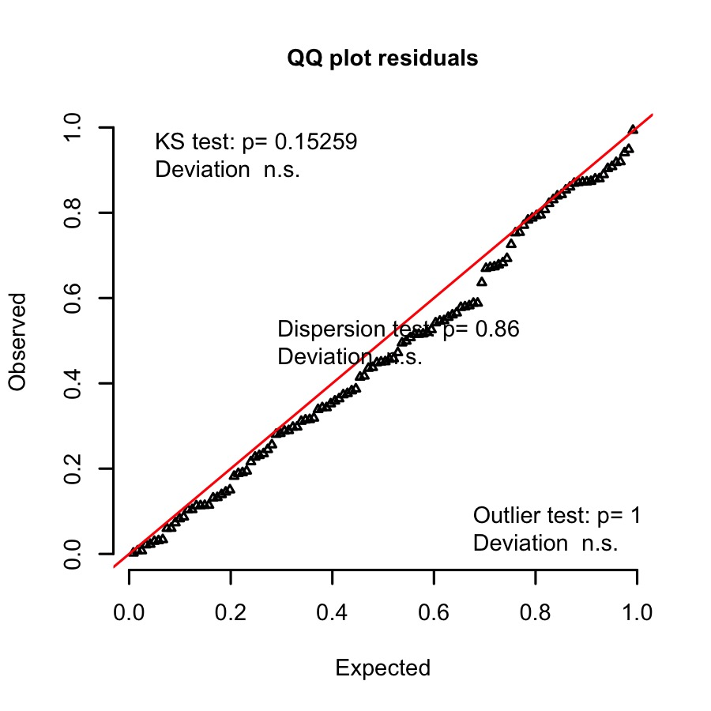
Residuals conform to assumptions
Check VIF
#Calculate the variance inflation factor
TopMod.SiteCapsFire.nb.VIF <- data.frame(Fixed = row.names(vif(TopMod.SiteCapsFire.nb)), vif = vif(TopMod.SiteCapsFire.nb))
Table 20: Site capture rate by %Burnt across three sessions: variance inflation factor for top model
Fixed | GVIF | DF | GVIF [1/(2*df)]
PropBurnt_Site | 2.091 | 1 | 1.446
Session_Site | 2.276 | 2 | 1.228
PropBurnt_Site:Session_Site | 3.384 | 2 | 1.356
VIF is less than 5 for all variables

Get model estimates, random effects and confidence intervals
# Get model summary and confidence intervals:
TopMod_SiteCapsFire.est <- tidy(TopMod.SiteCapsFire.nb, conf.int = TRUE, exponentiate = FALSE, effects = "fixed")[,-1]
colnames(TopMod_SiteCapsFire.est) <- c("Fixed terms", "Estimate", "Std. error", "z", "p", "2.5% CI", "97.5% CI")
Table 21: Site capture rate by %Burnt across three sessions: top model summary
Fixed terms | Estimate | Std. error | z | p | 2.5% CI | 97.5% CI
(Intercept) | -4.087 | 0.322 | -12.708 | 0.000 | -4.716 | -3.545
PropBurnt_Site | -0.084 | 0.350 | -0.239 | 0.811 | -0.776 | 0.547
Session_SiteS2 | 0.746 | 0.171 | 4.357 | 0.000 | 0.406 | 1.092
Session_SiteS3 | -0.129 | 0.172 | -0.750 | 0.453 | -0.466 | 0.217
PropBurnt_Site:Session_SiteS2 | -4.919 | 0.714 | -6.893 | 0.000 | -6.398 | -3.651
PropBurnt_Site:Session_SiteS3 | 0.597 | 0.436 | 1.370 | 0.171 | -0.233 | 1.457
# Get random effect
TopMod.SiteCapsFire_Randeff <- as.data.frame(VarCorr(TopMod.SiteCapsFire.nb))[,c(1,4,5)]
colnames(TopMod.SiteCapsFire_Randeff) <- c("Random Effect", "Variance", "Std.Dev.")
Table 22: Site capture rate by %Burnt across three sessions: top model random effects
Random.Effect | Variance | Std.Dev.
Group_Site | 0.439 | 0.662

Get model predictions
# Make a sequence from the focal variable
Pred.CapsFire.S <- expand.grid(Session_Site = unique(Session_Site), PropBurnt_Site = seq(0, 1, length = 50))
Pred.CapsFire.S$Predictions <- predict(TopMod.SiteCapsFire.nb, newdata = Pred.CapsFire.S, re.form = NA, type = "response")
Pred.CapsFire.S$SE <- predictSE(TopMod.SiteCapsFire.nb, newdata = Pred.CapsFire.S, re.form = NA, type = "response")$se.fit
Pred.CapsFire.S <- within(Pred.CapsFire.S, {
UCI <- Predictions + 1.96 * SE
LCI <- Predictions - 1.96 * SE
})
Pred.CapsFire.S$PercentageBurnt <- Pred.CapsFire.S$PropBurnt_Site*100
Pred.CapsFire.S$Analysis_Level <- "Site"
# Format for plotting later with trap data
Pred.CapsFire.S <- Pred.CapsFire.S[, c(1, 3, 5:8)]
colnames(Pred.CapsFire.S) <- c("Session", "Capture_Rate", "LCI", "UCI", "PercentageBurnt", "Level")
# Edit the raw veg data for plotting:
Site_Abund_edit <- Site_Abund
Site_Abund_edit$PercentageBurnt <- Site_Abund_edit$PropBurnt_Site*100
Site_Abund_edit$Capture_Rate <- Site_Abund_edit$Rtun_Total_Site/Site_Abund_edit$CorrectedTN_Site
Site_Abund_edit$Level <- "Site"
Site_Abund_edit <- Site_Abund_edit[, c(1, 8:10)]
colnames(Site_Abund_edit)[1] <- "Session"
I will use these model predictions to create a combined plot with trap-level and recapture predictions below.

Trap-level analysis
Define variables
TrapDat.S.A.edit <- TrapDat.S.A[, c(1:4, 8:9, 30, 38, 41:43)]
colnames(TrapDat.S.A.edit) <- c("Group_Trap", "Site_Trap", "Trap_Trap", "Session_Trap", "x_Trap", "y_Trap", "PropBurnt_Trap", "CorrectedTN_Trap", "Sex_Trap", "Age_Trap", "Total_Rtun_Trap")
Group_Trap <- TrapDat.S.A.edit$Group_Trap
Trap_Trap <- TrapDat.S.A.edit$Trap_Trap
Session_Trap <- TrapDat.S.A.edit$Session_Trap
x_Trap <- TrapDat.S.A.edit$x_Trap
y_Trap <- TrapDat.S.A.edit$y_Trap
PropBurnt_Trap <- TrapDat.S.A.edit$PropBurnt_Trap
CorrectedTN_Trap <- TrapDat.S.A.edit$CorrectedTN_Trap
Sex_Trap <- TrapDat.S.A.edit$Sex_Trap
Age_Trap <- TrapDat.S.A.edit$Age_Trap
Total_Rtun_Trap <- TrapDat.S.A.edit$Total_Rtun_Trap
TrapDat.S.A.edit$Autocov_Inv_Trap <- autocov_dist(Total_Rtun_Trap,
cbind(x_Trap, y_Trap),
nbs = 80,
longlat = NULL,
type = "inverse",
style = "B")
Autocov_Inv_Trap <- TrapDat.S.A.edit$Autocov_Inv_Trap

Run global Generalised Linear Mixed Model
glmm_TrapCapsFire <- glmer(Total_Rtun_Trap ~ PropBurnt_Trap*Session_Trap*Sex_Trap*Age_Trap + Autocov_Inv_Trap + (1|Group_Trap/Trap_Trap), offset = log(CorrectedTN_Trap), data = TrapDat.S.A.edit, family = "poisson", control=glmerControl(optimizer = "bobyqa"))
# Check if overdispersed:
glmm_TrapCapsFire.Overdisp <- as.data.frame(overdisp_fun(glmm_TrapCapsFire))
Table 23: Overdispersion Test for trap capture rate with percentage burnt, over the three sessions
Statistic | Value
chisq | 10374.614
ratio | 0.853
rdf | 12169.000
p | 1.000
The poisson model is not overdispersed, no need to use a negative binomial GLMM.

Model selection
Use model selection to compare models with different combinations of fixed effects, to select the best model and to determine which variables best predict R. tunneyi trap-level captures after fire. The models were ranked according to BIC.
options(na.action = "na.fail")
BIC_TrapCapsFire_Select <- dredge(global.model = glmm_TrapCapsFire, rank = "BIC", trace = 2, extra = list(R2.ModSel), fixed = "Autocov_Inv_Trap")
ModSel_TrapCapsFire <- as.data.frame(BIC_TrapCapsFire_Select)[,c(1, 3:5, 10, 2, 6:9, 11:24)]
ModSel_TrapCapsFire <- cbind(round(ModSel_TrapCapsFire[,1:3], 3), ModSel_TrapCapsFire[,4:17], round(ModSel_TrapCapsFire[,18:24], 3))
colnames(ModSel_TrapCapsFire) <- c("Intercept", "Spatial Autocovariate", "%Burnt", "Sess", "%Burnt:Session", "Age", "Sex", "Age:%Burnt", "Age:Sess", "Age:Sex", "%Burnt:Sex", "Sess:Sex", "Age:%Burnt:Sess", "Age:%Burnt:Sex", "Age:Sess:Sex", "%Burnt:Sess:Sex", "Age:%Burnt:Sess:Sex", "R2 Cond.", "R2 Mar.", "DF", "log(L)", "BIC", "DeltaBIC", "Weight")
Table 24: Trap capture rate by Proportion burnt over three sessions: Model selection for models with delta BIC <10 and null model.
Intercept | Spatial Autocovariate | %Burnt | Sess | %Burnt:Session | Age | Sex | Age:%Burnt | Age:Sess | Age:Sex | %Burnt:Sex | Sess:Sex | Age:%Burnt:Sess | Age:%Burnt:Sex | Age:Sess:Sex | %Burnt:Sess:Sex | Age:%Burnt:Sess:Sex | R2 Cond. | R2 Mar. | DF | log(L) | BIC | DeltaBIC | Weight
-5.2 | 1.9 | 0.5 | + | + | NA | NA | NA | NA | NA | NA | NA | NA | NA | NA | NA | NA | 0.3 | 0.2 | 9 | -3287.7 | 6660.2 | 0.0 | 0.9
-5.2 | 1.9 | 0.5 | + | + | + | NA | NA | NA | NA | NA | NA | NA | NA | NA | NA | NA | 0.3 | 0.2 | 10 | -3286.7 | 6667.4 | 7.3 | 0.0
-5.2 | 1.9 | 0.5 | + | + | NA | + | NA | NA | NA | NA | NA | NA | NA | NA | NA | NA | 0.3 | 0.2 | 10 | -3286.7 | 6667.4 | 7.3 | 0.0
-5.1 | 2.0 | NA | NA | NA | NA | NA | NA | NA | NA | NA | NA | NA | NA | NA | NA | NA | 0.2 | 0.1 | 4 | -3381.0 | 6799.6 | 139.4 | 0.0
There is only 1 top-ranked model (all of the others are > 2 delta BIC from the top-ranked). This includes a percentage burnt x session interaction.

Top ranked model
TopMod.TrapCapsFire <- glmer(Total_Rtun_Trap ~ PropBurnt_Trap*Session_Trap + Autocov_Inv_Trap + (1|Group_Trap/Trap_Trap), offset = log(CorrectedTN_Trap), data = TrapDat.S.A.edit, family = "poisson")

Test model assumptions
Check goodness of fit
set.seed(123)
SimResTopMod.TrapCapsFire <- simulateResiduals(fittedModel = TopMod.TrapCapsFire, n = 1000)
plotQQunif(SimResTopMod.TrapCapsFire)
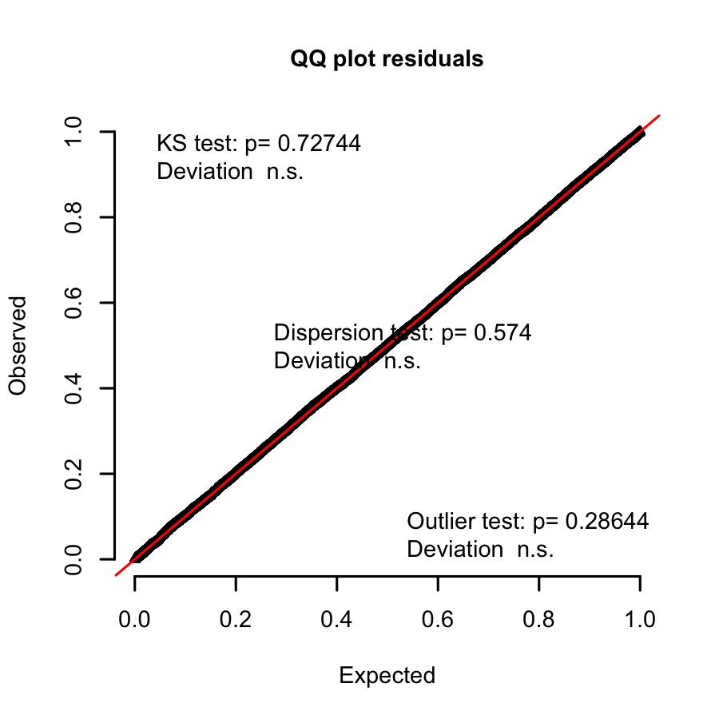
Residuals conform to assumptions
Check VIF
#Calculate the variance inflation factor
TopMod.TrapCapsFire.VIF <- data.frame(Fixed = row.names(vif(TopMod.TrapCapsFire)), vif = vif(TopMod.TrapCapsFire))
Table 25: Trap capture rate by %Burnt across three sessions: variance inflation factor for top model
Fixed | GVIF | DF | GVIF [1/(2*df)]
PropBurnt_Site | 2.091 | 1 | 1.446
Session_Site | 2.276 | 2 | 1.228
PropBurnt_Site:Session_Site | 3.384 | 2 | 1.356
VIF is less than 5 for all variables

Get model estimates, random effects and confidence intervals
# Get model summary and confidence intervals:
TopMod_TrapCapsFire.est <- tidy(TopMod.TrapCapsFire, conf.int = TRUE, exponentiate = FALSE, effects = "fixed")[,-1]
colnames(TopMod_TrapCapsFire.est) <- c("Fixed terms", "Estimate", "Std. error", "z", "p", "2.5% CI", "97.5% CI")
Table 26: Trap capture rate by %Burnt across three sessions: top model summary
Fixed terms | Estimate | Std. error | z | p | 2.5% CI | 97.5% CI
(Intercept) | -5.210 | 0.187 | -27.835 | 0.000 | -5.577 | -4.843
PropBurnt_Trap | 0.467 | 0.170 | 2.750 | 0.006 | 0.134 | 0.800
Session_TrapS2 | 0.692 | 0.083 | 8.304 | 0.000 | 0.529 | 0.856
Session_TrapS3 | -0.026 | 0.092 | -0.286 | 0.775 | -0.206 | 0.154
Autocov_Inv_Trap | 1.883 | 0.191 | 9.878 | 0.000 | 1.510 | 2.257
PropBurnt_Trap:Session_TrapS2 | -3.552 | 0.355 | -10.005 | 0.000 | -4.248 | -2.856
PropBurnt_Trap:Session_TrapS3 | 0.005 | 0.202 | 0.027 | 0.979 | -0.390 | 0.401
# Get random effect
TopMod.TrapCapsFire_Randeff <- as.data.frame(VarCorr(TopMod.TrapCapsFire))[,c(1,4,5)]
colnames(TopMod.TrapCapsFire_Randeff) <- c("Random Effect", "Variance", "Std.Dev.")
Table 27: Trap capture rate by %Burnt across three sessions: top model random effects
Random.Effect | Variance | Std.Dev.
Trap_Trap:Group_Trap | 0.492 | 0.702
Group_Trap | 0.100 | 0.316

Get model predictions
# Make a sequence from the focal variable
Pred.CapsFire.T <- expand.grid(Session_Trap = unique(Session_Trap), PropBurnt_Trap = seq(0, 1, length = 50), Autocov_Inv_Trap = mean(Autocov_Inv_Trap))
Pred.CapsFire.T$Predictions <- predict(TopMod.TrapCapsFire, newdata = Pred.CapsFire.T, re.form = NA, type = "response")
Pred.CapsFire.T$SE <- predictSE(TopMod.TrapCapsFire, newdata = Pred.CapsFire.T, re.form = NA, type = "response")$se.fit
Pred.CapsFire.T <- within(Pred.CapsFire.T, {
UCI <- Predictions + 1.96 * SE
LCI <- Predictions - 1.96 * SE
})
Pred.CapsFire.T$PercentageBurnt <- Pred.CapsFire.T$PropBurnt_Trap*100
Pred.CapsFire.T$Analysis_Level <- "Trap"
# Format for plotting later with trap data
Pred.CapsFire.T <- Pred.CapsFire.T[, c(1, 4, 6:9)]
colnames(Pred.CapsFire.T) <- c("Session", "Capture_Rate", "LCI", "UCI", "PercentageBurnt", "Level")
# Edit the raw veg data for plotting:
TrapDat.S.A.edit.2 <- TrapDat.S.A.edit
TrapDat.S.A.edit.2$PercentageBurnt <- TrapDat.S.A.edit.2$PropBurnt_Trap*100
TrapDat.S.A.edit.2$Capture_Rate <- TrapDat.S.A.edit.2$Total_Rtun_Trap / TrapDat.S.A.edit.2$CorrectedTN_Trap
TrapDat.S.A.edit.2$Level <- "Trap"
TrapDat.S.A.edit.2 <- TrapDat.S.A.edit.2[, c(4, 13:15)]
colnames(TrapDat.S.A.edit.2)[1] <- c("Session")
# Merge site/Trap data frames
Pred.CapsFire <- rbind(Pred.CapsFire.S, Pred.CapsFire.T)
CapDat <- rbind(Site_Abund_edit, TrapDat.S.A.edit.2)
CapFire_Plot <- ggplot(data = Pred.CapsFire, aes(x = PercentageBurnt, y = Capture_Rate, colour = Session)) +
geom_hline(yintercept= 0, size = 0.2, linetype = "dotted") +
scale_shape_manual(values = c(3, 1, 2)) +
geom_ribbon(aes(ymin= LCI, ymax= UCI, linetype = NA, fill = Session), alpha = 0.2) +
geom_line(size = 0.4) +
facet_wrap(~ Level, nrow = 2, scales = "free_y", strip.position = "right") +
scale_colour_manual(values = c("green4", "black", "grey")) +
scale_fill_manual(values = c("green4", "black", "grey")) +
labs(x = "Percentage of site burnt", y = "Capture rate") +
theme(panel.background = element_rect(fill = "white"),
panel.border = element_rect(linetype = "solid", colour = "black",
fill = "transparent", size = 0.2),
panel.grid.minor = element_blank(),
panel.grid.major = element_blank(),
axis.text = element_text(size = 5, color = "black"),
axis.title.y = element_text(size = 6, margin = margin(0,10,0,0), face ="bold"),
axis.title.x = element_text(size = 6, margin = margin(10,0,0,0), face ="bold"),
axis.ticks = element_line(size = 0.2),
strip.background = element_rect(fill = "lightgrey", colour = "black", size = 0.2),
strip.text = element_text(size = 6, face ="plain"),
legend.title = element_text(size = 6, face ="bold"),
legend.text = element_text(size = 5, color = "black"),
legend.position = "none")
ConstrainAxes <- data.frame(Session = rep(c("S1", "S2", "S3"), 2), PercentageBurnt = rep(50, 6), Capture_Rate = c(0.1, 0.1, 0.1, 1, 1, 1), Level = c(rep("Site", 3), rep("Trap", 3)))
CapFireRaw_Plot <- ggplot(data = CapDat, aes(x = PercentageBurnt, y = Capture_Rate, col = Session)) +
geom_hline(yintercept= 0, size = 0.2, linetype = "dotted") +
geom_point(data = ConstrainAxes, aes(x = PercentageBurnt, y = Capture_Rate), col = "white") +
geom_jitter(width = 3, height = 0.002, size = 0.3) +
scale_color_manual(values = c("green4", "black", "grey")) +
facet_grid(Level ~ Session, scales = "free") +
labs(x = "Percentage of site burnt", y = "Capture rate") +
theme(panel.background = element_rect(fill = "white"),
panel.border = element_rect(linetype = "solid", colour = "black",
fill = "transparent", size = 0.2),
panel.grid.minor = element_blank(),
panel.grid.major = element_blank(),
axis.text = element_text(size = 5, color = "black"),
axis.title.y = element_text(size = 6, margin = margin(0,10,0,0), face ="bold"),
axis.title.x = element_text(size = 6, margin = margin(10,0,0,0), face ="bold"),
axis.ticks = element_line(size = 0.2),
strip.background = element_rect(fill = "lightgrey", colour = "black", size = 0.2),
strip.text = element_text(size = 6, face ="bold"),
legend.title = element_text(size = 6, face ="bold"),
legend.text = element_text(size = 5, color = "black"),
legend.position = "right")
I will use these plots to create a combined plot with trap-level and recapture predictions below.

How does the spatial pattern of fire affect pale field rat vegetation preferences?

Overview
To investigate post-fire vegetation preferences in R. tunneyi I ran a GLMM of the number of unique individuals captured at each trap (within session recaptures were not included). I chose to run GLMMs using Group (i.e. grouped sites) as a random effect. Captures were included as count data (poisson), with the number of captures at each trap within a session, offset by the number of potential capture events (total number of trap nights - non-target species - recaptures). I fitted a base model as a first step, to be used in model selection.
Note that vegetation types were aggregated based on the pre-fire analysis. Riparian and tussock grass were grouped into a category called “preferred”, while annual grassland and mixed grasses were grouped into an “unpreferred” category.

Data set
Subset the data so that it only includes session 2 treatment sites and aggregate vegetation types. There is no need to calculate a spatial autocovariate, as there was no evidence of sptaial autocorrelation in capture patterns in this dataset.
Trap_S2 <- TrapDat[TrapDat$Session == "S2",]
TrapTreat_S2 <- Trap_S2[Trap_S2$Site_TreatmentControl == "Treatment",]
TrapTreat_S2 <- TrapTreat_S2[!TrapTreat_S2$Corrected_Potential_Capture_Events == 0, ]
TrapTreat_S2 <- droplevels(TrapTreat_S2)
Define variables
#Define variables
Group_S2 <- TrapTreat_S2$Group
Trap_S2 <- TrapTreat_S2$Trap
CorrectedTN_S2 <- TrapTreat_S2$Corrected_Potential_Capture_Events
Rtun_Total_S2 <- TrapTreat_S2$Rtun_Total
PropPreferred_S2 <- TrapTreat_S2$AFProp20m_Rip + TrapTreat_S2$AFProp20m_Tuss
PropUnpreferred_S2 <- TrapTreat_S2$AFProp20m_AG + TrapTreat_S2$AFProp20m_MG
PropBurnt_S2 <- TrapTreat_S2$AFProp20m_Burnt

Run global Generalised Linear Mixed Model
The idea here is to include everything, even though there will be collinearity, as the final model will not include all variables. I want to see whether there’s a positive or negative effect of the remaining vegetation types after fire.
# Count data, so first try poisson:
Base.TrapVeg.S2 <- glmer(Rtun_Total_S2 ~ PropUnpreferred_S2 + PropPreferred_S2 + PropBurnt_S2 + (1|Group_S2), offset = log(CorrectedTN_S2), data = TrapTreat_S2, family = "poisson")
# Check if base model is overdispersed:
Base.TrapVeg.S2.Overdisp <- as.data.frame(overdisp_fun(Base.TrapVeg.S2))
Table 28: Overdispersion Test for session 2 global vegetation type GLMM
Statistic | Value
chisq | 478.782
ratio | 0.967
rdf | 495.000
p | 0.691
The poisson model is not overdispersed, no need to use a negative binomial GLMM.

Model Selection
Run a model selection to compare models with different combinations of fixed effects, to select the best model and to determine whether preferred versus unpreferred vegetation types predicted R. tunneyi captures after fire. The models were ranked according to BIC.
options(na.action = "na.fail")
BIC_TrapVeg.S2_Select <- dredge(Base.TrapVeg.S2, rank = "BIC", trace = 2, subset = !(`*nvar*`== 3), extra = list(R2.ModSel))
# Don't include full model in model selection - colinear
ModSel_S2_TrapVeg <- as.data.frame(round(BIC_TrapVeg.S2_Select, 3))
colnames(ModSel_S2_TrapVeg) <- c("Intercept", "%Burnt", "Preferred", "UnPreferred", "Cond. R2", "Mar. R2", "DF", "log(L)", "BIC", "DeltaBIC", "Weight")
Table 29: Models describing session 2 post-fire captures by proportion of remaining preferred or unpreferred vegetation surrounding each trap, ranked by BIC
Intercept | %Burnt | Preferred | UnPreferred | Cond. R2 | Mar. R2 | DF | log(L) | BIC | DeltaBIC | Weight
-5.0 | NA | 2.3 | NA | 0.2 | 0 | 3 | -131.4 | 281.4 | 0.0 | 0.7
-3.7 | -1.5 | NA | NA | 0.2 | 0 | 3 | -133.1 | 284.9 | 3.5 | 0.1
-4.5 | NA | NA | NA | 0.3 | 0 | 2 | -136.4 | 285.2 | 3.8 | 0.1
-4.5 | -0.7 | 1.8 | NA | 0.2 | 0 | 4 | -131.0 | 286.8 | 5.4 | 0.0
-3.1 | -2.1 | NA | -1.5 | 0.2 | 0 | 4 | -131.2 | 287.3 | 5.9 | 0.0
-5.0 | NA | 2.4 | 0.3 | 0.2 | 0 | 4 | -131.3 | 287.5 | 6.1 | 0.0
-4.5 | NA | NA | -0.3 | 0.3 | 0 | 3 | -136.3 | 291.2 | 9.8 | 0.0
See previous note about R2

Top ranked model
There was one model with delta BIC less than 2. I will run this model and test its validity, using the DHARMa package to test for overall goodness of fit.
TopMod_TrapVeg.S2 <- glmer(Rtun_Total_S2 ~ PropPreferred_S2 + (1|Group_S2), offset = log(CorrectedTN_S2), data = TrapTreat_S2, family = "poisson")

Test Model Assumptions
Check goodness of fit
set.seed(123)
SimResTopMod_TrapVeg.S2 <- simulateResiduals(fittedModel = TopMod_TrapVeg.S2, n = 1000)
plotQQunif(SimResTopMod_TrapVeg.S2)
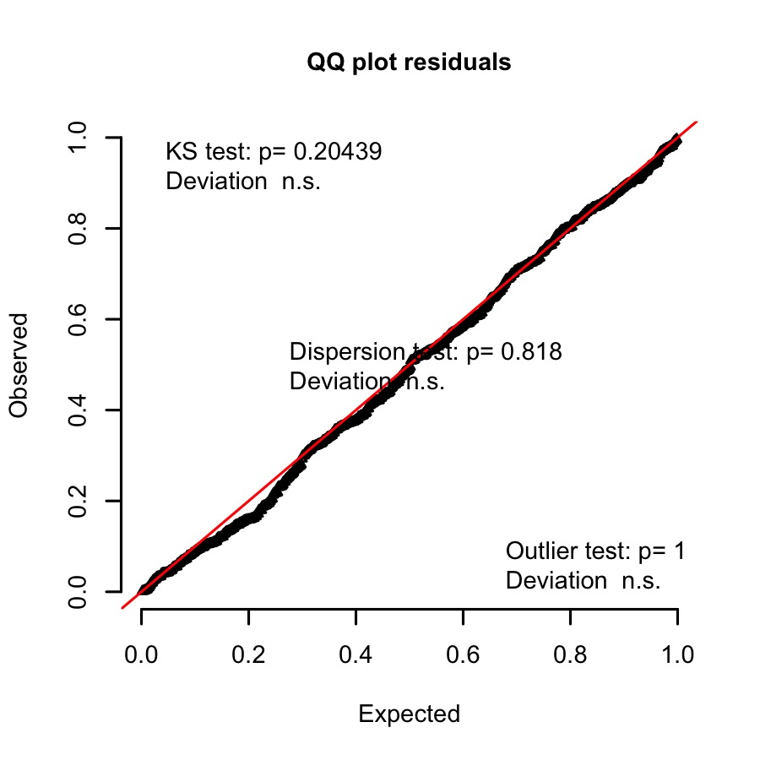
Residuals conform to assumptions

Get model estimates, random effects and confidence intervals
# Get model summary and confidence intervals:
TopMod_TrapVeg.S2.est <- tidy(TopMod_TrapVeg.S2, conf.int = TRUE, exponentiate = FALSE, effects = "fixed")[,-1]
colnames(TopMod_TrapVeg.S2.est) <- c("Fixed terms", "Estimate", "Std. error", "z", "p", "2.5% CI", "97.5% CI")
Table 30: Capture rate by remaining vegetation at trap: top model summary
Fixed terms | Estimate | Std. error | z | p | 2.5% CI | 97.5% CI
(Intercept) | -4.95 | 0.596 | -8.309 | 0 | -6.118 | -3.783
PropPreferred_S2 | 2.344 | 0.698 | 3.356 | 0.001 | 0.975 | 3.712
# Get random effect
TopMod_TrapVeg.S2_Randeff <- as.data.frame(VarCorr(TopMod_TrapVeg.S2))[,c(1,4,5)]
colnames(TopMod_TrapVeg.S2_Randeff) <- c("Random Effect", "Variance", "Std.Dev.")
Table 31: Capture rate by remaining vegetation at trap: top model random effects
Random.Effect | Variance | Std.Dev.
Group_S1 | 0.291 | 0.54

How does the spatial pattern of fire affect pale field rat recaptures?

Overview
The recapture (microchip) data was used to determine the proportion of recaptured individuals per site (based on the number originally chipped).

Recapture data set
Read in data and define variables.
Recaps <- read.csv("Data/Recaptures_per_Site.csv")
Group <- Recaps$Group
S1_S2 <- Recaps$S1_S2
S2_S3 <- Recaps$S2_S3
S1_S3 <- Recaps$S1_S3
S1_Total <- Recaps$Total_Chipped_S1
S1_S2_Total <- Recaps$Total_Chipped
Burn_Treatment <- Recaps$Burn_status_at_site
Prop_Burnt <- Recaps$Prop_Site_Burnt
No_Recaps_S1_S2 <- S1_Total - S1_S2
No_Recaps_S1_S3 <- S1_S2_Total - S1_S3
No_Recaps_S2_S3 <- S1_S2_Total - S2_S3

Run Generalised Linear Mixed Models
Run binomial GLMMs to determine whether the proportion of recaptures changed as a function of the percentage of the site that was burnt. The response is the proportion of recaptures between sessions, given the number that were originally chipped. Run a binomial GLMM.
# Session 1 to session 2
recap.glmer.S1_S2.binomial <- glmer(cbind(S1_S2, No_Recaps_S1_S2) ~ Prop_Burnt + (1|Group), data = Recaps, family = "binomial")
# Check for overdispersion
recap.glmer.S1_S2.binomial.Overdisp <- as.data.frame(overdisp_fun(recap.glmer.S1_S2.binomial))
Table 33: Overdispersion Test for GLMM of recaptures from session 1 to session 2
Statistic | Value
chisq | 7.655
ratio | 1.094
rdf | 7.000
p | 0.364
# Session 1 to session 2
recap.glmer.S1_S3.binomial <- glmer(cbind(S1_S3, No_Recaps_S1_S3) ~ Prop_Burnt + (1|Group), data = Recaps, family = "binomial")
# Check for overdispersion
recap.glmer.S1_S3.binomial.Overdisp <- as.data.frame(overdisp_fun(recap.glmer.S1_S3.binomial))
Table 34: Overdispersion Test for GLMM of recaptures from session 1 to session 3
Statistic | Value
chisq | 3.608
ratio | 0.515
rdf | 7.000
p | 0.824
# Session 1 to session 2
recap.glmer.S2_S3.binomial <- glmer(cbind(S2_S3, No_Recaps_S2_S3) ~ Prop_Burnt + (1|Group), data = Recaps, family = "binomial")
# Check for overdispersion
recap.glmer.S2_S3.binomial.Overdisp <- as.data.frame(overdisp_fun(recap.glmer.S2_S3.binomial))
Table 35: Overdispersion Test for GLMM of recaptures from session 2 to session 3
Statistic | Value
chisq | 8.185
ratio | 1.169
rdf | 7.000
p | 0.317
The binomial models are not overdispersed, no need to use a negative binomial GLMM.

Model selection
Use model selection to compare to null model.
options(na.action = "na.fail")
recap.glmer.S1_S2.binomial_Select <- dredge(recap.glmer.S1_S2.binomial, rank = "BIC", trace = 2, extra = list(R2.ModSel))
ModSel_Recap.S1_S2 <- as.data.frame(round(recap.glmer.S1_S2.binomial_Select, 3))
colnames(ModSel_Recap.S1_S2) <- c("Intercept", "%Burnt", "Cond. R2", "Mar. R2", "DF", "log(L)", "BIC", "DeltaBIC", "Weight")
Table 36: The proportion of recaptures between session 1 and session 2 by the percentage of the site that was burnt, ranked by BIC
Intercept | %Burnt | Cond. R2 | Mar. R2 | DF | log(L) | BIC | DeltaBIC | Weight
-0.7 | -8.5 | 0.7 | 0.7 | 3 | -17.5 | 42.0 | 0.0 | 1
-1.6 | NA | 0.1 | 0.0 | 2 | -43.0 | 90.7 | 48.7 | 0
options(na.action = "na.fail")
recap.glmer.S1_S3.binomial_Select <- dredge(recap.glmer.S1_S3.binomial, rank = "BIC", trace = 2, extra = list(R2.ModSel))
ModSel_Recap.S1_S3 <- as.data.frame(round(recap.glmer.S1_S3.binomial_Select, 3))
colnames(ModSel_Recap.S1_S3) <- c("Intercept", "%Burnt", "Cond. R2", "Mar. R2", "DF", "log(L)", "BIC", "DeltaBIC", "Weight")
Table 37: The proportion of recaptures between session 1 and session 3 by the percentage of the site that was burnt, ranked by BIC
Intercept | %Burnt | Cond. R2 | Mar. R2 | DF | log(L) | BIC | DeltaBIC | Weight
-4.210 | -14.169 | NA | 0.87 | 3 | -6.193 | 19.294 | 0.000 | 0.603
-4.956 | NA | 0.176 | 0.00 | 2 | -7.761 | 20.127 | 0.832 | 0.397
options(na.action = "na.fail")
recap.glmer.S2_S3.binomial_Select <- dredge(recap.glmer.S2_S3.binomial, rank = "BIC", trace = 2, extra = list(R2.ModSel))
ModSel_Recap.S2_S3 <- as.data.frame(round(recap.glmer.S2_S3.binomial_Select, 3))
colnames(ModSel_Recap.S2_S3) <- c("Intercept", "%Burnt", "Cond. R2", "Mar. R2", "DF", "log(L)", "BIC", "DeltaBIC", "Weight")
Table 38: The proportion of recaptures between session 2 and session 3 by the percentage of the site that was burnt, ranked by BIC
Intercept | %Burnt | Cond. R2 | Mar. R2 | DF | log(L) | BIC | DeltaBIC | Weight
-3.325 | -2.937 | NA | 0.224 | 3 | -11.792 | 30.491 | 0.000 | 0.642
-3.589 | NA | 0.022 | 0.000 | 2 | -13.528 | 31.662 | 1.171 | 0.358

Session 1 to Session 2

Test model assumptions
Check goodness of fit
set.seed(2)
S1_S2SimRes <- simulateResiduals(recap.glmer.S1_S2.binomial, n = 1000)
plotQQunif(S1_S2SimRes)
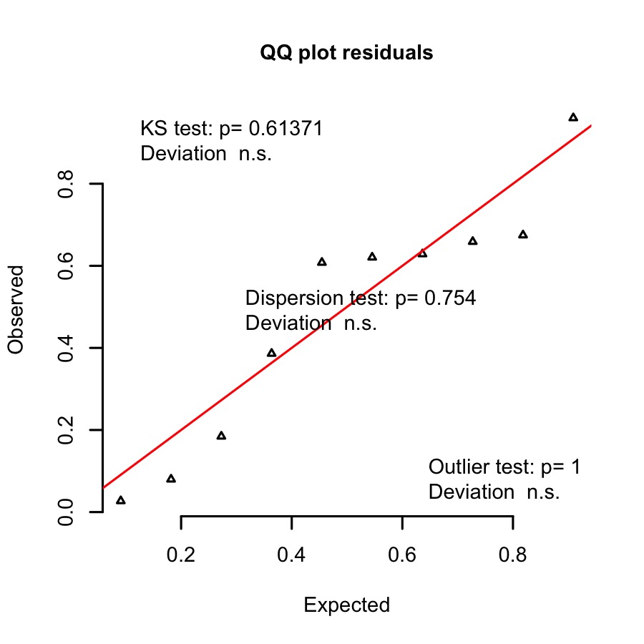

Get model estimates, random effects and confidence intervals
# Get model summary and confidence intervals:
recap.glmer.S1_S2.binomial.est <- tidy(recap.glmer.S1_S2.binomial, conf.int = TRUE, exponentiate = FALSE, effects = "fixed")[,-1]
colnames(recap.glmer.S1_S2.binomial.est) <- c("Fixed terms", "Estimate", "Std. error", "z", "p", "2.5% CI", "97.5% CI")
Table 39: S1 to S2 recaptures by percentage burnt: model summary
Fixed terms | Estimate | Std. error | z | p | 2.5% CI | 97.5% CI
(Intercept) | -0.729 | 0.240 | -3.044 | 0.002 | -1.199 | -0.260
Prop_Burnt | -8.097 | 2.056 | -3.938 | 0.000 | -12.126 | -4.067
# Get random effect
recap.glmer.S1_S2.binomial_Randeff <- as.data.frame(VarCorr(recap.glmer.S1_S2.binomial))[,c(1,4,5)]
colnames(recap.glmer.S1_S2.binomial_Randeff) <- c("Random Effect", "Variance", "Std.Dev.")
Table 40: S1 to S2 recaptures by percentage burnt: random effects
Random.Effect | Variance | Std.Dev.
Group | 0.09 | 0.3

Session 1 to Session 3

Test model assumptions
Check goodness of fit
set.seed(2)
S1_S3SimRes <- simulateResiduals(recap.glmer.S1_S3.binomial, n = 1000)
plotQQunif(S1_S3SimRes)
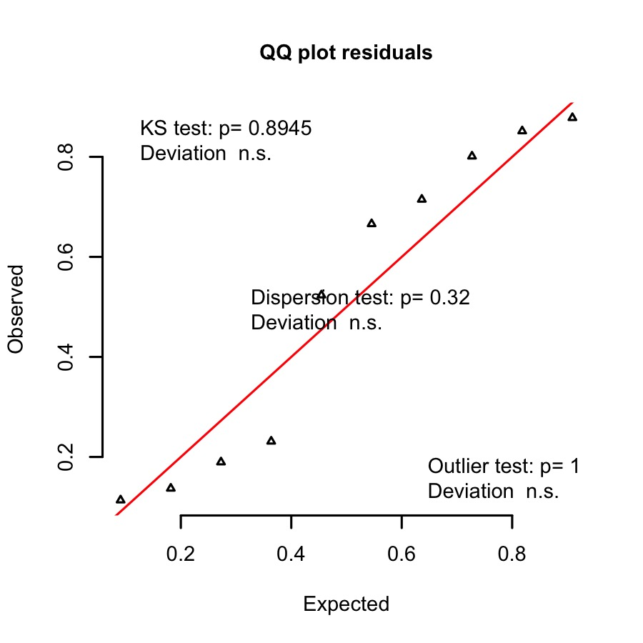

Get model estimates, random effects and confidence intervals
# Get model summary and confidence intervals:
recap.glmer.S1_S3.binomial.est <- tidy(recap.glmer.S1_S3.binomial, conf.int = TRUE, exponentiate = FALSE, effects = "fixed")[,-1]
colnames(recap.glmer.S1_S3.binomial.est) <- c("Fixed terms", "Estimate", "Std. error", "z", "p", "2.5% CI", "97.5% CI")
Table 41: S1 to S3 recaptures by percentage burnt: model summary
Fixed terms | Estimate | Std. error | z | p | 2.5% CI | 97.5% CI
(Intercept) | -4.210 | 0.414 | -10.166 | 0.000 | -5.022 | -3.399
Prop_Burnt | -14.169 | 26.874 | -0.527 | 0.598 | -66.841 | 38.503
# Get random effect
recap.glmer.S1_S3.binomial_Randeff <- as.data.frame(VarCorr(recap.glmer.S1_S3.binomial))[,c(1,4,5)]
colnames(recap.glmer.S1_S3.binomial_Randeff) <- c("Random Effect", "Variance", "Std.Dev.")
Table 42: S1 to S3 recaptures by percentage burnt: random effects
Random.Effect | Variance | Std.Dev.
Group | 0 | 0

Session 2 to Session 3

Test model assumptions
Check goodness of fit
set.seed(2)
S2_S3SimRes <- simulateResiduals(recap.glmer.S2_S3.binomial, n = 1000)
plotQQunif(S2_S3SimRes)
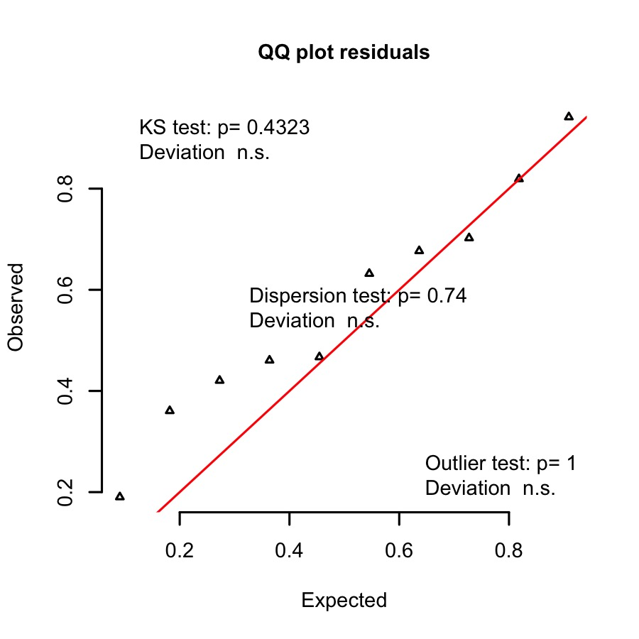

Get model estimates, random effects and confidence intervals
# Get model summary and confidence intervals:
recap.glmer.S2_S3.binomial.est <- tidy(recap.glmer.S2_S3.binomial, conf.int = TRUE, exponentiate = FALSE, effects = "fixed")[,-1]
colnames(recap.glmer.S2_S3.binomial.est) <- c("Fixed terms", "Estimate", "Std. error", "z", "p", "2.5% CI", "97.5% CI")
Table 43: S1 to S2 recaptures by percentage burnt: model summary
Fixed terms | Estimate | Std. error | z | p | 2.5% CI | 97.5% CI
(Intercept) | -3.325 | 0.267 | -12.436 | 0.000 | -3.849 | -2.801
Prop_Burnt | -2.937 | 1.944 | -1.511 | 0.131 | -6.747 | 0.873
# Get random effect
recap.glmer.S2_S3.binomial_Randeff <- as.data.frame(VarCorr(recap.glmer.S2_S3.binomial))[,c(1,4,5)]
colnames(recap.glmer.S2_S3.binomial_Randeff) <- c("Random Effect", "Variance", "Std.Dev.")
Table 44: S2 to S3 recaptures by percentage burnt: random effects
Random.Effect | Variance | Std.Dev.
Group | 0 | 0

Get model predictions
# Make a sequence from the focal variable
Pred.Recaps.S1_S2 <- expand.grid(Prop_Burnt = seq(0,1,by=0.01))
# Get model predictions
Pred.Recaps.S1_S2$Predictions <- predict(recap.glmer.S1_S2.binomial, newdata = Pred.Recaps.S1_S2, re.form = NA, type = "response")
Pred.Recaps.S1_S2$SE <- predictSE(recap.glmer.S1_S2.binomial, newdata = Pred.Recaps.S1_S2, re.form = NA, type = "response")$se.fit
Pred.Recaps.S1_S2 <- within(Pred.Recaps.S1_S2, {
UCI <- Predictions + 1.96 * SE
LCI <- Predictions - 1.96 * SE
})
Pred.Recaps.S1_S2$PercentageBurnt <- Pred.Recaps.S1_S2$Prop_Burnt*100
Pred.Recaps.S1_S2$Session <- "Session 1 to Session 2"
Pred.Recaps.S1_S2$SessionOrder <- "a"
# Format for plotting later with trap data
Pred.Recaps.S1_S2 <- Pred.Recaps.S1_S2[, c(7:8, 6, 2, 4:5)]
colnames(Pred.Recaps.S1_S2) <- c("Session", "SessionOrder", "PercentageBurnt", "PropRecaps", "LCI", "UCI")
# Make a sequence from the focal variable
Pred.Recaps.S1_S3 <- expand.grid(Prop_Burnt = seq(0,1,by=0.01))
# Get model predictions
Pred.Recaps.S1_S3$Predictions <- predict(recap.glmer.S1_S3.binomial, newdata = Pred.Recaps.S1_S3, re.form = NA, type = "response")
Pred.Recaps.S1_S3$SE <- predictSE(recap.glmer.S1_S3.binomial, newdata = Pred.Recaps.S1_S3, re.form = NA, type = "response")$se.fit
Pred.Recaps.S1_S3 <- within(Pred.Recaps.S1_S3, {
UCI <- Predictions + 1.96 * SE
LCI <- Predictions - 1.96 * SE
})
Pred.Recaps.S1_S3$PercentageBurnt <- Pred.Recaps.S1_S3$Prop_Burnt*100
Pred.Recaps.S1_S3$Session <- "Session 1 to Session 3"
Pred.Recaps.S1_S3$SessionOrder <- "c"
# Format for plotting later with trap data
Pred.Recaps.S1_S3 <- Pred.Recaps.S1_S3[, c(7:8, 6, 2, 4:5)]
colnames(Pred.Recaps.S1_S3) <- c("Session", "SessionOrder", "PercentageBurnt", "PropRecaps", "LCI", "UCI")
# Make a sequence from the focal variable
Pred.Recaps.S2_S3 <- expand.grid(Prop_Burnt = seq(0,1,by=0.01))
# Get model predictions
Pred.Recaps.S2_S3$Predictions <- predict(recap.glmer.S2_S3.binomial, newdata = Pred.Recaps.S2_S3, re.form = NA, type = "response")
Pred.Recaps.S2_S3$SE <- predictSE(recap.glmer.S2_S3.binomial, newdata = Pred.Recaps.S2_S3, re.form = NA, type = "response")$se.fit
Pred.Recaps.S2_S3 <- within(Pred.Recaps.S2_S3, {
UCI <- Predictions + 1.96 * SE
LCI <- Predictions - 1.96 * SE
})
Pred.Recaps.S2_S3$PercentageBurnt <- Pred.Recaps.S2_S3$Prop_Burnt*100
Pred.Recaps.S2_S3$Session <- "Session 2 to Session 3"
Pred.Recaps.S2_S3$SessionOrder <- "b"
# Format for plotting later with trap data
Pred.Recaps.S2_S3 <- Pred.Recaps.S2_S3[, c(7:8, 6, 2, 4:5)]
colnames(Pred.Recaps.S2_S3) <- c("Session", "SessionOrder", "PercentageBurnt", "PropRecaps", "LCI", "UCI")
# Combine for plotting
Pred.Recaps <- rbind(Pred.Recaps.S1_S2, Pred.Recaps.S1_S3, Pred.Recaps.S2_S3)
# Edit data for plotting:
Recaps.2 <- data.frame(SessionOrder = c(rep("a", nrow(Recaps)), rep("c", nrow(Recaps)), rep("b", nrow(Recaps))), PercentageBurnt = c(Recaps$Prop_Site_Burnt * 100, Recaps$Prop_Site_Burnt * 100, Recaps$Prop_Site_Burnt * 100), PropRecaps = c(Recaps$S1_S2_Recap_Rate, Recaps$S1_S3_Recap_Rate, Recaps$S2_S3_Recap_Rate))

Plot
# Create labels for plots
Recap.labs <- unique(Pred.Recaps$Session[order(Pred.Recaps$SessionOrder)])
names(Recap.labs) <- unique(Pred.Recaps$SessionOrder[order(Pred.Recaps$SessionOrder)])
Recaps_Plot <- ggplot(data = Pred.Recaps, aes(x = PercentageBurnt, y = PropRecaps)) +
geom_hline(yintercept= 0, size = 0.2, linetype = "dotted") +
facet_wrap(~ SessionOrder, nrow = 3, strip.position = "right", labeller = labeller(SessionOrder = Recap.labs)) +
geom_line(size = 0.4, col = "grey") +
geom_jitter(data = Recaps.2, aes(x = PercentageBurnt, y = PropRecaps), width = 0.01, height = 0.01, size = 0.5, col = "darkgrey") +
geom_ribbon(aes(ymin= LCI, ymax= UCI, linetype = NA, fill = Session), alpha = 0.2, fill = "lightgrey") +
labs(x = "Percentage of site burnt", y = "Proportion of recaptures") +
theme(panel.background = element_rect(fill = "white"),
panel.border = element_rect(linetype = "solid", colour = "black",
fill = "transparent", size = 0.2),
panel.grid.minor = element_blank(),
panel.grid.major = element_blank(),
axis.text = element_text(size = 5, color = "black"),
axis.title.y = element_text(size = 6, margin = margin(0,10,0,0), face ="bold"),
axis.title.x = element_text(size = 6, margin = margin(10,0,0,0), face ="bold"),
axis.ticks = element_line(size = 0.2),
strip.background = element_rect(fill = "lightgrey", colour = "black", size = 0.2),
strip.text = element_text(size = 6, face ="plain"),
legend.title = element_text(size = 6, face ="bold"),
legend.text = element_text(size = 5, color = "black"),
legend.position = "none")
# Merge all capture/recapture plots
CapRecap <- ggarrange(CapFire_Plot, Recaps_Plot, widths = c(3/5, 2/5), labels = c("a)", "b)"), font.label = list(size = 8, face = "bold"))
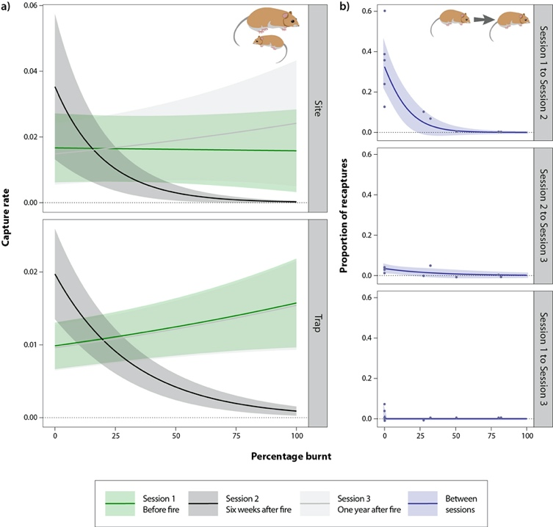
Capture rate (at the site and trap level) and the proportion of recaptures between sessions with increasing percentage burnt
Raw capture rate (at the site and trap level) with increasing percentage burnt

References
Bartoń, K. (2020). MuMIn: Multi-model inference. Retrieved from https://CRAN.R-project.org/package=MuMIn
Bates, D., Mächler, M., Bolker, B., & Walker, S. (2015). Fitting linear mixed-effects models using lme4. Journal of Statistical Software, 67(1), 1–48. doi: 10.18637/jss.v067.i01
Bivand, R. S., Pebesma, E., & Gomez-Rubio, V. (2013). Applied spatial data analysis with R, second edition. Springer, NY. Retrieved from http://www.asdar-book.org/
Bolker, B., & Robinson, D. (2020). Broom.mixed: Tidying methods for mixed models. Retrieved from https://CRAN.R-project.org/package=broom.mixed
Efford, M. (2020). Secr: Spatially explicit capture-recapture models. Retrieved from https://CRAN.R-project.org/package=secr
Fox, J., & Weisberg, S. (2019). An R companion to applied regression (Third). Thousand Oaks CA: Sage. Retrieved from https://socialsciences.mcmaster.ca/jfox/Books/Companion/
Hartig, F. (2020). DHARMa: Residual diagnostics for hierarchical (multi-level / mixed)Regression models. Retrieved from https://CRAN.R-project.org/package=DHARMa
Kassambara, A. (2019). Ggpubr: ’Ggplot2’ based publication ready plots. Retrieved from https://CRAN.R-project.org/package=ggpubr
Lüdecke, D., Makowski, D., Waggoner, P., & Patil, I. (2020). Performance: Assessment of regression models performance. CRAN. doi: 10.5281/zenodo.3952174
Mazerolle, M. J. (2020). AICcmodavg: Model selection and multimodel inference based on (q)AIC(c). Retrieved from https://cran.r-project.org/package=AICcmodavg
Nakagawa, S., & Schielzeth, H. (2013). A general and simple method for obtaining R2 from generalized linear mixed-effects models. Methods in Ecology and Evolution, 4(2), 133–142. doi: 10.1111/j.2041-210x.2012.00261.x
Wickham, H. (2016). Ggplot2: Elegant graphics for data analysis. Springer-Verlag New York. Retrieved from https://ggplot2.tidyverse.org
Xie, Y. (2020). Knitr: A general-purpose package for dynamic report generation in r. Retrieved from https://yihui.org/knitr/

