Appendix S2
Shelby C. McClelland, Keith Paustian, and Meagan E. Schipanski. Management of cover crops in temperate climates influences soil organic carbon stocks – A meta-analysis. Ecological Applications.

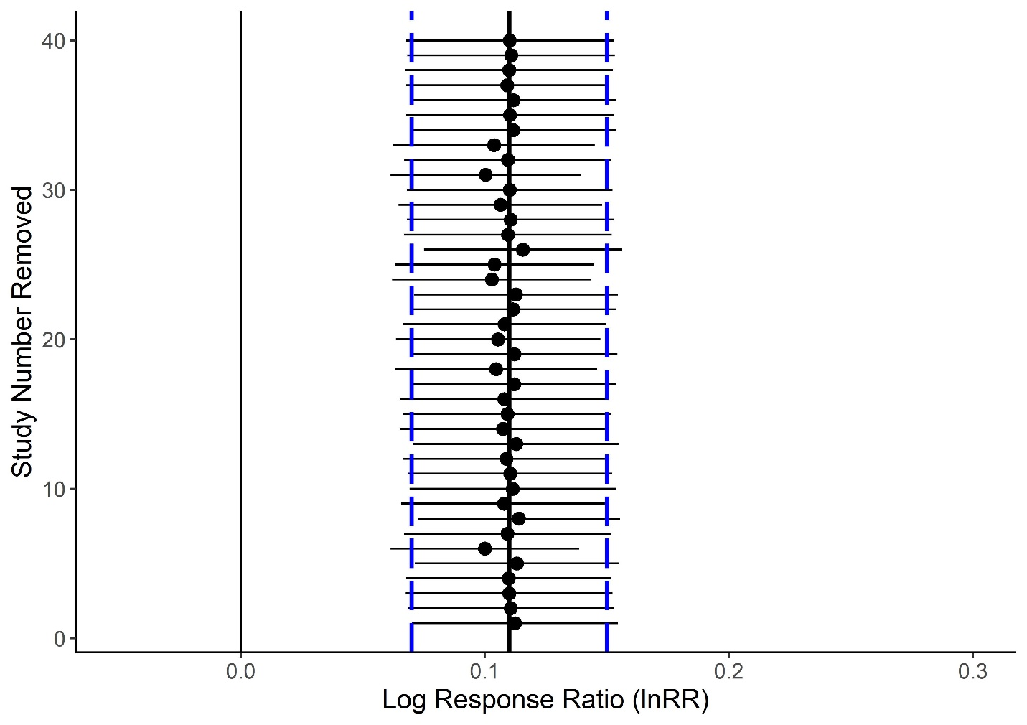
Figure S1. The results of the sensitivity analysis, which was completed using a Jacknife technique. The solid black line represents the overall lnRR and the blue dashed lines the lower and upper 95% confidence interval of the overall lnRR (prior to publication removal). The solid black line represents a null effect. Recomputed lnRR and 95% confidence intervals that do not cross zero were considered significant.

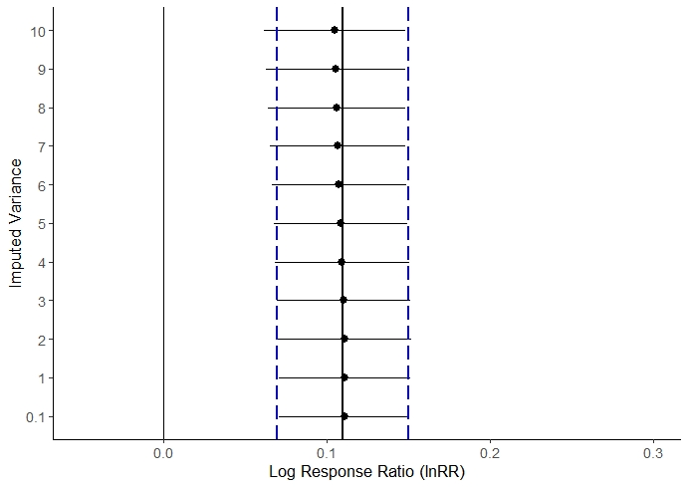
Figure S2. The results of the imputation sensitivity analysis. The solid black line represents the overall lnRR and the blue dashed lines the lower and upper 95% confidence interval of the overall lnRR (at each level of imputed variance). The solid black line represents a null effect. Recomputed lnRR and 95% confidence intervals that do not cross zero were considered significant.

