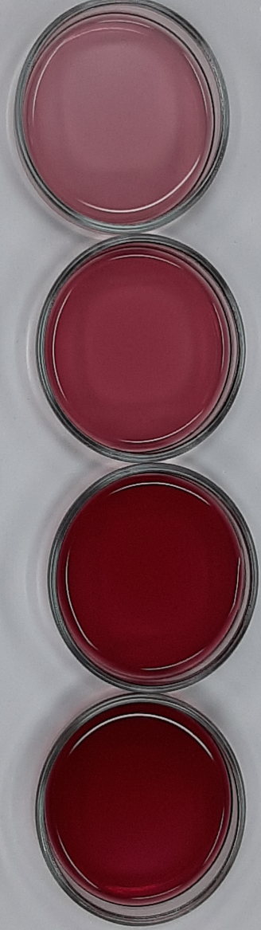
Fresh juice Cycle 1 Cycle 2 Cycle 3

Day 0
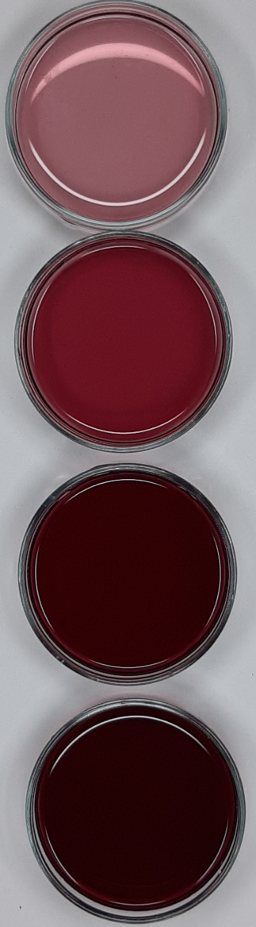
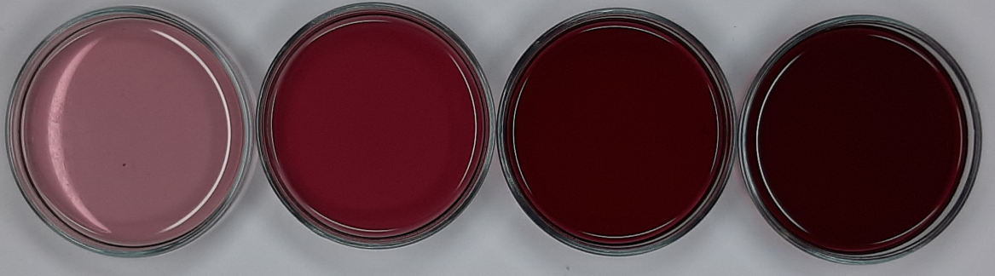

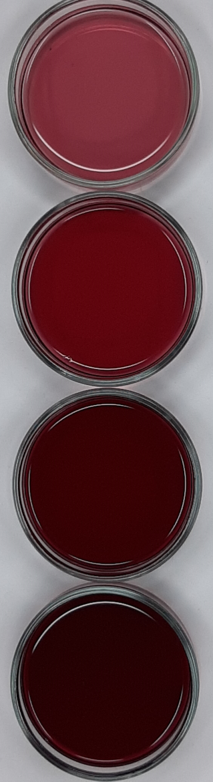
Day 7

Day 14
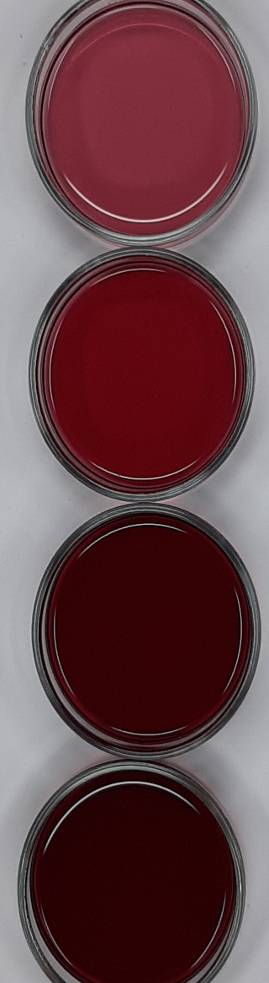

Day 21
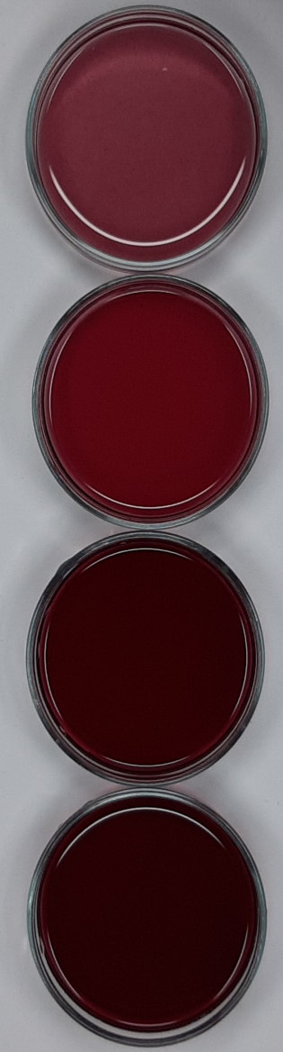

Day 28

Day 35

Fig. S1. Visual appearance of fresh juice and concentrate samples at each cycle during storage.
Table S1. Pearson’s correlation coefficients (r) between biological active compounds content of fresh calafate juice.
 | TPC | TAC | TFC | DPPH | ABTS | FRAP | ORAC
TPC | 1.00
TAC | 1.00* | 1.00
TFC | 0.99* | 1.00* | 1.00
DPPH | 0.99* | 1.00* | 1.00* | 1.00
ABTS | 0.97* | 0.98* | 0.98* | 0.99* | 1.00
FRAP | 0.97* | 0.98* | 0.98* | 0.99* | 1.00* | 1.00
ORAC | 0.96* | 0.97* | 0.97* | 0.98* | 1.00* | 1.00* | 1.00
*Significant at 5%.
Table S2. Pearson’s correlation coefficients (r) between biological active compounds content (TBC and TAA) obtained by CBCC process (first cycle).
 | TPC | TAC | TFC | DPPH | ABTS | FRAP | ORAC
TPC | 1.00
TAC | 0.99* | 1.00
TFC | 0.98* | 1.00* | 1.00
DPPH | 0.98* | 1.00* | 0.99* | 1.00
ABTS | 0.98* | 1.00* | 0.99* | 1.00* | 1.00
FRAP | 0.97* | 0.98* | 0.98* | 0.98* | 0.99* | 1.00
ORAC | 0.97* | 0.98* | 0.97* | 0.98* | 0.99* | 1.00* | 1.00
*Significant at 5%.
Table S3. Pearson’s correlation coefficients (r) between biological active compounds content (TBC and TAA) obtained by CBCC process (second cycle).
 | TPC | TAC | TFC | DPPH | ABTS | FRAP | ORAC
TPC | 1.00
TAC | 0.96* | 1.00
TFC | 0.91* | 0.99* | 1.00
DPPH | 0.96* | 1.00* | 0.99* | 1.00
ABTS | 0.94* | 1.00* | 0.99* | 1.00* | 1.00
FRAP | 0.94* | 0.99* | 0.98* | 0.99* | 0.99* | 1.00
ORAC | 0.94* | 0.98* | 0.97* | 0.99* | 0.99* | 1.00* | 1.00
*Significant at 5%.

