Text, Image, Data, Interaction: Understanding Information Visualization

Once the domain of expert users doing task-driven data analyses, information visualizations today are increasingly addressed to users in everyday contexts with a variety of interests and goals—from choosing a baby’s name (http://www.babynamewizard.com/voyager) to deciding whether to buy or rent (https://www.nytimes.com/interactive/2014/upshot/buy-rent-calculator.html) to building their own electoral map (https://www.270towin.com/) to gauging the mood of the internet (http://www.wefeelfine.org). Indeed, the reach of information visualization, or infovis, is extending more fully into our everyday lives, and we see an increasing number of interactive data visualization projects that are addressed to lay audiences and that encompass a range of purposes. Danziger (2008) described infovis as “on the verge of a significant paradigm shift brought on by the continued maturation of the Information Age” (11). With advances in the collection, storage, and access to data of all kinds; with the development and dissemination of engaging, interactive interfaces for that data; and with cultural shifts that make interacting with data more familiar and more compelling for more people, infovis is becoming more of a mainstream medium for communicating information. As a result, infovis is an increasingly rich and relevant object of study for writing researchers and teachers as we endeavor to understand and help our students gain proficiency with new digital literacies and practices. This article proposes a framework that engages four key elements in information visualizations—text, image, data, and interaction—with the goal of better understanding how information visualizations communicate, especially with mainstream audiences.

1.0 Everyday infovis
The most often cited definition of information visualization comes from Card et. al. (1999): it is “the use of computer supported, interactive, visual representations of abstract data to amplify cognition” (p. 7). In other words, in infovis projects users interact with visual representations of data in order to understand and derive insight from that data. Infovis is distinct from information graphics, or infographics, which present static rather than interactive visual representations of data. Infovis is also distinct from scientific visualization, which presents visual representations of data that have a physical or material referent rather than abstract data. Infovis combines visual features (e.g., color, size, position), textual elements (e.g., titles, labels, instructions), and interactive options (e.g., search, zoom, filter) to produce different views of data in order to leverage the human powers of perception in finding meaningful patterns and thus drawing information and insight out of data.

For infovis designers and developers, the opportunity to create interactive data visualizations for mainstream audiences has led to a wider range of choices and a greater consideration of the impact of those choices. Information visualizations have traditionally been designed for expert users in research or business settings who are exploring a data set in order to find answers to specific questions. Thus traditional information visualizations are designed to be clear and efficient and to present data objectively. As Charles Kostelnick (2008) noted with reference to static visualizations, data displays are “quintessentially utilitarian,” where clear and unambiguous communication is the goal. But Kostelnick (2008) also examined the complexity of clarity as a defining feature and outlined the different ways that clarity itself has been defined. In even the most utilitarian visualizations of data, designers have made choices—about what data to include, how to visualize it, what interactions to enable—and those choices can be interpreted and read rhetorically. When addressing a wider range of everyday users whose objectives and motivations are more varied—for instance, to be entertained and delighted, to socialize, to learn more about themselves and others—infovis designers have more options to employ. For instance, Kostelnick (2016) recently described a “new data design landscape” (132) in which pathos is increasingly important and emotional appeals are used to complement rational appeals and “to arouse users emotionally, creating excitement and enhancing user engagement and understanding” (117). In short, while there is a rhetorical dimension present in any infovis design, it is more clearly present and more integral to the success of infovis projects that attempt to engage everyday users.

Researchers in the field of information visualization have proposed several ways to think about infovis projects that target lay rather than expert audiences and that encompass a range of purposes people might have for interacting with data. Viegas and Wattenberg (2006) coined the term “communication-minded visualization” to describe visualization designs that integrate a social dimension, enabling interactions and facilitating conversation and the collaborative analysis of data. Pousman et. al. (2007) proposed “casual infovis” to designate both the non-work related contexts and the non-analytical tasks facilitated by mainstream infovis projects. They noted that casual infovis differs from traditional infovis in having a wider spectrum of users; interaction patterns that may be momentary or contemplative rather than focused; data that is more personally meaningful; and insights that may be social or reflective rather than strictly analytical (p. 1149). Danziger (2008) described “public-facing” infovis and “infovis for the people” as a way of highlighting the value of visualization as an information channel for the general public. Central to the concept of “public-facing” infovis is that developers need to account for the different motivations and practices of everyday “information consumers” as they interact with visualizations.

Closest to my own approach, Hullman and Diakopoulos (2011) proposed the framework of “visualization rhetoric,” which attends to how rhetorical techniques are used in information visualizations that tell stories and how these techniques affect users’ interpretations. They described four “editorial layers”— data, visual representation, annotations, and interaction—where “editorial judgments, and thus rhetorical techniques, can enter into the construction of narrative visualizations” (3). At each layer, Hullman and Diakopoulos (2011) identified different rhetorical techniques—for instance, omission, emphasis, ambiguity, contrast, redundancy, metaphor, and metonymy—and they delineated “a vocabulary for analyzing the underlying rhetorical functions of particular design strategies.” While Hullman and Diakopoulos (2011) limited their analysis to specific rhetorical strategies that infovis designers can use to tell stories more effectively, I approach these four “editorial layers” more broadly, as elements that are essential to the ways that information visualizations communicate; they are sites where authors make significant choices and where readers should therefore ask rhetorical and analytical questions. In what follows, I discuss some of the key considerations for each element (modifying Hullman and Diakopoulos’s “annotations” to include all text in an infovis), and I illustrate the discussion with brief examples in each section and a more extensive example carried through all of the sections.

2.0 Dollar Street
The example I’ve chosen to illustrate an extended analysis of these four infovis elements is Dollar Street (https://www.gapminder.org/dollar-street/), an interactive visualization of the world’s economy that shows, according to its authors, “how people across the world really live” (see Figure 1). Created by Anna Rosling Rönnlund and Ola Rosling at Gapminder, Dollar Street has the broad sweep and scope of its infovis older sibling, Gapminder World (https://www.gapminder.org/world/), which was created by Hans Rosling and ultimately purchased by Google. Gapminder World presents an interactive visualization of a wide range of global data drawn from public databases. Via his TED talks about this project, Hans Rosling became something of a luminary in infovis circles. He argued that global public data should be freely available and searchable by the public, and that data in general should be more accessible, easier to understand, and easier to use. As stated on Gapminder’s homepage: “We fight devastating misconceptions about global development with a fact-based worldview everyone can understand.”


Figure 1: The top of the Dollar Street interface

Though Hans Rosling died in 2015, his daughter-in-law and son have carried on this mission with Dollar Street, which launched in 2016 in collaboration with Save the Children Sweden. As Rosling Rönnlund described it, Dollar Street is “a visual framework that would help us understand socio-economic differences of the world” (https://www.gapminder.org/news/a-dream-come-true/). Data for the project includes 30,000 photos and 10,000 videos drawn from 264 homes in 50 countries. Visitors to the Dollar Street website can look at photos of the homes and possessions of families across the world by following fairly simple navigational cues. For example, clicking on the photo of the $10,098 family in China leads to more information and more photos of that family and their home, and those photos link to other pages with photos organized by possessions, families, countries, and regions. Dollar Street can thus be seen as a significant project put together by leaders in the field targeting a mainstream public audience with the goal of using information visualization to educate and ultimately effect social change. There is, as I will show, much to learn about how an information visualization might achieve these objectives by attending to the choices made at the levels of text, image, data, and interaction in this and other infovis projects.

3.0 Text
The point of a visualization is to convey information visually. People can much more effectively detect patterns, identify outliers, and develop insights by seeing data rather than encountering it in raw or numerical form. Indeed, as Colin Ware (2012) noted, “We acquire more information through vision than through all of the other senses combined” (p. 8), and a significant strand of research in the field of information visualization has to do with how designers can optimize their presentations to take advantage of the human visual system (e.g., Ware, 2012; Card et. al., 1999). But an infovis or infographic without text is rare. As the example below demonstrates (see Figure 2), this is because a visualization without any text can be impossible to decipher. Here we see an x-axis with years from 1985 to 2015, a y-axis measuring some variable on a scale of 4 to 10 with a midline at 7.3, and clusters of similarly colored circles with different opacities. We also see a logo at the bottom left of the image, and if we recognize this as the logo for FiveThirtyEight we can infer that the graphic comes from Nate Silver’s website (http://fivethirtyeight.com). Otherwise, the content of this visualization is a mystery.

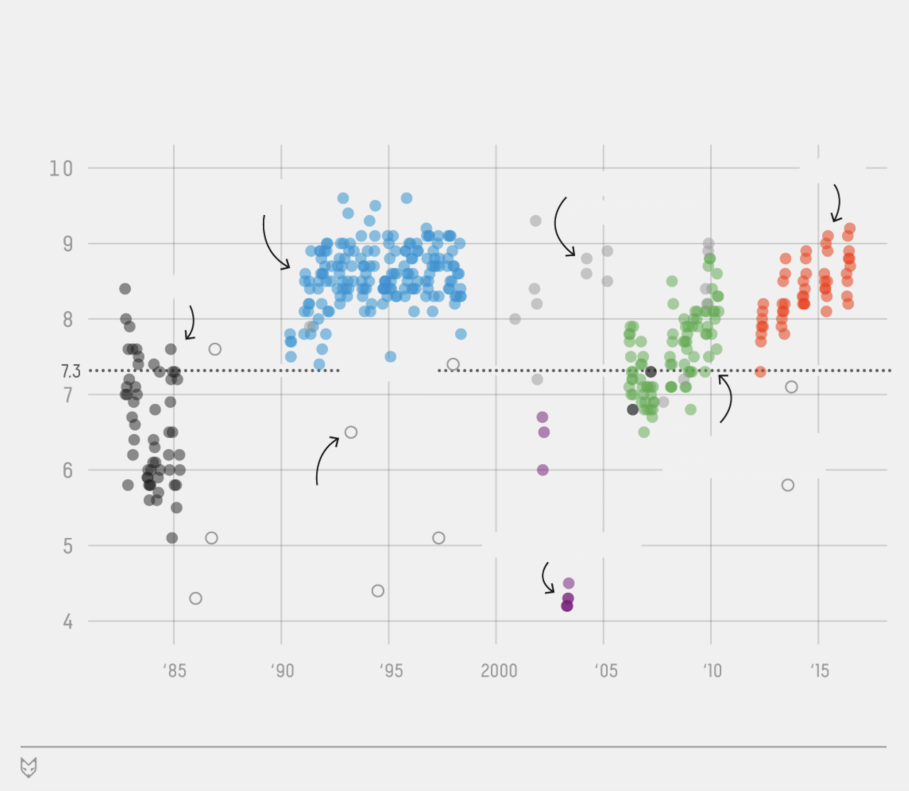
Figure 2. Visualization without text.

Only with the text included (see Figure 3) can we begin to understand and interpret this and most other visual presentations of data. Text is found in important places in most infovis projects: titles, labels, annotations, explanations, and other commentary. Here the title and subtitle immediately orient readers to the subject of the visualization and the variable being measured (Internet Movie Database ratings). The title adds an editorial element by pointing to the conclusion that we should draw from this data. Labels for the axes and the clusters provide further clarification, and the inclusion of the author and source at the bottom of the graphic helps to establish ethos.

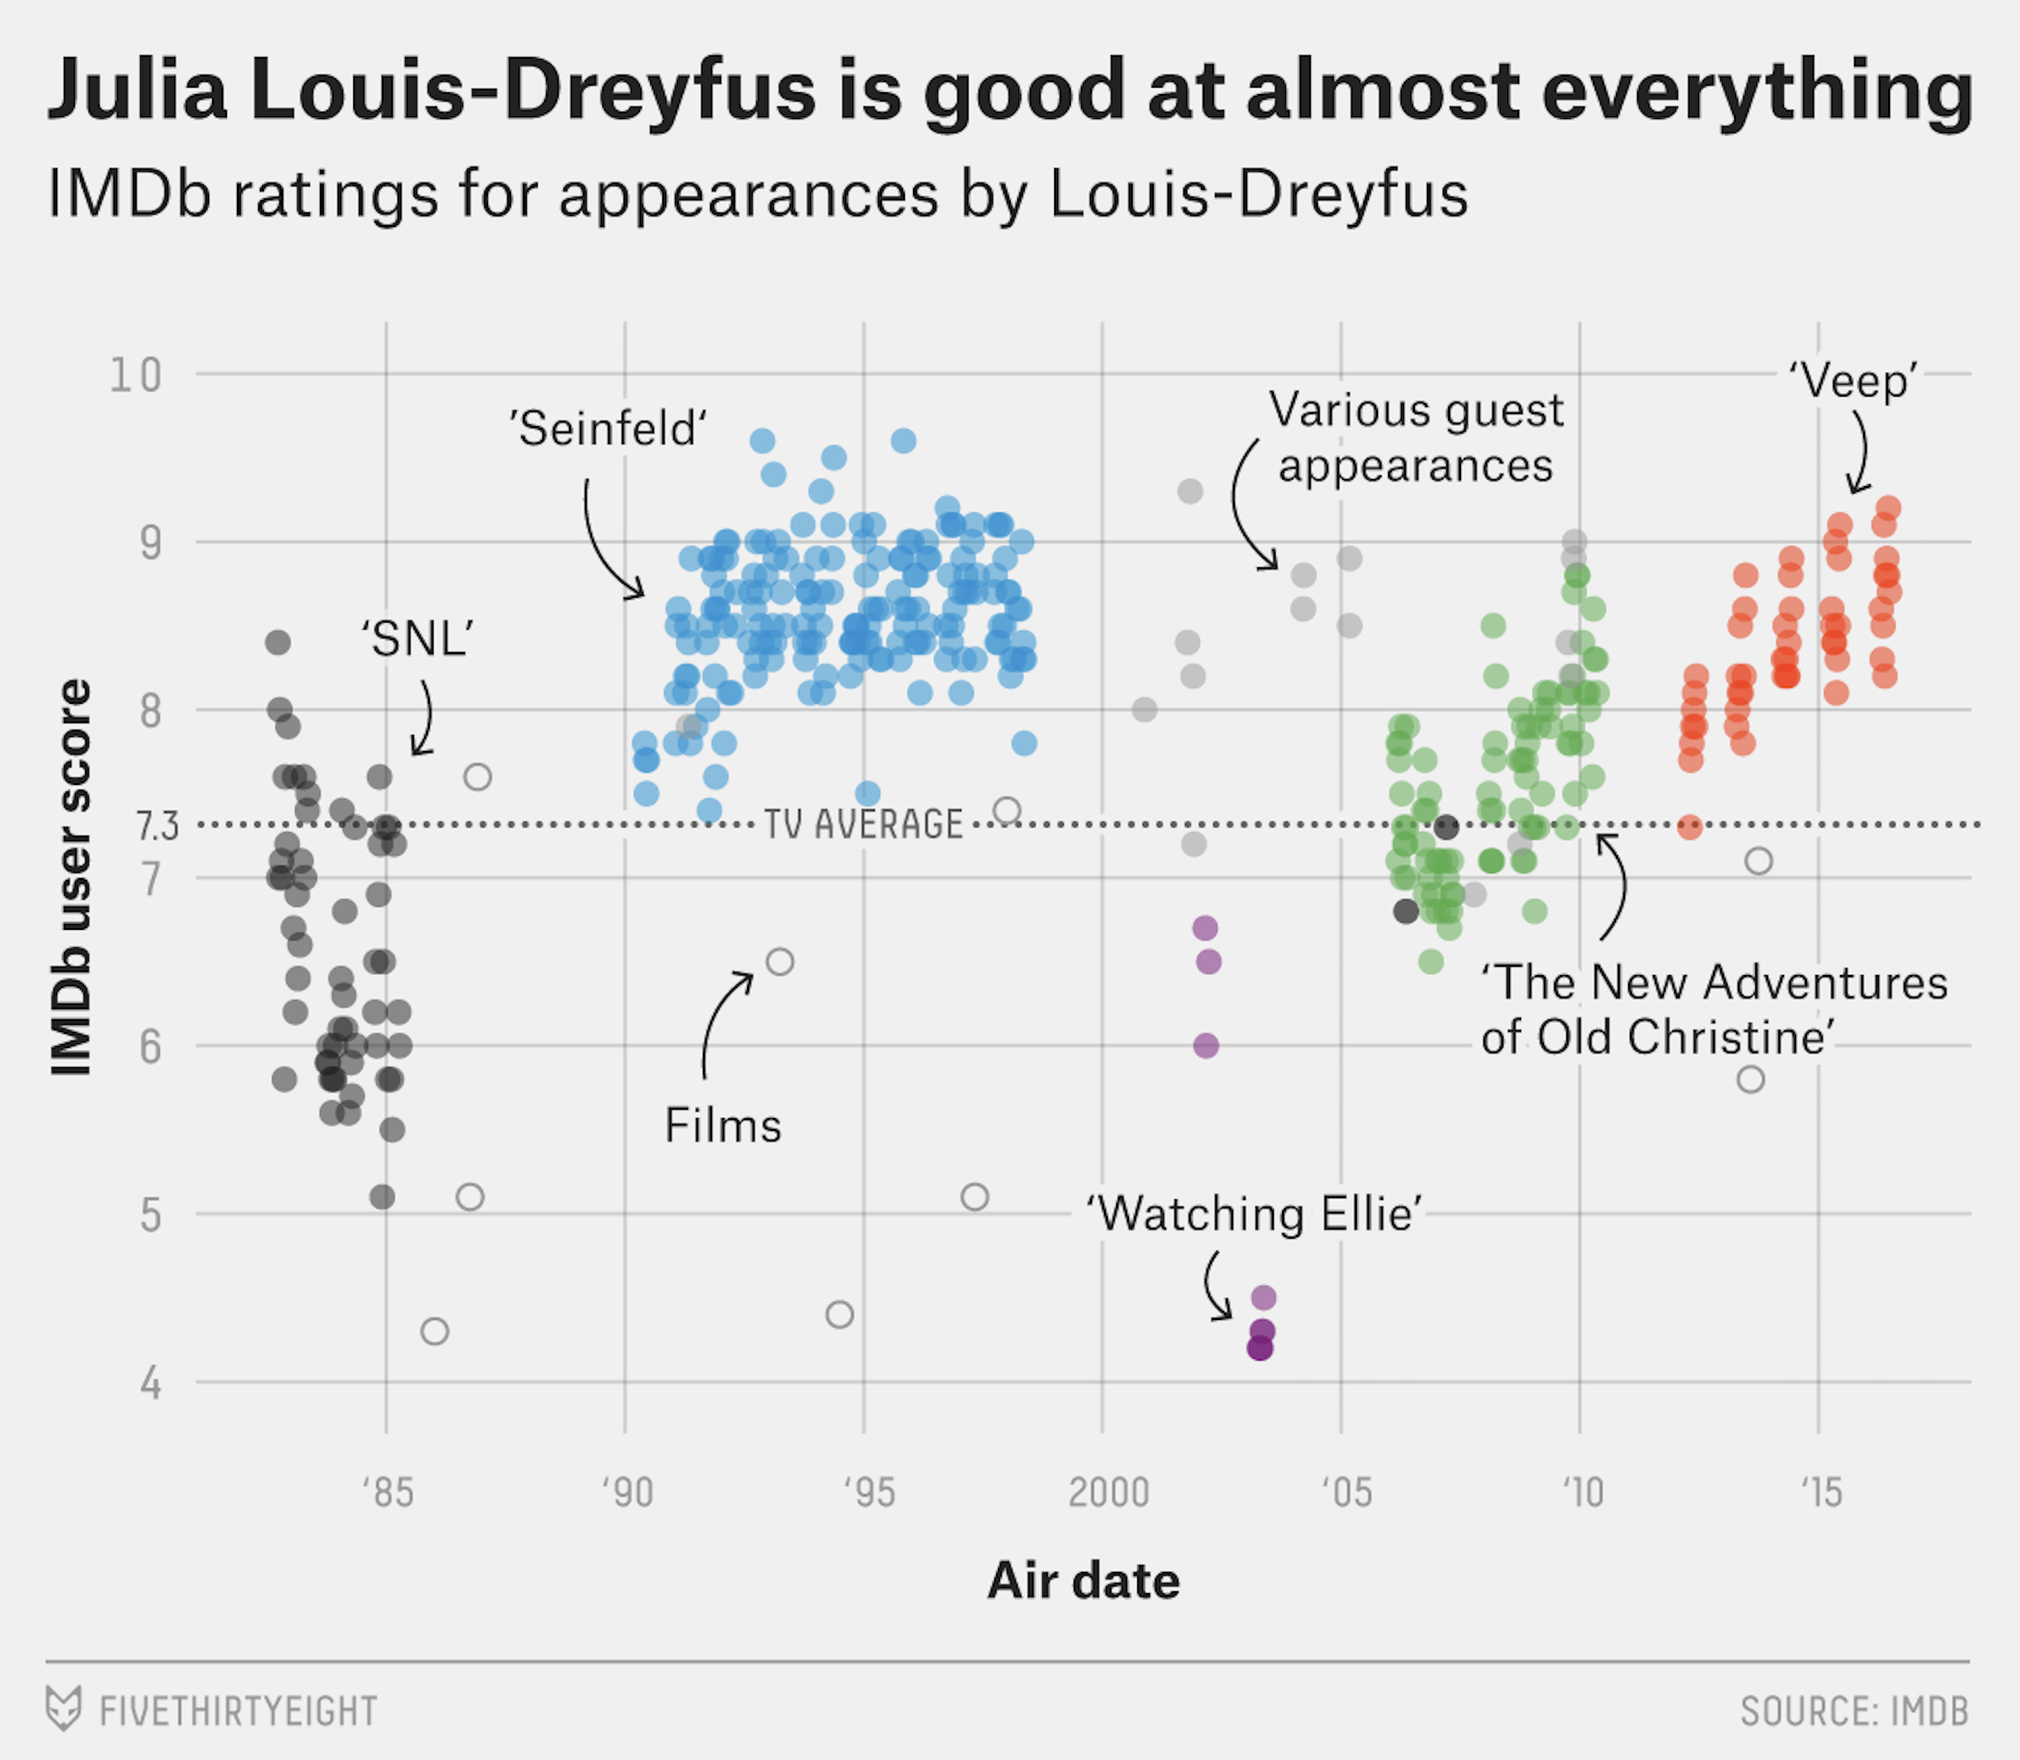
Figure 3. Visualization with text.

Text is non-preattentive. In other words, unlike elements of an image (e.g., size, color, position), text can’t be understood at a glance; it takes time and attention to read and comprehend text. Perhaps for that reason there has been a dearth of research on how text is most effectively used in static or interactive graphics. For instance, William Cleveland’s classic The Elements of Graphing Data noted only that legends should be “comprehensive and informative” (56). Technical communication textbooks offer similarly brief and general advice; for instance, Markel’s Technical Communication advised that “A graphic should be clearly labeled. Give every graphic (except a brief, informal one) a unique, clear, informative title. Fully label the columns of a table and the axes and lines of a graph” (314). Clear, direct, and informative: text seems to serve only a minor role while the content is primarily communicated visually.

However as we see in the example above and in the discussion of Dollar Street below, text performs at least four significant functions in an information visualization: text guides interpretation, provides explanation, establishes context, and facilitates navigation. Text can also often convey information in a way that visual elements cannot—for instance, through allusions, puns, metaphors, and cultural references. In analyzing how infovis projects communicate, then, text provides a familiar and important starting point.

The most important textual feature of an infovis project is often its title, and this is certainly true of Dollar Street. The title presents the governing metaphor of the project, which is that the whole world is a single street of houses, ordered by income. This metaphor—and its visual representation via the bar across the top of the interface (see Figure 1)—makes the world seem smaller and more familiar. People from different cultures and classes aren’t alien or unknowable; they’re our neighbors living some number of houses up or down the street from us. When the world becomes a single street, it seems much more accessible and easier to explore, and encouraging this exploration is a key goal of Dollar Street. But why is the project named Dollar Street? The project’s authors are Swedish; why not Krona Street? Or Euro Street? The choice of the dollar—in the title and in the calculations used for each family’s monthly income—both acknowledges the dollar’s dominance in the international financial world and indicates the authors’ desire to target a U.S. and first-world audience. Even when the site is translated into Spanish or Swedish, the title and the dollar figures remain the same (e.g., “Bienvenido a Dollar Street!”). Overall, the resonances of both parts of the title orient users to some of the key messages and goals of this infovis.

Text is also used in Dollar Street to facilitate navigation; as Figure 3 depicts, several dropdown menus (at “Families” and “the World”) show users their options in getting started with a search of the site (see also Figures 9, 10, and 11 for other text-based navigation options).

Beyond the title and the fairly straightforward options for navigation, there is quite a lot of text included in Dollar Street. The page for each family profiled on Dollar Street—arrived at by clicking on a photo of the family and following the navigation to “visit this home”—provides a short and long paragraph with details about the family. The short description of the Haji family ($176, from Tunisia) reads, “The Haji family lives in Tunis in Tunisia. Salah is 60 years old and works as a mason. His wife Dalila is 35 years old and they live with their 2 children. The family lives in a rented 1-bedroom house and have been living there for a year. Their next big plan is to buy a fridge. They dream of one day being able to buy a house.” On clicking “Read more” a longer description appears. The long paragraph for each family includes the number, age, and names of family members; occupation(s) and hours spent working; size of the home and length of time the family has lived there; amenities in the home (e.g., electricity, running water, toilet); how the family gets their food and how much it costs; how they cook their food and whether they have safe drinking water; whether the family can save money and where they’ve gone on vacation; and what their “dream” is (e.g., owning a car or a home, educating their children). These detailed paragraphs provide the kind of information that can’t be conveyed by photographs alone. Yet like the photographs, the textual content focuses on measurable, observable facts. Ultimately the paragraphs communicate what it means to be a family and what is important about families in the view of the Dollar Street authors, who, after all, are claiming to show how different people “really live.” The facts conveyed in the paragraphs focus on the basic conditions of life, not on the more intangible or emotional elements of individual and family life.

While each family is unique and the facts about them differ, it is worth noting that the paragraphs for all of the families have the same basic structure and address the same topics, described above. This structural sameness makes the families easier to compare, and comparison is at the heart of Dollar Street. Users are invited to look across the world at similarities and differences in people’s lives, to identify associations and commonalities even in families from different classes and cultures. Indeed, the two key messages of Dollar Street as described in its press kit (linked to the site) are that the world is not divided into two groups (us/them, first-world/third-world) and that people in other countries are not as strange or hard to understand as the media portray them. The fact that all families are described in the same terms makes it easier for readers to accept these premises and to draw connections among families that in other ways (e.g., economic, cultural, religious) would appear quite different.

Dollar Street also provides a large amount of text that explains and contextualizes the project. Via links from the site, there is much to read about the project itself, not just about the families being profiled. Following the About link, there are links to videos in which Rosling Rönnlund describes Dollar Street, invitations for readers to participate in various ways, licenses and terms of use, an FAQ, a press kit, links to awards, information about how family income was calculated, links to the Dollar Street “team”, and links to photographers who participated in the project. While more substantial information visualizations might include an About page that discusses the project and perhaps provides citations and author bios, the extent of information provided by Dollar Street is quite remarkable. As discussed in the Interaction section below, the Dollar Street authors clearly want to engage their audience at several levels and encourage them to get involved by providing extensive background information that contextualizes the project. This text around the project also helps to guide interpretation by explaining the overall goals of Dollar Street and answering questions users might have. Moreover, the additional text conveys ethos by identifying the authors and explaining their resources and methodologies, and it conveys pathos by providing pictures and videos of the “team” (Rosling Rönnlund is described as “Mother of Dollar Street”) and the participating photographers. Clearly, text around as well as within an infovis project yields insight into the intended message of the project and the choices authors make in conveying that message.

4.0 Image
Information visualizations typically deal with abstract data—that is, data that has no physical referent. One task of infovis developers is to map data values to a visual representation—as in Figures 2 and 3 above, for instance, where each television or movie appearance by Julia Louis-Dreyfus is represented as a circle of a particular color. There is no inherent or natural relationship between tv/movie appearances and circles or colors. A fundamental task that people have in understanding static or interactive visualizations, then, is determining what meaning to assign to the visual marks or images on the page or screen. Infovis designers put a lot of thought into making these marks meaningful, for example by using visual techniques to show relationships (e.g., proximity, color coding) or to draw attention (e.g, highlighting, brightening or bolding, placement, size). Still, especially with novice users, interpreting the visual aspects of an information visualization can be challenging and can involve a sometimes steep learning curve.

An example of the challenges of visual interpretation can be seen in the infovis project Listen to Wikipedia by Hatnote (http://listen.hatnote.com/), which represents real-time Wikipedia edits via images (and sound), creating an appealing and even mesmerizing interface (see Figure 4). Written by Stephen LaPorte and Mahmoud Hashemi, the project was inspired by and uses some code from BitListen (formerly Listen to Bitcoin), created by Maximillian Laumeister (http://www.bitlisten.com/).

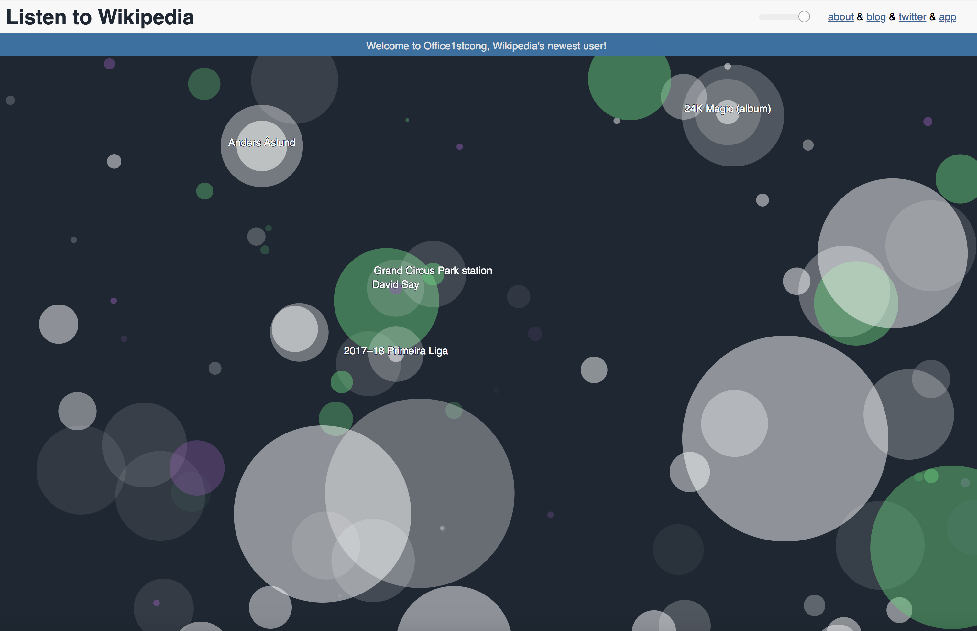
Figure 4. Listen To Wikipedia screenshot.

Listen to Wikipedia includes a number of visual properties that designate different aspects of Wikipedia edits. Some properties, such as the size of the circle, correspond readily with the information they are intended to convey—in this case, the length of the edit. It seems unlikely, though, that users would be able to intuit the meanings of other properties, such as the different colors; colors are explained via an About link (white circles show edits from registered contributors, green circles from unregistered contributors, and purple circles from automated bots). Other properties remain unexplained: the placement of the circles seems entirely random; opacity and duration seem to be uniform and to operate apart from the other variables. While it may take users some time to understand how the look and sound of this infovis project signify, the fact that the number of variables is relatively low and that the interface is aesthetically appealing may sustain users as they investigate (and enjoy) Listen to Wikipedia.

In contrast, Dollar Street presents an interface that is simpler to understand, with visual elements designed to clearly communicate with novice users. Although there is a lot of text in and around Dollar Street, as noted earlier, photographs are the dominant feature of this project. Since these photos serve as the primary data for Dollar Street, I discuss them in more detail in the Data section below. Here I remark primarily on how the photos are presented—the visual interface of the infovis and its impact on viewers. On first arriving at the site and in many of the subsequent page views that one gets from navigating around the site, the display is very much like a photo album, with a grid of photos scrolling down the page. The similarity to a photo album is enhanced by the fact that in its default view the photos are all of families, typically standing in front of or inside a home, looking directly at the camera and thus at the user (see Figure 1). The experience of looking at and being looked at by all of these diverse people engages users from the start, and the overall photo album design provides a familiar interface for a wide audience of users.

It is also worth noting that the grid design of the interface erases a more geographic approach to seeing families across the world. A map view is available at Dollar Street, but it is relatively hidden after the About and Donate links in the dropdown menu at the top right of the interface. It makes sense that the Dollar Street authors would want to minimize location as a factor in presenting these families because their argument is that geographic distances and differences can be overcome and that we have more than we imagine in common with families in other parts of the world. The grid is arranged so as to present rows of families across the economic range, with each family representing a group (e.g., in a quadrant of poor, less poor, less rich, rich). Each row is comprised of this arrangement, and thus each row represents a minimal version of the project as a whole, showing the economic range of families being profiled.

Overall the interface of Dollar Street is relatively easy for new users to figure out, and this makes the project more accessible to a general audience. Other visual elements in Dollar Street—for instance, the logo (see Figure 6)—also facilitate understanding. A clever visual amalgam of a dollar sign and a street, the logo visually translates the name of the project. In addition, the fact that Dollar Street has a logo at all signifies that it has a certain status—an identity or “brand” that builds ethos by making the project seem more substantial and permanent.


Figure 5. Dollar Street logo.

Visual elements in information visualizations are clearly central to how they communicate, and analyzing images and other visual design features as purposeful, strategic choices made by authors is a key task of users. More broadly, the question of aesthetics and visual appeal has become increasingly important as infovis reaches out to a wider range of users. Chaomei Chen (2005) named aesthetics one of the top 10 “unsolved information visualization problems” (12), and he called for empirical studies to “understand how insights and aesthetics interact” (15). Here Chen is concerned with the most effective ways to convey information and yield insight, using appealing visual design to generate and maintain users’ interest as they analyze data. Another approach altogether is represented in infovis projects that are oriented toward pleasure and enjoyment rather than insight, in which artists/developers use data as the medium, the material out of which they create. In this “data art” or “visualization art” (Lau and VandeMoere, 2007), the data itself might not even be readable or discernable, or it might serve as the impetus for enjoyment, reflection, or curiosity rather than as grounds for analysis and insight. In short, the visual impact of infovis encompasses both content and affect and should be analyzed with both of these orientations in mind.

5.0 Data
A crucial part of any information visualization is the data itself—that is, the content being visualized. Asking questions about the data—what type it is, how it was gathered, how it was classified and categorized, what was left out—is an important but often overlooked step in understanding an information visualization. More broadly, with the increasing amounts of data that we encounter in the various roles we play—e.g., as citizens, consumers, employees, parents—data literacy is becoming increasingly important in our individual and social lives. While the key skills and competencies needed for data literacy are still being formulated (see Wolff et. al. 2016; Bhargava and D’Ignazio, 2017), most definitions include the ability to access, understand, and manipulate data of various kinds. A robust data literacy would enable us to formulate questions and make decisions informed by data, create arguments based on data, effectively use tools to manipulate and represent data, and be able to communicate with data.

Even more fundamentally, though, we need to understand what data is. In contrast to its etymological implications, data is not simply a given. It is always created, the product of specific choices in selection, transformation, and encoding. In “Humanities Approaches to Graphical Display,” Johanna Drucker (2010) suggested that we use the term “capta” rather than data, to underscore “that knowledge is constructed, taken, not simply given as a natural representation of pre-existing fact.” For Drucker, this reconceptualization of data as capta is important because it undermines the transparent, observer-independent model of reality presumed in data displays and instead opens them up to humanistic inquiry and interpretation. Data and datasets are, as Trevor Owens (2011) suggested, “a species of human-made artifact,” very like texts in that they are authored, created for specific audiences and purposes, and subject to interpretation. One aspect of data literacy, then, and a key step in understanding information visualizations, is attending to the data-related choices made by infovis developers.

It is also important to recognize that the data being visualized in mainstream infovis projects is frequently not numerical data—or at least, not initially so. In visualizations of text, image, sound, and video, the data is digitized, rendered in binary code so that it can be read, acted on, and represented by computer programs. Here we see Lev Manovich’s (2001) first principle of new media: numerical representation. He wrote, “All new media objects, whether created from scratch on computers or converted from analog media sources, are composed of digital code: they are numerical representations” (27). Media objects are rendered into code in order to be processed by computers, and are then “translated” back into media form and re-presented as text, image, sound, or video.

This process is foundational for infovis projects, though media transformations and the use of non-numerical data are more evident in some projects than in others—for example, the transformations of text into image and sound in Listen to Wikipedia, discussed earlier. Another well known infovis project that works with non-numerical data is Yale University Library’s Robots Reading Vogue
(http://dh.library.yale.edu/projects/vogue/). Here text and images from more than 100 years of Vogue magazine have been digitized and tagged; they form the dataset from which various visualizations are constructed. In the project represented in Figure 6, the covers for all Vogue issues were scanned and an RGB value was assigned for each pixel in each digitized cover image; thus images are rendered numerically, pixel-by-pixel. To create the decade composites shown below, the mean RGB value for each pixel was calculated and rendered as a color. The results show the contrast between the distinctive covers of the 1940s and 1950s and the remarkable uniformity (and conventionalized sense of beauty) in the 1970s and 1980s covers. In other projects in Robots Reading Vogue, advertisements are sorted for frequency, date, and industry, and word usage is compared over time. There is even a “random memo generator” that creates memos written in the style of Diana Vreeland, the iconic former editor-in-chief of American Vogue. As this and other infovis projects demonstrate, different types of media serve as data in visualizations; they can be represented in a range of ways once they become digitized. To help develop our data literacy and better understand how data is represented in information visualizations, then, we need to broaden our perspective to think of non-numerical data and the various encodings and transformations involved (see also Manovich, 2012). In short, as Wolff et. al. (2017) argue, data literacy is no longer the same as statistical literacy.


Figure 6. Composite of Vogue magazine covers from the 1940s, 1950s, 1970s and 1980s

Turning to Dollar Street, we see that photos are presented as the primary form of data. There are more than 30,000 photos, digitized, stored in a database, and tagged with metadata in ways that allow this dataset to be searchable. Indeed, one premise of Dollar Street is that people are turned off by numbers and statistics. Dollar Street tries to engage its mainstream audience by presenting information via photos rather than via charts and graphs with numerical data. As Rosling Rönnlund wrote in her blog post announcing the debut of Dollar Street, “what if we could see statistics? What if, instead of trying to understand the numbers in a table or the figures in a graph, we could get a picture of what was being portrayed?” Photos are accessible, rich in detail, and seemingly self-evident and objective. On the About page, the authors wrote, “People in other cultures are often portrayed as scary or exotic. We want to show how people really live. It seemed natural to use photos as data so people can see for themselves what life looks like on different income levels.”

While we can appreciate the impulse behind the authors’ decision, a long history of scholarship on photography and visual rhetoric has critiqued their understanding of photographs as natural, realistic, unmediated representations. While seeming to deliver an unmediated view of reality, photos are actually a prime example of Drucker’s “capta”—literally, taken rather than given. In Dollar Street’s Photo Guide, accessible from the About page, instructions are provided for photographers who want to contribute to the project: “All photos should be with the [item] centered in the middle of the image. They should use natural light and they should be in their real environment, not ‘styled’. We want them as is.” Although the stated goal is to have “unstyled” photos and to present the items “as is,” in fact the items being photographed are often isolated and staged so as to be comparable to the same items from other families. One of the first interactive options one comes across in Dollar Street is to view the same item (e.g., a toothbrush, a cup, a bed) across different countries, continents, or the world. The photos thus have a kind of sameness about them (see Figure 7), with the occasional exception of the items from the most impoverished families (e.g., the stick that serves as a toothbrush for the family from Burundi). This sameness actually helps to prove a point that is central to the argument of Dollar Street, which is that we have more than we imagine in common with others in different countries and even in different classes.


Figure 7. Toothbrushes

A more troubling implication of using photos as data is the defining focus on material goods, on the objects centered in each photo. In this project, it is the material objects that we own or use that show “how we really live” rather than those aspects of our lives that can’t be easily photographed, such as relationships, ideas, or emotions. Using photos as data constrains the ways that Dollar Street can make comparisons across families and countries. Even the aspirations of the families are conceived of as “Things I dream of having” and emotions are tied to “Most loved items,” which are presented via photos. The opportunities and constraints of photos as data are fundamental to Dollar Street, to the way it conceptualizes and presents its argument. In general, attending to the kind of data used in this and other projects helps us understand the particular perspectives they offer.

In addition to the photos serving as data in Dollar Street, there is also numerical/financial data represented in the dollars per month amount assigned to each family. This number figures prominently as the key variable underlying the arrangement of families along the metaphorical street. As one of two pieces of textual information on the main image for each family (see Figure 8 below), the dollars per month number is presented, along with the country where the family lives, as a simple fact. Indeed, the text overview describing each family contains a sentence like the following that indicates in a straightforward way how the number was determined: “Imelda works for 60 hours a week and earns 8,000 Burundian Francs per month, which is approximately 27 USD/month (adjusted to purchasing power parity)” [Butoyi Family, Burundi]. This sentence describes a fairly simple process of determining the monthly income of family members, converting the local currency into dollars, and adjusting for the relative strength of the currency to purchase goods.


Figure 8: Screenshot of monthly income/country from Dollar Street homepage.

However, this process is complicated considerably by the additional explanation provided around the edges of Dollar Street. Accessed via a link at the bottom of the About page, “Detailed income calculations for Dollar Street” is a 12-page PDF, written by Mattias Lindgren (who is listed as “data guy” on the Team page), that specified how the authors incorporated a range of data and several different processes in determining the dollars per month for each family. Lindgren acknowledged that there were interpretations and choices involved all along the way. The term “guesstimate” appeared quite a few times in this document, and the general impression one takes away is that the dollar per month numbers presented so directly were actually arrived at quite circuitously.

As Lindgren explained, Dollar Street authors were guided first of all by what they wanted to measure: long-term standard of living. They decided that consumption rather than income was a better indicator of standard of living and that they wanted to measure income per adult equivalent rather than measuring per capita or household income. However, Lindgren subsequently described this approach as “an ambition”: “our ambition is to display the consumption, over an extended period (a year), and express it as per adult equivalent (using the ‘OECD modified scale’). But that is only an ambition, the information we have does not often fit this ambition well” (2). Lindgren went on to explain the approach they actually used with the data they had to work with. He also described difficult problems the team encountered in making their calculations, including how to determine income when it is paid in kind rather than in cash, when it is unreported or illegal, or when it is highly seasonal. Lindgren mentioned other weaknesses in the data: it doesn’t factor in savings or debt; it doesn’t account for the value of public services such as health care; it guesstimates the implicit renting cost for families that own their homes.

On the one hand, it is quite commendable that Lindgren and the Dollar Street authors so honestly present the choices, limitations, and compromises that have taken place behind the scenes of their data. On the other hand, the majority of Dollar Street’s visitors are unlikely to read this document and are therefore unlikely to question the dollars per month numbers displayed for each family or to understand how these numbers were determined. Here we see why it is crucial that readers of information visualization analyze the data rather than simply accept it as a given. In this case, learning more about the dollars per month figure leads readers to a better understanding of the goals of the Dollar Street team and the challenges they confronted in trying to create a particular view of the world. In fact, “Detailed income calculations for Dollar Street” adds richness to the project by showing how many variables, differences, and complications are involved in making economic comparisons across countries and classes. Unfortunately, this very complexity undermines Dollar Street’s goal of presenting a simple and accessible world view, and ultimately we’re left wondering about the accuracy of the statement about Imelda above (“Imelda works for 60 hours a week and earns 8,000 Burundian Francs per month”) and about similar statements for all of the families.

If the Dollar Street authors had not disclosed the choices and compromises in their data, we would not have cause to doubt. Clearly, this is capta rather than data, taken rather than given, constructed rather than self-evident. In other infovis projects as well, knowing more about the decisions made at the level of data yields a better understanding of the project and an ability to critically engage with its authors.

6.0 Interaction
The last and probably least familiar site of analysis is the interaction offered by an information visualization. The three elements discussed above—text, image, and data—are more familiar to mainstream audiences from the charts, graphs, and static infographics that we see more regularly. As noted earlier, the key distinguishing factor between infographics and infovis is that the latter offers users opportunities for interaction—that is, for “direct manipulation and immediate change” of the display (Becker, Cleveland, and Wilks, 1987). Through the options for interaction that are incorporated into an infovis project, users can adjust the visual representation according to their own needs and interests and thus can explore the data in ways that aren’t possible with a static display.

Over the years, infovis designers have developed many options for interaction techniques to engage users and enable exploration—for instance, dragging a slider to adjust the range of a variable; brushing over a highlighted term to trigger a pop-up window with more information; clicking to focus on a selected region and view it in greater detail. In understanding how an information visualization communicates a message, then, it is important to attend to the actions it facilitates. What can users actually do to interact with the infovis, and what goals or insights do these interactions open up for users? Yi et. al. (2007) provide a helpful taxonomy of interactions based on “user intent”—that is, what a user wants to achieve:

- Select: mark something as interesting
- Explore: show me something else
- Reconfigure: show me a different arrangement
- Encode: show me a different representation
- Abstract/Elaborate: show me more or less detail
- Filter: show me something conditionally
- Connect: show me related items (1226).

This taxonomy has the advantage of putting the user at the center of the scene; each interaction is done by someone for a reason. Other interaction taxonomies (e.g., Kosara et. al., 2003) focus on data type or interaction technique. But in projects targeting mainstream users with a range of goals and motivations, it seems more relevant to consider what users can actually do to examine and explore the data. Each interaction facilitates understanding and guides users in certain directions.

Beyond the specific interactions in the infovis, it is also important to consider the overall interactivity that it presents— that is, how the interactions come together to create an overall user experience. Sedig et. al. (2014) proposed a framework for distinguishing between interaction and interactivity, particularly in discussing visualization tools designed to support complex cognitive tasks. While an interaction is a single instance in which a user manipulates or acts upon the system, interactivity emerges from the combination and sequencing of interactions, encompassing how the system supports cognition and insight. At its broadest, according to Sedig et. al. (2014) “macro-level interactivity emerges from the whole interface of a [visualization tool]—that is, the properties of all its interactions and the relationships of these interactions with each other” (736). Understanding the interactivity of an information visualization enables a judgment of the quality and usefulness of its interactions in supporting users’ needs and interests. The interactivity also helps to convey the goals of the infovis and the perspectives of its designers.

Perhaps the best known model of interactivity is Ben Schneiderman’s (1996) “visual information-seeking mantra”: overview first, zoom and filter, then details-on-demand. This model describes a kind of honing in on information, as users first see the most general view and then sharpen and refine their search by zooming in on certain elements and filtering out others, accessing additional details as needed. A purposeful and directed model of interactivity, the mantra, as Amar and Stasko (2004) noted, “nicely summarizes the design philosophy of modern information visualization systems” (143). This design philosophy predominates especially in infovis systems created for expert, task-oriented users who are looking for clear, efficient pathways to help them answer specific questions.

For everyday users, there are other reasons to engage with an infovis project and other appropriate models of interactivity that are more exploratory, relational, or open-ended. Honing in on a specific point may be less important than looking around and discovering new things in a more serendipitous and fluid way. Marian Dörk et. al. (2011) articulated this approach in proposing “explorability as a new guiding principle for design” and forwarding a conception of the infovis user as an “information flaneur”. Dörk et. al. (2011) adapted the urban flaneur of Baudelaire and Benjamin in describing a model of interactivity that is “curious, creative, and critical” and in positing a user who explores information spaces for enjoyment and broad learning rather than for answers to focused queries. In this model of interactivity, the specific interactions and other features of the infovis encourage wandering, open-ended curiosity, and serendipitous discovery. Dörk’s own projects (e.g., PivotPaths, Dörk et. al., 2012, and Monadic Exploration, Dörk et. al., 2014) demonstrate different options for creating this kind of wandering interactivity.

The interactivity of Dollar Street incorporates opportunities for both purposeful searching and open-ended wandering, though overall it tends more toward an exploratory model of interactivity. Dollar Street offers an initial “quick tour” with five slides that point to starting points for interaction. A dropdown menu at the top left corner next to the home icon provides an initial interaction in which users can choose specified search terms or type a topic in a search field (see Figure 9); another dropdown menu allows users to specify geographic regions for a search, with “Show all countries” as the default setting. These starting points are clearly labeled and positioned so that it is easy to begin finding information in Dollar Street.

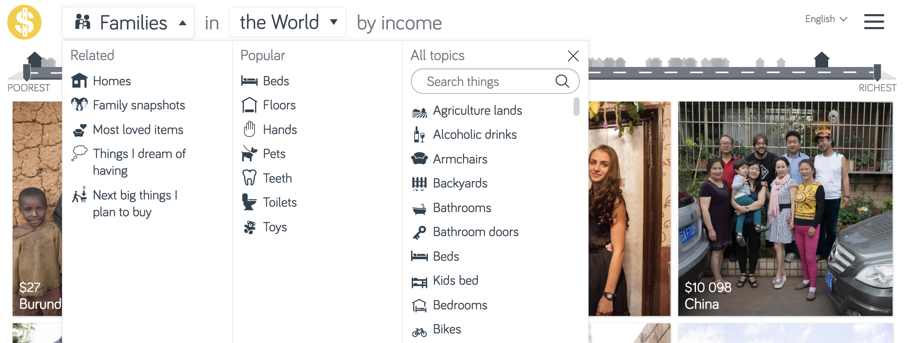
Figure 9. Dropdown interaction

The more exploratory opportunities for interaction occur once an initial choice is made and a user clicks on a specific photo. For instance, Figure 10 shows the interactions that are available if the user searches for Pets and then selects the cat associated with the $45 family from Myanmar.


Figure 10. Pets > $45 > Myanmar

The resulting page displays the name, two photos, and some details about the Raju family, to whom this cat belongs, the option to visit the home of this family, the option to see “All pets in Myanmar,” and a map that leads to a listing of all families in Myanmar. Choosing to “Visit this home” leads to a page with more information about the Raju family as well as photos of all of their items; choosing one photo from among these items (for instance, toys, in Figure 11 below) leads to a brief description of how toys differ across classes, along with more opportunities for comparisons: Toys in Myanmar, Toys in Asia, Toys in the World.


Figure 11. Toys, Raju family, Myanmar

Throughout this exploration of Dollar Street, almost all of the interactions exist to facilitate comparisons across families, classes, and regions. Indeed, as we saw earlier in the similar textual descriptions of families and photos of their possessions, the act of comparing is at the heart of Dollar Street. Families have pets and toys and toothbrushes, and though these items may vary by class and culture, the photos demonstrate that they are not as different—and people therefore are not as different—as we might suppose. This is a key message of Dollar Street, and the message is delivered in large part by its horizontal, wandering interactivity with interaction options that invite users to make comparisons.

The opportunity to participate and contribute to the project is a second kind of interactivity offered by Dollar Street and by an increasing number of information visualizations. On the About page, a paragraph invites participation (“To make Dollar Street even greater, we hope you want to help us!”) and provides a link to a Google form that suggests a variety of ways for people to contribute to the project—
for instance, by taking photos, writing text, translating text, and developing classroom materials. (There is a separate link to a Donate page, as well.) For people interested in photographing additional homes and families, there are links to a Google drive with necessary materials: a survey, a checklist, photographer guidelines, and an informed consent form for the families being photographed. Considerable planning has gone into this outreach, which reflects the desire of the authors to get people involved and build a community. The Google form inviting participation begins “To make Dollar Street truly outstanding, we rely on help from our community.” This outreach to users is entirely consistent with the purpose of Dollar Street. Creating a community involves making connections, making the world seem more like a neighborhood with similar inhabitants than a fractured world marked by cultural, geographic, and economic differences.

It is unclear how many people have acted on this call for participation, but in Dollar Street and other visualization projects, participation is a type of interactivity that can serve to enhance the engagement of everyday users. The opportunity to contribute to a project, to engage creatively, to become a collaborator and producer rather than simply a consumer, is appealing to people, many of whom were likely drawn to the infovis in the first place because of their interest in its content. An excellent example of a participatory visualization project is the Johnny Cash Project, by Aaron Koblin and Chris Milk (http://www.thejohnnycashproject.com/), an interactive music video in which viewers contribute drawings of frames to create a video for “Ain’t No Grave,” Cash’s final studio recording (see Figure 12).

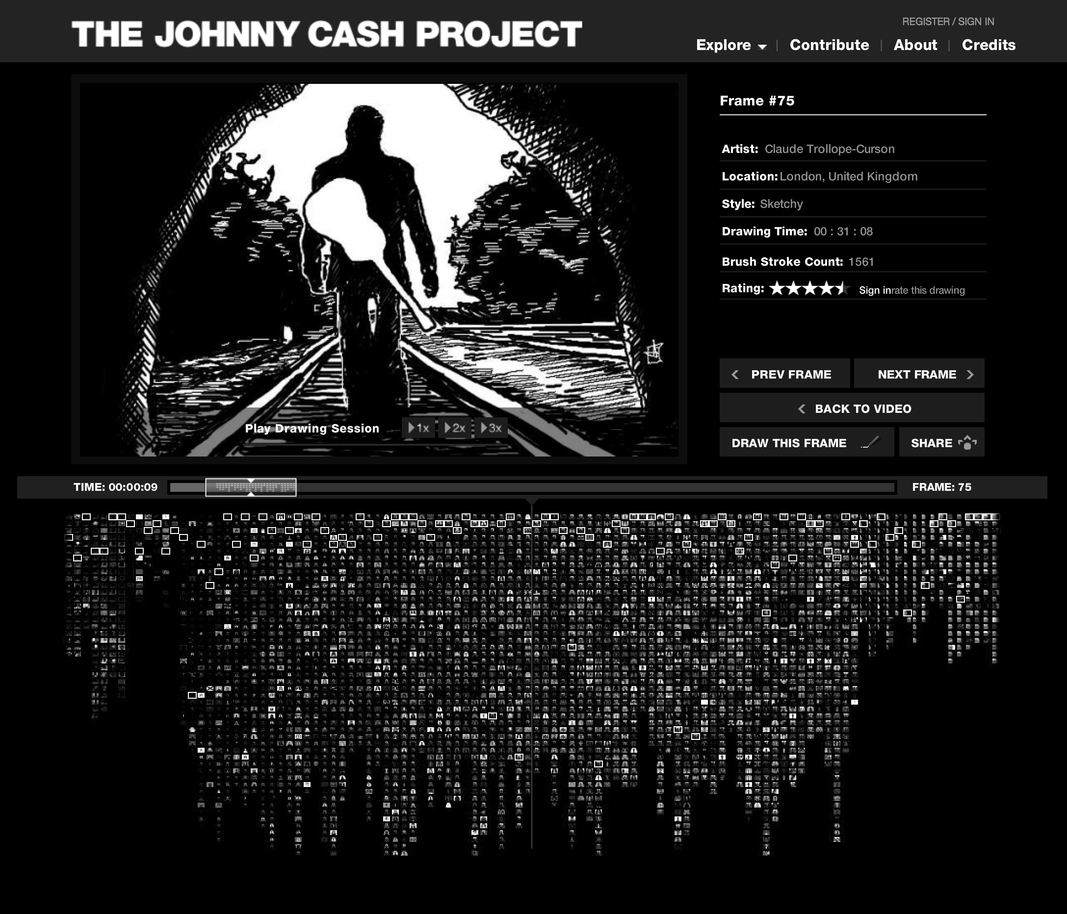
Figure 12. Frame #75 from the Johnny Cash Project

The interface has a custom drawing tool that makes it relatively easy for users to draw and upload a frame. Each “drawing session” is preserved and can be replayed by any visitor to the site; Figure 12 shows the option to replay a drawing session for frame 75 at various speeds. As of 2010, over 250,000 people from 172 countries had participated in making the video (Milk, 2010), and the frames they created now fill a database (partially shown at the bottom of Figure 12) from which different versions of the video can be constructed and played (e.g., Random Frames, Abstract Frames, Director Curated Frames, Highest Rated Frames). On the About page of the site, Koblin and Milk describe their project as a “moving, ever evolving homage to this beloved musical icon” and as a way for fans to represent their “vision of Johnny Cash, as he lives on in [their] mind’s eye.” The project thus draws in participants who share a common interest and facilitates their creative expression. The participatory model of interactivity presented in this project—and perhaps in a less realized way in Dollar Street—is central to its purpose, and also quite different from the honing in or wandering models of interactivity discussed earlier.

7.0 Conclusion
As we continue to accumulate data in the coming years, visualizations to help us understand that data will likely proliferate and address all manner of topics in innovative, engaging ways. It seems likely, in short, that information visualization will flourish as a medium of communication. In order to understand what and how infovis communicates, we can look to its constituent elements of text, image, data, and interaction, examining them as sites where infovis designers/developers/authors make choices that shape meanings for their viewers/users/readers. This approach provides a way for audiences to read closely, engage critically, and hone their textual, visual, and data literacies. With an ambitious project like Dollar Street as well as with the other visualization projects discussed above, this framework enables a deeper understanding and more substantial critical engagement with the ideas and strategies at work in the infovis.

Other approaches can productively address other important aspects of information visualization. For example, researchers can examine how everyday, non-expert users actually interact with and derive value from infovis projects. Unlike usability studies that focus on efficiency and that test users as they complete tasks related to the data being visualized, these tests might consider broader measures, such as engagement or personal fulfillment, and might work toward a different metric for determining what makes an infovis “effective”. In studying the reception and use of infovis, researchers can draw on genre theory as a means of categorizing types of infovis—e.g., artistic, journalistic, personal, social, collaborative—that use different strategies and target audiences with different needs and goals. Researchers can also attend to the social and cultural context in which infovis projects are created and received. As Kostelnick (2004) noted, “Information design also embodies the shared cultural knowledge—values, ideologies, and aesthetic tastes—of its designers and readers” (p. 239). Finally, the implications for pedagogy are important as infovis critique and creation move into the classroom (e.g., Sorapure, 2010; Stephens, 2018). Helping students develop a critical orientation as they both encounter and create visualizations of data is another means of building the rhetorical and technical literacies needed in contemporary information culture.

Works Cited

Becker, Richard A.; Cleveland, William S.; Wilks, Allan R. (1987). Dynamic graphics for data analysis. Statistical Science, 355-383.

Card, Stuart K.; Mackinlay, Jock D.; Shneiderman, Ben. (Eds.) (1999). Readings in information visualization: using vision to think. Morgan Kaufmann.

Chen, Chaomei (2005). Top 10 unsolved information visualization problems. IEEE computer graphics and applications, 25(4), 12-16.

Danziger, Michael J. (2008). Information visualization for the people (Doctoral dissertation, Massachusetts Institute of Technology, Department of Comparative Media Studies).

Dörk, Marian; Carpendale, Sheelagh; Williamson, Carey. (2011, May). The information flaneur: A fresh look at information seeking. In Proceedings of the SIGCHI conference on human factors in computing systems (pp. 1215-1224). ACM.

Dörk, Marian; Riche, Nathalie Henry; Ramos, Gonzalo; Dumais, Susan. (2012). Pivotpaths: Strolling through faceted information spaces. IEEE Transactions on Visualization and Computer Graphics, 18(12), 2709-2718.

Dörk, Marian; Comber, Rob; Dade-Robertson, Martyn. (2014, April). Monadic exploration: seeing the whole through its parts. In Proceedings of the 32nd annual ACM conference on Human factors in computing systems (pp. 1535-1544). ACM.

Drucker, Johanna. (2011). Humanities approaches to graphical display. Digital Humanities Quarterly, 5(1), 1-21.

Hullman, Jessica. Diakopoulos, Nick. (2011). Visualization rhetoric: Framing effects in narrative visualization. IEEE transactions on visualization and computer graphics, 17(12), 2231-2240.

Kosara, Robert; Hauser, Helwig; & Gresh, Donna L. (2003). An interaction view on information visualization. State-of-the-Art Report. Proceedings of EUROGRAPHICS, 123-137.

Kostelnick, Charles. (2004). Melting-pot ideology, modernist aesthetics, and the emergence of graphical conventions: The statistical atlases of the United States, 1874-1925. Defining visual rhetorics, 215-242.

Kostelnick, Charles. (2008). The visual rhetoric of data displays: The conundrum of clarity. IEEE Transactions on Professional Communication, 51(1), 116-130.

Kostelnick, Charles. (2016). The re-emergence of emotional appeals in interactive data visualization. Technical Communication, 63(2), 116-135.

Lau, Andrea; Vande Moere, Andrew. (2007, July). Towards a model of information aesthetics in information visualization. In Information Visualization, 2007. IV'07. 11th International Conference (pp. 87-92). IEEE.

Liu, Zhicheng; Stasko, John. (2010). Mental models, visual reasoning and interaction in information visualization: A top-down perspective. IEEE transactions on visualization and computer graphics, 16(6), 999-1008.

Manovich, Lev. (2001). The language of new media. MIT press.

Owens, Trevor. (2011). Defining data for humanists: Text, artifact, information or evidence. Journal of Digital Humanities, 1(1), 1-1.

Pousman, Zachary; Stasko, John; Mateas, Michael. (2007). Casual information visualization: Depictions of data in everyday life. IEEE transactions on visualization and computer graphics, 13(6), 1145-1152.

Rönnlund, Anna Rosling; Rosling, Ola. (2004, January). Free software for a world in motion. In Creating, Connecting and Collaborating through Computing, 2004. Proceedings. Second International Conference on (pp. 14-19). IEEE.

Rosling, Hans; Rönnlund, Anna Rosling; Rosling, Ola. (2005). New software brings statistics beyond the eye. Statistics, Knowledge and Policy: Key Indicators to Inform Decision Making. Paris, France: OECD Publishing, 522-530.

Sedig, Kamran; Parsons, Paul; Dittmer, Mark; Haworth, Robert. (2014). Human-centered interactivity of visualization tools: Micro-and macro-level considerations. In Handbook of Human Centric Visualization (pp. 717-743). Springer New York.

Shneiderman, Ben. (1996, September). The eyes have it: A task by data type taxonomy for information visualizations. In Visual Languages, 1996. Proceedings., IEEE Symposium on (pp. 336-343). IEEE.

Sorapure, Madeleine. (2010). Information visualization, web 2.0, and the teaching of writing. Computers and Composition, 27(1), 59-70.

Stephens, Sonia H. (2018). A narrative approach to interactive information visualization in the digital humanities classroom. Arts and Humanities in Higher Education, 1474022218759632.

Viegas, Fernanda B; & Wattenberg, Martin. (2006). Communication-minded visualization: A call to action. IBM Systems Journal, 45(4), 801.

Ware, Chris. (2012). Information visualization: perception for design. Elsevier.

Wolff, Annika; Gooch, Daniel; Cavero Montaner, Jose J.; Rashid, Umar; Kortuem, Gerd. (2017). Creating an understanding of data literacy for a data-driven society. Journal of Community Informatics, 12(3), In-press.

Yi, Ji Soo; ah Kang, Yun; Stasko, John. (2007). Toward a deeper understanding of the role of interaction in information visualization. IEEE transactions on visualization and computer graphics, 13(6), 1224-1231.

Website References
2020 Presidential election map. 270 To Win. https://www.270towin.com/ Accessed 28 March 2018.

Baby Name Wizard. http://www.babynamewizard.com/voyager Accessed 28 March 2018.

Bostock, Mike; Carter, Shan; Tse, Archie. (2014). Is it better to buy or rent? The New York Times. https://www.nytimes.com/interactive/2014/upshot/buy-rent-calculator.html Accessed 28 March 2018.

Dollar Street. https://www.gapminder.org/dollar-street/ Accessed 28 March 2018.

Harris, Jonathan; Kamvar, Sep. We Feel Fine. http://www.wefeelfine.org Accessed 28 March 2018.

King, Lindsay; Leonard, Peter. Robots Reading Vogue. http://dhlab.yale.edu/projects/vogue.html Accessed 28 March 2018.

LaPorte, Stephen; Hashemi, Mahmoud. Listen to Wikipedia. http://listen.hatnote.com Accessed 28 March 2018.

Laumeister, Maximillian. Listen to Bitcoin. http://www.bitlisten.com/ Accessed 28 March 2018.

Milk, Chris. (2010). Johnny Cash – Ain’t No Grave [Official HD] – The Johnny Cash Project. https://www.youtube.com/watch?v=WwNVlNt9iDk Accessed 28 March 2018.

While “data visualization” and “datavis” are appropriate terms to use here, I use the terms “information visualization” and “infovis” in order to reference research in the subfield of computer science that has focused on information visualization since the 1990s.

