DETAILED SOIL PIT DESCRIPTIONS

George K.D. Ametsitsi, Thomas Adjei-Gyapong, Vincent Logah, Jon Lloyd, & Elmar M. Veenendaal

Data set associated with
Ametsitsi et al. (2020) Fixed or mixed? Variation in tree functional types and vegetation structure in a forest-savanna ecotone in West Africa. Journal of Tropical Ecology.

Registration
a. Profile Number: KOGYAE F3 ( 28 TALL FOREST)
b. Soil name: Dobidi series
c. - WRB classification field: Eutric Arenosol
- WRB classification final: Eutric Sideralic Arenosol (Ochric)
- USDA classification: Ustic Quartzipsamment
d. Date of examination: 10th March 2015
e. Authors: TAG/ VL
f. Location: Kogyae Strict Nature Reserve; Sekyere Central District, Ghana
1̊ 9’ 27.721” W, 7 ̊ 18’13.769” N
g. - Kӧppen class Am, -Mean Annual Rainfall
- Number of dry months 4
- Temperature Regime Isohyperthermic
- Moisture Regime:Ustic
h. Physiographic position: Upper slope; slope form: convex; gradient: 1-2%
i. Land use: Nature Reserve
j. Vegetation of area: Forest- Savannah Transition
Vegetation site: Forest

Information on site
a. Parent material: Voltaian sandstone (fine-grained)
b. Drainage: moderately well but excessively drained in dry season.
c. Moisture condition in profile: slightly moist in surface (0-10 cm) dry in profile below 10 cm
d. Depth to groundwater table: Not encountered
e. Presence of surface stone/ rock outcrops: Nil
f. Evidence of erosion: Slight sheet
g. Human influence: Burning with few pottery artefacts at 60- 80 cm
Brief description
The soil developed from colluvial materials on upper slope of generally undulating landscape. Their characteristics suggest low clay content in the original sandstone from which the parent material was derived but could potentially be of aeolian origin.
The profile consists of 10 cm of dark yellowish brown loamy fine sand grading into a transitional horizon of about 15 cm below which is brown eluviated sands to about 60 cm depth. Between 60 and 115 cm from the soil surface the soil is brown loamy sand. Further down the soil is strong brown loamy sand to 195 cm depth typical of what used to be called "forest podzols"

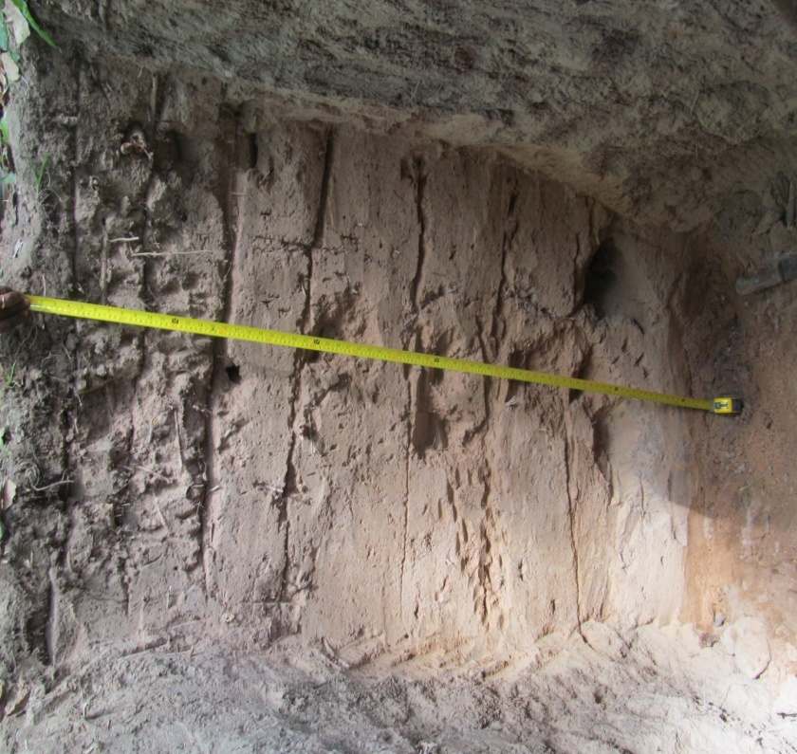

Horizon number | Horizon Symbol | Depth (cm) | Description
1 | A | 0- 10 | Dark yellowish brown (10YR 3/4), moist loamy fine sand; weak fine granular; soft, loose, non- sticky non- plastic; many fine interstitial pores; many very fine, few fine, medium and coarse roots; few millipedes and ants; clear smooth boundary
2 | AE | 10- 25 | Dark yellowish brown (10YR3/6), moist; fine sand; weak medium sub angular blocky; soft, loose, non- sticky non- plastic, many fine interstitial, few, medium channels; common very fine, few fine, medium and coarse roots; gradual smooth boundary
3 | E1 | 25- 40 | Brown (7.5YR 4/4), moist; sand; weak medium granular soft, loose, non- sticky non- plastic; many fine interstitial, few medium channels; common very fine; few fine and medium roots; gradual smooth boundary
4 | E2 | 40- 60 | Brown (7.5YR 5/4), moist; sand; weak medium granular; slightly hard, very friable, non-sticky non- plastic; many fine interstitial pores, few medium channels; few very fine, fine and medium roots; gradual smooth boundary
5 | B1 | 60- 90 | Brown (7.5YR 5/4), brown; sand; weak medium sub angular blocky; slightly hard, very friable non- sticky non- plastic, few faint clay bridging grains; many fine interstitial pores, few medium channels; few very fine and medium roots; few pottery artifact; gradual smooth boundary.
6 | B2 | 90- 115 | Strong brown (7.5YR 4/6), loamy sand; moderate coarse sub angular blocky; slightly hard, very friable, non- sticky non- plastic; very few faint clay + iron around grains; many fine interstitial pores; few fine, and medium roots; gradual smooth boundary
7 | B3 | 115- 140 | Strong brown (7.5YR 4/6), moist; loamy sand; moderate coarse sub angular blocky; slightly hard, very friable, non- sticky non- plastic; few clay + iron coatings around grains; many fine interstitial pores very fine, and medium roots diffuse smooth boundary
8 | Bt | 140- 170 | Strong brown (7.5YR 5/6), moist; loamy sand; moderate medium sub angular blocky; slightly hard, very friable, non- sticky non- plastic; few clay + iron coatings around grains and in pores; many fine interstitial pores few coarse roughs
Plate 1 Morphological properties of Dobidi series (Eutric Sideralic Arenosol (Ochric))

Table 1: Some physico-chemical properties of Dobidi series at Kogyae Strict Nature Reserve (Plot F3)
Hor. No. | Depth  (cm) | pH water | Total (% of soil) |  |  | Available Phosphorus (mg kg⁻¹ soil) | Exchangeable basic cations (cmol₍₊₎ kg⁻¹ soil) |  |  |  |  |  |  |  | BS¹  (%)
 |  |  |  |  |  |  | Basic cations |  |  |  |  | Acidity |  | ECEC | BS¹  (%)
Hor. No. | Depth  (cm) | 1:1 | C | O.M |  | Available Phosphorus (mg kg⁻¹ soil) | Ca²⁺ | Mg²⁺ | K⁺ | Na⁺ | TEB | Al³⁺ + H⁺ | Al³⁺ | ECEC | BS¹  (%)
1 | 0-10 | 5.98 | 0.40 | 0.69 |  | 6.48 | 0.66 | 0.88 | 0.00 | 0.25 | 1.80 | 0.50 | 0.17 | 2.30 | 91.50
2 | 10-25 | 6.54 | 0.24 | 0.41 |  | 1.96 | 1.56 | 1.86 | 0.02 | 0.13 | 3.57 | 0.17 | 0.00 | 3.73 | 100.00
3 | 25-40 | 6.67 | 0.28 | 0.48 |  | 1.24 | 1.26 | 1.10 | 0.02 | 0.18 | 2.57 | 0.17 | 0.00 | 2.73 | 100.00
4 | 40-60 | 6.17 | 0.38 | 0.65 |  | 1.24 | 1.10 | 1.06 | 0.01 | 0.20 | 2.38 | 0.17 | 0.00 | 2.54 | 100.00
5 | 60-90 | 6.75 | 1.00 | 1.72 |  | 1.96 | 0.86 | 1.36 | 0.01 | 0.12 | 2.34 | 0.17 | 0.00 | 2.51 | 100.00
6 | 90-115 | 6.39 | 0.18 | 0.31 |  | 1.24 | 1.16 | 1.30 | 0.01 | 0.13 | 2.60 | 0.33 | 0.00 | 2.94 | 100.00
7 | 115-140 | 6.41 | 0.26 | 0.45 |  | 5.70 | 1.48 | 1.02 | 0.01 | 0.14 | 2.65 | 0.15 | 0.00 | 2.80 | 100.00
8 | 140-170 | 5.57 | 0.24 | 0.41 |  | 1.24 | 1.24 | 1.16 | 0.01 | 0.15 | 2.56 | 0.33 | 0.00 | 2.90 | 100.00

Hor. No. | Depth  (cm) | Soil separates (%) |  |  | Textural class (Triangular scale) | Depth (cm) | Dry bulk density (Mg m⁻³) | Standard deviation
Hor. No. | Depth  (cm) | Sand | Silt | Clay
1 | 0-10 | 86.36 | 11.64 | 2.00 | Loamy sand | 0 - 20 | 1.43* | 0.01
2 | 10-25 | 93.36 | 5.64 | 1.00 | Sand | 20 - 40 | 1.57 | 0.02
3 | 25-40 | 93.36 | 5.64 | 1.00 | Sand | 40 - 60 | 1.70 | 0.02
4 | 40-60 | 92.36 | 6.64 | 1.00 | Sand | 60 - 80 | 1.71 | 0.02
5 | 60-90 | 88.32 | 8.68 | 3.00 | Loamy sand | 80 -100 | 1.76 | 0.03
6 | 90-115 | 86.36 | 9.64 | 4.00 | Loamy sand
7 | 115-140 | 87.36 | 7.64 | 5.00 | Loamy sand
8 | 140-170 | 86.32 | 7.68 | 6.00 | Loamy sand

*Bulk density values are means of triplicate samples (three replications)
Registration
a. Profile Number: KOGYAE F8 ( 32 FOREST)
b. Soil name: Dobidi series
c. - WRB classification field: Eutric Arenosol (Ochric)
- WRB classification final: Eutric Arenosol (Ochric)
- USDA classification:Ustic Quartzipsamment
d. Date of examination: 11th March 2015
e. Authors: TAG/ VL
f. Location: Kogyae Strict Nature Reserve, Sekyere Central District, Ghana

h. Physiographic position: Lower slope; slope form: straight; slope gradient: 1-2%
i. Land use: Nature Reserve
j. Vegetation of area: Forest- Savannah Transition
g. - Kӧppen class Am, -Mean Annual Rainfall:
- Number of dry months 4
- Temperature Regime: Isohyperthermic
- Moisture Regime:Ustic
Vegetation site: Forest

Information on site
a. Parent material: Voltaian sandstone (fine-grained)
b. Drainage: moderately well but excessively drained in dry season.
c. Moisture condition in profile: slightly moist in surface (0-10cm) dry in profile below 10cm
d. Depth to groundwater table: Not encountered
e. Presence of surface stone/ rock outcrops: Nil
f. Evidence of erosion: Slight sheet
g. Human influence: Burning with few pottery artefacts at 60- 80cm

Brief description
The soil developed from colluvial materials on lower slope of generally undulating landscape. The profile consists of about 20 cm of dark brown loamy fine sand over brown and light yellow brown fine sand to 170 cm depth. Below this depth, common iron and manganese nodules occur.

Horizon number | Horizon Symbol | Depth (cm) | Description
1 | A | 0- 10 | Dark brown (10YR 2.5/3), moist, Brown (10YR5/3), dry; loamy sand; moderate medium granular; soft, loose, non- sticky non- plastic; many fine interstitial pores; many very fine, common fine, few medium and coarse roots; clear smooth boundary
2 | AB | 10- 23 | Dark brown (7.5YR3/4), moist; loamy sand; weak fine and medium granular; soft, very friable, non-sticky, non- plastic, many fine interstitial pores, few medium, channels; common very fine, few fine and medium roots; clear smooth boundary
3 | Bw1 | 23- 43 | Brown (7.5YR 4/4), moist; sand; weak medium granular; soft, very friable, non- sticky non- plastic; many fine interstitial pores, few medium channels; common very fine; few fine and medium roots; clear smooth boundary
4 | Bw2 | 43- 60 | Brown (7.5YR 5/5), moist; fine sand; weak fine and medium granular; soft, very friable, non- sticky non- plastic; many fine interstitial pores, few medium channels and vughs; few very fine, fine, medium and coarse roots; gradual smooth boundary
5 | BC | 60- 80 | Light yellowish brown (10YR 6/3.5), moist; fine sand; weak fine and medium granular; slightly hard, very friable, non-sticky non-plastic; many fine interstitial pores, few medium channels and vughs; few very fine and medium roots; few pottery artifacts; gradual smooth boundary
6 | C1 | 80- 110 | Light yellowish brown (7.5YR 6/4), moist, few faint fine yellowish brown (10YR 5/6), moist, mottles; fine sand; weak fine and medium granular; slightly hard; very friable, non-sticky non- plastic; very few (1%) soft iron and manganese dioxide nodules; many fine interstitial pores, few very fine, fine, and medium roots; diffuse smooth boundary
7 | C2 | 110- 140 | Light yellowish brown (7.5YR 6/4), moist; fine sand; weak fine and medium subangular blocky; slightly hard, very friable, non-sticky non- plastic; very few (1%) soft iron and manganese dioxide nodules; many fine interstitial pores, few very fine, fine, and medium roots; diffuse smooth boundary
8 | C3 | 140- 170 | Light yellowish brown (7.5YR 6/4), moist; fine sand; weak fine and medium subangular blocky; slightly hard, very friable, non-sticky non- plastic; few (4%) soft iron and manganese nodules; many fine interstitial pores, few very fine, fine, and medium roots;
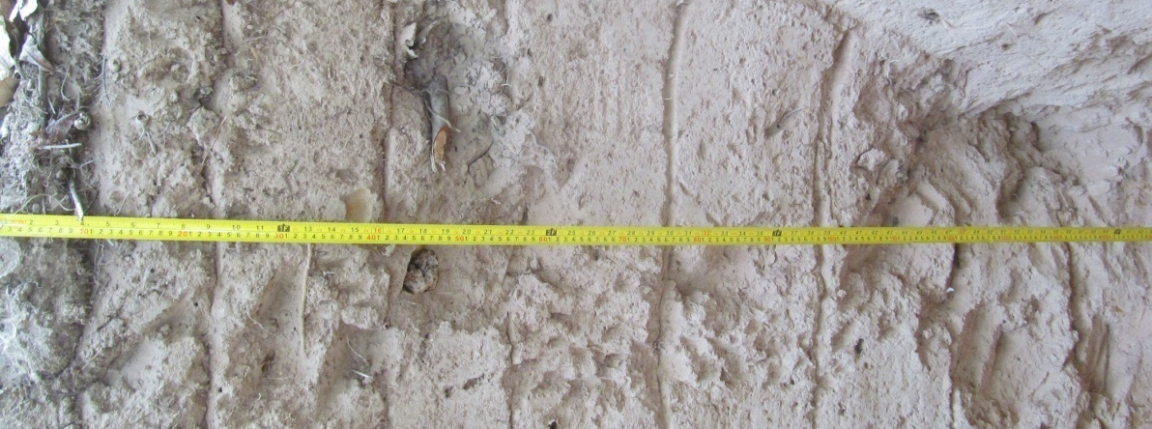
F8

Plate 2 Morphological properties of Dobidi series (Eutric Sideralic Arenosol (Ochric))

Table 2: Some physico-chemical properties of Dobidi series at Kogyae Strict Nature Reserve (Plot F8)
Hor. No. | Depth  (cm) | pH water | Total (% of soil) |  |  | Available Phosphorus (mg kg⁻¹ soil) | Exchangeable basic cations (cmol₍₊₎ kg⁻¹ soil) |  |  |  |  |  |  |  | BS  (%)
 |  |  |  |  |  |  | Basic cations |  |  |  |  | Acidity |  | ECEC | BS  (%)
Hor. No. | Depth  (cm) | 1:1 | C | O.M |  | Available Phosphorus (mg kg⁻¹ soil) | Ca²⁺ | Mg²⁺ | K⁺ | Na⁺ | TEB | Al³⁺ + H⁺ | Al³⁺ | ECEC | BS  (%)
1 | 0-10 | 5.33 | 0.70 | 1.20 |  | 1.24 | 1.12 | 0.96 | 0.02 | 0.18 | 2.28 | 0.33 | 0.17 | 2.61 | 93.18
2 | 10-23 | 5.21 | 1.04 | 1.79 |  | 2.70 | 0.86 | 0.90 | 0.01 | 0.11 | 1.88 | 0.84 | 0.33 | 2.72 | 84.94
3 | 23-43 | 5.48 | 0.30 | 0.52 |  | 1.24 | 0.76 | 0.64 | 0.02 | 0.15 | 1.56 | 0.67 | 0.17 | 2.23 | 90.35
4 | 43-60 | 5.19 | 0.88 | 1.51 |  | 7.26 | 0.50 | 0.84 | 0.00 | 0.12 | 1.46 | 0.33 | 0.00 | 1.80 | 100.00
5 | 60-80 | 5.37 | 0.96 | 1.65 |  | 2.70 | 0.58 | 0.86 | 0.00 | 0.09 | 1.54 | 0.84 | 0.17 | 2.37 | 90.21
6 | 80-110 | 5.44 | 0.88 | 1.51 |  | 2.70 | 0.52 | 1.00 | 0.00 | 0.01 | 1.54 | 0.33 | 0.00 | 1.87 | 100.00
7 | 110-140 | 6.23 | 0.76 | 1.31 |  | 1.24 | 0.78 | 0.90 | 0.00 | 0.07 | 1.75 | 0.00 | 0.00 | 1.75 | 100.00
8 | 140-170 | 6.40 | 0.92 | 1.58 |  | 2.70 | 3.02 | 1.60 | 0.03 | 0.16 | 4.81 | 0.33 | 0.00 | 5.15 | 100.00

Hor. No. | Depth  (cm) | Soil separates (%) |  |  | Textural class (Triangular scale) | Depth (cm) | Dry bulk density (Mg m⁻³) | Standard deviation
Hor. No. | Depth  (cm) | Sand | Silt | Clay
1 | 0 - 14 | 92.36 | 6.64 | 1.00 | Sand | 0-20 | 1.45* | 0.05
2 | 14 - 26 | 87.32 | 9.68 | 3.00 | Loamy sand | 20-40 | 1.56 | 0.02
3 | 26 - 40 | 88.36 | 9.64 | 2.00 | Sand | 40-60 | 1.68 | 0.03
4 | 40 - 60 | 87.32 | 9.68 | 3.00 | Loamy sand | 60-80 | 1.73 | 0.03
5 | 60 - 90 | 84.32 | 11.68 | 4.00 | Loamy sand | 80-100 | 1.80 | 0.06
6 | 90 - 115 | 84.32 | 12.68 | 3.00 | Loamy sand
7 | 115 -136 | 86.32 | 12.68 | 1.00 | Loamy sand
8 | 136 -160 | 89.32 | 9.68 | 1.00 | Sand
* Bulk density values are means of triplicate samples (three replications)

Registration
a. Profile Number: KOGYAE (T2 2 FOREST)
b. Soil name: Amantin series (Deep Phase)
c. - WRB classification field: Abruptic Lixisol (Loamic, Profondic)
- WRB classification final: Abruptic Lixisol (Loamic, Cutanic, Hypereutric, Ochric Profondic)
- USDA classification: Arenic Haplustalf
d. Date of examination: 11th March, 2015
e. Authors: TAG/ VL
f. Location: Kogyae Strict Nature Reserve; Sekyere Central District
1̊ 9’29.05” W, 7 ̊ 19’38.403” N
h. Physiographic position: middle slope, slope form: straight; slope gradient: 3%
i. Land use: Nature Reserve
j. Vegetation of area: Forest- Savannah Transition
g. - Kӧppen class Am, -Mean Annual Rainfall:
  - - Number of dry months 4
- Temperature Regime Isohyperthermic
- Moisture Regime:Ustic
Vegetation site: Forest

Information on site
a. Parent material: Voltaian sandstone (fine-grained)
b. Drainage: moderately well but excessively drained in dry season.
c. Moisture condition in profile: slightly moist in surface (0-10 cm) dry in profile below 10cm
d. Depth to groundwater table: Not encountered
e. Presence of surface stone/ rock outcrops: Nil
f. Evidence of erosion: Slight sheet
g. Human influence: Burning with few pottery artefacts at 20 - 50 cm

Brief description
The soil occurred on middle slope and developed in colluvium derived from sandstone. The profile consists of about 35cm greyish brown loamy sand over 10cm of a similar but brown transitional horizon (AB) directly below which is about 35 cm thick eluviated brown loamy sand horizon. Abruptly below the eluvial horizon (i.e. 80 cm from the soil surface), the soil is strong brown sandy clay loam to about 140 cm. The soil becomes plinthic further down the profile.

Horizon number | Horizon Symbol | Depth (cm) | Description
1 | A1 | 0- 16 | Dark brown (10YR 3/3), moist, greyish brown (10YR5/2.5), dry; loamy sand; moderate fine and medium granular; soft, very friable, non- sticky non- plastic; many fine interstitial pores few medium channels; common very fine, few fine, medium and coarse roots; clear smooth boundary
2 | A2 | 16- 34 | Dark brown (10YR3.5/4), moist; loamy sand; weak fine and medium granular; soft, very friable, non-sticky non- plastic; many fine interstitial, few, medium, channels; few very fine, fine and medium roots; few pieces of pottery; clear smooth boundary
3 | AB | 34- 46 | Brown (7.5YR 4/3), moist; loamy sand; weak medium granular; slightly hard, very friable, non- sticky non- plastic; many fine interstitial, few medium channels and planar voids; very few very fine, medium and coarse roots; few pieces of pottery; clear smooth boundary
4 | E | 46- 80 | Brown (7.5YR 5/4), moist; loamy fine sand; weak fine and medium granular; slightly hard, very friable, non- sticky non- plastic; few faint clay bridging grains; many fine interstitial, few medium channels and planar voids, very few, medium and coarse roots; few pieces of pottery; clear smooth boundary
5 | Bt1 | 80- 110 | Strong brown (7.5YR 5/6), moist; sandy clay loam; moderate medium subangular blocky; hard, firm sticky plastic; common clay coatings along pores and on pedfaces; many fine interstitial pores, few medium channels, planar voids; very few, medium and coarse roots; gradual smooth boundary
6 | Bt2 | 110-140 | Strong brown (7.5YR 5/8), moist; sandy clay loam; moderate medium subangular blocky; hard, firm sticky plastic; common clay coatings along pores and on pedfaces; many fine interstitial pores, few medium channels, planar voids few vughs; very few, fine and medium roots; gradual smooth boundary
7 | Btv1 | 140-165 | Strong brown (7.5YR 5/8), moist; few faint strong brown (7.5YR6/6), moist, mottles; sandy clay loam; moderate medium subangular blocky; hard, firm sticky plastic; common clay coatings along pores; many fine interstitial pores, few medium channels, planar voids and few vughs; very few, medium and coarse roots; few pieces of pottery; gradual smooth boundary
8 | Btv2 | 165-193 | Strong brown (7.5YR 5/8), moist; common faint strong brown (7.5YR6/6), moist, mottles; sandy clay loam; moderate medium subangular blocky; hard, firm sticky plastic; many fine interstitial pores, few medium channels, planar voids and few vughs; very few, medium and coarse roots; few pieces of pottery; gradual smooth boundary

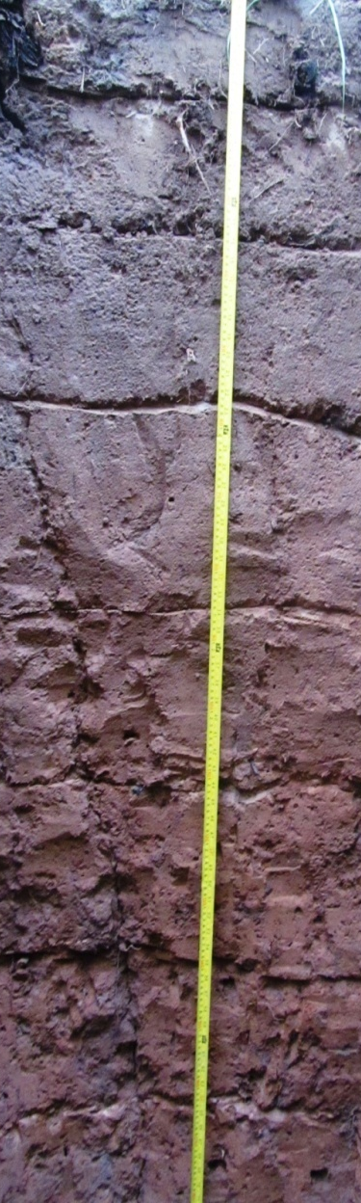
Plate 3 Morphological properties of Amantin series (Abruptic Lixisol (Loamic, Profondic))
Table 3: Some physico-chemical properties of Amantin series (Deep phase) at Kogyae Strict Nature Reserve (Plot T2)
Hor. No. | Depth  (cm) | pH water | Total (% of soil) |  |  |  | Available Phosphorus (mg kg⁻¹ soil) |  | Exchangeable basic cations (cmol₍₊₎ kg⁻¹ soil) |  |  |  |  |  |  |  |  |  |  | BS  (%)
 |  |  |  |  |  |  |  |  | Basic cations |  |  |  |  |  | Acidity |  |  | ECEC
Hor. No. | Depth  (cm) | 1:1 | C | O.M |  |  |  | Ca²⁺ |  | Mg²⁺ | K⁺ | Na⁺ | TEB | Al³⁺ + H⁺ |  | Al³⁺
1 | 0 -16 | 6.51 | 0.28 | 0.48 |  | 8.05 |  | 1.78 |  | 1.42 | 0.04 | 0.30 | 3.54 | 0.17 |  | 0.00 | 3.71 |  | 100.00
2 | 16- 34 | 5.16 | 0.44 | 0.76 |  | 4.94 |  | 0.80 |  | 1.12 | 0.02 | 0.09 | 2.03 | 0.50 |  | 0.00 | 2.53 |  | 100.00
3 | 34 – 46 | 5.35 | 0.36 | 0.62 |  | 14.69 |  | 0.68 |  | 1.02 | 0.01 | 0.13 | 1.84 | 0.84 |  | 0.50 | 2.68 |  | 78.60
4 | 46- 80 | 5.49 | 0.52 | 0.89 |  | 8.05 |  | 0.86 |  | 0.86 | 0.01 | 0.15 | 1.88 | 0.84 |  | 0.17 | 2.72 |  | 91.86
5 | 80 -110 | 5.43 | 0.42 | 0.72 |  | 2.70 |  | 1.50 |  | 0.88 | 0.01 | 0.20 | 2.60 | 1.00 |  | 0.33 | 3.60 |  | 88.60
6 | 110 -140 | 5.32 | 0.28 | 0.48 |  | 3.44 |  | 2.06 |  | 1.04 | 0.02 | 0.21 | 3.33 | 1.67 |  | 0.67 | 5.00 |  | 83.30
7 | 140-165 | 5.21 | 0.26 | 0.45 |  | 0.52 |  | 2.62 |  | 1.24 | 0.02 | 0.26 | 4.14 | 0.84 |  | 0.50 | 4.97 |  | 89.19
8 | 165-193 | 5.18 | 0.26 | 0.45 |  | 4.94 |  | 2.84 |  | 1.44 | 0.02 | 0.24 | 4.54 | 0.50 |  | 0.17 | 5.04 |  | 96.45
9 | 193-220 | 5.34 | 0.26 | 0.45 |  | 1.24 |  | 0.90 |  | 3.26 | 0.04 | 0.30 | 4.50 | 0.33 |  | 0.17 | 4.83 |  | 96.42
10 | 220-250 | 5.61 | 0.54 | 0.93 |  | 2.70 |  | 2.60 |  | 1.40 | 0.01 | 0.19 | 4.20 | 0.33 |  | 0.00 | 4.54 |  | 100.00

Hor. No. | Depth  (cm) | Soil separates (%) |  |  | Textural class (Triangular scale) | Depth (cm) | Dry bulk density (Mg m⁻³) | Standard deviation
Hor. No. | Depth  (cm) | Sand | Silt | Clay
1 | 0 -16 | 89.36 | 9.64 | 1.00 | Sand | 0-20 | 1.49* | 0.02
2 | 16- 34 | 90.32 | 7.68 | 2.00 | Sand | 20-40 | 1.57 | 0.09
3 | 34 - 46 | 90.24 | 6.76 | 3.00 | Sand | 40-60 | 1.65 | 0.00
4 | 46- 80 | 85.56 | 11.32 | 3.12 | Loamy sand | 60-80 | 1.72 | 0.02
5 | 80 -110 | 78.36 | 1.00 | 20.64 | Sandy clay Loam | 80-100 | 1.78 | 0.03
6 | 110 -140 | 72.24 | 6.76 | 21.00 | Sandy clay loam
7 | 140-165 | 71.36 | 7.64 | 21.00 | Sandy clay loam
8 | 165-193 | 66.24 | 9.76 | 24.00 | Sand clay loam
9 | 193-220 | 64.56 | 14.32 | 21.12 | Sandy clay loam
10 | 220-250 | 60.32 | 16.68 | 23.00 | Sandy clay loam
*Bulk density values aremeans of triplicate samples (three replications)

Registration
a. Profile Number: KOGYAE T19 ( 19 WOODLAND)
b. Soil name: Amantin series (Shallow Phase)
c. - WRB classification field: Chromic Petroplinthic Abruptic Lixisol (Loamic)
- WRB classification Final: Chromic Petroplinthic Lixisol (Loamic, Cutanic, Hypereutric, Ochric))
- USDA classification field: Typic Plinthustalf
d. Date of examination: 12th March 2015 (15/03/12)
e. Authors: TAG/ VL
f. Location: Kogyae Strict Nature Reserve; Sekyere Central District

g. - Kӧppen class Am, -Mean Annual Rainfall:
- Number of dry months 4
- Temperature Regime: Isohyperthermic
- Moisture Regime: Ustic
h. Physiographic position: Upper slope; slope form: convex; slope gradient: 1-2%
i. Land use: Nature Reserve
j. Vegetation of area: Forest- Savannah Transition
Vegetation site: Forest- Savannah Transition

Information on site
a. Parent material: Voltaian sandstone (fine-grained)
b. Drainage: moderately well but excessively drained in dry season.
c. Moisture condition in profile: slightly moist in surface (0-10 cm) dry in profile below 10cm
d. Depth to groundwater table: Not encountered
e. Presence of surface stone/ rock outcrops: Nil
f. Evidence of erosion: Slight sheet
g. Human influence: Burning

Brief Description
The soil developed in colluvium derived from sandstone on middle slope. The profile consists of about 20cmof dark brown loamy fine sand over 30 cm thick strong brown sandy loam. Between 50 and 90cm from the soil surface, the soil is reddish brown sandy clay loam and directly overlie sheet ironpan (petroplinthite).

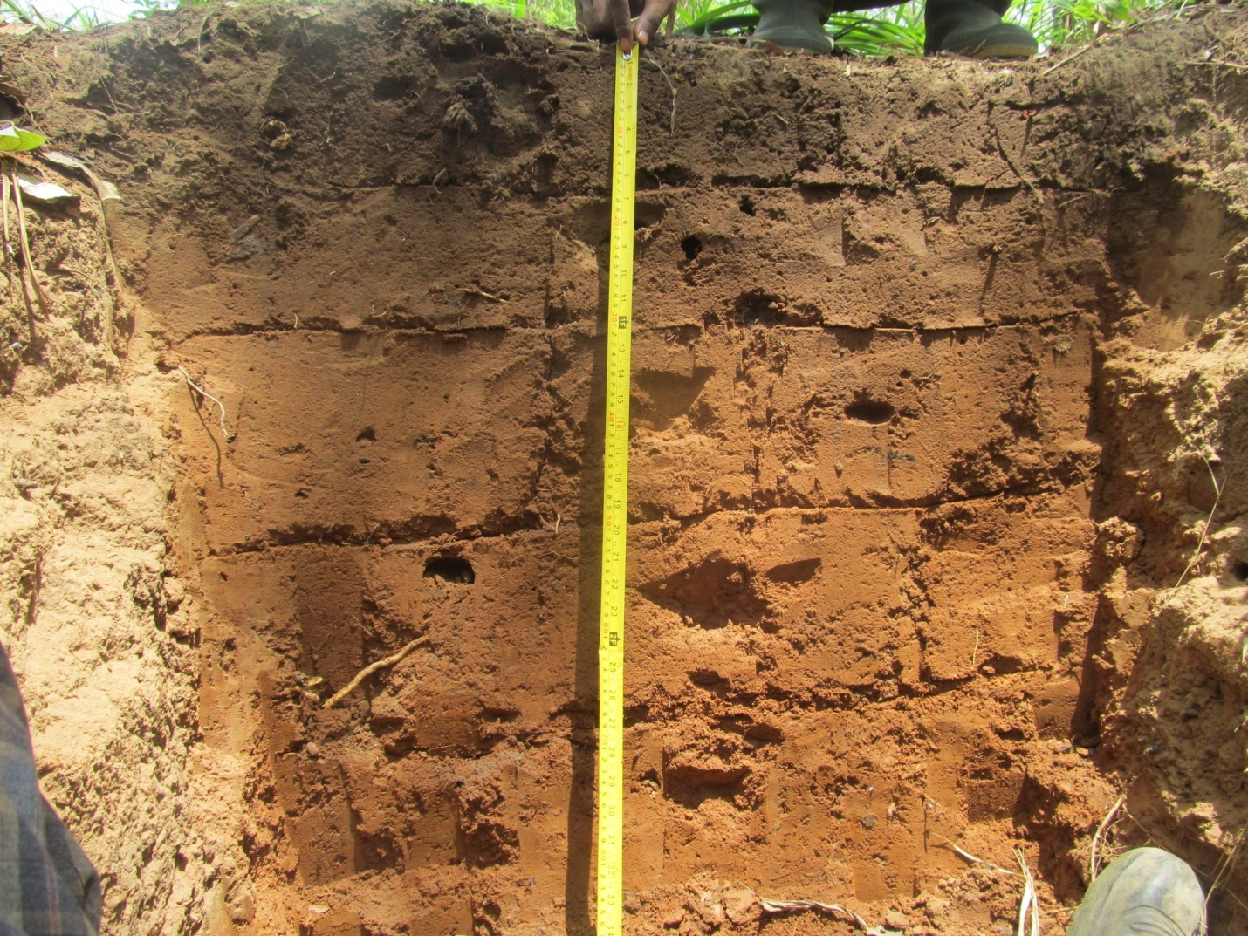
Horizon number | Horizon Symbol | Depth (cm) | Description
1 | A | 0- 17 | Dark brown (10YR 3/3), moist, brown (10YR 4/3), dry; loamy fine sand; moderate fine medium granular; soft, very friable non-sticky, non-plastic; many fine interstitial pores; common very fine, few fine, medium and coarse roots; gradual smooth boundary.
2 | AB | 17- 30 | Brown (7.5YR 4/4), moist brown (7.5 YR 4/4), dry; sandy loam; weak fine and medium granular slightly hard, friable, slightly sticky non-plastic; many fine interstitial pores, few vughs; few fine, medium and coarse roots; clear smooth boundary
3 | Bt1 | 30- 50 | Strong brown (7.5YR 4/6), moist; sandy loam; moderate medium subangular blocky; hard, friable, slightly sticky slightly plastic; few faint clay plus iron coating along pores; many fine interstitial, few planar voids and vughs; few fine medium and coarse roots; gradual smooth boundary  .
4 | Bt2 | 50- 70 | Reddish brown (5YR 4/4), moist; sandy clay loam; moderate medium subangular blocky; hard, friable, sticky, plastic; common distinct clay plus iron coatings in pores; many fine interstitial pores, few planar voids and vughs, few fine medium and coarse roots; diffuse smooth boundary  .
5 | Bt3 | 70- 90 | Strong brown (5YR 4/4), moist; sandy clay loam; moderate medium subangular blocky; hard, friable, sticky plastic; common distinct clay plus iron coatings in pores; many fine interstitial pores, few planar voids and vughs; few fine, medium and coarse roots; abrupt smooth boundary.
6 | Btcsm | 90⁺ | Indurated layer

Plate 4 Morphological properties of Amantin series(Chromic Petroplinthic Abruptic Lixisol (Loamic))

Table 4: Some physico-chemical properties of Amantin series (Shallow phase) Kogyae Strict Nature Reserve (Plot T19)
Hor. No. | Depth  (cm) | pH water | Total (% of soil) |  |  | Available Phosphorus (mg kg⁻¹ soil) | Exchangeable basic cations (cmol₍₊₎ kg⁻¹ soil) |  |  |  |  |  |  |  | BS  (%)
 |  |  |  |  |  |  | Basic cations |  |  |  |  | Acidity |  | ECEC | BS  (%)
Hor. No. | Depth  (cm) | 1:1 | C | O.M |  | Available Phosphorus (mg kg⁻¹ soil) | Ca²⁺ | Mg²⁺ | K⁺ | Na⁺ | TEB | Al³⁺ + H⁺ | Al³⁺ | ECEC | BS  (%)
1 | 0-17 | 5.60 | 0.64 | 1.10 |  | 2.70 | 2.58 | 1.82 | 0.13 | 0.15 | 4.68 | 0.33 | 0.00 | 5.01 | 100.00
2 | 17-30 | 6.09 | 0.44 | 0.76 |  | 3.44 | 1.54 | 1.70 | 0.02 | 0.13 | 3.39 | 0.33 | 0.00 | 3.72 | 100.00
3 | 30-50 | 5.24 | 0.26 | 0.45 |  | 3.44 | 1.12 | 1.36 | 0.02 | 0.12 | 2.62 | 0.84 | 0.33 | 3.46 | 88.70
4 | 50-70 | 5.09 | 0.28 | 0.48 |  | 3.44 | 1.42 | 1.42 | 0.02 | 0.19 | 3.05 | 1.34 | 0.67 | 4.38 | 82.03
5 | 80-90 | 4.97 | 0.40 | 0.69 |  | 1.24 | 2.08 | 1.36 | 0.04 | 0.30 | 3.78 | 1.67 | 0.84 | 5.45 | 81.89

Hor. No. | Depth  (cm) | Soil separates (%) |  |  | Textural class (Triangular scale) | Depth (cm) | Dry bulk density (Mg m⁻³) | Standard deviation
Hor. No. | Depth  (cm) | Sand | Silt | Clay
1 | 0-17 | 84.56 | 10.32 | 5.12 | Loamy sand | 0-20 | 1.42* | 0.11
2 | 17-30 | 83.32 | 9.68 | 7.00 | Loamy sand | 20-40 | 1.51 | 0.04
3 | 30-50 | 79.32 | 7.68 | 13.00 | Sandy loam | 40-60 | 1.50 | 0.06
4 | 50-70 | 76.30 | 3.70 | 20.00 | Sandy clay loam | 60-80 | 1.67 | 0.00
5 | 80-90 | 58.32 | 10.68 | 31.00 | Sandy clay loam
*Bulk density values are means of triplicate samples (three replications)

Registration
a. Profile Number: KOGYAE S12 (12 WOODLAND)
b. Soil name: Amantin series (Deep phase)
c. - WRB classification field: Chromic Lixisol (Loamic, Profondic)
- WRB classification final: Chromic Abruptic Lixisol (Loamic, Cutanic, Hypereutric, Ochric, Profondic)
- USDA classification: Arenic Haplustalf
d. Date of examination: 11th March 2015
e. Authors: TAG/ VL
f. Location:Kogyae Strict Nature Reserve; Sekyere Central District, Ghana
1̊ 9’30.478” W, 7 ̊ 19’22.822” N
h. Physiographic position: middle slope, slope form= straight; slope gradient 3%
i. Land use: Nature Reserve
j. Vegetation of area: Forest- Savannah Transition
g. Kӧppen class Am, -Mean Annual Rainfall
- Number of dry months 4
- Temperature Regime:Isohyperthermic
- Moisture Regime:Ustic
h. Vegetation site: Forest

Information on site
a. Parent material: Voltaian sandstone (fine-grained)
b. Drainage: moderately well but excessively drained in dry season.
c. Moisture condition in profile: slightly moist in surface (0-10 cm) dry in profile below 10 cm
d. Depth to groundwater table: Not encountered
e. Presence of surface stone/ rock outcrops: Nil
f. Evidence of erosion: Slight sheet
g. Human influence: Burning with few pottery artefacts at 40 - 65cm

Brief description
The soil developed from colluvial materials derived from sandstone on middle slope. The profile consists of about 25 cm of dark greyish brown loamy sand over brown loamy sand transitional horizon (AE) that grades into about 20cm of strong brown loamy sand. Below 65 cm from the soils surface the soil is strong brown sandy loam becoming yellowish red sandy clay loam with depth.

Horizon number | Horizon Symbol | Depth (cm) | Description
1 | A1 | 0- 9 | Very dark greyish brown (10YR 3/2), moist, dark greyish brown (10YR4/2), dry; loamy sand; moderate medium granular; soft, very friable, non- sticky non- plastic; many fine interstitial pores; common very fine, few medium roots; clear smooth boundary
2 | A2 | 9- 25 | Dark brown (10YR 3/3), moist, brown (10YR 4/3), dry; loamy sand; moderate medium granular; soft, very friable, non-sticky non- plastic; many fine interstitial pores, few medium, channels and vughs; few very fine and fine roots; clear smooth boundary
3 | AE | 25- 43 | Brown (7.5YR 4/4), moist; loamy sand; moderate medium subangular blocky; slightly hard, very friable, non- sticky non- plastic; many fine interstitial pores, few medium, channels and vughs; few fine and coarse roots; clear smooth boundary
4 | E1 | 43- 65 | Strong brown (7.5YR 4/6), moist; loamy sand; weak medium subangular blocky; slightly hard, very friable, non- sticky non- plastic many fine interstitial, few medium, channels and vughs; few fine roots; few pottery artifacts; clear smooth boundary
5 | E2 | 65- 92 | Strong brown (7.5YR 4.5/6), moist; sandy loam; moderate medium subangular blocky; hard, firm; sticky plastic; few (3%) hard iron concretions; many fine interstitial pores, few planar voids and vughs; few fine roots; gradual smooth boundary
6 | Bt1 | 92- 120 | Yellowish red (5YR 4/6), moist; sandy clay loam; moderate medium subangular blocky; hard, firm, sticky plastic; common distinct clay plus iron coatings in pores and on pedfaces; many fine interstitial pores, few planar voids and vughs; few fine roots; diffuse smooth boundary
7 | Bt2 | 120- 145 | Yellowish red (5YR 4/6), moist; sandy clay loam; moderate medium subangular blocky; hard, firm, sticky plastic; common distinct clay plus iron coatings in pores and on pedfaces; many fine interstitial pores, few planar voids and vughs; few fine roots; diffuse smooth boundary
8 | Bt3 | 145- 167 | Yellowish red (5YR 4/6), moist, few faint yellowish brown (10YR 5/6), moist, mottles; sandy clay loam; moderate medium subangular blocky; hard, firm, sticky plastic; common distinct clay plus iron coatings in pores and on pedfaces; many fine interstitial pores, few planar voids and vughs; few fine roots; clear smooth boundary
9 | Bt4 | 167-190 | Yellowish red (5YR 4/6), moist, many faint yellowish brown (10YR 5/6) mottles; sandy clay loam; moderate medium subangular blocky; hard, firm, sticky plastic; common distinct clay plus iron coatings in pores and on pedfaces; many fine interstitial pores, few planar voids and vughs few fine roots;

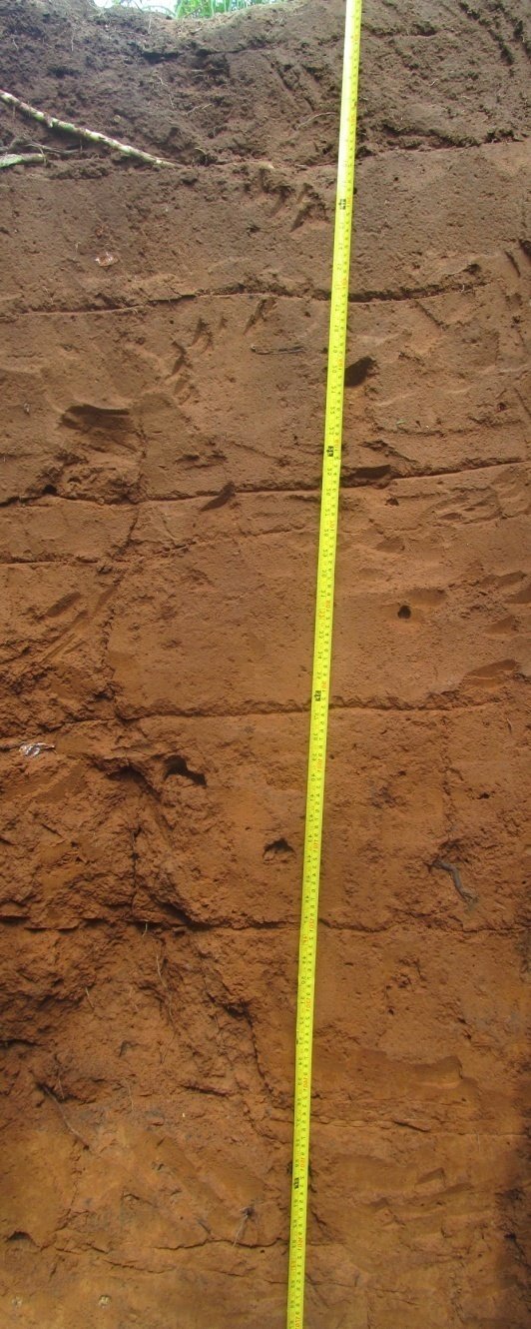
Plate 5 Morphological properties of Amantin series (Chromic Lixisol (Loamic, Profondic))

Table 5: Some physico-chemical properties of Amantin series (Deep phase) at Kogyae Strict Nature Reserve (Plot S12)
Hor. No. | Depth  (cm) | pH water | Total (% of soil) |  |  | Available Phosphorus (mg kg⁻¹ soil) | Exchangeable basic cations (cmol₍₊₎ kg⁻¹ soil) |  |  |  |  |  |  |  | BS  (%)
 |  |  |  |  |  |  | Basic cations |  |  |  |  | Acidity |  | ECEC | BS  (%)
Hor. No. | Depth  (cm) | 1:1 | C | O.M |  | Available Phosphorus (mg kg⁻¹ soil) | Ca²⁺ | Mg²⁺ | K⁺ | Na⁺ | TEB | Al³⁺ + H⁺ | Al³⁺ | ECEC | BS  (%)
1 | 0-9 | 5.46 | 0.62 | 1.07 |  | 3.44 | 2.78 | 1.36 | 0.04 | 0.24 | 4.41 | 0.33 | 0.00 | 4.75 | 100.00
2 | 9.0-25 | 5.65 | 0.50 | 0.86 |  | 1.96 | 1.96 | 1.40 | 0.03 | 0.21 | 3.59 | 0.17 | 0.00 | 3.76 | 100.00
3 | 25-43 | 6.01 | 0.50 | 0.86 |  | 9.65 | 1.36 | 1.10 | 0.01 | 0.15 | 2.62 | 0.50 | 0.00 | 3.12 | 100.00
4 | 43-65 | 5.99 | 0.52 | 0.89 |  | 9.65 | 1.08 | 1.46 | 0.02 | 0.20 | 2.77 | 0.33 | 0.00 | 3.10 | 100.00
5 | 65-92 | 5.94 | 0.36 | 0.62 |  | 0.52 | 2.28 | 0.70 | 0.02 | 0.14 | 3.14 | 0.50 | 0.00 | 3.64 | 100.00
6 | 92-120 | 6.44 | 0.56 | 0.96 |  | 1.96 | 2.32 | 1.72 | 0.03 | 0.25 | 4.32 | 0.50 | 0.17 | 4.82 | 96.28
7 | 120-145 | 5.79 | 0.66 | 1.13 |  | 1.96 | 2.76 | 1.66 | 0.03 | 0.25 | 4.70 | 0.50 | 0.00 | 5.20 | 100.00
8 | 145-167 | 6.75 | 0.46 | 0.79 |  | 44.53 | 3.18 | 1.32 | 0.03 | 0.30 | 4.82 | 0.33 | 0.00 | 5.16 | 100.00
9 | 167-190 | 5.60 | 0.28 | 0.48 |  | 1.24 | 2.72 | 1.44 | 0.02 | 0.19 | 4.37 | 0.50 | 0.00 | 4.87 | 100.00

Hor. No. | Depth  (cm) | Soil separates (%) |  |  | Textural class (Triangular scale) | Depth (cm) | Dry bulk density (Mg m⁻³) | Standard deviation
Hor. No. | Depth  (cm) | Sand | Silt | Clay
1 | 0-9 | 84.36 | 12.64 | 3.00 | Loamy sand | 0-20 | 1.43* | 0.06
2 | 9.0-25 | 90.24 | 6.76 | 3.00 | Sand | 20-40 | 1.64 | 0.03
3 | 25-43 | 86.36 | 9.64 | 4.00 | Loamy sand | 40-60 | 1.67 | 0.11
4 | 43-65 | 81.36 | 12.64 | 6.00 | Loamy sand | 60-80 | 1.71 | 0.03
5 | 65-92 | 74.36 | 3.00 | 22.64 | Sandy clay loam | 80-100 | 1.67 | 0.03
6 | 92-120 | 63.36 | 10.64 | 26.00 | Sandy clay loam
7 | 120-145 | 62.36 | 8.64 | 29.00 | Sandy clay loam
8 | 145-167 | 61.36 | 9.64 | 29.00 | Sandy clay loam
9 | 167-190 | 68.24 | 9.76 | 22.00 | sandy clay loam
* Bulk density values are means of triplicate samples (three replications)

Registraton
a. Profile Number: KOGYAE S14 (14 WOODLAND)
b. Soil name: Techiman series
c.-WRB classification field: Chromic Pisoplinthic Abruptic Lixisol (Loamic, Ochric)
- WRB classification final:Chromic Pisoplinthic Abruptic Lixisol (Loamic, Hyperuetric, Ochric)

- USDA Soil Taxonomy: Typic Plintiustalf
d. Date of examination: 12th March 2015
e. Authors: TAG/ VL
f. Location:Kogyae Strict Nature Reserve; Sekyere Central District

g. -Kӧppen class Am, -Mean Annual Rainfall
- Number of dry months 4
- Temperature Regime: Isohyperthermic
- Moisture Regime: Ustic
h. Physiographic position: Upper slope; slope form: convex; slope gradient 1-2%
i. Land use: Nature Reserve
j. Vegetation of area: Forest-Savannah Transition
Vegetation site: Savanna

Information on site
a. Parent material: Voltaian sandstone (fine-grained)
b. Drainage: well.
c. Moisture condition in profile: Dry throughout
d. Depth to groundwater table: Not encountered
e. Presence of surface stone/ rock outcrops: Nil
f. Evidence of erosion: Moderate sheet
g. Human influence: Burning with few pottery artifacts at 10- 50cm

Brief Description
The soil developed from sedentary materials from weathered sandstone on upper slope. The profile consists of about 10 cm of dark greyish brown loamy sand topsoil over 20 cm thick dark brown loamy sand transitional horizon (AE) which grades into about 30 cm thick somewhat eluviated dark brown loamy sand horizon which directly overlies reddish brown and red sandy loam to sandy clay loam pisoplinthic horizon to 175 cm depth . Slightly decomposed sandstone rock occurs at about 175 cm from the soil surface

Horizon number | Horizon Symbol | Depth (cm) | Description
1 | A | 0- 10 | Very dark greyish brown (7.5YR 2.5/3), moist, dark greyish brown (10YR 4/2), dry; loamy fine sand; moderate fine and medium granular; soft, very friable, non-sticky non-plastic; many fine interstitial pores; common very fine, few fine roots; gradual smooth boundary.
2 | AE | 10- 30 | Dark brown (7.5YR 3/4), moist, brown (7.5 YR 5/3), dry; loamy sand; moderate fine and medium granular; soft, very friable, non-sticky non-plastic; very few, hard, iron and manganese dioxide nodules; many fine interstitial pores; few fine, medium and coarse roots; few pottery artifacts; clear smooth boundary.
3 | E | 30- 58 | Dark brown (7.5YR 3/4), moist; loamy fine sand; moderate medium subangular blocky; slightly hard, very friable, non- sticky non- plastic; very few faint clay plus humus coating bridging grains; few (5%) hard iron and manganese dioxide nodules; many fine interstitial pores, few vughs, few fine medium and coarse roots; few pottery artifacts; abrupt smooth boundary.
4 | Bcs | 58- 78 | Reddish brown (5 YR 4/4), moist; loam sand; fine granular within gravels; hard, very friable, non-sticky non- plastic; few faint clay plus iron and humus coatings around grains; abundant (65%) hard iron and manganese dioxide nodules and rock brash; many fine interstitial pores; few very fine and fine roots; diffuse smooth boundary.
5 | Btcs1 | 78-105 | Red (2.5 YR 4/6), moist; sandy loam; fine granular within gravels; hard very friable, sticky plastic; few faint clay plus iron bridging grains; dominant (80%) hard iron and manganese dioxide nodules; many fine interstitial pores few vughs; few very fine and fine roots; diffuse smooth boundary.  .
6 | Btcs2 | 105-140 | Red (2.5 YR 4/6), moist; sandy loam; fine granular within gravels; hard, very friable, sticky plastic; few faint clay plus iron bridging grains; dominant (80%) hard iron and manganese dioxide nodules; many fine interstitial pores few vughs; few very fine and fine roots; diffuse smooth boundary
7 | Btcs3 | 140-173 | Red (2.5 YR 4/6), moist; sandy loam; fine granular within gravels; hard; very friable, sticky plastic; few faint clay plus iron bridging grains; dominant (80%) hard iron and manganese dioxide nodules; many fine interstitial pores few vughs; few very fine and fine roots; clear smooth boundary.
8 | CR | 173⁺ | Red (2.5 YR 4/6), moist, sandy loam; fine granular within gravels; hard very friable, sticky plastic;
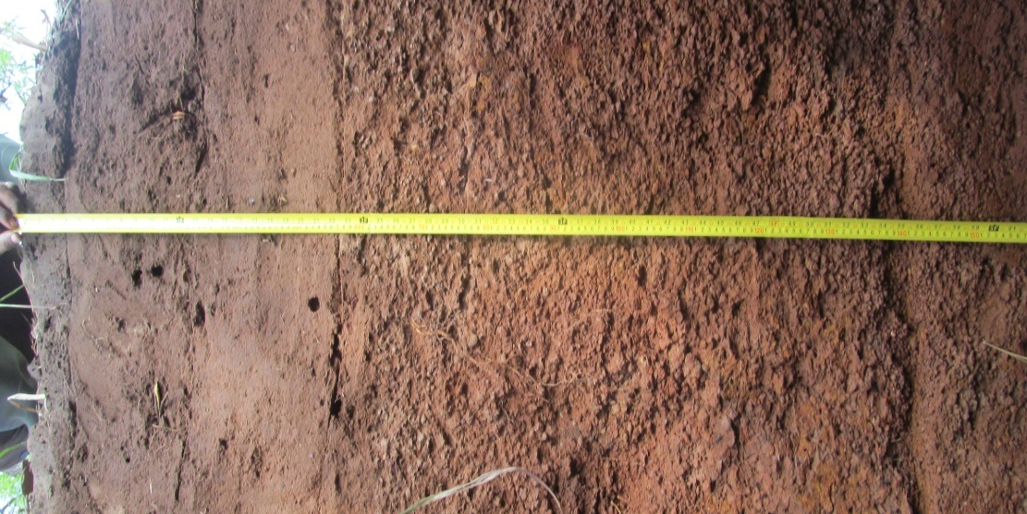
Plate 6 Morphological properties of Techiman series (Chromic Pisoplinthic Abruptic Lixisol (Loamic, Ochric))

Table 6: Some physico-chemical properties of Techiman series at Kogyae Strict Nature Reserve (Plot S14)
Hor. No. | Depth  (cm) | pH water | Total (% of soil) |  |  | Available Phosphorus (mg kg⁻¹ soil) | Exchangeable basic cations (cmol₍₊₎ kg⁻¹ soil) |  |  |  |  |  |  |  | BS  (%)
 |  |  |  |  |  |  | Basic cations |  |  |  |  | Acidity |  | ECEC | BS  (%)
Hor. No. | Depth  (cm) | 1:1 | C | O.M |  | Available Phosphorus (mg kg⁻¹ soil) | Ca²⁺ | Mg²⁺ | K⁺ | Na⁺ | TEB | Al³⁺ + H⁺ | Al³⁺ | ECEC | BS  (%)
1 | 0-10 | 5.40 | 0.82 | 1.41 |  | 13.83 | 2.84 | 0.80 | 0.04 | 0.20 | 3.88 | 0.17 | 0.00 | 4.05 | 100.00
2 | 10-30 | 5.72 | 0.54 | 0.93 |  | 12.13 | 1.70 | 1.26 | 0.04 | 0.24 | 3.24 | 0.33 | 0.00 | 3.57 | 100.00
3 | 30-58 | 6.37 | 0.36 | 0.62 |  | 1.96 | 1.02 | 0.88 | 0.02 | 0.13 | 2.05 | 0.58 | 0.17 | 2.63 | 92.45
4 | 58-78 | 6.12 | 0.30 | 0.52 |  | 4.18 | 2.16 | 0.76 | 0.01 | 0.24 | 2.41 | 0.50 | 0.00 | 2.91 | 100.00
5 | 78-105 | 5.67 | 0.58 | 1.00 |  | 1.24 | 1.40 | 0.96 | 0.02 | 0.25 | 2.64 | 0.84 | 0.17 | 3.47 | 94.04

Hor. No. | Depth  (cm) | Soil separates (%) |  |  | Textural class (Triangular scale) | Depth (cm) | Dry bulk density (Mg m⁻³) | Standard deviation
Hor. No. | Depth  (cm) | Sand | Silt | Clay
1 | 0-10 | 86.56 | 10.32 | 3.12 | Loamy sand | 0-20 | 1.47* | 0.02
2 | 10-30 | 88.36 | 8.64 | 3.00 | Loamy sand | 20-40 | 1.70 | 0.00
3 | 30-58 | 88.56 | 8.32 | 3.12 | Sand | 40-60 | 1.80 | 0.02
4 | 58-78 | 89.56 | 7.32 | 3.12 | Sand
5 | 78-105 | 85.36 | 5.64 | 9.00 | Loamy sand
*Bulk density values are means of triplicate samples (three replications)

Methods:
The pH of soil profile pits was determined in a soil: water ratio of 1:2.5 as described by Mclean (1982) and texture by the hydrometer method (Boyoucos, 1962). Soil organic carbon was determined following wet combustion (Nelson and Sommers 1982) and converted to organic matter with the van Bemmelen factor of 1.724. Exchangeable cations were determined by the methods described by Thomas (1982) and available phosphorus by the blue ammonium - molybdate method (Olsen and Sommers 1982).

Cited Literature
BOYOUCOS, G.J. 1962. Hydrometer methods improved for making particle size analysis of soils. Soil Sci. Soc. Am. Proc. 26: 464- 465.
MCLEAN, E.O. 1982. Soil pH and lime requirement. In: Page, A.L., Miller, R.H and Keeney, D.R. (eds.). Methods of soil analysis. Part 2. Chemical and microbiological properties. Second edition. American Society of Agronomy and Soil Science Society of America, Madison, Wisconsin USA. pp.199 – 223
NELSON, D.W. & L.E. SOMMERS. 1982. Total carbon, organic carbon, and organic matter. In: Page, A.L., R.H. Miller, and D.R. Keeney (eds.). Methods of soil Analysis. 2. Chemical and Microbiological properties. Agronomy 9: 301- 312.
OLSEN, S.R. & SOMMERS, L.E. 1982. Phosphorus. Pp. 403-430 in Page, A.L., Miller, R.H. and Keeney, D.R. (eds.). Methods of soil analysis. Part 2. Chemical and microbiological properties. Second edition. American Society of Agronomy and Soil Science Society of America, Madison, Wisconsin, USA
THOMAS, G. W. 1982. Exchangeable cations. In Methods of Soil Analysis. Number 9, Part 2. (A. L. Page, R. H. Miller and D. R. Keaney eds). Am. Soc. of Agron.

Base saturation calculated as BS= TEB x 100/(TEB + Exch. Al³⁺)

