Supplementary material

Geographic patterns in colonial reproductive strategy in Myrmecina nipponica: links between biogeography and a key polymorphism in ants

Supplementary Methods
Molecular analyses
DNA was extracted using Qiagen DNeasy Kits (Qiagen, Valencia, CA, USA) following the manufacturer’s instructions, and eluted in AE buffer. Extracted DNA was used for both Sanger sequencing of mitochondrial Cytochrome Oxidase subunit 1 (CO1) and a whole-genome reduced representation library generated using multiplexed ISSR genotyping by sequencing (MIG-Seq; Suyama and Matsuki 2015).

Sequencing of COI
We sequenced a 1281 bp segment of the mitochondrial Cytochrome Oxidase Subunit 1 (COI) gene using universal primers LCO1490 and TL2N3014 (Folmer et al. 1994; Zhang and Hewitt 1997) where possible, and additional primers designed for this study (Table S1) where universal primers were ineffective.

Table S1. Primers used for sequencing 1281bp of COI used in this study. Newly designed primers are indicated in bold. * from Folmer et al. (1994); ** from Zhang & Hewitt (1997).

Primer | direction | Application | Sequence
LCO1490* | forward | PCR, sequence | GGT CAA CAA ATC ATA AAG ATA TTG G
TL2N3014** | reverse | PCR, sequence | TCC AAT GCA CTA ATC TGC CAT ATT A
F337 | forward | sequence | ACA TGA GCT ATC CTA ATT ACA GCA
R704 | reverse | sequence | GAA TTG CAA TGA TTA TAG TGG CAG A
CO1R2 | reverse | PCR, sequence | GTC CAT TGC ACT TAA GTC TGC CAT

PCR was performed in a 20 μl reaction mixture containing template DNA (approximately 200 pg), dNTPs, a pair of primers (LCO1490 and TL2N3014) and ExTaq (Takara Bio Inc.), following the manufacturer’s instructions. The thermal cycling profile consisted of a precycling denaturation at 95 °C for 1 min, followed by 35 cycles of denaturation at 95 °C for 30 s, annealing at 51 °C for 10 s and extension at 72 °C for 1 min. The PCR products were then examined using electrophoresis on a 1.5% agarose gel, purified with magnetic beads (AMPure, Agencourt), cycle-sequenced using the above-mentioned primers and a BigDye® Terminator v. 3.1 Cycle Sequencing Kit (Applied Biosystems) and loaded onto an automated sequencer (ABI PRISMTM 3130 xl; Applied Biosystems). The sequences obtained were aligned unambiguously and edited to 1281 bp using the software BioEdit. Among all sequences there was only a single deletion of three nucleotides in the outgroup species from Hong Kong. Sequences were checked for Wolbachia infection using a BLAST search. All sequences were deposited in GenBank (Table S2).

Table S2. Identity codes and localities for all samples used in this study. Morph indicates whether the source colony had an ergatoid (E), winged (W), or unknown (?) queen or was orphan (o) and the number of queens in cases of polygyny. Letters in the haplotype column indicates haplotype group membership. Samples used for MIG-Seq analysis are denoted by “O” in the final column.

Site | Species | Morph | Genbank AC# | Sample ID | COI Haplotype | MIG-seq sample
Chitose | M. nipponica | 1E | KX016606 | CTS.43 | a | O
Chitose | M. nipponica | o | KX016607 | CTS.46 | b | -
Chitose | M. nipponica | o | KX016608 | CTS.102 | c | -
Chitose | M. nipponica | 8E | KX016609 | CTS.106 | c | O
Chitose | M. nipponica | 1E | KX016610 | CTS.205 | d | O
Chitose | M. nipponica | 2E | KX016611 | CTS.213 | b | O
Chitose | M. nipponica | o | KX016612 | CTS.216 | b | -
Chitose | M. nipponica | o | KX016613 | CTS.224 | e | O
Chitose | M. nipponica | W | KX016614 | CTS.325 | b | O
Chitose | M. nipponica | W | KX016615 | CTS.334 | b | O
Chitose | M. nipponica | W | KX016616 | CTS.335 | f | O
Fujio | M. nipponica | W | KX016623 | FUJ | g | O
Kaga | M. nipponica | W | KX016638 | KAG | h | O
Kanazawa | M. nipponica | W | KX016637 | KAN.1 | i | O
Kanazawa | M. nipponica | ? | DQ249331 | KAN.2 | j | -
Kanazawa | M. nipponica | ? | DQ249330 | KAN.3 | j | -
Kuraiyama | M. nipponica | W | KX016626 | KUR.3 | k | O
Kuraiyama | M. nipponica | E | KX016629 | KUR.5 | l | O
Kuraiyama | M. nipponica | E | KX016630 | KUR.15 | b | O
Kuraiyama | M. nipponica | E | KX016631 | KUR.16 | b | O
Kuraiyama | M. nipponica | E | - | KUR.20 | - | O
Kuraiyama | M. nipponica | W | KX016627 | KUR.21 | k | O
Kuraiyama | M. nipponica | W | KX016628 | KUR.23 | k | -
Manazuru | M. nipponica | W | KX016632 | MAN | m | O
Matsuyama | M. nipponica | W | MG592253 | MAT.1 | n | O
Matsuyama | M. nipponica | E | MG592254 | MAT.2 | o | O
Matsuyama | M. nipponica | E | MG592252 | MAT.3 | o | O
Matsuyama | M. nipponica | ? | MG592256 | MAT.4 | n | -
Nopporo | M. nipponica | E | KX016617 | NOP.402 | b | -
Nopporo | M. nipponica | E | KX016618 | NOP.403 | b | O
Nopporo | M. nipponica | E | KX016619 | NOP.404 | d | O
Nopporo | M. nipponica | E | KX016620 | NOP.406 | d | O
Nopporo | M. nipponica | E | KX016621 | NOP.407 | b | -
Nopporo | M. nipponica | E | KX016622 | NOP.408 | d | -
Nopporo | M. nipponica | E | KX016634 | NOP.1 | b | O
Nopporo | M. nipponica | E | KX016635 | NOP.2 | b | O
Nopporo | M. nipponica | E | KX016636 | NOP.3 | b | O
Takanawa | M. nipponica | E | KX016618 | TAK.1 | p | O
Takanawa | M. nipponica | E | KX016619 | TAK.2 | p | O
Tokamachi | M. nipponica | W | KX016600 | TOK | q | O
Tomakomai | M. nipponica | W | KX016601 | TOM.1 | b | O
Tomakomai | M. nipponica | W | DQ249329 | TOM.2 | r | -
Towada | M. nipponica | o | KX016598 | TOW.2 | s | O
Towada | M. nipponica | 1E | KX016599 | TOW.4 | b | O
Towada | M. nipponica | 1E | KX016600 | TOW.5 | b | O
Towada | M. nipponica | 2E | KX016601 | TOW.9 | t | O
Towada | M. nipponica | 1E | KX016602 | TOW.10 | u | O
Towada | M. nipponica | 1E | KX016603 | TOW.11 | v | -
Towada | M. nipponica | 1E | KX016604 | TOW.12 | v | O
Towada | M. nipponica | 1E | KX016605 | TOW.13 | v | -
Toyama | M. nipponica | W | KX016633 | TOY | j | O
Germany | M. graminicola | ? | DQ249326 | M. gram | Outgroup | -
USA | M. americana | ? | DQ249340 | M. amer | Outgroup | -
Indonesia | M. sp A | ? | DQ249332 | M. SpA | Outgroup | -
Hong Kong | M. sp Hong Kong | ? | KX021820 | M. HK | Outgroup | O
Austria | Myrmica rubra | ? | DQ074378 | Myrmica | Outgroup | -

We obtained sequences from 56 samples in total, comprising 51 M. nipponica colonies from 13 populations (47 new sequences and three sourced from GenBank). Five additional taxa were used as an outgroup (one new sequence, and four from GenBank; Table 1). After duplicate sequences were removed, we were left with 22 in-group haplotype sequences for M. nipponica (Table 1). Outgroup samples included four other species of Myrmecina (M. americana, M. graminicola, M. Sp A and M. Sp. Hong Kong) and Myrmica rubra (Table S2). For the ingroup samples, our 1281bp fragment of COI was variable at 9.6% of sites, with strong variation in bias between codon positions (3.7%, 1.6% and 23.4% for 1st, 2nd and 3rd codon positions respectively). There was also strong AT bias (71.5%) which varied between codon positions (64%, 62% and 88% respectively), and thus we partitioned codon positions in all analyses.

MIG-Seq data acquisition
We followed the general protocol for MIG-Seq analysis outlined in Suyama and Matsuki (2015). Approximately 2 ng of DNA was used for the 1st PCR as template DNA. The 1st PCR step was performed to amplify inter-simple-sequence repeats (ISSR) from genomic DNA with MIG-seq primer set-1 for the 1st PCR (see Table 1 of Suyama and Matsuki 2015). Fragments were amplified with a Multiplex PCR Assay Kit Ver. 2 (TaKaRa Bio Inc., Otsu, Shiga, Japan) using 7 μl reaction volumes in a thermal cycler with the following profile: 94°C for 1 min followed by 28 cycles of 94°C for 30 sec, 38°C for 1 min, 72°C for 1 min, and finally 72°C for 10 min. The PCR products were diluted 25 times for each 1st PCR product with deionized water. The 2nd PCR step was conducted independently to add individual indices to each sample using the common forward primers and indexed reverse primers (see Supplementary Table 5 of Suyama and Matsuki 2015). The fragments were amplified with PrimeSTAR GXL DNA polymerase (TaKaRa Bio Inc., Otsu, Shiga, Japan) using 10 μl reaction volumes in a thermal cycler with the following profile: 15 cycles of 98°C for 10 sec, 54°C for 15 sec, 68°C for 1 min. The PCR products were diluted three times for each 2nd PCR product with deionized water, and concentration measured using the Microchip Electrophoresis System (MultiNA, Shimadzu, Kyoto, Japan). Products from the 2nd PCR were then pooled into a single mixture library with approximately equimolar concentrations. The mixture library was purified using a QIAquick PCR Purification Kit (QIAGEN, Hilden, Germany) and separated using 2% agarose gel electrophoresis. Fragments in the range of 400 to 800 bp were isolated using a GEL/PCR Purification Mini Kit (FAVORGEN Biotech Corp., Taiwan). Concentration of the size-selected library was measured with a SYBR green quantitative PCR assay (Library Quantification Kit, Clontech, Mountain View, CA, USA) with primers specific to the Illumina system. Approximately 4 nM of the concentration-adjusted library was denatured using 0.2 N NaOH and mixed with Illumina-generated PhiX Control libraries (PhiX Control v3, Illumina, San Diego, CA, USA) according to Illumina’s protocol. Approximately 12 pM of library was then used for sequencing on an Illumina MiSeq Sequencer (Illumina) using a MiSeq Reagent Kit v3 (150cycles, illumina), with 80 bp and 94 bp sequences determined for Read 1 and Read 2, respectively.

De novo identification of putative loci from MIG-Seq data
Reads for the 38 ingroup (M. nipponica) samples and one outgroup sample (M. sp Hong Kong; Table S2) were pre-processed following (Suyama and Matsuki 2015). Briefly, the first 14 bases (comprising SSR regions and anchor sequences) were removed from Read 2 sequences, and then sequences were quality filtered using FastxTrimmer (hannonlab.cshl.edu/fastx_toolkit/). Finally, reads derived from very short library entries were removed using TagDust (Lassmann 2015).

Cleaned Read 1 and Read 2’s were pooled for determination of putative loci using the software Stacks 2.2 (Catchen et al. 2011). A denovo analysis was conducted with parameters m = 3, M = 2 and n = 1 after assessment of various parameters following Rochette and Catchen (2017), though analyses of different parameter settings produced highly congruent results. Putative loci were then catalogued using the Populations program of Stacks, with the setting r = 50 and p = 1 limiting SNPs to the first of each read in order to avoid the strong linkage between SNPs (Takahashi et al. 2016), with the added restrictions of a minimum minor allele frequency of 0.05 and maximum heterozygosity of 0.95, and output in phylip-var (haploid) and structure (diploid) formats. This dataset consisted of 3716 SNPs over 39 individuals, which was filtered of loci with >80% missing data, and purged of samples from Kanazawa and Tomakomai because very few reads were recovered from these two samples. The final dataset comprised 37 individuals and 1564 SNPs. The phylip-var output was converted to fasta format for phylogenetic inference in BEAST, and converted to binary format of presence/absence of loci using a custom script for PCA analysis.

Inference of genetic relationships between populations
Phylogenetic relationships between taxa were reconstructed for the COI dataset using a Bayesian approach in BEAST 1.10.4 (Drummond et al. 2012). We used a GTR + I + Γ model and Yule process with 50 million iterations sampling every 1000th iteration. Log files from BEAST runs were explored in TRACER 1.7.1 (Rambaut et al. 2014) to determine suitable burn in (10% was used in all cases) and to confirm effective samples sizes were > 200. Maximum credibility trees were generated from BEAST output using the software TreeAnnotator 1.10.4, discarding the first 10% of all trees. Maximum likelihood (ML) analyses were conducted in MEGA 10.0 (Kumar et al. 2018) using a GTR + I + Γ model with node support assessed with 1000 bootstraps. The MIG-Seq generated SNP dataset was analysed in BEAST 1.10.4 using a GTR + I + Γ model with lognormal priors, with sampling, iterations and tree identification as described above.

The structure file from Stacks was filtered of the same loci as above, purged of Read 2 data and outgroup data, and then stripped of remaining loci comprised entirely of missing data. The final dataset comprised 1431 diploid loci and was used to infer population genetic clustering in STRUCTURE 2.3.4 (Pritchard et al. 2000). We employed five replicates runs, each consisting of a burn-in of 100,000 generations followed by 50,000 MCMC generations for values of K between 1 and 10. The most likely value of K was then determined following Evanno et al (2005) using STRUCTURE HARVESTER (Earl and vonHoldt 2012).

Analysis of links between climatic factors and founding strategy
We used 19 comtemporary (1970-2000) ‘bioclimatic’ variables downloaded from the Worldclim 2.0 database (Fick and Hijmans 2017). These are summarized in Table S3 with numbers referring to those shown in figures here and in the main text.
Table S3: Definitions of bioclimatic variables. Key to ID codes for each of the 19 bioclimatic variables obtained from the WORLDCLIM website by given in the main text.

Variable ID | Variable description
1 | Mean annual temperature
2 | Daily temperature range
3 | Isothermality
4 | Temperature seasonality
5 | Maximum temperature of warmest month
6 | Minimum temperature of coldest month
7 | Temperature annual range
8 | Mean temperature of wettest quarter
9 | Mean temperature of driest quarter
10 | Mean temperature of warmest quarter
11 | Mean temperature of coldest quarter
12 | Annual precipitation
13 | Precipitation of wettest month
14 | Precipitation of driest month
15 | Precipitation seasonality
16 | Precipitation of the wettest quarter
17 | Precipitation of the driest quarter
18 | Precipitation of the warmest quarter
19 | Precipitation of the coldest quarter

Inference of historical biogeography
To estimate the ages of clade divergence, and the relationship between divergence times and environmental events, we used the COI dataset because it is difficult to estimate meaningful rate parameters for MIG-Seq loci derived from denovo analyses. We employed a strict molecular clock in BEAST, using a value of 6.2×10⁻⁸ for the clock rate. This value represents the mean mutation rate for mitochondrial DNA in Drosophila (number mutations per site per generation; Haag-Liautaud et al. 2008), and allowed us to interpret the x-axis scale of trees and plots as the number of years, assuming one generation per year. The mutation rate for mitochondrial DNA in insects is highly variable (Castro et al. 2002): a previous study of bumble bees used a rate of 2% per million years (Duennes et al. 2012), a study of beetles suggested a value of 3.5% (Papadopoulou et al. 2010), while a study used of Atta ants used 9.5% (Solomon et al. 2008), and estimates ranging over two orders of magnitude have been suggested by different authors (Brower 1994; Farrell 2001). One previous study of Myrmecina (Steiner et al. 2006) used rates of 2.3% and 1.5% per million years, though this was based on estimates for other insects (Brower 1994; Quek et al. 2004),
There is evidence that hymenopteran mtDNA exhibits a higher rate of mutation that for other insects (Kaltenpoth et al. 2012), and previous studies have also indicated the importance of taking into account base composition (Montooth and Rand 2008; Groom et al. 2013), which our data indicate is AT biased in Myrmecina (71.4%). We thus follow Groom et al. (2013) in using the rate of Haag-Liautard et al. (2008) for Drosophila for our mutation rate in COI, as this rate represents an intermediate value between other estimates for invertebrate mitochondrial mutation rates and is derived from another organism with a high degree of AT bias.

Supplementary Results
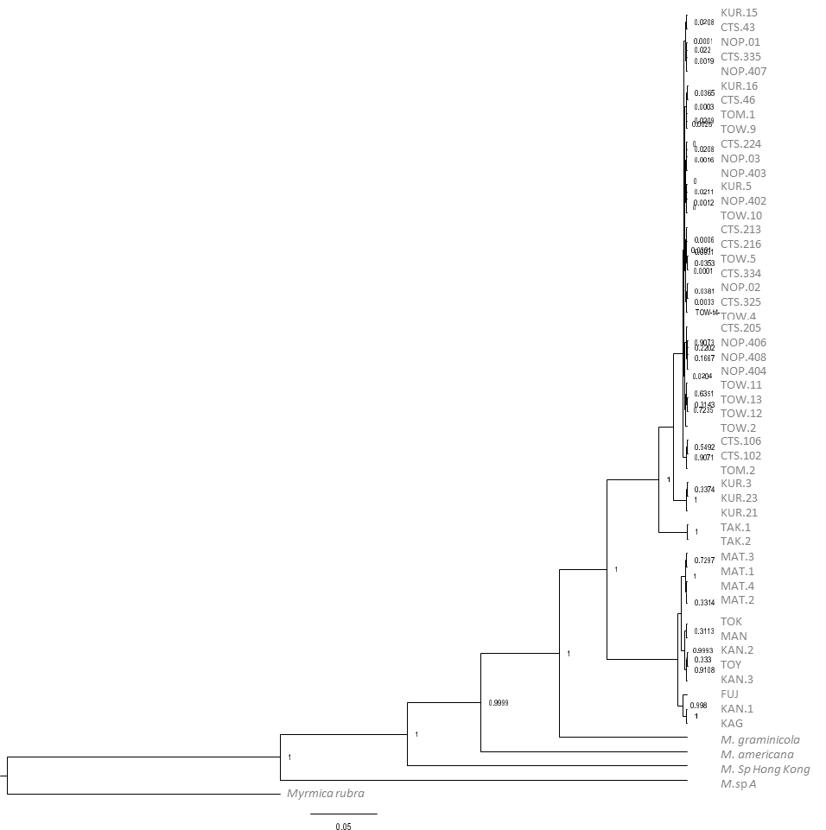
Figure S1 Maximum credibility tree from Bayesian phylogenetic reconstruction of COI data for all samples of Myrmecina, indicating relationships between genera.

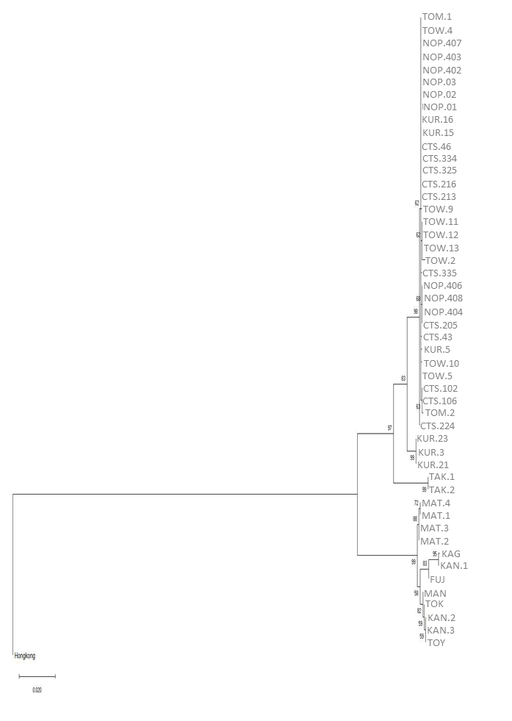
Figure S2. Phylogenetic reconstruction of relationships between samples based on COI data using Maximum Likelihood in MEGA X. Values given at nodes indicate bootstrap support over 1000 bootstraps.

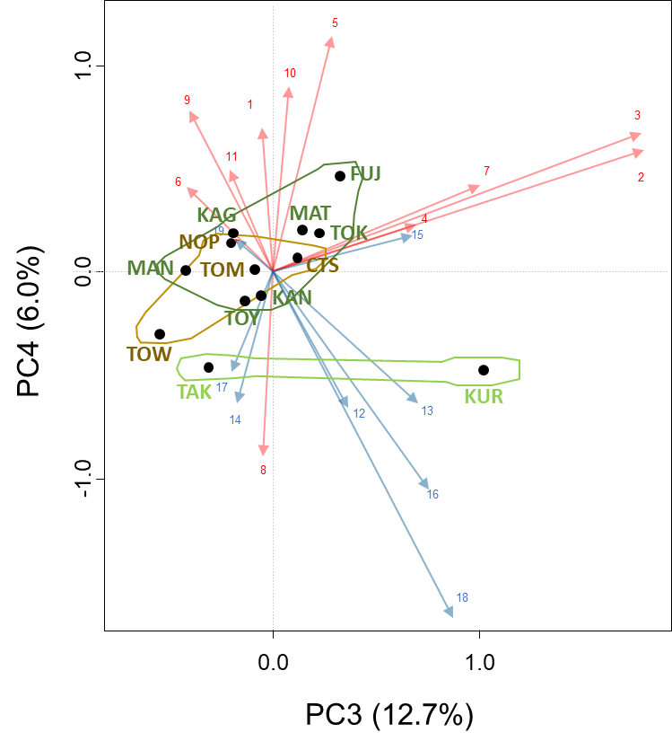

Figure S3. PCA Biplot of PC3 vs PC4 for Worldclim bioclimatic variables over the 13 sites of M. nipponica. Environmental variables are indicated in red (temperature) and blue (precipitation), with numbers indicating the bioclimatic variable (see Supplementary material). Circles mark different sites. Colored backgrounds indicate regions (light green = southern highland; dark green = southern lowland; brown = northern; see main text). Plot of PC1 and PC2 given in main text.

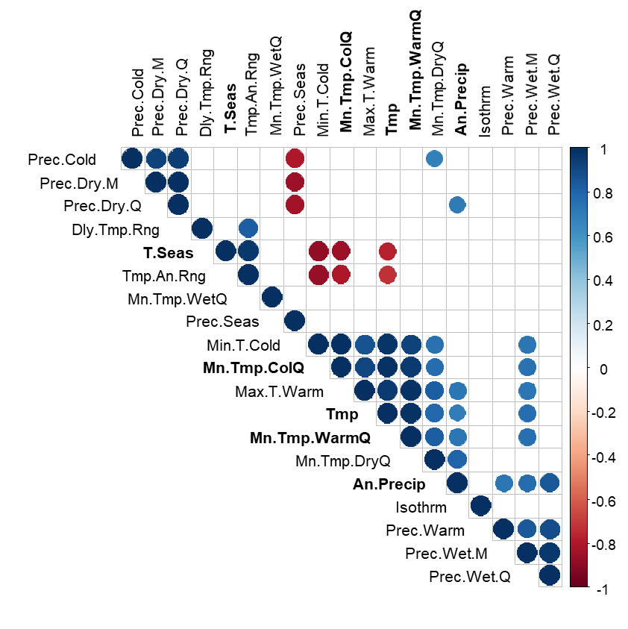
Figure S4. Correlation matrix for Worldclim bioclimatic variables used in this study. Coloured circles indicate significant correlations at the p < 0.01 level.

References
Brower AVZ, 1994. Rapid morphological radiation and convergence among races of the butterfly Heliconius erato inferred from patterns of mitochondrial DNA evolution. Proceedings of the National Academy of Science, USA 91:6491-6495.
Castro LR, Austin AD, Dowton M, 2002. Contrasting rates of mitochondrial molecular evolution in the parasitic Diptera and Hymenoptera. Mol Biol Evol 19:1100-1113.
Catchen JM, Amores A, Hohenlohe P, Cresko W, Postlethwait JH, 2011. Stacks: building and genotyping loci de novo from short-read sequences. G3 1:171-182.
Drummond AJ, Suchard MA, Xie D, Rambaut A, 2012. Bayesian phylogenetics with BEAUti and the BEAST 1.7. Mol Biol Evol 29:1969-1973.
Duennes MA, Lozier JD, Hines HM, Cameron SA, 2012. Geographical patterns of genetic divergence in the widespread Mesoamerican bumble bee Bombus ephippiatus (Hymenoptera: Apidae). Mol Phylogen Evol 64:219-231.
Earl DA, vonHoldt BM, 2012. STRUCTURE HARVESTER: a website and program for visualizing STRUCTURE output and implementing the Evanno method. Conserv Genet Res 4:359-361.
Evanno G, Regnaut S, Goudet J, 2005. Detecting the number of clusters of individuals using the software STRUCTURE: a simulation study. Mol Ecol 14:2611-2620.
Farrell BD, 2001. Evolutionary assembly of the milkweed fauna: cytochrome oxidase I and the age of Tetraopes beetles. Mol Phylogen Evol 18:467-478.
Fick SE, Hijmans RJ, 2017. WorldClim 2: new 1‐km spatial resolution climate surfaces for global land areas. Int J Climatol 37:4302-4315.
Folmer O, Black M, Hoeh W, Lutz R, Vrijenhoek R, 1994. DNA primers for amplification of mitochondrial cytochrome c oxidase subunit I from diverse metazoan invertebrates. Mol Mar Biol Biotechnol 3:294-299.
Groom SVC, Stevens MI, Schwarz MP, 2013. Diversiﬁcation of Fijian halictine bees: Insights into a recent island radiation. Mol Phylogen Evol 68:582-594.
Haag-Liautaud C, Coffey N, Houle D, Lynch M, Charlesworth B, Keightley PD, 2008. Direct estimation of the mitrochondrial DNA mutation rate in Drosophila melanogaster. PLoS Biol 6:1706-1714.
Kaltenpoth M, Showers Corneli P, Dunn DM, Weiss RB, Strohm E, Seger J, 2012. Accelerated evolution of mitochondrial but not nuclear genomes of Hymenoptera: new evidence from crabronid wasps. PLoS One 7:e32826.
Kumar S, Stecher G, Li M, Knyaz C, Tamura K, 2018. MEGA X: molecular evolutionary genetics analysis across computing platforms. Mol Biol Evol 35:1547-1549.
Lassmann T, 2015. TagDust2: a generic method to extract reads from sequencing data. BMC Bioinformatics 16:24.
Montooth KL, Rand DM, 2008. The spectrum of mitochondrial mutation differs across species. PLoS Biol 6:1634-1637.
Papadopoulou A, Anasasiou I, Vogler AP, 2010. Revisiting the insect mitochondrial molecular clock: the mid-Aegean trench calibration. Mol Biol Evol 27:1659-1672.
Pritchard JK, Stephens M, Donnelly P, 2000. Inference of population structure using multilocus genotype data. Genetics 155:945-959.
Quek S-P, Davies SJ, Itino T, Pearce NE, 2004. Codiversification in an ant-plant mutualism: stem texture and the evolution of host use in Crematogaster (Formicidae: Myrmicinae) in habitants of Macaranga (Euphorbiaciae). Evolution 58:554-570.
Author. 2014. Tracer v1.6, Available from http://beast.bio.ed.ac.uk/Tracer.
Rochette NC, Catchen JM, 2017. Deriving genotypes from RAD-seq short-read data using Stacks. Nature Protocols 12:2640–2659.
Solomon SE, Bacci Jr M, Martins Jr J, Vinha GG, Mueller UG, 2008. Paleodistributions and comparative molecular phylogeography of leafcutter ants (Atta spp.) provide new insight into the origins of Amazonian diversity. PLoS One 3:e2738.
Steiner FM, Schlick-Steiner BC, Konrad H, Linksvayer TA, Quek SP, Christian E, Stauffer C, Buschinger A, 2006. Phylogeny and evolutionary history of queen polymorphic Myrmecina ants (Hymenoptera : Formicidae). Eur J Entomol 103:619-626.
Suyama Y, Matsuki Y, 2015. MIG-seq: an effective PCR-based method for genome-wide single-nucleotide polymorphism genotyping using the next-generation sequencing platform. Sci Rep 5:16963.
Zhang D-X, Hewitt GM, 1997. Assessment of the universality and utility of a set of conserved mitochondrial COI primers in insects. Insect Mol Biol 6:143-150.

