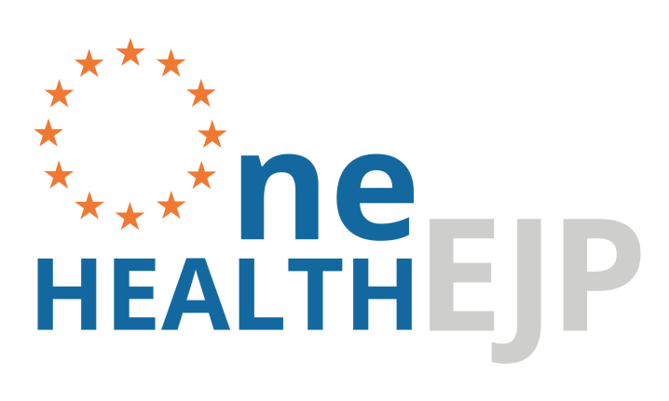

Report on requirement analysis for an “OH Harmonisation Infrastructure Hub”
JIP1 - ORION - AI1 - 1st Call

Responsible Partner: SVA

GENERAL INFORMATION

European Joint Programme full title | Promoting One Health in Europe through joint actions on foodborne zoonoses, antimicrobial resistance and emerging microbiological hazards
European Joint Programme acronym | One Health EJP
Funding | This project has received funding from the European Union’s Horizon 2020 research and innovation programme under Grant Agreement No 773830.
Grant Agreement | Grant agreement n° 773830
Start Date | 01/01/2018
Duration | 60 Months

DOCUMENT MANAGEMENT

JIP/JRP Deliverable | D-3.1 Report on requirement analysis for an “OH Harmonisation Infrastructure Hub”
Join Integrative/Research Project | JIP1 - ORION - AI1 - 1st Call
JIP/JRP Leader | Matthias FILTER (BfR)
Other contributors | Fernanda Dórea, Victor Oliveira, Wonhee Cha, Mia Holmberg, Valérie De Waele, Matthias Filter, Taras Günther, Joern Gethmann, Sandra Stelzer, Uffe Christian Braae, Johanne Ellis-Iversen, Mia Torpdahl, Katrin Kuhn, Eelco Franz, Ingrid Friesema, Karin Lagesen, Taran Skjerdal, Cecilia Jernberg, Olov Svartstrom, Marika Hjertqvist, Charlotte Cook, Joanna Lawes, Lesley Larkin
Due month of the deliverable | M12
Actual submission month | M12
Type  R: Document, report  DEC: Websites, patent filings, videos, etc.  OTHER | Report
Dissemination level  PU: Public  CO: confidential, only for members of the consortium (including the Commission Services) | PU

Data interoperability support to

One Health Surveillance (OHS)

Background

The ORION project
The ORION project aims at establishing and strengthening inter-institutional collaboration and transdisciplinary knowledge transfer in the area of surveillance data integration and interpretation, along the One Health (OH) objective of improving health and well-being. Through three main work packages (WP), ORION’s specific goals can be summarized as the delivery of three main resources:
- a “OH Surveillance Codex” (WP1) - a high level framework for harmonised, cross-sectional description and categorisation of surveillance data covering all surveillance phases and all knowledge types;
- a “OHS Knowledge Hub” (WP2) - a cross-domain inventory of currently available data sources, methods / algorithms / tools, that support OH surveillance data generation, data analysis, modelling and decision support; and
- “OHS Infrastructural Resources” (WP3) – that are practical, infrastructural resources forming the basis for successful harmonisation and integration of surveillance data and methods.

WP3 – Infrastructural resources for harmonisation and integration of surveillance
WP3 was planned to identify infrastructural resources which can support the harmonization and integration of existing methods regarding collection and analysis of surveillance data. Year 1 was dedicated to a requirement analysis, which aims were two-fold: (i) identify the priority problems; (ii) identify existing solutions and current gaps, in order to define where to focus efforts when developing solutions. In month 4, ORION conducted its first full consortium workshop, entitled « requirement analysis workshop ». The goal was to gather the initial results for the first 3 months of work and reach a conclusion about (i) above, so that the rest of the year could be focused on (ii).
During the first three months of work, we performed an inventory of the surveillance data flow between animal, human and food surveillance agencies within ORION partner countries, and the practices of mandatory reporting to the European Centre for Prevention and Disease Control (ECDC) and the European Food Safety Agency (EFSA). It became apparent that the development of a framework of One Health Surveillance (OHS) faces varied data interoperability challenges - among institutions, across health surveillance sectors, and among countries. Interoperability is used here to mean “the ability of different information technology systems and software applications to communicate, exchange data, and use the information that has been exchanged”.
EFSA and ECDC have done significant work, in their respective domains, to solve the problem of structural interoperability among datasets from different countries. As a result, standardised datasets collating surveillance information at the European level already exist, and can be accessed through different resources made available by these agencies. Semantic interoperability, on the other hand, is concerned with ensuring the integrity and meaning of the data across systems. Semantic interoperability is particularly important in OH in order to allow data reuse across sectors, and even reuse of data for research and knowledge discovery.
The issues listed above were exposed to the WP3 team during the requirement analysis workshop in month 4, and a decision was made to focus WP3 on resources to support semantic data interoperability in OH. Three working groups(WG) were created to support the work within WP3:
- The surveillance practice WG: this WG will be responsible for understanding the needs of surveillance practitioners regarding data workflows and communication across sectors. It will also help understand how developed solutions could be incorporated into surveillance practice.
- The technical development WG: this WG is concerned with the technical development of tools to support data interoperability. This WG will recommend and, when needed, develop tools that support semantic data interoperability in surveillance practice.
- The knowledge modelling WG: semantic interoperability can only be reached if we create semantic models of the knowledge we need to share across sectors involved in OH data analysis and interpretation. This WG was created to interact with WP1 and WP2-epi, where terminology and cross-sector harmonisation of terms are discussed, and identify the knowledge we need to model. This WG will also formalize the knowledge into proper computational knowledge models.
Each of these WG spent year 1 carrying requirement analyses of the solution space in their respective areas. This document presents the results of each of them:
- Surveillance practice WG requirement analysis: current data workflows and cross-sector collaboration for data analysis. We present the results of interviews carried out with representatives of all partners institutions in ORION.
- Technical development WG requirement analysis: this WG conducted a literature review of data interoperability solutions in health surveillance. Furthermore, it produced an outline of the technical architecture that would be needed to bring semantic interoperability into surveillance practice, and we present an inventory of software solutions for each of the steps outlined in the architecture.
- Knowledge modelling WG requirement analysis: existing terminologies and ontologies that can support one health surveillance. We present a review based on peer-reviewed and grey literature.
As we present these results, we also outline our conclusions for year 1, and lay out the plan ahead for WP3. In particular, the consolidation of our plan for a One-Health Pilot. All developed solutions in ORION will be exemplified and validated through One Health pilots, which will support the operationalization and implementation of OH surveillance solutions on a national level and provide crucial feedback for future development and dissemination actions. Based on the priorities set out by the countries involved in ORION, and in particular the priorities set out by the Swedish cross-sectorial group which is supporting WP3, we focus this discussion on the surveillance against three foodborne zoonotic agents: Salmonella sp., Campylobacter sp., E.coli.

Current data workflows in foodborne diseases surveillance
Experts from 13 institutes across 7 countries in Europe (Belgium, Denmark, Germany, Netherlands, Norway, Sweden, and United Kingdom) – all institutions part of the ORION consortium – were contacted for an individual interview. In total, experts from 5 institutes in the public health sector (PH), 4 institutes in the animal health sector (AH), 3 institutes from food safety (FS), and 1 institute of one-health (AH plus PH) participated (Table 1). All of the interviewees were directly or indirectly involved in reporting to either the European Centre for Disease Prevention and Control (ECDC) or the European Food Safety Authority (EFSA).
Table 1. List of institutes which contributed to the survey of data workflows.
Country | Institute | Sector
Sweden | Folkhälsomyndigheten (The Public Health Agency of Sweden) | PH
Sweden | Statens Veterinärmedicinska Anstalt (National Veterinary Institute) | AH
Denmark | Statens Serum Institut | PH
Denmark | Danmarks Tekniske Universitet | FS
Germany | Bundesinstitut fur Risikobewertung | FS
Germany | Friedrich-Loeffler-Institut, Bundesforschungsinstitut fur Tiergesundheit (Federal Research Institute for Animal Health) | AH
The Netherlands** | Rijksinstituut Voor Volksgezondheid en Milieu | PH
The Netherlands** | Nederlandse Voedsel | FS
UK | Public Health England | PH
UK | Animal and Plant Health Agency | AH
Belgium | Sciensano | PH & AH
Norway | Folkehelseinstituttet (Norwegian Institute of Public Health) | PH
Norway | Veterinaerinstituttet (National Veterinary Institute) | AH
* PH: Public Health; AH: Animal Health; FS: Food Safety
** the Wageningen Bioveterinary Research (animal health sector) is the actual partner in ORION, but they recommended a colleague from food safety for interview, considering their role on the EFSA reporting in the country.

A list of questions (Annex I) were sent to the interviewees in advance and interviews were conducted using either AdobeConnect or a phone call. Focus was given to the process of collating raw data from various surveillance activities to provide an epidemiological analysis of the hazard situation and the achievement of surveillance goals. The resulting output, here referred to as “surveillance system level data”, is the data reported to European agencies or made publicly available in yearly reports. We have focused on this level of data aggregation after our ground work during months 1-3, which identified that these are the data with the highest potential for sharing across sectors, possessing the highest quality (already validated, error checked and subjected to epidemiological analysis), and yet, the least frequently stored in reusable formats.

Data workflow at the national level
Based on the interviews, the following points were found in common regarding the data workflow of foodborne pathogens within each country, from steps of data collection to reporting to ECDC or EFSA.
- Surveillance data are collected in separate databases or repositories for different sectors, i.e., humans, animals, and food. In some countries, AH and FS may be collected together.
- Collected data are quality-checked and validated by the respective institutes before being reported to ECDC (human data) or EFSA (food/animal data).
- The validated data are stored in each institute’s repository or database, and further used by the institute, e.g. publications.
- There is a national report, e.g. surveillance report or zoonoses report, that is put together by at least two different sectors using the surveillance data, which becomes publicly available.
A more detailed discussion of challenges and opportunities based on the interviews is given further below.

Data workflow at the international level
Once the required data are submitted to ECDC and EFSA, the data are validated and stored in The European Surveillance System (TESSy) and Data Collection Framework (DCF), respectively.

Data distribution by ECDC
- The ECDC uses the data to update the ‘Surveillance Atlas of Infectious Diseases in Europe’ (https://ecdc.europa.eu/en/surveillance-atlas-infectious-diseases), which is an interactive web-based tool that allows users to visualize the data as well as to download it in excel format.
- The ECDC publishes an annual epidemiological report for each infectious disease, including foodborne diseases (https://ecdc.europa.eu/en/annual-epidemiological-reports).

Data distribution by EFSA
- EFSA uses the data to publish an annual summary report for zoonotic diseases every year, which is jointly done with ECDC (https://www.efsa.europa.eu/en/efsajournal/pub/5077).
- EFSA makes the data publicly available in the ‘Knowledge junction’ (http://doi.org/10.5281/zenodo.1119945), which contains all summary tables and figures produced for the annual summary reports. Appendix files in excel format are also available for each chapter to download, as well as country data which are the submitted data originally.
- EFSA also publicizes the national zoonoses country reports of all the countries in their website (https://www.efsa.europa.eu/en/biological-hazards-data/reports), which are used as the basis for the annual summary report.

The detailed interviews, structured after the questions presented in Annex I, are available upon request. Below, we summarize some of the common themes we could identify after collating information from the 7 countries listed in Table 1.

Existing gaps and challenges in current data workflow for OHS
- Limited national resources for data sharing between sectors
  - Generally, countries do not have a database or infrastructure for sharing data directly across sectors (between PH and AH/FS), although we identified one exception.
There are on-going intersectoral collaborations, i.e., outbreak investigation, research projects, within all 7 countries. The mode of collaboration is through meetings or via emails, in which data are shared by excel files, or graphs and tables. Whole Genome Sequencing data are shared in more structured ways, but the current use of such resources is limited within specific research projects. However, Denmark has a database and a secure site platform for sharing outbreak case information and genomic data, respectively, to which people from different sectors involved in outbreak investigations are granted access.
  - There is limited accessibility to other sector’s validated data.
After reporting to EFSA or ECDC, all the institutes reportedly store the validated data, either in a database or repository, but with limited accessibility. All five PH institutes have a database that they use both for data collection as well as exporting for reporting to ECDC (the database gets updated every night), but only 2 of them are publicly accessible. No institute in AH and FS sectors currently has such a database, but a repository of data files, which are accessible only within the institute.
- Challenges to getting access to the surveillance data on the international level
  - Data distribution by ECDC and EFSA may not happen timely enough for appropriate actions to be implemented for one health surveillance.
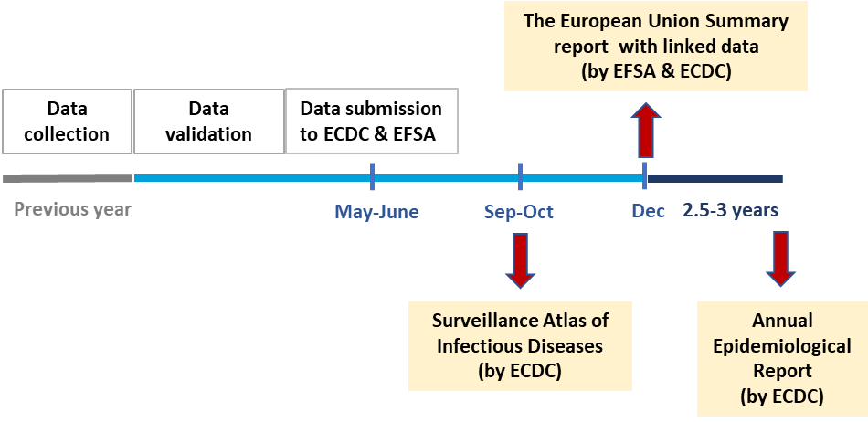
Figure 1 shows the current timeline of data workflow for each year’s data. The earliest public release of data from the previous year happens in October and in December for human and animal/food data, respectively. Thus, most of the surveillance data that each country has submitted to European agencies eventually become accessible a year later, even though validated data are ready by June at the latest to meet the deadlines for reporting.
Figure 1. Timeline of data workflow for national reporting to EFSA and ECDC.

Current opportunities to improve data interoperability between sectors for OHS
- Every country publishes at least one national report which includes foodborne zoonoses, a combined work of different sectors with validated surveillance data.
Different modes of collaboration to produce a national report were observed, as some countries reported having regular meetings for close collaboration on the work including data analysis, opposed to some countries having not much of interaction between institutes, e.g. putting links to the data from other sector’s report to the national report. However, the production of a national report is currently the only common ground found in every country interviewed, where different sectors are coming together with validated surveillance data. The time of publication varies between countries, from February to March (for previous year’s data) at the earliest to up to 3 years later. However, as noted previously, the validated surveillance data gets prepared by June for ECDC/EFSA reporting.
- Every national report is published online, making the associated data publicly available.
One institute in each country is responsible for publishing a national report on zoonoses, and although it is in PDF format, the report gets publicly accessible as they are published online on the website of the responsible institute (Table 2). Most of interviewees expressed interest in getting access to other countries’ national reports, not just for the data, but also to get information on the surveillance system. This further justifies making the national reports the initial platform for communication not just between sectors, but also between countries.
Table 2. National reports on zoonoses published by each country.
Country | Publishing Institute | Name of report | Time of publication | Language | Format
Sweden | SVA | Surveillance of infectious diseases in animals and humans in Sweden | June | English | PDF
Denmark | DTU-food | Annual report on Zoonoses in Denmark | June | English | PDF
Germany | BfR | Erreger von Zoonosen in Deutschland im Jahr | 1-2 (or 3) years later | German | PDF
The Netherlands | RIVM | Staat van Zoönosen | Nov-Dec | Dutch | PDF
UK | PHE | Zoonoses Overview Report | Dec | English | PDF
Belgium | FASFC | Reports on zoonotic agens in Belgium | Every 2 years, after 1-2 years | English | PDF
Norway | NVI | The Norwegian Zoonoses Report | Feb-Mar | Norwegian  English | PDF

Conclusion: Current scenario of cross-sector data analysis for OHS
A schematic overview of the current data workflows, based on the collated information of the interviews, is shown in Figure 2.
Figure 2 depicts no particular country, but a common workflow according to our requirement analysis work. Data workflows are run in parallel in each health sector, with little to no sharing of data across sectors until very late in the process. Various scenarios of data distribution exist, making the job of data collation at the surveillance system level more or less challenging. EFSA and the ECDC work together to analyse the reported data, but the data themselves are not interoperable, as the terminologies adopted across sectors are not semantically integrated. Data from all countries are available on the web through self-published national reports (with different timeliness), but these reports are available as text/PDFs, so the data behind them is not actually accessible.

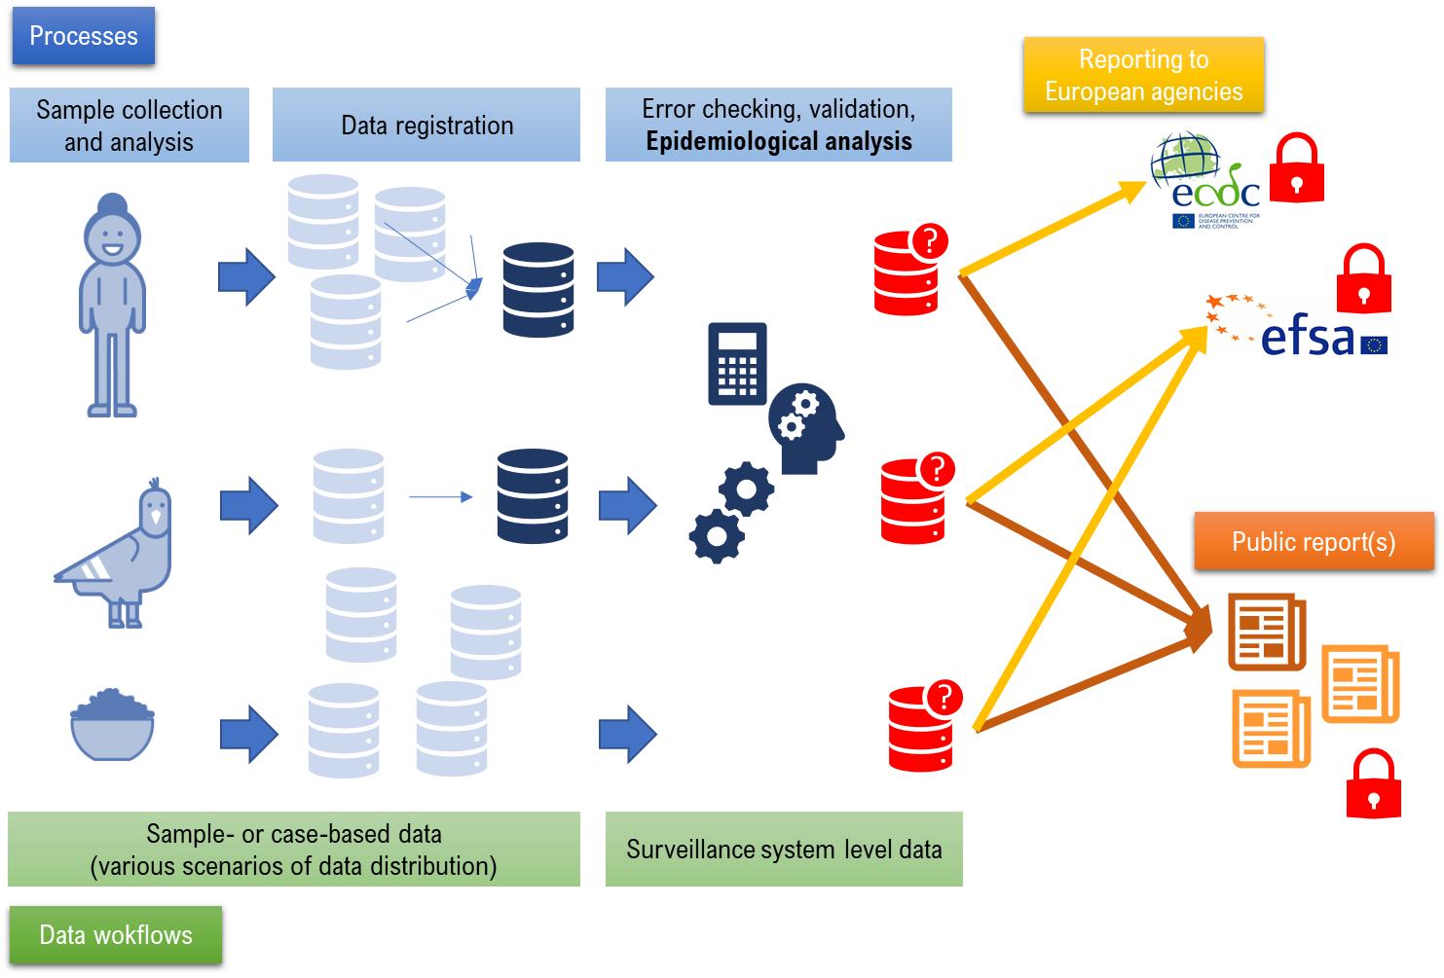
Figure 2. A illustrative view of current data workflows in public health, animal health and food surveillance.
Figure 3 depicts a scenario in which surveillance system level data has achieved semantic operability across sectors, which is the vision of WP3.
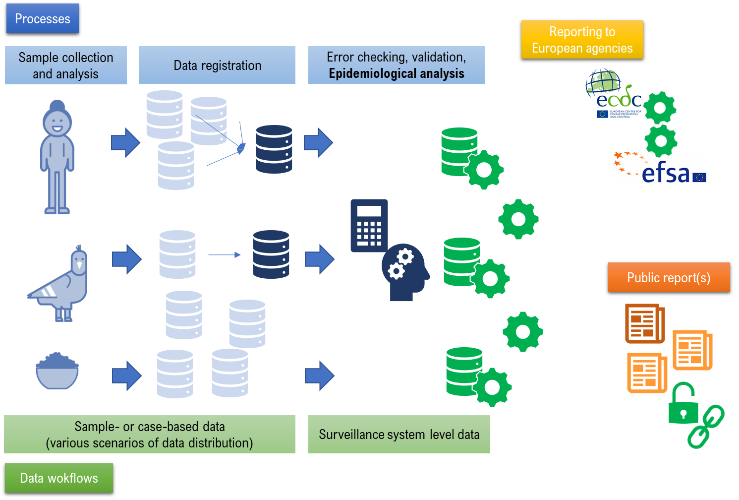
Figure 3. A data workflow in which semantic data interoperability has been achieved among health sectors.
In this scenario, no change in the current governance or accessibility to data is assumed. No new systems or extra workflows are put in place. But structures are created to annotate and store existing data, within the current data workflows, in formats that are interoperable.
As exposed above, the existence of public surveillance reports in every country gives us a target dataset that is already a point of cross-sectorial collaboration. Semantic interoperability at this step would not only facilitate cross-sector collaboration, but also improve the FAIRness of data which are already made accessible to other countries. We add value to existing data by improving its (re)usability. The main advantages of reaching this scenario of data interoperability are:
- Surveillance system data is collated, validated, subjected to error checking and epidemiological analysis only once. After that, they are stored in a system agnostic, machine interpretable format, which can be reused for all the purposes these data are needed for: reporting to European agencies, national reports, or analyse of historical trends across years. Time and resources are saved by reducing duplication in workflows.
- The three sectors become part of the same “surveillance engine”. Since data are interoperable, epidemiological analysis that take into consideration the situation across sectors is a matter of strengthening communication. With no barrier to data integration, collaborative work can start early in the process of data collation.
- Data interoperability across sectors is propagated with the data, so data reported to European agencies is also interoperable, that is, between the ECDC and EFSA.
- The national surveillance reports can be published as “linked data”. Software agents can be pointed to the address where the report was published to “read data”, the same way humans read the PDF.
This first requirement analysis gave us a goal – to annotate the data published in the surveillance reports to make it semantically interoperable across agencies and countries. But how to we get there?

Data interoperability in Health Surveillance
To define what are the state-of-art solutions to achieve data interoperability, we conducted a literature review. The following search string was entered in Scopus:
TITLE-ABS-KEY(data AND (((public OR population OR animal) AND health) OR ((health OR disease* OR infectio* OR zoono* OR veterinar* OR medic* ) AND (surveillance OR monitoring) ) OR (outbreak* OR epidem* OR epizoot*) ) AND (interoperability ) )
The string searches title, abstract and keywords of all published resources indexed in Scopus, to match the following criteria:
- Must have the word “data”
- Must have the word “interoperability”
- The health surveillance scope can be defined by:
  - the occurrence of the expressions “public health”, “population health”, or “animal health”; OR
  - the words “surveillance” or “monitoring” in combination with any of the following words: health, disease, any word with the root “infectio”(covering infection, infectious, etc), any word with the root “zoono”(zoonoses, zoonotic, etc), words with root “veterinar”, or words starting with “medic”.
The search returned 939 unique results, after we excluded publications not in English. We did not exclude conference abstracts, as we were interested in state-of-art solutions, and new ideas and solutions may still not be published in full original articles. Titles and abstracts of all 939 papers were read by 2 reviewers, who voted on inclusion or exclusion.
The following overarching inclusion criterium was used: the publication must refer to a specific data interoperability solution, addressing joint data analysis of data from different sources. The following exclusion criteria were applied:
- Publications which refer to data interoperability in the “data format” sense, not as a challenge to combining content. A particular example of this case were the many papers addressing data interoperability between computers and wearable devices.
- Not primary research.
- Publications which discuss needs and demand for interoperability, not addressing any particular, concrete data interoperability solution.
- Publications focused on data collection guidance (that is, standardisation of data collection, rather than addressing the issue of interoperability of already existing data), data collection tools or database development.
- Publications describing a specific terminology, standard or ontology, but not discussing the scenario of data interoperability it aims to address.
Reviewers were able to vote blind to each other’s vote using the freely available literature review tool Rayyan. Abstracts accepted by at least one reviewer were subjected to full-text review, during which the same inclusion and exclusion criteria were applied, focusing on exclusion criteria that were not obvious from reading only the abstract. One-hundred and eighteen papers were accepted. Five papers were broad discussions of the issue, which were kept as they addressed very specifically the issues raised here, that is, they are focused on cross-domain interoperability and data analysis, or even specific to health surveillance interoperability. We further classified the other 113 approved papers into whether they addressed only structural interoperability, or if they also addressed semantic interoperability. Considering the issues discussed in this document, only the latter were further reviewed. Table 3 details the steps of the screening process.

Table 3. Steps and criteria used to screen publications in a literature review of data interoperability in health surveillance.
Step | Outcome | Number
Scopus search | Retrieved | 939
Abstract review | Approved by at least 1 reviewer (out of 2) | 245
Full-paper review | Approved by 1 reviewer | 118
Full-paper review | Structural interoperability | 30
Full-paper review | Semantic interoperability | 83
Full-paper review | Discussion papers | 5

From the 83 papers focused on semantic interoperability solutions, 46 did not address the issue of cross-domain interoperability specifically. That is, the issue of interoperability among data from multiple sources was addressed, but these sources were generally distributed points of data entry that handled the same type of data. An overwhelming majority of these were papers concerned with electronic health records (EHR), discussing how to reach interoperability among various health care points, and how to reuse those data for clinical research.
Thirty-seven papers proposed solutions in a problem-space directly related to the challenges faced by OHS: data are collected in distributed environments, by different domains, and those data need to be reused in a new context, for decision making. From these 37 papers, 10 were documentations of specific semantic interoperability tools developed, while 27 were focused on a specific problem setting.
We plan to produce a full publication of the results in a peer-reviewed article, and the content of these 37 publications will guide the work of WP3 in the next 2 years of active development, in all 3 working groups.
The main outcome of the literature review were the following conclusions:
- It is widely accepted that semantic interoperability (not only structural interoperability) is the solution needed to address data interoperability when multiple domains and/or secondary use of data are involved. Semantic interoperability assures that data are stored with the information regarding the context in which those data were collected, and therefore ensures that those data can be reused to generate valid conclusions when analysed by third parties.
- The state-of-art in semantic interoperability is the use of linked data, in particular, data transformed into the triple format compliant with RDF (Resource Description Framework), a standard model for data and meta-data interchange on the Semantic Web.
- Publishing semantically enriched data using the RDF format requires the existence of an ontology of one health surveillance. “An ontology defines a common vocabulary for researchers who need to share information in a domain. It includes machine-interpretable definitions of basic concepts in the domain and relations among them”.
Based on these results and conclusions, the technical WG further outlined the architecture that would be needed to support conversion of surveillance system level data into linked data, as presented in Table 4. Notes are added regarding the requirement needs for the implementation of such architecture at the Swedish National veterinary Institute (SVA), leader of WP3, and the institution that would host the One-Health pilot for WP3, as detailed further below.
Table 4. Components of an architecture to support publishing surveillance system level data in the linked data format.
Component | Viable options | Notes
Server hosting | On-premises hosting at SVA*  Cloud-hosting:  Azure  AWS  GCP | Cloud hosting is only an option if there are no confidentiality requirements on the data that is processed in the system. However, if this is the case, such a hosting solution is preferred due to the simplicity of deployment. In this scenario, any cloud hosting provider could conceivably be used. SVA presently has an established business relationship with Microsoft (Azure).
Operating system | Windows  Linux | SVA’s informatics experts prefer Windows, particularly in the on-premises hosting scenario. Established practice if developing on Java infrastructure would be to use Linux, and if developing on .NET infrastructure, to use Windows. Generally speaking, the use of Linux enables simpler reuse of many open source components.
Infrastructure/  Runtime | Java JVM  .NET CLR | The large majority of existing tools and frameworks for Semantic Web / Linked Data tasks are developed to run on the Java JVM, so this is the natural choice. However, competing technologies are getting increasingly more mature over time.
Tabular to RDF data translation | OpenRefine (single-user)  TopBraid Composer (single-user)  Virtuoso triple store import tools  Stardog triple store import tools  CSV2RDF | CSV2RDF URL: https://github.com/theodi/csv2rdf  This component will likely need to be custom-built based on configuring and possibly extending existing components. For single-user prototyping two of the solutions can be used as-is, but for an integrated server-based workflow these are likely inappropriate.
RDF schema translation | OpenRefine (single-user)  Custom SPARQL query library  Custom SADI annotation services | Required to move from one graph representation to another, which will be needed for data integration purposes. Could conceivably be integrated with the tabular to RDF data translation component. This component is likely to be custom-built but reusing existing tools to a large degree.
RDF Store | Virtuoso  Stardog  Jena TDB + Fuseki | An RDF store will be needed if the project is to host user-facing services operating on the published data. If it is sufficient that the data be published as raw triples (a “data dump”) with no such services, the RDF store may not be needed.  It would be cost-prohibitive to develop an RDF store from scratch. Several components exist in this space and should be reused. Features that may be required include:  Geospatial querying  OWL reasoning  SPARQL interface  RDF4J or Jena interface

Existing terminologies and ontologies that can support OHS
As outlined in the conclusions of the literature review, we identified during year 1 that the most value to existing data workflows could be added by providing a knowledge model to support cross-sector data analysis for OHS. A knowledge model is the result of combining data with an ontology which provides the necessary model to interpret data, both by humans and by computers.
SVA has been working, funded by the Swedish Innovation Agency (Vinnova), on an ontology for animal health surveillance. Co-funded by Vinnova, the knowledge modelling WG was tasked with expanding the “animal health surveillance ontology” (AHSO), into a one-health surveillance ontology.
Several terminology catalogues already exist in health and epidemiology, and we highlight in particular those implemented by EFSA and ECDC to achieve structural interoperability among member states (MS). Ontologies can incorporate these existing resources and re-use all their knowledge. But we move beyond the listing of concepts and include also “relationships” between concepts (semantics), creating a knowledge model for health surveillance. A machine-interpretable version of the domain knowledge offers several advantages, as demonstrated through the literature review. In particular:
- Use of automated reasoners to make inferences and detect errors in the data.
- Flexibility to accommodate to knowledge growth and updates.
- Reuse. Ontologies are meant to model specific pieces of knowledge, in a way that allows linking to complementary pieces. As epidemiology is highly multi-disciplinary, the use of ontologies allows us to piece together expertise from many different domains.
- Interoperability. Terminologies allow humans to understand each other and agree on what things mean. Ontologies allow software to talk to each other.
We have placed background materials on ontologies in general, and AHSO in particular, at: http://datadrivensurveillance.org/ontology/.
With the goal of reusing as much knowledge as possible, in preparation for the active development phase in year 2, this WG carried out an inventory of existing resources that can support the creation of an ontology for OHS. The results are presented in Annex II. We identified 42 resources related to the health surveillance domain. From those, 24 were considered relevant to contribute, in some manner, to the OHS ontological framework (highlighted in green or yellow in Annex II). Four are ontologies which contain useful concepts, but do not appear to be under active development, and therefore we would need to import their concepts and review the associated structure. Another 11 resources contain useful concepts, but are terminologies or vocabularies not constructed using a semantic framework, or are not available in OWL, and therefore cannot be readily imported into the ontological framework. Nine ontologies available in OWL could contribute directly to the framework, and are highlighted in green in the Annex II.

Conclusions regarding the way forward
The results of our requirement analysis allowed us to set the following main goals for the work to be carried out within this WP in the next two years:
- Build an ontological framework for one-health surveillance (OHS) that allows computers to understand and reason with current data terminologies in the same way that humans do, maximising the benefit to cost ratio of the effort put into producing surveillance data;
- Improve usability of data inside the institutions who own and/or use the data, as well as the potential for reuse by external stakeholders and for research and discovery.
We will make sure this task is achievable within the time period of ORION by focusing on a very specific part of the surveillance data workflow: the data already shared publicly through national reports. Moreover, we will start from only a few foodborne diseases as a proof-of-concept.
The “One health surveillance pilot” that will test the application of the proposed framework in practice will be a joint effort of the Swedish National Veterinary Institute (SVA), and the Public Health Agency of Sweden (FoHM), advised by EFSA and ECDC. SVA and FoHM have chosen the surveillance against Campylobacter spp. as the primary focus of the pilot, and in secondary focus we will also revise surveillance data for Salmonella spp, and E.coli EHEC.

In this pilot, we will work to improve coordination and cooperation among public health, animal health and food surveillance agencies, so that the production of the surveillance report becomes a true one health initiative, with communication and data sharing starting as soon as we start analysing the data.
Our goal is to support collaborative data analysis among health sectors. At the end of the pilot, we aim to have the Swedish national surveillance report chapters on foodborne diseases published as “linked data”, backed up by an ontology (a “key” for software agents to be able to make meaningful use of the data). The knowledge model (data plus “key”) will be made publicly available. We will also publish guidelines to allow other MS to adopt the same structure, if desired, to support their internal collaboration across agencies, or even also publish public linked data.
The 3 parallel working groups, previously described in this document, will support these goals as follows:
- The surveillance practice WG will continue mapping the data workflows from data collation to production of the Swedish surveillance report, and working to improve inter-agency collaboration as early in the process as possible. In particular, this track will lead multi-agency collaborative discussions – the surveillance report workshops. This WG aims to understand how the technology can support and strengthen the collaboration work. Moreover, it aims to understand how we can support the production of linked data through the existing practices, without adding an extra burden on those who carry our data analysis and publishing.
- The technical development WG will be supported by a consultants (sponsored by co-financing to ORION) which are developing the necessary tools to support data annotation using the ontology, as well as storage and access to linked data.
- The knowledge modelling WG, advised by ontology experts from the computer science field, and supported by expert elicitation from ORION partners, will develop the ontology to support OHS data annotation and analysis. All resources can be consulted here: http://datadrivensurveillance.org/ontology/
By focusing on the surveillance report, we will be able to demonstrate the benefits of interoperable data in the part of the current data workflow that involves the greater amount of inter-agency collaboration, allowing technical developments and mutual collaboration efforts to support each other.
This work focus on data usability, maximising the value of data produced within current workflows, rather than creating extra workflows. Our aim is to keep the current workflows, which are a result of extensive national and multi-national collaboration efforts, but create a new layer of data interoperability across health surveillance sectors, adding value to existing practices. After this “proof-of-concept” pilot, applying these methods to other parts of the surveillance data workflow, in the future, would lead to ever improving timelines in the production and sharing of data for One Health.
The pilot will be conducted in Sweden, where it is supported by the multi-agency group that already produces the surveillance report (animal health, public health and food safety surveillance agencies in Sweden). The tools developed, however, will be publicly available and we will provide guidelines for their implementation by other countries. The goal is to improve usability of data with potential to inform decisions in OHS. The literature review showed that these tools can be particularly useful in low resource settings, where the scarcity of data increases the need to provide efficient tools to convert data into actionable information. Therefore, we expect that the results will be useful across a range of European member states.

Annex I: Structure for the discussion regarding data workflow, which was sent ahead to each of the interviewees for the requirement analysis
Data workflows and interoperability needs to advance One Health Surveillance
Data workflows specific to foodborne disease surveillance
In particular: Campylobacter, Salmonella, EHEC
- After collection of case- or sample-based data within specific surveillance systems, these data are collated, analysed epidemiologically, and reported to EU agencies (EFSA and ECDC, mainly) once a year. Considering specifically these data at the surveillance system level, collation and analysis:
  - Are these data also made available in any other way? For example a national report, or made available on your website, etc?
  - Where and in which formats are they made available?
  - How do the timelines compare? Are parts of the workflow reused to produce the EU reports and the national reports? Are these other reports also only produced once a year?
  - What is the data collation process – how does the registration of surveillance system data compare to the collation of sample-based / case-based data? Are these data stored in any central database/repository so that it can be reused for other purposes? Can it be reused historically (can you retrieve the data from previous years)?
- Multi-agency collaboration:
  - Are data shared with other health agencies (Animal health / public health / food safety)?
  - At what point of the data analysis and reporting workflow?
  - How is the mode of collaboration (for instance analysing data together, or analysing data separately and just putting it all in the same report).
- Do you ever look at reports from other countries? Would it be useful to have them available as open data so that you could access historical trends for other countries?
- Overall, please think about frustrations in the workflow, specifically related to data access, data usability, data reusability, data interoperability, workflow delays. In other words, what are the main frustrations due to waste/repetition of human effort with data workflows, lack of possibility to reuse data, etc.
- Any disease specific differences in the data workflow, which are worth remarking?

Annex II. Inventory of ontologies and terminology resources that could be useful in the construction of an ontology to support OHS
Rows highlighted in green are ontological resources with high potential for direct reuse: the concepts are valuable for OHS, available publicly and in the OWL language, and the ontology seems to be active. Rows highlighted in yellow are resources that may offer concepts for reuse, but they would need to either be coded into an ontological framework within the ORION project (terminologies and vocabularies not available as an ontology) or updated within the project (inactive ontologies). Other resources related to epidemiological knowledge are presented, but those with no highlighting (white background) were not considered to be useful in the near future, during the OHS ontology development phases that will be carried out within ORION.
Ontology | OWL | Notes | Source and references
AEO (Anatomical Entity Ontology) | YES | AEO is an ontology of anatomical structures that expands CARO, the Common Anatomy Reference Ontology, providing a detailed type classification for tissues. It focuses on humans and the last recorded activity was in 2015. | http://bioportal.bioontology.org/ontologies/AEO
ARO | ? | “ARO is a key component of the Comprehensive Antibiotic Resistance Database (CARD), a recently developed resource for AMR molecular surveillance that includes a curated collection of AMR gene and mutation sequences, bioinformatics models for their detection, and software in the form of the Resistance Gene Identifier (RGI) for their detection in raw genomic and metagenomic sequences.”.  CARD is available online (https://card.mcmaster.ca/download) but ARO was not found as a separate set of downloadable codes.  See notes on GenEpiO. | Part of the GenEpiO framework (genepio.org)
ATOL (Animal Trait Ontology for Livestock) | YES | Domains: Welfare, Growth and meat production trait, Mammary gland and milk production trait, eggs, nutrition, reproduction and fertility. Last updated in 2014. Doesn’t seem to be active, but could be a source for concepts reuse and update within the AHSO framework. | https://bioportal.bioontology.org/ontologies/ATOL
BioCaster | YES | Useful content - associations between:  - pathogen and host (<hasPrimaryHost>)  - disease and symptom (<hasSymptom>)  - disease and country (<notifiableIn>)  - pathogen and organ (<infectsOrgan>)  - pathogen and mode of transmission to humans (<hasTransmissionMode>)  - disease and symptom (<hasSymptom>).  The central backbone taxonomy is deliberately shallow and taken from the ISO’s Suggested Upper Merged Ontology. The last public update was in 2016. Designed specifically to mine news text online for event detection, so it only addresses some of the complexity needed.  The structure does not readily fit the more complex and deep framework planned for AHSO, but a number of concepts could be reused. | https://github.com/nhcollier/biocaster-ontology
CARO (Common Anatomy Reference Ontology) | YES | References mention that “will provide a template for building new anatomy ontologies. […] combining FMA and model organism anatomical ontologies. How this will be achieved is yet to be decided.”  But it doesn’t seem to have been developed since 2011. | http://www.bioontology.org/wiki/index.php/CARO:Main_Page
CMO (Clinical Measure Ontology) | NO | The Clinical Measurement Ontology is designed to be used to standardize morphological and physiological measurement records generated from clinical and model organism research and health programs | https://bioportal.bioontology.org/ontologies/CMO
CSSO (Clinical Signs And Symptoms Ontology) | YES | Lists signs by organ systems, but focuses on humans only. Last updated in 2016. | https://bioportal.bioontology.org/ontologies/CSSO
DOID (Human Disease Ontology) | YES | Focuses on humans, and it has been criticized for a poor organization, that does not follow semantic practices and confuses for instances issues of disease types with disease locations. It also focuses only on humans. It can be a good source of concepts, but for ontological organization we should refer to IDO (below). | https://bioportal.bioontology.org/ontologies/DOID
ECO (Evidence and Conclusion Ontology) | NO | An ontology of evidence types for supporting conclusions in scientific research. Seems more appropriate for documenting experiments and observational studies, rather than the type of data generally used for surveillance. | https://bioportal.bioontology.org/ontologies/ECO
EFSA’s terminology cataligues | NO | The European Food Safety Authority provides several catalogues harmonizing terminology for collecting and analysis of data related to animal and food safety. | https://zenodo.org/record/344473#.XAi7mmhKiI5
ENVO (Environment Ontology) | YES | EnvO is an OBO Foundry and Library ontology for the concise, controlled description of environmental entities such as ecosystems, environmental processes, and environmental qualities. | https://bioportal.bioontology.org/ontologies/ENVO
EPO (Epidemiology Ontology) | YES | From their homepage on the OBO Foundry: “The Epidemiology Ontology is an ontology designed to support the semantic annotation of epidemiology resources. It is being developed under the EU-funded EPIWORK project, a multidisciplinary research effort which aims at increasing the amount of epidemiological data available, improving disease surveillance systems, and promoting the collaboration among epidemiological researchers. The EO is integrated into NERO (Network of Epidemiology Related Ontologies), a collection of existing ontologies that supports the semantic annotation of epidemiology resources contained in the Epidemic Marketplace (EM), a platform for sharing resources and knowledge within the Epidemiology community.”  Neither of these resources seems to be active or available online any longer. | http://www.obofoundry.org/ontology/epo.html
ESSO (Extended Syndromic Surveillance Ontology) | YES | An ontology for syndromic classification of emergency records and radiological diagnostics. Focuses on humans. Follows Biocaster. Has not been updated since 2009. | https://bioportal.bioontology.org/ontologies/SSO
FMA (Foundational Model of Anatomy) | YES | Ontology of anatomical locations - focuses on humans only. | http://www.obofoundry.org/cgi-bin/detail.cgi?id=fma_lite
FoodOn (Food Ontolog) | YES | A broadly scoped ontology representing entities which bear a “food role”. It encompasses materials in natural ecosystems and food webs as well as human-centric categorization and handling of food.  Useful for modeling concepts in foodborne disease surveillance. | https://bioportal.bioontology.org/ontologies/FOODON
Galen | YES | An ontology of surgical procedures, last updated in 2009. | https://bioportal.bioontology.org/ontologies/GALEN
GenEpiO (Genomic Epidemiology Ontology) | YES | “The Genomic Epidemiology Ontology (GenEpiO) covers vocabulary necessary to identify, document and research foodborne pathogens and associated outbreaks.”  The ontology goals and project development structure are very aligned with AHSO, though the focus here is on humans and surveillance reports, rather than secondary use of data. We will try to focus on areas not covered by GenEpiO, so that we can build complementary, rather than overlapping modules. | https://bioportal.bioontology.org/ontologies/GENEPIO
GO (Gene Ontology) | YES | Highly successful ontological framework that models three main concepts: molecular function (molecular activities of gene products) ; cellular component (where gene products are active); and  biological process (pathways and larger processes made up of the activities of multiple gene products). Offers good examples of how to build a community and develop a framework together, but the actual ontology is not useful for AHSO at the moment. | http://www.geneontology.org/
Host Pathogen Interaction Ontology (HPIO) | YES | Ontology for host pathogen interactions in farmed animals. This was a small modules which focused on the interactions between pigs and salmonella. It has not been updated since 2011, and it didn’t evolve to other interactions, but it is a good example of how ontologies can be developed in modular pieces. | https://bioportal.bioontology.org/ontologies/HPIO
ICAR (International Committee for Animal Recording) | NO | The International Committee for Animal Recording publishes standards for disease recording in livestock animals, as well as for the recording of animal genetic traits and production performance. | http://www.icar.org/
IDO (Infectious disease Ontology) | YES | Suite of interoperable ontology modules that together cover the entire infectious disease domain  IDO consists of a core ontology (henceforth “IDO Core”) intended to cover terms common to all infectious diseases (e.g., ‘host’, ‘pathogen’, ‘infection’, ‘immunity’), and a suite of extension ontologies for specific diseases. | http://www.obofoundry.org/cgi-bin/detail.cgi?id=infectious_disease_ontology
LOINC (Logical Observations, Identifiers, Names and Codes) | NO | LOINC is an international standard for identifying health measurements, observations, and documents. It is not in ontological format, but due to broad use and public availability, it may be important to consider the concepts covered, and how they map to other resources. | http://loinc.org/downloads
MeSH (Medical Subject Heading) | NO | MeSH is the National Library of Medicine's controlled vocabulary thesaurus. It is a good source of concepts, but the concepts are not organized following description logics. Some concepts are placed in multiple parts of the hierarchy. | http://www.nlm.nih.gov/mesh/MBrowser.html
MP (Mammalian phenotype ontology) | YES | Models abnormal morphology and physiology of specific systems. | https://bioportal.bioontology.org/ontologies/MP
NCBI (National Center for Biotechnology Information (NCBI) Organismal Classification) | NO | The NCBI Taxonomy Database is a curated classification and nomenclature for all of the organisms in the public sequence databases.  This should be a reference for the listing of organisms, such as pathogens. | http://bioportal.bioontology.org/ontologies/NCBITAXON
OBI (Ontology of Biomedical Investigations) | YES | OBI is a model to report scientific investigations. The structure used to define assays, devices, objectives, etc, should be studied and is possible reused when modeling a surveillance system. | http://obi-ontology.org/
PATO (Phenotypic Quality Ontology) | YES | “Phenotypic qualities (properties). This ontology can be used in conjunction with other ontologies such as GO or anatomical ontologies to refer to phenotypes. Examples of qualities are red, ectopic, high temperature, fused, small, edematous and arrested.” | https://bioportal.bioontology.org/ontologies/PATO
PDO (Pathogenic Disease Ontology) | YES | An ontology to describe infectious diseases. It is focused on humans only, but should be compared to IDO and concepts reused when relevant. | https://bioportal.bioontology.org/ontologies/PDO
PTRANS (Pathogen Transmission Ontology) | NO | Models the transmission process (“a process that is the means of how a pathogen is transmitted from one host, reservoir, or source to another host. This transmission may occur either directly or indirectly and may involve animate vectors or inanimate vehicles”). It has not been updated since 2010. As AHSO will not model events, but observations, it is not clear yet if we would need some of these concepts. | http://bioportal.bioontology.org/ontologies/PTRANS?p=summary
REPO (Reproductive Trait and Phenotype Ontology) | YES | Ontology for livestock reproductive traits and phenotypes. Not updated since 2011. | https://bioportal.bioontology.org/ontologies/REPO
RxNorm | NO | Standardized nomenclature for clinical drugs. | http://bioportal.bioontology.org/ontologies/RXNORM
SNOMED-CT | NO | A very extensive clinical health terminology. It follows description logic to some extent, but cannot be readily modelled as an ontology. As it is a very complete list of clinical concepts, it should be used to inform AHSO and mapping to SNOMED terms and other resources considered should be taken into account. | http://bioportal.bioontology.org/ontologies/SNOMEDCT
SSO (Syndromic Surveillance Ontology) | YES | Focus on humans, and modelled four syndromes (from chief complaint text): influenza-like-illness, constituional, respiratory and gastrointestinal. Some lessons were documented regarding expert agreement processed, which will be informative. But the ontology is obsolete as has been replaced by ESSO (see above). | http://bioportal.bioontology.org/ontologies/SSO
SurvO (Surveillance Ontology) | ? | “SurvO will define key indicators of reportable disease surveillance systems”.  Still in the planning phase. See notes on GenEpiO. | Planned as part of the GenEpiO framework (genepio.org)
SYMP (Symptom Ontology) | YES | An ontology focused on clinical symptoms (understood as “A perceived change in function, sensation or appearance reported by a patient indicative of a disease”). For AHSO we need to focus on clinical signs, as symptoms are a human specific concept. | https://bioportal.bioontology.org/ontologies/SYMP
UBERON | YES | “Uberon is an integrated cross-species anatomy ontology representing a variety of entities classified according to traditional anatomical criteria such as structure, function and developmental lineage. The ontology includes comprehensive relationships to taxon-specific anatomical ontologies, allowing integration of functional, phenotype and expression data.” | https://bioportal.bioontology.org/ontologies/UBERON
UMLS (Unified Medical Language System) | NO | “The UMLS integrates and distributes key terminology, classification and coding standards, and associated resources to promote creation of more effective and interoperable biomedical information systems and services, including electronic health records”.  This comprehensive collection of standards is broadly adopted and should be consulted as a source of terms for AHSO, and mapping to other resources also considered. | https://www.nlm.nih.gov/research/umls/
vHOG  (Vertebrate Homologous Organ Group Ontology) | NO | “vHOG is a multi-species anatomical ontology for the vertebrate lineage”. It is not available in OWL and UBERON seems to be more complete and more broadly adopted. | http://bioportal.bioontology.org/ontologies/VHOG
VO (Vaccine Ontology) | YES | An ontology for vaccines. To be consulted when we reach a module that may need modeling vaccines. | http://bioportal.bioontology.org/ontologies/VO
VSAO (Vertebrate Skeletal Anatomy Ontology) | YES | An anatomy ontology covering the vertebrate skeletal system. It is too specific in focus, so we should focus on UBERON. | https://bioportal.bioontology.org/ontologies/VSAO
VSMO (Ontology for Vector Surveillance and Management) | ? | Available as a publication (S S Lozano-Fuentes, A Bandyopadhyay, L G COWELL, A Golfain, and L Eisen. Ontology for vector surveillance and management. Journal of medical entomology, 50(1):1–14, 2013), but no actual online resource to download the ontology. | .

HIMSS Dictionary of Healthcare Information Technology Terms, Acronyms and Organizations, 2nd Edition, 2010, Appendix B, p190
https://www.force11.org/group/fairgroup/fairprinciples
Linked Data refers not only about datasets, but recommended best practices for exposing, sharing, and connecting pieces of data, information, and knowledge on the Semantic Web. The Semantic Web is about making links between datasets that are understandable not only to humans, but also to machines. http://linkeddata.org/
https://rayyan.qcri.org. Mourad Ouzzani, Hossam Hammady, Zbys Fedorowicz, and Ahmed Elmagarmid. Rayyan — a web and mobile app for systematic reviews. Systematic Reviews (2016) 5:210, DOI: 10.1186/s13643-016-0384-4.
https://www.w3.org/RDF/
Natalya F. Noy and Deborah L. Mcguinness. 2001. Ontology Development 101: A Guide to Creating Your First Ontology. Available at http://protege.stanford.edu/publications/ontology\_development/ontology101.pdf

