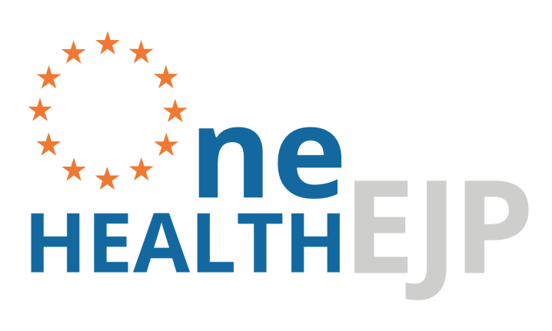

Deliverable WP2 2.5 - Status report on OH Knowledge Base - NGS
Workpackage 2-NGS

Responsible Partner: 33-NVI

GENERAL INFORMATION

European Joint Programme full title | Promoting One Health in Europe through joint actions on foodborne zoonoses, antimicrobial resistance and emerging microbiological hazards
European Joint Programme acronym | One Health EJP
Funding | This project has received funding from the European Union’s Horizon 2020 research and innovation programme under Grant Agreement No 773830.
Grant Agreement | Grant agreement n° 773830
Start Date | 01/01/2018
Duration | 60 Months

DOCUMENT MANAGEMENT

Deliverable | JIP1-2.5 - Status report on OH Knowledge Base - NGS
WP and Task | JIP1 – WP2-NGS - T-2.3
Leader | Karin Lagesen (NVI)
Other contributors | Karin Lagesen (NVI), Umaer Naseer (NIPH), Thomas H.A. Haverkamp (NVI), Jeevan Karloss Antony Samy(NVI, NIPH), Wonhee Cha(SVA), Cecilia Jernberg (FOHM), Mia Torpdahl (SSI).
Due month of the deliverable | M24
Actual submission month | M24
Type  R: Document, report  DEC: Websites, patent filings, videos, etc.  OTHER | R
Dissemination level  PU: Public  CO: confidential, only for members of the consortium (including the Commission Services) | PU

Use of NGS for suveillance –
year report 2019 ORION WP2-NGS

Executive summary
The main goal of this work package is to create a One Health Knowledge Hub (OHKH) for NextGen analytical data, methods, analyses and systems. The goal of the tasks in this work package in 2019 has been on establishing a framework for the handbook, as well as exploration of data management and analysis tools and other infrastructure related issues. This work has been done through site visits, online meetings with users and developers of such platforms, and also hands-on experimentation with the platform tools.
In addition, we have also started the work for the pilots. This work package has several associated pilots - a pilot in Norway focused on infrastructure and on cross-sector investigation of Listeria, a UK pilot focusing on collaboration between the veterinary and public health sectors with regards to Salmonella, and a Danish pilot focusing on real time sequencing based investigation of Campylobacter outbreaks. This work is as it is proceeding resulting in input for the handbook.
Through the work done 2019, we have come up with what we believe to be a good framework and suggestions for what should be included in the OHKH within this area. This year report contains information based on our work within work package in 2019.

ORION-NGS Handbook framework
A main focus for the work this year has been on establishing a platform for the ORION NGS handbook. This is one of the main deliverables from this work package. As a framework for this handbook we have selected to use the ReadTheDocs (https://readthedocs.org/) platform. ReadtheDocs is a platform that allows for creating well organized online documentation without any prior web-building knowledge. This allows everyone involved to contribute without spending time on learning how to build a website. This platform is also in common use in the bioinformatics community. We believe that these features will contribute to the sustainability of the handbook, in that people outside of ORION can also contribute once the framework has been established.

ReadtheDocs uses a Github repository to create HTML pages online with unique URLs for the documentation. A contributor creates content in GitHub using the markdown language in reStructuredText (.rst) files. Then the GitHub repository is connected to ReadtheDocs using GitHub and the webpages are created under a unique URL. Every time a contributor makes changes in GitHub and commits/saves the changes, the changes will be reflected in ReadtheDocs page. Guidelines on how contributions can be done is documented in the handbook.

Here are the links for the ORION NGS GitHub repository and handbook.
https://github.com/NorwegianVeterinaryInstitute/ORION_HandBook
https://orion-handbook.readthedocs.io/en/latest/index.html

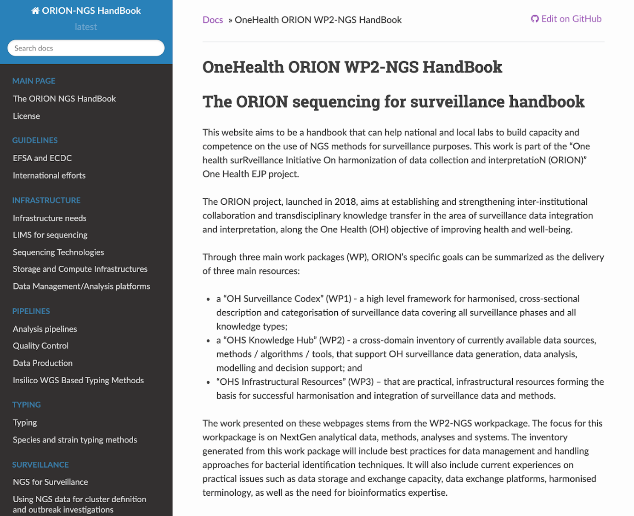

Figure 1: Front page of the ORION NGS HandBook

The handbook currently consists of the following sections:
overview over public guidance documents from institutions such as EFSA and ECDC
discussions regarding infrastructure solutions for sequencing and analysis
review of bioinformatics tools and pipelines used for analyzing and typing foodborne pathogens
databases and other resources needed to perform species specific analyses
guidance on how to use typing data for surveillance and outbreak detection, including clustering guidelines.

The work done regarding infrastructure in 2019 is currently migrating into the handbook. A main focus for spring 2020 will be on building more content. In cases where an area is already more fully explored elsewhere, the handbook will act as a guide to those resources.

Data management and analysis platforms (DMAPs)
One of the main sections of the handbook discusses the infrastructure and data management tools that are needed to do sequencing for surveillance. In 2019 we have evaluated two data management and analysis platforms, namely IRIDA and INNUENDO. In order to evaluate these platforms, we first had face-to-face and online meetings with developers of these DMAPs. In these meetings we got valuable information regarding the status of the projects, their user base, and their further development plans. We also conducted meetings with current users of these platforms to get their impressions regarding how the platform worked for their use cases.

We also performed hands-on tests of these platforms. For a first evaluation, we asked the developers of the two platforms if they could give us access to a test instance. This allowed us to see how the platforms worked in practice. We have in addition attempted to install the platforms ourselves, to help discover how installable they are and what competence and resources are required to run the platforms. Our test install of IRIDA was successful, however, we are still working on seeing what is required to get Innuendo installed. Through our installation experience, we also have evaluated the technical support from the developers team.

Based on our face-to-face, online meetings and hands-on experience with IRIDA and INNUENDO so far, we summarize our current evaluation in three key points.

IRIDA is a good choice where different research groups or institutes want to use/share/collaborate one DMAP with defined access control on their data and results. On the other hand, INNUENDO is a good choice where each research group wants to have their own independent platform for their data and results.

IRIDA needs more hardware and human resources than INNUENDO since IRIDA is designed as an institutional level or inter-institutional level DMAP and INNUENDO is designed more as a research group level DMAP.

IRIDA has a well established core developer group with continuous developments and bug fixes, clear-working installation documentation, installation and user support. As of now, INNUENDO is re-establishing their developer group. Thus installation and user support as well as installation documentation is not currently at the level of IRIDA.

Information gathering
Throughout this year we have also conducted several face-to-face and online meetings with people at various veterinary and public health labs in Europe to discover their experiences with doing sequencing for surveillance. Our main focus for these meetings was on exploring the work processes and the best practices that these labs had gathered in their work with establishing sequencing as a tool at their institutions.

The labs we visited in person in connection with this work were Public Health England (PHE), Statens Veterinærmedisinska Anstalt (SVA) and Folkhalsomyndigheten (FOHM), both in Sweden, and also Istituto Zooprofilattico Sperimentale dell'Abruzzo e del Molise (ISZAM, Teramo, Italy). Additionally, we had an online meeting with Statens Serumsinstitut (SSI) in Denmark.

In these meetings we aimed to map their complete work process, from the incoming samples to the finished analysis. While we are still in the process of distilling the knowledge gathered from these meetings, some preliminary conclusions are clear. First, most of the labs that we talked to were public health labs. These generally begun incorporating whole genome sequencing into their processes at an earlier date than the food and veterinary labs. The labs we talked to started sequencing from 2013 and onwards. They have all gathered a dedicated bioinformatics team, however, there seem to be relatively few computer scientists involved in the process. While the laboratory processes seem to be quite standardized, the labs all presented widely different solutions with regards to bioinformatics analyses. It was noted that each lab had developed their own in-house system for processing their data. It was also clear that there was relatively little interaction between labs with regards to development of analysis systems and pipelines, despite these labs all being geographically close and mostly within the same sector. Thus it was evident that even for established labs there could be significant gains from development of resources for sharing analytical processes.

Collaboration with Listadapt and COHESIVE
A significant part of the Oslo pilot (described below) focuses on setting up a shared infrastructure, including databases, to allow for collaborative analyses of Listeria. For these reasons, we visited ISZAM in Italy, who is a partner in the ListAdapt and COHESIVE OHEJP projects. Our aim was to learn about their Listeria monocytogenes (LM) bioinformatics analysis pipeline and their newly developed COHESIVE Information System (CIS).

During our visit to ISZAM, we had a technical meeting with the goal to obtain more information on the schematics of the locally developed LM bioinformatics pipeline. Our aim is to compare their pipeline with other available LM specific pipelines and to create a pipeline for LM whole genome sequence (WGS) analysis. This pipeline will produce a report which contains quality of the reads, assembly statistics, cgMLST, annotation, Antimicrobial Resistance (AMR), Virulence, Phylogenetics, tools version numbers, and other information.

In addition we had user and technical level meetings to get to know about CIS. CIS is a browser based database managament system (DBMS) with a secure login system. CIS can be the intermediate system connecting laboratory information management system (LIMS) and whole genome sequencing data, analysis and reports.

Through this meeting we came to know how CIS can be useful for WGS data management, how it was developed, how it can be installed and the resources needed for installation. CIS can be modified (add/delete) based on the institution’s need. A fully configured CIS can be obtained in a Virtual Machine (VM) which can be deployed quickly.

Our aim is to install one of the DMAPs (eg. IRIDA) in a national infrastructure and connect with our inhouse NextGen sequencing facility. Sequencing data will be transferred to the DMAP for bioinformatics analysis. CIS will help us to extract information about the samples from our LIMS and integrate to the WGS data at DMAP for analysis.

This knowledge will help us to connect CIS to our LIMS and DMAP (eg. IRIDA).

Work done in connection with the WP2-NGS pilots
There are four pilots attached to this work package.

The Norwegian pilot is a collaboration between the Norwegian Veterinary Institute and the Norwegian Institute for Public Health. The aim for this pilot is to set up an analysis platform that can be used by both institutions, and focuses on the analysis of Listeria monocytogenes. The target is to create a system that can allow for real time surveillance of L. monocytogenes in food products in Norway, and to enable comparison between isolates from patients with those found in food products. Within this pilot we are currently in the process of setting up an analysis platform. Our chosen platform is IRIDA, and we are currently running a test installation of that platform to see how that behaves. We are currently in negotiations with a national e-infrastructure provider to see if we can outsource the infrastructure to that provider. We are in addition currently mapping the analysis pathway that is currently in use at the NIPH for Listeria and comparing that to the pathway used at ISZAM, Italy. We are in addition drawing on information found in recommendations from the ECDC regarding analysis of Listeria, and also the preliminary ISO standard for whole genome sequencing for typing and genomic characterization of foodborne bacteria. Our aim is to create an analysis pipeline that complies with the requirements of ECDC and EFSA, and that others can also use for analyzing Listeria. This process will also result in information for the handbook on best practices for Listeria analysis.

The Danish pilot focuses on Campylobacter jejuni, which is the leading cause of bacterial gastroenteritis in industrialized countries. Despite the high disease burden outbreaks are rarely reported, which may reflect limitations of the current surveillance where molecular typing is not routinely performed. Whole-genome sequencing (WGS) has been performed on 1,509 C. jejuni isolates collected from Danish patients (n=774) and food/animal sources (n=735) in 2015-2017 to determine the frequency of genetic clusters among patients and to find links to concurrent poultry meat, broilers, cattle, pigs and dogs. Prospective core-genome MLST analysis has revealed numerous clusters with 366/774 (47.3%) clinical isolates forming 104 clusters of two or more isolates. Forty-one patient clusters representing 199/366 (54%) patients matched a potential source, primarily domestic chickens/broilers. This study has revealed serial outbreaks and numerous matches to concurrent food and animal isolates. The knowledge gained has formed the basis of a new study, that includes real-time WGS and analysis on samples of Campylobacter isolates received from March to December 2019. Isolates include both human isolates mostly from a specific region in Denmark and food and animal isolates for source tracing. Data analysis has been followed by epidemiological follow-up (patient online questionnaire) on isolates from patients included in clusters.

The UK pilot is focusing on harmonizing data transfer between PHE and APHA with regards to Salmonella surveillance. In order to accomplish this, this pilot focuses on the legal and practical framework that is needed to enable data sharing and collaboration between the two institutions.

There is also a Swedish pilot planned, but not yet fully decided on. This pilot will, if it proceeds, focus on collaboration between SVA and FOHM. It is likely to have its main focus on infrastructures, and is likely to focus on either Salmonella or STEC. More information on this pilot will be available early 2020.

Dissemination and training
The work in this work package was presented as a poster at the “Applied Bioinformatics and Public Health Microbiology” conference in Cambridge in May 2019. This work was also presented at an internal event for the microbial genomics online community in February, 2019. In addition a paper has been written on the basis of the results of the Danish pilot.

This work package hosted a two-day bioinformatics pipeline building workshop for the One Health EJP in October 2019. This workshop had 18 participants from 8 different countries. In this workshop the participants got an introduction to the Nextflow pipeline building language. The instructors were Paolo di Tommaso and Even Floden, both developers of the language.

Appendix: ORION WP2-NGS meeting list

Date | topic | Types of Meeting
2019-01-15 | Visit to Folkhälsomyndigheten - Sweden – NGS-Meeting | In person
2019-01-18 | Meeting with SVA – Sweden | In person
2019-02-04 | Conference call with ECDC, discussion about Pilot project | Teleconference
2019-02-27/28 | Visit to Public Health England – Introduction into their NGS surveillance platform | In person
2019-03-08 | Meeting with Carrico – Walkthrough of Innuendo platform. | Teleconference
2019-03-29 | Meeting with Salmenlinna at THL Finland | Teleconference
2019-05-09 | WGS surveillance on foodborne pathogens in Denmark. | Teleconference
2019-05-21 | Meeting with Claire Bertelli- IRIDA user/advisor | Teleconference
2019-06-05 | Meetings with IRIDA users from Quadram institute Nabi Khan and Andrew Pagel | In person
2019-06-06 | Meeting with INNUENDO user (Jani) from THL, Finland | In person
2019-06-18 | Meeting with Irida developers team | Teleconference
2019-09-16 | COG wheel Infrastructure-Workshop in Dubrovnik | In person
2019-09-30 | Meeting between ORION WP2-NGS and EFSA | Teleconference
2019-11-19 | NGS data storage and analysis Pipeline meeting at Adriano at IZS, Teramo | In person

