Lesson Title: Practice with Expansion |  | Theme: Algebra
Practice Activity: PHM-08-116 |  | Class: JSS 2
Learning Outcome

By the end of the lesson, you will be able to expand an algebraic expression by multiplying.

Overview
In today’s lesson, you will expand algebraic expressions. Expanding means removing the brackets. For example, consider $2(5x-4)$. In order to simplify such expressions, we must first remove the brackets. In removing brackets, multiply the term outside the bracket by each of the terms inside the bracket.
We must be very careful with signs when removing brackets. When there is a positive (+) number before the bracket, the sign inside the brackets does not change when the brackets are removed. When there is a negative number (−) in front of the brackets, the signs inside the bracket change when the brackets are removed. This is because of the rules of multiplication.
Remember the rules for multiplying positive and negative numbers:
- Positive x Positive = Positive
- Negative x Positive = Negative
- Positive x Negative = Negative
- Negative x Negative = Positive
Solved Examples
- Simplify: $2(5x-4)$
Solution
Multiply 2 by each term inside the brackets. The terms inside the brackets are $5x$ and $-4$.
$2(5x-4)$ | $=\left(2×5x\right)+(2×-4)$ | Multiply each term by 2
 | $=10x-8$

- Simplify: $-4(2y-3)$
Solution
This is an example of a problem with a negative number in front of the brackets.
$-4(2y-3)$ | $=\left(-4×2y\right)+(-4×-3)$ | Multiply each term by −4
 | $=-8y+12$

- Simplify: $-(a+4b)$
Solution
If there is a negative sign in front of the brackets, it is the same as having $-1$ in front of the bracket. Multiply each term inside the brackets by $-1$. This changes the sign on each term. In other words, the negative sign is distributed to each term inside the brackets.
$-(a+4b)$ | $=(-1×a)+(-1×4b)$ | Multiply each term by $-3$
 | $=-a-4b$

- Multiply: $x\left(x+3\right)$
Solution
Multiply $x$ by each term inside the brackets. The terms inside the brackets are $x$ and $3$.
$x\left(x+3\right)$ | $=\left(x×x\right)+(x×3)$ | Multiply each term by $x$
 | $=x^{2}+3x$

- Expand: $x\left(x^{2}-2\right)$
Solution
In this case, ‘expand’ means to multiply. Remember to apply the laws of indices to multiply the variables.
$x\left(x^{2}-2\right)$ | $=\left(x×x^{2}\right)+(x×-2)$ | Multiply each term by $x$
 | $=x^{1+2}-2x$ | Apply the law of indices
 | $=x^{3}-2x$

- Multiply: $-x(4-5x)$
Solution
Each term in brackets is multiplied by $-x$. Remember the rules for multiplying negative values.
$-x(4-5x)$ | $=\left(-x×4\right)+(-x×-5x)$ | Multiply each term by $-x$
 | $=-4x+5x^{1+1}$
 | $=-4x+5x^{2}$

- Expand: $3x\left(x-4\right)$
Solution
In this case, the expression is multiplied by a monomial with both a number (3) and a variable ($x$). $3x$ is multiplied by both terms in brackets. Use the techniques you learned in the previous lesson on multiplying monomials.

$3x\left(x-4\right)$ | $=\left(3x×x\right)+(3x×-4)$ | Multiply each term by $3x$
 | $=3x^{2}-12x$

- Expand: $x\left(x+1\right)-2x(3-x)$
Solution
There are 2 sets of brackets in this problem. Multiply each set of brackets separately, then combine any like terms.
$x\left(x+1\right)-2x(3-x)$ | $=\left(x×x\right)+\left(x×1\right)+\left(-2x×3\right)+(-2x×-x)$
 | $=x^{2}+x-6x+2x^{2}$
 | $=x^{2}+2x^{2}+x-6x$
 | $=\left(1+2\right)x^{2}+\left(1-6\right)x$
 | $=3x^{2}-5x$

Practice

Remove the brackets and simplify the following algebraic expressions:
- $5(x-4)$
- $-7(3y-4)$
- $-2\left(m+n\right)$
- $3\left(2v+3\right)$
- $-\left(2x-4y\right)$
- $8\left(-3m+2n\right)$
- $-2\left(-2a-3\right)$
- $10\left(a-3b\right)$
- $x\left(4-x\right)$
- $-x\left(9-x+y\right)$
- $3x\left(x-4\right)$
- $-2x\left(4x+1\right)$

Lesson Title: Practice with Factorisation |  | Theme: Algebra
Practice Activity: PHM-08-117 |  | Class: JSS 2
Learning Outcome

By the end of the lesson, you will be able to identify common factors and factor an algebraic expression by dividing.

Overview
In this lesson, you will identify that factorisation involves using division to break an expression into parts. You will identify and factor integers that are common factors in an algebraic expression.
Factorisation is the opposite of expansion. Remember that we multiply to expand a bracket: $2\left(x+3\right)=2×x+2×3=2x+6$
In this lesson, you will take an expression like $2x+6$ and use division to find all its factors. This process is called factorisation. You will use factorisation to get from $2x+6$ to $2(x+3)$.
Use these steps to factor an expression:
- Find the highest common factor (HCF) of the terms in the expression.
- Write the HCF outside of empty brackets.
- Divide each term in the expression by the HCF, and write the result in the brackets.
Always check your result to make sure the expression in brackets cannot be factorised further. If you choose a factor that is not the GCF, you may need to factorise more than once to complete the factorisation.
In some cases, you can factor both an integer and a variable. Divide the expression by both of them at the same time. For example, consider $10x^{2} + 20x$. The common factors are $10$ and $x$. The HCF of this expression is found by multiplying the common factors. The HCF is $10x$. When you factorise the expression, you will divide by the HCF: $10x^{2} + 20x=10x(x+2)$
Solved Examples
- Factorise the expression $2x+6$.
Solution
First, look for the HCF of the expression. It is 2. This is the largest number which can divide $2x$ and 6.
$2x+6$ | $$=$$ | $2( )$ | Factor the HCF, 2
 | $$=$$ | $2(x+3)$ | Divide each term in $2x+6$ by 2
Answer: $2(x+3)$
Check your answer by expanding the brackets:
$2(x+3)$ | $$=$$ | $2×x+2×3$ | Multiply each term in brackets by 2
 | $$=$$ | $2x+6$ | Check that this is the original expression

- Factorise: $10+3y-2+y$
Solution
Note that there is no HCF for the 4 terms of this expression. However, there are like terms in the expression. Combine the like terms first, then try to factorise the expression.
$10+3y-2+y$ | $$=$$ | $10-2+3y+y$ | Collect like terms
 | $$=$$ | $8+4y$ | Combine like terms
 | $$=$$ | $4( )$ | Factor the HCF, 4
 | $$=$$ | $4(2+y)$ | Divide each term in $8+4y$ by 4
Check your answer by expanding the brackets:
$4(2+y)$ | $$=$$ | $4×2+(4×y)$ | Multiply each term in brackets by 4
 | $$=$$ | $8+4y$ | Original expression

- Factorise: $x^{2}+5x$
Solution
Note that the HCF of the expression is $x$.
$x^{2}+5x$ | $$=$$ | $x( )$ | Factor the HCF, $x$
 | $$=$$ | $x(x+5)$ | Divide each term in $x^{2}+5x$ by $x$
Answer: $x(x+5)$
Check your answer by expanding the brackets:
$x(x+5)$ | $$=$$ | $x×x+(x×5)$ | Multiply each term by $x$
 | $$=$$ | $x^{2}+5x$ | Original expression

- Factorise: $12x^{2}-6x$
Solution
Note that there are 2 common factors in the expression, 6 and $x$. This means the HCF is $6x$. Bring $6x$ outside of the brackets.
$12x^{2}-6x$ | $$=$$ | $6x( )$ | Factor the HCF, $6x$
 | $$=$$ | $6x(2x-1)$ | Divide each term by $6x$
Check your answer by expanding the brackets:
$6x(2x^{2}-1)$ | $$=$$ | $\left(6x×2x\right)+\left(6x×-1\right)$
 | $$=$$ | $12x^{2}-6x$

- Factorise: $a^{2} + a + 7a + 3a^{2}$
Solution
Note that there are like terms in this expression. Remember to combine like terms before factorising the expression.
$a^{2} + a + 7a + 3a^{2}$ | $$=$$ | $a^{2} + 3a^{2}+ a + 7a$ | Collect like terms
 | $$=$$ | $4a^{2}+8a$ | Combine like terms
 | $$=$$ | $4a( )$ | Factor the HCF, $4a$
 | $$=$$ | $4a(a+2)$ | Divide each term by $4a$
Check your answer by expanding the brackets:
$4a(a+2)$ | $$=$$ | $\left(4a×a\right)+\left(4a×2\right)$
 | $$=$$ | $4a^{2}+8a$

Practice
Factorise the expressions below. Please check all answers.
- $4x+12$
- $7x-21y$
- $14-2x$
- $20x+30$
- $4y-6$
- $10s+12t-4t$
- $9-18p+3$
- $9x^{2}-12$
- $xy+y$
- $xy+yz$
- $2a^{2}-a$
- $3x^{2}+8x$
- $y^{3}+y^{2}$
- $5x^{2}-15x$
- $9a^{2} + 13a-3a- 4a^{2}$

Lesson Title: Substitution with One Variable |  | Theme: Algebra
Practice Activity: PHM-08-118 |  | Class: JSS 2
Learning Outcome

By the end of the lesson, you will be able to substitute a given value into an algebraic expression with one variable and find its value.

Overview
In this lesson, you will substitute given values in an algebraic expression and evaluate the answers.
In substitution, variables are replaced by numbers, and we evaluate the expression to find a final result. Substitution is a useful tool in algebra to find a value or to rewrite equations in terms of a single variable.
In substitution, you will need to observe the following rules:
- When substituting negative numbers put them in brackets () so that you can get the calculation right.
- Two like signs (−)(−) or (+)(+) become a positive sign and two unlike signs (+)(−) or (−)(+) become a negative sign. This follows the rule for multiplying negative numbers.
- Remember to use the correct order of operations (BODMAS).
Solved Examples
- Find the value of $x-2$ if $x=6$.
Solution
Substitute 6 for $x$ and evaluate:
$x-2$ | $=6-2$ | Substitute $x=6$
 | $=4$ | Subtract

- Find the value of $-2x+1$ when $x=-3$.
Solution
Substitute $x=-3$ and evaluate, applying BODMAS:
$-2x+1$ | $=-2\left(-3\right)+1$ | Substitute $x=-3$
 | $=6+1$ | Multiply
 | $=7$ | Add

- Evaluate $x^{2}+2x+1$ given $x=5$.
Solution
$x^{2}+2x+1$ | $=5^{2}+2\left(5\right)+1$ | Substitute $x=5$
 | $=25+10+1$ | Multiply
 | $=36$ | Add

- Evaluate $2-a+a^{2}$ when $a=-2$.
Solution
$$2-a+a^{2}$$ | $=2-\left(-2\right)+({-2)}^{2}$ | Substitute $a=-2$
 | $=2+2+4$ | Simplify
 | $=8$

- The formula $C=\frac{5}{9}(F-32)$ converts the temperature from degrees Fahrenheit to degrees Celsius. Use the formula to convert $50℉$ to Celsius.
Solution
Substitute the given temperature into the formula, and evaluate:
$$C$$ | $=\frac{5}{9}(F-32)$ | Formula
 | $=\frac{5}{9}(50-32)$ | Substitute $F=50$
 | $=\frac{5}{9}(18)$ | Subtract
 | $=10$
$50℉$ is equal to $10℃$.
Practice
- Find the value of $5-x$ if $x=4$.
- Find the value of $3x+8$ when $x=-5$.
- Find the value of $-2x-3$ when:
  - $x=1$ b. $x=-2$ c. $x=5$
- Evaluate $a^{2}+a-5$ when $a=-3$.
- Evaluate $x^{2}-x+4$ given:
  - $x=3$ b. $x=-2$ c. $x=10$
- The formula $C=\frac{5}{9}(F-32)$ converts the temperature from degrees Fahrenheit to degrees Celsius. Use the formula to convert the following temperatures to Celsius:
  - $59℉$ b. $41℉$
- Find the value of $\frac{y^{2}-5y}{y^{2}}$ if $y = -3$.
- Given that $x=5$, find the value of the expression $\frac{200}{x^{2}}-10$.

Lesson Title: Substitution with Two Variables |  | Theme: Algebra
Practice Activity: PHM-08-119 |  | Class: JSS 2
Learning Outcome

By the end of the lesson, you will be able to substitute given values into an algebraic expression with two variables and find its value.

Overview
In this lesson, you will continue to practise substitution, but with two variables. Follow the same process as in the previous lesson. Remember to use the correct order of operations (BODMAS).
Solved Examples
- If $x=3$ and $y=4$, what is $x+xy$?
Solution
Remember that two variables written together in a term (as in $xy$) means they are multiplied together.
$$x+xy$$ | $$=3+\left(3\right)(4)$$ | Substitute $x=3$ and $y=4$
 | $=3+12$ | Multiply
 | $=15$ | Add

- Evaluate the expression $x^{2}+xy$ given $x=3$ and $y=4$.
Solution
$x^{2}+xy$ | $=3^{2}+(3)(4)$ | Substitute $x=3$ and $y=4$
 | $=9+12$ | Multiply
 | $=21$ | Add

- Find $-x+5y$ when $x=3$and $y=-1$.
Solution
$-x+5y$ | $=-(3)+5(-1)$ | Substitute $x=3$and $y=-1$
 | $=-3-5$ | Multiply
 | $=-8$ | Subtract

- Evaluate $2x^{2}y-3xy^{2}$ given $x=-2$ and $y=3$.

Solution
$2x^{2}y-3xy^{2}$ | $=2{\left(-2\right)}^{2}(3)-3(-2){(3)}^{2}$ | Substitute $x=-2$ and $y=3$
 | $=2\left(4\right)(3)-3\left(-2\right)\left(9\right)$ | Powers (‘of’)
 | $=24+54$ | Multiply
 | $=78$ | Add

Practice
- If $a=7$ and $b=3$, calculate the value of:
- $a+b$
- $3a-b$
- $a^{2}+b^{2}$
- If $x=3$ and $y=-1$, calculate the value of:
  - $x-y$
  - $x-xy$
  - $x+y$
  - $x^{2}+y$
  - $\frac{x}{y}$
- Evaluate $-x^{2}+2xy$ given $x=3$ and $y=-4$.
- Find $2x^{2}y-3xy^{2}$ when $x=-2$and $y=3$.
- Evaluate $x^{2}+2x-y$ given $x=2$ and $y=-2$.
- Given that $x=3$ and $y=2$, find the value of the expression $\frac{x^{2}-y^{2}}{x+y}$.
- Evaluate $xy-\left(x-y\right)$ if $x=-\frac{1}{2}$ and $y=2$.

Lesson Title: Substitution Practice |  | Theme: Algebra
Practice Activity: PHM-08-120 |  | Class: JSS 2
Learning Outcome

By the end of the lesson, you will be able to substitute any given value into an algebraic expression and find its value.

Overview
In this lesson, you will practise substitution in expressions with 3 variables. You can now substitute any given value into an algebraic expression and find its value.
Solved Examples
- Evaluate $x-y+2z$ when$x=4$, $y=-2$ and $z=3$.
Solution
$x-y+2z$ | $=(4)-(-2)+2(3)$ | Substitute $x=4$, $y=-2$, $z=3$
 | $=4+2+6$ | Multiply
 | $=12$ | Add

- Find the value of $\frac{abc}{ab-bc}$ if $a=2, b=4$ and $c=-1$.
Solution
$\frac{abc}{ab-bc}$ | $=\frac{(2)(4)(-1)}{(2)(4)-(4)(-1)}$ | Substitute $a=2$,$b=4,c=-1$
 | $=\frac{-8}{8+4}$ | Multiply
 | $=\frac{-8}{12}$ | Add denominator
 | $=-\frac{2}{3}$ | Simplify fraction

- Find $xyz-xy + 2yz$ when $x = 1, y =2, and z = 3$.
Solution
$xyz-xy + 2yz$ | $=\left(1\right)\left(2\right)\left(3\right)-\left(1\right)\left(2\right)+2(2)(3)$ | Substitute $x=1$, $y=2$, $z=3$
 | $=6-2+12$ | Multiply
 | $=16$ | Add/Subtract

- Evaluate $2x^{2}y- 3xyz + yz^{2}$ when $=2,$ $y=-1$, and $z=3$.

Solution
$2x^{2}y- 3xyz + yz^{2}$ | $=2{\left(2\right)}^{2}(-1)- 3(2)(-1)(3) +(-1){(3)}^{2}$ | Substitute
 | $=2\left(4\right)\left(-1\right)-3(2)(-1)(3) +(-1)(9)$ | Powers (of)
 | $=-8+18-9$ | Multiply
 | $=1$ | Add/subtract

Practice
- Evaluate $x-y+z$ when$x=3$, $y=-1$ and $z=2$.
- Evaluate 3$x-2y+6z$ when$x=1$, $y=2$ and $z=3$.
- Find the value of $xyz+2x-yz$ when $x = -1, y =-2, and z = 4$.
- Evaluate $2x^{2}- xy + yz$ when $x =2,$ $y=-1$, and $z=3$.
- Evaluate $x^{2}y- xyz + y^{2}z^{2}$ when $=-2,$ $y=4$, and $z=-1$.
- Find the value of $xy+2x^{2}-y^{2}+yz$ when $x = 1, y =2, and z = -2$.
- What is the value of $\frac{str}{st+tr}$ if $s=-6, t=2$ and $r=3$?
- Find the value of the expression $\frac{\left(a×b\right)+c^{2}k}{ck}$ if $a=-2, b=3, c=4 and k=1$.

Lesson Title: Linear Equations in One Variable |  | Theme: Algebra
Practice Activity: PHM-08-121 |  | Class: JSS 2
Learning Outcome

By the end of the lesson, you will be able to identify simple linear equations in one variable and their solutions.

Overview
In this lesson, you will identify simple linear equations in one variable and their solutions.
Remember that a variable is a letter in an algebraic expression, like $x$ or $y$. It is a letter that represents a number we do not know.
A linear equation in one variable is an equation with 1 variable, such as $x$. The variable may appear more than once. The highest power of the variable in a linear equation is 1. For example, if the variable is squared ($x^{2}$), it is not a linear equation.
For example, these are all linear equations:
$x+5=7$ $8=3x-7$ $7y=2y+20$ $4-7y=3y+4$
In this lesson, you will find the solutions to linear equations using addition and subtraction facts that you already know. The solution to a linear equation gives the value of the variable.
Solved Examples
- Find the solution of $x+5=7$.
Solution
In this equation, $x$ is an unknown number. This problem is asking, “What number plus 5 equals 7?”
You know the addition fact $2+5=7$. This means that $x=2$. If $x=2$, the linear equation is true.
- Solve: $x-4=1$
Solution
What number plus 4 equals 1? You know the subtraction fact $5-4=1$. This means that $x=5$.
- Solve: $7+y=10$

Solution
Seven plus what number equals 10? You know the subtraction fact $7+3=10$. This means that $y=3$.

- Find the solution of $6-z=2$.
Solution
Six minus what number equals 2? You know the subtraction fact $6-4=2$. This means that $z=4$.

Practice
Solve each of the linear equations for the variable:
- $z+7=9$
- $4+a=4$
- $10-s=2$
- $10=12-b$
- $9=x+3$
- $t-4=3$
- $5=10-y$
- $c+3=12$
- $3=p-2$
- $5-q=1$

Lesson Title: Solving Linear Equations I |  | Theme: Algebra
Practice Activity: PHM-08-122 |  | Class: JSS 2
Learning Outcome

By the end of the lesson, you will be able to solve linear equations in one variable by adding or subtracting values to balance the equation.

Overview
In this lesson, you will learn how to solve linear equations by adding or subtracting values to balance the equation.
The balancing method is used to solve for the variable in a linear equation. To use the balancing method, apply the same operation to both sides of an equal to sign. For example, add 3 to both sides of the equation. Our goal is to get the variable by itself.

It is good practice to check the answer by substituting the solution into the equation. The right-hand side (RHS) should be equal to the left-hand side (LHS). You will know when you have made a mistake if you do not get RHS = LHS.

Solved Examples
- Solve for $x$ in the equation $x+5=7$.
Solution
To balance the equation, subtract 5 from both sides.
$$x+5$$ | $$=$$ | $$7$$
$$x+5-5$$ | $$=$$ | $$7-5$$ | Subtract 5 from both sides
$$x+0$$ | $$=$$ | $$2$$ | Simplify
$$x$$ | $$=$$ | $$2$$

Check your answer by substituting $x=2$ into the equation:
$$x+5$$ | $$=$$ | $$7$$
$$\left(2\right)+5$$ | $$=$$ | $$7$$
$$7$$ | $$=$$ | $$7$$
$$LHS$$ | $$=$$ | $$RHS$$
The answer is correct, because the LHS and RHS are equal.

- Solve for $y$ in the equation $y-2=11$.
Solution
To balance the equation, add 2 to both sides.
$$y-2$$ | $$=$$ | $$11$$
$$y-2+2$$ | $$=$$ | $$11+2$$ | Add 2 to both sides
$$y$$ | $$=$$ | $$13$$ | Simplify

Check your answer by substituting $y=13$ into the equation:
$$y-2$$ | $$=$$ | $$11$$
$$\left(13\right)-2$$ | $$=$$ | $$11$$
$$11$$ | $$=$$ | $$11$$
$$LHS$$ | $$=$$ | $$RHS$$
The answer is correct, because the LHS and RHS are equal.

- Solve for $z$ in the equation $9=z-4$.
Solution
To balance the equation, add 4 to both sides.
$$9$$ | $$=$$ | $$z-4$$
$$9+4$$ | $$=$$ | $$z-4+4$$ | Add 4 to both sides
$$13$$ | $$=$$ | $$z$$ | Simplify

Check your answer by substituting $z=13$ into the equation:
$$9$$ | $$=$$ | $$z-4$$
$$9$$ | $$=$$ | $$13-4$$
$$9$$ | $$=$$ | $$9$$
$$LHS$$ | $$=$$ | $$RHS$$
The answer is correct, because the LHS and RHS are equal.

Practice
Solve for the variable in each equation. Check your answers.
- $3+x=15$
- $z+12=-1$
- $x-5=-3$
- $y+2=-14$
- $b+7=-2$
- $7+x=9+4$
- $12=y+2$
- $-10=x-4$
- $x+14=25$
- $y-10=42$

Lesson Title: Solving Linear Equations II |  | Theme: Algebra
Practice Activity: PHM-08-123 |  | Class: JSS 2
Learning Outcome

By the end of the lesson, you will be able to solve linear equations in one variable by multiplying or dividing values to balance the equation.

Overview
In this lesson, you will solve linear equations by multiplying and dividing values to balance the equation. Remember that when solving an equation, your goal is to get the variable by itself.
When the variable has an integer coefficient, you can divide by the integer to cancel it. For example, consider $5y=40$. You can divide both sides by 5 to get $y$ by itself. See Solved Example 1.
When a variable is divided by a number, you can multiply by the denominator to cancel it. Consider $\frac{x}{2}=-4$. This is the same as $\frac{1}{2}x=-4$. You can multiply both sides by 2 to get $x$ by itself. See Solved Example 2.
Remember that multiplication and division are opposites, so they can be used to cancel each other.

Solved Examples
- Solve: $5y=40$
Solution
The coefficient on $y$ is 5. Get $y$ by itself by dividing both sides of the equation by $5$.
$5y$ | $$=$$ | $40$
$\frac{5y}{5}$ | $$=$$ | $\frac{40}{5}$ | Divide both sides by $5$
$y$ | $$=$$ | $8$

Check your answer by substituting it into the equation:
$5y$ | $$=$$ | $40$
$5\left(8\right)$ | $$=$$ | $40$
$40$ | $$=$$ | $40$
LHS | $$=$$ | RHS
$y=8$ is the correct answer, because we have LHS = RHS.

- Solve: $\frac{x}{2}=-4$
Solution
To get $x$ by itself, multiply both sides by 2, the denominator of the fraction.
$\frac{x}{2}$ | $$=$$ | $-4$
$\frac{x}{2}×2$ | $$=$$ | $-4×2$ | Multiply both sides by 2
$x$ | $$=$$ | $-8$

Check your answer by substituting it into the equation:
$\frac{x}{2}$ | $$=$$ | $-4$
$\frac{-8}{2}$ | $$=$$ | $-4$
$-4$ | $$=$$ | $-4$
LHS | $$=$$ | RHS
$x=-8$ is the correct answer, because we have LHS = RHS.

- Solve: $\frac{1}{3}y=14$
Solution
Note that $\frac{1}{3}y$ is the same as $\frac{y}{3}$. To get $y$ by itself, multiply both sides by 3, the denominator of the fraction.
$\frac{1}{3}y$ | $$=$$ | $14$
$\frac{1}{3}y×3$ | $$=$$ | $14×3$ | Multiply both sides by 3
$y$ | $$=$$ | $42$

Check your answer by substituting it into the equation:
$\frac{1}{3}\left(42\right)$ | $$=$$ | $14$
$\frac{42}{3}$ | $$=$$ | $14$
$14$ | $$=$$ | $14$
LHS | $$=$$ | RHS
$y=42$ is the correct answer, because we have LHS = RHS.

Practice

Solve the following equations:
- $6x=12$
- $2x=8$
- $16=4x$
- $5y=5$
- $9p=0$
- $\frac{x}{2}=9$
- $\frac{x}{10}=2$
- $\frac{a}{4}=-3$
- $7=\frac{b}{4}$
- $\frac{1}{2}y=12$

Lesson Title: Solving Linear Equations III |  | Theme: Algebra
Practice Activity: PHM-08-124 |  | Class: JSS 2
Learning Outcome

By the end of the lesson, you will be able to solve linear equations with brackets and with variables on both sides of the equation.

Overview
In this lesson, you will use the balancing method to solve problems that involve more than 1 step.
Remember that in using the balancing method, you may add, subtract, multiply or divide the same number from both sides. You often need to perform multiple operations to get the answer. For example, consider $8=3x-7$. You will need to take multiple steps to get $x$ by itself. You will need to combine like terms using addition and subtraction first. In general, when balancing, perform addition or subtraction before multiplication and division.
You will also solve linear equations that involve brackets. In this case, remove brackets before balancing the equation.
In other cases, a variable may be on both sides of the equation. For example, $5x-3=3x+7$. You need to get the variable on one side of the equation. Follow these steps:
  - Identify the like terms.
  - Make sure the terms with the variable are on the same side of the equation.
  - Solve for the variable.
Solved Examples
- Solve: $8=3x-7$
Solution
This problem requires multiple steps. Remember to add/subtract before multiplying/dividing.
$8$ | $$=$$ | $3x-7$
$8+7$ | $$=$$ | $3x-7+7$ | Add $7$ to both sides
$15$ | $$=$$ | $3x$
$\frac{15}{3}$ | $$=$$ | $\frac{3x}{3}$ | Divide both sides by $3$
$5$ | $$=$$ | $x$

- Solve: $2\left(x+1\right)=6$
Solution
Remove the brackets before balancing the equation.
$2\left(x+1\right)$ | $$=$$ | $6$
$2x+2$ | $$=$$ | $6$ | Remove the brackets
$2x+2-2$ | $$=$$ | $$6-2$$ | Subtract 2 from both sides
$2x$ | $$=$$ | $4$
$\frac{2x}{2}$ | $$=$$ | $\frac{4}{2}$ | Divide both sides by 2
$x$ | $$=$$ | $2$

- Solve for $x$ if $5x-3=3x+7$.
Solution
In this problem, there are 2 terms that contain $x$. We want to combine them. Get them together on one side of the equation, and solve.
$5x-3$ | $$=$$ | $3x+7$
$5x-3-3x$ | $$=$$ | $3x+7-3x$ | Subtract $3x$ from both sides
$2x-3$ | $$=$$ | $7$
$2x-3+3$ | $$=$$ | $7+3$ | Add 3 to both sides
$2x$ | $$=$$ | $10$
$\frac{2x}{2}$ | $$=$$ | $\frac{10}{2}$ | Divide both sides by 2
$x$ | $$=$$ | $5$

- Solve: $7y=2y+20$
Solution
$7y$ | $$=$$ | $2y+20$
$7y-2y$ | $$=$$ | $2y-2y+20$ | Subtract $2y$ from both sides
$5y$ | $$=$$ | $20$
$\frac{5y}{5}$ | $$=$$ | $\frac{20}{5}$ | Divide both sides by 5
$y$ | $$=$$ | $4$

Practice

Solve the following equations:
- $11+5m=-4$
- $3n-15=45$
- $5y-2=18$
- $2y+7=-5$
- $0=10-5y$
- $x+4=7-2x$
- $1+7m=5m+1$
- $9y-1=7y$
- $3(2x-1)=15$
- $8=4(x+3)$

Lesson Title: Solving Linear Equations IV |  | Theme: Algebra
Practice Activity: PHM-08-125 |  | Class: JSS 2
Learning Outcome

By the end of the lesson, you will be able to solve linear equations with negative coefficients and fractions.

Overview
In this lesson, you will continue to practise solving linear algebra equations. You will solve equations involving negative coefficients and fractions.

Solved Examples
- Solve: $-8y=24$
Solution
Divide both sides by $-8$ to get $y$ by itself. Remember to apply the rules for dividing negative numbers. A positive number divided by a negative number is negative.
$-8y$ | $$=$$ | $24$
$\frac{-8y}{-8}$ | $$=$$ | $\frac{24}{-8}$ | Divide both sides by $-8$
$y$ | $$=$$ | $-3$

- Solve: $-2x+1=-5$
Solution
Remember to subtract 1 from both sides before dividing by $-2$.
$-2x+1$ | $$=$$ | $-5$
$-2x+1-1$ | $$=$$ | $-5-1$ | Subtract $1$ from both sides
$-2x$ | $$=$$ | $-6$
$\frac{-2x}{-2}$ | $$=$$ | $\frac{-6}{-2}$ | Divide both sides by $-2$
$x$ | $$=$$ | $3$

- Solve: $-\frac{x}{3}=6$
Solution
To get $x$ by itself, multiply both sides by $-3$, the denominator of the fraction. Note that multiplying by a negative number makes $x$ positive. Getting the variable by itself also means making it positive.

$-\frac{x}{3}$ | $$=$$ | $6$
$-\frac{x}{3}×-3$ | $$=$$ | $6×-3$ | Multiply both sides by $-3$
$x$ | $$=$$ | $-18$

- Solve: $4-7y=3y+4$
Solution
$4-7y$ | $$=$$ | $3y+4$
$4-7y-3y$ | $$=$$ | $3y-3y+4$ | Subtract $3y$ from both sides
$4-10y$ | $$=$$ | $4$
$4-4-10y$ | $$=$$ | $4-4$ | Subtract 4 from both sides
$-10y$ | $$=$$ | $0$
$\frac{-10y}{-10}$ | $$=$$ | $\frac{0}{-10}$ | Divide both sides by$-10$
$y$ | $$=$$ | $0$

- Solve: $2-x=4$
Solution
Note that $-x$ is actually $-1x$, or $x$ with a coefficient $-1$.
$2-x$ | $$=$$ | $4$
$2-2-x$ | $$=$$ | $4-2$ | Subtract 2 from both sides
$-x$ | $$=$$ | $2$
$\frac{-x}{-1}$ | $$=$$ | $\frac{2}{-1}$ | Divide both sides by $-1$
$x$ | $$=$$ | $-2$

- Solve: $\frac{1}{2}x+\frac{3}{8}=\frac{7}{8}$
Solution
Follow the normal process for balancing an equation. You will need to use the rules for operations on fractions.
$\frac{1}{2}x+\frac{3}{8}$ | $$=$$ | $\frac{7}{8}$
$\frac{1}{2}x+\frac{3}{8}-\frac{3}{8}$ | $$=$$ | $\frac{7}{8}-\frac{3}{8}$ | Subtract $\frac{3}{8}$ from both sides
$\frac{1}{2}x$ | $$=$$ | $\frac{4}{8}$
$\frac{1}{2}x$ | $$=$$ | $\frac{1}{2}$ | Simplify RHS
$2×\frac{1}{2}x$ | $$=$$ | $2×\frac{1}{2}$
$x$ | $$=$$ | $1$

Practice

Solve the following equations:
- $-4p=-12$
- $-3x=30$
- $-24=-2y$
- $y-3y=-4$
- $-2x+5=13$
- $2=-3-x$
- $3-4x=5x+12$
- $-\frac{1}{2}x+2=-6$
- $\frac{1}{3}x+\frac{2}{9}=\frac{8}{9}$
- $\frac{1}{2}x+\frac{1}{4}=2$

Lesson Title: Verifying Solutions |  | Theme: Algebra
Practice Activity: PHM-08-126 |  | Class: JSS 2
Learning Outcome

By the end of the lesson, you will be able to verify solutions to linear equations using substitution.

Overview
After solving a linear equation, you can always verify your solution using substitution. Substitute the answer that you found back into the equation and evaluate. If the left-hand side is equal to the right-hand side, your solution is correct.

Solved Examples
- Is $x=3$ a solution to $2x=-x+ 12$?
Solution
We are given a possible solution $x=3$. We do not need to solve the given equation for $x$. We can simply substitute $x=3$ and answer the question.
$2x$ | $$=$$ | $-x+ 12$ | Equation
$2(3)$ | $$=$$ | $-(3)+ 12$ | Substitute
$6$ | $$≠$$ | $9$ | Evaluate
LHS | $$≠$$ | RHS
No, $x=3$ is not a solution to the equation. The left-hand side is not equal to the right-hand side.

- Is $y=-1$ a solution to $3-y=2y+6$?
Solution
We are given a possible solution $y=-1$. We do not need to solve the given equation for $y$. We can simply substitute $y=-1$ and answer the question.
$3-y$ | $$=$$ | $2y+6$ | Equation
$3-(-1)$ | $$=$$ | $2\left(-1\right)+6$ | Substitute
$3+1$ | $$=$$ | $-2+6$ | Evaluate
$4$ | $$=$$ | $4$
LHS | $$=$$ | RHS
Yes, $y=-1$ is a solution to the equation. The left-hand side is equal to the right-hand side.

- Solve $-x-4 = 2x+14$ for $x$ and use substitution to check your answer.
Solution
Solve for $x$:
$-x-4$ | $$=$$ | $2x+14$
$-x-4+4$ | $$=$$ | $2x+14+4$ | Add $4$ to both sides
$-x$ | $$=$$ | $2x+18$
$-x-2x$ | $$=$$ | $2x-2x+18$ | Subtract $2x$ from both sides
$-3x$ | $$=$$ | $18$
$\frac{-3x}{-3}$ | $$=$$ | $\frac{18}{-3}$ | Divide both sides by $-3$
$x$ | $$=$$ | $-6$
Check your answer by substituting $x=-6$:
$-x-4$ | $$=$$ | $2x+14$ | Equation
$-\left(-6\right)-4$ | $$=$$ | $2\left(-6\right)+14$ | Substitute
$6-4$ | $$=$$ | $-12+14$ | Evaluate
$2$ | $$=$$ | $2$
LHS | $$=$$ | RHS
$x=-6$ is the correct answer.

Practice
- Is $x=7$ a solution to the equation $3x+10=x-4$?
- Is $x=-4$ a solution to the equation $-\frac{1}{2}x-3=-5-x$?
- Is $x=1\frac{1}{2}$ a solution to the equation $\frac{1}{x}+\frac{1}{3}=1$?
- Solve each equation for $x$ and use substitution to check your answer:
  - $15-5x=10$
  - $-2x=-32$
  - $14x-2=10x+6$
- Solve each equation for $y$ and use substitution to check your answer:
  - $\frac{1}{4}y+5=-2$
  - $-y-1=y+9$
  - $\frac{1}{2}y-\frac{1}{4}=\frac{1}{8}$

Lesson Title: Introduction to Linear Equation Story Problems |  | Theme: Algebra
Practice Activity: PHM-08-127 |  | Class: JSS 2
Learning Outcome

By the end of the lesson, you will be able to create linear equations in one variable based on story problems.

Overview
This lesson is on writing algebraic expressions from story problems. There are many types of word problems which involve relations among known and unknown numbers. These can be written in the form of expressions. The unknown values in story problems are assigned variables, such as $x$.
Follow these steps to write an algebraic expression for a story:
  - Identify the unknown variable.
  - Assign a letter to represent that variable.
  - Identify any value that is multiplied by the variable (the coefficient).
  - Identity any value that is constant.
  - Write the algebraic expression representing the situation.
  - Write the algebraic equation representing the situation.

Solved Examples
- Write an equation for the story: It takes Hawa 40 minutes to complete her maths assignment. She spent the first 10 minutes reading the overview. Then, she spent 5 minutes solving each problem.
Solutions
Steps a. through f. from the overview are given below:
  - Identify the unknown variable. The unknown quantity is the number of maths problems that Hawa solves.
  - Let $m$ be the number of maths problems that Hawa solves.
  - Hawa spends 5 minutes solving each maths problem. This means that she spends $5m$ minutes solving maths problems in total.
  - In addition to the $5m$ minutes she spends solving problems, Hawa spends 10 minutes reading the overview. 10 is the constant.
  - In total, she spends $5m+10$ minutes. This is the algebraic expression.
  - We know that Hawa spends 40 minutes in total. This gives the equation $5m+10=40$.
Answer: $5m+10=40$

- Write an equation for the story: Martin gave his daughter Le 50,000.00 this month. He gave her Le 10,000.00 at the start of the month for new books. Then, he gave her Le 2,000.00 each day that she attended school for her transport and food.
Solutions
Steps a. through f. from the overview are given below:
- Identify the unknown variable. The unknown quantity is the number of days that Martin’s daughter attends school.
- Let $s$ be the number of days Martin’s daughter attends school.
- Martin gives his daughter Le 2,000.00 each day. This means he gives her $2,000s$ for transport and food in total.
- In addition to the $2,000s$ that he gives her daily, Martin gave her Le 10,000.00 for new books. The constant is 10,000.
- In total, Martin gave his daughter $2,000s+10,000$.
- We know that Martin gave his daughter Le 50,000.00 in total. This gives the equation $2,000s+10,000=50,000$.

Answer: $2,000s+10,000=50,000$

- Write an algebraic equation for each of the following statements:
  - Ten less than a certain number is seven.
  - Four times a certain number equals the number plus twelve.
  - A certain number minus 3 equals 2 times the number.
  - Five less than 2 times a number is 11.
Solutions
Each statement describes what to write using numbers and variables. Assign a variable to the “certain number”, sometimes called just “number”.
Read the statements carefully. Note that “times” a certain number means that the variable should have a coefficient. Phrases like “less than” and “more than” tell you to subtract and add.
The equations are:
- $x-10=7$
- $4y=y+12$
- $a-3=2a$
- $2p-5=11$

Practice
- Write an algebraic equation for each of the following statements:
  - Four times a number is subtracted from 3 and the result is multiplied by 7.
  - Two less than a number is equal to five times the number.
  - Three more than five times the number is two less than seven times the number.
- Write an equation for the story: Fatu sells phones at an electronics store. For each day that she works, she earns Le 10,000.00 automatically. She earns an additional Le 5,000.00 for each phone that she sells that day. Fatu earned Le 90,000.00 on one busy Saturday.
- Write an equation for the story: Sia takes 50 minutes to complete her English exam. The exam had one essay, and some multiple-choice problems. She spent 30 minutes writing an essay, and she spent 4 minutes solving each multiple-choice problem.
- Write an equation for the story: Mustapha washes cars for extra spending money each Sunday. He spends 1 hour to gather his supplies and set up. He then spends 15 minutes washing each car. He spent 5 hours in total.
- Write an algebraic equation for each of the following statements:
  - Four less than twice a certain number is fourteen.
  - A certain number plus 21 equals 3 more than twice the number.
  - Six more than 4 times a number is 4 less than 5 times the number.
  - Twelve less than three times a certain number equals the number plus twenty.

Lesson Title: Solving Linear Equations Story Problems I |  | Theme: Algebra
Practice Activity: PHM-08-128 |  | Class: JSS 2
Learning Outcome

By the end of the lesson, you will be able to solve simple story problems by creating and solving linear equations.

Overview
In the previous lesson, you learned how to read a word problem and write a linear equation based on that word problem. In this lesson, you will follow the same process, but you will solve the linear equations.
These are the steps. The last step is new:
  - Identify the unknown variable.
  - Assign a letter to represent that variable.
  - Identify any value that is multiplied by the variable (the coefficient).
  - Identity any value that is constant.
  - Write the algebraic expression representing the situation.
  - Write the algebraic equation representing the situation.
  - Solve the algebraic equation you wrote.
Solved Examples
- Fatu is a baker. She is going to the market to buy sugar. Sugar costs Le 2,000.00 per cup. She has Le 8,000.00 to spend on sugar.
  - Write a linear equation for the story, where $s$ is cups of sugar.
  - Solve the linear equation to find how many cups of sugar Fatu can buy.
Solutions
- To find the amount that Fatu spends for $s$ cups, multiply $s$ by the cost of 1 cup. Fatu spends $2,000s$ on sugar. We also know that she spends $8,000$ on sugar.
This gives the equation $2,000s=8,000$. This equation says that $s$ cups of sugar at Le 2,000.00 equals Le 8,000.00.

- Solve the linear equation for $s$ to find how many cups she can buy:
$2,000s$ | $$=$$ | $8,000$
$\frac{2,000s}{2,000}$ | $$=$$ | $\frac{8,000}{2,000}$
$s$ | $$=$$ | $4$
Fatu can buy 4 cups of sugar.
- The football coach went to the market to buy new jerseys for the team. He bought 7 new jerseys, and now the team has 12 jerseys in total.
  - Write a linear equation for the story, where $j$ is the number of jerseys they started with.
  - How many jerseys did they start with?
Solutions
  - We will use addition in the equation to show that the sum of $j$ and the new jerseys equal 12 in total. The equation is $j+7=12$.
  - Solve the equation for $j$:
$j+7$ | $$=$$ | $12$ | Equation
$j+7-7$ | $$=$$ | $12-7$ | Subtract 7 from both sides
$j$ | $$=$$ | $5$
The team started with 5 jerseys.

- Aminata is raising money for her school fees. She already had some money. Her aunt gave her Le 4,000.00 and her cousin gave her Le 2,000.00. If she has Le 17,000.00 now, how much did she start with?
Solution
The first step is to write a linear equation for the story. Let the variable be $m$, the money Aminata started with. We will use addition in the equation to show that the sum of $m$ and the new amounts Aminata received equal Le 17,000.00.
The equation is $m+4,000+2,000=17,000$.
Solve the equation for $m$:
$m+4,000+2,000$ | $$=$$ | $17,000$ | Equation
$m+6,000$ | $$=$$ | $17,000$ | Combine like terms
$m+6,000-6,000$ | $$=$$ | $17,000-6,000$ | Subtract 6,000 from both sides
$m$ | $$=$$ | $11,000$
Aminata started with Le 11,000.00.

Practice
- You make 5 dollars for every hour that you work. You made 120 dollars in total this week.
  - Write a linear equation for the story, where $h$ is hours you worked.
  - Solve the linear equation to find how many hours you worked.
- Foday earns Le 2,000.00 for every pumpkin that he sells. If he earned Le 18,000.00 from pumpkin sales this week, how many pumpkins did he sell?
- Martina wants to buy petrol for her car. Petrol costs Le 5,000.00 per litre. She has Le 70,000.00 to spend on petrol.
  - Write a linear equation for the story, where $l$ is litres of petrol.
  - Solve the linear equation to find how many litres of petrol Martina can buy.
- George loves to garden. This week, he planted 3 more rows of vegetables. He now has 11 rows of vegetables in total.
  - Write a linear equation for the story, where $r$ is rows of vegetables he started with.
  - How many rows did he start with?
- Sunny Secondary School has a very popular basketball club. This week, 8 new girls and 7 new boys joined the club. There are now 60 members of the club.
  - Write a linear equation for the story, where $m$ is members the club started with.
  - How many members did the club start with?
- Mustapha is a carpenter. He is going to the market to buy wood. The wood he buys costs Le 4,000.00 per metre. He has Le 28,000.00 to spend on wood.
  - Write a linear equation for the story, where $w$ is metres of wood.
  - Solve the linear equation to find how many metres of wood Mustapha can buy.

Lesson Title: Solving Linear Equation Story Problems II |  | Theme: Algebra
Practice Activity: PHM-08-129 |  | Class: JSS 2
Learning Outcome

By the end of the lesson, you will be able to solve more difficult story problems by creating and solving linear equations.

Overview
In the previous lesson, you wrote linear equations for story problems and solved them. You will continue to solve linear equation story problems in this lesson. The story problems in this lesson will have multiple steps.

Solved Examples
- Three more than twice a certain number is seventeen. What is the number?
Solution
We need to write a linear equation based on the first sentence. Then we will solve the linear equation. Read the sentence carefully. Assign a variable to the “certain number”, say $x$. The first sentence gives $2x+3=17$.
Solve the equation for $x$:
$2x+3$ | $$=$$ | $17$ | Equation
$2x+3-3$ | $$=$$ | $17-3$ | Subtract 3 from both sides
$2x$ | $$=$$ | $14$
$\frac{2x}{2}$ | $$=$$ | $\frac{14}{2}$ | Divide both sides by 2
$x$ | $$=$$ | $7$
Answer: The certain number is 7.
- Mustapha drives a taxi. He charges each passenger a flat fee of Le 3,000.00. In addition, he charges Le 2,000.00 per kilometre that he drives.
  - Write an expression for the amount that a passenger would pay, where $k$ is kilometres in the trip.
  - If a passenger pays Le 25,000.00, how many kilometres did they travel?
Solutions
- Follow the steps given in previous lessons for writing an algebraic expression. The coefficient of $k$ will be 2,000, the amount he charges per kilometre. You will also add 3,000 for the flat fee. The expression is $2,000k+3,000$.
- To find how far the passenger traveled, set your expression from part a equal to 25,000 and solve for $k$.
$2,000k+3,000$ | $$=$$ | $25,000$ | Equation
$2,000k+3,000-3,000$ | $$=$$ | $25,000-3,000$ | Subtract 3,000
$2,000k$ | $$=$$ | $22,000$
$\frac{2,000k}{2,000}$ | $$=$$ | $\frac{22,000}{2,000}$ | Add 3 to both sides
$k$ | $$=$$ | $11$
The passenger traveled 11 kilometres.

- Bintu is 4 years older than Aminata, and Aminata is $2x$ years old.
  - Write an expression for Bintu’s age.
  - If their combined age is 20 years, find the age of both people.
Solutions
- Use the information in the first sentence to write the algebraic expression. Bintu is 4 years older than Aminata ($2x$), so she is $2x+4$ years old.

- The word ‘combined’ tells us to add. Add the ages of Bintu ($2x+4$) and Aminata ($2x$) and set the sum equal to 20. Find the value of $x$, and substitute it into the expressions to find the ages of Bintu and Aminata.

The equation is: Bintu’s age + Aminata’s age $=2x+4+2x=20$.

Solve for $x$:
$2x+4+2x$ | $$=$$ | $20$ | Equation
$4x+4$ | $$=$$ | $20$ | Combine like terms
$4x+4-4$ | $$=$$ | $20-4$ | Subtract 4 from both sides
$4x$ | $$=$$ | $16$
$\frac{4x}{4}$ | $$=$$ | $\frac{16}{4}$ | Divide both sides by 4
$x$ | $$=$$ | $4$
Use $x=4$ to find the ages of the 2 people:
- Bintu’s age $=2x+4=2\left(4\right)+4=8+4=12$ years old
- Aminata’s age $=2x=2\left(4\right)=8$ years old

Practice
- Amma is selling watermelons. She started the day with Le 5,000.00 in her pocket. She sold each watermelon for Le 4,000.00. She has Le 33,000.00 at the end of the day.
  - Write a linear equation for the problem.
  - Find the number of watermelons Amma sold.
- Michael went to the pump for water. He spent 20 minutes waiting in line, and 3 minutes to pump water into each of his buckets. If he spent 32 minutes in total, how many buckets of water did he fill?
- Emmanuel teaches maths lessons to pupils in his community. He charges Le 5,000.00 to each pupil to enroll in his lessons, and Le 3,000.00 for each hour that he teaches them. If a certain pupil pays Emmanuel Le 17,000.00, how many hours of lessons did he have?
- Hawa is twice as old as Musa, and Musa is $x+3$ years old,
  - Write an expression for Hawa’s age.
  - If their combined age is 33 years, find the age of both people.
- Two more than a certain number is equal to two times the same number. Find the number.
- Four less than 3 times a certain number is eleven. What is the number?
- Abass is four times as old as Bah. In ten years’ time, Abass will be twice as old as Bah. Find their ages.
- $\frac{5}{6}$ of the number of pupils in a class is 4 greater than three-quarters of the number in the class. Find the number of pupils in the class.
- If $\frac{1}{3}$ of a number is added to $\frac{1}{5}$ of the same number, the result is 8. Find the number.
10. The sum of three consecutive even numbers is 24. Find the numbers.
Lesson Title: Linear Equation Practice |  | Theme: Algebra
Practice Activity: PHM-08-130 |  | Class: JSS 2
Learning Outcome

By the end of the lesson, you will be able to create and solve linear equations in one variable.

Overview
In this lesson, you will practice the skills that you learned during the previous lessons. You will write and solve linear equations for various types of problems.

Solved Examples
- David went to the market. He spent Le 9,000.00 on cassava. He spent the rest of his money on rice, which costs Le 1,200.00 per cup. If he spent Le 18,600.00 at the market, how many cups of rice did he buy?
Solution
Follow the steps given in previous lessons for writing an algebraic equation. The unknown value is cups of rice. Let $c$ be cups of rice. The coefficient of $c$ will be 1,200, the cost of 1 cup of rice. You will also add 9,000 for the amount he spent on cassava. The expression is $1,200c+9,000$. This is equal to the total amount he spent, which is Le 18,600.00. The algebraic equation is $1,200c+9,000=18,600$.
To find how many cups of rice he bought, solve for $c$.
$1,200c+9,000$ | $$=$$ | $18,600$ | Equation
$1,200c+9,000-9,000$ | $$=$$ | $18,600-9,000$ | Subtract 9,000
$1,200c$ | $$=$$ | $9,600$
$\frac{1,200c}{1,200}$ | $$=$$ | $\frac{9,600}{1,200}$ | Divide both sides by 1,200
$c$ | $$=$$ | $8$
David bought 8 cups of rice.

- Three less than a certain number is equal to one-half the sum of 4 and the number. Find the number.
Solution
We need to write a linear equation based on the first sentence. Then we will solve the linear equation. Read the sentence carefully. Assign a variable to the “certain number”, say $x$. The first sentence gives $x-3=\frac{1}{2}(4+x)$.
Solve the equation for $x$:
$x-3$ | $$=$$ | $\frac{1}{2}\left(4+x\right)$ | Equation
$x-3$ | $$=$$ | $\frac{1}{2}\left(4\right)+\frac{1}{2}x$ | Remove brackets
$x-3$ | $$=$$ | $2+\frac{1}{2}x$
$x-3+3$ | $$=$$ | $2+3+\frac{1}{2}x$ | Add 3 to both sides
$x$ | $$=$$ | $5+\frac{1}{2}x$
$x-\frac{1}{2}x$ | $$=$$ | $5+\frac{1}{2}x-\frac{1}{2}x$ | Subtract $\frac{1}{2}x$ from both sides
$\frac{1}{2}x$ | $$=$$ | $5$
$2×\frac{1}{2}x$ | $$=$$ | $2×5$ | Multiply both sides by 2
$x$ | $$=$$ | $10$
Answer: The certain number is 10.
- The ages of 4 friends are $x$, $x+3$, $x-1$ and $x+2$.
  - Write an expression for the combined age of the friends.
  - If their combined age is 44 years, what is the age of the youngest friend?
Solutions
- The words “combined age” tell us to add their ages. Add all 4 of the given expressions together:
Combined age | $=x+\left(x+3\right)+\left(x-1\right)+(x+2)$ | Add ages
 | $=x+x+3+x-1+x+2$
 | $=x+x+x+x+3-1+2$ | Group like terms
 | $=4x+4$
The expression for their combined age is $4x+4$.
- Set the expression equal to 44 to find $x$. Then, use the expressions for the ages of the friends to find the age of the youngest friend.
Find $x$:
$4x+4$ | $$=$$ | $44$ | Equation
$4x+4-4$ | $$=$$ | $44-4$ | Subtract 4 from both sides
$4x$ | $$=$$ | $40$
$\frac{4x}{4}$ | $$=$$ | $\frac{40}{4}$ | Divide both sides by 4
$x$ | $$=$$ | $10$
Use the value of $x$ to find the age of each friend:
- $x=10$
- $x+3=10+3=13$
- $x-1=10-1=9$
- $x+2=10+2=12$
The youngest friend is 9 years old.

Practice
- Sia kept track of her expenses this week. She spent Le 25,000.00 on food, and she spent Le 1,500.00 on transport each day that she went to her university. In total, she spent Le 31,000.00. How many days did she travel to her university?
- Michael earns Le 85,000.00 for working 8 hours in a day. If he works more than 8 hours in a day, he earns Le 15,000.00 for each additional hour. On one day, he earned Le 145,000.00.
  - How many extra hours did he work?
  - How many hours did he work that day in total?
- Three friends measured their weights on a scale. Their weights are $x$, $x+5$ and $x-7$ kilogrammes.
  - If their combined weight is 178 kg, find the value of $x$.
  - Find the weight of the heaviest friend.
- Four more than a certain number is equal to twice the sum of three and the number.
  - Write the equation described in the sentence.
  - Find the value of the number.
- Half the sum of a certain number and 4 is equal to negative 8.
  - Write the equation described in the sentence.
  - Find the value of the number.

Lesson Title: Introduction to the Cartesian Plane |  | Theme: Algebra
Practice Activity: PHM-08-131 |  | Class: JSS 2
Learning Outcomes

By the end of the lesson, you will be able to:
- Draw a Cartesian plane, identify the x and y axes and label them with positive and negative values.
- Identify that the same x and y are often variables in linear equations, and the Cartesian plane is used to graph equations.

Overview
This lesson is on the Cartesian plane. A plane is any flat surface, like a paper or board. We use the Cartesian plane to draw graphs for equations.
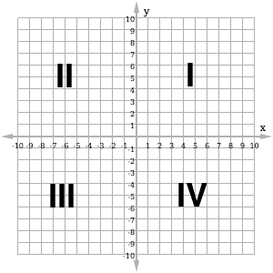
We draw the 2 axes on the Cartesian plane, the x-axis and the y-axis. These 2 axes intersect at a right angle.
The x-axis goes from left to right and increases in value as shown by the arrow. Only a small part of the axis is shown, from −10 to +10. Negative values are to the left of the y-axis. Positive values are to the right of the y-axis.
The y-axis goes from the bottom of the board to the top. It also increases in value in the direction of the arrow. We have shown only the part from −10 to +10. Negative values are below the x-axis. Positive values are above the x-axis.
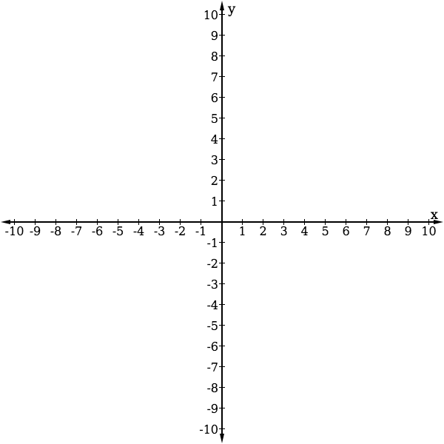
Both axes actually go to infinity in both directions. We draw arrows at the end of the axes to show this.
The 2 axes divide the Cartesian plane into 4 quadrants, numbered as shown with Roman numerals.
When you draw a Cartesian plane of your own, it is not necessary to draw the entire grid. You may just draw tick marks on each axis, as shown to the right. Make sure all of your tick marks are the same distance apart.
The point where the x-axis and y-axis intersect is called the origin. Both axes are 0 at the origin.
Solved Examples
- Draw a Cartesian plane with axes from $-8$ to $+8$ in the space below:

Solution
Your Cartesian plane should look like the one below. Make sure your tick marks are the same distance apart. Label your axes and tick marks.
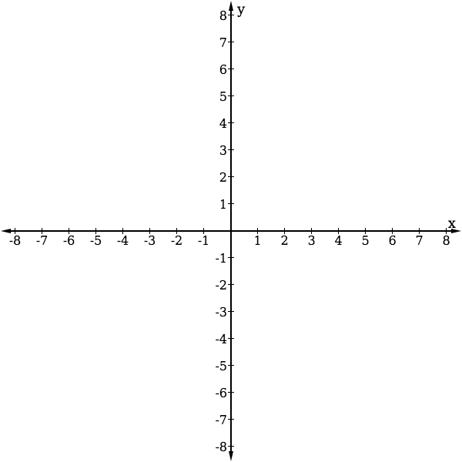

Practice
- Draw a Cartesian plane with axes from $-12$ to $+12$.
- Draw a Cartesian plane with axes from $-5$ to $+5$. Label the origin and each of the 4 quadrants.

Lesson Title: Identifying Points in the Cartesian Plane |  | Theme: Algebra
Practice Activity: PHM-08-132 |  | Class: JSS 2
Learning Outcome

By the end of the lesson, you will be able to identify points in each quadrant of a Cartesian plane and write them in the form $(x, y)$.

Overview
We can identify points on the Cartesian plane through their coordinates, or ordered pair $(x, y)$. The x-value of a point’s coordinates tells how far to move along the x-axis to reach the point. The y-value the point’s coordinates tells how far to move along the y-axis to reach the point.
Examples of a few points on the plane are given below. See the Solved Examples section for how to identify points on the Cartesian plane.
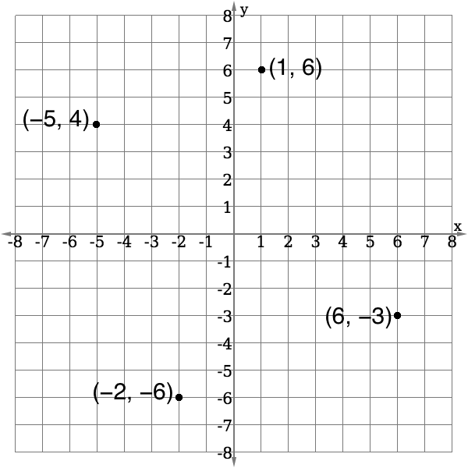
Remember that the origin is where the x-axis and y-axis intersect. It has coordinates (0, 0).

Solved Examples
- Write the coordinates of point X in the diagram below:
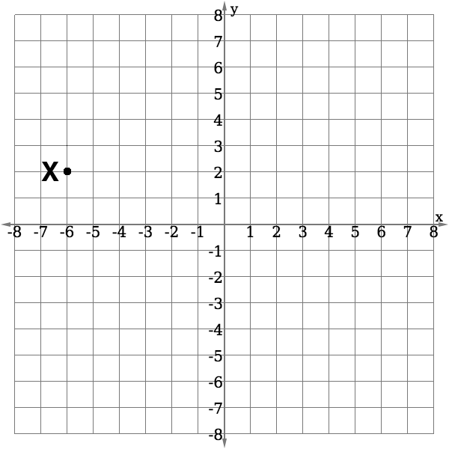
Solution
To find the coordinates of X, find the points on the x-axis and y-axis that it corresponds to. In other words, find how many spaces you need to move away from the origin (0, 0) to reach X.

X corresponds to $x=-6$ on the x-axis. You need to move 6 spaces in the negative direction along the x-axis to reach X.

X corresponds to $y=2$ on the y-axis. You need to move 2 spaces in the positive direction along the y-axis to reach X.

The coordinates of X are $(-6, 2)$.

- Write the coordinates of each point in the diagram below:
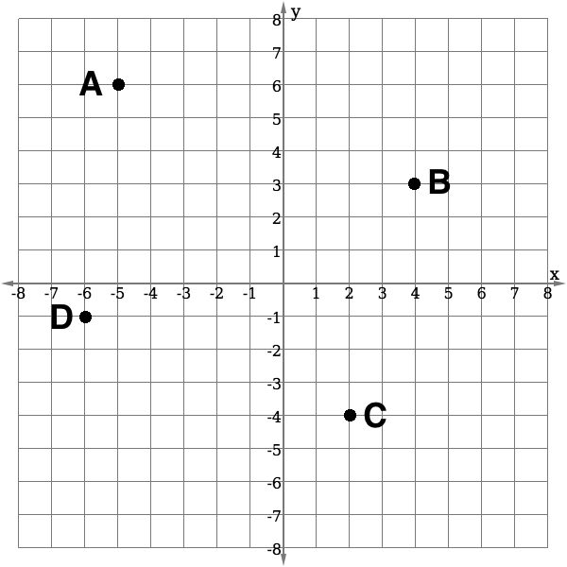

Solution
Remember that each point has an ordered pair (x, y). The x-value tells you its position on the x-axis, and the y-value tells you its position on the y-axis. From each point (A, B, C, D) move along the grid line and find the numbers along the axes that it corresponds to.

Answers: $A\left(-5,6\right)$, $B\left(4, 3\right)$, $C\left(2, -4\right)$, $D\left(-6, -1\right).$ Note that each point is given by its letter before the ordered pair.

- Identify which quadrant each of the following points is in:
  - $(3, 2)$ b. $(-1, -1)$ c. $(-2, 4)$
Solutions
Look at the axes on the Cartesian plane. You will notice that quadrant I has both x and y positive. Quadrant II has x negative and y positive. Quadrant III has both x and y negative. Quadrant IV has x positive and y negative.
Use this information to answer the problem:
  - $(3, 2)$ is in quadrant I because both x and y are positive.
  - $(-1, -1)$ is in quadrant III because both x and y are negative.
  - $(-2, 4)$ is in quadrant II because x is negative and y is positive.
Practice
- Write the coordinates of each point in the diagram below:
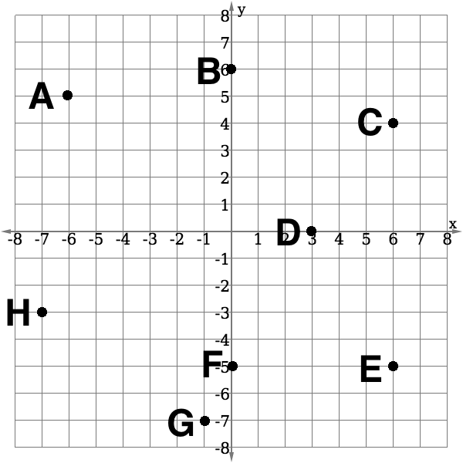
- Identify which quadrant each of the following points is in:
  - $(-3, 2)$ b. $(-5, -7)$ c. $(1, -3)$

Lesson Title: Plotting Points on the Cartesian Plane |  | Theme: Algebra
Practice Activity: PHM-08-133 |  | Class: JSS 2
Learning Outcome

By the end of the lesson, you will be able to plot given points on any quadrant of the Cartesian plane.

Overview
In the previous lesson, you wrote the coordinates for points that were plotted on the Cartesian plane. In this lesson, you will plot points given their coordinates.
Remember that a set of coordinates is an ordered pair $(x, y)$. The x-value tells you how far to move along the x-axis, and the y-value tells you how far to move along the y-axis. If the x-value is positive, move to the right. If the x-value is negative, move to the left. If the y-value is positive, move up. If the y-value is negative, move down.
Follow these steps to plot any point $(x, y)$:
- Start at the origin $\left(0, 0\right);$
- Move along the $x$-axis $x$ units from the origin, and draw a vertical line;
- Move along the $y$-axis $y$ units from the origin, and draw a vertical line;
- Mark the point where the 2 lines intersect and write the ordered pair $(x, y)$.

Solved Examples
- Draw a Cartesian plane and plot the point (4, 7).
Solution
To draw your Cartesian plane, you do not need to draw the grid. You can draw only the 2 axes. Make sure the tick marks on your axes are all the same distance apart.
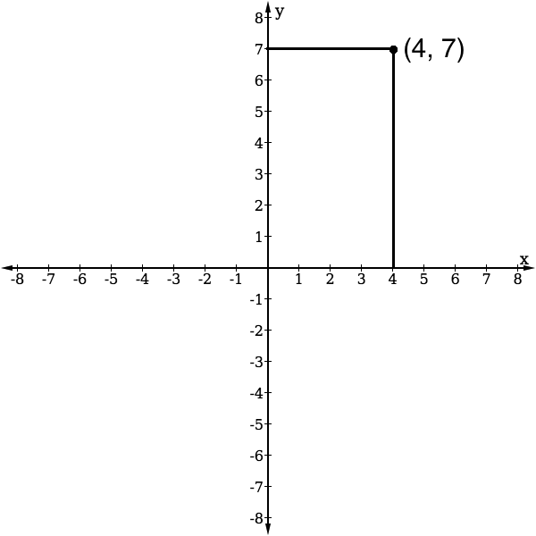
Use a ruler or any type of straight edge (for example, the side of a book) to locate the point. Put your ruler at 4 on the x-axis, and draw a vertical line. Put your ruler at 7 on the y-axis and draw a horizontal line.

Label the point with its coordinates, (4, 7).

- Draw a Cartesian plane and plot the point $(-2, -5)$.
Solution
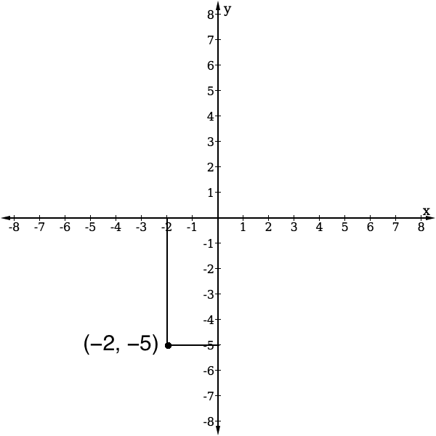
Draw the axes and make sure the tick marks on your axes are all the same distance apart.

Use a ruler or any type of straight edge (for example, the side of a book) to locate the point. Put your ruler at $-2$ on the x-axis, and draw a vertical line. Put your ruler at $-5$ on the y-axis and draw a horizontal line.

Label the point with its coordinates, $(-2, -5)$.

- Plot the following points on the Cartesian plane below: $A\left(-1,7\right)$, $B\left(0, -3\right)$, $C\left(5, 5\right)$, $D\left(3, -1\right),$ $E\left(0, -7\right)$, $F\left(-4, -6\right)$, $G\left(-5, 0\right)$.
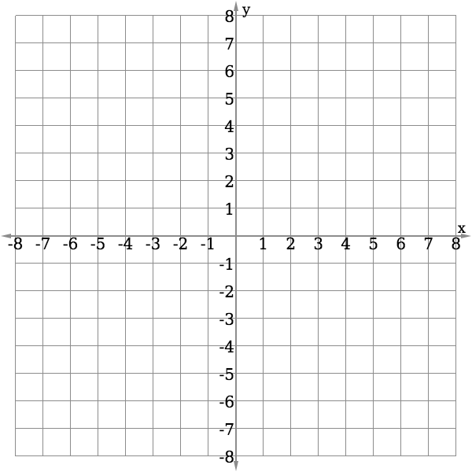

Solution
Identify each point on the Cartesian plane and plot it. Write the letter next to each point. It is not necessary to write both the letter and coordinates.
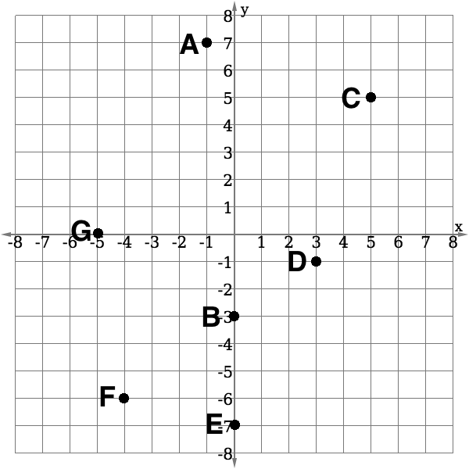

Practice
- Draw a Cartesian plane and plot the point $(4, -6)$.
- Draw a Cartesian plane and plot the point $(-3, 7)$.
- Plot the following points on the Cartesian plane below: $A\left(-7,0\right)$, $B\left(0, 6\right)$, $C\left(5, 1\right)$, $D\left(-3, -1\right),$ $E\left(0, -1\right)$, $F\left(7, -6\right)$, $G\left(8, 0\right)$.
- Plot the following points on the Cartesian plane below: $T\left(-1,-1\right)$, $U\left(7, 7\right)$, $V\left(1, 6\right)$, $W\left(-3, -3\right),$ $X\left(0, -5\right)$, $Y\left(-6, 4\right)$, $Z\left(7, -4\right)$.

Lesson Title: Table of Values |  | Theme: Algebra
Practice Activity: PHM-08-134 |  | Class: JSS 2
Learning Outcome

By the end of the lesson, you will be able to create a table of values and plot each point on the Cartesian plane.

Overview
In this lesson, you will create a table of values for a simple linear equation in 2 variables. This is the first step in graphing a linear equation. Any linear equation can be graphed, or drawn, on the Cartesian plane. You must know how to make a table of values first.
The linear equation $y=mx+c$ has 2 variables, $x$ and $y$. The value of $y$ will change depending on the value of $x$. $y$ is called the dependent variable, and $x$ is called the independent variable.
Each column in the table of values represents 1 solution to the linear equation. To complete a table of values, you will substitute each value of $x$ into the given linear equation and solve for $y$. This will be one ordered pair. You will do this for each $x$-value in the table, so that you find several ordered pair solutions. Instead of writing each ordered pair in the form $(x, y)$ you will write it in one column of the table of values.
For example, the table below holds 7 solutions to the equation$y=x+2$.
$$x$$ | $$-3$$ | $$-2$$ | $$-1$$ | $$0$$ | $$1$$ | $$2$$ | $$3$$
$$y$$ | $$-1$$ | $$0$$ | $$1$$ | $$2$$ | $$3$$ | $$4$$ | $$5$$

$$x$$ | $$y$$
$$-3$$ | $$-1$$
$$-2$$ | $$0$$
$$-1$$ | $$1$$
$$0$$ | $$2$$
$$1$$ | $$3$$
$$2$$ | $$4$$
$$3$$ | $$5$$
Each column is one ordered pair ($x$, $y$). The solutions in this table are $(-3, -1)$, $(-2,0)$, $(-1, 1)$, and so on.
The same table of values can be drawn vertically, as shown at right.
Each ordered pair in a table of values can be plotted on the Cartesian plane. A table of values can be used to graph many different types of equations. After plotting the points, you will be able to see the shape of the graph. In this lesson, you will only graph linear equations, which always result in lines when graphed.

Solved Examples
- The table of values gives solutions to the linear equation $y=x+2$. Plot the values from the table in the given Cartesian plane.
$$x$$ | $$-3$$ | $$-2$$ | $$-1$$ | $$0$$ | $$1$$ | $$2$$ | $$3$$
$$y$$ | $$-1$$ | $$0$$ | $$1$$ | $$2$$ | $$3$$ | $$4$$ | $$5$$

Solution
Plot each point from the table of values. Remember that the ordered pairs are given by the columns, so we have $\left(-3, -1\right), \left(-2, 0\right), \left(-1,1\right),$ and so on.
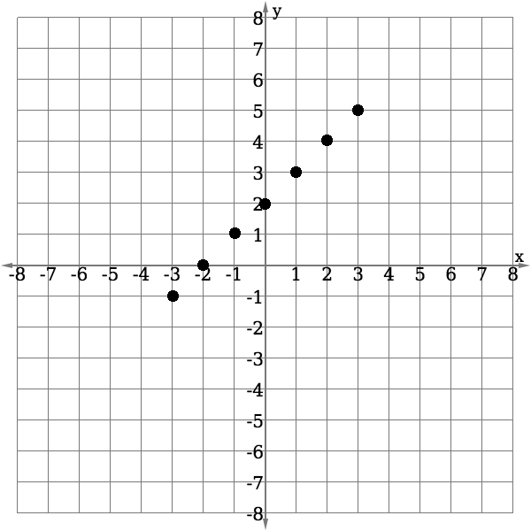

- Complete the table of values for the linear equation $y=-2x+1$. Plot each point on the given Cartesian plane.
 | 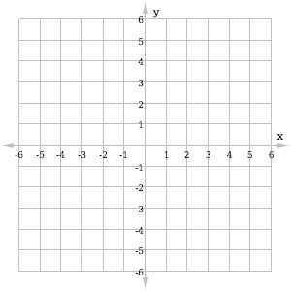
  $$x$$ | $$-2$$ | $$-1$$ | $$0$$ | $$1$$ | $$2$$
  $$y$$ |  | $$3$$ |  | $$-1$$
Solution
Two of the ordered pairs are given in the table. Use the linear equation to find the other 3 points from the table. Then, plot each point on the Cartesian plane.
- If $x=-2$, then $y=-2\left(-2\right)+1=4+1=5$
- If $x=0$, then $y=-2\left(0\right)+1=0+1=1$
- If $x=2$, then $y=-2\left(2\right)+1=-4+1=-3$
Completed table and plane:
 | 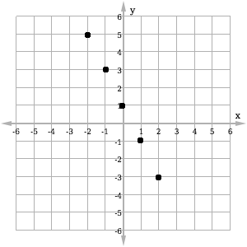
  $$x$$ | $$-2$$ | $$-1$$ | $$0$$ | $$1$$ | $$2$$
  $$y$$ | $$5$$ | $$3$$ | $$1$$ | $$-1$$ | $$-3$$

Practice
- Complete the table of values for the linear equation $y=-x-3$. Plot the values from the table in the given Cartesian plane.
$$x$$ | $$-2$$ | $$-1$$ | $$0$$ | $$1$$ | $$2$$
$$y$$

- Complete the table of values for the linear equation $y=-3x+2$. Plot the values from the table in the given Cartesian plane.
 | 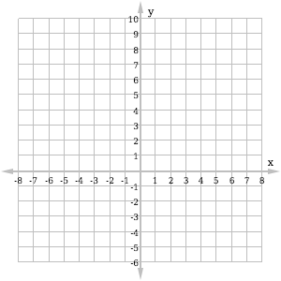
  $$x$$ | $$-2$$ | $$-1$$ | $$0$$ | $$1$$ | $$2$$
  $$y$$

Lesson Title: Graphing a Line |  | Theme: Algebra
Practice Activity: PHM-08-135 |  | Class: JSS 2
Learning Outcome

By the end of the lesson, you will be able to plot points and connect them to graph a straight line.

Overview
In the previous lesson, you learned how to create a table of values for an equation and plot the points from the table on the plane. In this lesson, you will create a table of values for a given linear equation in 2 variables and graph it on the Cartesian plane. You will follow the same process as the previous lesson, but you will connect the points with a line and label the line with its equation.
Solved Examples
- Complete the table of values below for the linear equation $y=x-1$. Graph the relation on the Cartesian plane.
$$x$$ | $$-2$$ | $$-1$$ | $$0$$ | $$1$$ | $$2$$
$$y$$

Solution
First, complete the table of values. Substitute each value of $x$ into$y=x-1$, and find $y$.

When $x=-2,$ $y=-2-1=-3$

When $x=-1,$ $y=-1-1=-2$

When $x=0,$ $y=0-1=-1$

When $x=1,$ $y=1-1=0$

When $x=2,$ $y=2-1=1$

Completed table:
The completed table is below. Plot the points from the table on the Cartesian plane. Connect them with a line, and label the line with the equation $y=x-1$.
 | 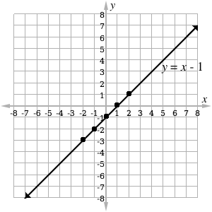
  $$x$$ | $$-2$$ | $$-1$$ | $$0$$ | $$1$$ | $$2$$
  $$y$$ | $$-3$$ | $$-2$$ | $$-1$$ | $$0$$ | 1
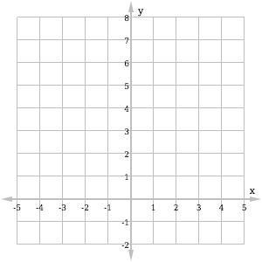
- Draw a table of values of $x$ from $-2$ to $+2$ of the linear equation $y=4-x$. Use the table of values to graph the equation on the given plane.

Solution
In this problem, you are not given the table of values. Draw your own table of values with values of $x$ from $-2$ to $+2$:
$$x$$ | $$-2$$ | $$-1$$ | $$0$$ | $$1$$ | $$2$$
$$y$$
Then, substitute each value of x into the given equation and fill the table.

When $x=-2,$ $y=4-\left(-2\right)=4+2=6$

When $x=-1,$ $y=4-\left(-1\right)=4+1=5$

When $x=0,$ $y=4-\left(0\right)=4-0=4$

When $x=1,$ $y=4-\left(1\right)=4-1=3$

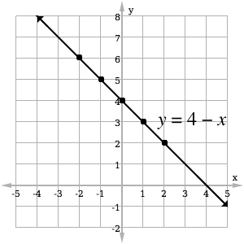
When $x=2,$ $y=4-\left(2\right)=4-2=2$

Write the results in your table of values:
$$x$$ | $$-2$$ | $$-1$$ | $$0$$ | $$1$$ | $$2$$
$$y$$ | $$6$$ | $$5$$ | $$4$$ | $$3$$ | $$2$$
Plot each point on the Cartesian plane, and connect them in a line.
Practice
- Complete the table of values below for the linear equation $y=2x+4$. Graph the relation on the Cartesian plane.
$x$ | $$-3$$ | $-2$ | $-1$ | 0
$y$

- Complete the table of values below for the linear equation $y =3-2x$. Graph the relation on the Cartesian plane.
$x$ | $-2$ | $-1$ | 0 | 1 | 2
$y$

- Create a table of values and draw the graph of the linear equation $y =2x+3$ for values of $x$ from $-3$ to $+2$.

Lesson Title: Data Collection |  | Theme: Statistics and Probability
Practice Activity: PHM-08-136 |  | Class: JSS 2
Learning Outcome

By the end of the lesson, you will be able to collect data from class members and display it in lists and pictograms.

Overview
In this lesson, you will learn how to collect and display data. Data are any numerical facts, information, or measurements of something.
Writing a list is one form of collecting data. For example, this is a list of the ages of Hawa’s family members: 4, 28, 2, 32, 8.
A list is very basic and does not give us much information. We can organise our list by writing the numbers in rank order. This means we will write the list in ascending or descending order. In this case, we have:
- Ascending order: 2, 4, 8, 28, 32
- Descending order: 32, 28, 8, 4, 2
Symbols or pictures can also be used to represent a certain number of items. For example, if you are counting people, you may draw pictures of the people to keep count of them. This is called a pictogram. A pictogram is a diagram that uses pictures or drawings to display the data collected. See Solved Examples 2 and 3 for examples of a pictograms.

Solved Examples
- Foday collected the ages of his classmates in a survey. They are written on his paper below. Use Foday’s results to complete the following questions.
12 11 12 12 10 13 11 10 10 10 12 12 11 9 13 12 9 13 11 12 11 9 12 13

  - Write the ages of his classmates in ascending order.
  - What is the age of Foday’s oldest classmate?
  - What is the age of Foday’s youngest classmate?
  - How many of his classmates are 12?

Solutions
  - The age of each classmate should appear in your list. Numbers may appear more than once. Write down the numbers exactly as many times as they appear. The list is:
9, 9, 9, 10, 10, 10, 10, 11, 11, 11, 11, 11, 12, 12, 12, 12, 12, 12, 12, 12, 13, 13, 13, 13
  - The age of Foday’s oldest classmate is the last number in the list, 13 years old.
  - The age of Foday’s youngest classmate is the first number in the list, 9 years old.
  - Count the number of times 12 appears in the list. It appears 8 times, so 8 of Foday’s classmates are 12 years old.

- Sia counted the members of her family. She counted 7 females and 6 males. Help her draw a pictogram to show the number of family members with symbols. Use the following symbols for male and female:
Male:  Female:
Solution
There are 7 females, so the female symbol should be drawn 7 times. There are 6 males, so the male symbol should be drawn 6 times.
Females:
Males:

- The pupils in one class took a quiz worth 10 marks in total. The pictogram below shows the marks they obtained. Use the pictogram to answer the questions below.

Marks on the Quiz | Number of Pupils
0
1
2
3 |  |  | represents 1 pupil
4
5
6
7
8
9
10
- How many pupils sat for the quiz?
- What mark did the greatest number of pupils obtain?
- What mark did the lowest number of pupils obtain?
- How many pupils obtained 4 marks?
- If 7 marks is passing, how many pupils passed?
Solutions
- To find how many pupils sat for the quiz, count the number of symbols in the pictogram. There are 37 symbols, so 37 pupils sat the quiz.
- The greatest number of pupils obtained 7 marks. This has the most symbols: 8.
- The lowest number of pupils obtained 1 mark. No pupils obtained 1 mark.
- There are 2 symbols next to 4, so 2 pupils obtained 4 marks.
- Count the number of that obtained 7 or more marks. That is, the number of symbols after 7, 8, 9 and 10. There are 23 symbols, so 23 pupils passed.
Practice
- Martin is carrying a basket of fruit home for his family. He has 5 oranges, 8 bananas and 3 mangos. Record the number of each fruit that he has been carrying using a pictogram. Use the following symbols for the fruits:
Orange: Banana: Mango:
- The school will buy new shoes for all of the football players on the team. The shoe sizes of the football players are given in the pictogram. Use the pictogram to answer the questions below.
Shoe Size | Number of Players
38 |  |  | represents 1 player
39
40
41
42
43
- How many football players are there?
- How many of the players wear size 39?
- How many players wear size 40 or smaller?
- The shop has 3 pairs of shoes in size 40. Is it enough?
- The coach took the height measurements of the football players to buy them new uniforms. Their heights (in centimetres) are: 178, 170, 167, 172, 173, 177, 172, 170, 172, 173, 177, 169, 170, 168, 172, 173.
  - Write the heights of the players in ascending order.
  - What is the height of the tallest player?
  - What is the height of the shortest player?
  - If players taller than 175 cm wear a large uniform, how many large uniforms are needed?

Lesson Title: Tables of Data |  | Theme: Statistics and Probability
Practice Activity: PHM-08-137 |  | Class: JSS 2
Learning Outcome

By the end of the lesson, you will be able to organise and display collected data in a table.

Overview
In this lesson, you will learn how to organise and display collected data in a table.
In your table of data, you will have 1 column for tally marks. This is to keep count while you are collecting data. The next column is for the number that you counted in with tally marks.
For example, say you want to take a survey of your classmates to understand what subjects are their favourite. You will draw a table with a row for each subject:
SUBJECT | TALLY MARKS | NUMBER OF PUPILS
Mathematics
English Language
Social Studies
Integrated Studies
Total
As you survey your classmates, you will keep count of their answers in the “tally marks” column. After you complete the survey, you will write the number of pupils who prefer each subject in the “number of pupils” column. You can find the total number of pupils surveyed, and write the numbers in the last column, for “Total”.
Here is an example of a completed table, for a classroom with 40 pupils:
SUBJECT | TALLY MARKS | NUMBER OF PUPILS
Mathematics |  | 6
English Language |  | 10
Social Studies |  | 15
Integrated Studies |  | 9
Total | 40 | 40

Solved Examples
- The ages of 15 pupils in a class were recorded as follows: 12, 14, 15, 13, 13, 12, 14, 14, 13, 15, 13, 13, 14, 12, 15.

Use this data to complete the table below:
AGES | TALLY MARKS | NUMBER OF PUPILS
12
13
14
15
Total

Solution
For each number in the list, make 1 tally mark in the table. It can help to cross off the ages in the list as you record them. After you record all of the pupils with tally marks, write the total number of pupils of each age in the “number of pupils” column.

12, 14, 15, 13, 13, 12, 14, 14, 13, 15, 13, 13, 14, 12, 15

AGES | TALLY MARKS | NUMBER OF PUPILS
12 |  | 3
13 |  | 5
14 |  | 4
15 |  | 3
Total | 15 | 15

- Below is a list of the marks obtained by pupils in a mathematics quiz worth 10 possible points. Organise the data in a table, then answer the questions.

Marks: 9, 10, 10, 7, 8, 6, 6, 7, 5, 9, 10, 9, 9, 7, 7, 7, 6, 8, 10, 5, 6, 4, 7, 8, 9, 6, 8, 8.

  - How many pupils took the maths quiz?
  - How many pupils obtained 10 marks?
  - What is the lowest mark obtained by a pupil?
  - What mark did the greatest number of pupils achieve?
Solutions
First, draw the table. You will have columns for “quiz marks”, “tally marks”, and “number of pupils”. Record the marks in the list in your table:

QUIZ MARKS | TALLY MARKS | NUMBER OF PUPILS
4 |  | 1
5 |  | 2
6 |  | 5
7 |  | 6
8 |  | 5
9 |  | 5
10 |  | 4
Total | 28 | 28

Use the information in the table to answer the questions:
  - Twenty-eight pupils took the maths quiz.
  - Four pupils obtained 10 marks.
  - The lowest mark obtained is 4.
  - The mark with the greatest number of pupils is 7 marks.
Practice
- Fatu is a nurse in a hospital. This morning, she recorded the weights of the babies in the hospital. Help her organise this data in a table, then answer the questions below.
Weights of babies (kg): 3, 4, 4, 5, 3, 4, 6, 5, 7, 4, 3, 5, 5, 6, 6, 7, 5, 5, 3
  - How many babies did Fatu weigh?
  - What is the weight of the heaviest baby?
  - How many babies weigh 4 kg?
  - What is the most common weight of the babies?

- Some pupils in a JSS1 class measured their height to the nearest 5 cm. Their heights are recorded below. Organise this data in a table, then answer the questions below.
Height of pupils (cm): 160, 155, 155, 170, 165, 165, 155, 150, 160, 155, 165, 170.
  - How many pupils measured their heights?
  - What is the height of the tallest pupil?
  - How many pupils are 160 cm tall?

Lesson Title: Bar Charts |  | Theme: Statistics and Probability
Practice Activity: PHM-08-138 |  | Class: JSS 2
Learning Outcome

By the end of the lesson, you will be able to display collected data in a bar chart.
Overview
This lesson is on drawing bar charts based on data. The data is given in a table similar to the frequency tables you created in the previous lesson. The numbers in the table give the frequency, or quantity, of each item.
In a bar chart, the height of each bar tells the frequency. Bar charts are used to compare different quantities.
When drawing a bar chart, draw and label the axes first, and give your chart a title. Then you will draw the bars. It is important to use an appropriate scale on your y-axis. It should extend to at least the greatest frequency in the table.

Solved Examples
- A teacher surveyed a class to learn the favourite fruits of the class members. The result of the survey is shown in the frequency table below. Draw a bar chart for the data.
Favourite Fruits
Fruit | Frequency
Mango | 10
Pawpaw | 12
Orange | 3
Banana | 16
Pineapple | 8

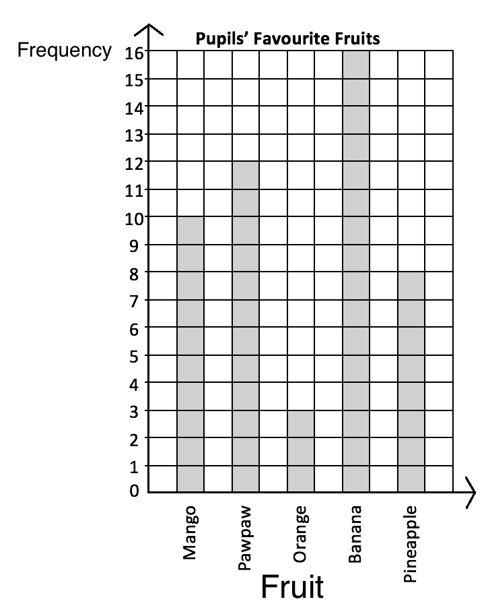
Solution

Each row on the table is 1 bar on the chart.

Draw the axes. The ‘Frequency’ axis should extend to at least 16. The ‘Fruit’ axis should have the 5 fruits.

Draw the bars. The height of each bar is given in the frequency table.

- The table below shows the number of JSS pupils that play football on the school team. Using the grid below, draw a bar chart to present the data.
Level | JSS 1 | JSS 2 | JSS 3
No. of Pupils | 8 | 6 | 9

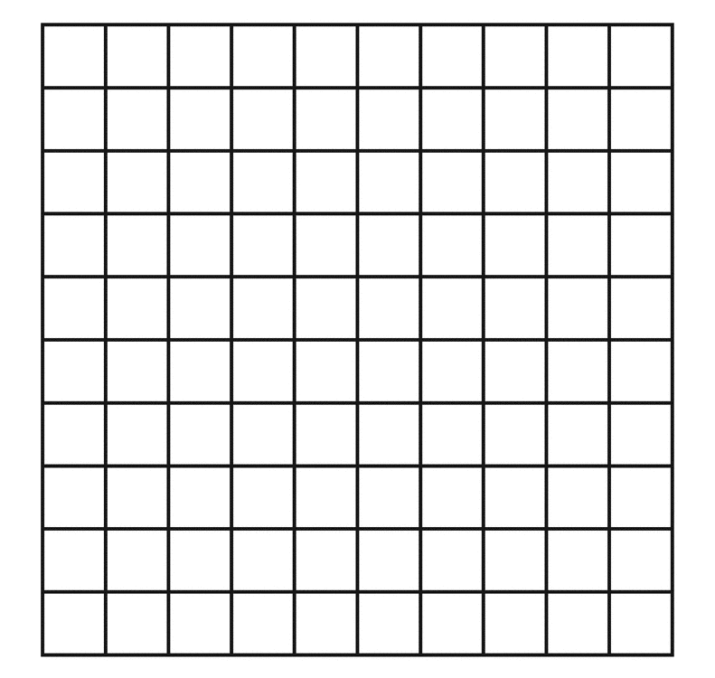

Solution

This frequency table is drawn horizontally. It is the same as a frequency table drawn vertically. In this case, each column gives information for a bar on the chart.

In this case, you are given a grid for the bar chart. Draw the axes on it, and label each bar with the correct JSS level.

Practice
- The following is the result a survey conducted by an NGO on the jobs worked by adults in a community in Kailahun district. Draw a bar chart to show the information.
Job | No.
Farmers | 8
Traders | 2
Health workers | 3
Teachers | 5
Other | 4

- The table below shows the marks of pupils on a test. No pupil scored lower than 40% or higher than 85%. Draw a bar chart for the information using the grid below.
Marks | 40% | 45% | 50% | 55% | 60% | 65% | 70% | 75% | 80% | 85%
No. of Pupils | 1 | 2 | 4 | 3 | 0 | 2 | 5 | 8 | 1 | 2


- On a recent quiz worth 10 points, pupils’ marks were as follows: 7, 5, 5, 6, 7, 7, 8, 4, 9, 9, 10, 8, 8, 7, 6, 10, 10, 7, 7, 8, 5, 6, 7, 9, 10, 8, 8, 7.
  - Display the scores in a frequency table.
  - Use your frequency table to draw a bar chart.

Lesson Title: Line Graphs |  | Theme: Statistics and Probability
Practice Activity: PHM-08-139 |  | Class: JSS 2
Learning Outcome

By the end of the lesson, you will be able to display collected data in a line graph.

Overview
In this lesson, you will learn to display collected data in another type of chart, called a line graph. To draw a line graph, you need a collection of data that has changed over time. A line graph is a graph that uses points connected by a line to show how something changes in value as time goes by.
In a line graph, the $x$-axis is time. It can be measured in any unit of time, including minutes, hours, days, weeks, months, or years. The $y$-axis shows the quantity of something that changes over time.
Solved Examples
- Mariama wants to show how much weight her dog Billy has gained from when he was a puppy to when he was fully grown. Here is the data she collected on her notepad:
Months | 1 | 2 | 3 | 4 | 5 | 6 | 7 | 8 | 9
Weight in lbs | 10 | 15 | 20 | 25 | 30 | 35 | 40 | 45 | 50

Display the data in a line graph.
Solution
Like other graphs, line graphs need two axes, one vertical ($y$-axis), and one horizontal ($x$-axis). In this case, the $x$-axis is the time in months. Each number in the “Months” row of the table should be on the $x$-axis.
The $y$-axis represents the range of Billy’s weight in pounds. The dog’s lowest weight was 10 lbs. and his highest weight was 50 lbs. We will make our $y$-axis range from 0 to 60 lbs. to cover all of his weight. You may count by 5s or 10s on the $y$-axis.
Plot each point from the table. Connect each point to the next one with a straight line. You may use a ruler or straight edge.

Make sure your line graph has a title, and each axis is labeled.

- Hawa’s parents measured her height each year on her birthday. Her height for 7 years is given in the table below, in centimetres. Draw a line graph for the data.
Age (years) | 1 | 2 | 3 | 4 | 5 | 6 | 7
Height (cm) | 70 | 85 | 95 | 100 | 110 | 115 | 120

Solution
Draw the two axes. The $x$-axis is age in years, and the $y$-axis is height in centimetres. Plot each point from the table. Connect each point to the next with a straight line.

Note that it is not necessary to draw lines from the axes to each point. However, you may draw the lines (as in Solved Example 1) with a straight edge. This can help you plot the points accurately.
Practice
- The table below shows daily temperatures for London, recorded for 6 days in degrees Celsius. Display the data in a line graph with a $y$-axis ranging from 15 to 25 degrees.
Day | 1 | 2 | 3 | 4 | 5 | 6
Temperature (°C) | 17 | 19 | 18 | 16 | 21 | 23

- Mustapha sells rice in his shop. He keeps track of the amount of rice he sells each day, in kilogrammes. This helps him to know when to buy more rice for his shop. The amount of rice he sold each day for one week is in the table below. Display the data in a line graph.
Day | 1 | 2 | 3 | 4 | 5 | 6 | 7
Rice sold (kg) | 3 | 4 | 2.5 | 3.5 | 5 | 5.5 | 3

- Fatu travels each day for her job. She kept track of the money she spent on transportation this week. Display the data below in a line graph.
Day | 1 | 2 | 3 | 4 | 5
Leones (Le) | 4,000.00 | 2,000.00 | 1,000.00 | 6,000.00 | 5,000.00

Lesson Title: Interpreting Charts and Graphs |  | Theme: Statistics and Probability
Practice Activity: PHM-08-140 |  | Class: JSS 2
Learning Outcomes

By the end of the lesson, you will be able to:
1. Make comparisons using pictograms, bar charts and line graphs.
2. Draw conclusions from charts and graphs.

Overview
In this lesson, you will make comparisons and draw conclusions using pictograms, bar charts, and line graphs.
Solved Examples
- The bar chart below shows the pocket money received by pupils in a class in a week. Use the bar chart to answer the questions below.
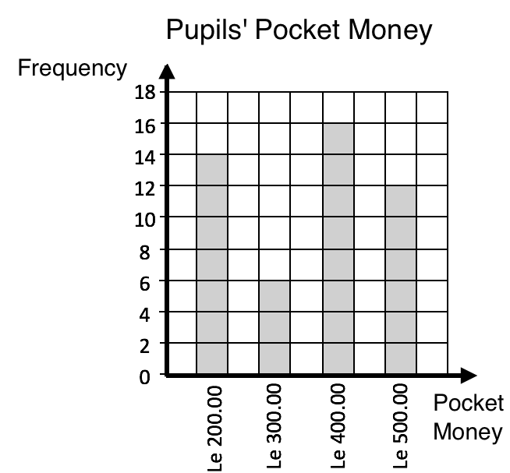
- Find the total number of pupils in the class.
- What is the maximum amount of pocket money that any pupil received?
- Which amount of money did the highest number of pupils receive?
- How many pupils received $Le 200.00$ for a week?
- How many pupils received either $Le 300.00$ or $Le 500.00$ for a week?

Solutions
- Add the heights of the bars: $14+6+16+12=48$ pupils
- The maximum amount of money that any pupil received is $Le 500.00$. It is the greatest number on the “Pocket Money” axis.
- The highest number of pupils received $Le 400.00.$Sixteen pupils received $Le 400.00$ for a week.
- Fourteen pupils received $Le 200.00$ for a week. This is the height of the $Le 200.00$ bar.
- We want to include all of the pupils who received $Le 300.00$ and all of the pupils who received $Le 500.00$. Add the heights of the bars for Le 300.00 and Le 500.00:
$6+12=18$ pupils

- The line graph below gives the temperature in Freetown in degrees Celsius during the first 6 days of the year. Use the graph to answer the questions below.
- Which day was the hottest?
- Which day was the coldest?
- What was the temperature difference between the hottest day and coldest day?
- Were any 2 dates the same temperature? If so, which dates?
- What was the greatest temperature change from one day to the next?
Solutions
- 5 January was the hottest day, because it is the highest on the graph at 35 degrees.
- 3 January was the coldest day, because it is the lowest on the graph at 27 degrees.
- Subtract to find the temperature difference: 35 – 27 = 8 degrees.
- Yes, 1 and 6 January were the same temperature, 28 degrees.
- The greatest temperature change was from 5 January to 6 January. The temperature dropped from 35 to 28 degrees, a change of 7 degrees.

- The pictogram below gives the ages of members of the school drama club. Use the pictogram to answer the questions.
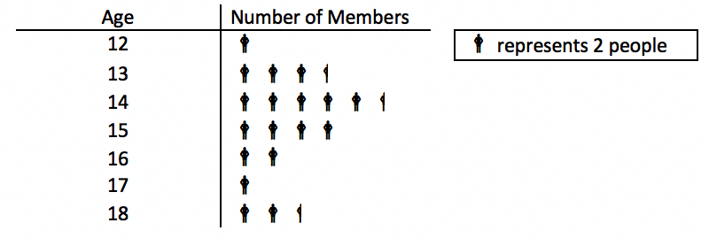
- How many people are in the drama club?
- How many drama club members are 14 years old?
- How many drama club members are either 12 or 13?
- The drama club will go on a trip to Freetown. Only members aged 16 or older are eligible to go. How many members can go to Freetown?
Solutions
In this case, note that represents 2 people. This means that half of the symbol represents 1 person. You can count by 2’s or multiply by 2 to find how many people are each age. There are two 12-year-old members, seven 13-year-old member, and so on.
- Count the number of symbols and multiply by 2. There are 19.5 symbols, so there are $19.5×2=39$ members of the club.
- Count the number of symbols for 14 years old, and multiply by 2. There are 5.5 symbols, so there are $5.5×2=11$ members.
- To find the number of members that are 12 or 13, add the number of members in the 2 categories. There are 4.5 symbols, which makes $4.5×2=9$ members.
- Add the number of members who are 16, 17 or 18. There are 5.5 symbols, which makes $5.5×2=11$ members.

Practice
- The bar chart below shows the marks that a class of pupils received on a test. Use the bar chart to answer the questions.
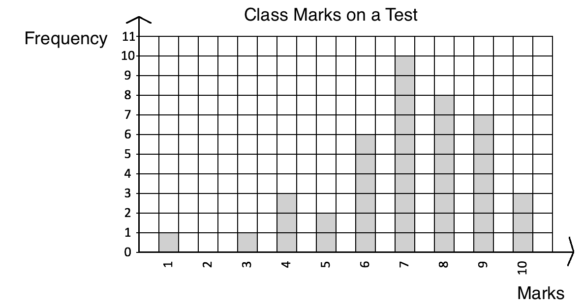
  - How many pupils sat for the test?
  - What was the lowest score on the test?
  - How many pupils scored 8 marks?
  - If pupils need 7 marks or higher to pass, how many pupils passed?

- Emmanuel likes to study the weather. He measured the rainfall in Bo during 1 week in August and recorded it in the graph below. Use the graph to answer the questions.
- How much did it rain on 6 August?
- On which date did it rain the most?
- On which date did it rain the least?
- How much more did it rain on 5 August than on 4 August?
- How much less did it rain on 7 August than on 5 August?

Lesson Title: Mean |  | Theme: Statistics and Probability
Practice Activity: PHM-08-141 |  | Class: JSS 2
Learning Outcomes

By the end of the lesson, you will be able to:
1. Calculate the mean of a set of data from a list, chart, or graph.
2. Interpret mean.

Overview
The mean is a number that can tell us where the middle of the data is. It is also commonly known as the ‘average’. To find the mean of a list of data, add the numbers together and divide the total by the number of items.
To find the mean from a bar chart, add the bar heights and divide by the number of bars. Follow a similar process to find the mean from a line graph. Add the value of each point on the y-axis, and divide by the number of points.
Solved Examples
- Mustapha has 5 children aged 10, 6, 7, 4, and 3. Find the mean of their ages.
Solution
Add the numbers: $10+6+7+4+3=30$
Divide by the number of children: $30÷5=6$
The mean age of Mustapha’s children is 6 years old.

- Ten pupils received the following scores on their maths exam: 87, 100, 76, 92, 90, 95, 85, 67, 99 and 95. Find the mean of the scores.

Solution
Add the scores and divide by the number of pupils, 10:
$\frac{87+100+76+92+90+95+85+67+99 +95}{10}=\frac{886}{10}=88.6$
The mean score is 88.6.

- The bar chart below shows the number of JSS pupils that play football on the school team from each class. Find the mean number of players in each class.
Solution
The heights of the bars give the number of pupils on the football team in each class. You may record them in a list: 8, 6, 9.
Find the mean by adding the number of pupils per class, and dividing by the number of classes: $\frac{8+6+9}{3}=\frac{23}{3}=7\frac{2}{3}$
The mean number of pupils on the team from each class is $7\frac{2}{3}$ pupils.

- The line graph below shows the rainfall in Bo over a 1-week period. Find the mean amount of rain that Bo received each day.

Solution
You may record the rainfall for each day in a list: 1, 2, 4, 3, 5, 2, 1
Find the mean by adding the rainfall for each day, and dividing by the number of days: $\frac{1+2+4+3+5+2+1}{7}=\frac{18}{7}=2\frac{4}{7}$
The mean amount of rain was $2\frac{4}{7}$ cm per day.

Practice
- Agnes received the following scores in examinations in $8$ subjects: 67, 75, 80, 56, 77, 68, 98, and 87. Calculate the mean of her scores, correct to the nearest whole number.
- The shoe sizes of five pupils are $10, 9, 10, 11$and $8$. Calculate the mean shoe size, correct to 1 decimal place.
- The number of goals scored by a team in 9 football matches are as follows:
$3, 5, 7, 7, 8 ,8, 8, 11, 15$. Calculate the mean number of goals scored.
- After 15 matches, a football team’s goal average was 1.6. How many goals has the team scored in total?
- Fatu took a survey of her classmates and recorded their favourite fruits in the bar chart below. Find the mean number of pupils who prefer each fruit.
- The line graph below gives the temperature in Freetown over 6 days. Find the average temperature during the 6 days.

Lesson Title: Median |  | Theme: Statistics and Probability
Practice Activity: PHM-08-142 |  | Class: JSS 2
Learning Outcomes

By the end of the lesson, you will be able to:
1. Calculate the median of a set of data from a list, chart, or graph.
2. Interpret median.

Overview
The number in the middle when the numbers are listed in ascending or descending order is called the median. When there is an even number of items in the list, there are 2 numbers in the middle. The median is found by calculating the mean of these 2 numbers.
To find the median from a chart or graph, identify the bar or point with its height in the middle.
Solved Examples
- Mustapha has 5 children aged 10, 6, 7, 4, and 13. Find the median of their ages.
Solution
List the numbers in ascending order: 4, 6, 7, 10, 13
Identify the middle of the list: 7
The median age of Mustapha’s children in 7 years old.

- Ten pupils received the following scores on their maths exam: 87, 100, 76, 92, 90, 95, 85, 67, 99 and 95. Find the median of the scores.

Solution
List the numbers in ascending order: 67, 76, 85, 87, 90, 92, 95, 95, 99, 100
Identify the middle of the list: 90, 92
Since there is not one number in the middle, find the mean of the 2 numbers in the middle. Add them together and divide by 2: median $=\frac{90+92}{2}=91$

- The bar chart below shows the number of JSS pupils that play football on the school team from each class. Find the median number of players in each class.
Solution
The heights of the bars give the number of pupils on the football team in each class. You may record them in a list: 8, 6, 9.
Write the numbers in ascending order: 6, 8, 9.
The median is the number in the middle, 8 pupils.

- The line graph below shows the rainfall in Bo over a 1-week period. What is the median amount of rain fall?

Solution
You may record the rainfall for each day in a list: 1, 2, 4, 3, 5, 2, 1
Write the list of numbers in ascending order: 1, 1, 2, 2, 3, 4, 5
The median rainfall was 2 cm. This is the number in the middle.
Practice
- Agnes received the following scores in examinations in $8$ subjects: 67, 75, 80, 56, 77, 68, 98, and 87. Calculate the median of her scores, correct to the nearest whole number.
- The shoe sizes of five pupils are $10, 9, 10, 11$and $8$. Find the median shoe size.
- The number of goals scored by a team in 9 football matches are as follows:
$3, 5, 7, 7, 8 ,8, 8, 11, 15$. Calculate the median number of goals scored.
- Fatu took a survey of her classmates and recorded their favourite fruits in the bar chart below. Find the median number of pupils who prefer each fruit.
- The line graph below gives the temperature in Freetown over 6 days. Find the median temperature during the 6 days.

Lesson Title: Mode and Range |  | Theme: Statistics and Probability
Practice Activity: PHM-08-143 |  | Class: JSS 2
Learning Outcomes

By the end of the lesson, you will be able to:
1. Calculate the mode and range of a set of data from a list, chart, or graph.
2. Interpret mode and range.

Overview
In the previous lessons, you calculated the mean and median of a list of numbers. In this lesson, you will calculate the mode and range. These can also be calculated from a list, chart or graph.
The mode is the number that appears most often in a list. It can often be easily observed. If no number appears more than once, there is no mode. If multiple numbers appear more than once, there are multiple modes.
The range is the difference between the highest and lowest numbers. It tells us how spread apart our numbers are. To find the range, subtract the lowest number from the highest number.
Solved Examples
- Find the mode and range of the list of numbers: 2, 1, 7, 5, 6, 8, 6, 9, 6, 9
Solution
It is helpful to write the numbers in ascending order. It becomes easy to see the lowest and highest numbers, and the mode.
In ascending order, we have: 1, 2, 5, 6, 6, 6, 7, 8, 9, 9.
Mode: The mode is the number that appears most often. The number 6 appears 3 times, so 6 is the mode.
Range: Subtract the lowest number from the highest number: 9 – 1 = 8. The range is 8.

- The ages of 10 pupils are listed below. Find the mode and range of their ages.
10, 11, 13, 10, 10, 12, 11, 13, 11, 12
Solution
Write the numbers in ascending order: 10, 10, 10, 11, 11, 11, 12, 12, 13, 13
Mode: The numbers 10 and 11 both appear 3 times. This is the greatest number of times any number appears. There are 2 modes: 10 and 11 years old.
Range: Subtract the lowest number from the highest number: 13 – 10 = 3. The range is 3 years.
- The bar chart below shows the number of JSS pupils that play football on the school team from each class. Find the mode and range of the number of players in each class.
Solution
The number of pupils on the football team in each class are: 8, 6, 9.

Mode: There is no mode, because each number appears only once.
Range: Subtract the lowest number from the highest number: 9 – 6 = 3. The range is 3 pupils.

- The line graph below shows the rainfall in Bo over a 1-week period. What are the mode and range of the rain fall?

Solution
The rainfall for each day is: 1, 1, 2, 2, 3, 4, 5

Mode: There are 2 modes, 1 cm and 2 cm. These amounts appear twice.
Range: Subtract the lowest number from the highest number: 5 – 1 = 4. The range is 4 cm.

Practice
- The heights of 15 pupils are given in centimetres. Calculate the mode and range of the data:
155, 161, 160, 157, 155, 159, 160, 156, 155, 162, 158, 157, 161, 163, 153
- Hawa is a doctor. Today, she treated 10 children. She recorded the weight of each child in kilogrammes, listed below. Find the mode and range of their weights.
14, 20, 17, 21, 15, 13, 20, 19, 15, 12
- Mustapha sells watermelons from his farm. He recorded the number of watermelons that he sold each day for a week. Find the mode and range of the data.
5, 12, 14, 7, 9, 10, 11
- Fatu took a survey of her classmates and recorded their favourite fruits in the bar chart below. Find the mode and range in the number of pupils who prefer each fruit.
- The line graph below gives the temperatures in Freetown over 6 days. Find the mode and range in the temperatures during the 6 days.

Lesson Title: Interpreting Pie Charts |  | Theme: Statistics and Probability
Practice Activity: PHM-08-144 |  | Class: JSS 2
Learning Outcome

By the end of the lesson, you will be able to interpret information from a pie chart.

Overview
This lesson is on interpreting pie charts and solving problems related to pie charts. A pie chart is a type of graph in which a circle is divided into sectors that each represents a portion of the whole.
In this lesson, parts of the whole will be given as percentages. The percentages in a pie chart always add up to 100%. Remember that 100% is the same as one whole. A bigger percentage takes up more space than a smaller percentage in the pie chart.
You can find the number of items represented by each sector of a pie chart using the percentage of the whole. You also need to know the total number represented in the chart. See parts c. and d. in Solved Example 1.
When you know the percentages for each sector, you can also figure out how many degrees each angle at the centre of each sector is. Being able to calculate the angles allows us to construct our own pie charts.
To find the degrees for the angle at the centre of each sector we can multiply the percentage for each fruit by $360°$. Remember that a full rotation (or a full circle) is $360°$.

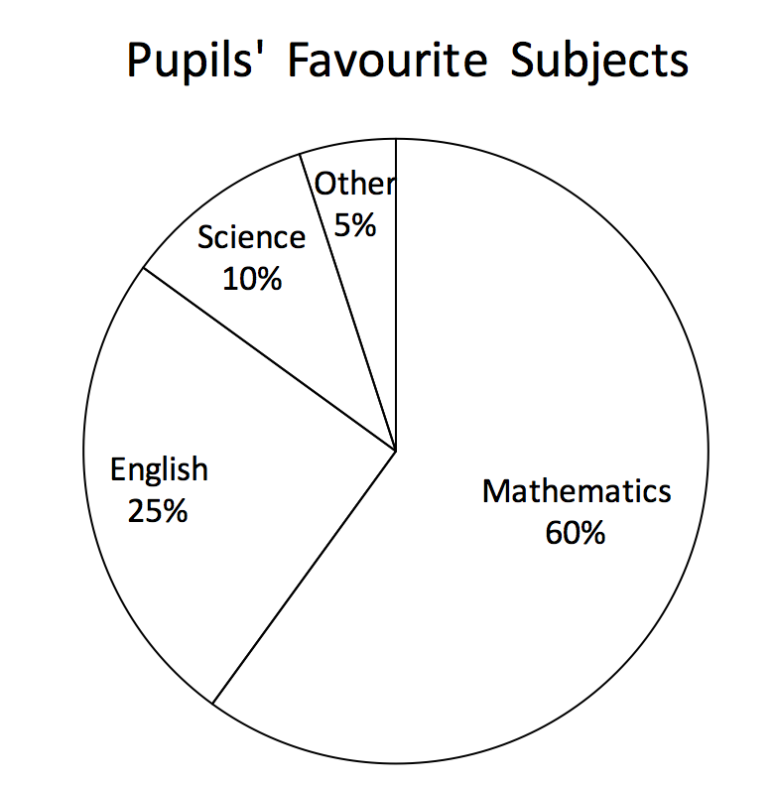
Solved Examples
- The principal of a school conducted a survey of 200 pupils to learn their favourite subjects. The result of the survey is in the pie chart to the right. Use the pie chart to answer the questions:
  - Which subject was the most popular?
  - What percentage of pupils prefer English?
  - How many pupils prefer English?
  - How many pupils prefer mathematics?
Solutions
- Mathematics was the most popular subject. It has the largest sector in the pie chart.
- Twenty-five percent of pupils prefer English.
- To find the number of pupils who prefer English, find 25% of 200, the number of pupils surveyed. The number who prefer English $=\frac{25}{100}×200=25×2=50$ pupils.
- To find the number who prefer mathematics, find 60% of 200. The number who prefer maths $=\frac{60}{100}×200=60×2=120$ pupils.

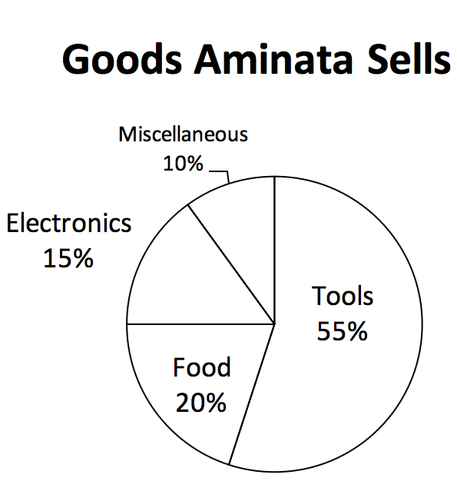
- This week, Aminata earned Le 2,000,000.00 by selling goods in her shop. The pie chart to the right shows the percentage that Aminata earned this week in each category of goods that she sells. Use the pie chart to answer the questions.
  - From which category of goods did Aminata earn the most money?
  - From which category of goods did Aminata earn the least amount of money?
  - How much did Aminata earn from electronics?
  - How much did Aminata earn from food?
  - How much more did Aminata earn from tools than from electronics?
  - Do you have any business ideas for Aminata?
Solutions
- Aminata earned the most money from tools, which has the largest sector.
- Aminata earned the least amount of money from “miscellaneous”, which has the smallest sector. This is a category that includes everything she sold that is not tools, food, or electronics.
- To find how much she earned from electronics, find 15% of Le 2,000,000.00. Earned from electronics $=\frac{15}{100}×Le 2,000,000=15×20,000=Le 300,000.00$
- Earned from food $=\frac{20}{100}×Le 2,000,000=20×20,000=Le 400,000.00$
- To find how much more she earned from tools than electronics, we need to first know how much she earned from tools.
Earned from tools $=\frac{55}{100}×Le 2,000,000=15×20,000=Le 1,100,000.00$
Remember that she earned Le 300,000.00 from electronics (part c).
Subtract to find the difference: $1,100,000-300,000=Le 800,000$
Aminata earned Le 800,000.00 more from tools than from electronics.
- The next time Aminata orders goods, she could try ordering more tools since this sector makes her more money.

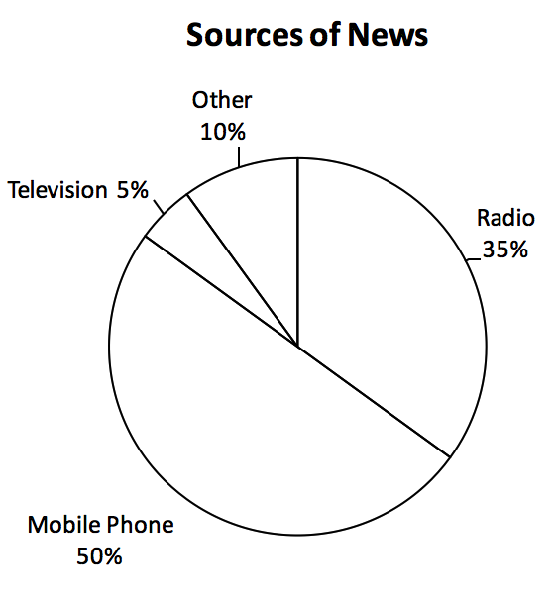
Practice
- Fatu conducted a survey of 300 members of her community to learn how people get news. The results of her survey are in the pie chart to the right. Use the chart to answer the questions:
  - How do most people get news?
  - What is the least common news source?
  - How many people get news by radio?
  - How many people get news by mobile phone?

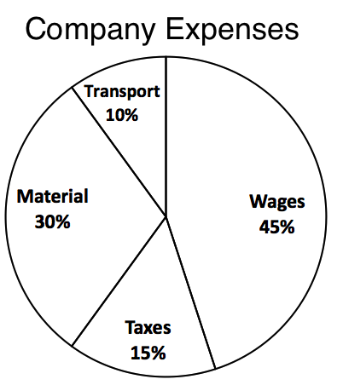
- Abu started a company. He created a pie chart to show his company expenses this week. His company spent a total of Le 4,000,000.00 this week. Use this information to answer the questions:
  - What was the company’s greatest expense this week?
  - How much did the company spend on transport?
  - How much did the company spend on taxes?
  - How much more money did the company spend on wages than materials?

- The pie chart below shows how Abass spends his monthly salary.
  - Find the value of $x$.
  - Abass earns Le 630.00 a month. How much of this does he spend on food?
  - What percentage of his salary does he spend on rent and utilities?
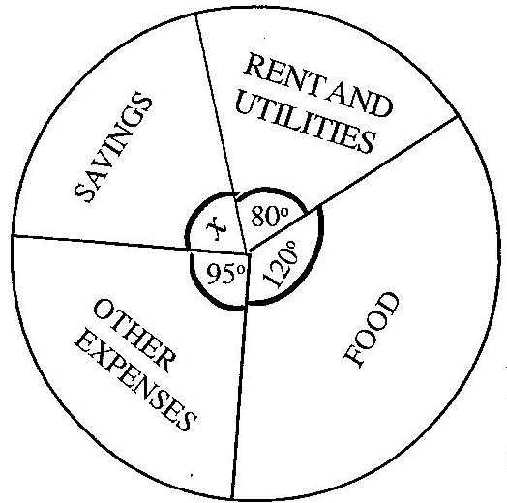

Lesson Title: Pie Chart Angles |  | Theme: Statistics and Probability
Practice Activity: PHM-08-145 |  | Class: JSS 2
Learning Outcome

By the end of the lesson, you will be able to find the sectoral angles of a pie chart and relate them to the whole (360°).

Overview
In this lesson, you will find the sectoral angle of a pie chart. That is, the angle that a sector forms at the centre of the pie chart. To find out how large each sector will be, we need to determine how many degrees its sectoral angle is.
To draw a pie chart accurately, we must use a protractor. The entire circle is 360°, and each sector is one part of the whole. We must find what part of the whole each sector is, and assign a degree to it. To find the degree of a sectoral angle, write the size of the sector as a fraction, and multiply by 360°. When you are given the size of the sector as a percentage, you can write the percentage as a fraction to find the degree of the sector.
The diagram at right shows a pie chart with 3 sectors. One sector is shaded, and the sectoral angle is marked.
In the next lesson, you will draw pie charts using the measures of sectoral angles.

Solved Examples
- A group of pupils was surveyed to find their favourite fruits. The data is in the table below. The pupils want to draw a pie chart for their data. Help them find the sectoral angle for each fruit.
Favourite Fruit | Frequency | Percentage
Banana | 16 | 40%
Mango | 10 | 25%
Orange | 6 | 15%
Pineapple | 8 | 20%
TOTAL | 40 | 100%
Solution
You will calculate the degree measure for each fruit. Give each frequency as a fraction of the whole (40), and multiply that fraction by 360°.
$Banana=\frac{16}{40}×360°=144°$
$Mango=\frac{10}{40}×360°=90°$
$Orange=\frac{6}{40}×360°=54°$
$Pineapple=\frac{8}{40}×360°=72°$
You can check your answer by adding the angles. They should sum to $360°$, one full rotation: $144°+90°+54°+72°=360°$.
- The table below shows how a family spends their money in one day. The family will display this data in a pie chart. Help them find the sectoral angle for each item.
Items | Amount Spent
Food | Le 15,000
House rent | Le 9,000
Electricity | Le 10,000
Transportation | Le 24,000
Other | Le 2,000

Solution
Find each quantity as a fraction of the whole, and multiply it by $360°$ to find the degree of its sector.

Calculate the total. This will be the denominator:
$$15,000+8,000+10,000+24,000+3,000=60,000$$
Calculate the measures of the sectors:
$Food=\frac{15,000}{60,000}×360°=90°$
$House rent=\frac{9,000}{60,000}×360°=54°$
$Electricity=\frac{10,000}{60,000}×360°=60°$
$Transportation=\frac{24,000}{60,000}×360°=144°$
$Other=\frac{2,000}{60,000}×360°=12°$
Check your answer by adding the angles: $90°+54°+60°+144°+12°=360°$.
- Find the sectoral angle of each sector of the pie chart of Pupils’ Favourite Subjects.

Solution
The percentage of pupils who prefer each subject is given. Write each percentage as a fraction, and multiply it by $360°$.

Mathematics: $\frac{60}{100}×360°=216°$
English: $\frac{25}{100}×360°=90°$
Science: $\frac{10}{100}×360°=36°$
Other: $\frac{5}{100}×360°=18°$

Check your answer by adding the angles: $216°+90°+36°+18°=360°$

Practice
- In a high school, a census was taken regarding the favourite subjects of pupils. The results are given in the table below. The principal has asked you to draw a pie chart from the data. Find the measure of the sectoral angle for each subject.
Subjects | Number of pupils
Mathematics | 200
English Language | 50
Literature | 90
Biology | 100
Government | 60
History | 80
Economics | 140

- The cost incurred on infrastructure development by a mining company is as follows: Wages: $45\%$, Taxes: $15\%$; Materials: $30\%$; Transport: $10\%.$ If this data is displayed in a pie chart, what will be the measure of each sectoral angle?
- A radio broadcaster took a survey to understand where people in a certain community get their news. She displayed the data in the pie chart to the right. Find the sectoral angle of each sector of the pie chart.

Lesson Title: Creating Pie Charts |  | Theme: Statistics and Probability
Practice Activity: PHM-08-146 |  | Class: JSS 2
Learning Outcome

By the end of the lesson, you will be able to display data collected from the class in a pie chart.

Overview
In this lesson, you will display data in a pie chart. To draw a pie chart accurately, we must use a protractor. Remember that a protractor is used to measure angles. Angles are measured in degrees, and a protractor can measure any angle less than 180 degrees. The protractor is like a ruler, but instead of measuring length we use it to measure angles.
Remember that a sectoral angle is the angle that a sector forms at the centre. We use a protractor to draw angles at the centre of the pie chart with the correct measurements. To draw a sector, draw one radius of the circle. Draw a second radius the correct number of degrees from the first radius.
If you do not have a protractor, you can make one with paper. Trace this protractor with a pen onto another piece of paper.
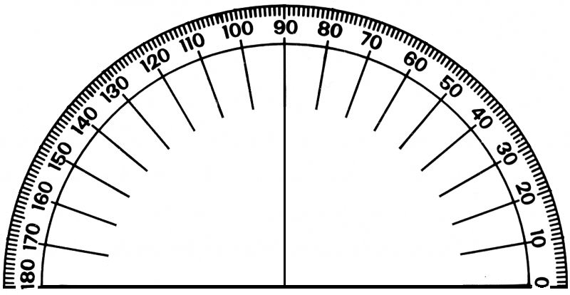
Solved Examples
- In the previous lesson, you calculated the sectoral angles for the data in the table below. Create a pie chart for this data.
Favourite Fruit | Frequency | Percentage
Banana | 16 | 40%
Mango | 10 | 25%
Orange | 6 | 15%
Pineapple | 8 | 20%
TOTAL | 40 | 100%

Solution
Look at your solution from the previous lesson. The sectoral angles are: Banana: $144°$; Mango: $90°$; Orange: $54°$; Pineapple: $72°$.
Now, draw the pie chart using the degrees you found:
- Draw the empty circle and add the heading, ‘Pupils’ Favourite Fruits’.
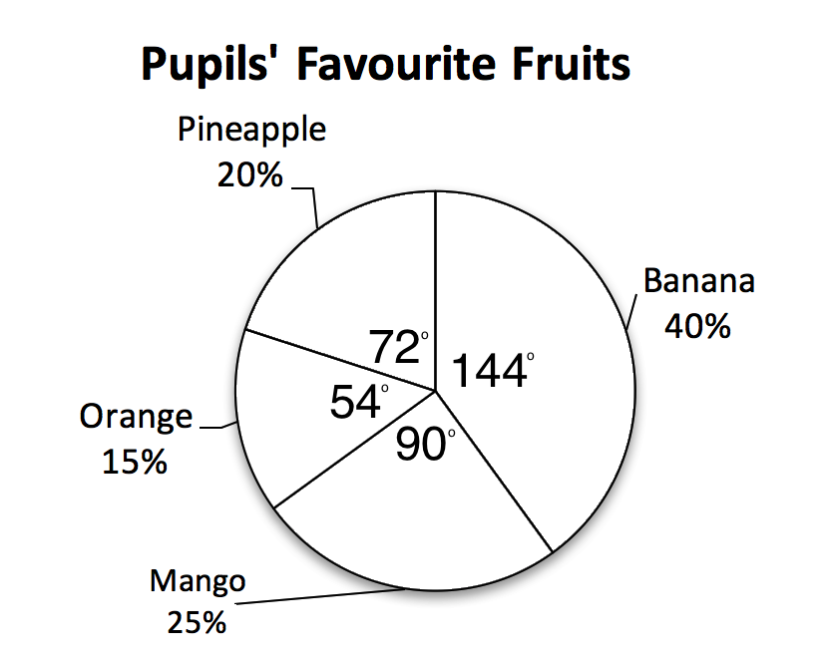
- Draw each sector using a protractor. For example, here are the steps for drawing the ‘Banana’ sector:
  - Place the centre of the protractor on the centre of the pie chart and place the bottom of the protractor exactly along one radius of the circle.
  - Find the angle measurement for banana, 144°.
  - Use a straight edge to draw another radius from the centre at 144°.
- Label each sector as shown.

- Michael sells fresh food in the market. The table below gives the amount of money that he earned from selling food items in 1 day. Represent the information in a pie chart.
Items | Amount Earned
Onion | Le 14,000
Potato | Le 30,000
Tomato | Le 40,000
Cassava Leaf | Le 6,000
Pepper | Le 10,000

Solution

Find the size of each sector using the process from the previous lesson. Find each quantity as a fraction of the whole, and multiply it by $360°$.

Calculate the total: $14,000+30,000+40,000+6,000+10,000=100,000$

Calculate the measures of the sectors:
$Onion=\frac{14,000}{100,000}×360°=50.4°$
$Potato=\frac{30,000}{100,000}×360°=108°$
$Tomato=\frac{40,000}{100,000}×360°=144°$
$Cassava Leaf=\frac{6,000}{100,000}×360°=21.6°$
$Pepper=\frac{10,000}{100,000}×360°=36°$
Check your answer by adding the sizes of the sectors: $50.4°+108°+144°+21.6°+36°=360°$.
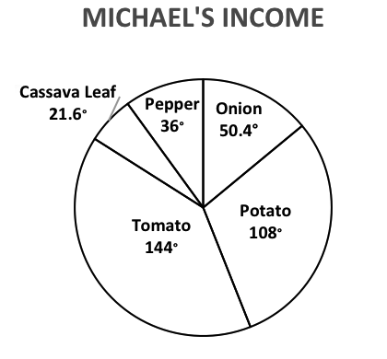
Use a protractor to draw the pie chart:

Practice
- In a high school, a census was taken regarding the favourite subjects of pupils. You calculated the sectoral angle for each subject in the previous lesson. Represent the information on a pie chart.
Subjects | Number of pupils
Mathematics | 200
English Language | 50
Literature | 90
Biology | 100
Government | 60
History | 80
Economics | 140
- The cost incurred on infrastructure development by a mining company is as follows: Wages: $45\%$, Taxes: $15\%$; Material: $30\%$; Transport: $10\%.$ You calculated the sectoral angle for each sector in the previous lesson. Show this information in a pie chart.
- In a secondary school in Sierra Leone, a census taken regarding the various ethnic groups gives the following results. Represent the data on a pie chart.
Ethnic group | Number of pupils
Temne | $$80$$
Mende | $$100$$
Susu | $$60$$
Krio | $$200$$
Fullah | 50
Limba | 90
Others | 140

Lesson Title: Creating Stem Diagrams |  | Theme: Statistics and Probability
Practice Activity: PHM-08-147 |  | Class: JSS 2
Learning Outcome

By the end of the lesson, you will be able to display data collected from the class in a stem diagram.

Overview
In this lesson, you will display data in another way. You will use a stem diagram, sometimes called a ‘stem and leaf’ diagram. Stem diagrams are a special type of table. The data is divided between two columns. The first digit (or digits) goes in the left column, and the last digit goes in the right column.
For example, consider the following list of numbers: 29, 30, 41, 37, 29, 28, 33, 31, 35, 45.
This is displayed in the stem diagram:
AGES OF MOTHERS AND FATHERS
Stem | Leaf
2 | 8, 9, 9
3 | 0, 1, 3, 5, 7
4 | 1, 5
 | Key: 2|8= 28

The stem is the digit in the left column and the leaf is the last digit in the right column. The key at the bottom shows how the number 28 is displayed in the diagram. Think of a stem on a plant. One stem can have many leaves. That is the same way a ten’s digit on a stem diagram may have many one’s digits.
A stem chart may also have multiple digits in its stem part. See Solved Example 1.
Solved Examples
- The following list is the number of pupils enrolled in JSS at eight different schools: 205, 208, 245, 218, 227, 236, 222, 217. Display this data in a stem diagram.
Solution
You may include 2 digits in the stem (hundreds and tens), and list the ones digits as leaves.
First, write the list in ascending order: 205, 208, 217, 218, 222, 227, 236, 245.
Make note of the ‘stems’: 20, 21, 22, 23 and 24.
Draw the stem diagram as shown below. The stem is the hundred’s and ten’s digits in the left column and the leaf is the one’s digit in the right column. The key shows us how to read it.
PUPILS ENROLLED IN JSS
Stem | Leaf
20 | 5, 8
21 | 7, 8
22 | 2, 7
23 | 6
24 | 5
Key: | 20|5 = 205 pupils

- The following are the weights of 12 pupils in kilogrammes: 50, 44, 52, 60, 61, 70, 48, 68, 62, 54, 57, 49. Display the data in a stem diagram.
Solution
In this case, the tens digit will be the stem and the ones digit will be the leaf.
Write the data in ascending order: 44, 48, 49, 50, 52, 54, 57, 60, 61, 62, 68, 70.
Draw the stem diagram as shown below. The stem is the hundred’s and ten’s digits in the left column and the leaf is the one’s digit in the right column. The key shows us how to read it.
PUPILS’ WEIGHTS
Stem | Leaf
4 | 4, 8, 9
5 | 0, 2, 4, 7
6 | 0, 1, 2, 8
7 | 0
Key: | 4|9 = 49 kg

Practice
- The heights of the players on the JSS football team (in centimetres) are: 170, 164, 159, 172, 154, 160, 149, 150, 148, 160, 165, 167, 171, 158, 162. Display the data in a stem diagram.
- The ages of 20 people living in one community are: 12, 5, 21, 9, 18, 35, 42, 68, 50, 38, 2, 90, 54, 48, 32, 39, 67, 62, 81, 51. Display their ages in a stem diagram.
- Mohamed has a large farm. He recorded the amount of cassava he sold each day for 10 days. This is his data, in kilogrammes: 12, 20, 31, 17, 40, 6, 28, 16, 10, 21. Display his data in a stem diagram.
- The number of JSS pupils enrolled at several schools in Freetown is: 161, 170, 204, 190, 181, 163, 154, 173, 141, 206, 198. Display this data in a stem diagram.

Lesson Title: Interpreting Stem Diagrams |  | Theme: Statistics and Probability
Practice Activity: PHM-08-148 |  | Class: JSS 2
Learning Outcomes

By the end of the lesson, you will be able to:
1. Interpret information from a stem diagram.
2. Calculate the mean, median, mode and range from a stem diagram.

Overview
In this lesson, you will interpret information from a stem diagram, and calculate the mean, median, mode and range.
To calculate the mean, median, mode and range from a stem diagram, you will follow the normal process. The mean is calculated by adding all of the items from the diagram, and dividing by the number of items. The mean, median, and range can be easily observed in a stem diagram because the numbers are already in ascending order. You can count the ‘leafs’ to find the median, the number in the middle. The mode can be observed by leafs that repeat. Finally, calculate the range using the first and last numbers in the stem diagram.
We can include decimals in a stem diagram as well. We just need to make sure there is a digit (leaf) in the right column for every piece of data even if it is a zero. See Solved Example 1.
Solved Examples
- Ten babies were born this week in a local hospital. Their weights were recorded in kilogrammes as: 3.0, 4.1, 2.9, 2.8, 3.1, 3.6, 3.3, 3.0, 2.7, 4.0.
  - Organise the data in a stem diagram.
  - Find the mean, median, mode and range of the data.
Solutions
- Organise the data in a stem diagram where the ones digit is the ‘stem’ and the tenths digit is the ‘leaf’.
BABIES’ WEIGHTS
Stem | Leaf
2 | 7, 8, 9
3 | 0, 0, 1, 3, 6
4 | 0, 1
Key: | 2|7 = 2.7 kg
- Calculate the mean by adding all of the numbers and dividing by 10, the number of babies:
Mean $=\frac{2.7+2.8+2.9+3.0+3.0+3.1+3.3+3.6+4.0+4.1}{10}=\frac{32.5}{10}=3.25$ kg
Count the babies’ weights to find the one in the middle. There are 10 babies, so the median will be the mean weight of the 5th and 6th babies:
Median $=\frac{3.0+3.1}{2}=\frac{6.1}{2}=3.05$ kg
The mode is the number that occurs most often. From the stem diagram, you can see that 3.0 kg is the mode.
To calculate the range, subtract the weight of the first baby in the stem diagram from the weight of the last baby:
Range $=4.1-2.7=1.4$ kg

- A doctor at the hospital recorded the ages of all of the patients she treated for a week. She recorded their ages in the stem diagram below. Calculate the mean, median, mode and range of the data.
PATIENTS’ AGES
Stem | Leaf
0 | 2, 2, 4, 7, 9
1 | 0, 2, 5, 8
2 | 1, 5, 6, 6, 6, 8
3 | 0, 5, 9
4 | 1, 6, 8
5 | 3, 5
6 | 9
7 | 2
Key: | 0|2 = 2 years
Solution
Calculate the mean by adding all of the ages and dividing by 25, the number of patients:
Mean | $$=$$ | $\frac{2+2+4+7+9+10+12+15+18+21+25+26+26+26+28+30+35+39+46+48+49+53+55+69+72}{25}$
 | $$=$$ | $\frac{650}{25}$
 | $$=$$ | $26$ years old

The median is the age in the middle. Of 25 patients, the 13th patient will have the median age. Count in the stem diagram up to the 13th patient. The median age is 26 years old.
The mode is the age that appears most often. From the stem diagram, the mode is 26 years old.
To find the range, subtract the age of the youngest patient from the age of the oldest patient: Range $=72-2=70$ years
Practice
- Fatu is a farmer. This year, her watermelon crop was very successful. She recorded the number of watermelons that she harvested each week: 15, 20, 32, 12, 17, 30, 23, 14, 38, 42, 32.
  - Organise her data in a stem diagram.
  - Find the mean, median, mode and range of the data.
- Francis is a tailor. This year, he made 15 new uniforms for primary school pupils. He measured the height of each pupil and recorded them in the stem diagram below. Find the mean, median, mode and range of their heights.
PUPILS’ HEIGHTS
Stem | Leaf
12 | 0, 3, 4, 4
13 | 2, 3, 4, 6, 7
14 | 1, 5, 7
15 | 0, 3, 6
Key: | 12|0 = 120 cm

- Martin is a driver. He recorded the amount of petrol that he used each day for 10 days in the stem diagram below. Find the mean, median, mode and range of the data.
PETROL USED
Stem | Leaf
0 | 8, 9
1 | 4, 7
2 | 3, 6, 6
3 | 0, 4
4 | 2
Key: | 1|4 = 1.4 litres

Lesson Title: Choosing a Graph or Chart |  | Theme: Statistics and Probability
Practice Activity: PHM-08-149 |  | Class: JSS 2
Learning Outcome

By the end of the lesson, you will be able to collect data and decide on the best type of graph or chart to represent it.

Overview
In this lesson, you will practise displaying data in charts and graphs. Remember that different types of charts and graphs are used to show different types of data. Review their definitions:
- A bar chart is used to compare different amounts.
- A line graph is used to display and compare information that changes over time.
- A pie chart is a type of graph in which a circle is divided into sectors that each represents a proportion of the whole.
- A stem diagram lists numbers in 2 columns, with their last digit in the right-hand column.
In this lesson, you will be given data in a table. You will decide which type of graph or chart is the best for representing the data. Use the definition of each type of chart above to help you decide. You will not use stem diagrams in this lesson. A stem diagram is better for displaying data from a list than data from a table.
Solved Examples
- The table below shows the humidity level recorded in Freetown for 7 days. Construct a graph which best demonstrates the humidity level for each day.
HUMIDITY LEVELS IN FREETOWN
Day | Humidity Level (%)
1 | 51
2 | 59
3 | 65
4 | 68
5 | 70
6 | 67
7 | 72
Solution
Humidity tells us the amount of water vapour, or moisture, in the air. We want to compare different values, and we can see that the data is changing over time. A line graph would be the best choice for displaying this data.

- Martin took a survey of his classmates to understand what field they want to work in when they finish school. He found that 25% want to work in education, 20% chose health, 30% chose agriculture, 15% chose law, and the rest chose other fields. Display this information in a chart or graph.
Solution
We are dealing with percentages as parts of a whole. We will use a pie chart to represent all of Martin’s survey participants. There will be 5 sectors: education, health, agriculture, law and other.
Find the size of ‘other’ by subtracting the known percentages from 100%: $100-25-20-30-15=10\%$
Find the measure of the angle in each sector, and use a protractor to draw them accurately.
Education: $\frac{25}{100}×360°=90°$
Health:$\frac{20}{100}×360°=72°$
Agriculture: $\frac{30}{100}×360°=108°$
Law:$\frac{15}{100}×360°=54°$
Other:$\frac{10}{100}×360°=36°$

- Dr. Bangura wants to create a chart or graph to show the patients admitted to the hospital this week. This week, there were 9 men, 8 women, 11 boys and 12 girls admitted to the hospital. Display this information for her.
Solution
Dr. Bangura wants to compare different amounts. A bar chart is the best option. A pie chart could also be used to show parts of the whole. We would need to calculate percentages for each type of patient. The bar chart is shown below:
Practice
- David kept track of his spending this month. He found that he spent 20% on transportation, 30% on food, 35% on rent, and the rest on entertainment. Draw a graph or chart to show David’s spending.
- The principal of a secondary school collected the data in the table below. Help him display his data in a graph or chart.
Pupil Population
Class | Number of Pupils
JSS 1 | 35
JSS 2 | 40
JSS 3 | 38
SSS 1 | 34
SSS 2 | 30
SSS 3 | 28
SSS 4 | 25
- Hawa is interested in studying the weather. She measured the temperature in her village for 6 days and recorded it in the table below. Help her display her data in a graph or chart.
Date | 8 May | 9 May | 10 May | 11 May | 12 May | 13 May
Temperature (°C) | 30 | 31 | 33 | 29 | 30 | 35

Lesson Title: Practice Making Statistical Calculations |  | Theme: Statistics and Probability
Practice Activity: PHM-08-150 |  | Class: JSS 2
Learning Outcome

By the end of the lesson, you will be able to calculate the mean, median, mode from various types of graphs and charts.

Overview
In the previous lesson, you calculated mean, median, and mode from a graph or chart. You will use information from previous lessons.

Solved Examples
- The line graph below gives the humidity in Freetown during one week. Find the mean, median, mode and range of the humidity level.

Solution

Remember that the humidity is given by the height of each point on the y-axis. It can be helpful to first note that humidity level for each day: 51, 59, 65, 68, 70, 67, 72.

To find the mean, add the humidity on each day and divide by 7.

Mean $=\frac{51+59+65+68+70+67+72}{7}=\frac{452}{7}=64\frac{4}{7}\%$ or $64.6\%$ humidity

The median is the humidity level in the middle. List the humidity levels in ascending order: 51, 59, 65, 67, 68, 70, 72. The median is 67% humidity.

There is no mode, because each humidity level occurs only once.

To find the range, subtract the lowest humidity from the highest: $72-51=21\%$

- The bar chart below gives the number of pupils in each level at a certain secondary school. Calculate the mean, median, mode and range for the number of pupils in each level.
Solution

Remember that the number of pupils is given by the height of each bar. It can be helpful to first note that number of pupils in each level: 35, 40, 38, 34, 30, 28, 25.

To find the mean, add the size of each class and divide by 7.

Mean $=\frac{35+40+38+34+30+28+25}{7}=\frac{230}{7}=32\frac{6}{7}$ or $32.9$ pupils

The median is the class size. List the class sizes in ascending order: 25, 28, 30, 34, 35, 38, 40. The median is 34 pupils.

There is no mode, because each class size occurs only once.

To find the range, subtract the smallest class from the largest: $40-25=15$ pupils.

Practice
- The stem diagram below gives the ages of a group of people. Calculate the mean, median, mode and range of their ages.
PATIENTS’ AGES
Stem | Leaf
1 | 2, 4, 4, 8, 9
2 | 3, 3, 3, 5, 7, 8
3 | 0, 2, 4, 6
4 | 1, 4, 4, 5, 8
Key: | 0|2 = 2 years

- The graph below gives the average high temperature during each month in Freetown. Find the mean, median, mode and range of the data.

- The bar chart below gives the amount of rice sold by a trader for 6 days of a week. Find the mean, median, mode and range of the data.

