Methodology for the dynamic identification of damaged

unreinforced masonry walls through vibrations tests
Silvia Ientile, Antonella Cecchi, Giosuè Boscato
IUAV University of Venice, Italy
Pierre Argoul, Franziska Schmidt, Boumediene Nedjar, Dominique Siegert
IFSTTAR, Marne-la-Vallée, France
Contact: silvia.ientile@gmail.com

Abstract
The preservation of architectural heritage from natural hazards and catastrophic events, including the seismic risk, requires in-depth investigation on structural behavior and in particular on the dynamic response of monumental and existing buildings, such as masonry structures. The support of experimental tests, dynamic identification techniques together with structural monitoring allow to a non-destructive evaluation of dynamic parameters and more in general for the seismic vulnerability assessment of heritage buildings, preserving its integrity and considering its operational status. In this paper, an experimental campaign on unreinforced masonry (URM) walls is presented on three typologies of walls considering induced damage. A methodology for the investigation of dynamic behavior of damaged URM walls proposed to support the most common dynamic identification techniques pointing out information through a simple spectral estimation.
Keywords: masonry, architectural heritage, dynamic vibrations, vulnerability assessment, signal processing, non-destructive tests, structural dynamic identification

Introduction
The Italian architectural heritage and the existing buildings, in general, are made up of a wide variety of structural typologies, among which the main one is represented by masonry structures. In most cases, the age of construction of these buildings is such that the state of conservation adopted reveals the vulnerability of the built heritage. In many damage scenarios of URM buildings in case of earthquake events, the failures are divided in two common modes: out-of-plane failure and in-plane failure of the walls. The occurrence of either typology depends on various factors, primarily on the geometry of the structure, the boundary conditions, the magnitude of the vertical loads and also it is influenced by the properties of the brick, mortar and brick/mortar interface [1]. Dynamic identification techniques together with structural monitoring allow to a non-destructive evaluation of structural parameters preserving its integrity and considering its operational status, particularly suitable for existing buildings [2][3].
In this paper, a procedure for dynamic identification is presented for a typical damage situations on unreinforced masonry (URM) walls characterized by injury due to seismic actions and to the deterioration or imperfections of the building, in order to obtain reference dynamic parameters for the seismic vulnerability assessment of URM walls through ambient vibration testing.

Ambient Vibration Testing and Signal Processing
Operational Modal Analysis (OMA) is based on measuring the output responses of a structure using ambient and natural operating forces as unmeasured inputs. Particular attention has to be paid to the data acquisition system, due to the field measurements and environmental conditions, OMA requires high accuracy in the control of the test set-up and in the analysis of the measured data in order to rate the influential factors (nature of the test object, test environment and operating conditions)[4][5]. Moreover, there are difficulties for detecting different mode shapes due to very closely spaced modes, to the subjectivity in the system order estimation and to the identification of spurious modes created by noise or redundant degrees of freedom of the model.
Given a signal x (t), the auto-correlation function R_{xx}(τ) and the related Power Spectral Density(PSD) S_{xx}(w) are defined as follows:
$${\text{R}}_{\text{xx}}\left(\text{τ}\right)\text{=}\underset{\text{T→∞}}{\text{lim}}{\frac{\text{1}}{\text{T}}}\int_{\text{-}\frac{\text{T}}{\text{2}}}^{\frac{\text{T}}{\text{2}}}{\text{x}\left(\text{t}\right)\text{x}\left(\text{t+}\text{τ}\right)\text{dt}}$$ | (1)
$${\text{S}}_{\text{xx}}\left(\text{w}\right)\text{=}F\left\{{\text{R}}_{\text{xx}}\text{(}\text{τ}\text{)}\right\}$$ | (2)
The auto-correlation function can be used to detect repetition or periodicity in a signal, it compares a signal with a time-delayed version of itself. Given a periodic signal, in absence of noise, the function oscillates with constant amplitude and the period of the auto-correlation corresponds to the period of the signal. In presence of noise, the function decreases exponentially. While, PSD function tells where the average power of signal is distributed as a function of frequency. The calculation of this function gives the distribution of energy signal, it shows at which frequencies the energy is strong or weak. PSD estimations can be carried out according to a non-parametric approach as Welch’s Method [6]. It provides a split up of the recorded signal into k overlapping segments of length L; then the modified periodogram I_{k}(f_{n}) through the computation of discrete Fourier transform, and the related average spectral estimation is:
$$\hat{P}{(f}_{n})=\frac{1}{K}\sum_{k=1}^{K}{I_{k}{(f}_{n}})$$ | (3)
where f_{n} is n/L with n=0,..,L/2.
Along to the estimation of FFT and PSD spectra, spectrogram is used as signal analysis’ tool. It is a representation of the amount of energy in the signal at any given time through a scale of colors. For its calculation, the Short Fourier Transform (SFT) of the signal is calculated, it gives a local snapshot in time of the frequency content of the signal during a short time of period. What concerns is to analyze how the frequency content changes in time, in order to identify local and global modes.
The type of testing carried out in this study, vibration test during a shear-compression test, cannot be considered as a standard procedure, then signal analysis methods were required to understand all the phenomena related to this process. Indeed signal processing, to be understood as technique to determine the frequency content of signal and related information, can be used to analyze and to assess the acquired data, especially in the case of multiple output signals for a single system. The experimental campaign provided a first phase of ambient vibration tests at initial conditions: the wall specimen in the test rig at zero loads. Vibrations tests were performed through a system of 9 accelerometers (Figure 1) in order to obtain the dynamic parameters. Observing the vibration data for the first wall specimen, here considered as a case-study, some parts of the acquired total signal are unusual for acquisitions with only ambient vibration. In fact, the signal contains some discontinuities in the waveform that can be assumed as transient responses, i.e. change in the steady-state of the system. They are probably due to the testing environment where other experimental machines were ongoing. According to the evaluation of the autocorrelation function (1), the response of the panel, in terms of signal, could be considered an assembly of different responses, transient and noise parts, as shown in Figure 2 for the signal acquired in CH1 channel.
Figure 1. Scheme of accelerometer sensors
Figure 2. Transient and Noise part from the total signal of CH1 channel
Four parts of it can be identified as transient responses between another one assumed as ambient noise. The transient responses have been assembled into a unique signal with a length of 146 seconds, while for the noise part a signal length of 416 seconds was considered. For each of them, PSD were calculated (Figure 3, Table 1). In the case of noise signal, the energy is highly concentrated in correspondence of 8,40 Hz, except for weak peak at the range frequency 40-50 Hz. Regarding the total and transient signals, the energy is higher respectively for the first peaks of 8,40 Hz and at 8,24 Hz . In both signals other two close peaks are identified, the first one has a higher energy. In the total signal, the second peak corresponds to a very low value of PSD magnitude. Then a peak appears at 70 Hz.
Figure 3. PSD of total, transient and noise signal related to CH1 channel
Table 1. Identified frequencies from PSD spectra for CH1 channel’s signal
Signal | Peaks of power spectra  [Hz]
Total | 8,40 | 33,95 | - | 70,46
Transient | 8,24 | 33,95 | 36,74 | 70,42
Noise | 8,40 | - | - | -
The considerations and results obtained from CH1 channel can also be extended to the data acquired for the other channels.

Methodology for dynamic identification of URM walls
Therefore the proposed procedure provides the evaluation of the type of recorded signals, either transient or noise. As a function of this, signal processing’s tools are used to obtain a preliminary assessment of the overall behavior of URM walls in terms of frequency in comparison with the dynamic identification in terms of frequency and modal shapes through the use of frequency domain technique. The estimation of PSD is sufficient for the identification of the frequency peaks in the case of ambient noise signals. Where transient responses are observed, the tools of the FFT together with the spectrograms is used to obtain the frequency peaks; spectrograms is evaluated through SFT with Hamming’s window according to the length of the selected signals.
Then the presented methodology is proposed to optimize the dynamic identification process for URM walls based on the following points:
- Identification of the presence of particular types of signal (such as transient response)
- Signal processing through frequency and power spectra, spectrograms according to the type of signal
- Evaluation of modal parameters with the available dynamic identification technique
- Comparison between the results obtained by signal processing and the ones by modal analysis identification technique

Experimental Campaign on URM walls
8 URM panels were built divided in three typologies: unaltered masonry walls and fired brick walls; the second and third ones relate to induced damage through the presence of brick units core exposed to high temperature [7]. The characteristics of test specimens represent ordinary unreinforced masonry walls with Flemish bond pattern (brick unit dimensions 250x120x55 mm) as masonry arrangement; each specimen is 150 cm tall, 130 cm width and a wall thickness of 25 cm, with 1 cm for the thickness of mortar joints. The three typologies of URM walls were tested in the laboratory LabSCo of IUAV University of Venice. The walls were subjected to Shear-Compression(SC) test, a vertical constant compression and an horizontal incremental force applied at the top of the wall according to predefined loading steps. The boundary conditions reproduce a cantilever. Ambient-vibrations tests were contemporary performed. The SC tests were carried out in control displacement, the loading velocity of the horizontal load was 0.03 mm/s. The loading history was made up several loading steps (Figure 4) until the failure, each of them (S_{i}) provided an increasing displacement of 5 mm (loading time of 170 seconds). Each loading step was followed by a pause period P_{i} of 15 minutes where the reached horizontal and compression loads are kept constant.
Figure 4. Scheme of the loading history of the SC Test
The application of the methodology, reported in the following paragraphs, concerns the initial conditions and then selected phases of the SC test considering a case study.

Application of methodology
Considering the complexity of the tests, the recorded data of a wall belonging to the first masonry typology have been analyzed applying the proposed methodology for selected load conditions steps.

Signal Processing for Initial Conditions
Vibrations data were acquired in a preliminary phase, defined as initial conditions (IC), in which no load is applied to the specimen. The data obtained were analyzed and three transient signals were identified from the total signals for each acquisition channel corresponding to the same time intervals. The three different responses are such that the system (the wall specimen at initial conditions) is excited in different ways in each transient signal. In Table 2 the average frequency values evaluated through Fourier analysis from each transient signal are summarized; window-length is 512 for Transient 1 and 3 and 256 for Transient 2 for the SFT.
Table 2. Average frequency values identified by FFT analysis for each transient signals at IC
Signal | Frequency  [Hz]
Transient_1 | 8,26 | - | - | -
Transient_2 | - | - | - | 71,88
Transient_3 | 8,04 | 33,80 | 36,54 | -
The first frequency peak, average value of 8,26 Hz is clearly identifiable by Transient_1 signal of each channel. Regarding the response in Transient_2 signal, the associated frequency spectra do not detect clear peak amplitudes and it seems that the energy of the signals is such to excite mainly the higher value of frequency (around 70 Hz) with respect the other transient responses as it is shown in Figure 5. In Transient_3 signal, additional peaks in the frequency range 33-36 Hz are identified with higher amplitudes with respect the first mode. The evaluated FFT spectra compared to spectrogram reveals what highlighted in the previous preliminary observations. Observing the spectrograms, frequencies identified by FFT spectra are represented by a constant line for the duration of considered signal, as shown for CH4 channels in Figure 6. According to this, the frequency peak identified by Transient_2 around 70 Hz, cannot be considered related to a mode of the wall, it disappears with the time probably due to the lower excitation of this signal. This allows to evaluate the reliability of the identified frequencies. It allows to identify four stable frequencies: a first bending mode and two torsional modes at two close frequencies as shown in Figure 7. The last one can be considered as a local mode related to the left upper part of the wall. The corresponding frequency is 71,4 Hz, very close to the peak identified by Transient_2 signal associated to a low amplitude of FFT. This is in agreement with the stabilization chart where also the related amplitude peak is very low. Considering these results, it could be due to the local response of the accelerometer in that specific point.
Figure 5. Frequency spectra for Transient_2 signals (a) and Transient_3 signals (b)
Figure 6. Frequency spectra and spectrograms for transient signals of CH4 channel at IC
Figure 7. Modal Shapes of B1_1 wall specimen at initial conditions

Signal Processing for Pre and Post-Damage Step
The proposed methodology is now applied to the following pause steps: P₁ step (after the first loading step S₁) and P₉ step that is after the ultimate reached failure. They respectively represent the reference configurations before and after the damage. The loading history with the steps of interest is shown in Figure 8. P₆ step is the phase before occurring the first cracks(main failure) in the wall at the reached loading conditions.
Figure 8. Loading history of the SC Test for the B1_1 Wall Specimen
During the execution of SC test, observing the sequence of loading and pause steps, at the increase of horizontal load the beginning of the pause phases is characterized by a loss of load which becomes greater in the steps at the time where the cracking of the panel occurred.

Pre-damage condition:P₁ pause step
Observing the plot of acquired signals during this step, they can be considered as a typical noise signal. Then it is useful to evaluate the power spectrum of each signal to estimate the frequency content and the distribution of energy associated to each one. A summary plot is shown in Figure 9. The frequency values with higher density of energy are mainly three. The first one is common to all the channels at 10,48 Hz. The other two modes are at the average values of 30,76 Hz and 41,59 Hz. Between these two peaks, other two can be identified: at the values of 36,67 Hz and at 39,60 for some of the 9 channels with low magnitudes.
Figure 9. Power spectra of all channels at P₁ step

Comparison with LSCF dynamic identification technique
Stabilization diagram for the P₁ step identified stable modes in correspondence of four frequency values.as shown in Figure 10.
The results confirms what found with the signal analysis. Mode 1 and Mode 2 are identified respectively at the frequency values of 10,43 Hz and 15,41 Hz, both modal shapes are characteristic of first bending mode in the perpendicular direction of longitudinal section of the wall, the second one can be considered as harmonic mode according to the lower amplitude of PSD.
Then Mode 3 can be defined as a local mode of the lateral upper part of the wall, in fact PSD show a peak just for CH3 channel. Mode 4 at the frequency value of 42,98 Hz can be considered the other global mode of the wall, indeed the torsional mode affect all the channels and this is demonstrated by the PSD evaluated for each signal.
Figure 10. Modal Shapes at P₁ step

Pre-damage condition:P₆ pause step
In P₆ step, the total signals are characterized by some transient responses plus noise, as occurred for the data acquired at the initial conditions. In this case two transient signals are selected. For both transient signals, according to frequency spectra and related spectrograms the first mode is respectively identified at 11,01 Hz and 11,12 Hz. Then, for Transient_1 frequency peaks are determined at 31.04 Hz and at 32.83 Hz for all the channels. While for Transient_2, in addition to the first mode, the frequency peak of 32,65 Hz is common to all the channels and for some channels a mode is found at 37,94 Hz. Frequency peaks results are summarized in Table 3. In case of high values of amplitude of FFT, it may be more likely to have non-linear effects as occurred for Transient_1 signals. As shown in Figure 10 for CH3 and CH9 channels, the first identified frequency is a straight line constant for all the duration of signals; while the two frequency peaks at 32,82 Hz and 37,17 Hz are for the first part of the signal up to about 6 second. This non-linear effect can be due to the unstable condition of wall caused by the alternation of loading and pause steps.
Table 3. Average frequency values identified by FFT analysis for each transient signals at P₆ step
Signal | Frequency  [Hz]
Transient_1 | 11,01 | 31,04 | 32,83 | 37,17
Transient_2 | 11,12 | 32,65 | 37,94 | 53,48
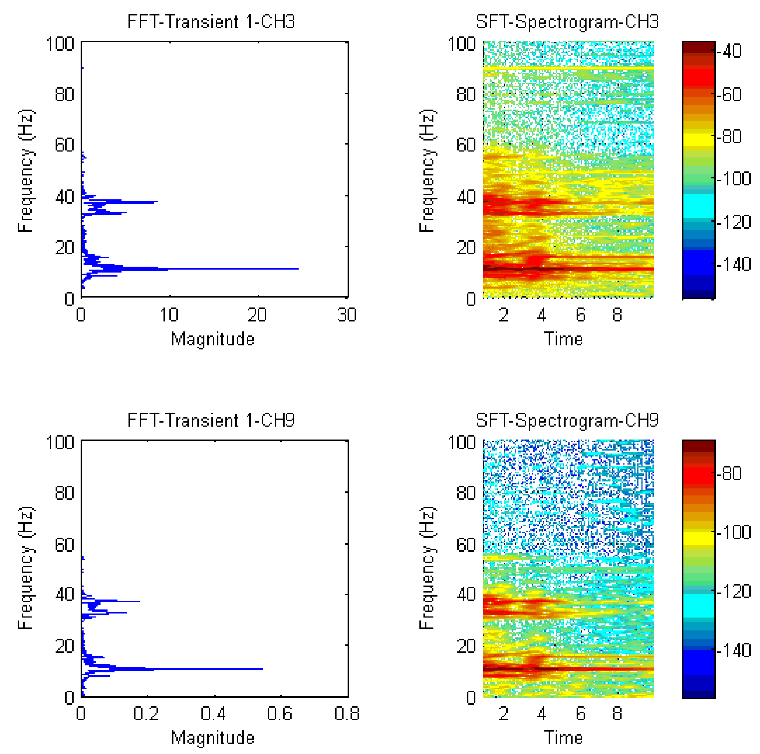
Figure 10. Frequency spectra and spectrograms for Transient_1 signals of CH3 and CH9 channels

Post-damage condition:P₉ pause step
This conditions is the ultimate loading step when the shear failure is occurred. The acquired signal has higher values of acceleration for the first 100 seconds which decreases to reach a constant trend over time. From the analysis of the signal, the second part of the signal contains more information according the evaluated power spectra (Figure 11). The energy is distributed among several frequency values reported in Table 3.
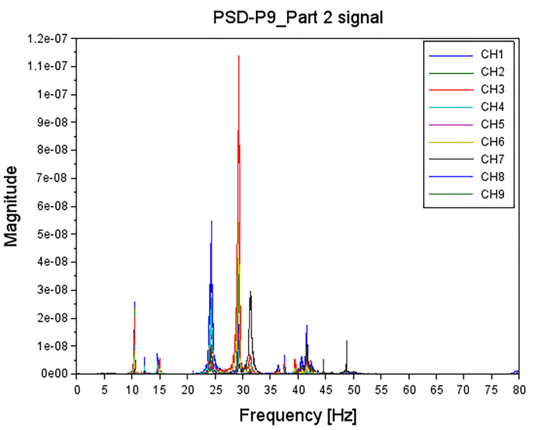
Figure 11. Power spectra of all channels at at P₉ step
Table 3. Average frequency values identified for Part_2 Signal at P₉ step
Signal | Frequency  [Hz]
Part_2 Signal | 10,44 | 14,69 | 24,31 | 29,34 | 31,34

Comparison with LSCF dynamic identification technique
According the stabilization diagrams calculated for Part_2 Signal, the wall is then characterized by 6 modes (Figure 12). The first bending mode of the wall can be identified at Mode 1 and 2, while the torsional mode is the third one. The other ones are mainly local, respectively of the left and of the right lateral part of the wall. The last modal shape is a combination of a torsional mode and a second bending mode interesting much the left side of the wall confirmed by the peaks of power spectra of signal analysis.

Discussion of results
Comparing the evaluated frequencies for the different conditions (Table 4) for the 1st Mode, common to every load conditions, a good correlation between the two methods is observed. In P₁ step, the results also show an increase of the frequency value probably due to the change of boundary conditions and the applied loads. Then a decrease in P₉ step when the failure is occurred, the cracks affect the stiffness of the wall.
Figure 12. Modal Shapes for Part_2 Signal at P₉ step
Table 4. Average frequency values identified at different configurations
 | Frequency [Hz]
 | IC | P₁ Step | P₉ Step
Signal processing Procedure | 8,04-8,26 | 10,48 | 10,44
LSCF PolyMAX | 8,35 | 10,43 | 10,41

Conclusions
The proposed methodology through signal processing’ tools such as FFT,PSD and spectrogram provides a support for the dynamic identification of URM walls pointing out information on the dynamic behavior of the wall during the test that is difficult to obtain through the dynamic identification technique with ambient vibration tests. This procedure helps to detect the modes due to the global behavior of the wall and the ones due to local phenomena for a preliminary assessment of dynamic behavior.
For the dynamic identification of damaged URM wall, the signal analysis is useful to assess the presence of non-linear effects caused by the SC test and to the occurrence and development of shear failure.

Acknowledgements
The Laboratory of Strength Materials of IUAV University of Venice and its technical stuff is gratefully acknowledged. The research has been carried out thanks to the financial support of PRIN 2015 (under grant 2015JW9NJT_014, project ‘‘Advanced mechanical modelling of new materials and structures for the solution of 2020 Horizon challenges’’)

References
- Boscato, G., Reccia, E., Cecchi, A. Non-destructive experimentation: Dynamic identification of multi-leaf masonry walls damaged and consolidated. Composites Part B: Engineering 133, pp. 145-16, 2018
- De Stefano, A., Ceravolo, R., Assessing the Health State of Ancient Structures: The Role of Vibrational Tests. Journal of intelligent material systems and structures, Vol. 18, 2007.
- Ceravolo R, Pistone G, Zanotti Fragonara L, Massetto S, Abbiati G. Vibration-based monitoring and diagnosis of cultural heritage: a methodological discussion by way of three examples. Int J Archit Herit. 2014.
- Jacobsen N.J.,Thorhauge O. Data acquisition systems for Operational Modal Analysis.Proc3rdIOMAC,215-22,PortoNovo(Ancona)2009.
- Peeters B, Sforza G, Sbaraglia L, Germano F. Efficient operational modal testing and analysis for design verification and restoration baseline assessment: Italian case studies. Exp Vib Anal Civil Eng Struct Evaces, Varenna 2011.
- Welch P.The use of fast Fourier transform for the estimation of power spectra: A method based on time averaging over short, modified periodograms. IEEE Transactions on Audio and Electroacoustics, vol. 15, 2, pp. 70-73, 1967.
- Karaman S., Ersahin S.,Gunal H. Firing temperature and firing time influence on mechanical and physical properties of clay bricks. Journal of Scientific & Industrial Research. 2006; 65:153-159.
- Peeters B., Van der Auweraer H., Guillaume p., Leuridan J. The PolyMAX Frequency-Domain Method: A New Standard for Modal Parameter Estimation?. Shock and Vibration. 2004, 11 (3-4): 395-409.

