General anesthetic agents and renal function after nephrectomy
: Supplemental Materials

Number | Title | Page
Supplemental  Table S1. | Comparison of incidence of primary and secondary outcomes between patients according to the main anesthetic agents during surgery after propensity score matching. | 2
Supplemental  Figure S1. | Histograms (left) and covariate balance plot (right) of distribution of standardized differences of covariates between the patients who received propofol and sevoflurane during surgery before and after matching. | 4
Supplemental  Figure S2. | Histograms (left) and covariate balance plot (right) of distribution of standardized differences of covariates between the patients who received propofol and desflurane during surgery before and after matching. | 5
Supplemental  Figure S3. | Histograms (left) and covariate balance plot (right) of distribution of standardized differences of covariates between the patients who received sevoflurane and desflurane during surgery before and after matching. | 6
Supplemental  Figure S4. | Histograms (left) and covariate balance plot (right) of distribution of standardized differences of covariates between the patients who received propofol and volatile agents during surgery before and after matching. | 7
Supplemental  Figure S5. | Kaplan-Meier survival curve analysis of new-onset chronic kidney disease according to the main anesthetic agents (TIVA vs. inhalation agents) before (A) and after (B) propensity score matching. | 3

Supplemental Table S1. Comparison of incidence of primary and secondary outcomes between patients according to the main anesthetic agents during surgery after propensity score matching.
Outcomes | Propofol | Volatile agents | P-value
Number of patients before matching | 130 | 957
Postoperative AKI, n | 29 (22.3) | 342 (35.7) | 0.002
Stage 1 | 24 (18.5) | 303 (31.7)
Stage 2 | 1 (0.8) | 5 (0.5)
Stage 3 | 4 (3.1) | 34 (3.6)
Postoperative new-onset CKD stage 3a, n | 33 (25.4) | 427 (44.6) | <0.001
CKD upstaging, n | 38 (29.2) | 448 (46.8) | <0.001
Number of patients after matching | 126 | 126
Postoperative AKI, n | 27 (21.4) | 43 (34.1) | 0.024
Stage 1 | 23 (18.3) | 41 (32.5)
Stage 2 | 1 (0.8) | -
Stage 3 | 3 (2.4) | 2 (1.6)
Postoperative new-onset CKD stage 3a, n | 32 (25.4) | 44 (34.9) | 0.100
CKD upstaging, n | 36 (28.6) | 69 (54.8) | <0.001

The values are presented as the median (interquartile range) or number (%).
AKI = acute kidney injury determined by KDIGO creatinine criteria, CKD = chronic kidney disease.

Supplemental Figure S1. Histograms (left) and covariate balance plot (right) of distribution of standardized differences of covariates between the patients who received propofol and sevoflurane during surgery before and after matching. BMI = body-mass index, ASA_class = American Society of Anesthesiologist physical status classification, HTN = hypertension, DM = diabetes mellitus, CVA = cerebrovascular accident, Hb = hemoglobin, Alb = albumin, GFR = glomerular filtration rate, pRBC = packed red blood cells.
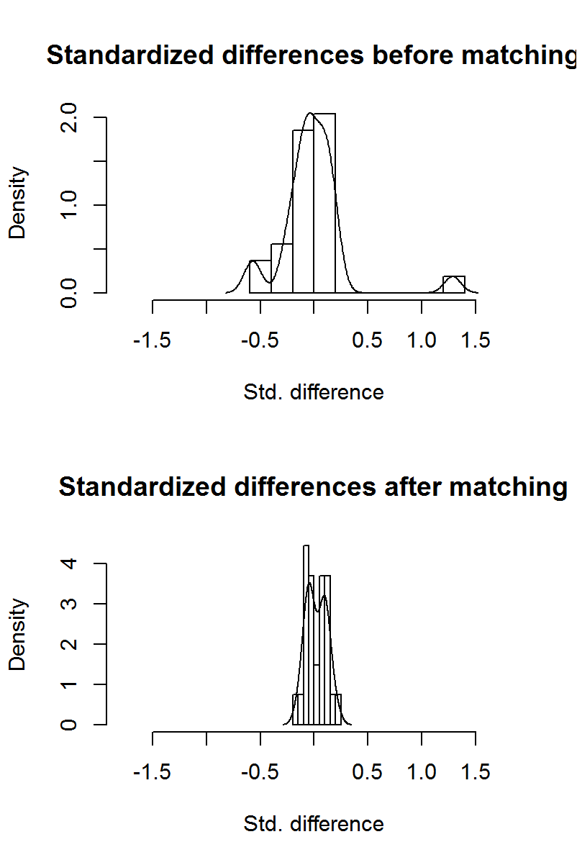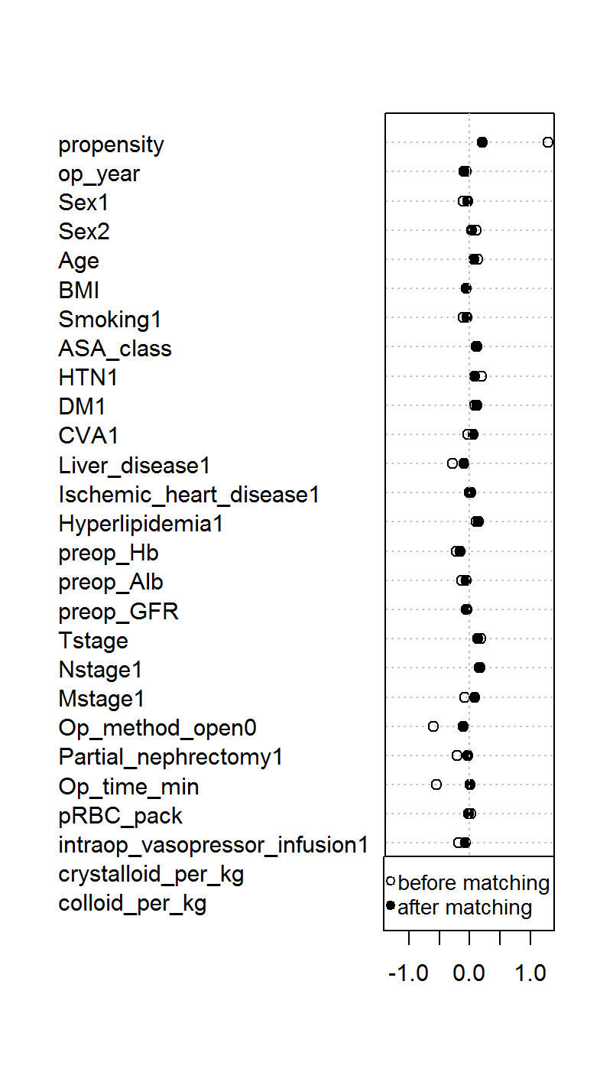

Supplemental Figure S2. Histograms (left) and covariate balance plot (right) of distribution of standardized differences of covariates between the patients who received propofol and desflurane during surgery before and after matching. BMI = body-mass index, ASA_class = American Society of Anesthesiologist physical status classification, HTN = hypertension, DM = diabetes mellitus, CVA = cerebrovascular accident, Hb = hemoglobin, Alb = albumin, GFR = glomerular filtration rate, pRBC = packed red blood cells.
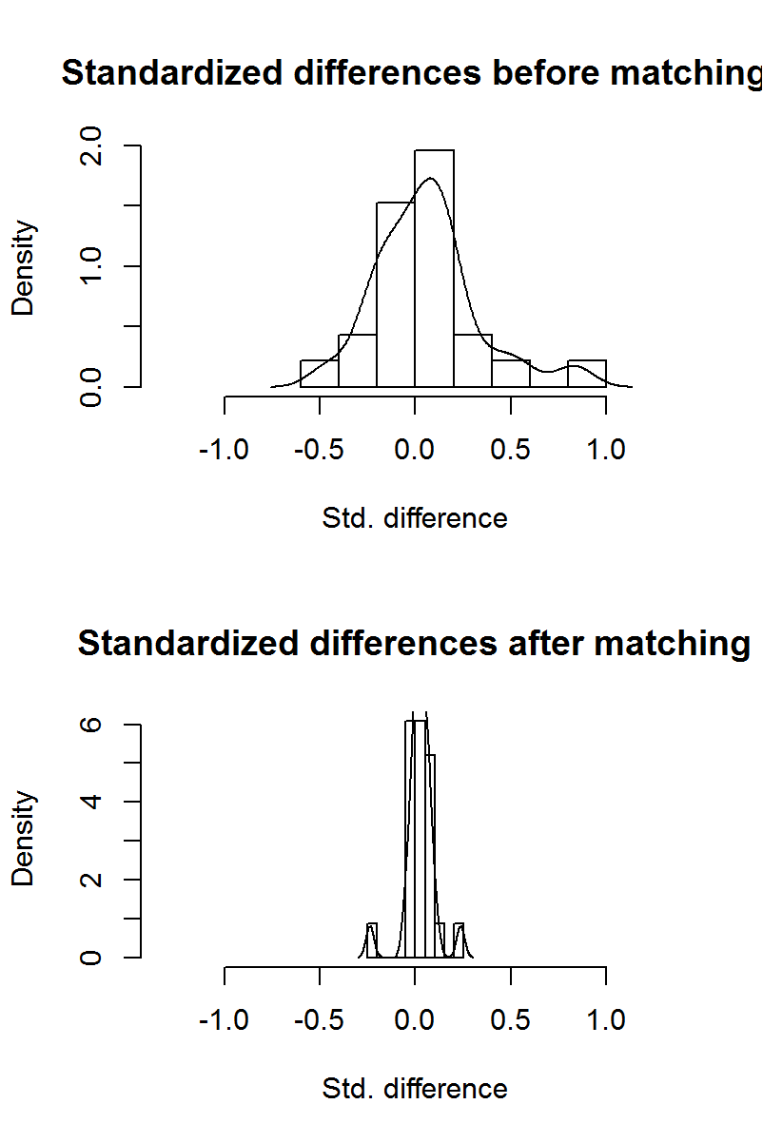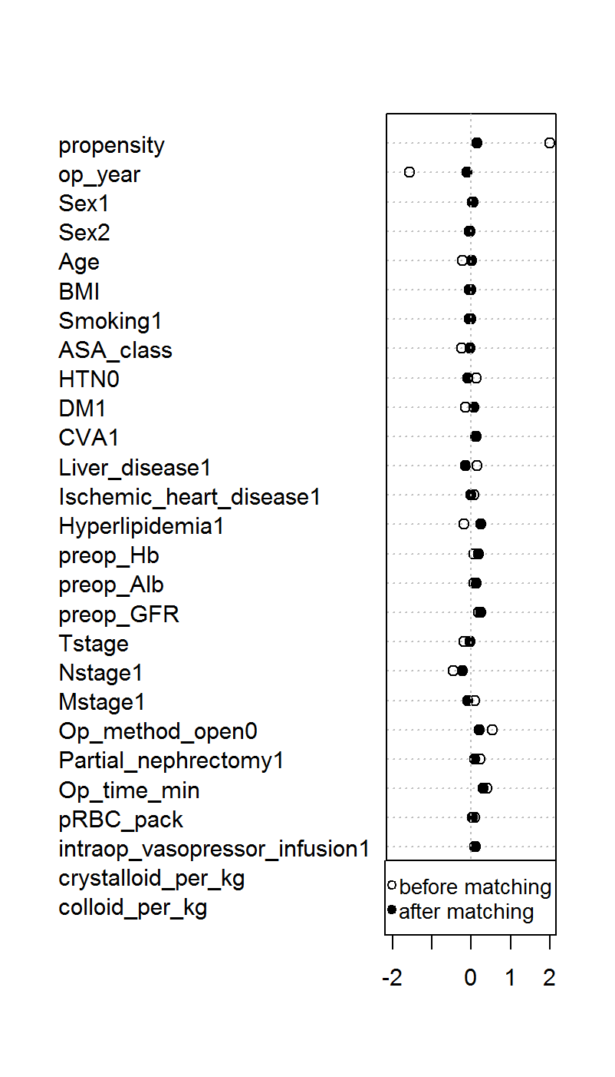

Supplemental Figure S3. Histograms (left) and covariate balance plot (right) of distribution of standardized differences of covariates between the patients who received sevoflurane and desflurane during surgery before and after matching. BMI = body-mass index, ASA_class = American Society of Anesthesiologist physical status classification, HTN = hypertension, DM = diabetes mellitus, CVA = cerebrovascular accident, Hb = hemoglobin, Alb = albumin, GFR = glomerular filtration rate, pRBC = packed red blood cells.
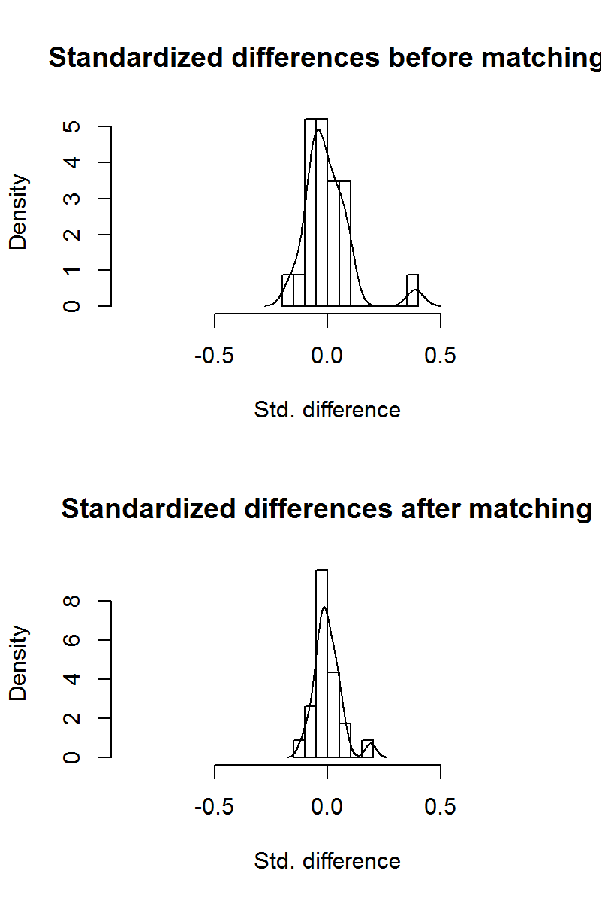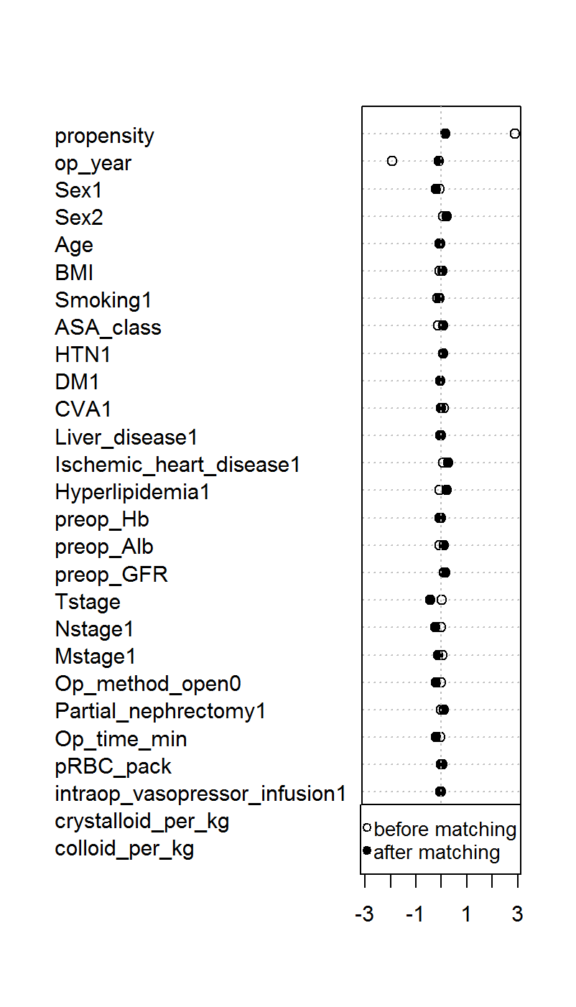

Supplemental Figure S4. Histograms (left) and covariate balance plot (right) of distribution of standardized differences of covariates between the patients who received propofol and volatile agents during surgery before and after matching. BMI = body-mass index, ASA_class = American Society of Anesthesiologist physical status classification, HTN = hypertension, DM = diabetes mellitus, CVA = cerebrovascular accident, Hb = hemoglobin, Alb = albumin, GFR = glomerular filtration rate, pRBC = packed red blood cells.
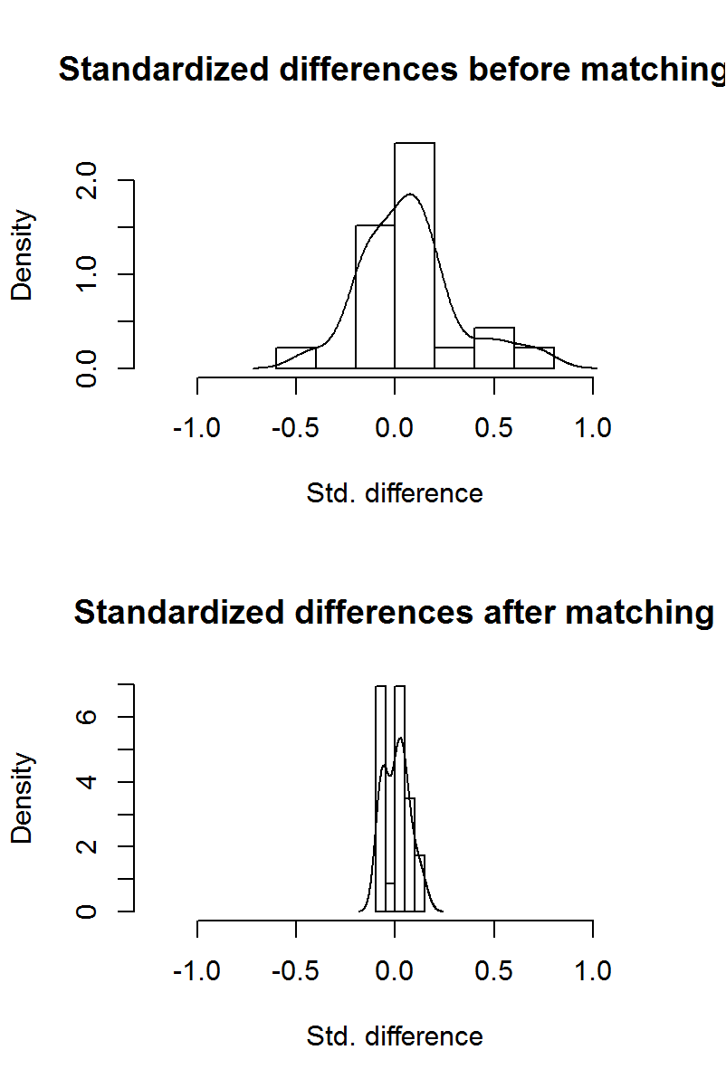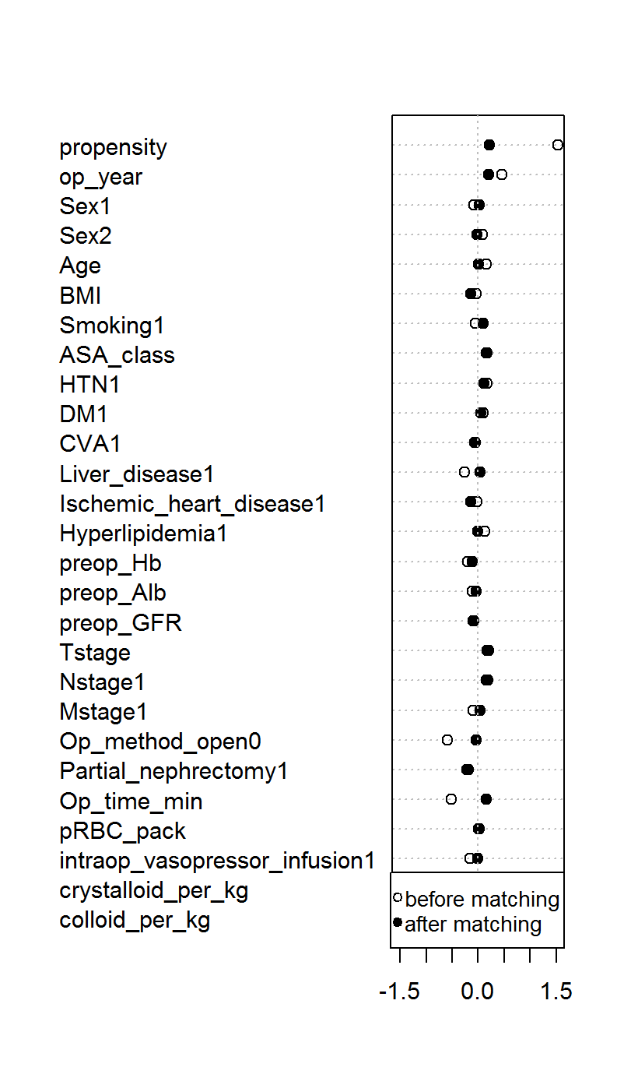

Supplemental Figure S5. Kaplan-Meier survival curve analysis of new-onset chronic kidney disease according to the main anesthetic agents (TIVA vs. inhalation agents) before (A) and after (B) propensity score matching. The results of log-rank test between the groups are shown on the figure.
