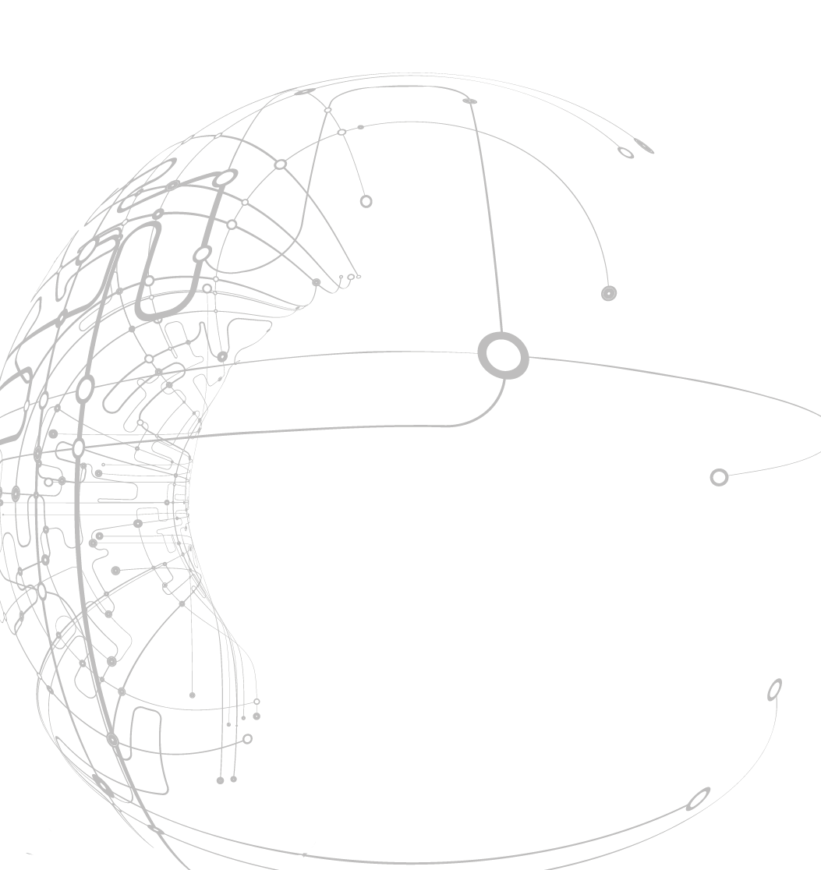
Style Guidelines for Final Year Project ReportsNon-Intrusive User Interaction Monitoring for WinCC OA based Applications

August 2015

Author:

Shubham Gupta

Supervisor:

Jean-Charles Tournier


A 4th Year StudentCERN openlab Summer Student Report 2015

Abstract
WinCC OA is a SCADA (Supervisory Control and Data Acquisition) system tool that is used to develop the Control System applications. As most of the control systems used in CERN are developed in WinCC OA, it is better useful to understand how the applications developed by EN/ICE are actually used by the different operators .It becomes more and more important to monitor users’ behavior and analyzing it. The final goal of this project is to develop a generic WinCC OA component to collect data about user interaction which will take advantage of (1) the internal mechanisms already present in WinCC OA to monitor some user interactions such as the internal UI data points; and (2) the commonalities of applications through the use of the standard frameworks JCOP, UNICOS and CPC. The final component developed provides the capability of storing as well as displaying user interaction data on a single timeline.
Kewords: WinCC OA, SCADA, JCOP, UNICOS, CPC

Acknowledgement
I would like to express my special thanks of gratitude to my supervisor Jean-Charles Tournier as well as our section head Manuel Gonzalez Berges who gave me the golden opportunity to do this wonderful project, and also for encouraging and guiding me throughout the process. I am really thankful to Paul Burkimsher for the very well structured course on WinCC OA.
I would also like to express my gratitude towards the members of EN-ICE-SCD section for being kind enough to patiently answer my questions and also for their kind co-operation and encouragement which help me in completion of this project.

Table of Contents
Abstract 2
Acknowledgement 3
1 Introduction 6
1.1 Background 6
1.2 Existing System 6
1.2.1 SCADA 6
1.2.2 WinCC OA 7
1.3 Motivation 8
1.4 Objective 9
1.5 Methodology 9
1.5.1 Data Selection 9
1.5.2 Data Archival 9
1.5.3 Data Filtration 9
1.5.4 Data Dictionary 9
1.5.5 Data Retrieval 9
1.5.6 Designing 9
1.6 Chapter Breakdown 10
2 Requirement Analysis 11
2.1 Filters 11
2.2 Mapping 11
2.3 Data Timeline 11
3 Design and Architecture 12
3.1 Overview 12
3.2 Architecture 12
4 Development and Implementation 14
4.1 Data Archiving 14
4.2 Data Dictionary 14
4.3 Panel 14
4.3.1 fwGeneral 14
4.4 Creating the xml file 15
4.5 Installation of component 16
5 Results 17
5.1 Running fwAnalytics 17
5.2 Archiving DPEs at runtime 17
5.3 Display of user interactions 18
6 Conclusion 20
7 Future Scope 21
7.1 Component Testing 21
7.2 Testing on the real application 21
7.3 Analysis 21
7.4 Statistics 21

Introduction

Background
The project has been done is the EN-ICE-SCD section. EN-ICE is Industrial Control & Engineering group under the Engineering Department (EN) which develops solutions and gives support in the area of extensive and medium scale laboratory control systems. Currently, they support five major installations: ALICE, CMS, ATLAS, LHCb and the accelerator complex, each of them with hundreds of logical boards and millions of parameters. In terms of data analytics, the main goal for the ICE group is to develop a data analytics framework. The main challenge, taken by the Control Group, is to integrate the data analytics functionalities with the current CERN control system (mainly through the SIMATIC WinCC OA SCADA system) and provide it as a service. EN-ICE-SCD is the SCADA System section that focuses on the development of WinCC OA applications for CERN experiments and infrastructure. Apart from development, providing services for the control systems and monitoring is also a major part of work that is done in the section. A progressing effort by the CERN Industrial Controls & Engineering Group is to provide tools that help the operators find abnormal situations with their systems by monitoring different aspects of them.

Existing System

SCADA
SCADA stands for Supervisory Control and Data Acquisition. It is a system used to monitor and control a plant or equipment in industries remotely. SCADA systems have 5 main components:
- Field Devices: Sensors and actuators. Sensors are used to physically record the real time data from the field. Actuators are used for the control functionality as they convert the electrical signals to mechanical actions.
- Terminal Units: Remote Terminal Units, Master Terminal Units, Programmable Logic Controllers. They are used to gather data from sensors and send them over the network and also get data and send it to actuators. They convert sensor signals to digital data. It has a telemetry hardware which is capable of sending digital data to the SCADA Master. PLCs are preferred over RTUs because they have more sophisticated embedded control capabilities and are more economical and flexible to use.
- Network: A communication network to connect the field with the Control Centre and also for data to transfer over the network
- SCADA Master: These are dedicated servers which enables the functioning of SCADA system. It is a supervisory system that maintains all the logics and Data that is archived.
- HMI: HMI stands for Human Machine Interface and is used to provide a UI for the users to work and control systems.

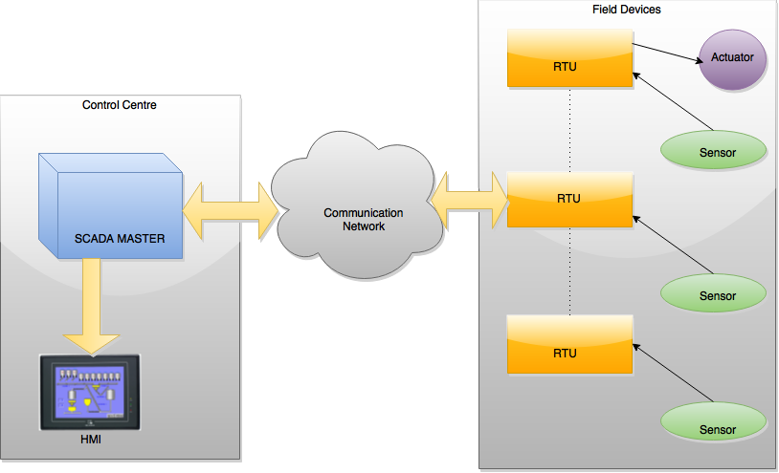
Figure 1 SCADA System Architecture

WinCC OA
WinCC OA (earlier known as PVSS) is a SCADA framework developed by ETM professional control GmbH and presently owned by Siemens. This tool helps in the visualization, operation of processes and production flows in all kinds of business and research fields. Most of the control systems at CERN are developed using WinCC OA. For example, applications for monitoring and controlling detectors of major experiments, ventilation, cryogenics, cooling systems and other infrastructure etc.

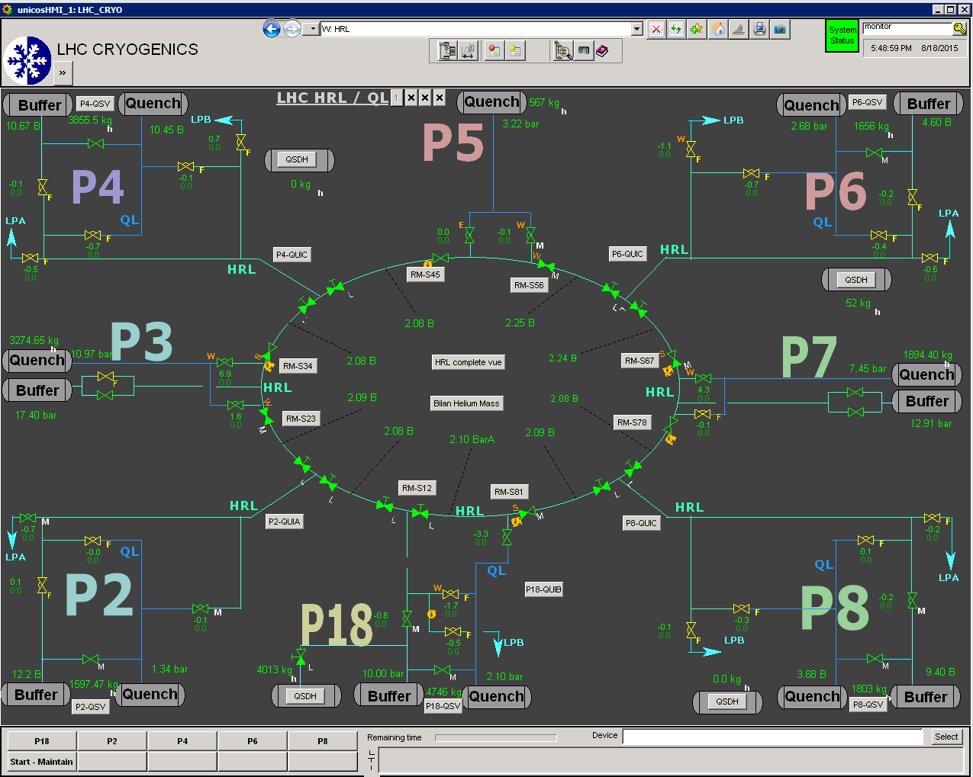
Figure 2: A modern WinCC OA interface that controls LHC CRYOGENICS system

Motivation
TheWinCC OA applications are developed without any knowledge of how the application will be used by the user. There is little or no information about how user interacts with those applications. As most of the control systems at CERN are developed by WinCC OA, it becomes important to know how these WinCC OA based applications are being used by the users.
Also, users relies on logs to know what happened with the system which are not complete source of information. It is very hard for an operator to detect an error or fault in the system using logs as they are complex and long. Moreover, logs are not able to tell what actions operator performed at the time of the error. To get the information about actions in log files, ‘DebugN’ is required to be intrumented everywhere in the code which is not a feasible solution.
The development of applications are done in an unprioritized way as there is no information about which panels and modules are used most. This can sometimes leads to wastage of time and effort as the panel that is being developed has no significance on the operational side.

Objective
To develop a non-intrusive generic WinCC OA component which aims to provide :
- User interaction tracking: Tracking each and every action user performs on the application.

- Monitoring the users’ behaviour over time and creating statistics.

Methodology
The general steps for the execution of the project in the sequential manner are as follows:

Data Selection
The data options available within the WinCC OA are needed to be filtered to match the requirements of the project.

Data Archival
It deals with the storage of data- the kind of database involved. The data should be stored such that it can be pulled out as per the requirement. Each action that the user performs on the application generates some data such as value, time stamps of the action, username, manager number etc.. All the information about user interaction needs to be archived in the database.

Data Filtration
Archived data needs to be filtered before it is retrieved so various data filters are needed to be designed. The data filtration can be done on the basis of time intervals, user, manager numbers, etc.

Data Dictionary
Data being archived is stored in the complex form which is difficult to understand by the operator. Therefore, a data dictionary is required to map the complex text to simple text at the time of execution of query.

Data Retrieval
The data stored in the database needs to be retrieved so as to display the results of the query of the user.

Designing
This section deals with the data representation and front end i.e. how the UI is made as per the analysis.

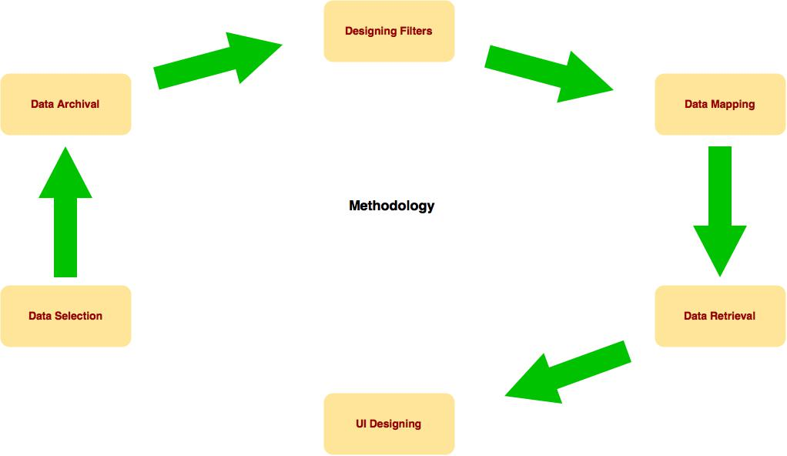
Figure 3 Sequential steps required for development

Chapter Breakdown
Chapter 1 introduces the title of the project, the background and motivation behind the project, objectives the project is aimed at, the methodologies that will be followed during the development stage.
Chapter 2 mentions the requirements that are required to be fulfilled and analysed to complete the project
Chapter 3 discusses the system architecture that will be followed for complete implementation of the project.
Chapter 4 consists of the development model and the implementation steps that were put into action for the completion of project.
Chapter 5 mentions the results of the project. It contains the screen shots of output window.
Chapter 6 consists of the summary of project.
Chapter 7 consists of the details of the future scope of the project.

Requirement Analysis

Filters
The archived data needs to be filtered using various parameters. The user should be able to filter the data on following basis :
- Time Interval : Given a set of results, a user should be able to .
- Username : the model should be able to filter the data giving information about specific user.
- Manager No. : The Manager that is being currently used by the user.
- Parameter Name : The parameter on which the Action is done. For ex. panel name, module name, etc.

Mapping
A data dictionary needs to be created to map key values ie. the original values to the key pairs that are values that we want the users to see. As the actions are needed to be converted in General English Texts which are easy to understand by everyone, a generic data dictionary is required.

Data Timeline
All the desired data should be displayed in displayed in one timeline with the following attributes:
- Action that was performed.
- Parameter on which the action was performed.
- Time stamp of the action.
- Name of the user which performed the action.
- System number.
- Manager Type.
- Manager Number.

Design and Architecture

Overview
The most creative and challenging face of the system development is System Design. It provides the understanding and procedural details necessary for the logical and physical stages of development. In designing a new system, the system analyst must have a clear understanding of the objectives, which the design is aiming to fulfil. The first step is to determine how the output is to be produced and in what format. Second, input data and master files have to be designed to meet the requirements of the proposed output. The operational phases are handled through program construction and testing. Design of the system can be defined as a process of applying various techniques and principles for the purpose of defining a device, a process or a system in sufficient detail to permit its physical realization. Thus system design is a solution to ―how to approach to the creation of a new system. This important phase provides the understanding and the procedural details necessary for implementing the system recommended in the feasibility study. The design step provides a data design, architectural design, and a procedural design.

Architecture
Figure 4 depicts the internal function of component. It gives an overview of how the elements in the fwAnalytics component are interacting with each other as well as the database. The user can apply some filters and search for the results. The original values in results are mapped to the desired values and the results are displayed.

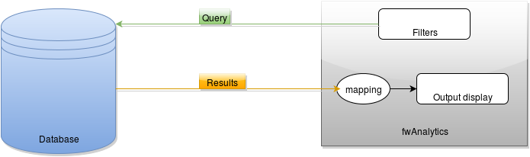

Figure 4 fuctioning of the model

Figure 5 depicts the architecture of the proposed system and how various elements of the system are communicating with each other. The user interacts with the WinCC OA application and generated data which is getting archived in the database. Archiving of data is continuous and automated process. These archived data points can be retrieved by the fwAnalytics component.

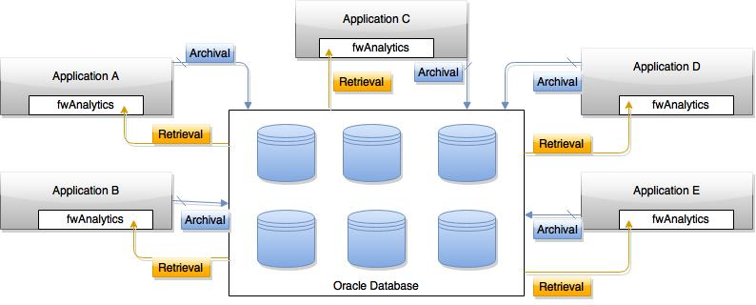
Figure 5 Architecture diagram of the proposed model

Development and Implementation

Data Archiving
All the Data Point Elements of _Ui Data Point Type are archived using archive class as ‘5 minutes archive’. The component is using the following function to archive the DPEs from the library fwConfigs/fwArchive.
_fwArchive_setMany()
When a new _UI Data Point is created and is not archived, the panel checks for the archive settings at initialisation and notifies the user with a popup panel that some DPs are not being archived.

Data Dictionary

Panel
The panel is developed using simple filters and table. The table is used to display the results of the query and the filters are used to get the desired results while querying the database. The panel also csv export button which is used to email or download the results of the table into csv format.
The Config button in the panel is used to archive the DPEs if they are not being archived. It can also be used to change the archive class.

fwGeneral
fwGeneral DataTimeWidget has been used for the implementation of date and time filter. The fwAnalytics library is using the functions such as setTimePeriod(), getTimePeriod from fwGeneral library. So for the functioning of the component it is required to have fwGeneral installed.
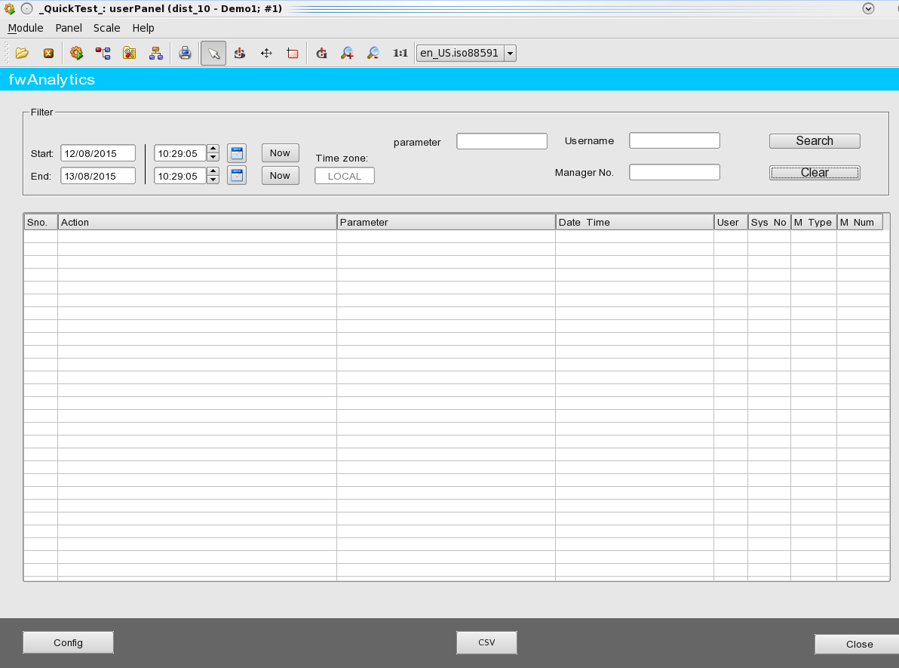
Figure 6 User Interface

Creating the xml file
For the installation of the component to other systems an XML file is needed. This XML file is selected for the installation which includes the details of the component such as name, version etc. It also includes the path of files used by the component such as panels, libraries and other necessary files.
<component>
…..
…..
</component>

Installation of component
The component can be installed on other systems. This is done using the ‘fwInstallation.pnl’ already present in WinCC OA. The installation requires the XML file which can be found on CERN SVN.

Results

Running fwAnalytics
After the installation of the component, ‘mainpanel.pnl’ can be run using the following command:
WCCOAui –proj Project_Name –p Panel_Name
The panel will check for the _Ui Data Point Elements being archived or not at the time of initiation of the panel. If the archiving is not active even for a single DPE from the defined group, it will open a popup panel ‘Attention Panel’. Otherwise, the panel will just open and wait for the user to search for the data.

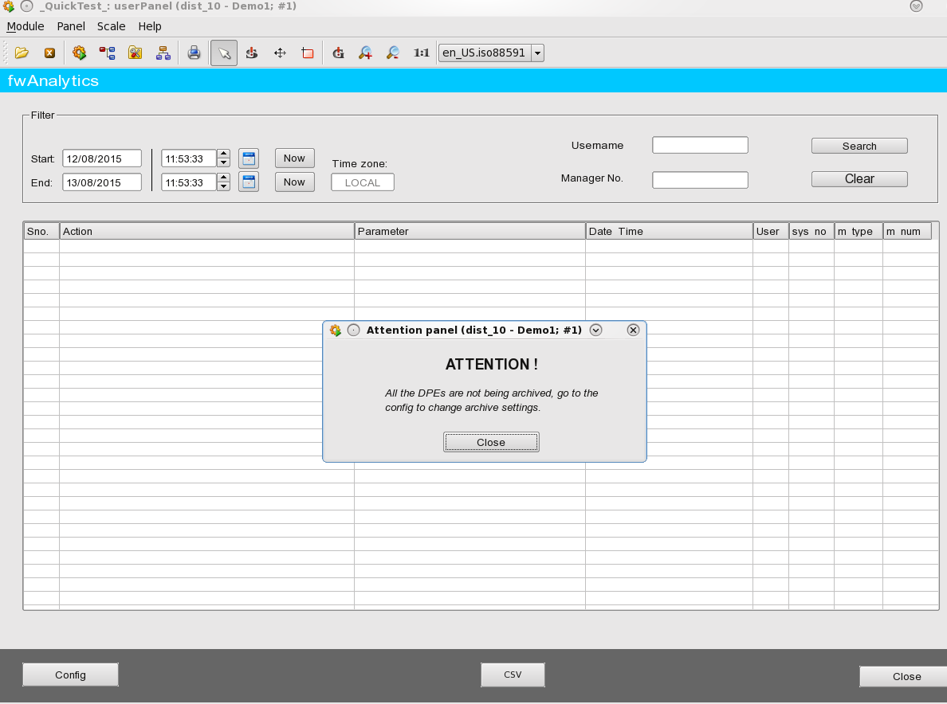

Figure 7 Running the mainpanel.pnl

Archiving DPEs at runtime
Clicking at the config button will open a popup panel ‘config.pnl’ from where users can start archiving the DPEs and also can change the archive class of the DPEs being archived.

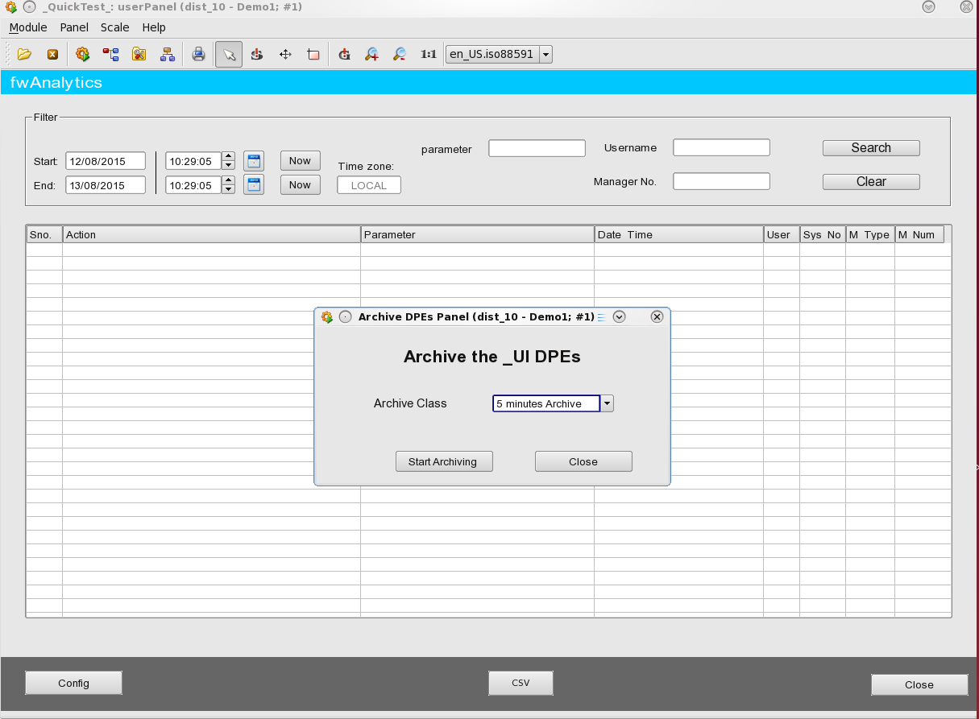

Figure 8 Config.pnl ( popup panel)

Display of user interactions
Figure 9 shows an example of user interactions that were recorded and displayed. The results in the figure are filtered by the user “para” and the time period.
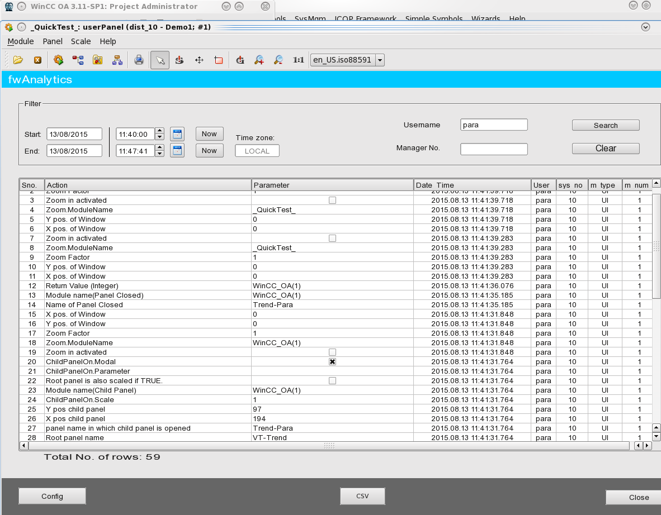

Figure 9 User Interaction Results

Conclusion
With the current results of this project, it can be concluded that the fwAnalytics component allows users, developers and operators to monitor the users’ interaction with the applications developed by WinCC OA. These results can be further used for analysis and statistics.
The component can also be used for archiving the datapoint elements if they are not being archived.

Future Scope

Component Testing
The fwAnalytics can be tested for it’s functionality using various tests. Test cases can be generated for these tests. Tests that can be performed on the component are :
- Unit Testing
- Integration Testing
- Validation Testing

Testing on the real application
fwAnalytics component can be installed on a real application and tested. This can give an idea of how much information we are actually getting using the component. Testing on real application can be helpful as it can give an idea about the up gradations and changes that are to made to the component to make it more efficient, useful and easy to use.

Analysis
Analysing the data generated by user interactions with the application can lead to useful information. It can tell us that how a user propagates through an application and the actions that are performed to do a certain task.

Statistics
Some statistics can be done on the results and fur
- The panels that are most frequently opened can be easily determined. This statistic can tell more about the importance of a panel so that more time and efforts can be devoted to the development and up gradation of more important ones rather than panels which are rarely used.

- An average time period of when a system is mostly used can be calculated using the results. This can be helpful in efficiently allocating the resources.

- To calculate the most used Ui managers.

- These results can also be used to determine the time spent on each panel by the user.
These types of statistics can further help in the development environment of the application by providing a lot more information.

