Barbara Bordalejo - Peter M. W. Robinson

Manuscripts with few significant introduced variants

The literature of stemmatics is rich in discussions of two phenomena which, it is commonly held, render the orderly assignation of manuscripts into families problematic, even impossible. These two phenomena are coincident agreement (where unrelated manuscripts share the same reading, apparently by simple coincidence) and contamination (where a manuscript combines readings from two or more manuscripts). In this article, we suggest that there is a third area of difficulty which causes considerable problems to the stemmatic project. This third area is the phenomenon of multiple manuscripts within a tradition which cannot be assigned to any family because there is no consistent pattern of agreement in introduced variants between them and other manuscripts.

This article describes four textual traditions in which we find this phenomenon, and reflects on how editors have responded to it. Although it appears that no previous scholar has identified the case of manuscripts with few significant shared introduced variants as a problem, our identification of this as a cause of editorial difficulty in four unrelated manuscript traditions (not to mention the exceptional importance of three of those four) leads us to posit that this phenomenon, though previously unacknowledged, may be widespread. Indeed, it is likely to be present in every large manuscript tradition.

First identification: the Old Norse narrative sequence Svipdagsmál

Robinson first observed the phenomenon of manuscripts which share few variants with any other manuscripts within a textual tradition in the course of his doctoral work on the Old Norse Svipdagsmál. Svipdagsmál is the name given to two poems, Gróugaldr and Fjöllsvinsmál, normally appearing one after another in manuscripts and long recognized as forming a single narrative sequence, named for the protagonist of the two poems, Svipdagr. The two poems are found in some 46 manuscripts, all dating from after c. 1650, although the two poems were likely composed and first copied some two centuries before.

The Svipdagsmál tradition has several features which made it serendipitously suited to an exploration of stemmatic techniques. Firstly, an extraordinarily high number of manuscripts are known from unambiguous external evidence to have been copied from one another. Fourteen of the forty-six manuscripts are linked as exemplar and copy. This evidence of direct filiation could be used as both the foundation of analysis and as a check upon it. Thus, one could measure the success of a quantitative method by the degree to which the method was able to link these fourteen manuscripts. Secondly, the high proportion of manuscripts explicitly linked to one another suggested that the surviving manuscripts represent a high proportion of all those which ever existed. We are not facing the situation we have with, for example, the Greek New Testament where whole branches of the tradition disappeared or left just one or two representatives behind. Thirdly, at one point in the history of the tradition history it became fashionable to turn a manuscript into a mini-edition, by writing variants from other manuscripts into its margins. When these manuscripts were copied some of these marginal variants were copied from the margin into the text, thereby creating a useful laboratory for exploring contamination. Finally, the tradition was sufficiently compact (46 manuscripts of a text of around 200 short lines) for it to be completely transcribed, collated and analyzed within the span of a doctorate.

Considerably aided by these advantages, Robinson was able to produce the table of relationships of the manuscripts given in Figure 1. In essence, he used classic Lachmannian techniques to identify groups of manuscripts which shared distinctive (often nonsensical) readings and hence form a distinct family within the tradition. Robinson also used a database to validate and refine the identification of distinctive sets of variants. With these tools, cross-checked against the external knowledge of what manuscripts were copied from which, he was able to allocate almost all the manuscripts to one of five groups.

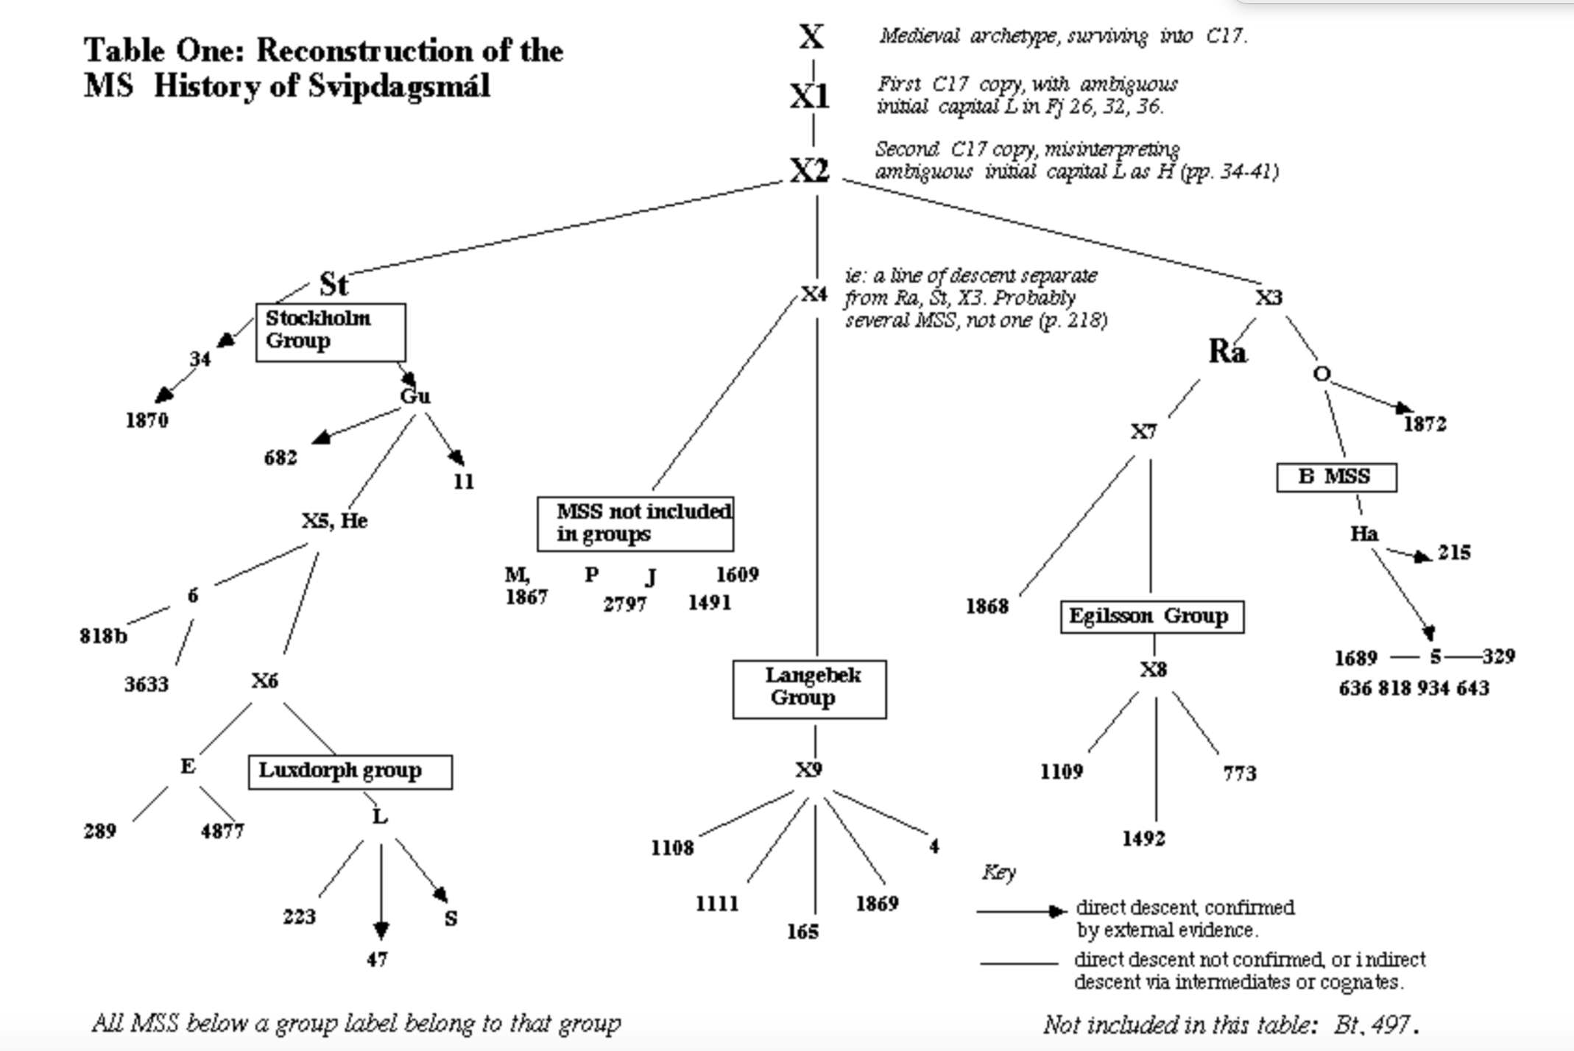
Figure 1. Table of relationships of the manuscripts of Svipdagsmál

Almost all: but not all. Six manuscripts did not fit into any of the five groups. If they did have any of the variants characteristic of any group, there were so few variants (perhaps just one or two) that the presence of these few variants was likely to be the result of mere coincidence. Having failed to allocate any of the six to any of the five groups Robinson sought evidence that any of the six might form some kind of affiliation with any others in the six. Once more, if any variants suggested any such affiliation there were so few that they were likely to be the result of mere coincidence. Further: there were no variants whatsoever shared by all six (or even any three or more of the six) and not found in the rest of the tradition. Hence there is no evidence that the six descend from a single exemplar and no evidence that the six might be divided into smaller groups.

However, to say that there is no evidence of any such affiliation is not the same as to say there is no such affiliation. The problem is not just that these manuscripts share very few variants with any others. It is that in these six there are very few variants of any kind: they seem to be particularly careful copies of their exemplars, all the way back to the common archetype of the whole tradition. Of course, there are variants. But these few variants are either found randomly distributed elsewhere in the tradition or occur nowhere else, and hence have no classificatory power. However, this lack of positive evidence of affiliation within the six cannot prove a negative, that there is no affiliation. The six might represent just one of descent, or as many as six separate lines of descent.

Robinson was left, as the editor, with a table of manuscript relationships which showed three clear branches (whose heads are represented by St X1 and X2 in Figure 1) and these six manuscripts. He designated these six as «manuscripts not members of any groups» and placed them, rather arbitrarily, around the centre of the map, with a line pointing to the six coming (again, arbitrarily) from the line leading to X2 in in the table.

What should an editor do with this information? According to the classic Lachmannian formula one should go through the text word by word and at every point where there is variation one should look at the stemma, see which variant was in the most lines of descent and declare it the winner. This would be “scientific” editing indeed (except of course in the annoying case of competing variants being in equal numbers of lines of descent, where one would have to use some kind of editorial judgement). By this time, Robinson was very skeptical of this procedure. It takes no account of the fundamental rule of lectio difficilior: that a “difficult” reading, though present in a minority of lines of descent or even in none, might have been the origin of “easier” readings found in more lines of descent, and so should be selected by the editor. As we discuss in the next section, at very many points an editor of the Canterbury Tales would have good reason to select such “difficult” readings. Secondly, he had by now come to think that this was not a stemma at all, certainly not in the sense that it offered an iron-clad representation of how the manuscripts related to one another. This applied especially to these six manuscripts. If the six independent lines of descent were treated as independent from each other then their testimony might overwhelm the other three lines of descent. In particular: it meant accepting that any one of the six, all copied late in the tradition, was the equivalent of (for example) Stockholm papp. 15 (“St”), copied some 150 years earlier, likely in Iceland, probably only one or two copies away from the single now-lost medieval exemplar of the whole tradition.

In the event, Robinson took a pragmatic course as an editor. He elected to use St and another early manuscript (“Ra”) as the base for his edition, with a preference for St where possible, and as the base for the spelling of the edition. He sought to keep the reading of St where possible; when it was not possible, he looked to Ra; and when neither yielded a good reading he looked among the other manuscripts (guided by the table of relationships given in Figure 1), and at the work of other editors (An edition of Svipdagsmál, pp. 16-61). It is notable that he did not accept one reading occurring in any of the six and nowhere else.

It would not be unfair to say that Robinson solved the problem of what to do with these six manuscripts by ignoring them. In the context of Svipdagsmál this was possible. However, this is not a remedy for all occasions.

Geoffrey Chaucer’s Canterbury Tales and O

John Manly and Edith Rickert are the only scholars to have produced a complete analysis of the whole textual tradition of the Tales, a labour that took them some twenty years. The results of their work were published in 1940 in eight volumes, of which the first two are dedicated to the descriptions of the witnesses and the analysis of their findings and the resulting genetic groups. Their grouping of witnesses of the Tales is one of the two most enduring conclusions reached by Manly and Rickert. It was also their opinion that National Library of Wales Peniarth 392d (Hengwrt; Hg) had the best extant text of the Canterbury Tales and used this manuscript as their base-text.

Even though their groupings present considerable problems, their basic structure has been retained and used by every scholar after them. Vance Ramsey, for example, points out that before Manly and Rickert the majority of the studies carried out ended up by concluding a binary classification of the manuscripts, a condition avoided by their classification. Manly and Rickert also made an important contribution to the refinement of the stemmatic method (and part of the basis for the New Stemmatics). They proposed that not only do errors have to be taken into account when establishing relationships between texts, but also agreements in possibly “correct” readings.

It follows that for their own research and for the classification of the witnesses, they used all agreements and identified those which they regarded as indicative of what they called “variational groups”. In their wording, these indicative agreements must be “persistent” and “consistent” to have potential to show the relationships between genetic groups. Aside from the importance that Manly and Rickert conferred upon Hengwrt, they also showed that there were certain other manuscripts that were especially relevant. In the end, Manly and Rickert proposed four main groups (a b c d) and an agglomeration of unclassified manuscripts. Their classification has been in use since the publication of their work in 1940.

Despite this massive effort, and the broad acceptance of Manly and Rickert’s major conclusions about the value and Hengwrt and the four major groups, their edition has been admired rather than used. «No Chaucer edition before it [Manly and Rickert's] had been supported by such an elaborate apparatus: six volumes to accompany two of text», and perhaps its sheer volume was one of the reasons that textual critics made little use of it. The reception of their work was also influenced by the opinions of those who doubted their methodology. Kane, for example, repeatedly accused them of making mistakes, such as using Skeat’s Student Edition as their base for collation when this was an unoriginal text or for supposedly assuming that the rate of variation is uniform among witnesses. What Manly and Rickert were looking for was evidence of non-random variation which was not the result of agreement by coincidence, thus their interest in “consistency.”

Perhaps the major reason their edition has not had the use they would have wished is the extraordinary complexity of the picture of manuscript relations they give. They choose to present their analysis tale by tale, and the result is that we are offered some thirty-nine separate histories, each one of them different from each other. Manly and Rickert explain this (as have many following them) by arguing that this suggests that this is because of “part-publication”: that the separate parts were originally published separately, and this is why the histories are distinct. Yet, this picture of part-publication is contradicted, as noted above, by the evidence that their four constant groups are indeed constant: they appear in every one of the separate histories. How is this possible if the histories are separate? Indeed, as we go from to part, a pattern emerges. The same constant groups, and some pairs, do appear in every part history. But in each part there appears to be a loose set of manuscripts which usually stand apart from the constant groups, but whose relationships with each other vary from part to part. Thus, they assign Oxford Christchurch MS 152 (Ch) the following relationships in four parts:

- In the General Prologue: it is with Hg El Gg DoTo1, as not sharing an ancestor from which the other 43 manuscripts descend, and hence perhaps independently descended from the archetype
- In the Miller’s Tale: it appears on its own, as representing a line of descent distinct from El Hg (which represent two other lines of descent), with Gg now grouping with mss Ad3/Ha5 and To1 apparently contaminated by El
- In the Wife of Bath’s Prologue: Ch appears to join a group made up of Ad3/Ha5 Ra3 Tc1 Gl, but then they appear to qualify this by asserting that at some point (their argument is here unclear) it shifts allegiance from this group to a distinct group composed of Hg Ht Bo2
- In the Nun’s Priest’s Tale: Ch appears to come from the same exemplar as Hg El Gg Ad3 and the a group.

One notices that in all four cases, Ch is linked to Hg, and in several to El. We highlight these three manuscripts for several reasons. Hg (Hengwrt) has been long acknowledged as presenting an excellent text, and it has been recently suggested that both Hg and El (the Ellesmere Chaucer manuscript, Huntington library, San Marino) are both written by Adam Pinkhurst, who as well as bearing the name “Adam”, which may make him the “Adam scriveyn” addressed as his scribe in a poem by Chaucer, may have worked as Chaucer’s scribe in the London customs house from 1375 to 1385. This places the copying of both manuscripts very close to Chaucer himself. We add Ch to this pair because in all sections of the Tales analyzed by us so far, Ch El Hg form an extraordinarily close trio, over and over sharing variants often found nowhere else or in very few other manuscripts.

Because of the likely closeness of these manuscripts to the original of the whole tradition, a possible explanation for these inconsistencies presents itself. We note above that the Manly and Rickert groupings do not rely solely on errors to establish genetic affiliations. Indeed, this is one of their strong points. However, the danger is that the editors may fail to realize that they are in the presence of an archetypal reading and attempt to classify and group texts based on such readings. Archetypal variants are non-classificatory from a stemmatic perspective because they could be (and should be expected to be) distributed in all parts of the tradition. Only variation that has been introduced below the archetype is significant for the classification of witnesses into distinct family groupings. Thus: it might be that what Manly and Rickert see as evidence of affiliation might simply be agreement in ancestral readings in the group Hg El Ch (joined often by Gg Ad3 Ht and others).

Since 1992, the Canterbury Tales Project, now led by the co-authors of this article, has been following in the footsteps of Manly and Rickert. There is much in common with our approach and that of Manly and Rickert. Like Manly and Rickert, we believe that we have to base our analysis on the variants at every word in every witness. Like them, we think we should disregard the question of originality in seeking to establish consistent groupings of manuscripts, and we should base these groupings on “persistent” and “consistent” attestation of witness groupings -- though we are acutely aware that some of these groupings may be in variants ancestral to the whole tradition, and so not indicative of families within the tradition. As of this date, four of the separate parts of the Tales have been fully collated, analyzed and published: the four parts General Prologue, Miller’s Tale, Wife of Bath’s Prologue and Nun’s Priest’s Tale.

For these sections we are able to compare directly our results with those of Manly and Rickert. Firstly, we confirm the existence of the four “constant groups” a b c d, clearly present in each section with the same core manuscripts identified by Manly and Rickert. Secondly, we found ourselves confronted directly with the same phenomenon which Manly and Rickert found, of manuscripts which do not belong to any of the constant groups but which do not seem to have any other settled affiliation. The outstanding example was Ch, which we found over and over sharing readings with both or either one of Hg and El, frequently against almost every other manuscript in the tradition. We found a number of other manuscripts which followed the same pattern, though less frequently in agreement with the key Hg/El pair than Ch. The agreement with Hg/El, very commonly in a lectio difficilior usually replaced by an easier reading in the constant groups, suggested to us that these variants were actually present in the archetype of the whole tradition, and that their appearance in these manuscripts was evidence of their common descent from, and their closeness to, the archetype. Hence, we named these the O manuscripts, and the variants the O variants, identifying them as such in Robinson 2003.

We list here a few variants from the Miller’s Tale and the Nun’s Priest’s Tale, all following the same pattern. Our comments below explain why we believe the Hg El reading (here always with Ch, and usually with a few others)

Miller’s Tale 605: I am thyn Absolon my derelyng
my Ch El Gg Hg Ps To1
thyn dere Ad1 Bo1 En3 Ha3 Mg Mm Ph2
thyn Ad3 Bo2 Bw Cn Cp Dd Ds1 En1 En2 Fi Ha2 Ha5 Hk Ht La Lc Ld2 Ma Ne Nl Pw Py Ry1 Ry2 Se Sl1 Tc1
thyn owne Cx1 Cx2 Dl He Ln Pn Ra3 Tc2 Wy
I am thyn dere Gl
O my Ha4 Ii
thyn swete Ra1
and thyn Sl2

Line 605 of the Miller’s Tale is a clear case of lectio difficilior. If the text had modern punctuation we would have a comma after “Absolon” clearly indicating “my derelyng” is a vocative expression. The analysis of the Miller’s Tale states:

We can imagine it working superbly in a live performance or reading. But it is exactly this shift which a scribe, working from a written exemplar, might fail to catch: and the evidence is that apart from witnesses close to the original (the trio El Hg Ch; but also To1 Gg Ps with the pair Ii Ha4 having the related ‘O my’), every other copy failed to register this, and substituted ‘thyn’ for ‘my’ following the ‘thyn’ earlier in the line. Once this change was made, it was very unlikely to be reversed, and hence the complete absence of ‘my’ from elsewhere in the tradition.

In this variant, the direction of variation seems obvious, from the lectio difficilior to an easier one in a relatively easy mistake to make. When scribes replaced “my” with “thyn” they did so in following the previous “thyn Absolon.” One can easily see why the derivative reading might have made sense for the scribes who were not particularly interested in the performative aspects of the text. What we find most interesting about the distribution of this variant is that it is present in various witnesses representing independent lines of descent. Thus, Hg El Ch Ha4 Gg all descend from the archetype of the tradition but each in a separate line (although Gg is related to other witnesses).

Nun’s Priest’s Tale 29: In which she hadde a cok heet Chauntecler
a cok heet Ch El Hg Me
a cok hight Ad1 Ad3 Bw Cn Cx1 Cx2 Ds1 En1 Fi He Ii Ln Ma Ne Nl Pn Py Tc2 Wy
a cok that hight Bo1 Cp Dl En2 Gl Ha2 Ha3 Ha4 Ht La Lc Ld1 Mc Mg Mm Ph2 Ph3 Ps Pw Ra3 Ry2 Se Sl1 Sl2 Tc1 To1
a cok hight Chaū En3
that hight Ry1

As in the previous example, the archetypal reading here is a lectio difficilior. Four witnesses preserve this reading, including Hg El and Ch, but also Me (a fragmentary manuscript currently at the National Library of Wales). Here is what we wrote as part of the Stemmatic Commentary of the Nun’s Priest’s Tale on CD-ROM:

There are two characteristic patterns of variant distribution associated with a distinctive or difficult reading preserved almost alone in O. In the first model (as here) we see the archetypal difficult reading generate a range of variants through the tradition as different scribes struggle with the reading (Contini’s ‘diffraction’): for further instances, see on NP 108. In the second model, the reading is replaced by a single, obvious and easier reading, which might occur independently to different scribes: for instances of this, see on NP 170.

We have found that it happens with relative frequency that an easier reading appears independently in otherwise unrelated witnesses within the tradition. This occurs when the reading is easily conjectured through its contexts. This is the case of the variant, Certres/ Sterres in KT 1179 where the context allows anyone to guess that the intended reading must have been “sterres”. Despite that, the variant distribution points towards a misplaced abbreviation in the archetype. Bordalejo wrote about this variant:

KT 1179 is another example in which the variant in Cx2 agrees with Ad3 Ch and Ha4. Hg El Cp Dd Gg and La share the reading 'sertres.' Only Cx1 has 'serelis.' It could be assumed since Ad3 Ch Ha4 and Cx2 have shown a consistent relationship in this part of the text, that their ancestor corrected a mistake in O.

In each of these examples, we see three manuscripts our research has shown to be descended directly from the archetype, Hg El Ch, agreeing in difficult and likely Chaucerian original readings against almost all other manuscripts. Some other manuscripts do agree with them, but in an inconsistent way. Consider the following examples of what we call O readings (readings coming directly from the archetype), showing for each likely archetypal reading just what manuscripts agree with the trio Hg El Ch:

Link 1, line 4: to Ch Dd El En1 Gg Hg Ps Pw
Link 1, line 31: that I Ad2 Bo2 Ch Dd El En1 Ha4 Ha5 Hg Ht Ln Ph2
Link 1, line 32: preye Bo2 Ch Dd Ds1 El En1 Gg Hg Hk Ra3 Tc1 To1
Link 1, line 40: fame Bo2 Ch Cp Dl El Gg Hg La Ra3 Sl2 Tc1
Link 1, line 54: nor Bo2 Ch Ds1 El En1 Gg Hg Hk Ln Ra3
Miller’s Tale, line 12: hem Ch Dd Dl El En1 Gg Ha4 Hg Ii Lc Mg Ps
Miller’s Tale, line 91: ich Ch Cp Dd El En1 Hg
Miller’s Tale, line 132: wyndow Ad1 Bo2 Ch Cp El Gg Hg La Lc Mg Ph2 Ra3 Tc1 To1
Miller’s Tale, line 204: til Bo2 Ch Cn Cp Cx2 El En1 Gg Hg La Ma Pn Ra3 To1
Miller’s Tale, line 231: for Ad2 Ad3 Bo1 Ch Cp Dd El En2 Hg La Ln Ma Ph2
Miller’s Tale, line 265: Astromye Bo2 Ch Cn El Hg La Py
Miller’s Tale, line 271: Astromye Bo2 Ch El Hg
Miller’s Tale, line 600: He cogheth Ad3 Bo2 Ch Dd El Gg Ha4 Ha5 He Hg Ph2 To1
Miller’s Tale, line 600: knokketh Ad3 Bo2 Ch Dd El En1 Ha4 Ha5 He Hg Pn Ps To1
Miller’s Tale, line 634: til he cam Ad1 Ad3 Ch Dd Ds1 El En1 En3 Ha5 Hg La Pn Ps Ry1
Miller’s Tale, line 641: he brosten hadde Ad1 Ad3 Ch Dd Ds1 El En1 En3 Ha5 Hg La Pn Ps Ry1
Miller’s Tale, line 655: that Bo2 Ch Cn Ds1 El En1 Ha5 Hg Hk Ma Nl
Nun’s Priest’s Tale, 22: No wyn ne drank she Ch Cp Cx2 El Ha3 Hg Pn Ry2 Sl2 Wy
Nun’s Priest’s Tale, 29: a cok heet Ch El Hg Me
Nun’s Priest’s Tale, 35: he krew Ch Cx1 Cx2 El Ha3 He Hg Ne Pn Pw Py Se Tc2 Wy
Nun’s Priest’s Tale, 37: was it Ad3 Ch Ds1 El En1 Ha4 Hg Ld1 Ma

This is only a selection of the instances found, in these four and other sections. We note the inconsistency between the witness distribution in these agreements. Besides Hg El Ch, the other witnesses come and go. This makes grouping of these O witnesses impossible. Where they agree with Hg El Ch this is likely only agreement in ancestral variants. Where they do not agree with Hg El Ch they agree with other witnesses in such a random way that one cannot infer any groupings.

We can now recognize the same fundamental phenomenon we saw in the Svipdagsmál tradition. We see in these variants, again and again, the same sigils: Ad2 Ad3 Bo2 Dd Ds1 En1 Ha3 Ha5 Hk Ps Py To1 and others, with a different selection of sigils joining Hg El Ch at each instance. Once more, we have the case of multiple manuscripts within a tradition which cannot be assigned to any family because there is no consistent pattern of agreement in introduced variants between them and other manuscripts. This is complicated here by the clear ancestral nature of these variants, making it still more difficult to divide these manuscripts into subfamilies.

In terms of editing: the identification of these variants as likely to be archetypal is important. Further, the identification of a set of manuscripts as likely to have archetypal variants where others do not gives the editor reason for confidence. If a reading is (for example) in two of Hg El Ch, and in a number of these other manuscripts, it is then highly probably to have been present in the ancestor of the whole tradition, regardless of what other witnesses might or might not attest to it.

Dante's Commedia and α

We focus here on just one aspect of the vast textual tradition of the Commedia (800 manuscripts complete in at least one canticle): the question of manuscripts close to the archetype, which - like the O witnesses of the Tales, and the ungrouped manuscripts In the Svipdagsmál tradition - evidence the phenomenon of sharing few significant introduced variants with other manuscripts.

First, a brief history. The most influential edition of the Commedia of the last decades is that of Giorgio Petrocchi, first published in 1966. Petrocchi elected to build his edition on 27 manuscripts which date from before Boccaccio's copying of the Commedia around 1355, representing what he called the “antica vulgata”. From a complete collation of these 27 he created the stemma given below, which he then used in the making of his text. His use of his stemma in the editing of his text was (as it happens) quite similar to Robinson’s practice in Svipdagsmál in that he used the stemma as a guide when selecting readings, and not as an iron rule. However, he did not select a single manuscript as the base: rather, he typically chose readings from what one might term the Florentine tradition, from the influence of the Trivulziano manuscript, written in Florence in 1337.
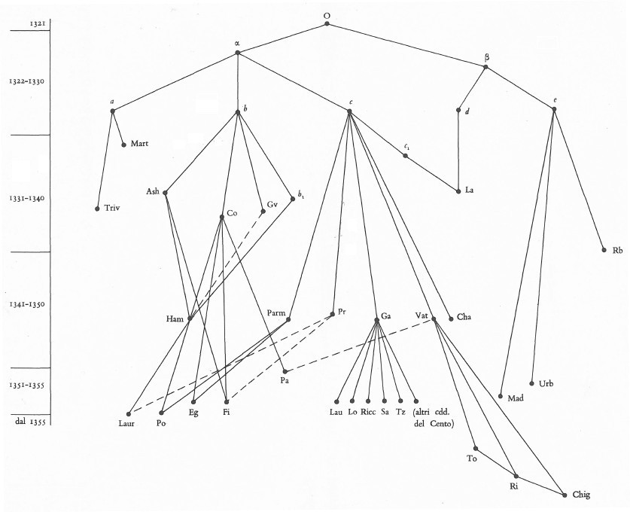
Figure 2: Petrocchi’s stemma of the 27 antica vulgata manuscripts of the Commedia.

Petrocchi's edition was a staggering effort by a much respected scholar. However, in 2001 Federico Sanguineti published a new edition of the Commedia which challenged both Petrocchi’s methods and his conclusions. Petrocchi’s methods: where Petrocchi based his analysis on a collation of every variant in 27 witnesses, Sanguineti claimed that he had looked at variants in all 800 manuscripts: in fact, at the variants in some 396 lines (the “Barbi loci”). Petrocchi’s conclusions: Petrocchi divided the manuscripts at the top of his stemma into five families (designated a to e), and suggested that these five groups may descend from two exemplars, α (abc) and β (de). Sanguineti retained the fundamental division of Petrocchi’s stemma, with all the manuscripts descend from two copies made from the exemplar, which he names (following Petrocchi) α and β. However: according to his analysis the beta family consists of precisely one manuscript: Vatican Library Codex Urbinate Latino 366 (Urb), with all 800 or so other manuscripts descending from the α hyparchetype. This contradicted Petrocchi, who placed two other manuscripts as descending from the same beta branch. Sanguineti also upended the fundamental premise of Petrocchi's edition, that no manuscript after 1355 had value for the establishment of the text, by including Laurenziana Santa Croce Ms. Plut. 26.1 (LauSC), dating from around 1376, in the base seven manuscripts he chose as “necessary and sufficient” for the making of an edition.

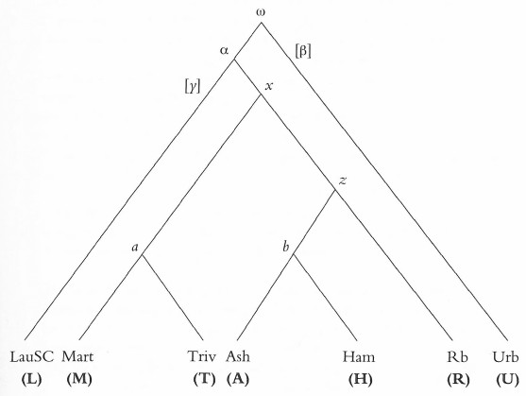
Figure 3: Sanguineti’s stemma.

Around 1996, while Sanguineti was developing this argument, Prue Shaw and Robinson became aware of his work through two Australian scholars, Mary Dwyer and Diana Modesto. The first plan of this group was for all to work together on a digital edition of the Commedia based on the “Sanguineti seven”, the seven manuscripts identified by Sanguineti as the base for an edition. For various reasons this collaboration did not continue. In the event, Shaw and Robinson decided to proceed on their own, with Shaw as editor and Robinson responsible for the technical aspects of the edition, particularly its use of digital tools for transcription, collation and analysis. Bordalejo joined this team around 2002, and was responsible for the formal specification of the transcription system used by the edition, the training of the collation team, and the overseeing of the collation process.

Shaw’s edition of the Commedia was published in 2010. In the period since its first conception as a partnership involving Sanguineti, and following Sanguineti’s withdrawal from the collaboration in 2003, the purpose of the edition had shifted markedly. As well as exploring the tradition, we now focussed on testing Sanguineti’s hypotheses about the tradition. They did not fare well. Our analysis suggested that Urb was not the unique representative of the β family. Rather, a second manuscript also appeared to descend from β: Rb. Petrocchi had suggested this affiliation and our analysis confirmed it, thereby exactly halving the value of Urb. Also, our analysis confirmed the traditional view of the LauSC manuscript as valueless for the establishment of the original text. We were able to show that it presents an extremely eclectic text, typical of post-Boccaccio texts, hence adding support to Petrocchi's choice not to include post -1355 manuscripts.

However, there was one key assertion by Sanguineti on which we could not give a definitive answer. It was his explicit assertion that there was a single exemplar, α, from which almost all the manuscripts descend. In terms of the manuscripts analyzed in the Shaw edition, this would mean that the two non-β pairs of manuscripts, Mart/Triv and Ash/Ham, descend from a single exemplar below the original. The question is important because if there is such an exemplar, then a reading present in both groups represents only one line of descent. If there is not such an exemplar, then a reading present in both Mart/Triv and Ash/Ham represents two independent lines of descent and so has double the evidentiary weight of (say) a reading found only in the beta manuscripts.

Accordingly, Robinson sought evidence that there was such an exemplar, using the digital VBase tool created for the Shaw edition. VBase allows you to ask complex questions about the distribution of a textual tradition. In this instance, if there were an α exemplar below the archetype from which the two pairs Mart/Triv and Ash/Ham both descend, distinct from the β exemplar, how might the variants introduced by that exemplar be distributed across the tradition? One might expect each variant to satisfy the following conditions:

- The variant should be present in all four of Ash Ham Mart-c2 Triv;
- It should be not present in either the editions of Petrocchi (PET) or Sanguineti, and so according to their best judgement, it is unlikely to have been present in the archetype;
- It should not be present in either β manuscript (Urb Rb)

The Shaw edition VBase tool allows the reader to find out, in a few seconds, which variants might satisfy these conditions. Figure 4 shows our use of this tool to identify the putative set of variants evidencing a shared ancestor below the archetype for the two pairs Ash/Ham and Mart/Triv:

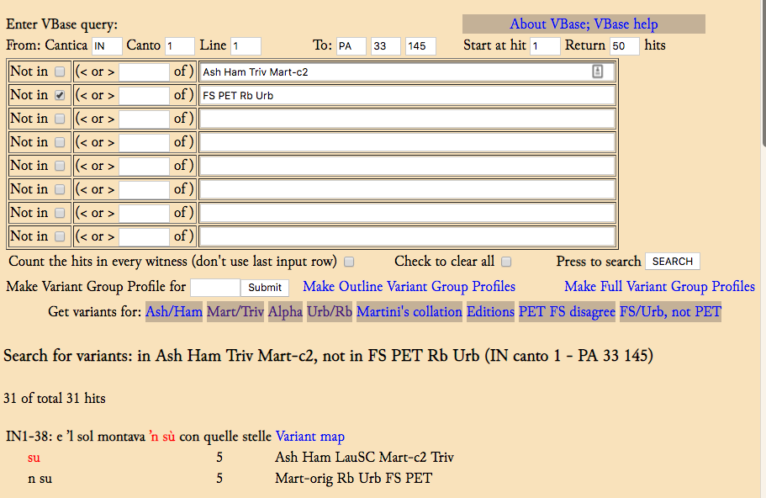
Figure 4. The VBase tool, showing a search for evidence of α.

The first line of the query corresponds to the first requirement, that it should be present in all four of Ash/Ham Mart/Triv. The second line corresponds to the second and third requirement, that it should not be present in any of FS PET Rb Urb.

As this figure shows, there are just 31 variants in the 110,382 variants in the 14223 lines of the Commedia which satisfy these conditions. To complicate matters still further: if one alters the query slightly, to return variants where one of Urb/Pet agrees with Ash/Ham and Mart/Triv, the number more than doubles, to 67 variants. One could explain this by hypothesizing that in fact all of Ash/Ham Mart/Triv Urb/Rb share an ancestor below the archetype - above both α and β - which introduced these 67 variants, but that some were not copied into the joint ancestor of Rb/Urb.

One could multiply hypotheses about these manuscripts at will. We have presumed here that a variant not accepted by either Sanguineti or Petrocchi is unlikely to have been present in the archetype of the whole tradition. But their judgement could be wrong -- or, the archetype could itself have contained errors. Further, we are dealing with so few variants, among such a mass of variants (110,382 in all), that we have to reckon with the likelihood that at least some of the 31 are there by simple accident, through coincident variation. Where we are dealing with so few variants, the addition or removal of just a few variants because either they are ancestral to the whole tradition or the result of coincidence would change the numbers disproportionately.

Hence, we find ourselves in the same position as for the Chaucer and Svipdagsmál traditions surveyed earlier. Indeed, there might be an ancestor below the archetype of the whole tradition, α, from which both the Ash/Ham and Mart/Triv pairs descend, as both Sanguineti and Petrocchi assert. Or, there might not be. The numbers of variants indicative of either hypothesis are so few as not to be decisive.

As with both the Canterbury Tales and the Svipdagsmál traditions, this state of affairs deprives the editor of the simple recourse, of counting variants in discrete lines of descent. Once more, at the very top of the stemma, exactly where it is nearest to the archetype, we are unable to determine exactly how many lines of descent there are. There might be just two, α and β, as both Petrocchi and Sanguineti assert. But it might be that all three of Petrocchi’s a b c groups (a: Mart/Triv; b: Ash/Ham; c was not represented among the seven we analyzed) represent independent lines of descent. In that situation, it appears that the editor’s best strategy is to proceed with caution as Petrocchi did, looking at each variant on a case by case basis, and being advised by the distribution of variants but not ruled by it.

The Greek New Testament

Whatever the problems of editing Svipdagsmál, the Canterbury Tales and the Commedia, they are as nothing compared to the challenge of editing the Greek New Testament. Firstly, we are dealing with a massive number of manuscripts: some 5000 for the whole text, with up to 2000 for any single section (thus, for the Gospel of John). Secondly, we are dealing with a tradition that extends across millennia, across vast geographical space, and with many versions in many languages, all of which must be examined for their possible testimony.

Because of these factors, there is the question of just what should be the editorial goal. For the three traditions we have surveyed, and particularly for the Chaucer and the Dante, where our oldest extant manuscripts date to within a few years of the author’s life (or even to his life) one might plausibly declare that we are trying to recover the closest possible text to that which left the author’s hand: the “original”, if you like. But the gap between the historical Jesus and the first manuscripts, the complexity of the tradition and the paucity of evidence at its very earliest stages render the notion of the “original” text of the New Testament problematic indeed. Accordingly, the editors of the Editio Critica Maior (ECM) series of editions of the Greek New Testament, the most ambitious and advanced initiative in Greek New Testament textual scholarship, declare that the edited text which they offer on the basis of research into all the evidence, including all extant manuscripts and versions in every language, represents not the “original” text but the “initial” text (German “Ausgangstext”). This “initial text” is glossed in the introduction to the ECM edition of 1-2 Peter, 23* n.4 as «the form of a text that stands at the beginning of a textual tradition». The editors are at pains to distinguish this from both the “original” (what might have been first written down) and the “archetype” (the reconstructed ancestor of all surviving witnesses). It is both less than the original, and more than the archetype: as Klaus Wachtel explained it to Robinson, it is «the text which explains all the texts» (personal communication). Holmes describes it further as «the reconstructed hypothetical form of text from which all surviving witnesses descend, a stage of a text’s history that stands between its literary formation, on the one hand, and the archetype of the extant manuscripts, on the other» (p. 653).

In this discussion, we focus on a single place of variation in the ECM publication: the variation at 1 Peter 4:16, where it appears that we have an instance of the same phenomenon identified as present in the three traditions discussed to this point, of the difficulty caused by manuscripts which do not show consistent patterns of agreement in introduced variants between them and other manuscripts.

The whole text of this verse is given in most editions as:

ει δε ως χριστιανος μη αισχυνεσθω δοξαζετω δε τον θεον εν τω ονοματι τουτω

This verse is translated in the NetBible as «But if you suffer as a Christian, do not be ashamed, but glorify God that you bear such a name». The context is that the writer (the apostle Peter) is speaking to the reader about the sufferings which might be brought upon him or her as a Christian. In the previous verses, the writer instructs the reader that he or she is not insulted but is actually blessed if he or she is called a Christian (verse 14); he or she should not accept suffering as a mere criminal (verse 15) but should glorify God that he or she is called a Christian. However, the exact wording of the Greek is awkward, as can be seen by the variety of translations of this verse:

Common English Bible: But don’t be ashamed if you suffer as one who belongs to Christ. Rather, honor God as you bear Christ’s name. Give honor to God,
Good News Bible: However, if you suffer because you are a Christian, don't be ashamed of it, but thank God that you bear Christ’s name.
Lexham English Bible: But if [someone suffers] as a Christian, he must not be ashamed, but must glorify God with this name. (Bible Translations).

It appears that the exact reference of the phrase εν τω ονοματι τουτω (“in this name”) causes difficulty: from the immediate context, following the reference to God, the most natural reading is that the name of Christian is to be applied to God, and not to the suffering person (δε τον θεον εν τω ονοματι τουτω: “concerning God in this name”). Hence the variety of periphrases seen in the translations, intended to show that the name of Christian belongs to the suffering person, while the glory belongs to God.

Where there is difficulty in the text, one might expect variation: and that is what we have here. In many manuscripts, we find εν τω μερει τουτω (“in this part”) instead of εν τω ονοματι τουτω (“in this name”). This is the reading underlying the King James bible, for long the most influential English-language bible: “Yet if any man suffer as a Christian, let him not be ashamed; but let him glorify God on this behalf”. Here is the distribution of the variants, as summarized by Gurry and Wasserman:

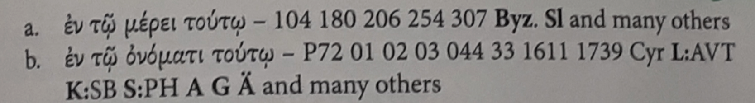
Figure 5. The variants at 1 Peter 4:16, Gurry and Wasserman p. 71.

Gurry and Wasserman observe, as do many other commentators (see the notes to Gurry and Wasserman’s discussion), that the witnesses to the reading εν τω μερει τουτω are confined almost exclusively to just one branch of the New Testament tradition: to the Byzantine manuscripts copied after 800 AD and current in the Orthodox church to this day. Just one other branch of the tradition, the Old Church Slavonic (also dating in its earliest hypothesized form to the 9th century), supports the Byzantine text reading here.

In contrast, the reading εν τω ονοματι τουτω is found in every witness and every version dating from before 800 AD. It is found in the three great uncial manuscripts Sinaiticus Alexandrinus and Vaticanus (designated 01 02 03 here), all dating from between 300 and 500 AD. It is found in the Bodmer Papyrus VII-VIII (P72), possibly earlier than all three uncials. It underlies both the Vetus Latina and Vulgate Latin versions, dating from before 400 AD; and is the source of the readings in the Coptic, Syriac, Ethiopic, Georgian and Armenian versions, and indeed every version dating before 800 AD. It is also the reading of the important minuscule 1739, which is held to be a copy of a fourth century uncial manuscript.

Yet, despite this complete unanimity of the earliest versions, the ECM editors choose the late Byzantine reading here. Why do they accept this reading? Here, we must take two further factors into account. Firstly, although the Byzantine tradition arose centuries after the earliest manuscripts and versions, it exists in far more manuscripts than any other version, because the Orthodox church has continued using Greek, and the Greek text has continued to be copied (and later printed) up to this day. As a result when renaissance scholars sought Greek manuscripts, for the making of new translations and editions, they found manuscripts carrying the Byzantine text. The first printed text of the Bible, prepared by Erasmus and printed by Froben in Basel in 1516, was based on seven minuscule manuscripts, all dating after 1100 and all carrying the Byzantine text. Erasmus’s second edition (1519) was used by Martin Luther as the basis of this German translation of the Bible; the third edition (1522) was used by William Tyndale for the first English New Testament based on Greek sources, and also by the creators of the Geneva Bible and the King James Bible. The influence of the King James Bible for later anglophone culture cannot be overstated: for England, and later for its colonies, and then for the emergent United States, it became the book of books; the touchstone by which not just religion but language itself was measured. To this day, there are many fundamentalist Christian groups, especially in the United States, and not a few textual scholars, who ascribe extraordinary authority to the King James Bible. There are groups of fundamentalist Baptists with the motto “King James Only”, and a group of well-qualified scholars who assert the value of the Byzantine text under various labels: as “textus receptus” or the “majority text”. It is the King James Bible which infuses the language of the Book of Mormon. It is a notable feature of the ECM editions that at many places - as here in 1 Peter 4:16 - they prefer a reading from the Byzantine text where other editors (including the earlier Nestle-Aland editions) prefer a reading attested by earlier manuscripts. The ECM editors declare no such policy. But that is the effect.

The second factor is the reliance of the ECM editors on the “Coherence-based Genealogical Method” (CBGM): a method developed by Gerd Mink, formerly of the Münster Institute for New Testament Research, specifically to help the ECM editors, and others, choose which reading, among the many shown by their comprehensive collation, should be chosen for the “Ausgangstext” (and hence, to appear as the text in the many editions which use the text established by the Institute and its partners). This method has become controversial among some New Testament scholars, in part because it is difficult to understand. A full description and analysis of the CBGM is beyond the scope of this article; we will focus on its implications for manuscripts which share few introduced variants with others.

The fundamental tool of CBGM is that it builds, at every point of variation, what it calls “textual flow diagrams” (see Figure 6).
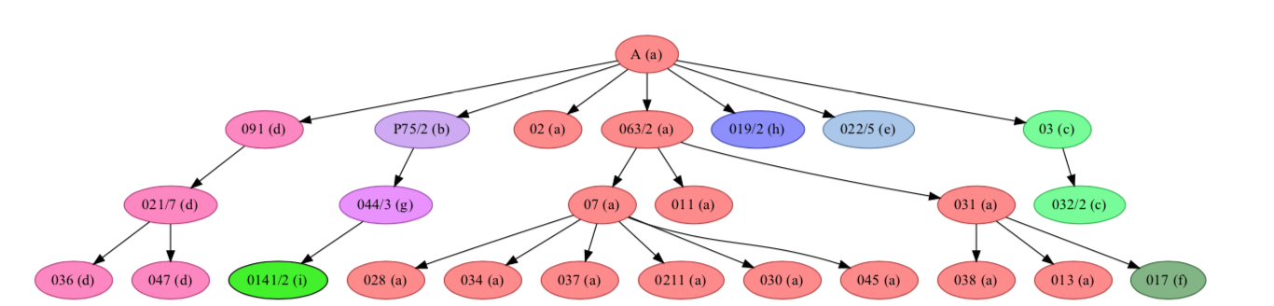
Figure 6. CBGM textual flow diagram for the variants at John 6: 23 (addresses 4-10), showing the descent of reading c from a.

These textual flow diagrams look like traditional stemmata, but they differ in two crucial ways:

- They exclude hypothetical sub-ancestors. Only extant manuscripts are included.
- The textual flow diagrams represent the relationship between texts, not manuscripts, and the direction of flow between texts is determined entirely by the relative closeness of each text to the hypothetical Ausgangstext: in fact, the text of the Greek New Testament established by the Nestle-Aland and ECM editors. This can lead to odd results. Although we know that the miniscule 0141 (written around 950 AD) is the direct exemplar of 821 (written some 600 years later), the textual flow diagrams actually reverse this, and show 821 as the ancestor of 0141, because 821 differs from the Nestle-Aland text at only 27 points, while 0141 differs at 28 points.

The central tenet of the CBGM is that textual flow hypotheses which show greater “coherence” are to be preferred to those that do not. “Coherence” may be significantly affected by many factors, including the choice of what variant is the Ausgangstext.

In several respects, the CBGM works on a model of textual variation which differs from what most scholars think happens in textual traditions: thus the exclusion of hypothetical ancestors, and the determination of textual flow as quite detached from the historical dates of the manuscripts which carry the texts. However, it has powerful practical advantages. It greatly simplifies the textual flow diagrams, as they include only extant manuscripts. It also permits texts which appear in only late manuscripts but represent much earlier states of the text to have full weight.

Most often, the method yields apparently good results, or at least results that the great majority of scholars are prepared to accept. But in a few cases -- as here -- the CBGM offers a surprising choice of reading. The key to CBGM’s choice of the Byzantine text reading here is that among the many manuscripts of the Byzantine tradition, there are eight which actually have the (b) reading of the uncial manuscripts and others, εν τω ονοματι τουτω (“in this name”), and not the (a) reading εν τω μερει τουτω (“in this part”) of all other Byzantine manuscripts. These eight represent three lines of descent. Accordingly, the textual flow diagrams show reading (b) descended from (a) three times. Now, if the initial text was the older reading (b), we have to deal with two changes, from ονοματι to μερει and back to ονοματι (Figure 7).
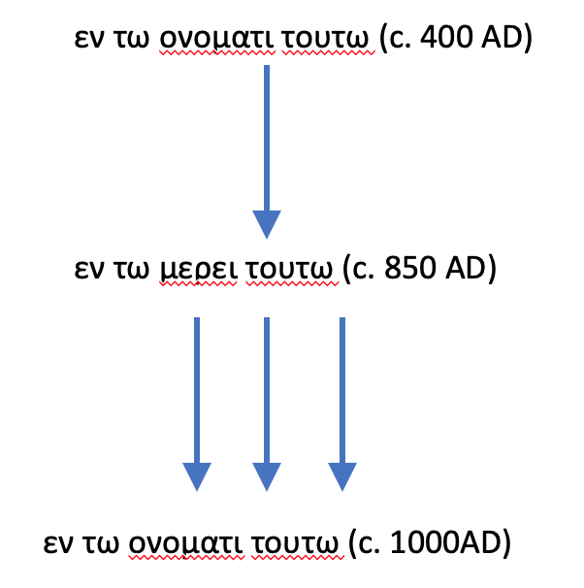
Figure 7. Textual flow at 1 Peter 4:16, with the initial text set to εν τω ονοματι τουτω.

However, if we presume that the initial text were the Byzantine reading (a) we have only to deal with one variant, the shift from μερει to ονοματι (Figure 8).
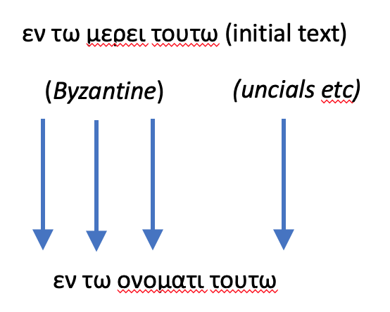
Figure 8. Textual flow at 1 Peter 4:16, with the initial text set to εν τω μερει τουτω.

In the terms of the CBGM, the second hypothesis (that the original reading was μερει not ονοματι) is more “coherent” than the first. It means that we do not have to presume that the change εν τω ονοματι τουτω to εν τω μερει τουτω ever happened. Instead we have only to presume the change εν τω μερει τουτω to εν τω ονοματι τουτω occurred just four times. Accordingly, the ECM editors print this reading in their edition of 1 Peter 4:16 without qualification.

However, a little more thought suggests there is something fundamentally wrong with this hypothesis. Consider just the three uncial manuscripts Sinaiticus Alexandrinus and Vaticanus, the papyrus P72, and the minuscule 1739, all with texts dating from before 500 AD. The textual flow diagrams typically show the presence ofονοματι in all five of these as the result of a single change, from Ausgangstext μερει (as assigned by the ECM editors) to ονοματιμερει. This is represented as follows by Edmondson in Figure 9.
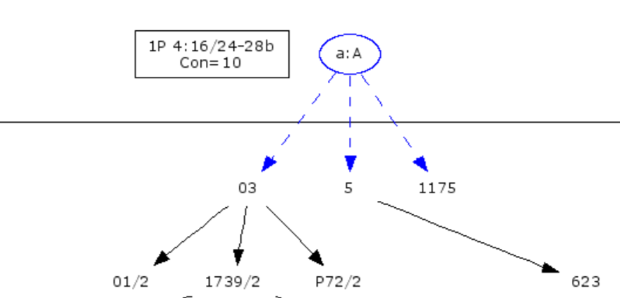
Figure 9. Textual flow in 1 Peter 4:16, showing Vaticanus (03) as the ancestor of Sinaiticus Alexandrinus (01 02) P72 and 1739.

That is: the change appears first in Vaticanus (03) and thence descends to Sinaiticus Alexandrinus (01 02) P72 and 1739. This is in accord with the way in which the CBGM shows textual flow working. Because Sinaiticus has more variants from the Ausgangstext (350) than has Vaticanus (280), the textual flow shows the text of Sinaiticus as descended from Vaticanus. But this is simply not true. Sinaiticus is comprehensively not a copy of Vaticanus or descended from it. It is here that the exclusion of sub-ancestors from the textual flow diagrams becomes a problem. Edmondson’s representation of the textual flow appears to show all of 01 02 P72 and 1739 descending from 03. But this is not the case. Not one of these four manuscripts is a descendant of 03.

It is possible that there might have been an exemplar below the archetype from which all of the uncials, P72 1739, and all the versions, might have descended. And here we come up against the same problem we have seen in the other three instances studied. We have here multiple witnesses - ten or so - which may or may not share an exemplar below the original, or some of which may share exemplars with others. But it appears that generations of study have failed to find convincing evidence of any such relationship.

Indeed, even if there were sure evidence of a single exemplar which introduced the reading ofονοματι for Ausgangstext μερει, it is difficult to accept the historical scenario this implies. It suggests that the archetype had μερει, that this is miscopied as ofονοματι just once into a single exemplar some time before 300 AD, from which all the copies made before c. 850 AD descend. Somehow, no other copies of the archetype with μερει survive until c. 850 AD, when the first manuscripts with the Byzantine text appear. However, difficult as this is to imagine, the alternative in which every one of these copies had μερει in their exemplar, and in every case (ten or more) altered this independently to ofονοματι, is even more difficult to accept.

For these reasons, all modern editions before the ECM accepted the older reading ofονοματι, sometimes not even recording the Byzantine (and Old Church Slavonic) μερει as a variant. Although Mink argues that reading μερει is more likely on “internal” grounds, as the harder reading, it is not clear that it is.The reading ofονοματι in three branches of the very large Byzantine tradition (in place of μερει) might have arisen as a repetition from two verses earlier, where the same word appears in a parallel context. Similarly, as the various translations of ofονοματι suggest, scribes might have found the sense difficult here and substituted the bland μερει in the exemplars of the Byzantine and Old Church Slavonic traditions.

One thing that appears clear is this: in this instance, the effect of the CBGM is to act as a kind of sleight of hand, with the textual flow diagram suggesting that all the older manuscripts and versions amount to a single line of descent, and so (indeed) having no more stemmatic weight than the single line of descent represented by the Byzantine text (or even less, if one regards the Old Church Slavonic as a second, independent line). Accordingly, the ECM editors consider they are licensed to prefer the Byzantine reading here. However, in our view, this is an instance of the same problem of multiple manuscripts representing an uncertain number of lines of descent from the exemplar that we met in the other three traditions here analyzed. As in those cases, the editor must deal with this phenomenon, and not ignore it.

Conclusions

It is well-known that contamination and agreement by coincidence make it difficult to determine the exact affiliations of manuscripts within a tradition. The four traditions surveyed in this paper suggest that there is a third circumstance which makes it difficult to determine affiliations within a tradition. This circumstance is when manuscripts do not share significant numbers of introduced variants with other manuscripts. This is further complicated by the case (as seen in the Dante and New Testament traditions) when it is uncertain whether a particular variant is ancestral to the whole tradition (and hence of no evidentiary value) or introduced below the archetype (and hence of evidentiary value). When a significant number of archetypal variation is shared by witnesses (as it is the case of Hg, El, and Ch in the Canterbury Tales tradition), researchers might interpret the shared variation as if it were characteristic of a determinate sub-family when that is not the case. Archetypal variation, unless the witnesses in question are very close to the archetype, tends to shift and change, presenting different groupings at diverse points. Mistaking these groupings for genetic ones would lead to incorrect conclusions about a tradition.

It is notable that in all four instances, the readings in question are all found in manuscripts which, for multiple reasons, are considered especially close to the archetype. Furthermore, many of the variants themselves are strong candidates for identification as present in the archetype of the whole tradition (whether this archetype be the “original”, the “initial text”, or some other formulation). This is in contrast with the problems offered by instance of contamination and coincident agreement, which are typically seen in manuscripts further from the archetype. Accordingly, editorial policy on how to treat these variants is of special importance. We are not able to offer a general rule as to how they should be treated, beyond this: editors need to be alert to this likely situation, at any point where there is variation.

For discussion of the problems caused by contamination and coincident agreement see Kane’s introduction to his edition of the A version of Piers Plowman (George Kane, ed. Piers Plowman: The A Version. London: Athlone, 1960.)
The glossing of “significant” in the formulation of the problem (“of manuscripts with few significant shared variants”) by the phrase “no consistent pattern of agreement” is deliberate. It is our core conviction, based on decades of work with digital tools, that “significant variants” are defined entirely by how the variants are distributed across the whole tradition. That is: if we find a number of variants which are present, over and over again, in the same distinctive pattern of witnesses, then those variants are significant (Robinson, “Four rules for the application of phylogenetics in the analysis of textual traditions.” Digital Scholarship in the Humanities, 31, 2015. Pp. 637-651.) This differs sharply from the practice of traditional stemmatics, which puts considerable effort into a priori attempts to define, on the basis of the variant itself (omission? Substantive semantic shift?) whether it is “significant” or not (for example, Eugene Vinaver, «Principles of Textual Emendation», in Studies in French Language and Medieval Literature Presented to Mildred K. Pope (1939), pp. 351-69). It is also a crucial tenet in our work that we base our identification of what patterns of agreement are significant on the most complete collation possible (every word in every witness, or as close as we can manage) rather than any kind of sampling. On the dangers of sampling, see Peter M. W. Robinson, «The Textual Tradition of Dante’s Commedia and the Barbi ‘loci’», Ecdótica 9 (2013), pp. 7-38.
Peter M. W Robinson. «An Edition of Svipdagsmál. » Doctoral Dissertation. Oxford, 1991.
It appears that Trovato would have had Robinson proceed in exactly this manner (Paolo Trovato, Everything You Always Wanted to Know about Lachmann’s Method, Padova, Libreriauniversaria.it, 2014, pp. 196-197). Trovato’s certainty that he knows how to edit Svipdagsmál without ever having looked at a single word of the poem is impressive.
John M. Manly, and Edith Rickert, eds, The Text of the Canterbury Tales: Studied on the Basis of All Known Manuscripts, volume 1, Chicago: Chicago University Press, 1940.
Vance Ramsey. The Manly and Rickert Text of the Canterbury Tales. First Ed. Lampeter, Wales: Edwin Mellen Press, 1994, p. 153.
Manly and Rickert, I 23.
Manly and Rickert I 20.
George Kane. «John M. Manly and Edith Rickert.» Editing Chaucer: The Great Tradition. Ed. Paul G. Ruggiers. Norman, Oklahoma: Pilgrim Books, 1984, 207.
For example, Germaine Dempster, 'Manly's Conception of the Early History of the Canterbury Tales', PMLA, 61 (1946), 379-415, has pointed out that one must be Manly to understand the four-hundred page account of the manuscripts in volume II. One needs to understand just what is meant by cd, and how this differs from cd*, and how both differ from √cd. A key is given on Manly and Rickert, volume 2, pp. 49-50 to all the “constant pairs” and “constant groups” represented by Manly and Rickert’s conventions: this key is not set out clearly, and so dense are the references to these pairs and groups that the reader is soon fatigued with moving back and forth from the text to the key.
Manly and Rickert did not assert this. Instead the quote provided by Kane states that «The law of probability is so steady in its working that only groupings of classificatory value have the requisite persistence and consistency to be taken as genetic groups (2.22)».
Mooney, Lynne, «Chaucer's Scribe», Speculum, 81 (2006), pp. 97–138.
Two other sections have been fully transcribed and collated, for the Merchant’s and Franklin’s Tales, but not analyzed and published.
Peter M. W. Robinson and Barbara Bordalejo, «Stemmatic Commentary» in The Miller’s Tale on CD-ROM, edited by Peter Robinson, Leicester, Scholarly Digital Editions, 2004.
Barbara Bordalejo and Peter M. W. Robinson, «Stemmatic Commentary», in The Nun’s Priest’s Tale on CD-ROM. Edited by Paul Thomas, Leicester, Scholarly Digital Editions, 2006.
Walter Skeat, The Evolution of The Canterbury Tales. Second Series. First ed. Vol. 38. London: Trubner & CO., Limited (for the Chaucer Society), 1907.
Barbara Bordalejo, «The Manuscript Source of Caxton's Second Edition of the Canterbury Tales and its Place in the Textual Tradition of the Tales». PhD. De Montfort, 2002, p. 166.
Giorgio Petrocchi, ed. Dante Alighieri: La Commedia, secondo l’antica vulgata. Milan: Mondadori. 1966.
Federico Sanguineti, ed. Dantis Alaghierii Comedia. SISMEL, 2001.
This simplifies matters somewhat: what Petrocchi calls “d” is not really a family but a hypothetical ancestor of La, which also contains readings (presumably by contamination) from Petrocchi’s c.
Prue Shaw, ed. Dante Alighieri: Commedia. A Digital Edition. Leicester and Florence, Scholarly Digital Editions and SISMEL. 2010.
“Mart-c2” was the designation we gave to the variants introduced by Luca Martini in 1548 into his copy of the 1515 Aldine edition from a now-lost manuscript written in 1330-31.
It should be noted that the difficulties are compounded if one chooses to carry out a sample collation rather than a full collation. See Robinson, “The Textual Tradition of Dante's Commedia and the Barbi loci”.
ECM: Barbara Aland, Kurt Aland†, Gerd Mink, Holger Strutwolf, and Klaus Wachtel, ed., Novum Testamentum Graecum: Editio Critica Maior, vol. 4: Catholic Letters. Instl. 2: The Letters of Peter, Münster, Institute for New Testament Research, 2000. This discussion of the ECM “Ausgangstext” draws upon Michael W. Holmes, «From ‘Original Text’ to ‘Initial Text’: The Traditional Goal of New Testament Textual Criticism in Contemporary Discussion», in The Text of the New Testament in Contemporary Research: Essays on the Status Quaestionis, 2nd ed. (ed. by Bart D. Ehrman and Michael W. Holmes), 2012, pp. 637-688.
https://netbible.org/. Accessed 15 March 2019.
These translations from https://www.biblestudytools.com/ (Accessed 19 March 2019).
Peter J. Gurry and Tommy Wasserman. A New Approach to Textual Criticism. An Introduction to the Coherence-Based Genealogical Method, Stuttgart, Society for Biblical Literature and Deutsche Bibelgesellschaft, 2017.
Kirsopp Lake and Silva New. Six Collations of New Testament Manuscripts. Cambridge, Mass. and Oxford: Harvard UP and Oxford UP. 1932.
See, for example, the postings at http://evangelicaltextualcriticism.blogspot.com/, with Peter M. Head, Tommy Wasserman and P. J. Williams named as contributors on the masthead as of 28 March 2019. These three are professional academic scholars of high repute. One might fairly report that many posts on the blog show sympathy towards the “Majority Text” movement, without subscribing to its more extreme positions. See, for example, http://evangelicaltextualcriticism.blogspot.com/2006/06/whats-happened-to-majority-text.html with its report of the activities of the “Majority Text Society”. The site http://www.majoritytext.com is still maintained, but with little evidence of activity in recent years.
Barbara Aland, Kurt Aland†, Johannes Karavidopoulos, Carlo M. Martini and Bruce M. Metzger. Novum Testamentum Graece. 28th Edition. Stuttgart: Deutsche Bibelgesellschaft. 2012.
Mink, Gerd. «Problems of a Highly Contaminated Tradition: The New Testament. Stemmata of Variants as a Source of a Genealogy for Witnesses». In Studies in Stemmatology II. Ed.Pieter Th. van Reenen, A. A. den Hollander, Margot van Mulken. Amsterdam: John Bnjamins. 2004. Pp. 13-87.
Andrew C. Edmondson, An Analysis of the Coherence-Based Genealogical Method Using Phylogenetics, Doctoral Dissertation, University of Birmingham, 2019, p. 108.
Edmondson, p. 291.
Edmondson, p. 26.
Mink 43-44.

