Introduction to Methods for Digital Humanities
Final Project
Story Focus and Success in Video Game Sales and Reviews
Timo Poutanen 014183984
Introduction:

The aim of this project is to see if there is any correlation between sales and aggregate review scores for video games and how they focus their development. The data used for this project is based off harvested elements from the website Metacritic (data collected in 2016), and has gathered details on the names of games, their year of release, regional and global sales figures, aggregate critic review scores, and aggregate user scores. The data was then cleaned to remove any games that only had partial data present about them as they would not provide any meaningful statistic to the study, the criteria for this removal was missing sales data, review data or year of release, as all of these are major factors in understanding we are seeing certain patterns.
After cleaning the data down to approximately 7000 entries from the original 16720 entries, it was tagged manually between three categories, first looking at a 50/50 split between story and gameplay focus; meaning that certain games could be both gameplay focused, and story focused and providing an additional sorting category for whether the game is part of a series. For the sake of this study, a series will be understood as a collection of games that follow the same character throughout their story, exist within the same world and have relevance between themselves, or feature character development elements between them.
This manual tagging and discarding of entries has created some bias within the data, as I am personally not familiar with all of the games present on the list, and this has resulted in some game genres being tagged as gameplay focused simply because I don’t know much else about it. With more time and research, I would be able to eliminate this further, but it simply was not possible to fix all of the inconsistencies on my own. Another issue with the tabular data used is that due to games being released on multiple platforms, they can appear in the visualisations multiple times. Along with this, older games have relatively low sales numbers due to an ever-increasing number of players worldwide. To accommodate for this for this bias, sales will not be filtered to only feature games that have sold more than a specific number of units.
All of the visualizations of the data were generated with Voyager 2 (vega.github.io/voyager) as it was the most robust tool that allowed me to change between different views in order. The data itself was cleaned with OpenRefine v3.1. The filters used are available in the file titled “Voyager2FilterExport.txt”

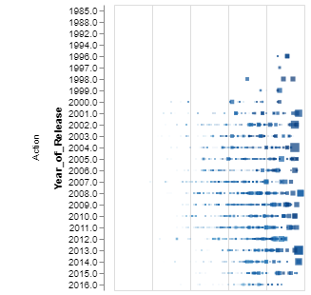
Data:

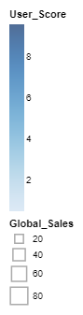
Without too many filters active, the output received from the data looks very plain and shows all 7,000 entries in the various categories. As can be seen in figure 1, the action category is generally well filled out and has plenty of entries to use as data points. The obvious focuses are on the largest entries, which consists of GTA titles, Legend of Zelda titles, with Metal Gear Solid, Tomb Raider, Uncharted and the Batman games filling the gap years between the releases of the largest titles in the category. What is interesting here is the comparison of the unfiltered action category versus the filtered category. If we set the filter to remove the games that are purely gameplay focused to having a divided focus between the importance of the two, we start to see some differences in the entries.
Figure 1: Non-Filtered Action + Graph Info
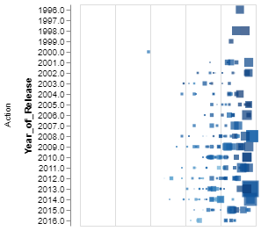
The curious element here comes from another category that could be seen as a parallel to the action category, the “Shooter” category. As can be seen, the years have been shaved down from 1985-2016, to just 1996 to 2016. This is partially caused by the method of data cleaning and the personal tagging system. However, we start seeing the difference between user scores and sales more clearly. There are cases of games being rated very highly by the users, while having a critic score around the 80’s that don’t have many sales. More importantly, the removal of purely action games that may have some narrative elements present, has cleared the middle of the graph extensively. This is the first instance that we can see storytelling impacting the sales of games.
Figure 2: Filtered Action
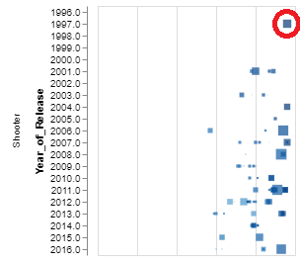
One of the primary games that has been attributed to causing a major shift in storytelling within video games is Half Life 1 [Unforeseen Consequences: A Half Life Documentary; 17:20 – 20:00; Noclip 2018], which was a unique take on the first-person shooter genre at the time. The story isn’t told through cutscenes or dialogue, but rather the events happening in the background as character discuss what is happening at the main locale of the game, the Black Mesa Testing Facility. Acknowledging the bias of the tagging system, it remains one of the only early shooters that had a split focus between action and storytelling. The story itself is very rudimentary as it features a silent protagonist alongside a very linear story, it heavily focuses on the militarisation of science and how dangerous experiments can be without proper oversight and how blindly following the instructions of others can lead to everything around you going awry. Half Life 2 is also featured on this list which continues the narrative of Half Life 1 but adds elements of environmentalism through the depictions of the resource hungry combine, mixing in elements of post-colonial storytelling. While these narratives are never overt, they can still be seen as aspects that have helped them garner sales and critical acclaim. [Egenfeldt-Nielsen, Simon; Smith, Jonas; Tosca, Susana; Understanding Video Games: The Essential Introduction]
Figure 3: Filtered Shooter + Half Life
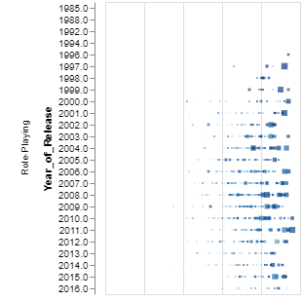
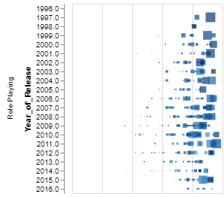
Focusing on the role-playing category, which primarily consists of story focused games due to the nature of the genre. While having a high about of franchises, the category features the least amount of series of games that would continue an overarching plot. As we can see from figures 4 and 5, it is clear to see that while the sales may be low in terms of the average when contrasted to games like GTA V and Wii Sports that have sold 19 million and 80 million copies respectively, many of the high scoring games also sell well. In this category, it is clear to see that stronger narratives sell more copies than their counterparts with average ratings. Also, considering the number of releases that happen within the category, it has definitely seen an increase after the 2000’s, after prominent series like Baldur’s Gate, Fallout and Final Fantasy breached into the mainstream gaming market after what has generally been a more niche genre of games. Some of the later popular titles consists of Bethesda’s forays into The Elder Scrolls games and their attempts at creating newer Fallout titles.

It is important to note that in general some of the games that are in the middle of the graphs have very dark colouration and some one the right most edge are very light. This can point towards disagreements between critics and users, which can be caused by a multitude of factors that are impossible to identify. Stories of critics being paid for good reviews or the companies providing reviews hosting ads of specific games on their website can all influence a critic to give a particularly high score to a game, while personal taste is also often something that can give or take away points from an experience. The aggregation of the scores alleviates this to an extent, but all scores need to be taken with a grain of salt if there is little to no correlation between the critic score, sales and user score.
Figure 5: Unfiltered Roleplaying
Figure 4: Filtered Roleplaying

Analysis:

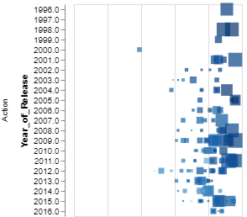
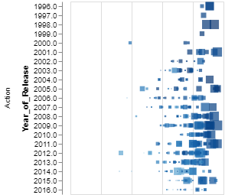
With all of the data available to us from Metacritic, is it possible to say that storytelling is a vital part of a games success? With 95% accuracy, I would say yes. Many of the highest grossing games on the list; aside from a few outliers, are games that combine their efforts into creating an enjoyable gameplay loop and an engaging narrative. The results of tagging all of the games despite category reveals that action games have started to implement more relevant plots that sometimes are told through serialization as seen in figure 6 and 7.
Figure 6: All Serial Action Games
Figure 7: Serial Story Action Games

As we can see from the graph, once we take serialisation into account, the landscape of the graph changes drastically. The entries around the middle in terms of user score disappear and from this we can gain an argument that long running series that actively continue the same story, are likely to stay more relevant than serialised games that mainly provide a level of familiarity for the players. The serialised stories include series such as Metal Gear Solid, which boasts one of the more ambitious crossovers between gameplay and storytelling as its anti-war narrative is what gave its creator, Hideo Kojima, a reputation within the games industry [Courcier, Nicolas; Kanafi, Mehdi; Brusseaux, Denis; Metal Gear Solid: Hideo Kojima’s Magnum Opus].
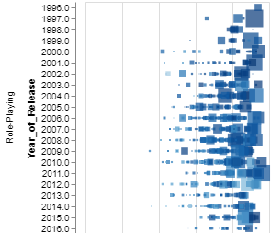
Looking at this more from an English literature perspective, as most games have been translated into the language and most of the games are developed in English and the audience is primarily formed of English speakers, we can apply several writing theories and see how these involved plots can also create player involvement. One of the more modern factors is the digital humanities side of English literature in the form of the analysis of digital storytelling and how relational databases have allowed games to feature player interactive and reactive narratives. Most of the later RPG’s on the list do not simply feature random encounters based on tile data that the player’s avatar is currently standing on but are picked from databases similar to the ones we are analysing in this course. Now, looking at the serialisation in RPG games in figured 8 and 9:
Figure 8: Serial RPG's only
Figure 94: Only RPG's
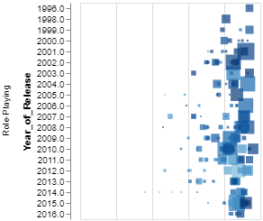
We see another interesting side of the data. The category shrinks down drastically, but most of the large entries remain. This space is occupied by games like Mass Effect, worldbuilding titles like Fallout, and the Witcher series. What makes this category interesting is that some of the sequels have higher sales numbers than the original, which can mean one of two things:
- The sequel in question tells the backstory of the first game and is self-sufficient in its narrative, but continues to build on the characters of the previous title; or
- The sequel has separated itself from the previous main character, but it takes place in the same universe and the effects of the previous main character can still be seen in the game world or in the characters.
In both cases, there is sufficient narrative depth to justify the effort of writing a story that engages audiences over multiple games in a semi transmedia narrative. This could be related to the disappearance of multiple smaller titles from the list and how they are standalone experiences, but it also implies that the grander the narrative is, the more successful the game may be.
Games share many fundamentals with novels, they have their scenario and their main characters, all of which can be analysed, albeit analysis of a player character requires more psychological work to understand. The advantage that the digital medium has in this regard, is the visual aspect of storytelling it borrows from film, the story isn’t restricted to the page in this regard, making pure textual analysis give only partial answers. [Howitt, Grant; Writing Video Games Narrative as Important as Gameplay; The Guardian, 2014]

Conclusion:
The aim of this limited final project was to see if narratives in video games equate to critical and financial success within the space. There is a 95% likelihood that the data is pointing the right direction, but it would need more work in order to conclusively prove that the collaborative efforts of animators, artists, writers, and programmers would all be vital to the experience at large. The purely story-based games tend to have middling sales, which could point to a general preference of having more gameplay present within the experience. Meanwhile on the action-based games tend to have higher sales numbers, but lower critic and user score averages, which may reveal that the game is primarily played for its multiplayer component rather than single player component, which is the case with many Call of Duty titles. Games are a unique medium that combine storytelling and gameplay design as its own field is something that has emerged because of video games popularity.

References and Tools:

- https://openrefine.org/index.html Version 3.1
- vega.github.io/voyager
- Egenfeldt-Nielsen, Simon; Smith, Jonas; Tosca, Susana; Understanding Video Games: The Essential Introduction, Routledge, New York, 2013
- Courcier, Nicolas; Kanafi, Mehdi; Brusseaux, Denis; Metal Gear Solid: Hideo Kojima’s Magnum Opus
- https://www.theguardian.com/culture/australia-culture-blog/2014/feb/21/writing-video-games-can-narrative-be-as-important-as-gameplay Accessed on 19.12.2018

