CEREBRAL EXOPHYTIC GLIOMA - A RARE CASE

Dr.Survashe Pravin Tukaram, Dr.Guthe Sachin, Dr.Velho Vernon, Dr. Harish Naik
Department – Neurosurgery of Grant Government Medical College and Sir J.J. Group of Hospitals, Mumbai

 | Abstract
Keywords:  CEREBRAL EXOPHYTIC GLIOMA | Gliomas of the cerebral hemisphere are locally invasive tumors. They infrequently grow and extend exophytically in the subarachnoid space as an extraaxial mass lesion. Brainstem gliomas are known for exophytic growth however cerebral hemispheric gliomas with exophytic component are rarely seen. Hereby we report a case of low grade temporal glioma with exophytic extension (extraxial).
Introduction
Low-grade gliomas (LGGs) are diffusively infiltrating tumors and almost always remain confined to brain parenchyma. [1]They commonly follow white matter fibrous tracts and remain confined within pial borders except in brain stem location. This exophytic growth is classically seen in brainstem gliomas as these tumors grow along the path of least resistance. Rather than infiltrating the brainstem itself, most of tumors extend into the fourth ventricle and basal cisterns. However the cerebral hemispheric low grade glioma with exophytic growth is very rare and not reported previously.

Case report
45 year old male presented with history of multiple episodes of convulsions. On examination he was conscious and oriented without any neurological deficits. His past medical history was unremarkable. He was initially investigated with Computed Tomography (CT) and Magnetic Resonance Imaging (MRI) brain with other routine preoperative workup.MRI brain was suggestive of a large heterogeneous lesion involving right temporal lobe with extraxial component displacing the temporal lobe superomedially. Contrast scan demonstrated inhomogeneous enhancement. Mass effect was evident in the form of effacement of basal cisterns and compression on midbrain. [Figure 1,2,3]Spectroscopy revealed significant elevation of Choline with suppression of N-acetylaspartate(NAA) suggestive of Low Grade Glioma.

Patient underwent right fronto- temporo-parietal craniotomy. After opening the dura tumor was evident as an extraxial lesion enveloping the temporal lobe [Figure – 4]. Extraxial part was gelatinous, soft, yellowish gray and mildly vascular. It was filling the right temporal fossa completely and was extending across the tentorial hiatus into basal cisterns. After debulking the extraxial part, it was found to be continuous with temporal lobe parenchyma. Most of the inferior temporal gyrus was filled with tumor which was firm and was not easily suckable. The transition zone between the normal brain tissue and tumor was illdefined. Gross total excision of the tumor done. Post operative CT scan revealed near total excision of the lesion [Figure - 5]. Final histopathology report after examining both Intraxial and Extraxial parts revealed moderately cellular, well differentiated, diffusely arranged glial tumor of astrocytic origin seen against a background of loose fibrillary matrix suggestive of diffuse fibrillary astrocytoma (WHO grade 2) [Figure - 6]
.
Discussion
Fibrillary astrocytomas also called low grade or diffuse astrocytomas, are a group of primary slow growing brain tumors. They are predominantly composed of a tumour matrix rich with neuroglial fibrils, which give the tumour its name and firm consistency . They typically occur in adults between the ages of twenty and fifty. As the name implies, the borders of a diffuse astrocytoma tend to infiltrate into surrounding normal brain tissue. [1] They exhibit a characteristic cellular migration along the white matter fiber tracts. Breaching of parenchymal boundries and extraxial growth is extremely rare.

An exophytic tumor is a tumor that has the epicenter in the nervous tissue, but grows outside the anatomical superficial boundaries of the brain within an adjacent space. (2)The definition of exophytic glioma includes following two criteria:
1) Preoperative magnetic resonance imaging (MRI) with evidence of exophytic local tumor extension outside the anatomical superficial boundaries of the brain.
2) Surgical identification of piamater and arachnoid invasion with tumor growth to the adjacent cisterns.

Reason for such extraxial growth is not exactly known however it depends upon two components .1) Local invasion of the pia and arachnoid 2) Special characteristics of the tissue surrounding the brain. Local invasion generally is attributed to aggressive tumors. The exophytic tumor growth frequently is seen in brain stem,cerebellum, optic chiasm, hypothalamic, and spinal cord gliomas. All these areas have a common characteristic: they are surrounded by large subarachnoid cisterns with porous arachnoid trabeculae. On the other hand, the hemispheres are surrounded by narrow spaces with dense arachnoid trabeculae.It has been hypothesized that the large spaces within the basal cisterns represent a path of less resistance,which facilitates tumor migration, whereas the dense arachnoid trabeculae on the convexity surface of the hemispheres represents a barrier for tumor growth. [2][3][4][5]

In our case the tumor had shown extraxial growth inspite of being a low grade lesion . During surgery extraxial part could be excised completely without much difficulty. Excision of intraxial part was technicaly demanding due to lack of differentiation from normal parenchyma. Though the consistencies of both these parts were different, histopathological examination showed common origin from neuroglial cells. Hence it was confirmed that the tumor was a temporal lobe glioma with extraxial extension.

Conclusion
Glioma can be one of the possibility while dealing with extraxial cerebral hemispheric lesions. Preoperative identification of this exophytic growth pattern is of major significance for surgical planning.Resection of extraxial part is facilitated by natural plane of cleavage formed by arachnoid membranes. Histopathological examination of both the parts is required for tumor grading and planning further treatment.

References
- Duffau H, editor. Diffuse low-grade gliomas in adults: natural history, interaction with the brain, and new individualized therapeutic strategies. Springer Science & Business Media; 2013 Mar 19.
- Passos ID, Pliakou E, Triantafyllidis A, Plakas S, Mitsos A, Nakos G, Sambaziotis D, Samelis A. Glioblastomamultiforme with exophytic growth in young adult: a case report. Balkan Military Medical Review. 2014;17(1):28-32

Velasquez C, Caballero H, Vazquez-Barquero A, Vega M, Rial JC, Carcedo-Barrio MC, Martino J. Insular gliomas with exophytic extension to the sylvian cistern: a glioma growth pattern that has gone previously unnoticed. World neurosurgery. 2015 Dec 25.

Yamamoto M, Fukushima T, Sakamoto S, Tsugu H, Nagasaka S, Hirakawa K, Utsunomiya H, Tomonaga M. Cerebellar Gliomas with Exophytic Growth-Three Case Reports- Neurologia medico-chirurgica 1997; 37 (5):. 411-5 .
- Venkataramana NK, Kolluri VR, Swamy KN, Jain VK, Das BS, Das S. Exophytic gliomas of the spinal cord. Acta neurochirurgica. 1990;107(1-2):44-6.

Figure - 1
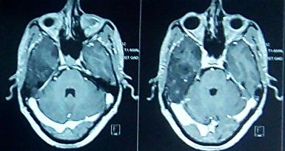

Figure - 2
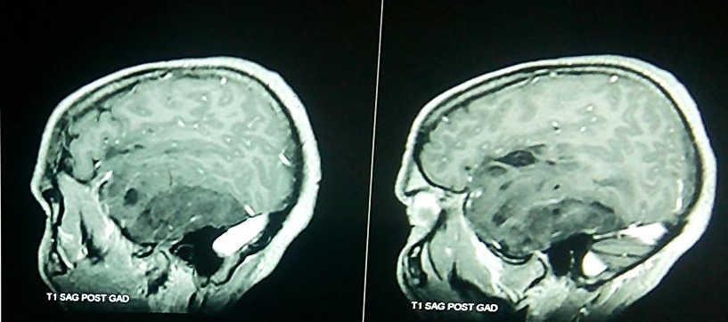
Figure 1 and 2 – Contrast enhanced axial and sagittal images showing Temporal lobe intrinsic lesion with well demarcated extra axial lesion

Figure – 3 – T2W coronal image
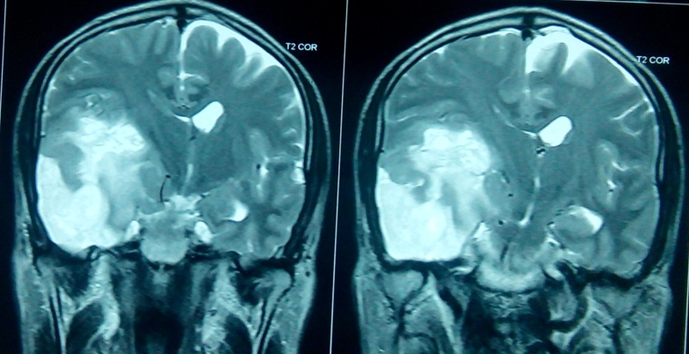

Figure 4 – intraoperative image – showing exophytic part enveloping the temporal lobe.
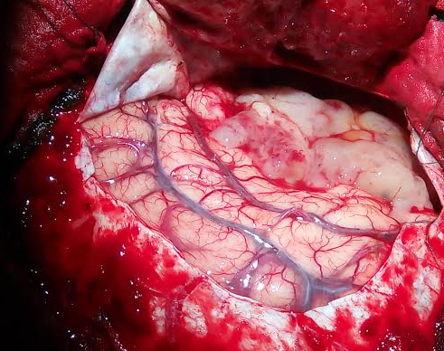
Figure 5 – postoperative contrast CT scan – showing near total excision of tumor.
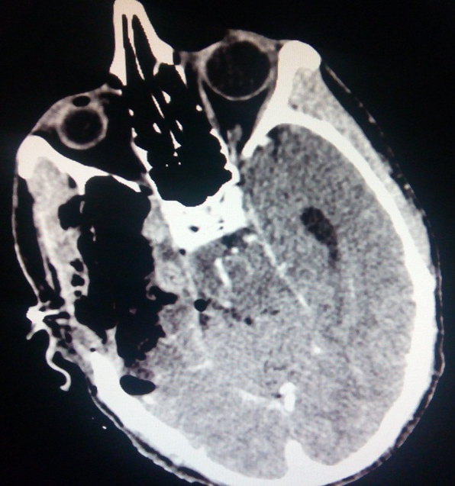

Figure – 6 – histopathological slide –
