Sleep, Stress, and Cognitive Performance in Early Adolescence: A Two-Week Data-Driven Case Study
Author: Elaheh Shiralizadeh
Department of Psychology
Date: June 2026
Abstract
A two-week analysis of the effects of sleep quality, stress, and mental functioning is presented in this case study. The analysis involved the recording of sleep pattern, levels of concentration, and stress levels of a 14-year-old individual. It was noted that increased sleep quality correlated to high concentration levels and low stress levels.
Introduction
Adolescence is a critical developmental period characterized by rapid changes in brain structure, emotional regulation, and cognitive functioning. During this stage, sleep plays a fundamental role in supporting learning processes, attention, and psychological well-being. Adequate sleep is particularly important for adolescents, as it contributes to memory consolidation, emotional stability, and overall cognitive efficiency.
Research has consistently shown that insufficient or poor-quality sleep in adolescents is associated with higher levels of stress, reduced attention span, and impaired cognitive performance. Sleep deprivation has also been linked to difficulties in academic achievement and emotional regulation, highlighting its importance in daily functioning during early life stages (Carskadon & Acebo, 2002; Owens et al., 2014).
Despite extensive research on adolescent sleep at a population level, fewer studies have focused on individual, real-life daily tracking of sleep and its immediate relationship with cognitive performance and stress. Such case-based approaches can provide more detailed insights into how day-to-day variations in sleep influence psychological functioning.
This two-week case study investigates the relationship between sleep quality, stress levels, and cognitive performance in a 14-year-old adolescent. By collecting daily self-reported data on sleep duration, sleep quality, stress, and concentration, this study aims to explore how sleep patterns are associated with cognitive efficiency and emotional regulation in everyday life.
Method
2.1 Participant
The participant was a 14-year-old female adolescent with no neuro or psychological problems that have been reported. The participant was a full-time student and voluntarily involved in this research work.
2.2 Measures
In this research, the following measures have been used:
Sleep Duration: Total time spent sleeping per night, in hours.
Sleep Quality: Subjective assessment of quality of sleep based on how restful the sleep was, measured on a scale of 1 (very poor) to 10 (very good).
Concentration: Daily self-report rating of individual’s concentration level, measured on a scale of 1 (very poor) to 10 (very good).
Stress Level: Daily self-report rating of the level of stress experienced by an individual throughout the day, measured on a scale of 1 (low stress) to 10 (high stress ).
2.3 Procedure
The research was carried out for a span of 14 continuous days. Sleep duration and quality were rated every morning right after awakening. Concentration and stress levels were rated at the end of each day on the basis of daily experience.
2.4 Data Analysis
Following data collection, all the variables collected were analyzed using Python software. The analysis involved calculations of descriptive statistics such as the mean and standard deviation for each variable. Besides that, correlations were performed to assess the relationship between sleep duration, sleep quality, level of stress, and ability to concentrate. Data visualization techniques, such as plotting of lines and scatterplots, were also carried out.
Result
Variable | Mean
Sleep duration | 6.500000
Sleep quality | 4.071429
Concentration | 4.714286
Stress level | 3.785714
Table 1. Descriptive statistics for the study variables.
Variable | Sleep duration | Sleep quality | Concentration | Stress level
Sleep duration | 1.000000 | 0.587510 | -0.086897 | -0.609253
Sleep quality | 0.587510 | 1.000000 | 0.210695 | -0.323156
Concentration | -0.086897 | 0.210695 | 1.000000 | -0.040908
Stress level | -0.609253 | -0.323156 | -0.040908 | 1.0000000

Table 2 . Correlation matrix among sleep duration, sleep quality, concentration, and stress level.
The descriptive analyses showed that the average duration of sleeping was 6.50 hours each day for 14 days of monitoring. Sleep quality scores had a mean of 4.07, and concentration had an average rating of 4.71. The stress level averaged 3.79 each day.
The correlation analysis shows that there was a moderate positive association between sleep duration and sleep quality (r = 0.59). It means that longer sleep duration led to a better perception of the quality of sleep. Besides, a moderate negative association between sleep duration and the level of stress was established (r = -0.61). This finding indicates that a person experienced lower levels of stress when sleeping more.
There was a weak positive association between sleep quality and concentration (r = 0.21), meaning that a good quality of sleep had a small effect on increased concentration. Moreover, a weak negative association between sleep quality and the level of stress was found (r = -0.32). The association between concentration and the stress level is negligible (r = -0.04).
The graphic results give additional information about daily changes in sleep and concentration.
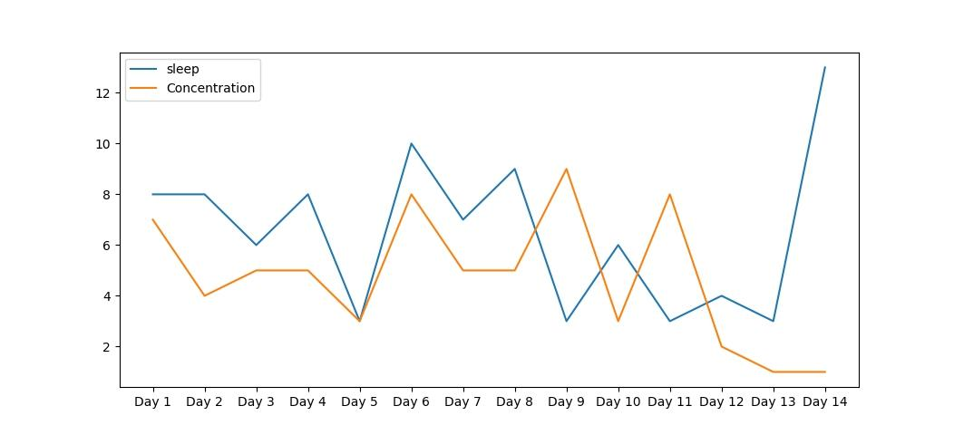
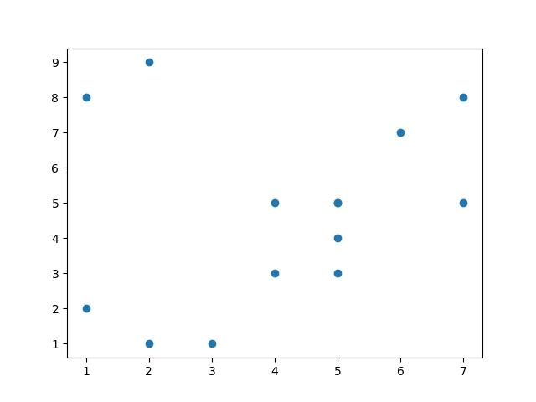
Figure 1.
Daily changes in sleep duration and concentration across the 14-day study period

Figure 2. Relationship between sleep quality and concentration

Discussion :
This case study for two weeks investigated the correlation between sleep duration, quality of sleep, level of concentration, and level of stress of a teenager who is 14 years old. There were certain significant trends found from the findings.
First, it was seen that there was a moderately negative correlation between sleep duration and stress level (r = -0.61). Practically, this means that when the time spent in sleeping was greater, the self-perceived stress level was smaller. Thus, it can be implied that sleeping properly may assist adolescents in dealing with stress better.
The positive correlation between sleep duration and sleep quality (r = 0.59) indicates that longer sleep generally led to higher perceived sleep quality, which aligns with existing literature emphasizing the restorative role of sufficient sleep in adolescents (Carskadon & Acebo, 2002; Owens et al., 2010). A weaker positive correlation was observed between sleep quality and concentration (r = 0.21), suggesting that better sleep may slightly enhance attentional functioning, although this effect was modest in this single-case study. Similarly, sleep quality and stress level showed a weak negative correlation (r = -0.32), consistent with findings that higher-quality sleep supports emotional well-being.
Several limitations should be acknowledged. First, the study involved only a single participant, limiting generalizability to broader populations. Second, the data were self-reported, which may introduce subjective bias. Third, the observation period was relatively short (14 days), which might not fully capture long-term patterns of sleep, stress, and cognitive performance.
Despite these limitations, the study provides preliminary evidence supporting the importance of adequate sleep for stress reduction and cognitive performance in early adolescence. Future research could expand this work by including larger samples, longer observation periods, and objective measures of sleep (e.g., actigraphy) to validate and extend these findings. Additionally, examining interventions to improve sleep habits may clarify causal links between sleep and cognitive-emotional outcomes in adolescents.

Conclusion

According to the findings from the two-week case study conducted, it is possible to conclude that sleep is crucial for adolescents’ daily life. There was shown a moderate positive correlation between sleep duration and sleep quality, indicating that individuals who spend more time sleeping experience higher-quality sleep.

Additionally, a moderate negative correlation was found between sleep duration and stress level. This indicates that sufficient time spent sleeping is related to reduced daily stress experienced. Finally, while there was no strong correlation found between sleep quality and concentration, it can still be said that good sleep may have a positive influence on cognition.

However, there are several limitations to consider when analyzing the results obtained. In the first place, the research included only one participant, and hence its outcomes cannot be generalized. Next, all the ratings used throughout the study are subjective, and therefore, their influence should not be ignored. Thirdly, only two weeks of observation were taken into account.

Nonetheless, some important findings have been established regarding sleep’s significance during early adolescence.

References

Carskadon, M. A., & Acebo, C. (2002). Regulation of sleepiness in adolescents: Update, insights, and implications. Sleep Medicine Reviews, 6(6), 453–470.
Owens, J. A., Belon, K., & Moss, P. (2010). Impact of delaying school start time on adolescent sleep, mood, and behavior. Archives of Pediatrics & Adolescent Medicine, 164(7), 608–614.
Tarokh, L., Saletin, J. M., & Carskadon, M. A. (2016). Sleep in adolescence: Physiology, cognition and mental health. Neuroscience & biobehavioural Reviews, 70, 182–188.
Dahl, R. E., & Lewin, D. S. (2002). Pathways to adolescent health: Sleep regulation and behavior. Journal of Adolescent Health, 31(6), 175–184.

