Generation and interaction of elevated shear inflow turbulence with scaled tidal turbine
Mohd. Hanzla¹ and Arindam Banerjee¹
¹Department of Mechanical Engineering & Mechanics, Lehigh University, Bethlehem, PA 18015
Tidal energy sites are characterized by strong shear and elevated levels of turbulence, which can significantly impact turbine performance, fatigue loading, and turbine wakes, among others. A Tidal Turbulence Testing Facility (T³F) is being developed at Lehigh University as part of the Atlantic Marine Energy Center to recreate site-specific turbulent characteristics in its open surface, recirculating water tunnel using an active grid turbulence generator. A detailed discussion on the shear flow generation using an active grid turbulence generator will be presented. Figure 1 illustrates an example of shear profiles at three locations from the test-section inlet (i.e., 0.5D, 1D, and 2D, where D is the turbine diameter) and the homogeneity of the flow across the water tunnel at 2D (rotor plane). Additional emphasis is placed on turbulence characterization, with measurements performed using an Acoustic Doppler Velocimetry and a Hotwire X-film probe. The data sets are compared with some of the turbulence metrics obtained from highly energetic open-water tidal sites. Finally, a detailed study of the spectral response of the 1:20 scaled tidal stream turbine power fluctuations is carried out to understand the dynamic interaction [1]. We explicitly explore the effect of elevated turbulence, higher integral length scales, and coherent structures atop shear on the turbine power fluctuations. The results presented herein would benefit the scientific community from an improved understanding of the turbulence-turbine interaction, governing parameters, and a novel data set valuable for computational tools.
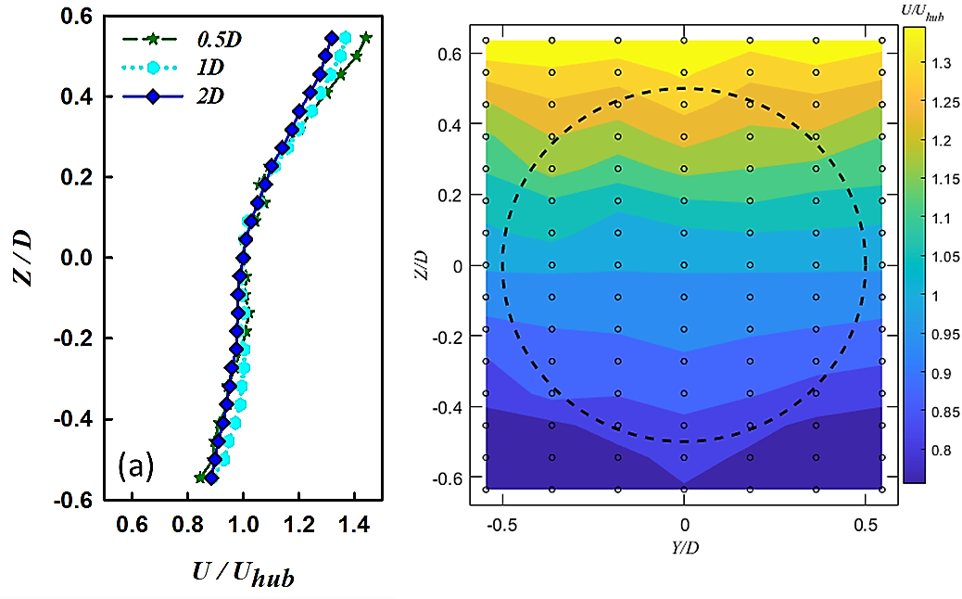
Figure 1. (a) Mean velocity profiles and (b) its contours normalized with hub height velocity at the rotor plane (2D). The points are the measured locations and the dashed circle is the rotor area.

References:
- Mohd Hanzla and Arindam Banerjee, Spectral behavior of a horizontal axis tidal turbine in elevated levels of homogeneous turbulence, Applied Energy, Volume 380, 124842 (2025).
Acknowledgment: This material is based upon work supported by the U.S. Department of Energy, Office of Energy Efficiency and Renewable Energy (EERE), specifically the Water Power Technology Office under award number DE-EE0009450 (Atlantic Marine Energy Center).
Submission Format: Oral
Topic Areas: Tidal, Device Deployment Strategies, Resource Assessment

