Optimal Power Flow in Marine-Enhanced Grids Integrating Offshore Wind and Wave Energy Kevin Wyckoff, Farrah Moazeni, Javad Khazaei, Arindam Banerjee*
Atlantic Marine Energy Center, Lehigh University, Bethlehem, PA 18015
*Corresponding Author, co-Director Atlantic Marine Energy Center (E-mail: arb612@lehigh.edu)

Offshore wind and wave energy are resources whose importance is growing due to clean energy initiatives and increasing power demands. However, adding these resources to an electricity grid is more complicated than adding conventional power plants. First, the power that offshore renewable resources generate is variable and dependent on wind and wave conditions. Second, these resources do not provide a consistent supply of power in the same way as conventional generators. For these reasons, integrating offshore wind and wave energy can potentially challenge the generation-demand balance [1]. In this study, we investigate the potential problems introduced when wind and wave energy are added to the grid to better understand how to mitigate those problems and enable a smoother adoption of these technologies. Using site-specific data and models of offshore wind turbines and wave energy converters to generate the power delivered to the grid has not been carried out for the optimal power flow problem. A modified IEEE 57 bus system is used as a test case for the grid. The load is modified to reflect local site-specific load corresponding to wind and wave data used to generate resources. The optimal placement of wind and wave energy into the IEEE 57 bus system is evaluated. A preliminary examination of the power from offshore renewable energy is used to choose specific cases for consideration. Based on the mean power produced during days and the power variations in those, both typical and extreme cases are considered. Then, a subset of chosen cases is simulated by solving the optimal power flow for the system. Ramping rate limits are included for the conventional generators in the problem. Figure 1 shows an example of such an analysis, showing the optimal usage of conventional and renewable energy in the microgrid. An analysis of the changes in economic performance and grid stability due to the inclusion of offshore renewable energy is performed, and different levels of renewable energy penetration are considered to better understand how increasing the reliance on wind and wave energy will affect the grid.
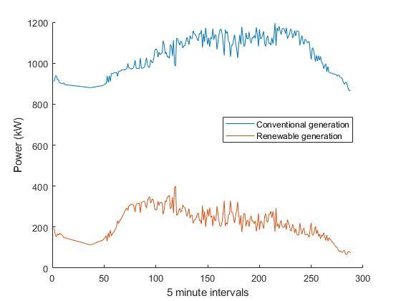
Figure 1: The power usage of conventional and renewable generation for the modified IEEE-57 bus system using optimal power flow with 5-minute intervals over a day

Acknowledgment: This material is based upon work supported by the U.S. Department of Energy, Office of Energy Efficiency and Renewable Energy (EERE), specifically the Water Power Technology Office under award number DE-EE0009450 (Atlantic Marine Energy Center).

References:
- M. Noman, G. Li, M. W. Khan, K. Wang, and B. Han, A Multi-Stage Design Approach for Optimizing a PMSG-Based Grid-Connected Ocean Wave Energy Conversion System. Protection and Control of Modern Power Systems, November 2024

Submission Format: Oral

Topic Areas: Wave, Device Deployment Strategies, Economic Considerations

