CARBON SEQUESTRATION and storage in soils
TEACHING PROTOCOL
Grade Level: Secondary High School
Duration & Lesson Structure:
min. two school lessons for the introduction (“Engage”),
min. four school lessons for the field trip (“Explore”)
min. four school lessons for background information on carbon sequestration, carbon calculation, and impacts of CO2 (“Explain” &” Elaborate”)
INTRODUCTION
This learning unit helps students understand the importance of carbon sequestration by plants and carbon storage in floodplain and peatland soils. The students learn about the role of CO₂ as a greenhouse gas, as well as significant natural and human sources and sinks of CO₂. The activities highlight the crucial role of wetland plants in sequestering carbon, which is then stored in wetland and peatland soils over centuries, thereby mitigating global warming. Students integrate theoretical information with their field experience to form a comprehensive understanding of the carbon cycle. They are encouraged to critically evaluate questions concerning land-use and its potential impact on carbon sequestration, as well as the factors that may influence carbon storage in wetland soils.
The school lessons presented here are part of the Horizon Europe project Restore4Life and primarily focus on wetland soils. They can be expanded to include investigations of carbon sequestration and storage in tree biomass (see “Carbon sequestration in floodplain forests”).
Students’ learning objectives:
By the end of this activity, students will be able to:
- Identify key carbon sinks and sources in wetlands
- Measure and calculate soil organic carbon content and various other soil parameters, and assess soil conditions in wetlands
- Explain the role of wetland soils in mitigating global warming due to long-term organic carbon storage
- Assess human impacts on the carbon storage in wetland soils
- Understand how science works and draw links between theoretical information and collected data
Keywords: Carbon sequestration, carbon sink/source, above-ground and below-ground biomass, greenhouse gases, warming potential
ENGAGE - Sparking curiosity
Aims: Students can explain how greenhouse gases contribute to global warming and how CO₂ in the atmosphere is removed by carbon sequestration (i.e., the incorporation of CO₂ into plant biomass via primary production). They can name important carbon sinks (e.g., forests, peatlands) and sources (e.g., anoxic sediments of water bodies) in wetlands and other ecosystems.
Guiding questions:
How do water vapor, CO₂, and other greenhouse gases (e.g., methane) cause global warming? What are the primary natural and human sources for these gases?
How is CO₂ naturally removed from the atmosphere? What does carbon sequestration mean? Why are intact (wetland) forests important for carbon sequestration?
Which conditions in wetlands favor carbon sinks and sources?
Teacher Support
The activity is split into two tasks: (1) A short indoor experiment to demonstrate the warming effects of CO₂ and water vapor on air temperature, and (2) an internet search.

- Climate change experiment
This activity helps students understand the concept of climate change by conducting a small-scale experiment on global warming in a classroom setting. Through this hands-on experiment, students will gain insight into the greenhouse effect and observe how different atmospheric conditions influence temperature changes.
Activity Overview: Students will set up three glass bottles, each representing different atmospheric conditions: a control bottle with normal air, a bottle with added water vapor, and a bottle with CO₂ generated from a reaction between limestone and a descaling solution. Infrared lamps will simulate solar radiation, and temperature changes will be recorded over time.
Discussion Points: Before starting, discuss the greenhouse effect and its significance in climate change. Ask students to hypothesize which bottle will show the greatest temperature increase and why. After collecting data, facilitate a discussion on the results and their implications for understanding global warming.
Expected results: The temperature in the water vapor bottle and the CO₂ bottle will rise faster and reach a higher end temperature than the reference bottle with just air. The CO₂ bottle will show a higher temperature increase than the water vapor bottle.
Materials needed and detailed instructions: see students’ worksheet “Explore – Floodplain Soils”

- Internet search
This activity helps students develop research skills and deepen their understanding of climate change topics by conducting an internet search to gather and evaluate information. Through this exercise, students will learn about greenhouse gases, global warming, and carbon sequestration, and they will practice assessing the trustworthiness of online resources.
Activity Overview
- Students are divided into small groups of 3-4 people. Half of the groups collect background information on greenhouse gases and global warming (how do greenhouse gases cause global warming? Which is the most potent greenhouse gas?). The other half focuses on carbon sequestration (What is it? Which natural habitats have the highest potential? Which have a low potential).
- After 30 minutes, the students present their findings to the others.
- The students draw a mind-map of the (global) carbon cycle.
Discussion Points: Discuss the importance of reliable sources and how to evaluate the trustworthiness of information found online. Encourage students to think critically about the sources they use and to cross-reference information. After the presentations, facilitate a discussion on the global carbon cycle and how the topics of greenhouse gases and carbon sequestration are interconnected
Materials needed: Computer or Smartphones; links to search for information; instructions on how to search and decide whether these are trustworthy resources

EXPLORE – Hands-on Learning Activity
Aims: Students can analyze and measure various soil parameters to assess soil conditions in wetlands and estimate the organic carbon stored in soils.
Guiding questions:
How can you estimate the organic carbon storage in soils?
Which soils do you think are the largest organic carbon stores?
Teacher support
Activity Overview: This activity gives students hands-on experience in investigating soil types, structure and parameters of wetland soils. Depending on the local environment, students will follow one of two protocols:
For floodplain soils - characterized by a shallow organic layer in floodplain forests - follow protocol 1 below and use the students’ worksheet “Explore – floodplain soils”.
For peatlands - characterized by a deep organic layer in bogs and mires - follow protocol 2 below and use the students’ worksheet “Explore – peatland soils”.
- Soil organic carbon in floodplain forests
Materials needed: Soil sampler (drill) or shovel; plastic bags (1 L), spoons, measuring stick, small water bottle; mason jar, balance, and oven (only indoor); two measuring cylinders; students’ worksheet “Explore – floodplain soils”
For advanced analyses: clean beakers (min. 50 mL), coffee filters, funnel, soil test strips (either single strips for pH, nitrate, and hardness, or combined strips), distilled water
- Support students in identifying a suitable area within a floodplain forest. Students document the location (GPS/photo) using their smartphones.
- Students take soil samples, measure and record the depth of the upper layer and analyze soil type and structure following the instructions on the worksheet.
Ensure that students dig/drill deep enough and reach the brighter mineral soil layer (B horizon) beneath the dark, organic-rich upper layer (A horizon)!
- Students collect a handful of the upper dark soil layer in a labeled zipper bag to bring back to school for further indoor analyses.
- In the classroom, students calculate moisture content, volume, and estimate organic matter and carbon concentration using simple drying and weighing methods according to the students’ worksheet.
Important: The organic carbon content is approximately 50% of the organic matter. The rest is composed of other elements, such as N, P, Ca, and Mg, among others.
- Advanced soil parameter analyses: For further chemical analysis, students prepare a soil-water extract and analyze it using test strips (see students’ worksheet).
- Soil organic carbon in peatlands
Materials needed: 2 m steel rods: If you use threaded rods (M8 x 1000mm) and connecting nuts (M8), you can extend the rod as long as needed (see picture); colored tape, shovel, plastic bags (1 L), measuring stick; 2 measuring cylinders (indoor); students’ worksheet “Explore – peatland soils”
- Support students in identifying a suitable sampling area within a peatland. Students document the location (GPS/photo) using their smartphones.
- Students measure peat depth and peat degradation following the instructions on the worksheet.
- Students collect a handful of the top peat layer in a labeled zipper bag to bring back to school for further indoor analyses.
- Back in the classroom, students calculate the moisture content, the sample volume, and the organic matter content according to the students’ worksheet.

EXPLAIN – Making Sense of the Experiences
Aim: Students can calculate the organic carbon stored in floodplain or peatland soils and explain the role of long-term carbon storage in mitigating global warming.
Guiding questions:
How much organic carbon is stored in your floodplain/peatland? How much organic carbon is stored in other soils (e.g., agricultural)? What happens if peatlands are drained?

Teacher Support
This activity provides students with hands-on experience estimating the carbon storage capacity of wetland soils. Depending on the local environment, students follow one of two protocols. For floodplain soils, use the students’ worksheet “Explain – How to calculate the carbon content of floodplain soils”. For peatland soils, use the students’ worksheet “Explain – How to calculate the carbon content of peatland soils”.
Materials needed: Appropriate soil carbon calculation worksheet (floodplain or peatland), calculator
Activity Overview
- The teacher hands out the correct protocols “Calculate carbon storage in soils”
- Students prepare the data collected during their field trip and perform the calculations according to the worksheet.
- Compare results among sites and with online data on the organic content of different soils and other global carbon stores (e.g., tree biomass).
Potential link:
https://www.visualcapitalist.com/sp/visualizing-carbon-storage-in-earths-ecosystems/
- Discuss what may happen if wetlands are turned into arable land and settlements or used by forestry or tourism (the first two transformations lead to the loss of the carbon sequestration potential; the latter two uses maintain it). In peatlands, discuss what happens if peatlands are drained.

EXTEND / ELABOrate – Expanding Understanding
Aim: Students can name large natural and human CO₂ emitters and explain how CO₂ emissions can be reduced globally and by each of them.
Guiding questions:
Which natural and human CO₂ sources can you find? What are the largest CO₂ emitters? How can CO₂ emissions be compensated/reduced globally and by yourself?
Teacher Support
This activity aims to help students identify significant natural and human sources of CO₂ emissions and explore strategies for reducing these emissions both globally and individually. By investigating various sectors and calculating their own carbon footprints, students will gain insight into the impact of human activities on climate change and the importance of sustainable practices.
Materials needed: Computer, smartphone
Activity Overview
- Students calculate their CO₂ footprint
- Students search for further CO₂ emission data of different economic sectors (transport, industry, farming, households, etc)
- Students discuss ways to reduce CO₂ emissions in general and at home
- Based on the findings in the field, how many (floodplain) forests have to be restored to compensate for the global human CO₂ emissions?
Background information and links:
Carbon Footprint Calculator – CO₂ Emissions
  - Link: https://www.carbonfootprint.com/calculator.aspx
  - The calculator helps individuals and organizations estimate their carbon footprint and CO₂ emissions based on various activities, such as energy consumption, transportation, waste generation, etc. Based on the data entered, the calculator provides an estimate of the total CO₂ emissions produced and may suggest strategies for reducing those emissions.

CDP – Carbon Disclosure Project
  - Link: https://www.cdp.net/en
  - CDP is a nonprofit organization that encourages companies and cities to disclose their environmental and climate data. Many international companies participate in CDP surveys annually, providing detailed information on their CO₂ emissions and climate strategies.
Global Reporting Initiative (GRI)
  - Link: https://www.globalreporting.org/
  - GRI is one of the leading global organizations for sustainability reporting. It provides standards that help companies disclose their environmental, social, and governance (ESG) data. Many companies publish their CO₂ emissions in GRI-compliant sustainability reports.
IEA (International Energy Agency) – CO₂ Emissions Data
  - Link: https://www.iea.org/
  - The IEA provides extensive data on CO₂ emissions at both the global and regional levels, including information related to energy production and emissions from large industries and companies.

Evaluate – Assessing Learning
Aims: Assess students’ understanding of the emission and sequestration of carbon and the role of (wetland) forests as a carbon sink.
Teacher Support
This activity assesses students' understanding of carbon emission and sequestration, and the crucial role of wetland forests as carbon sinks. Through a climate game, students will explore connections between global warming, CO₂ emissions, carbon sequestration, and the importance of preserving intact wetland forests.

Activity: Play a climate game - game suggestions:
- „Climate Call Game“
Students learn how everyday activities impact the climate by playing the game. The game is engaging and informative, leading to lively discussions and eye-opening discoveries.
2-6 players, one round takes about 15 minutes, age 12+; https://climatecallgame.com/

- “Climate Change: The Game” (2023)
Players simulate decisions related to policy, economics, and technology to reduce emissions and combat climate change. While CO₂ certificates are not explicitly traded, the game explores emissions reductions and the global efforts to tackle climate change.
2-5 players, 60-120 min, age 12+; https://boardgamegeek.com/boardgame/390899/climate-change-the-game
- „CO₂ – Second Chance“ (2018)
This game revolves around the global CO₂ emission market and the challenge of promoting renewable energy while trading CO₂ certificates. Players take on the role of companies that need to reduce their CO₂ emissions to earn CO₂ certificates, which can then be traded.
1-4 players, 60-120 min, age 12+; https://boardgamegeek.com/boardgame/214887/co2-second-chance
- “Power Grid” (2004)
In this game, players build an energy network and trade energy sources, some of which cause CO₂ emissions. While not directly focused on CO₂ certificates, it deals with sustainable energy and the challenges of the energy market.
2-6 players, 120 min, age: 12+; https://boardgamegeek.com/boardgame/2651/power-grid
Authors: Gabriele Weigelhofer, Eva Feldbacher, Clara Rosenberger – BOKU University

Reference: Weigelhofer, G., Feldbacher, E., Rosenberger, C. (2025) Carbon sequestration and storage in soils. Teaching materials. In: Horizon Europe Project Restore4Life. Doi: 10.5281/zenodo.17453840

CARBON storage in Soils
STUDENT WORK SHEET “EXPLORE – Floodplain soils”
Soil organic carbon in floodplain forests
- Field work
Materials needed: Soil sampler (drill) or shovel; plastic bags (1 L), spoons, measuring stick, small water bottle;
- Determine the GPS position of the sampling area and take a picture with your smartphone.
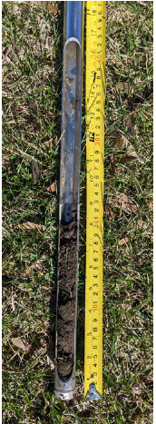
- Select 3-5 sampling sites, remove plants and litter from the ground, and dig a 15-20 cm deep hole (approx. 20x20 cm area). If you have a soil drill, drive it to a depth of 15-20 cm and carefully extract the soil sample instead.
The hole/drill should be deep enough so that the brighter mineral soil layer (B horizon) below the dark, organic-rich layer (A horizon) is visible!
- Measure and record the depth of the upper dark (organic-rich) layer.
- Analyze the soil type and the structure of the upper and lower layer:
Soil type: Carefully extract a walnut-sized sample from the lower, brighter layer. If the sample is dry, lightly moisten it with water from the water bottle. Now, conduct the soil type test on the next page. Try to form the sample between your fingers into a sphere. Then, try to make a cylinder. Now, rub the sample carefully between your fingers. Based on your observations, determine the soil type according to the table below and record it in the soil form.
Organic carbon content: Compare the color of the (slightly wet) soil sample with the color chart below and note the color.
- Put a large handful of the upper dark soil layer into a plastic bag, label it, and transport it to the school for the indoor analyses.

Soil type test:

Soil type | Form to a sphere   | Make a cylinder   | Soil feeling | Sticks to your fingers
Sand | Not possible | crumbles | Rough, small grains can be felt and seen | no
Silt | Not possible | crumbles | Like velvet or flour, no grains visible | Only in the grooves of the finger
Loam | Difficult, easily crumbles | Small roll possible (pencil-thick), then crumbles | Soil consists of approx. 50% small grains and 50% very fine material | Only in the grooves of the finger
Clay | Easily possible | Easily possible | Sample shines; no grains perceptible, feels soapy-greasy | Yes, strongly

Soil colour test:
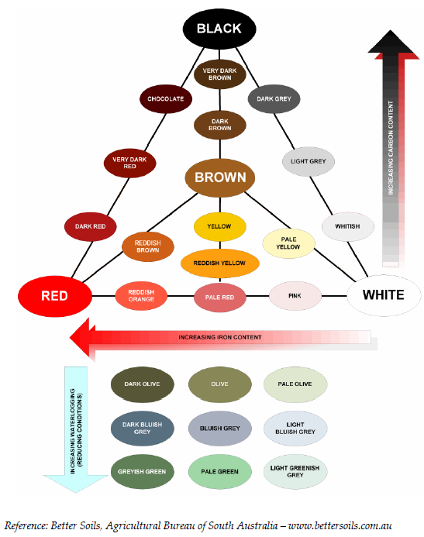

SOIL FORM
Name
Date |  | Time
Location |  | Vegetation
GPS |  | Depth of upper dark layer (cm)
 | Upper dark layer |  | Lower brighter layer
Form into a sphere
Form into a cylinder
Soil feeling
Stickiness
Soil type
Soil color
Comments

- Indoor analyses
Materials needed: mason jar, balance, oven (or dry place); aluminum foil (for oven drying), two measuring cylinders;
For advanced analyses: clean beakers (min. 50 mL), coffee filters, funnel, soil test strips (either single strips for pH, nitrate, and hardness, or combined strips), distilled water

- Moisture content: Take two spoonfuls of soil from each sample, weigh them, put them into an oven or into a dry place (use an aluminum foil for the oven), and weigh them again when the sample is dehydrated/dry. The difference in weight is the moisture content.
- Sample volume:
- Put the remaining soil sample into a measuring cylinder.
- Fill a second cylinder with water and note the starting volume.
- Now, pour water from the second cylinder into the first cylinder until the soil sample is entirely covered.
- Record the volume of water added and the total volume (soil + water). - Subtract the water volume from the total volume to estimate the sample volume.
Important: You have probably measured the volume in liters or milliliters. Convert volumes into cubic decimeters (dm³) for calculations (1 L = 1 dm³).

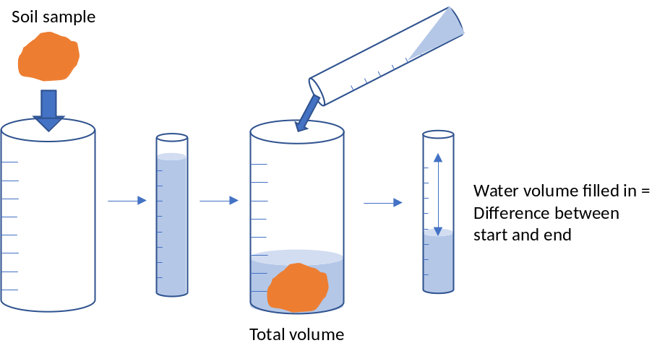

- Organic content – Jar experiment:
- Fill the remaining soil sample into a mason jar (leave one spoonful aside for advanced analyses).
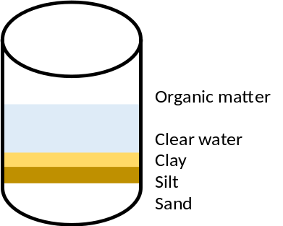
- Then, pour water into the jar, shake for 3 minutes, and let the soil particles settle for 1–2 days.
- Observe the layers that form: The organic matter floats on top of the water (dark color). At the bottom, you can see the mineral particles: the lowest is sand, followed by silt, and then clay (see the picture).
- Measure the height of each layer with a ruler.
- Carefully remove the organic layer on top of the water, dry it, and weigh it separately
- Finally, dry the rest of the sample in the jar and weigh it

- Advanced soil parameter analyses:
- Put one spoonful of soil in about 50 mL of distilled water, stir for 1 minute
- Filter the mixture through a coffee filter into a clean beaker
- Use test strips to measure various parameters such as pH, nitrates, and hardness.

Soil CARBON Storage - STUDENT WORK SHEET
How to calculate the carbon content of floodplain soils
- Soil moisture content SM (%):
Subtract the dry weight of the sample from the initial wet weight to get the water weight. Then, divide the water weight by the initial wet weight and multiply by 100 to get the soil moisture content (in %).
Soil moisture SM (%) = (Wet weight – dry weight) / wet weight x 100

- Soil bulk density BD (g/dm³):
Divide the dry weight (g) by the sample volume (dm³).
Soil bulk density BD (g/dm³) = Dry weight (g) / sample volume (dm³)

- Soil type – Jar experiment:
In addition to the estimation in the field, you can use the data from the jar experiment to determine the soil type. Calculate the percentage of each soil component by dividing the height of each layer by the total height and multiplying by 100:
Height of sand layer / Total height of soil layers x 100 = % sand.
Height of silt / Total height of soil layers x 100 = % silt.
Height of clay / Total height of soil layers x 100 = % clay.

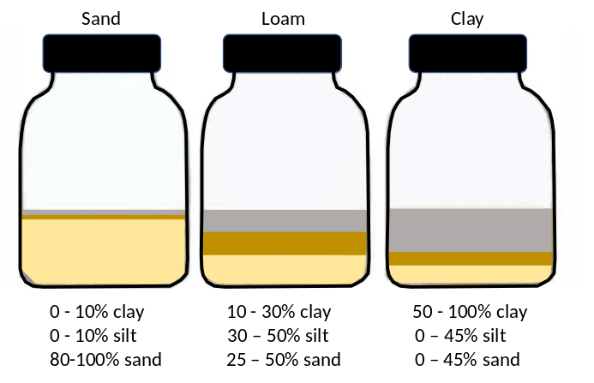
- Organic carbon content OC (%) – Jar experiment:
- Calculate the total dry weight TW of the sample in the jar by adding the dry weight of the organic matter to the dry weight of the rest of the sample.
Total dry weight TW (g) = Dry weight OM (g) + Dry weight rest of sample (g)
- Divide the dry weight of the organic matter by 2 to get the amount of organic carbon OC. Most organic matter has a carbon content of around 50%.
Organic carbon OC (g) = Dry weight OM (g) / 2
- Finally, divide the organic carbon OC by the total dry weight TW
Percentage of organic carbon OC = dry weight OC / total dry weight TW

- Soil organic carbon storage:
Multiply the soil bulk density (BD) by the percentage of organic carbon OC to get the organic carbon concentration (g/dm³).
Organic carbon concentration OCC (g/dm³) =
Soil bulk density BD (g/dm³) x Percentage of Organic carbon OC
Now, calculate the average organic carbon storage per square meter OC_{storage} (kg/m²) by multiplying the carbon concentration by the depth of the organic layer at your site (m).
OC_{storage} (kg/m²) =
Organic carbon concentration OCC (g/dm³) x Depth (m)

Note: To keep units consistent, remember that converting from g/dm³ to g/m³ involves multiplying by 1000, and converting grams to kilograms involves dividing by 1000. These factors cancel each other out in the final formula.

CARBON Storage in soils
STUDENT WORK SHEET “EXPLORE – PEATLAND Soils”
Soil organic carbon in peatlands
- Field work
Materials needed: 2 m steel rods: If you use threaded rods (M8 x 1000mm) and connecting nuts (M8), you can extend the rod as long as needed (see picture); colored tape, shovel, plastic bags (1 L), measuring stick
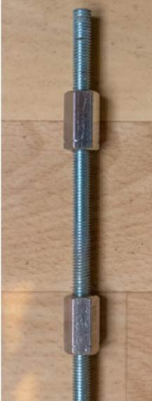
- Determine the GPS position of the sampling area and take a picture with your smartphone.
- Peat Depth: Push the rods (see picture) into the peat until you feel a strong resistance. Mark the top of the peat on the rod with a tape, then remove the rod and measure the length (this is the depth of the peat).
- Peat Degradation: Dig about 10 cm into the peat and take a sample about the size of a golf ball. Squeeze it tightly in your fist. Check the H0 to H10 value on the “von Post scale” below.
- Take a handful of the top peat layer, put it in a zipper bag, and label it. Transport the sample to the school for further indoor analyses.

- Indoor analyses
Materials needed: 2 measuring cylinders, Oven or dry place, Aluminum foil (for oven drying), Balance (scale)
- Split the peat sample into two equal halves: Half A for sample volume measurement, Half B for dry weight/moisture content
- Sample volume:
- Place Half A into a measuring cylinder.
- Fill a second measuring cylinder with water and note the starting water volume.
- Now, pour water from the second cylinder into the first until the peat is fully covered.
- Record the volume of water added and the total volume (soil + water).
- Subtract the water volume from the total volume to estimate the sample volume.

Important: You have probably measured the volume in liters or milliliters. Convert volumes into cubic decimeters (dm³) for calculations (1 L = 1 dm³).

- Dry weight/Moisture content:
- Weigh Half B of the sample
- Place Half B in the oven wrapped in aluminum foil (or in another dry place).
- Weigh again after drying.
- Use the difference between wet weight and dry weight to calculate moisture content.

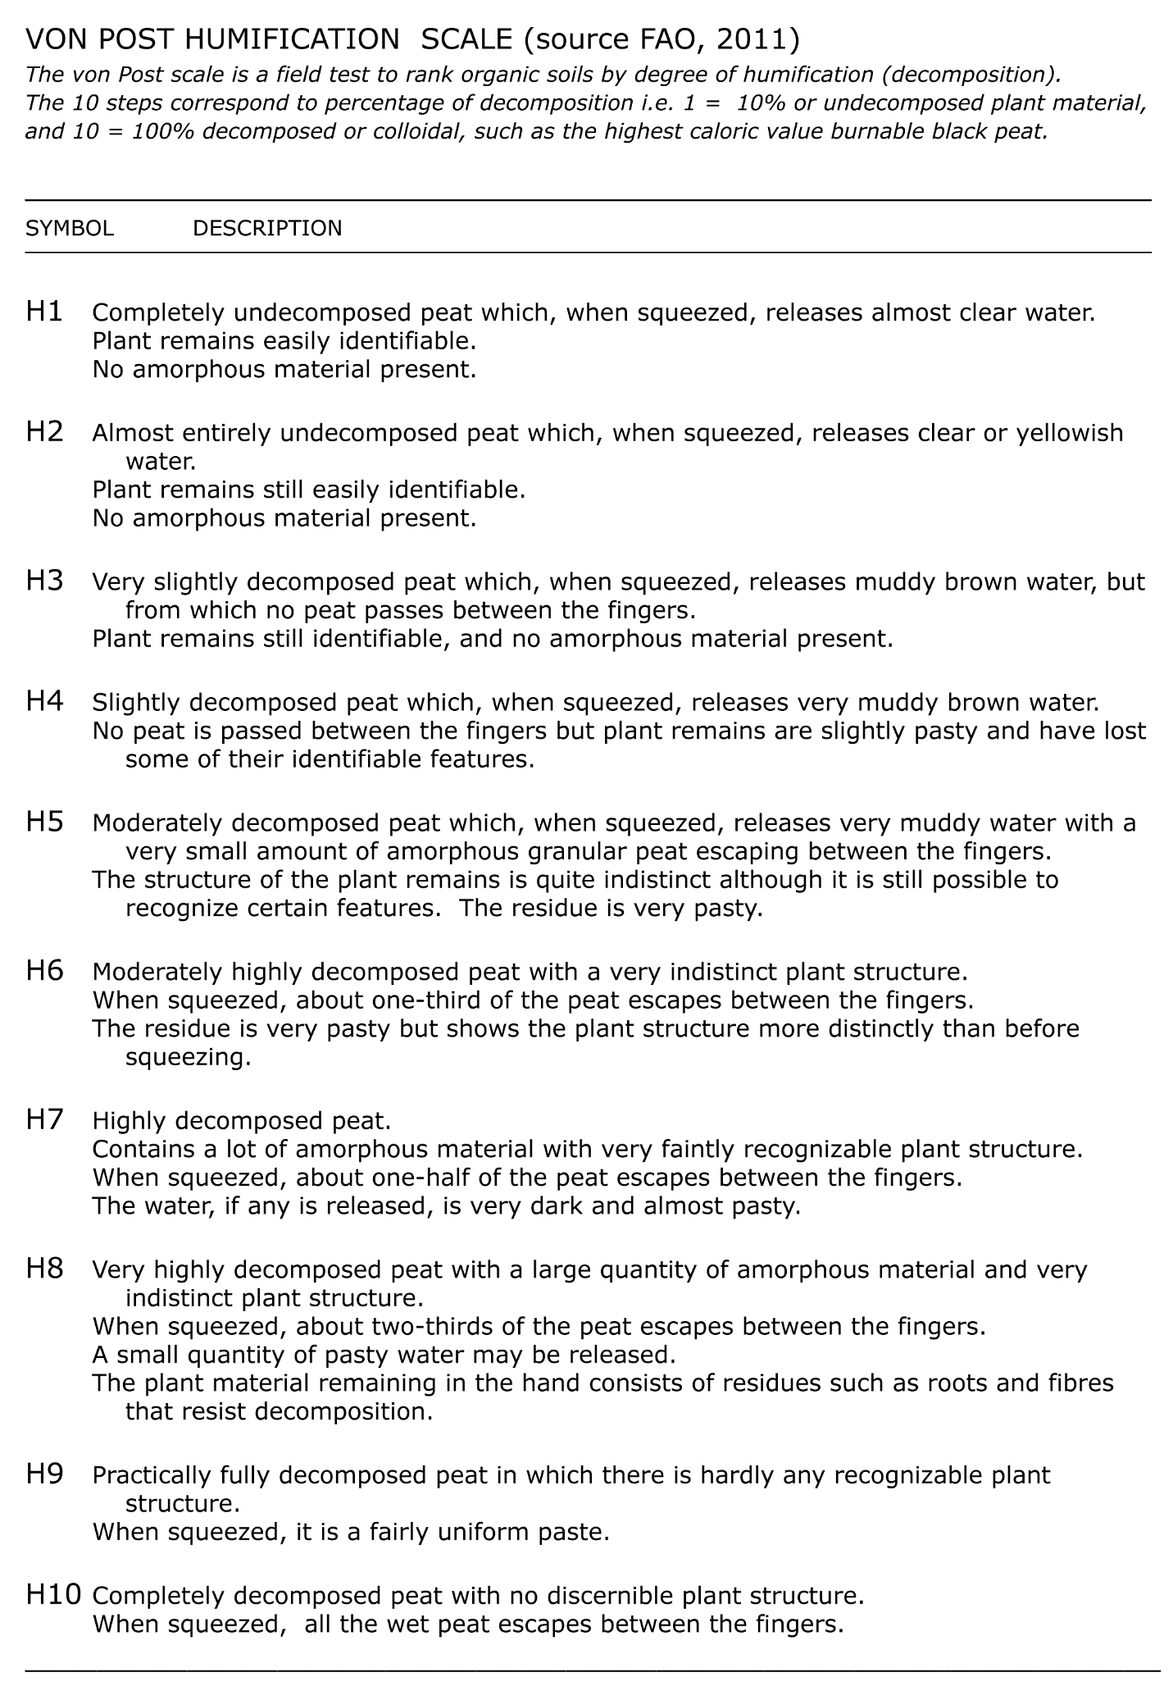
Soil CARBON Storage - STUDENT WORK SHEET
How to calculate the carbon content of peatland soils
- Soil moisture content SM (%):
Subtract the dry weight of the sample from the initial wet weight to get the water weight. Then, divide the water weight by the initial wet weight and multiply by 100 to get the soil moisture content (in %).
Soil moisture content SM (%) = (Wet weight – dry weight) / wet weight x 100

- Organic carbon amount (g):
The organic carbon amount is approximately 50% of the dry weight (g). Thus, divide the dry weight by 2.
Organic carbon amount (g) = Dry weight (g) / 2

- Soil organic carbon storage:
Divide the organic carbon amount (g) by the sample volume (L). The result is the organic carbon content in g/dm³.
Organic carbon content OC (g/dm³) =
Organic carbon amount (g) / sample volume (L)
Now, calculate the average organic carbon storage per square meter OC_{storage} (kg/m²) by multiplying the carbon concentration by the peat depth (m).
Organic carbon storage per square meter OC_{storage} (kg/m²) =
Organic carbon content OC (g/dm³) x Peat Depth (m)
Note:
To keep units consistent, remember that converting from g/dm³ to g/m³ involves multiplying by 1000, and converting grams to kilograms involves dividing by 1000. These factors cancel each other out in the final formula.

If you combine the activity with the tree identification explained in the “Carbon sequestration in floodplain forests” lesson , you can compare the indicator values of the trees regarding pH and nitrate with the actually measured values.
The percentage is given as a dimensionless fraction here. So, 20% = 0.2, 50% = 0.5, 100% = 1.

