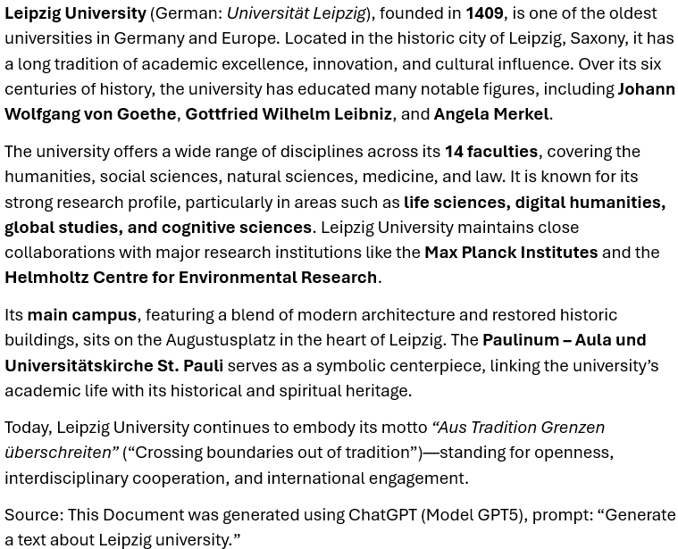

„Leipzig University (German: Universität Leipzig), in Leipzig in Saxony, Germany, is one of the world's oldest universities and the second-oldest university (by consecutive years of existence) in Germany. The university was founded on 2 December 1409 by Frederick I, Elector of Saxony and his brother William II, Margrave of Meissen, and originally comprised the four scholastic faculties. Since its inception, the university has engaged in teaching and research for over 600 years without interruption.
Famous alumni include Angela Merkel, Gottfried Wilhelm von Leibniz, Johann Wolfgang von Goethe, Leopold von Ranke, Friedrich Nietzsche, Robert Schumann, Richard Wagner, Tycho Brahe, Georgius Agricola. The university is associated with ten Nobel laureates, most recently with Svante Pääbo who won the Nobel Prize for Medicine in 2022.
History
The university was modelled on the University of Prague, from which the German-speaking faculty members withdrew to Leipzig after the Jan Hus crisis and the Decree of Kutná Hora. The Alma mater Lipsiensis opened in 1409, after it had been officially chartered by Pope Alexander V in his Bull of Acknowledgment on (9 September of that year). Its first rector was Johannes Otto von Münsterberg. From its foundation, the Paulinerkirche served as the university church. After the Reformation, the church and the monastery buildings were donated to the university in 1544. In order to secure independent and sustainable funding, the university was endowed with the lordship over nine villages east of Leipzig (university villages). It kept this status for nearly 400 years until land reforms were carried out in the 19th century.
Like many European universities, the University of Leipzig was structured into colleges (collegia) responsible for organising accommodation and collegiate lecturing. Among the colleges of Leipzig were the Small College, the Large College, the Red College (Rotes Kolleg, also known as the New College), the college of our Lady (Frauenkolleg) and the Pauliner-College (Pauliner Kolleg). There were also private residential halls (bursen, see English 'bursaries'). The colleges had jurisdiction over their members. The college structure was abandoned later[timeframe?] and today only the names survive.
During the first centuries, the university grew slowly and was a rather regional institution. This changed, however, during the 19th century when the university became a world-class institution of higher education and research.[citation needed] At the end of the 19th century, important scholars such as Bernhard Windscheid (one of the fathers of the German Civil Code) and Wilhelm Ostwald (viewed as a founder of modern physical chemistry) taught at Leipzig.

Formerly organized as a collegiate university, the Red College of Leipzig University was established in the 16th century.
Leipzig University was one of the first German universities to allow women to register as "guest students".[4] At its general assembly in 1873, the Allgemeiner Deutscher Frauenverein [de] thanked the University of Leipzig and Prague for allowing women to attend as guest students. This was the year that the first woman in Germany obtained her JD, Johanna von Evreinov.
During the decline and dissolution of the Ottoman Empire in the 19th and first decade of 20th century together with some other German universities Leipzig University turned into one of the centers of higher education for state administrations and elites of newly independent Balkan states (Romania, Greece, Bulgaria and Serbia) educating over 5,500 students from the region in 1859–1909 period.[5]
Until the beginning of the Second World War, Leipzig University attracted a number of renowned scholars and later Nobel Prize laureates, including Paul Ehrlich, Felix Bloch, Werner Heisenberg and Sin-Itiro Tomonaga. Many of the university's alumni became important scientists. “ Source: https://en.wikipedia.org/wiki/Leipzig_University (access 20th Oct 2025)

