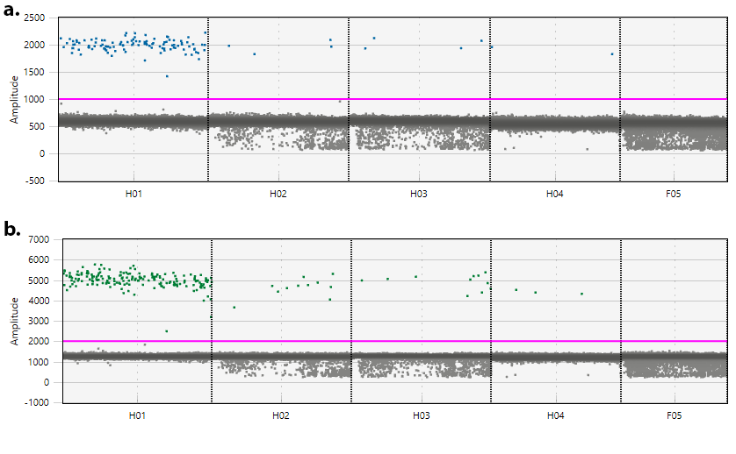
Supplementary Materials:
A
B
Figure 1. Positive samples containing plasmid DNA with copy numbers of 6 (H01), 0.6 (H02) , 0.3 (H03), 0.15 (H04) and 0.06 (F05) for both target genes. Blue (A), green (B) represent positive droplets for F. magna, G. truncatula respectively.
Assay | Positive Samples | Estimated Copy Number | qPCR Ct | ddPCR Accepted droplets | Positive droplets | ddPCR (copies/µL)* | Absolute Quantity**
F. magna | 5 | 6 | 29.1 | 16922 | 110 | 8,20 | 25
G. truncatula | 5 | 6 | 26.8 | 16922 | 184 | 13,75 | 42
F. magna | 6 | 0.6 | 32.8 | 15840 | 4 | 0,32 | 1
G. truncatula | 6 | 0.6 | 31 | 15840 | 12 | 0,95 | 3
F. magna | 7 | 0.3 | NA | 15867 | 4 | 0,32 | 1
G. truncatula | 7 | 0.3 | NA | 15867 | 11 | 0,87 | 2.6
F. magna | 8 | 0.15 | NA | 14721 | 2 | 0,17 | 0.5
G. truncatula | 8 | 0.15 | NA | 14721 | 3 | 0,26 | 0.8
F. magna | 9 | 0.06 | NA | 14141 | 0 | NA | NA
G. truncatula | 9 | 0.06 | NA | 14141 | 0 | NA | NA

Figure 2. Results from positive sample dilutions tests with ddPCR and qPCR. Estimated Copy Number reports the estimated number of plasmids containing target gene inserts per µL of sample.
* Numbers indicate copy numbers identified per µL of ddPCR reaction.
** Numbers indicate the copy numbers identified per µL of sample calculated by the formula below:
$$Absolute Quantity=\frac{ddPCR copy number ×Reaction Volume}{Sample Volume}$$

