Suppl. material 3
Figure S1. Optimal number of clusters (K) in STRUCTURE analysis.
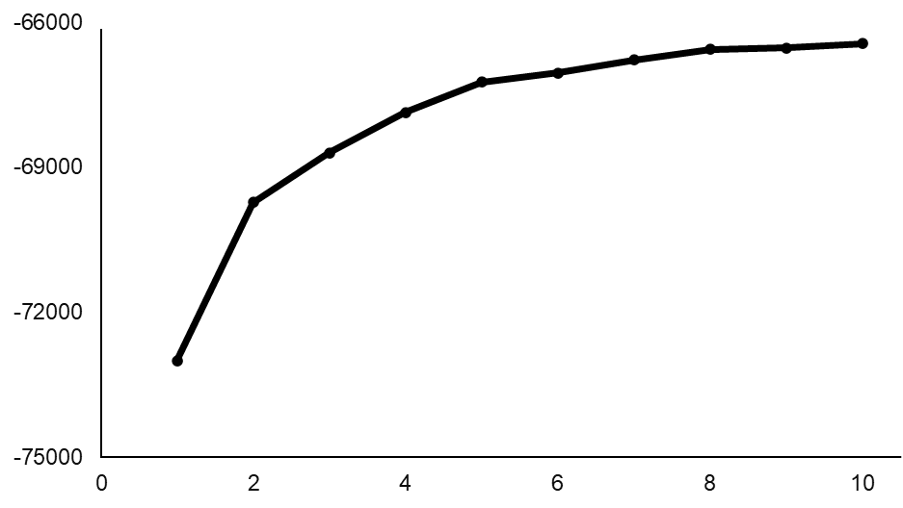

Figure S2. Mismatch distribution for wild samples based on 685 bp of mitochondrial COII gene.

Figure S3. Principal component analysis (PCA) plots based on 570 SNPs obtained via MIG-seq.
(a) PCA including all wild individuals.
(b) PCA excluding individuals from Okinawa and Kumejima Islands.
Color coding represents regional groups defined in STRUCTURE and COII analysis.
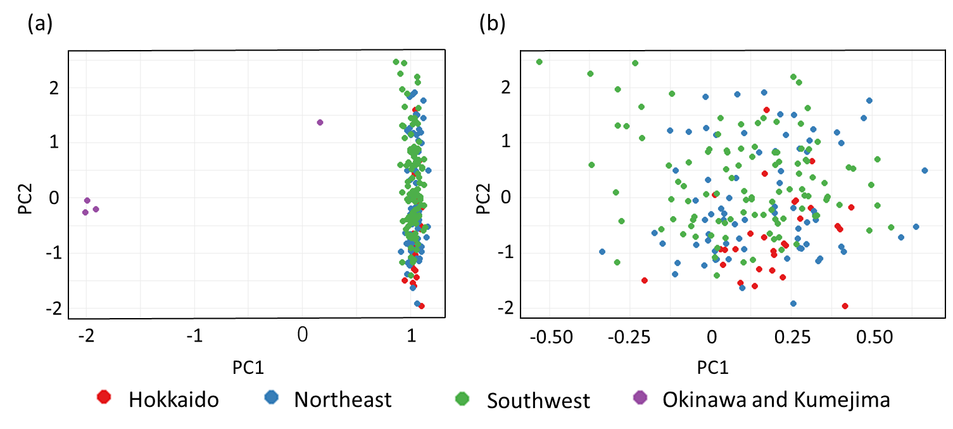

Figure S4. Results of STRUCTURE analysis for K values ranging from 2 to 5.
