Potential of the green seaweed Codium for human food production: from line seeding to biomass processing
E.-j. Malta*¹, D. Marín¹, T. Picò¹, P. Fajardo², M. Alonso², S. Scarfi³, M. Moussa³, M. Chiantore³ and M. Macías¹
¹⁾ Centro Tecnológico de Acuicultura de Andalucía (CTAQUA), Muelle Comercial S/N, 11500, El Puerto de Santa María, Spain. Presenter: e.malta@ctaqua.es
²⁾ ANFACO-CECOPESCA, Ctra. Colexio Universitario 16, 36310, Vigo, Spain
³⁾ Department of Earth, Environment and Life Sciences, University of Genova, 16132, Italy

Introduction
Seaweeds have a longstanding tradition in their use for human consumption in many Asian countries. In the western world, their use has long been limited to limited coastal areas and has been associated for a long time with episodes of hunger and war. This view has been changing drastically as the need for new prime matter for human food production has been growing. Seaweeds are now also in the Western world increasingly being considered as a more sustainable, high-quality food source.
Against this background, several R&D projects have been executed in the last 5 years, focusing on cultivation of seaweeds and their use in human food production, such as the Spanish INNOVALGA project (2020-2023) and the EU Horizon Europe project NOVAFODIES (2023-2026) that both aimed to stimulate diversification, efficiency, innovation, and upscaling of European micro- and macroalgae solution.
In this contribution, we will present an integral overview of a potential production chain based on the green seaweed Codium, from line-seeding to biomass composition and production of a food prototype. The genus Codium has a worldwide distribution and a traditional use in various countries both within and outside Europe, and various interesting functional properties. Its taste is generally considered subtle, reminiscent of crustaceans. It is therefore considered to be a promising ingredient for the food of the (near) future.

Material and Methods
Locally collected specimens of the species Codium taylorii were maintained in a climate room (20 °C) in plastic containers in fresh seawater (weekly renovation) at minimum light (< 20 μmol photons m⁻² s⁻¹) and under constant aeration. Biomass samples were analysed for their nutritional composition, antioxidant properties and antimicrobial properties. To optimize low-cost cultivation of Codium, seeding trials were carried out, studying the effects of temperature, irradiance, and substrate type for biomass seeding on lines. A fully factorial experiment has been carried out considering two light intensities (60 and 100 μmol photons m⁻² s⁻¹) and two temperatures (15 and 20 °C) and three substrate types (cotton, hemp and polypropylene ropes). Seeded lines were deployed in earthen ponds to study outgrowth. The seaweed was subjected to shelf-life trials in which fresh biomass was stored directly or in vacuum packaging in the refrigerator. Organoleptic properties and food microbial analyses were carried out at different time intervals to determine shelf-life. Finally, a food prototype product was developed in the form of fish-filled ravioli-type pasta. Freshly harvested algae were added to the pasta-dough in different recipe formulations and products were subjected to organoleptic and biosecurity tests.

Results and discussion
Freshly harvested Codium biomass can be maintained for more than 6 months with minimal maintenance effort as described. With respect to composition, compared to other macroalgae, C. taylorii had a relatively high water content (92% DW), whereas protein content was relatively low (8-10% DW). However, literature values for the species list values up to 18% and therefore claim to be high fibre and high protein biomass according EU regulations (EC Regulation No. 1924/2006). The percentage of essential amino acids for all samples was approximately 40% and generally favourable for human nutritional needs.
Mean antioxidant capacity of Codium was comparable to reported values of other green seaweeds and consistent across TEAC and ORAC test methods. No antimicrobial properties of the algae were detected were detected using the agar well diffusion method, however, watery extracts from Codium presented significant antimicrobial activity against the food pathogen Staphylococcus aureus.
With respect to the cultivation trials, successful seeding of the lines was obtained. Both temperature and substrate significantly affected appearance of Codium Forming Units (CFU) on lines, whereas irradiance was significant in second-order interactions. The highest number of CFUs (11 units/cm) occurred in the high-temperature, low-irradiance treatment for hemp yarn. It was concluded that substrate was the main factor determining fixation success, moderated by temperature and light interactions. Outgrowth in earthen ponds proved successful initially, although modifications had to me made to the seeding lines.
Shelf-life tests indicated limited storage time (1 week) of fresh Codium under refrigerated conditions, although vacuum packaging seemed to slightly prolong shelf life. Although counts of major food pathogens were well below legal limits, general count of aerobic bacteria was too high and organoleptic properties decreased drastically after 1 week. First pasta dough prototype products elaborated with Codium produced satisfactory results with respect to product structural and organoleptic qualities. The final product was slightly orange coloured, probably due to relatively high β-carotene contents of the Codium.
It is concluded that Codium shows considerable promise for cultivation as prime matter for human food ingredients with prospects of efficient cultivation. Future studies should concentrate on the outgrow phase. Regarding biomass processing, further studies on the effects of storage methods on nutritional qualities and alternative storage methods to ensure longer shelf life are required.
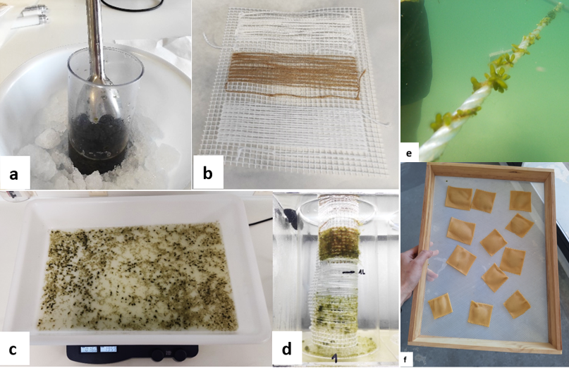
Figure 1: Shredding process (a), support with the different types of seeding yarns (b), shredded mixture sieved and ready to incubate the support with the yarns (c), aquarium with the yarns arranged cylindrically (d) seeded line deployed for outgrow (e), and ravioli-type pasta prototype product (f).

Acknowledgments/Funding
This study has been carried out as part of the projects INNOVALGA and NOVAFOODIES. INNOVALGA was funded within the framework of Plan de Recuperación, Transformación y Resiliencia (PRTR) of the Spanish Goverment. The NOVAFOODIES project has received funding from the European Union under Grant Agreement N° 101084180.

