Grant Agreement No: 101004761
AIDAinnova
Advancement and Innovation for Detectors at Accelerators
Horizon 2020 Research Infrastructures project AIDAINNOVA

deliverable report

Report of beam tests of irradiated radiation-hard DMAPS

Deliverable: D5.4
Document identifier: | AIDAinnova-D5.4
Due date of deliverable: | End of Month 46 (July 2025)
Report release date: | 15/07/2025
Work package: | WP5: Depleted Monolithic Active Pixel Sensors
Lead beneficiary: | CERN
Document status: | Final

Abstract:
This deliverable report summarizes the beam tests studies of Depleted Monolithic Active Pixel Sensors (DMAPS) prototypes, which primarily target excellent radiation tolerance (radiation-hardness), carried out within the project. Each study resulted in one or more publications highlighted in this report.

AIDAinnova Consortium, 2023
For more information on AIDAinnova, its partners and contributors please see http://aidainnova.web.cern.ch/

The Advancement and Innovation for Detectors at Accelerators (AIDAinnova) project has received funding from the European Union’s Horizon 2020 Research and Innovation programme under Grant Agreement no. 101004761. AIDAinnova began in April 2021 and will run for 4 years.

Delivery Slip
 | Name | Partner | Date
Authored by | F. Huegging  S. Grinstein | Ubonn, IFAE | 25/04/2024
Edited by | Rebecca Pragassa | CERN | 19/08/2025
Reviewed by | Daniela Bortoletto [Deputy Scientific coordinator] | UOXF | 20/08/2025
Approved by | Daniela Bortoletto [Deputy Scientific coordinator]  Steering Committee | UOXF | 29/08/2025

TABLE OF CONTENTS
1 Introduction 4
2 Radiation hard DMAPS Prototype Development 5
3 Prototypes IN TJ 180 NM (TJ-MONOPIX2 AND TJ-MALTA2) 5
5 PROTOTYPE RD50-MPW2, 3 AND 4 IN 150 NM TECHNOLOGY 12
6 CONCLUSIONS 13
6 REFERENCES 15

Executive summary
The production of several Depleted Monolithic Active Pixel Sensors (DMAPS) using CMOS technologies that primarily target excellent high radiation tolerance (radiation-hardness) have been successfully carried out and included in the previous AIDAinnova Deliverable report D5.3 [1]. This report presents the characterization of these prototypes with particle beams, some of which resulted in publications (highlighted in this report).

The TJ-Monopix2 [2] and the TJ-MALTA2 [3] are full size, mature devices, that were fully characterized within the framework of the AIDAinnova WP5 activities. The very encouraging results obtained before and after irradiation are summarized below. The LF-Monopix2 [4, 5].

These activities represent significant progress in advancing Monolithic DMAPS detectors towards their application in the next generation of High Energy Physics experiments.

Introduction
Depleted Monolithic Active Pixel Detectors (DMAPS) are a key technology within the AIDAinnova project. They represent the most promising new direction of pixel detector development and are a fundamental approach for present and planned accelerator experiments.
The WP5 activities follow two main lines, one focusing on high granularity devices, targeting above all high position resolution, and the other targeting radiation hardness. The production and initial testing of several radiation-hard DMAPS prototypes are documented in the AIDAinnova Milestone report MS20, and the test beam activities of un-irradiated prototypes is documented in the AIDAinnova Milestone report MS21. The current Deliverable Report concentrates on the beam tests of irradiated prototypes of DMAPS devices designed for enhanced radiation hardness. This Report includes the characterization of the following prototype devices:

- TJ-MALTA2 sensors in 180 nm CMOS technology, a mature large-size prototype implementing a full readout architecture.
- TJ-Monopix2 sensors in 180 nm CMOS technology, a mature large-size prototype implementing a different full readout architecture.
- LF-Monopix2 sensors in 150 nm technology, a mature large-size prototype implementing a full readout architecture similar to TJ-Monopix2.
- RD50-MPW2/3/4 in 150 nm technology, a more recent development and more exploratory endeavour.

Each section below summarizes the main results of these efforts, followed by conclusions and outlook.

Radiation hard DMAPS Prototype Development

The development of Depleted Monolithic Active Pixel sensors has followed so far essentially two generally distinct design approaches (Fig. 2.1): (a) large electrode design and (b) small electrode design. Within AIDAinnova approach (a) is pursued primarily for high radiation hardness, while approach (b) targets high granularity, i.e. small pixels, low-noise and low-power operation, albeit with good radiation tolerance. Development of designs (a) is the theme of this report.
The large electrode design benefits charge collection, and is, in principle, intrinsically more radiation-hard than small electrode designs. This feature is critical for specific applications, particularly in the inner layers of tracking detectors at hadron collider experiments. On the downside, large electrodes result in a larger capacitance at the input of the pre-amplifiers, resulting in larger noise and power consumption and slower timing performance. Therefore, the development focuses on achieving full charge collection after irradiation while maintaining a large signal-to-noise ratio to ensure high hit-detection efficiency.
However, during the development it turned out that the small electrode design also showed a quite remarkable radiation hardness. For this reason, we included results from irradiated devices of this development line as well in this report.

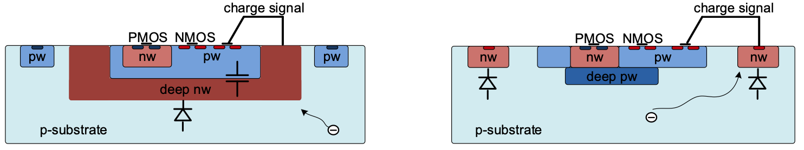
Fig. 2.1 Two approaches for DMAPS: (a) large electrode cell design, (b) small electrode cell design.

Prototypes IN TJ 180 NM (TJ-MONOPIX2 AND TJ-MALTA2)

The small charge-collection electrode offers low noise and low power consumption due to the resulting small capacitance at the amplifier input. On the other hand, charge collection (signal) is more challenging, particularly under operating conditions that cause radiation damage to the structures, as is the case at the LHC. Development efforts therefore focus on achieving radiation-tolerant full charge collection and large signal-to-noise ratio for high hit-detection efficiency.
The two large area chips TJ-MALTA2 (1x2 cm²) and TJ-Monopix2 (2x2 cm²) are developed in 180 nm technology offered by Tower Semiconductor (Israel) and have common front-ends (charge collecting structure and readout amplifier). These chips are part of successive iterations in the TJ-Monopix (1 → 2) and TJ-MALTA (1 → 2 → 3) design lines. Both chips are fabricated on a common reticule. The difference rests in the architecture of the pixel readout: while TJ-Monopix1/2 employs an established column-drain-type readout architecture, TJ-MALTA1/2/3 features a challenging low-power asynchronous readout needing GHz synchronization. The otherwise very successful production of the Monopix1/MALTA1 prototypes showed an efficiency drop in pixel corners after irradiation which was intensively studied by interim prototyping (miniMALTA) to cure this problem.

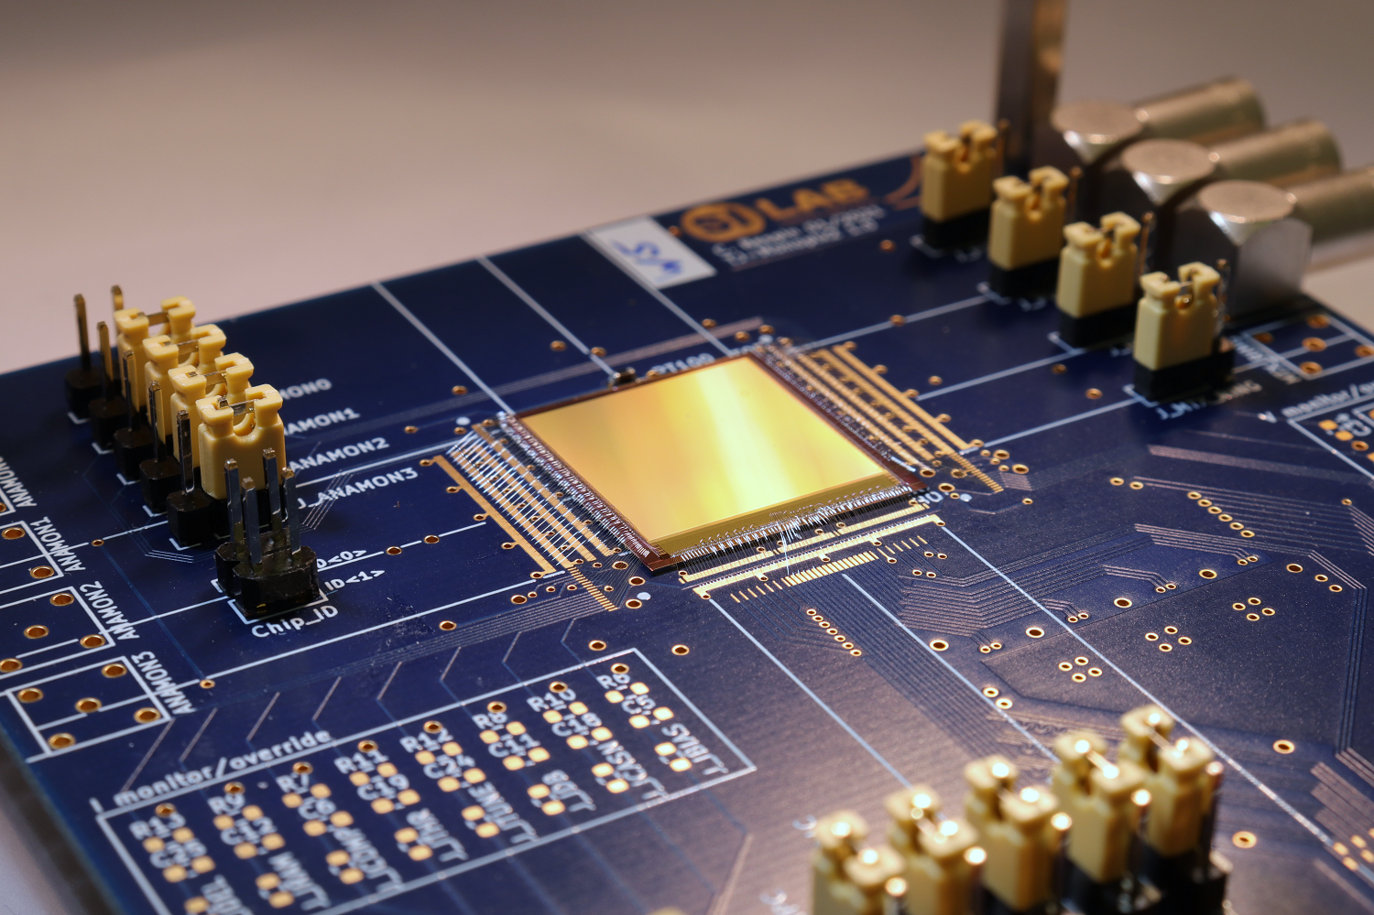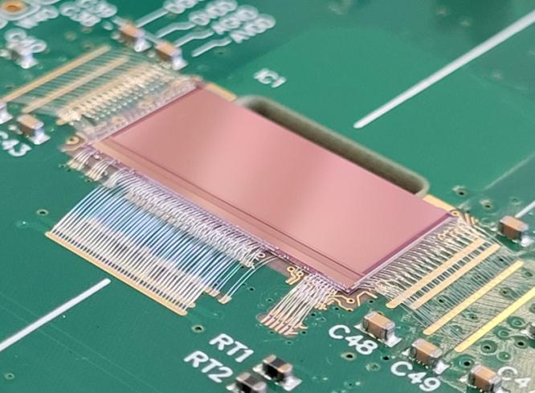
Fig. 3.1: Photographs of successfully produced TJ-Monopix2 (left) and TJ-MALTA2 (right).

The correction of this efficiency drop was the focus of version 2 of both chips. The measures implemented were:
- reshaping the charge collection path by increasing the lateral electric field for better charge collection;
- improving the first stage of the readout electronics for lower noise (primarily suppression of RTS noise) and lower threshold operation;
- increasing the depletion depth by employing Czochralski (Cz) material as wafer substrate instead of epitaxial Si.

The TJ-Monopix2 and MALTA2 chips were successfully delivered in 2021, and results were presented in D5.1 [1]. The measures were successful and solved the efficiency problem observed in the predecessor versions. Results on their radiation tolerance as demonstrated in beam tests and laboratory measurements are scope of this report.

3.1 TJ-MALTA2 BeAM TEST resulTs

Characterization of TJ-MALTA2 samples was carried out in dedicated particle beam tests campaigns at the Super Proton Synchrotron (SPS) at CERN between 2021 and 2024, using a 180 GeV hadron beam. A MALTA telescope [4] comprised of six tracking planes, and a cold box to operate devices under test in a dry environment at cold temperatures (-20 ºC) was used. Tracks were reconstructed from particle hit deposits on the planes, and their trajectory interpolated into the device under test.
TJ-MALTA2 was produced with several modified processes: an extra deep p-well (XDPW) and gap in the n-layer (NGAP), with different doping concentrations of the n-layer, identified by low, high (H-dop), and very high (V-dop) doping concentrations, and in two different substrates, epitaxial (epi), and Czochralski (Cz) high-resistivity p-type silicon. Samples were operated at lowest possible threshold settings.
TJ-MALTA2 Cz samples with XDPW modifications and high doping n-layer thinned to 100 μm with backside metallisation, and irradiated with reactor neutrons uniformly to 1, 2, and 3×10¹⁵ 1 MeV n_{eq}/cm² at the TRIGA Mark II reactor in Ljubljana, were evaluated [8]. The average cluster size was observed to increase as a function of bias voltage, as shown in figure 3.1.1 (left), consistent with enhanced charge collection indicating an increase of the active depth of bulk. This observation is confirmed by other measurements. Radiation damage is visible for fluences above 1×10¹⁵ 1 MeV n_{eq}/cm². However, hit detection efficiency remains above 95% for samples irradiated to 2×10¹⁵ 1 MeV n_{eq}/cm², as shown in Figure 3.1.1 (right).

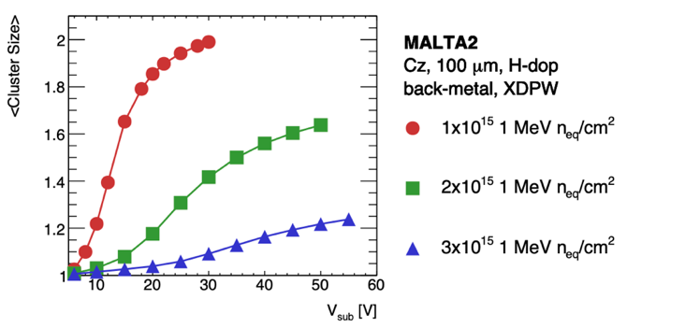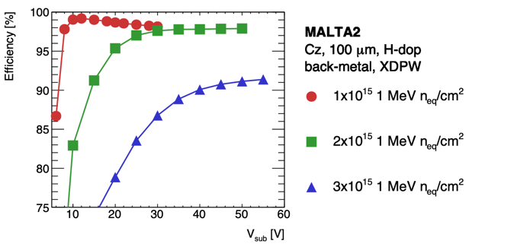
Fig 3.1.1 Average cluster size (left) and for TJ-MALTA2 as a function of substrate voltage.

Another important characterization parameter is the time of arrival of the signal, as shown in figure 3.1.2 (left). The difference between the mean arrival time of a hit in the pixel corner and the pixel centre is less than 5 ns in the case of a non-irradiated sample and remains very similar after irradiation to 1×10¹⁵ 1 MeV n_{eq}/cm². However, this difference increases by more than a factor of three, reaching around 17 ns, for samples irradiated to 3×10¹⁵ 1 MeV n_{eq}/cm². The same parameter is shown in Figure 3.1.2 (right), comparing the high doping with the very high doping. An increase in doping concentration leads to a reduction in the time of arrival, partially compensating for radiation damage. The time resolution expressed as the RMS of the time of arrival distribution, is shown in Figure 3.1.3. The results show that for all samples the RMS decreases as the bias voltage is increased. As the substrate voltage and the depleted area increase, a sharper signal pulse is generated due to a greater amount of collected charge. This is consistent with a faster signal with higher amplitude and reduced tails.

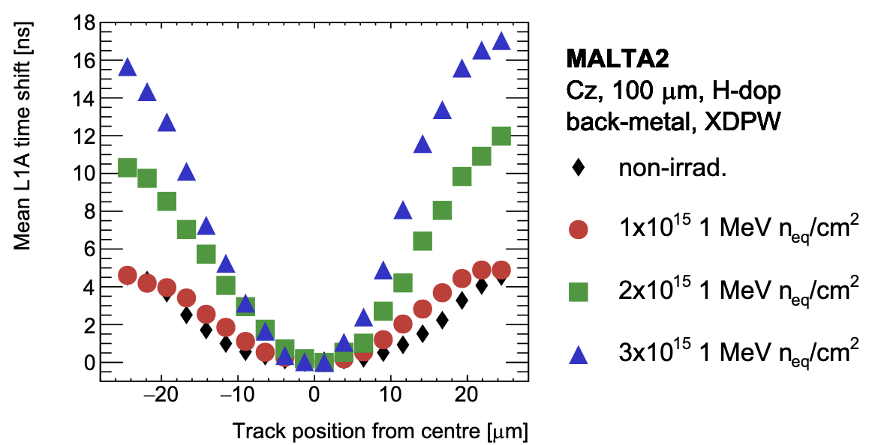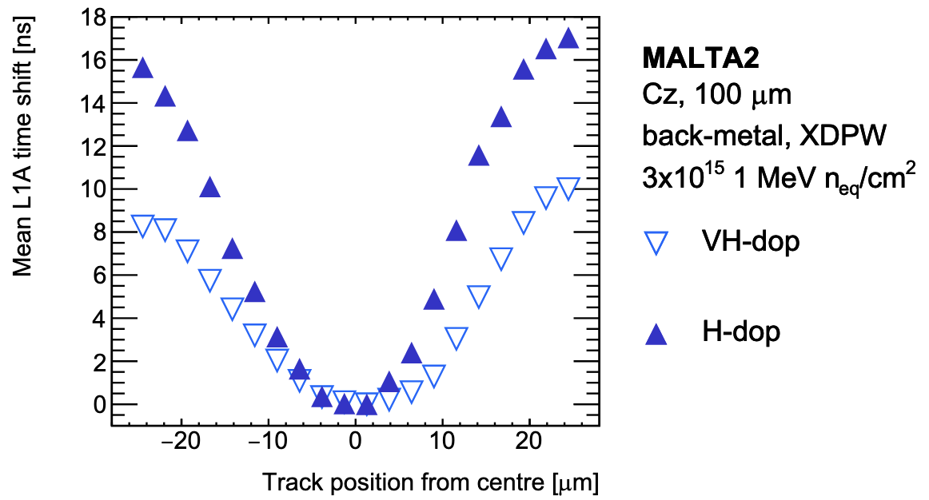
Fig 3.1.2 Relative shift of the mean time of arrival for H-dop TJ-MALTA2 samples (left) and comparison between H-dop and VH-dop as a function of track position to the centre of the pixel.

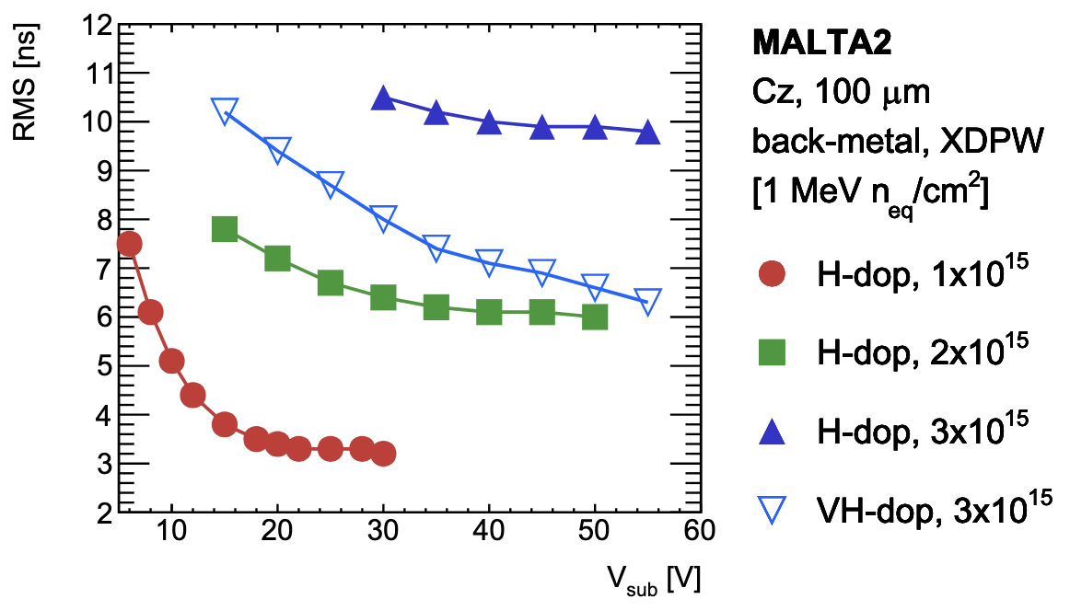
Fig 3.1.3 RMS of the time of arrival for TJ-MALTA2 samples as a function of substrate voltage.

3.2 TJ-Monopix2 BeAM TEST resulTs

Irradiated TJ-Monopix2 chips are available at 5×10¹⁴ n_{eq}/cm² and 1×10¹⁵n_{eq}/cm² NIEL fluence. All chips were uniformly irradiated at the Bonn isochronous cyclotron with 14 MeV protons. Initial laboratory characterization was conducted at -10 °C and demonstrated full functionality at both irradiation levels. Typical thresholds of around 250 e⁻ were achievable across all fluences, while the equivalent noise charge (ENC) increased from around 6 e⁻ before irradiation to more than 13 e⁻ after irradiation. Beam tests were performed at the DESY electron test beam facility. Measurements for variable substrate biasing voltages were conducted to investigate the compensation of the damage to the silicon bulk by increasing the sensitive area. Figure 3.2.1 (left) shows the hit-detection efficiency of TJ-Monopix2 as a function of the substrate voltage for both fluences.

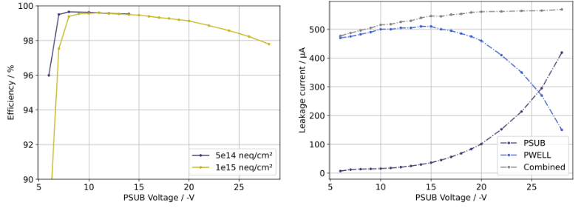
Figure 3.2.1: (left) Hit-detection efficiency of TJ-Monopix2 for different substrate voltages; (right) contributions of the leakage current for different substrate voltages.

The drop in efficiency towards substrate voltages larger than -15 V is caused by a shift in the baseline of the amplifier input which effectively increases the chip threshold due to a change in leakage currents. Figure 3.2.1 (right) shows how the leakage current dominantly flows through PWELL for lower substrate voltages, while the current through the substrate (PSUB) becomes dominant for higher substrate voltages. Re-tuning may potentially compensate for this effect but this has not been tested yet.

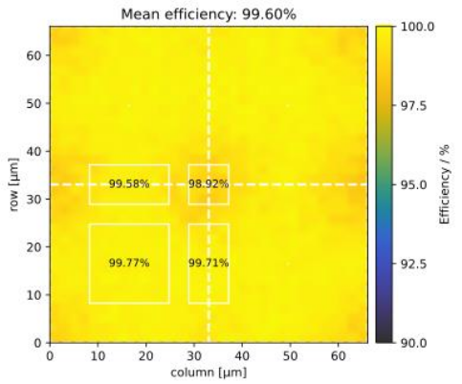
Figure 3.2.2: Hit-detection efficiency of TJ-Monopix2 after irradiation to 1×10¹⁵ n_{eq}/cm² projected onto a 2x2 pixel matrix for in-pixel studies.

At the best performing substrate voltage of -11 V, after irradiation to the highest fluence, a mean hit-detection efficiency of 99.6 % was achieved. Figure 3.2.2 shows the hit-detection efficiency of TJ- Monopix2 after irradiation to 1×10¹⁵ n_{eq}/cm², projected onto a 2x2 pixel matrix for in-pixel studies. Despite the long drift distances, an efficiency close to 99% is stills achieve in the pixel corners at the highest fluence.

4 LF-Monopix2 BeAM TEST resulTs

The Monopix chip line also includes prototypes in the LFoundry 150 nm technologies. LF-Monopix2 chip has a size of 1 × 2 cm² and a pixel pitch of 50 × 150 µm² (see Fig. 4.1). The pixel matrix occupies about 82% of the chip area, while the remaining area is taken up by guard rings, decoupling capacitors and peripheral circuitry at the top and bottom of the chip. Due to the smaller pixel size and hence reduced capacitance (250 − 300 fF) an improved signal-to-noise ratio and a better timing performance are expected. The large electrode approach should also result in excellent charge collection after irradiation. The matrix is divided into three main sub-matrices, including different charge-sensitive amplifier (CSA) designs. One of the sub-matrices is further subdivided into four regions with different CSA feedback capacitances (1.5 fF or 5.0 fF), local threshold tuning schemes (unidirectional or bidirectional) and pixel-level logic. The pixel design of LF-Monopix2 features rounded corners for reduction of the electric field on the edges, which, together with an optimized guard-ring design, improve the breakdown behaviour of the sensor. Wafers have successfully been thinned to 100 µm and backside processed.

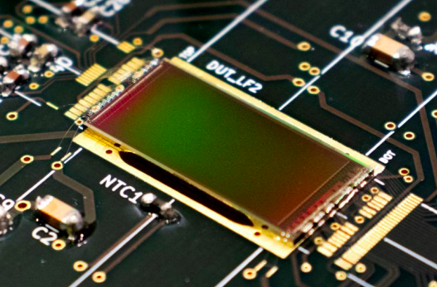
Figure 4.1: Photograph of the LF-Monopix2 mounted on a readout board.

Throughout the AIDAinnova funding period, 100 µm thin, backside-processed LF-Monopix2 chips were measured at multiple NIEL fluences ranging from 1×10¹⁵ to 5×10¹⁵ n_{eq}/cm² from proton- and neutron irradiation as well as up to 400 MRad TID from X-ray irradiation. All proton irradiated devices were uniformly irradiated at the Bonn isochronous cyclotron with 14 MeV protons except for the 2×10¹⁵ n_{eq}/cm² sample which were uniformly irradiated at MC40 cyclotron at Birmingham using 27 MeV protons. The neutron irradiated devices were all irradiated at the TRIGA Mark II reactor in Ljubljana using reactor neutrons. Initial laboratory measurements at -20 °C confirmed full functionality of all devices after irradiation. Figure 4.2 shows the I-V characteristics of LF-Monopix2 comparing neutron and proton irradiation at NIEL fluences of 1×10¹⁵ and 2×10¹⁵ n_{eq}/cm² [6]. While the leakage currents at 2×10¹⁵ n_{eq}/cm² agree nicely between proton and neutron irradiated samples, a deviation is observed at 1×10¹⁵ n_{eq}/cm². This may be due to deviations in the actual fluences within the errors of the respective irradiation site or because the neutron-irradiated chip suffered peripheral damage, resulting in additional leakage current. A detailed investigation is still pending.

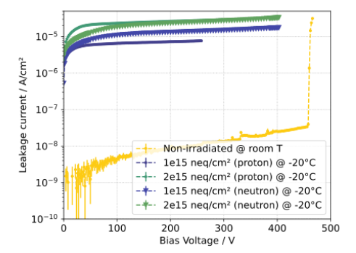
Figure 4.2: I-V characteristics of LF-Monopix2 comparing neutron and proton irradiated samples at multiple NIEL fluences, from [6].

All irradiated samples were measured in beam tests at the DESY electron test beam facility. Figure 4.3 (left) shows the depletion depth extracted from the Landau-shaped charge spectrum for different bias voltages across all NIEL fluences. Figure 4.3 (right) shows the corresponding hit-detection efficiencies for each data point, including the threshold settings at which the samples were operated. Full depletion of the sensitive area was still reachable after irradiation to 3×10¹⁵ n_{eq}/cm² due to the large breakdown voltage of the chip. This translated into an excellent hit-detection efficiency of >99% at this fluence. At 5×10¹⁵ n_{eq}/cm² NIEL fluence, a bias of 400 V was no longer sufficient to fully deplete the sensor. Nevertheless, the sample achieved a hit-detection efficiency close to 98%. Careful re-tuning allowed to lower the threshold of this sample to 2.2 ke⁻, which improved the hit-detection efficiency to nearly 99%. The depletion depth of the neutron-irradiated samples deviates from that of proton irradiated samples at the same fluence. This difference is expected as the bulk damage of neutrons and protons results in different mixtures of point-like and cluster defects, that affect charge collection efficiency. Still, LF-Monopix2 can be fully depleted after 2×10¹⁵ n_{eq}/cm² neutron irradiation and reaches hit-detection efficiencies >99%. The decrease in efficiency towards larger bias voltages is due to a larger number of noisy pixels compared to proton-irradiated samples, that spam the readout.

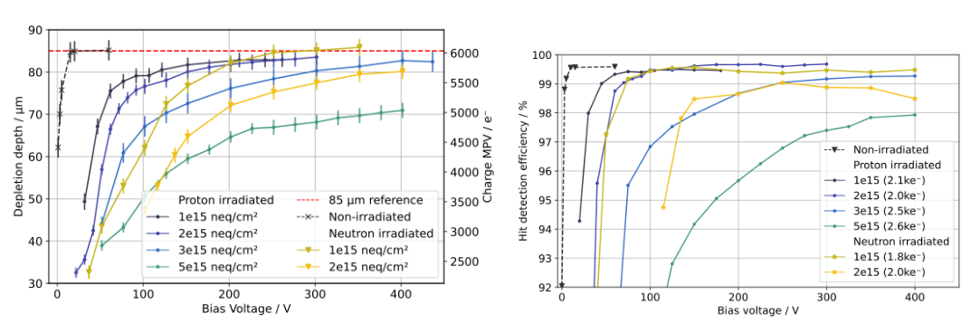
Figure 4.3: (left) Depletion depth of irradiated LF-Monopix2 samples across all available fluences at different bias voltages; (right) Hit-detection efficiency of irradiated LF-Monopix2 samples across all available fluences at different bias voltages, from [6].

In addition to the NIEL irradiated samples, the 400 Mrad X-ray irradiated sample was measured in beam to have a hit-detection efficiency of 99.43% at a measured threshold of 1.9 ke⁻. Figure 4.4 shows the efficiency projected into a single-pixel map for in-pixel studies. While the performance is very uniform across the pixel, a drop to 98.9% is visible in the pixel corners [6]. Since X-ray irradiation does not damage the silicon bulk and, thus, the charge collection, this observation is more likely the result of a change in the charge calibration. Consequently, the actual threshold is expected to be higher than the measured one. However, this still needs to be confirmed in lab.

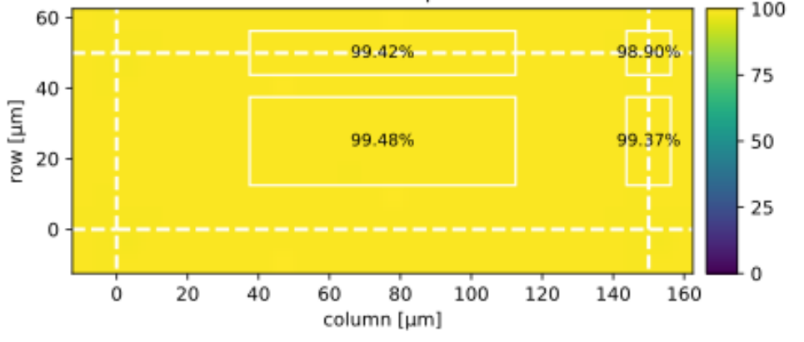

Figure 4.4: Hit-detection efficiency of the 400 Mrad X-ray irradiated LF-Monopix2 sample projected onto a single-pixel map.

5 PROTOTYPE RD50-MPW2, 3 AND 4 IN 150 NM TECHNOLOGY

Another effort to develop radiation hard devices was launched after the LF-Monopix approach. The RD50-MPW2 chip [5], fabricated in the framework of AIDAinnova, followed the MPW1 chip which suffered from a large leakage current. To better understand the high current, the MPW2 chip implements a smaller, very simple, chip structure with a guard ring frame at the edge. The chip avoided certain post-processing filling layers involving conductive material. The chip consists of an 8x 8 matrix of 60 µm x 60 µm pixels with analogue readout only (see Fig. 5.1). The RD50-MPW2 has several design limitations, such as the small number of rows and columns in the pixel matrix, the lack of digital readout electronics to identify events and a very simple peripheral readout that makes certain types of measurements too slow or even impossible. To address these shortcomings, the RD50-MPW3 was developed. MPW3 extends the number of pixels in the matrix (64 columns x 64 rows), integrates digital readout electronics based on the column-drain architecture directly into the pixel area, and includes optimized peripheral readout electronics for effective pixel configuration. The MPW3 chip is currently being tested and tests after irradiation are expected later this year. The MPW3 was also found to suffer from high noise due to cross-coupling of the digital periphery to the analogue part of the pixel matrix.
These problems were finally addressed in the RD50-MPW4 submission, which incorporated several bug fixes, including an improved guard-ring design and, most importantly, a complete redesign of the digital readout periphery. Submitted in 2023, the first prototype tests—reported previously—showed promising results. Tests with non-irradiated samples achieved hit detection efficiencies exceeding 99.9 % and a spatial resolution of about 16 μm.

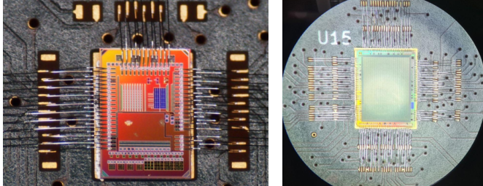
​​
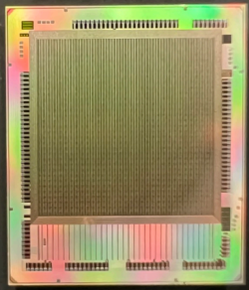

Figure 5.1: Photographs of produced RD50-MPW2 (left) and RD50-MPW3 (middle) chips mounted on boards for testing as well as MPW4 bare chip (right).

For irradiated samples, the RD50-MPW4 sensors were subjected to uniform neutron irradiation up to fluences of 1×10¹⁶ n_{eq}​/cm² at the TRIGA Mark II reactor in Ljubljana, with successful tests so far conducted on samples irradiated up to 1×10¹⁵ n_{eq}​/cm² [7]. The test-beam campaigns demonstrated clear improvements in sensor robustness compared to previous prototypes in high-radiation environments. Although the initial efficiency might appear low at lower bias voltages after irradiation, the results highlight the ability of these HV-CMOS devices to restore high hit detection efficiency by increasing the applied bias voltage. Specifically, samples irradiated to 1×10¹⁵ n_{eq​/}cm² achieved efficiencies exceeding 99% when biased at approximately 580 V, confirming their operational capability under high radiation levels. These findings indicate that this latest prototype represents a significant advancement in radiation hardness.

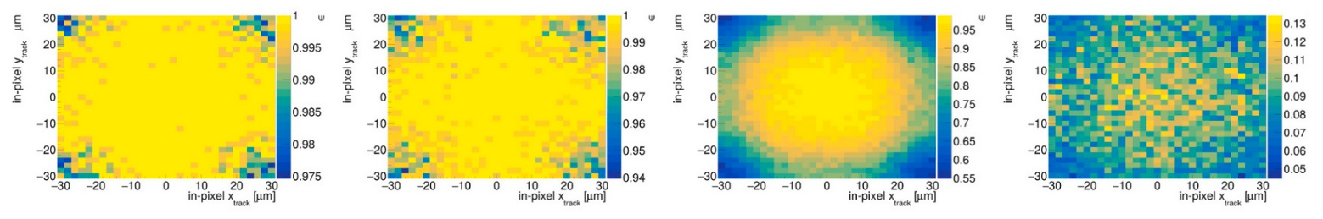
(a) (b) (c) (d)
Fig 5.2. In-pixel efficiency maps of differently irradiated samples at common bias and threshold
settings. (a) unirradiated, (b) 1×10¹⁴ n_{eq}/cm², (c) 3×10¹⁴ n_{eq}/cm², (d) 1×10¹⁵ n_{eq}/cm².

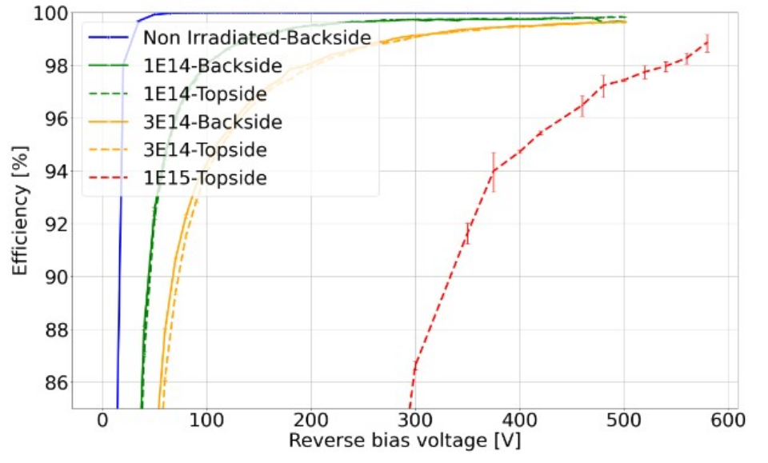

Fig 5.3. Hit detection efficiency as a function of the bias voltage of the various MPW4 irradiated
samples. The prefixes Topside and Backside in the legend correspond to different biasing schemes.

6 CONCLUSIONS

The results of the test beam characterization of radiation-hard DMAPS prototypes developed in the framework of AIDAinnova (MALTA, LF/TJ-Monopix, and RD50-MPW) were presented. Both the LF-Monopix2 and the MALTA2 devices offer excellent performance in terms of operation and hit reconstruction efficiency before and after irradiation to 2×10¹⁵ n_{eq​/}cm². This clearly demonstrates, with experiment-ready devices, that radiation-tolerant DMAPS fulfilling the demanding requirements for operation in proton collider vertex detectors, are indeed feasible.
The RD50-MPW4 development, the culmination of the RD50 effort in this series, represents a clear and significant improvement over previous prototypes. Building on lessons learned from MPW2 and MPW3, including addressing issues like high noise from digital-to-analogue cross-coupling and refining guard ring designs, MPW4 was specifically engineered for enhanced radiation hardness. Test results from non-irradiated samples confirmed promising baseline performance, achieving excellent results before irradiation.
Crucially, the test beam characterization of irradiated RD50-MPW4 samples demonstrated its improved resistance to radiation damage. For instance, sensors irradiated to 1×10¹⁵ n_{eq​/}cm² exhibited a remarkable efficiency recovery to above 98% when operated with appropriately increased in bias voltage. Investigation of the ultimate performance of these devices with and without specific backside processing are still on-going, with the aiming to further optimize their operational parameters and long-term stability. In summary, WP5 has completed the full cycle (development, assembly and characterization with particle beams) of several DMAPS prototypes and demonstrated that this technology can reach excellent performance up to fluences of 1-2×10¹⁵ n_{eq}​/cm².

6 REFERENCES
[1] N. Wermes, F. Huegging and S. Grinstein, “Report on performance of radiation-hard DMAPS”,
AIDAinnova Deliverable report, https://zenodo.org/records/1119060.

[2] C. Bespin et al., “Development and characterization of a DMAPS chip in TowerJazz 180 nm
technology for high radiation environments”, Nuclear Inst. and Methods in Physics Research, A
1040 (2022) 167189. https://doi.org/10.1016/j.nima.2022.167189.

[3] M. LeBlanc et al., “Recent results with radiation-tolerant TowerJazz 180 nm MALTA sensors”,
Nuclear Inst. and Methods in Physics Research, A 1041 (2022) 167390,
https://doi.org/10.1016/j.nima.2022.167390.

[4] J. Dingfelder, et al., “Progress in DMAPS developments and first tests of the Monopix2 chips in
150 nm LFoundry and 180 nm TowerJazz technology”, NIM A Vol 1034, 1 July 2022, 166747. doi:10.1016/j.nima.2022.166747.

[5] P. Sieberer, et al., “RD50-MPW3: a fully monolithic digital cmos sensor for future tracking detectors”, JINST 18 (2023) C02061. doi:10.1088/ 1748-0221/18/02/C02061.

[6] C. Bespin et al., “Charge collection and efficiency measurements of the TJ-Monopix2 DMAPS
in 180 nm CMOS technology”, PoS Pixel2022 (2023) 080. https://doi.org/10.22323/1.420.0080.

[7] B. Pilsl et al., “Enhancing radiation hardness and granularity in HV-CMOS: The RD50-MPW4
sensor”, NIMA A 1080 (2025) 170752. https://doi.org/10.1016/j.nima.2025.170752.

[8] M van Rijnbach, el al., “Radiation Hardness of MALTA2 Monolithic CMOS Sensors on Czochralski Substrates“ Eur. Phys. J. C (2024) 84: 251.
https://doi.org/10.1140/epjc/s10052-024-12601-3

NOTE: for a full list of the AIDAinnova WP5 publications, please see the following link:
https://zenodo.org/communities/aidainnova-project/search?page=1&size=20&keywords=WP5.

